3GPP TSG-RAN WG2 #129-bis Tdoc R2-250xxxx

Wuhan, China, April 7 – 11, 2025

Agenda Item: x.x

Source: Ericsson

Title: Initial guidance for trial of Git

Document for: Information

# 1 Introduction

Following the previous plan for a trial (R2-2501456), this document provides more details on the plan.

# 2 Offline trial of Git

## 2.1 Scope

The intention of the plan is to try out CR handling. Namely preparing a CR, receiving comments, update the CR based on those comments and approve/reject/postpone a CR. The figure below depicts the main steps in way of working that can be different with Gitlab.

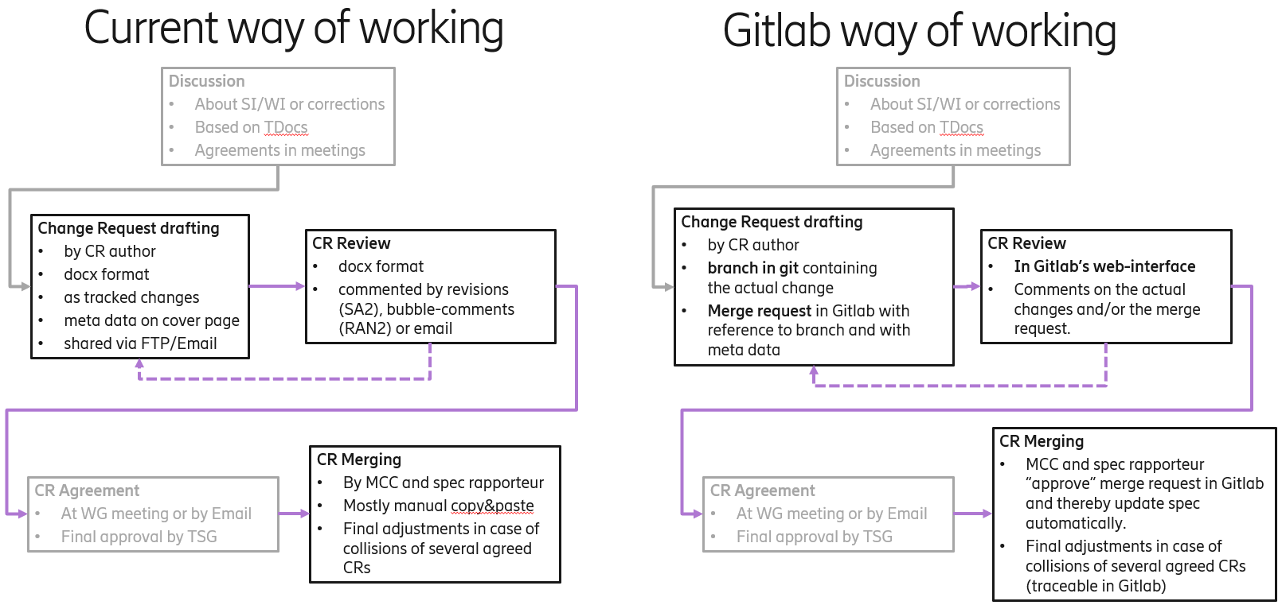

## 2.2 Preparations

Ericsson has setup a repository in 3GPPs Git-environment. The link to the repository is here: <https://forge.3gpp.org/rep/bergstromm/ran2_trial>

In this repository, there is a mock specification (regarding system information, connection control and PUSCH power control) which have been converted to Markdown and has some figures, flow diagrams and equations. This forms the “main” branch, i.e. corresponds to what would be the actual latest version of the specification.

We also provided a [first CR](https://forge.3gpp.org/rep/bergstromm/ran2_trial/-/merge_requests/3) (merge request) which can be used as basis for other delegates to create their own.

## 2.3 The trial

Interested delegates can login to the 3GPP forge and enter the repository to start playing around with the environment. We think the trial can be open in the sense that delegates can play around without restrictions, however there are a few things which we would highlight hereafter to take into account during the trial. Other options are available and thus this document does not limit what one can do but can give some direction for those new into the tools involved in this trial. For those that would want to get familiar with the git commands and how to perform the steps below via such commands, one can refer to the [Gitlab documentation](https://docs.gitlab.com/user/get_started/).

### 2.3.1 Provide comments to CRs

Open [the trial repository](https://forge.3gpp.org/rep/bergstromm/ran2_trial). On the left side menu, you can click on the option “Merge requests” (or one can directly go to the [link for merge requests](https://forge.3gpp.org/rep/bergstromm/ran2_trial/-/merge_requests)). A list of all available CRs (here called “merge requests”) should appear.

Click in one of the CRs, which should depict the CR overview as below.

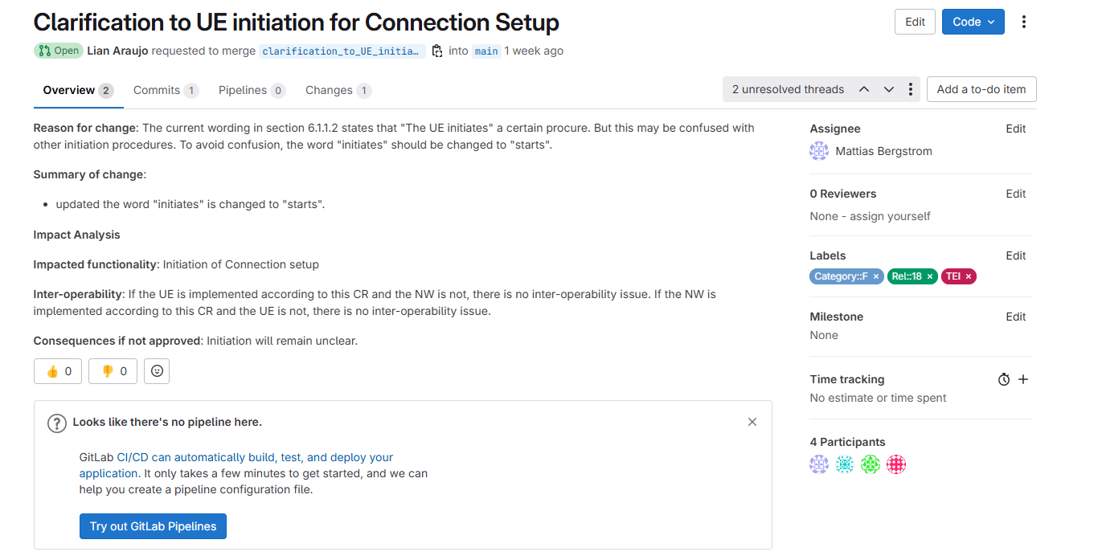

In the “Overview” tab one can see the usual coversheet elements of the CR. In the “Changes” tab one can check all the changes proposed by the CR. When checking the changes, the left side shows the line number of each text. If one mouse-over one of the lines, a comment icon should appear (as depicted below), which when clicked should open a dialog box for comments. Alternatively, one can also click at the right top comment icon, to make a comment to the overall CR instead of a particular line.

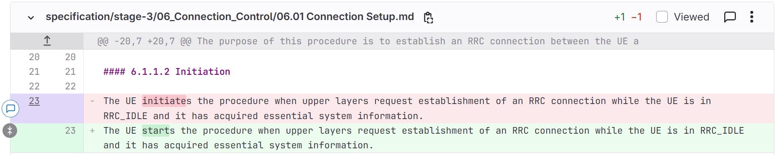

Once the comment is done one can click on “Add comment now” to insert the comment.

### 2.3.2 Create CRs

Open [the trial repository](https://forge.3gpp.org/rep/bergstromm/ran2_trial). In the top right, select the vertical ellipsis and select “Request Access”.

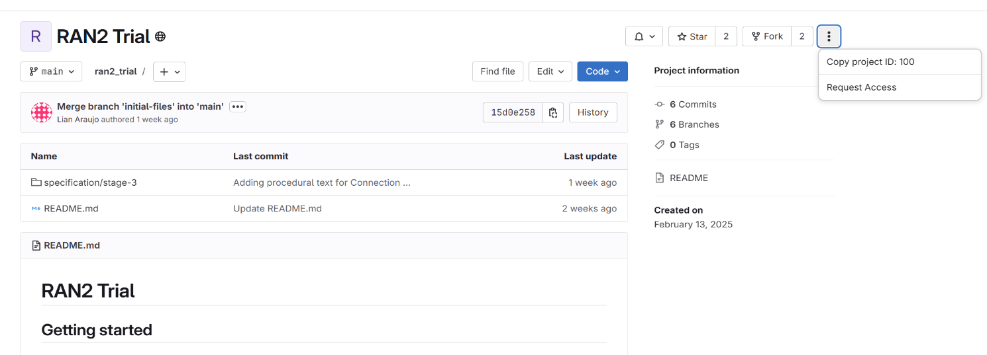Note this step is essential for all others below, and you would have to wait for someone to approve your request before following the remaining steps.

On [the trial repository](https://forge.3gpp.org/rep/bergstromm/ran2_trial) in the top right, select “Edit” and then “Open in Web IDE”. The editor view will open. On the left side menu, one can navigate through the files in the trial and modify multiple ones. These modifications will be marked in the left side bar with branch icon (called “source control”). For instance, in the depicted example below two modifications were done (one in Connection Setup.mb and one in System Information.md) and those are marked by the number two on the branch icon.

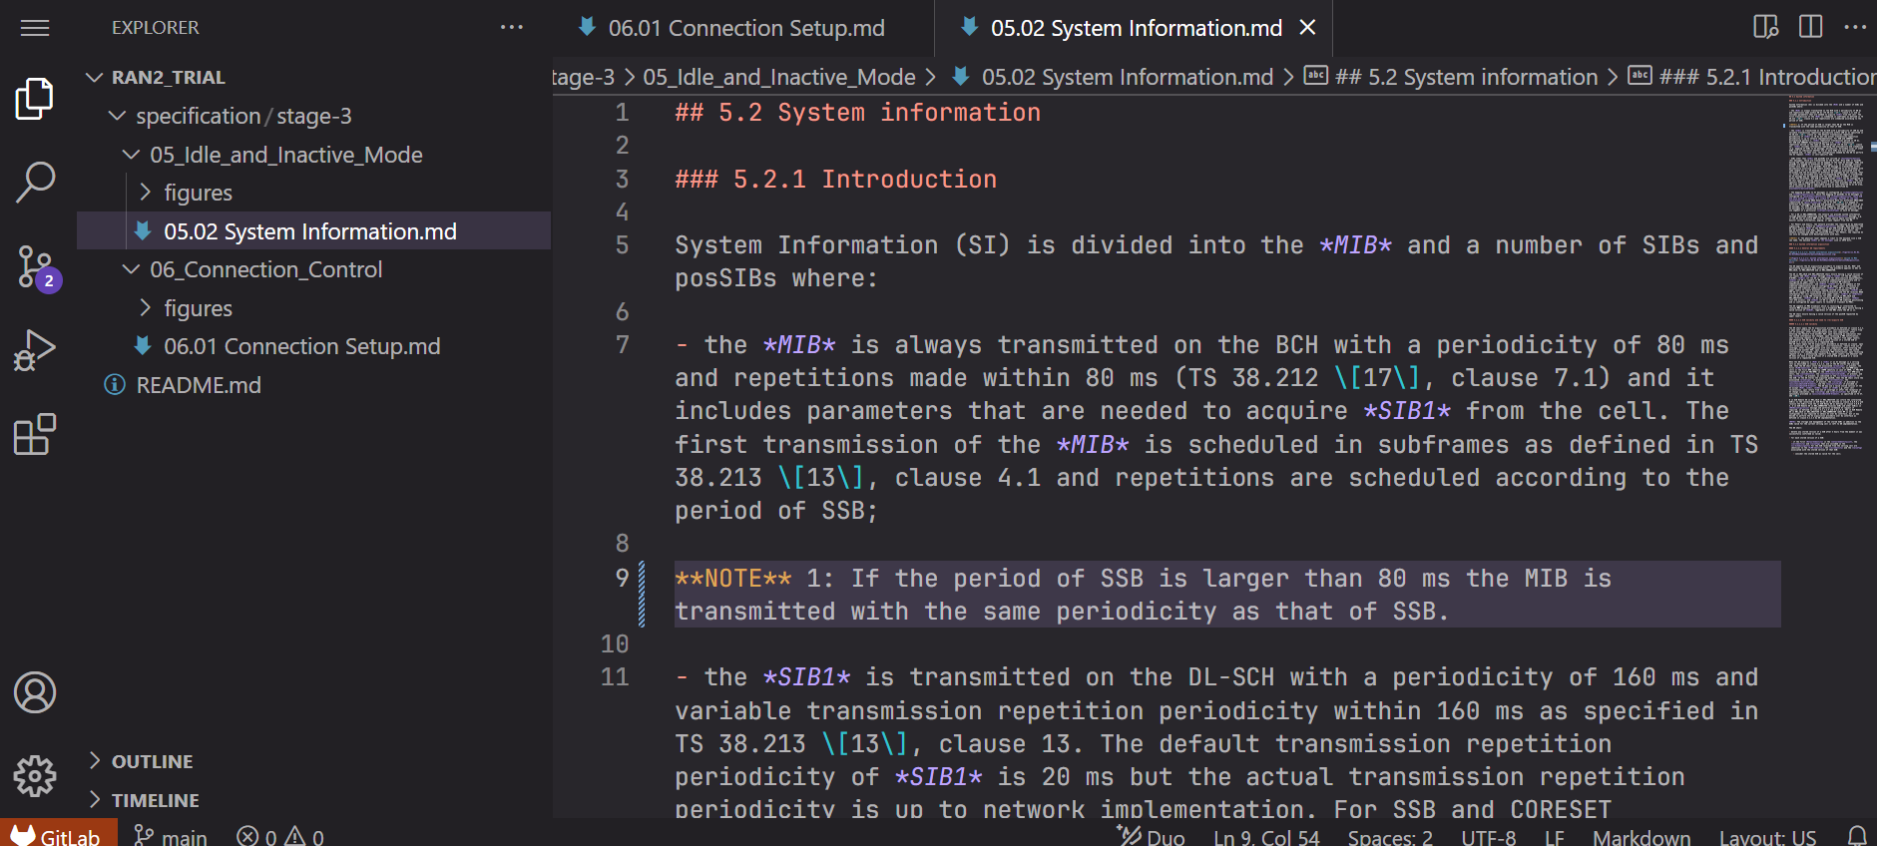

When all the modifications are done, one can click on the branch icon and see all the changes performed. Under “Commit message” write a one sentence summary of your CR. Then on the right of “Commit and push to ‘main’”, one can click on the down arrow icon and an option should appear to “Commit to new branch”. Once that option is clicked you should write the name of the new branch i.e. a CR tittle (note that there should be no spaces between words names, - can be used instead e.g. this-is-the-CR-tittle).

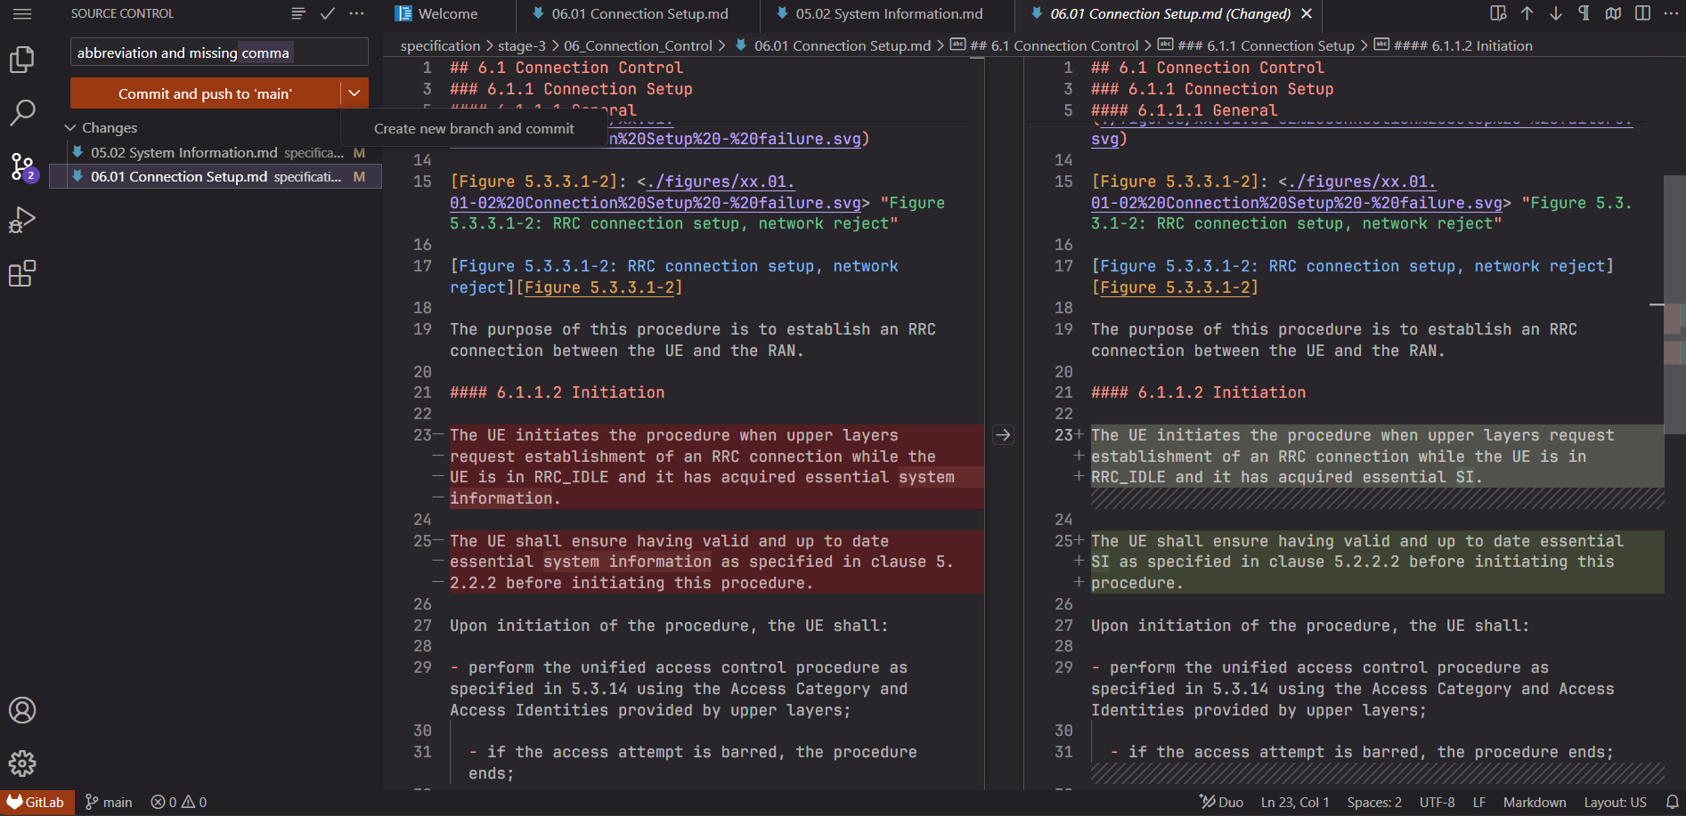

After this step, on the right bottom of the screen it should appear an option to create a merge request “Create MR”. When clicked, this will lead to the merge request view where you can fill in details similar as done in the [first CR](https://forge.3gpp.org/rep/bergstromm/ran2_trial/-/merge_requests/3) (merge request) we provided as example (e.g. the “**Description**” field and “**Labels**” could be filled in).

Once done filling in the merge request details, click on “Create merge request” at bottom left.

### 2.3.3 Approve/Reject CRs

Open [the trial repository](https://forge.3gpp.org/rep/bergstromm/ran2_trial). On the left side menu, you can click on the option “Merge requests” (or one can directly go to the [link for merge requests](https://forge.3gpp.org/rep/bergstromm/ran2_trial/-/merge_requests)). A list of all available CRs (here called “merge requests”) should appear.

Click in one of the CRs, which should depict the CR overview as below.



On the right side menu, note the “Labels” option can be edited. If “Edit” in “Labels” is clicked, the labels applicable to this merge request can be changed. One can look for the specific labels *Agreed*, *Postponed* or *Rejected* and add one of them to the merge request.

# 4 Summary

In this document we have provided some guidance that participants can consider when the participate in the RAN2 trial of handling specifications in Git.