**3GPP TSG-RAN WG2 Meeting #129 R2-250**

**Athens, Greece, 17th – 21st Feb, 2025**

**Agenda Item: 8.xx**

**Source: Huawei, HiSilicon**

**Title: Summary of [POST128][108][MOB] RRC running CR (Huawei)**

**Document for: Discussion and Decision**

# 1 Introduction

This paper summarizes the post meeting email discussion for the RRC running CR

**[POST128][108][MOB] RRC running CR (Huawei)**

**Scope:** For L1 event-driven MR, prepare 38.331 running CR capturing all RAN2 agreements, identify stage 3 issues (possibly with rapporteur’s suggestion) that need to be discussed, and discuss them.

**Intended outcome:** 38.331 running CR, to be endorsed next meeting, and discussion summary.

**Deadline: Long email discussion**

Based on the companies' inputs, the proposals have been formulated at the conclusion section.

Please fill in the contact information in the table below

|  |  |  |
| --- | --- | --- |
| **Company** | **Contact Person** | **Email Address** |
|  |  |  |
|  |  |  |

# 2. Discussion

## 2.1 Resource configuration

Regarding the resource configuration, the current draft running CR is implemented as follows.

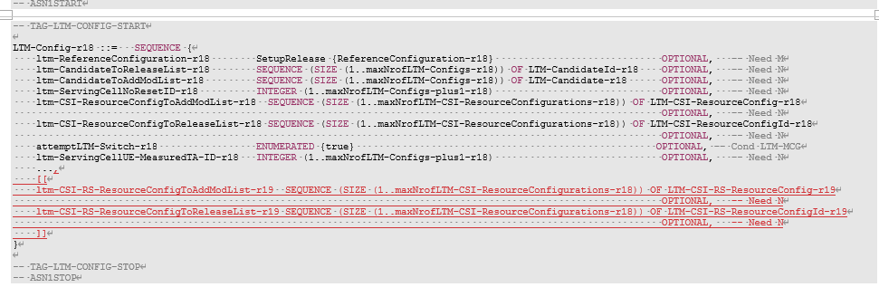

The reason why we introduce the CSI-RS configuration in parallel with the SSB configuration is that within the legacy field *LTM-CSI-ResourceConfig*, the field *LTM-SSB-CSI-Config* is configured as mandatory. Then, it is impossible to add CSI-RS configuration under this IE anymore.

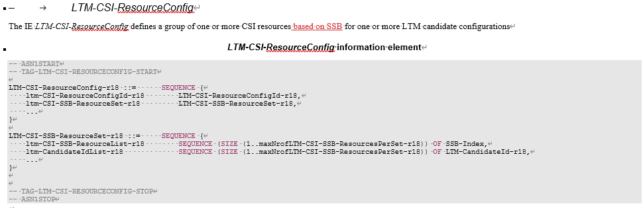

So, the solution is

* The R18 *LTM-CSI-ResourceConfig* is used to configure CSI resources based on SSB for LTM
* We introduce a new R19 field *LTM-CSI-RS-ResourceConfig-r19* for configuring the CSI resources based on CSI-RS for LTM

During the RAN2 meeting 127bis, the following agreement regarding the resource configuration has been reached.

|  |
| --- |
| RAN2#127bis  3. For measurement resource configuration, R18 LTM CSI resource configuration is reused if possible. If CSI-RS resource only IE needs to be defined, we can revisit it in the stage 3. |

The rapporteur observes that change per above agreement may have the following issues:

* In the legacy IR for *LTM-CSI-ResourceConfig,* the field *ltm-CSI-SSB-ResourceSet* is mandatory. If we reuse the existing LTM CSI configuration, it would mandatorily include the SSB configuration. While for R19 LTM, CSI-RB-based measurement is supported for both event-triggered report by MAC CE and legacy CSI report. It does not make sense to mandatorily support SSB for event-triggered measurement report or CSI-based report
* If we introduce the resource for event-triggered measurement report by MAC CE within the *LTM-CSI-ResourceConfig*, it is hard to see which resource is configured for report by CSI and which is for report by MAC CE. We could potentially by-pass the issue by what is currently being done in IE description that (a) the resource configuration associated with *LTM-ReportConfig* configured with *periodic/semi-persistentOnPUCCH/semi-persistentOnPUSCH/aperiodic* report type is for CSI report and (b) resource configuration associated with *LTM-ReportConfig* configured with *event-triggered* is for MAC CE report. But, the adding suffix like this makes the spec hard to read. For example, the current RAN1 spec (like TS 38.214 as an example in the figure below) for measurement report by CSI extensively uses the field name *LTM-CSI-ResourceConfig*

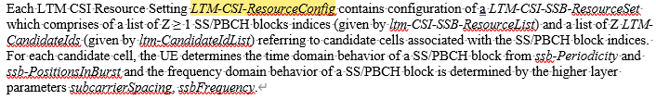

* The name of the IE and the fields within the IE still include the "CSI" part, which is not applicable for event-triggered measurement report by MAC CE anymore
* Limitation on the resource configuration Id and the number of *SSB-Index* and *LTM-CandidateId* with the introduction of event-triggered measurement report.

Based on the above observations and to revisit the issue during stage3, we would like to ask the following question:

***Question1: Do companies agree that, we add the resource configuration for event-triggered measurement report separately from the configuration for CSI resource?***

|  |  |  |
| --- | --- | --- |
| **Company** | **Yes/No** | **Comment** |
|  |  |  |
|  |  |  |

The resource configuration in the current running CR is caputured as follows. An FFS is kept for how to indicate the CSI-RS resource. We need to downselect between two choices, whether to indicate in the resource set level or in the resource level

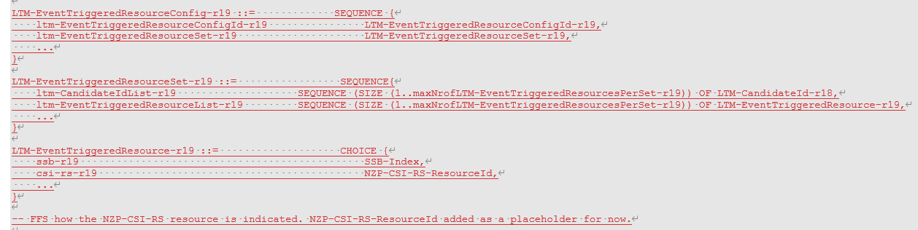

***Question2: How should the CSI-RS resource be indicated in the resource set for event-triggered measurement report ? (a) resource set id (b) resource id***

|  |  |  |
| --- | --- | --- |
| **Company** | **(a)/(b)** | **Comment** |
|  |  |  |
|  |  |  |

## 2.2 Report configuration

Another issue to revisit is the configuration of report configuration for event-triggered report. Regaring the placement of the report configuration, we have agreed on the following in our previous RAN2 discussion.

|  |
| --- |
| 4. For measurement reporting configuration, R18 LTM-CSI-ReportConfig is reused if possible. We can revisit it in the stage 3 if needed. |

Current running CR implemented the previous agreement as follows:

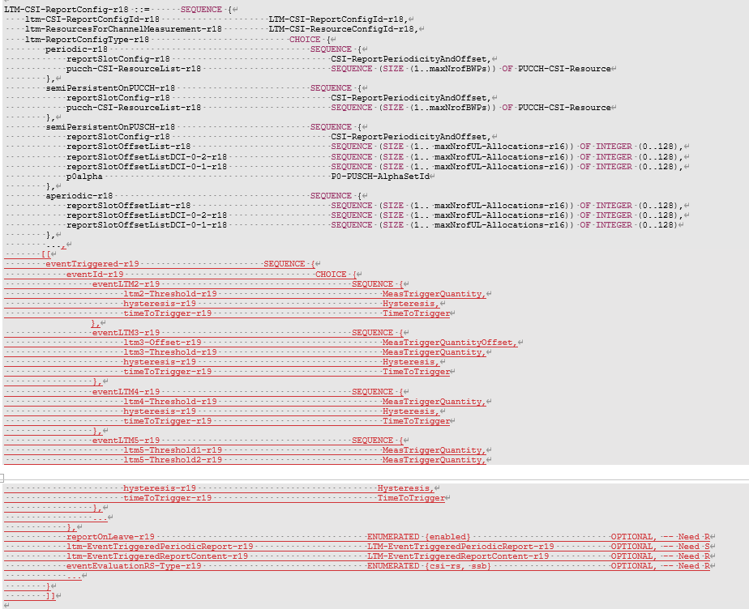

Similar issue as report config also exists that

* In other groups’ spec, the name *LTM-CSI-ReportConfig* is extensively used for report by CSI, either as periodic, semi-persistent on PUSCH, semi-persistent on PUCCH or aperiodic. While if we want to keep the current structure, RAN1/4 would be required to change their spec by adding suffix to the procedure text that uses the name *LTM-CSI-ReportConfig*, restricting that the ReportConfigType set to *periodic, semi-persistent, aperiodic*.

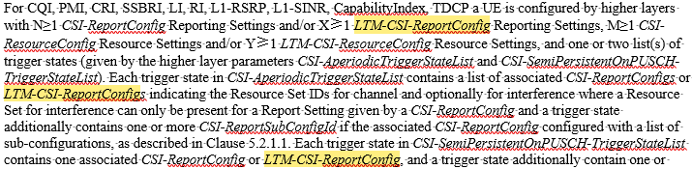

* Same issue on the report config id and that the name CSI is not applicable for report by MAC CE

Based on the above, we would like to ask the following question:

***Question3: Do comapnies agree that we add report configuration for event-triggered measurementr report separately from the R18 LTM-CSI-ReportConfig?***

|  |  |  |
| --- | --- | --- |
| **Company** | **Yes/No** | **Comment** |
|  |  |  |
|  |  |  |

One of the original reasons to keep the report configuration on the level of serving cell configuration is to reuse the legacy field and to reduce the workload. If we reached agreement on the above question that report and resource confifguration does not need to reuse the legacy field, the above reason does not hold anymore.

Beside, if the report is sent by MAC CE, it is not reasonable either to configure the report configuration on the serving cell level, since MAC CE should be permitted to transmit on whichever cell with UL grant. We would like to ask the following question

***Question4: Do companies agree that the report configuration should be configued in the CG level rather than the serving cell level?***

|  |  |  |
| --- | --- | --- |
| **Company** | **Yes/No** | **Comment** |
|  |  |  |
|  |  |  |

In the current draft CR, the following FFS has been kept for further studying the issue.



It needs to be further discussed the maximum number of measurement results can be reported for the beams.

***Question5: What should be the maximum number of beam measurement results can be reported?***

|  |  |  |
| --- | --- | --- |
| **Company** | **Maximum# of beams (e.g., 256, 128, etc)** | **Comment** |
|  |  |  |
|  |  |  |

## 2.3 Linkage between resource and report configuration

In the legacy L3 measurmenet configuration, a meas ID is configuerd as the linkage between the measurment object configuration and measurement report configuration. This allows for flexible assocaition between MO and MR config and reduces the signaling overhead.

In the legacy LTM confifguration, a resource id is included in the report configuration to establish the association between the resource configuration and report configuration. In R19 LTM discussion, we have agreed on the following

|  |
| --- |
| For association between measurement resource configuration and measurement reporting configuration, R18 LTM way is reused if possible. We can revisit it in the stage 3 if needed. |

Hence, we would like to ask the following question

***Question6: Which option do companies prefer for association between measurement resource configuration and measurement reporting configuration,***

* ***(a) R18 LTM way is reused, ie., by adding resource id into report configuration***
* ***(b) Legacy L3 way is reused, ie., by a measurement id liking resource and report id***

|  |  |  |
| --- | --- | --- |
| **Company** | **(a)/(b)** | **Comment** |
|  |  |  |
|  |  |  |

## 2.4 Confirmation of the RAN1/4 aspects

During RAN2#126, it was agreed that

|  |
| --- |
| 1. For event triggered L1 measurement, use of beam level measurement result for event evaluation is baseline. FFS for the cell level measurement. |

In the current running CR, the RSRP values is captured as a separate IE from the legacy, as it is used in both event-triggered and L3 measurement as the triggering quantity.

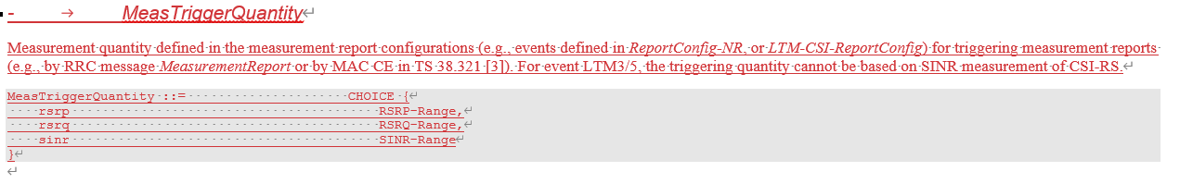

Then, in the definition of RSRP-Range, the following has been captured

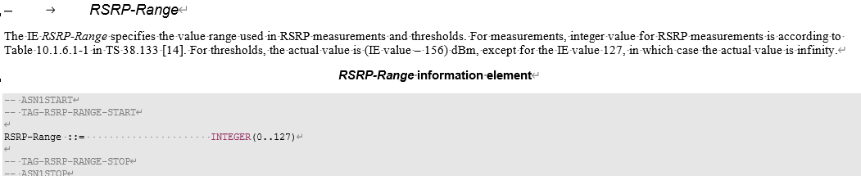

In the RAN4 spec TS 38.133, the following table has been captured on the mapping between the integer value and the real RSRP value.

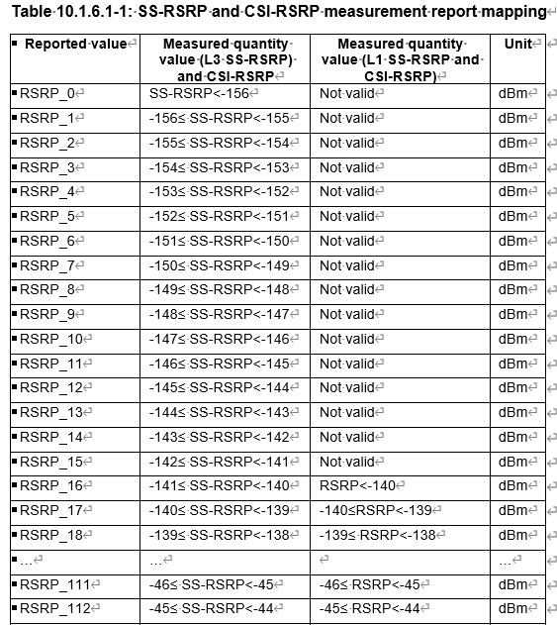

Since this table has been reused for R15 L1 measurement and R18 LTM measurement report by CSI, for R19 event-triggered measurement report, it can be still assumed that they are reused. Rapp would like to ask the following question.

***Question7: Confirm that the legacy RSRP values used for L1 measurement report can be reused for L2 measurement report***

|  |  |  |
| --- | --- | --- |
| **Company** | **Yes/No** | **Suggestion** |
|  |  |  |
|  |  |  |

# 3 Examining the running CR

This section is used to collect comments for the running CR in *Introduction of event-triggered L1 report for RRC spec_v00*.

***Question8: Any comments on the running CR?***

|  |  |  |
| --- | --- | --- |
| **Company** | **Issue** | **Suggestion** |
|  |  |  |
|  |  |  |

4 Conclusion

Based on the discussion above, we propose that

5 Reference

1. RP-240299, Revised Work Item: NR mobility enhancements Phase 4;
2. TS 3GPP 38.331 V18.4.0