**3GPP TSG RAN WG2#128 R2-24xxxxx**

**Orlando, US, 18th – 22nd Nov 2024**

**Source: Offline Rapporteur (RAN2 Basketball team captain)**

**Title: Report on RAN2 Basketball team**

**Agenda item:** **2.5**

**Document for:** **Discussion and Decision**

# Introduction

[POST127bis][021][Basketball] Team (Team captain Shi Cong)

Intended outcome: decide team and cheerleading team, response to RAN3 and timeline

Deadline: Long email discussion

RAN2 received the LS from RAN3 ([R2-2409411](https://www.3gpp.org/ftp/Meetings_3GPP_SYNC/RAN2/Inbox/R2-2409411.zip)) on the challenge of basketball game. Based on the chairlady’s guidance on the incoming LS, we will accept the challenge and we will set up the RAN2 basketball team, with the following considerations from RAN2 side:

1. Chairs from RAN2/RAN3 need to be in the team and always play in the court.
2. We aim to have a mix team for each group, e.g., 3 gentlemen plus 2 ladies (exact number to be determined but we encourage athletic ladies to participate).
3. We prefer to have the match in February meeting; The day of the match will further be negotiated.

The draft reply LS is in the sub-folder, please provide any comments to that directly and save it back in that folder.

# Background – Basketball introduction

Not too many words to say about basketball, I assume it’s a famous sports, but if you’re interested in some of the roles we play in the court, would be good to refer to: <https://en.wikipedia.org/wiki/Basketball_positions>.

Below is a court with some typical roles and players:

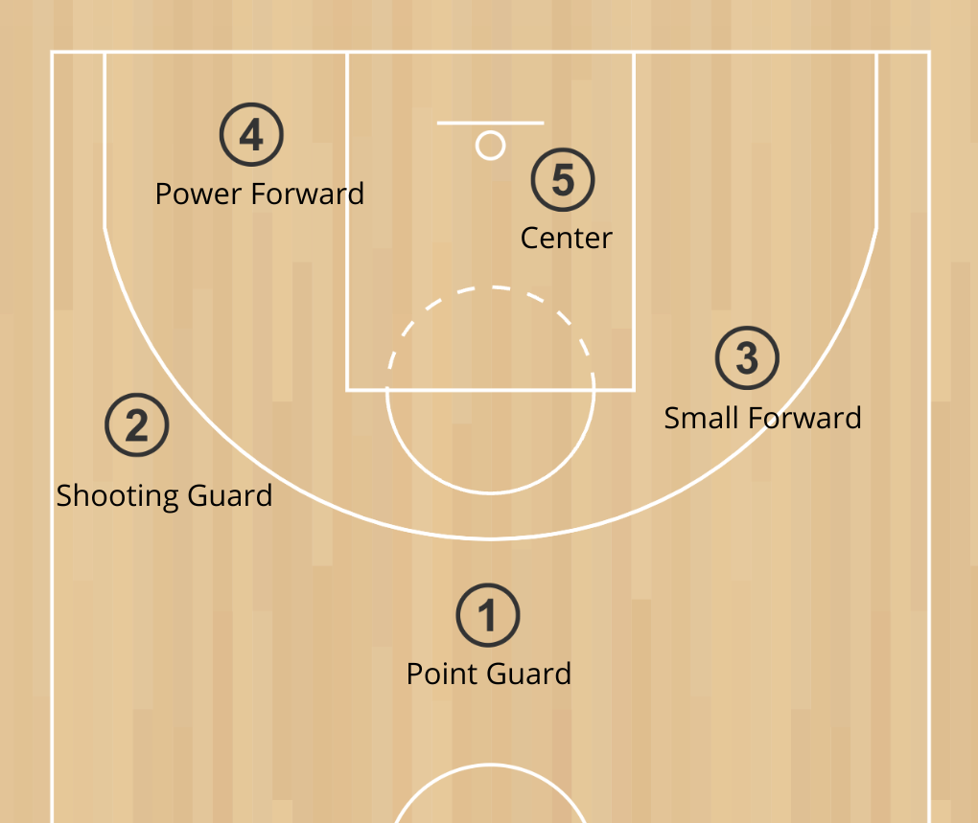

In total, we have 5 players in the court, with the following roles. Of course, u don’t need to be always there in the same point the picture, u need to run in a strategy way so that the team can get more points. The following are some simple descriptions of each role in the court, but believe me, sometime it’s easy to forget what role you’re playing, just shoot if u have chance 😊

• Point guard: The point guard (PG), also known as the one, is typically the team's shortest player and best ball handler and passer.

• Shooting guard: The shooting guard (SG)—also known as the two or the off guard—is, along with the small forward, often referred to as a wing because of its use in common positioning tactics.

• Small forward: The small forward (SF), also known as the three, is considered to be the most versatile of the main five basketball positions.

• Power forward: The power forward (PF), also known as the four, often plays a role similar to that of the center, down in the "post" or "low blocks".

• Center: The center (C)— also known as the five, the pivot, or the big man; typically plays near the baseline or close to the basket (the "low post").

If there are further questions, you can always reach out to either me (privately) or any other basketball players you already know in RAN2 😊. Hopefully you will now spend the rest of your summer researching about basketball and hitting a ball with the bat!

# Logistics for the match

Logistics are still to be determined , but this is what I suggest so far:

**Date for official match:** We aim to have the match in Athen meeting, February 2025, the data is TBD.

**Date for practice:** Orlando, Sunday Nov. 17th, 2024

**Venue:** TBD

**Food and drinks:** Please bring your own. You can watch the game with a drink and some food.

**Format:** 5 v 5, at least 1 lady (aim to have two ladies) plus 3 gentlemen each team, the chairladies have to be always in the court.

**Other info:** We will also have basketball jerseys with the preferred number (you can input in the following table) and name printed for the team.

I am sure I missed some information, if you have any questions, please can you send me (a private) email and I will get back.

# RAN2 team questionnaire

Now we need a team. So, if you want to take part, please volunteer yourself by adding your name to the following table (save the file with a new version number and your name at the end):

You can select multiple options for each question… add your own option and explain etc 😊.

|  |  |  |  |  |
| --- | --- | --- | --- | --- |
| Name and contact email | **What is your experience with playing Basketball?**  a) I am/was a professional/league player  b) I am a current player playing for a (friendly) club  c) I played it in the past but am not an active player now  d) I never played it but I have watched others play, know the rules, and I am confident I can give it a go  e) I am not playing but would like to be a cheerleader  f) Other (please explain) | **What’s your primary role in a basketball team?**   1. Point guard 2. Shooting guard 3. Small forward 4. Power forward 5. Center 6. Cheer leader (I can dance and cheer) 7. Audience (I like watching, eating, drinking, clapping and heckling the opposition players – the last one is a must) 8. Umpire (I am familiar with basketball laws) 9. Other (please explain) | **What number in the basketball jersey do u prefer if u are in the team?** | **Would you be available to have a practice in Orlando, tentative day Sunday.**  Answer yes/no (time you are available) |
| ShiCong  [shicong@oppo.com](mailto:shicong@oppo.com) | b) | a), c)  Normally, it’s easy for me to forget the role i play in the court, so just play it 😊 | 25 | Yes  (Maybe Sunday, still waiting for my US visa) |
| Gyeong-Cheol LEE  [gyeongcheol.lee@lge.com](mailto:gyeongcheol.lee@lge.com) | c), I was in a (friendly) club before. | Usually c) and d), sometimes b) in the past. | 11 | Maybe No (I will arrive around 6PM in Orlando.) |
| Rao Shi  shi_rao@nec.cn | a) I was a professional player in college | a) and b) | 3 | Yes  (Arrive in the early morning, Sunday) |
| Stepan Kucera  [Stepan.kucera@nokia.com](mailto:Stepan.kucera@nokia.com) | c) I played it in the past but am not an active player now | I am tall but played long time ago, so probably defense is the best match. Otherwise same as ShiCong. | 8 | Maybe (I will arrive around 6pm). |
| Marcin Augustyniak  marcin.augustyniak@huawei.com | c) I played in High School, but that was 20 years ago… | a)/b)/c)  Not high enough for e), not young and strong enough for d) 😉 | 24 | Yes, Sunday afternoon/evening |
| Rudraksh Shrivastava  shrivastavar@sharplabs.com | b) | a) and c) | 23 | Yes |
| Emre A. Yavuz  emre.yavuz@ericsson.com | c) | a), b), or c) |  | I would like to join the practice, but I can not make it on Sunday. How about Monday, Tuesday, or Wednesday at lunch break? It may also be possible to have a practice after the sessions are closed provided that we can find a basketball court with light. |
|  |  |  |  |  |
|  |  |  |  |  |
|  |  |  |  |  |
|  |  |  |  |  |
|  |  |  |  |  |
|  |  |  |  |  |
|  |  |  |  |  |
|  |  |  |  |  |
|  |  |  |  |  |
|  |  |  |  |  |
|  |  |  |  |  |

# Conclusion and final team selection

Thanks for all the input! We have a full team for the match! Details below:

|  |  |  |
| --- | --- | --- |
| **Team** | | |
| 1 |  |  |
| 2 |  |  |
| 3 |  |  |
| 4 |  |  |
| 5 |  |  |
| 6 |  |  |
| 7 |  |  |
| 8 |  |  |
| 9 |  |  |
| 10 |  |  |
| 11 |  |  |
| 12 |  |  |
| 13 |  |  |
| 14 |  |  |
| 15 |  |  |
| 16 |  |  |
| 17 |  |  |
| 18 |  |  |

# Reference

1. xxx