3GPP TSG-RAN WG2 Meeting #127 R2-24xxxx
Maastricht, Netherlands, 19-23 August 2024

Agenda item: 7.2.5
Source: Ericsson
Title: [Post127][405][POS] Rel-18 positioning RRC CRs (Ericsson)
Document for: Discussion and Agreement

1 Introduction
This document is to kick off the following email discussion:

- [Post127][405][POS] Rel-18 positioning RRC CRs (Ericsson)
Scope: Check the CRs in R2-2407721 and R2-2407769, including confirming list extension mechanism for R2-2407769.
Intended outcome: Agreed CRs
Deadline: Short (for RP)

2 Contact Information

Company Name | Contact: Name (E-mail)

3 Discussions

3.1 SL RRC Correction for CBR Range
As captured in main session in RAN2#127

=> guidance is that NBC change for SLPP
=> For the RRC CR in R2-2407769 discuss the option over email discussion

For both alternatives, a UE that indicates the support for Rel-18 SL CBR feature (sl-PRS-CongestionCtrl-r18) shall support the CR and consequently the 18.3.0 RRC version of the specification. This means RAN2 assumes there are no UEs and Networks that implemented the feature based on 38.331 18.2.0.
During SL pos online discussion, companies expressed preferences for a BC solution (Alt 2), but during late offline discussions, it was discovered that a “real ASN.1 change” (Alt 1) was probably the best and simplest for UE and Network implementations.
Alt 1: NBC Change (“real ASN.1 change”)
Alt 1 means that the ASN.1 in 18.2.0 is directly modified to have the correct list sizes. To ensure that there are no problems with UEs (that do not support SL CBR feature), a NW will not include the corresponding configuration fields unless the UE indicates support of the feature in UE capabilities. The changes have isolated impact on the ASN.1 to this particular feature, but no impact on other features. In the past, RAN2 indicated similar ASN.1 deviations on the specification web page, since the ASN.1 in 18.2.0 cannot be used to implement all Rel-18 features.
A CR of Alt 1 is provided in R2-2406510
Alt 2: BC Change (Dummify erroneous fields/IEs and introduce new with correct sizes)
Instead of modifying the ASN.1 as in Alt 1, we replace the erroneous fields/IEs with new fields/IEs with correct size. The erroneous fields/IEs are dummified (meaning that they remain in the ASN.1, but a network shall not include them in messages sent to UE, and UE ignores the fields/IEs if anyway received). The new fields/IEs are introduced respecting the RRC extension principles. Hence, the new ASN.1 is backwards compatible with 18.2.0. Still, UEs and Networks that intend to support Rel-18 SL CBR feature must support the CR and 18.3.0. Typically, we did in the past to indicate similar issues on the specification web page.
A CR of Alt 2 is provided in R2-2407769 (Section 6.3.5, 6.4)
Please provide which alternative is preferred and any comments.

Alt 3: BC Change via NCE (provided in document SL_CBR_Option3)

Alt 4: Leave the specification as it is.

Company Name | Preferred Alternative (Alt 1/Alt 2/Alt3/Alt4) | Comments
ZTE | Alt1 | Alt 1 is simpler and more readable considering there is no implementation of the corresponding feature at this stage.
CATT(Proponent) | Alt2 | Please follow the conclusion which has been reached at the meeting online.  Extension of CBR ranges (NBC and BC alternatives)  R2-2406510 Corrections on SL positioning in TS 38.331 CATT CR Rel-18 38.331 18.2.0 4879 - F NR_pos_enh2-Core  - Changes 3 and 4 are merged into the rapporteur CR  R2-2407559 Corrections for the extension of these IEs which do not support the maximum number of CBR ranges and levels for sidelink positioning in TS 38.331 CATT, Ericsson draftCR Rel-18 38.331 18.2.0 F FS_NR_pos_enh2  - Dummification to replace the field names completely as usual  - No capability is introduced  - To be merged into the rapporteur CR  - Change will be indicated as mandatory for UEs and networks implementing the concerned functionality  This short email is not for the decision on different options which have been finished online.  I don’t find any reason to revise the conclusion we have reached online.
Huawei, HiSilicon | Option3/4 | We have provided revisions towards the current draft for Option3 in the folder, please check  No NBC change should be allowed after spec freeze  Another option in addition to Option4 is  Option4b, accept the change for sl-CBR-RangeDedicatedSL-PRS-RP-List-r18, while not accept the change for SL-CBR-LevelsDedicatedSL-PRS-RP-r18  This is also acceptable to us.
CATT | Alt2/Alt3 | We agree with syntax BC changes as principle after our discussion online. There is no need to discuss Alt1 anymore.  There are two candidate ways for BC change: Alt2-Dummy the original IEs or Alt3-NCE.  However the provided document SL_CBR_Option3 is not correct because of observed issues:  1. The changes are not real extension. For example: these IEs which are not supposed to be extended should not be included in the extended IE.  SL-PRS-TxPoolDedicated-v18xy ::= SEQUENCE {  sl-PRS-PoolToReleaseList-v18xy SEQUENCE (SIZE (1..maxNrofSL-PRS-TxPool-r18)) OF SL-PRS-ResourcePoolID-r18 OPTIONAL, -- Need N  2. dummy is not supposed in document SL_CBR_Option3 since Alt3 goes with NCE. The asn.1 design of SL-PRS-ResourcePool-v18xy is not correct since only the extended part is required in alt3.  There are also observed issues in document SL_CBR_CR_Alternate3_HW.  1. The changes on SL-BWP-PRS-PoolConfig-v18xy are not correct because these deleted IEs include the IE: SL-CBR-CommonTxDedicatedSL-PRS-RP-List-r18 which is not correct.  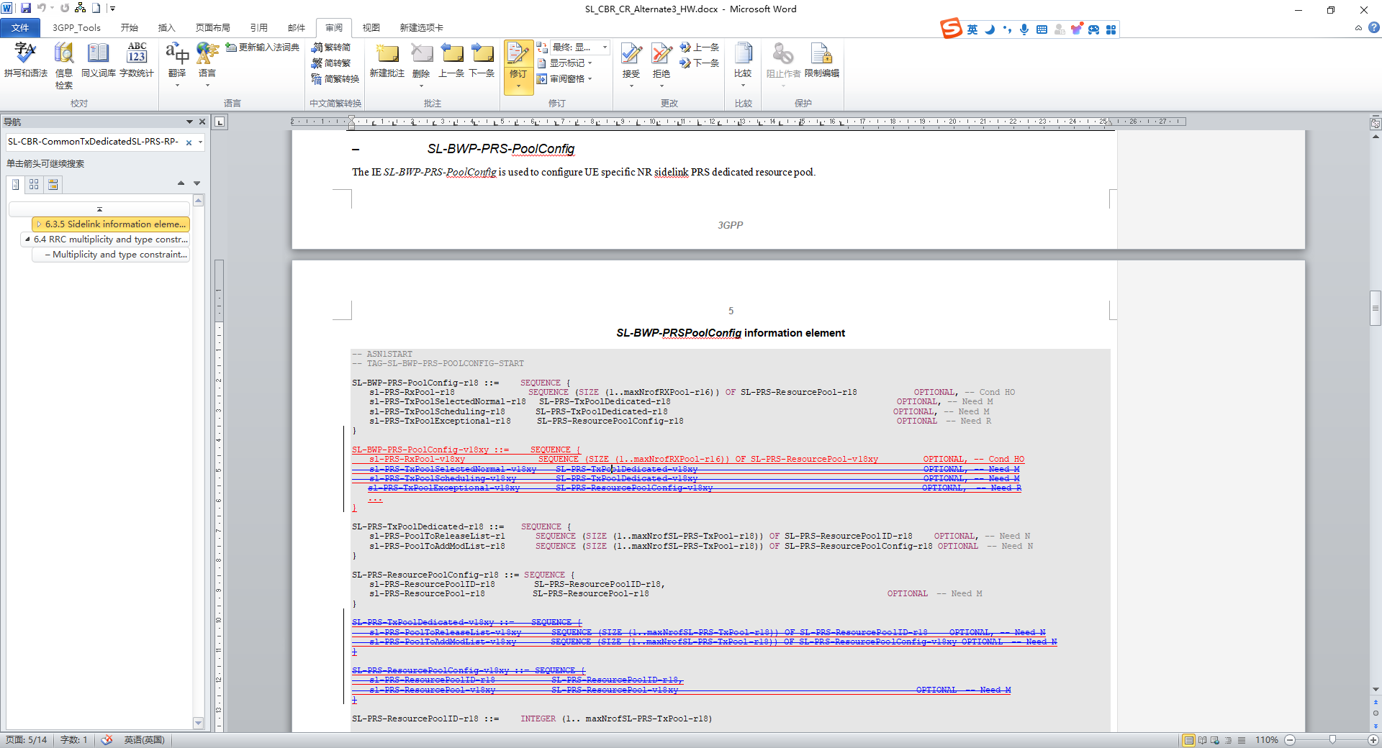  2. The SL-CBR-CommonTxDedicatedSL-PRS-RP-List-v18xy doesn’t fix the existing issues.  We can try to reach the agreement on which way at first: Alt2-Dummy the original IEs or Alt3-NCE?
Qualcomm | Alt-1 | We would be O.K. with Alt-1 (without the added ellipsis in SL-CBR-CommonTxDedicatedSL-PRS-RP-List-r18), given that the change is isolated and assuming no UEs are available supporting the feature.  The least preferred option is Alt-2.  Alt-4 may also be an option if we can get some information on how serious the issue actually is (in particular for the SL-CBR-LevelsDedicatedSL-PRS-RP-r18).
vivo | Alt3 as Rapp v2, with changes | Okay with this version of BC change, but the following modifications are needed:  maxCBR-ConfigDedSL-PRS-r18 INTEGER ::= 16 -- Maximum number of CBR ranges for dedicated SL PRS resource pool  - The maxi number of CBR ranges for dedicated resource pool should be 8 rather than 16  SL-CBR-CommonTxDedicatedSL-PRS-RP-List-r18 ::= SEQUENCE {  sl-CBR-RangeDedicatedSL-PRS-RP-List-r18 SEQUENCE (SIZE (1..maxCBR-ConfigDedSL-PRS-1-r18)) OF SL-CBR-LevelsDedicatedSL-PRS-RP-r18  OPTIONAL, -- Need M  sl-CBR-SL-PRS-TxConfigList-r18 SEQUENCE (SIZE (1.. maxNrofSL-PRS-TxConfig-r18)) OF SL-CBR-SL-PRS-TxConfig-r18  OPTIONAL -- Need M  }  SL-CBR-CommonTxDedicatedSL-PRS-RP-List-v18xy ::= SEQUENCE {  sl-CBR-RangeDedicatedSL-PRS-RP-List-v18xy SEQUENCE (SIZE (1..maxCBR-ConfigDedSL-PRS-r18)) OF SL-CBR-LevelsDedicatedSL-PRS-RP-v18xy  OPTIONAL, -- Need M  ...  }  - Since SL-CBR-CommonTxDedicatedSL-PRS-RP-List-v18xy should be used as the new version of SL-CBR-CommonTxDedicatedSL-PRS-RP-List-r18 rather than an extension, therefore a NOTE should be added to clarify that the network is only expected to configure one of these two for UE.  Another approach is to straightforwardly substitute SL-CBR-CommonTxDedicatedSL-PRS-RP-List-r18 with dummy, which requires no further clarification.

Summary: Since, the spec is frozen, we will need 100% consensus to do any backward compatible change. As we do not have full consensus, we will not be able to do NBC change. Further, the dummification requires several changes from top IE which is also not preferred. Hence, the way forward is to consider below 2 aspects:

- If current ASN.1 is workable and if we can leave it is. It would require some disucssion.
- If conidered essential to correct, one approach is to do ASN.1 NCE

3.2 Validity Area list size correction

For validity area, the correction is needed so that the number of cells in validity area can be aligned with that of NRPPa. As discussed during online.

R2-2406793 Correction on SRS transmission in RRC_INACTIVE ZTE Corporation draftCR Rel-18 38.331 18.2.0 F NR_pos_enh2
- Constant to be replaced with maxNrOfCellsInVA-Ext-r18 (also equal to 16)
- No capability is introduced
- To be merged into rapporteur CR
- Change will be indicated as mandatory for UEs and networks implementing the concerned functionality

During Comeback session, it was mentioned that this can be simplified espcially considering the implemntation aspects which has to consider two lists instead of one list. Hence, we propose below alternatives.

Below we show that there are two different options to solve this issue (i.e use only one list) apart from the agreed third option.

For all options, a UE that indicates the support for LPHAP shall support the CR and consequently the 18.3.0 RRC version of the specification. This means RAN2 assumes there are no UEs and Networks that implemented the feature based on 38.331 18.2.0.

Option 1: NBC change. We can update the value of maxNrOfCellsInVA-r18 diretcly to 32. This means that the ASN.1 in 18.2.0 is directly modified to have the correct list sizes. To ensure that there are no problems with UEs (that do not support LPHAP feature), a NW will not include the corresponding (srs-PosRRC-InactiveEnhanced) configuration fields unless the UE indicates support of the feature in UE capabilities. The changes have isolated impact on the ASN.1 to this particular feature, but no impact on other features. In the past, RAN2 indicated similar ASN.1 deviations on the specification web page, since the ASN.1 in 18.2.0 cannot be used to implement all Rel-18 features.

SuspendConfig ::= SEQUENCE {
:
srs-PosRRC-InactiveEnhanced-r18 SetupRelease { SRS-PosRRC-InactiveEnhanced-r18 } OPTIONAL, -- Need M
:
}

SRS-PosRRC-InactiveValidityAreaConfig-r18 ::= SEQUENCE {
srs-PosConfigValidityArea-r18 SEQUENCE (SIZE(1..maxNrOfCellsInVA-r18)) OF CellIdentity,
srs-PosConfigNUL-r18 SRS-PosConfig-r17 OPTIONAL, -- Need R
srs-PosConfigSUL-r18 SRS-PosConfig-r17 OPTIONAL, -- Need R
bwp-NUL-r18 BWP OPTIONAL, -- Need S
bwp-SUL-r18 BWP OPTIONAL, -- Need S
areaValidityTA-Config-r18 AreaValidityTA-Config-r18 OPTIONAL, -- Need R
...
}

:

maxNrOfCellsInVA-Ext-r18 = 32

Option 2: Dummy the previous defintion and create a new one with 32. Instead of modifying the ASN.1 as in Option 1, we replace the erroneous fields/IEs with new fields/IEs with correct size. The erroneous fields/IEs are dummified (meaning that they remain in the ASN.1, but a network shall not include them in messages sent to UE, and UE ignores the fields/IEs if anyway received). The new fields/IEs are introduced respecting the RRC extension principles. Hence, the new ASN.1 is backwards compatible with 18.2.0. Still, UEs and Networks that intend to support Rel-18 LPHAP feature must support the CR and 18.3.0. Typically, we did in the past to indicate similar issues on the specification web page.

SRS-PosRRC-InactiveValidityAreaConfig-r18 ::= SEQUENCE {
dummy SEQUENCE (SIZE(1..maxNrOfCellsInVA-r18)) OF CellIdentity,
srs-PosConfigNUL-r18 SRS-PosConfig-r17 OPTIONAL, -- Need R
srs-PosConfigSUL-r18 SRS-PosConfig-r17 OPTIONAL, -- Need R
bwp-NUL-r18 BWP OPTIONAL, -- Need S
bwp-SUL-r18 BWP OPTIONAL, -- Need S
areaValidityTA-Config-r18 AreaValidityTA-Config-r18 OPTIONAL, -- Need R
...,
[[
srs-PosConfigValidityAreaExt-r18 SEQUENCE (SIZE(1..maxNrOfCellsInVA-Ext-r18)) OF CellIdentity OPTIONAL -- Need R
]]
}

maxNrOfCellsInVA-Ext-r18 = 32
SRS-PosRRC-InactiveValidityAreaConfig field descriptions
dummy
This field is not used in the specification. If received it shall be ignored by the UE.

Option 3: Use the previous definition and create a new extention to have another so that a total of 32 cells can be defined in a VA. Same as agreed during online session.

SRS-PosRRC-InactiveValidityAreaConfig-r18 ::= SEQUENCE {
srs-PosConfigValidityArea-r18 SEQUENCE (SIZE(1..maxNrOfCellsInVA-r18)) OF CellIdentity,
srs-PosConfigNUL-r18 SRS-PosConfig-r17 OPTIONAL, -- Need R
srs-PosConfigSUL-r18 SRS-PosConfig-r17 OPTIONAL, -- Need R
bwp-NUL-r18 BWP OPTIONAL, -- Need S
bwp-SUL-r18 BWP OPTIONAL, -- Need S
areaValidityTA-Config-r18 AreaValidityTA-Config-r18 OPTIONAL, -- Need R
...,
[[
srs-PosConfigValidityAreaExt-r18 SEQUENCE (SIZE(1..maxNrOfCellsInVA-Ext-r18)) OF CellIdentity OPTIONAL -- Need R
]]
}

maxNrOfCellsInVA-Ext-r18 = 16

srs-PosConfigValidityArea/ srs-PosConfigValidityAreaExt
This field provides list of cells present in the validity area. The maximum number of cells in a validity area is 32 which can be provided by using these two fields srs-PosConfigValidityArea and srs-PosConfigValidityArea-Ext.

Please provide which option would you prefer and any comments.

Company Name | Preferred Options (Option 1/Option 2/Option3) | Comments
ZTE | Option 3 | This BC change is readable for this change, so option2/3 are both ok. Option 3 is what we agreed during online so we prefer this.
CATT | Option 3 | Stick to the conclusion reached online which follows the same rule for Q1. We can’t revise the online conclusion freely.

Summary: We stick to what was agreed during positioning online session.

3.3 Any comments on CR available in R2-2407721
Company Name | Comments

3.4 Any other SL corrections

Company Name | Comments

3.5 Any other Comments

Company Name | Comments

Conclusion
For SL BBR Changes:

Summary: Since, the spec is frozen, we will need 100% consensus to do any backward compatible change. As we do not have full consensus, we will not be able to do NBC change. Further, the dummification requires several changes from top IE which is also not preferred. Hence, the way forward is to consider below 2 aspects:

- If current ASN.1 is workable and if we can leave it is. It would require some disucssion.
- If conidered essential to correct, one approach is to do ASN.1 NCE
For Validity Area:
Below option is selected.
Option 3: Use the previous definition and create a new extention to have another so that a total of 32 cells can be defined in a VA. Same as agreed during online session.

