3GPP TSG-RAN WG2 #128 R2-240xxxx
Orlando, US, November 18-22, 2024

Agenda Item: 8.13.2
Source: LG Electronics Inc.
Title: Report of [Post127][401][Relay] Multi-hop relay discovery and (re)selection (LG)
Document for: Discussion and decision

Introduction
This is the trigger of the following email discussion:
- [Post127][401][Relay] Multi-hop relay discovery and (re)selection (LG)
Scope:
  - Discovery message initiating/forwarding condition at intermediate relay UE
  - PC5 AS conditions for discovery at the last relay UE
  - Reselection triggers for all UEs
  - (Re)selection criteria for all UEs (considering discovery models A/B and whether criteria beyond the first hop are considered)
  - Whether to support cross-path topologies, e.g., whether (physically) different remote UE can select each (physically) different last relay UE via one (physically same) intermediate relay UE
Intended outcome: Report to RAN2#128
Deadline: Very long (for RAN2#128)

The purpose of the first phase of email discussion is to address the basic subjects within the scope and gather companies’ opinions on any missing parts that should be discussed. In the second phase, the Rapporteur makes summary proposals and can discuss additional subjects based on the companies’ inputs from the first phase email discussions. Also, throughout the email discussion, we will consider extensibility over 2-hops based on the WID of Rel-19 multi-hop relay.
The deadline for this email discussion will be as follows:
- Phase 1 Deadline 2024-10-21 UTC 10:00
- Phase 2 Deadline 2024-11-04 UTC 10:00

Contact information
Company | Email address
LG | seoyoung.back@lge.com

2. Phase 1 Discussion

2.1 Discovery message initiating/forwarding condition at intermediate Relay UE
(The condition to be intermediate Relay UE)
The agreement for the last Relay UE to have upper and lower Uu threshold bound was made at the last meeting as the followings:
- If the Uu RSRP measurement of the serving cell is above a low threshold and below a high threshold, the last relay UE can perform discovery transmission.
However, it’s not made an agreement related to the Uu threshold condition for the intermediate Relay UE.

[Question 2.1-1] Do you think the intermediate Relay UE has the upper and/or lower bound of the Uu threshold? Please check your opinion and you can describe the reason if you want.
Company | Need upper bound | Need lower bound | Need both bounds | Need none of them | You can write down the reason for your answer if you want.

(discovery message initiation at intermediate Relay UE)
The conclusion in SA2 TR 23.700-03 and the subclause 6.3.2.5.2/3 in TS 23.304, it looks like the intermediate Relay UE does not initiate a discovery announcement message broadcast in discovery model A and discovery model B.
[Conclusions on SA2 TR 23.700-03]
- When Model A discovery is performed, the Remote UE may choose the Intermediate Relay based on the announcement message sent by the Intermediate Relay.
- When Model B discovery is performed, the Remote UE selects both the UE-to-Network Relay and the path to reach the UE-to-Network Relay. To perform link management, the DCR message is unicasted between Relays according to the path information included in the message. The path information is an (ordered) list of User Info ID of Relays in the selected path. The Remote UE sends the selected path information to the Intermediate UE-to-Network Relay for communication setup.
However, considering multi-hop extensibility over 2-hops, additional schemes can be required in the discovery procedure. For example, the intermediate Relay UE may be required to initiate the discovery procedure when the RLF happens or the RSRP threshold is below the configured threshold among the hops between intermediate Relay UEs or between the intermediate Relay UE and the last Relay UE. It may be helpful to fast recovery of the multi-hop relay link as the hop counts increase. However, it’s not sure whether intermediate Relay UE can initiate the discovery procedure. Also, it’s not sure whether this issue can be discussed in the RAN2, not SA2.

[Question 2.1-2] Do you think discovery procedure should be initiated at the intermediate Relay UE considering multi-hop extensibility over 2-hops? If your answer is ‘yes’, describe how to handle this issue.
Company | Yes/No | Describe how to handle this issue

(discovery message forwarding at intermediate Relay UE)
For the discovery model A, the following agreement was made for relay UE to initiate discovery announcement message broadcast.
- For Model A discovery, the relay UE should only announce the neighbour UEs for which the SD-RSRP/SL-RSRP between the relay UE and the neighbour UE is above a configured threshold in a discovery announcement message.
In Rel-19 multi-hop U2N relay operation, SD-RSRP/SL-RSRP seems to be considered as condition for the discovery announcement message forwarding at intermediate Relay UE.

[Question 2.1-3] Do you think the discovery announcement message can be forwarded at the intermediate Relay UE when the SD-RSRP or SL-RSRP is above a configured threshold?
Company | Yes/No | Reason, if you want to describe.

[Question 2.1-4] Do you have any further ideas other than threshold of SD/SL-RSRP about the AS condition for forwarding the discovery announcement message at the intermediate Relay UE? If you have anyone, you can add it freely and describe the reason.
Company | You can describe AS conditions other than SD/SL-RSRP threshold for forwarding discovery announcement message.

For the discovery model B, the following agreements was made at Rel-18 U2U relay operation.
- For Model B, the relay UE forwards the solicitation message only if the PC5 RSRP between the relay UE and the source remote UE is above a threshold.
- For Model B discovery, upon discovery response messages reception, the source remote UE considers a relay UE as a candidate relay UE if the SD-RSRP towards the relay UE is above a configured threshold.
- For Model B, no AS criterion is needed for the relay UE to forward the response message to the source Remote UE.
The same principle seems to be reused for the multi-hop U2N relay operation as the followings:
- For Model B, the intermediate Relay UE forwards the solicitation message only if the PC5 RSRP between the Remote UE (or intermediate Relay UE) and the intermediate Relay UE is above a threshold.
- For Model B discovery, upon discovery response messages reception, the Remote UE considers an intermediate Relay UE(s) as a candidate relay UE(s) along the path to the last Relay UE if the SD-RSRP towards the first intermediate Relay UE is above a configured threshold.
- For Model B, no AS criterion is needed for the intermediate Relay UE(s) to forward the response message to the Remote UE.

[Question 2.1-5] Do you think the above descriptions (in the box) about discovery message forwarding conditions are available for the multi-hop operation in discovery model B? If you have any other view, you can describe it.
Company | Yes/No | If the answer is ‘No’, please describe your opinions.

2.2 PC5 AS conditions for discovery at the last Relay UE
In the legacy Rel-17 U2N Relay operation, the U2N Relay UE has upper and lower Uu thresholds bound to act as a U2N Relay UE. For example, the Rel-17 U2N Relay UE can initiate discovery procedure when the Uu RSRP threshold is below a configured upper bound and/or above a configured lower bound.
In multi-hop U2N Relay UE operation, the last Relay UE has a similar condition to act as the last Relay UE as the following agreement.
- If the Uu RSRP measurement of the serving cell is above a low threshold and below a high threshold, the last relay UE can perform discovery transmission, as in Rel-17/18 (subject to how the gNB configures one or both thresholds).
Meanwhile, some other companies think that PC5 AS condition can be additionally needed in the case of the last Relay UE in multi-hop. However, it’s not clear which PC5 AS condition can be specified for the last Relay UE. So, we’d like to listen to the PC5 AS condition for discovery at the last Relay UE

[Question 2.2-1] Do you think PC5 AS condition is needed for discovery at the last Relay UE? If your answer is ‘yes’, describe the reason of the necessity in detail.
Company | Yes/No | Describe your opinions freely

2.3 (Re)selection triggers for all UEs
Based on the Rel-17 U2N Relay (re)selection triggering conditions in subclause 5.8.15.3 in TS 38.331, the Rel-19 Remote UE for multi-hop may reuse them for relay (re)selection such as the following:
[Relay (re)selection triggering conditions for Remote UE]
- If the Remote UE has no serving cell;
- If the Remote UE does not have a selected intermediate Relay UE;
- If the SL-RSRP of the currently selection intermediate Relay UE is below a configured threshold;
- If the SD-RSRP of the currently selected intermediate Relay UE is below a configured threshold;
- If the upper layer indicates not to use the currently selected intermediate Relay UE;
- If the upper layer of the selected intermediate Relay UE requests the release of the PC5-RRC connection;
- If the RLF is detected on the PC5-RRC connection with the current intermediate Relay UE;
- If the Remote UE receives a notification message from the (first) intermediate Relay UE caused by one of the following:
h-1) if intermediate Relay UE detects PC5 RLF between intermediate Relay UE and last Relay UE (or serving intermediate Relay UE)
h-2) if intermediate Relay UE receives RRCReconfiguration message for HO
h-3) if intermediate Relay UE performs cell reselection
h-4) if intermediate Relay UE fails Uu RRC connection establishment/Resume via last Relay UE
h-5) if intermediate Relay UE receives PC5-RRC connection release between intermediate Relay UE and last Relay UE (or serving intermediate Relay UE)

[Question 2.3-1] Do you think the above relay (re)selection triggering conditions (from (a) to (h) in the box) based on the legacy Rel-17 U2N can be reused for Rel-19 Remote UE? You can answer exclude and include conditions separately among them. You can add other triggering conditions with reason, if you want.
Company | include conditions | Exclude conditions with reason | Additional conditions with reason (other than the above conditions)

The intermediate Relay UE may reuse similar conditions for relay (re)selection. The relay (re)selection conditions for intermediate Relay UE can be suggested like the following:
[Relay Triggering conditions for intermediate Relay UE]
- If the intermediate Relay UE has no serving cell;
- If the intermediate Relay UE does not have a selected last (/serving intermediate) Relay UE;
- If the SL-RSRP of the currently selection last (/serving intermediate) Relay UE is below a configured threshold;
- If the SD-RSRP of the currently selected last (/serving intermediate) Relay UE is below a configured threshold;
- If the upper layer indicates not to use the currently selected last (/serving intermediate) Relay UE;
- If the upper layer of the selected last (/serving intermediate) Relay UE requests the release of the PC5-RRC connection;
- If the RLF is detected on the PC5-RRC connection with the current last (/serving intermediate) Relay UE;
- If the intermediate Relay UE receives a notification message from the last (/serving intermediate) Relay UE caused by one of the following:
h-1) if last Relay UE detects Uu RLF
h-2) if serving intermediate Relay UE detects PC5 RLF
h-3) if last (/serving intermediate) Relay UE receives RRCReconfiguration message for HO
h-4) if last (/serving intermediate) Relay UE performs cell reselection
h-5) if last (/serving intermediate) Relay UE fails Uu RRC connection establishment/Resume
h-6) if last (/serving intermediate) Relay UE receives Uu connection release between gNB and last (/serving intermediate) Relay UE
h-7) if serving intermediate Relay UE receives PC5-RRC connection release between last (/the other serving intermediate) Relay UE and the serving intermediate Relay UE

[Question 2.3-2] Do you think the above suggested relay (re)selection triggering conditions (from (a) to (h) in the box) based on the legacy Rel-17 U2N can be used for intermediate Relay UE? You can answer exclude and include conditions separately among them. You can add other triggering conditions with reason, if you want.
Company | include conditions | Exclude conditions with reason | Additional conditions with reason (other than the above conditions)

2.4 (Re)selection criteria for all UEs (considering discovery models A/B and whether criteria beyond the first hop are considered)
In the Rel-18 U2U Relay, the following agreements are generated.
- SL-RSRP and SD-RSRP can be used for relay selection/reselection criteria.
- In both cases, it is left to remote UE implementation whether to use SL-RSRP or SD-RSRP for relay (re)selection trigger evaluation in case of no data transmission.
- Besides the PC5 link quality, RAN2 does not pursue other AS criteria for relay (re)selection.
The Rel-18 U2U relay (re)selection criteria may be reused to the Rel-19 multi-hop U2N relay (re)selection criteria.

[Question 2.4-1] Do you think the above Rel-18 relay (re)selection criteria, from (1) to (3) in the box, can be reused for relay (re)selection criteria for the Rel-19 multi-hop?
Company | Yes/No | Reason

[Question 2.4-2] If you think that the other relay (re)selection criteria other than SD-RSRP or SL-RSRP are needed for the multi-hop relay, please write them down along with the reason.
Company | Describe other criteria, if it exists | Reason

2.5 Whether to support cross-path topologies, e.g., whether (physically) different remote UE can select each (physically) different last Relay UE via one (physically same) intermediate Relay UE
According to the Rel-19 WID, it’s clear that one Remote UE has one indirect path. However, it’s not clear whether the intermediate Relay UE can have one indirect path or not. Considering this issue, we can consider which topologies can be excluded or included.
In the contributions by Qualcomm (R2-2407102), several cases of the multi-hop topologies, which we have to treat, are displayed. Based on Qualcomm’s contribution, Rapporteur will display further topologies cases that we should include and exclude. All the remote UEs have only one indirect path in the provided topologies. In the figures, the red or green color means the link to support multi-hop U2N relay from Remote UE and gNB. The big blue circle means physically one Relay/Remote UE.
For each question, you can answer in terms of Rel-19 U2N relay should handle these topologies.
- Case-A
  - The red link from gNB to Remote UE(1) is for supporting multi-hp U2N relay operation.
  - The green link from gNB to Remote UE(2) is for single-hop U2N relay operation.
  - In Figure 2.5A-1, the big blue circle means the L2 ID(D) and L2 ID(D’) belong to the physically same last relay UE. And L2 ID(C) and L2 ID(C’) belong to the physically same intermediate Relay UE. However, the physically one intermediate Relay UE acts as an intermediate Relay for the Remote UE(1) and also acts as Remote UE(2) by itself. The intermediate Relay UE has one C-RNTI value because the UE is physically one UE regardless of acting as intermediate Relay UE and Remote UE simultaneously. In this case, the intermediate Relay UE has two different indirect paths via physically one last Relay UE by using different PC5 connections.
  - In Figure 2.5A-2, the big blue circle at the last Relay UE means the L2 ID(D) and L2 ID(D’) belong to the physically one UE. However, L2 ID(D) and L2 ID(D’) has connection with each physically different intermediate Relay UE and Remote UE(2). In this case, it doesn’t look like there is any problem with just the figure.
  - In Figure 2.5A-3, the big blue circle at the intermediate Relay UE means the L2 ID(C) and L2 ID(C’) belong to physically the same UE. The intermediate Relay UE acts as an intermediate Relay UE for supporting Remote UE(1) and acts as Remote UE(2) by itself simultaneously. The intermediate Relay UE has two indirect connections with gNB via physically different last Relay UE(s) (i.e., via last Relay UE(1) and last Relay UE(2)). Each last Relay UE(1) and last Relay UE (2) is connected to the same gNB/cell.
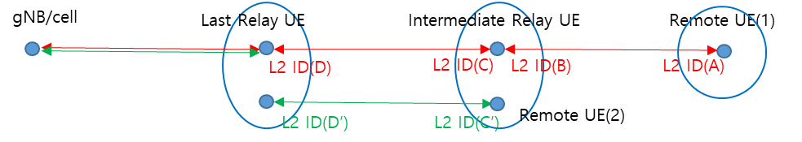

(Figure 2.5A-1)
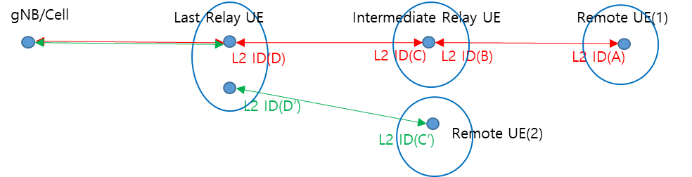
(Figure 2.5A-2)
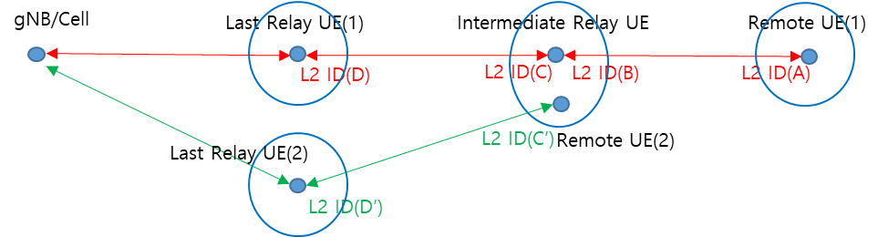
(Figure 2.5A-3)

[Question 2.5A-1] In Figure 2.5A-1 and 2.5A-2, do you think the last Relay UE of a multi-hop relay operation can also act as last Relay UE of a single-hop relay operation simultaneously?
Company | Yes/No | Reason

[Question 2.5A-2] In Figure 2.5A-1, do you think the intermediate Relay UE of multi-hop relay operation can act as a Remote UE of single-hop relay operation simultaneously?
Company | Yes/No | Reason

[Question 2.5A-3] As Figure 2.5A-1, do you think one physical UE which acts as both intermediate Relay UE and Remote UE can have two indirect connections with different PC5 connections via physically the same last Relay UE?
Company | Yes/No | Reason

[Question 2.5A-4] As Figure 2.5A-2, do you think physically one last Relay UE can have two connections with one intermediate Relay UE and one Remote UE (the intermediate Relay UE and Remote UE are physically different UE)?
Company | Yes/No | Reason

[Question 2.5A-5] As Figure 2.5A-3, do you think one intermediate Relay UE, which also acts as Remote UE, can have two different indirect connection via physically different last Relay UE?
Company | Yes/No | Reason

[Question 2.5A-6] If your answer to the [Question 2.5A-3] or [Quest 2.5A-5] was 'NO', do you have any ideas on how to prevent these topologies? Because the AS layer can only see L2 ID(s), the AS layer cannot differentiate whether the different L2 ID(s) belong to the same physical UE. It seems like it should be controlled from the upper layer, but if you have any idea, you can describe it freely.
Company | Describe how to prevent

[Question 2.5A-7] If your answer was ‘yes’ for one of the questions 2.5A-3, 2.5A-4, or 2.5A-5, do you have any preference on which topology should be handled priori than others for Rel-19 multi-hop? If you have any preference, you can describe it with reason.
Company | Preference with reason

- Case-B
  - The red link from gNB to Remote UE(A) is for multi-hop U2N relay operation.
  - The green link from gNB to Remote UE(B) is for multi-hop U2N relay operation.
  - In Figure 2.5B-1, the big blue circle at the intermediate Relay UE means the L2 ID(B) and L2 ID(B’) belong to the physically one intermediate relay UE. Each physically different Remote UE has an indirect path via the same intermediate Relay UE and the same last Relay UE. It looks link no problem.
  - In Figure 2.5B-2, the big blue circle at the last Relay UE means the L2 ID(D) and L2 ID(D’) belong to the physically one last Relay UE. The big blue circle at the intermediate Relay UE means the L2 ID(C) and L2 ID(C’) (/L2 ID(B) and L2 ID(B’)) belong to the physically one intermediate Relay UE. Each physically different Remote UE(A) and Remote UE(B) has an indirect path via the same intermediate Relay UE and last Relay UE. However, comparing Figure 2.5B-1, the intermediate Relay UE and last Relay UE have connections via different PC5 connections to support each Remote UE.
  - In Figure 2.5B-3, the big blue circle at the intermediate Relay UE means the L2 ID(C) and L2 ID(C’) (/L2 ID(B) and L2 ID(B’)) belong to the physically one UE. The intermediate Relay UE has two different PC5 connections with physically different last Relay UE(A) and last Relay UE(B). Each last Relay UE(A) and last Relay UE (B) is connected to the same gNB/cell. The intermediate Relay UE has one C-RNTI when it is CONNECTED because the intermediate Relay UE is physically one UE. It looks like one intermediate Relay UE has two different indirect paths via physically different last Relay UE(s).
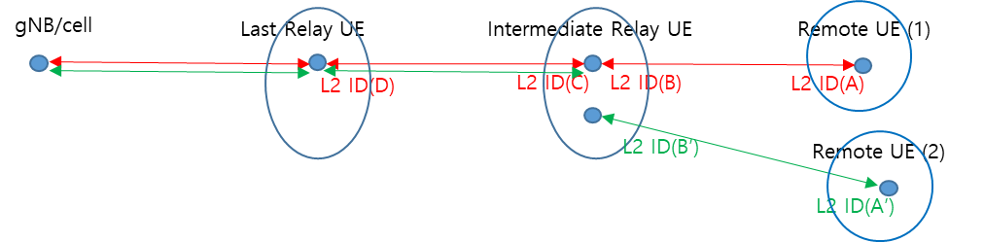
(Figure 2.5B-1)
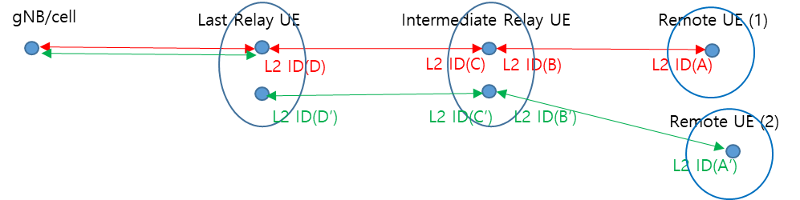
(Figure 2.5B-2)
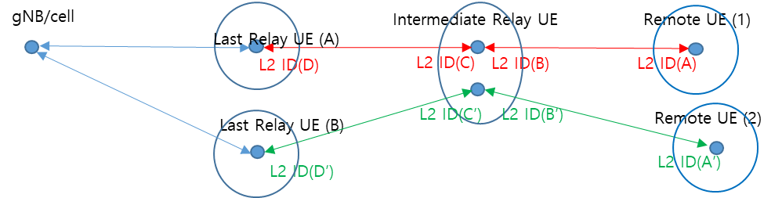
(Figure 2.5B-3)

[Question 2.5B-1] As Figure 2.5B-1, do you think two physically different Remote UE(s) can have each indirect path via the same intermediate Relay UE and the same last Relay UE? If your answer is ‘no’, please describe the reason.
Company | Yes/No | Reason

[Question 2.5B-2] As Figure 2.5B-2, do you think two physically different Remote UE can have each indirect path via the physically same intermediate Relay UE and physically same last Relay UE? Here, the intermediate Relay UE and last Relay UE have two different PC5 connections to support each physically different Remote UE.
Company | Yes/No | Reason

[Question 2.5B-3] As Figure 5B-3, do you think two physically different Remote UE can have each indirect path via the physically same intermediate Relay UE and physically different last Relay UE(s)? i.e., physically one intermediate Relay UE has connections with physically two different last Relay UE(s) to support physically different Remote UE(s).
Company | Yes/No | Reason

[Question 2.5B-4] If your answer of the [Question 5B-2] or [Quest 5B-3] was “NO”, do you have any idea to prevent happening these topologies? The answer to this question may be the same as the answer to [Question 5A-6]. However, if you want to describe further for the solution to prevent these topologies, you can write down.
Company | Describe how to prevent

[Question 2.5B-5] If your answer was ‘yes’ for one of the questions 2.5B-1, 2.5B-2, or 2.5B-3, do you have any preference on which topology should be handled priori than others for Rel-19 multi-hop? If you have any preference, you can describe it with reason.
Company | Preference with reason

- Case-C
  - The red and green link from gNB to Remote U are for multi-hop U2N relay operation.
  - In Figure 2.5C-1, the big blue circle at the last Relay UE means the L2 ID(D) and L2 ID(D’) belong to the physically same last relay UE. The big blue circle at the intermediate Relay UE means the L2 ID(C) and L2 ID(C’) (/L2 ID(B) and L2 ID(B’)) belong to the physically same intermediate Relay UE. And, the big blue circle at the Remote UE means the L2 ID(A) and L2 ID(A’) belong to the physically same Remote UE. Each indirect link belongs physically same last Relay UE, intermediate Relay UE, and Remote UE. However, each indirect link has its own PC5 connection (i.e., has its own L2 ID pair) to support the multi-hop relay path. Each last Relay UE, intermediate Relay UE, and Remote UE has each only one C-RNTI when they are connected.
  - In Figure 2.5C-2, each last Relay UE(A) and last Relay UE(B) is physically different last Relay UE. The big blue circle at the Remote UE means the L2 ID(A) and L2 ID(A’) belong to the physically same Remote UE. The big blue circle at the intermediate Relay UE means the L2 ID(C) and L2 ID(C’) (/L2 ID(B) and L2 ID(B’)) belong to the physically same intermediate Relay UE. Each indirect link belonging to the physically same Remote UE has connections with gNB via physically different two last Relay UE(s) and the physically same intermediate Relay UE. Each last Relay UE(A) and last Relay UE (B) is connected to the same gNB/cell. Each indirect path has its own PC5 link(s) and Uu links to support the multi-path.
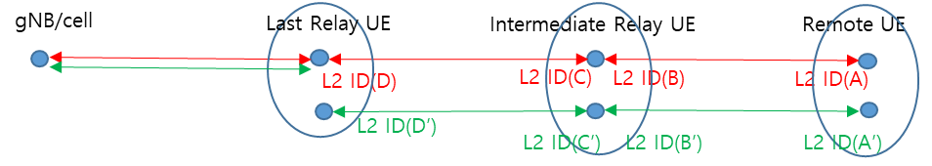

(Figure 2.5C-1)
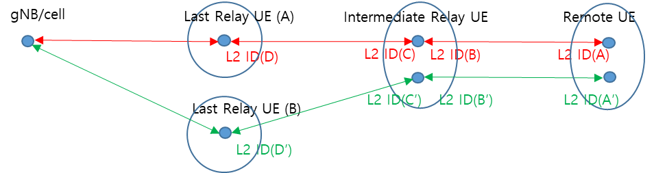
(Figure 2.5C-2)

[Question 2.5C-1] As Figure 2.5C-1, do you think two different indirect links at the physically same Remote UE can have connections with the gNB via the physically same intermediate Relay UE and physically same last Relay UE?
Company | Yes/No | Reason

[Question 2.5C-2] As Figure 2.5C-2, do you think two different indirect links at the physically same Remote UE can have connections with the gNB via the physically same intermediate Relay UE and physically different last Relay UE?
Company | Yes/No | Reason

[Question 2.5C-3] If your answer of the [Question 2.5C-1] or [Question 2.5C-2] was “NO”, do you have any idea to prevent happening these topologies? The answer to this question may be the same as the answer to [Question 2.5A-6] or [Question 2.5B-4]. However, if you want to describe further for the solution to prevent these topologies, you can write down.
Company | Yes/No | Reason

[Question 2.5C-4] If your answer was ‘yes’ for one of the questions 2.5C-1, or 2.5B-2, do you have any preference on which topology should be handled priori than others for Rel-19 multi-hop? If you have any preference, you can describe it with reason.
Company | Preference with reason

- Case-D
  - Figure 2.5D-1, 2.5D-2 and 2.5D-3 are the similar to the Figure 2.5A-3, 2.5B-3 and 2.5C-2 except that each multi-hop indirect path have connect with different cells in the same gNB.
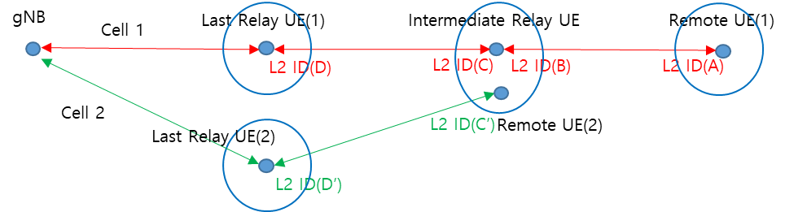
(Figure 2.5D-1)
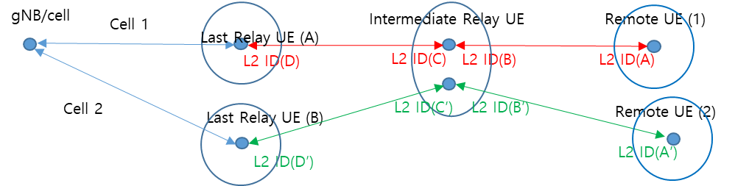
(Figure 2.5D-2)
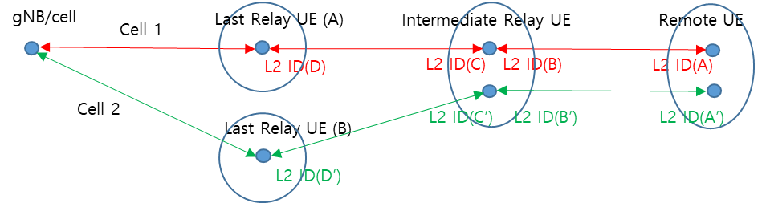
(Figure 2.5D-3)

[Question 2.5D-1] For each figure, i.e., Figure 2.5D-1, 2.5D-2, 2.5D-3, do you think these three cases should be considered for Rel-19 multi-hop topologies?
Company | For Figure 2.5D-1  (Yes/No) | For Figure 2.5D-2  (Yes/No) | For Figure 2.5D-3  (Yes/No) | Reason

2.6 Others

[Question 2.6] If there is further issue we should handle in this email discussion but missing, you can describe it freely.
Company | Other issues that should be handled

3. Phase 2 Discussion
[TDB]

Conclusion and recommendation
In conclusion, Rapporteur recommends agreeing the following proposals:
[TDB]

Annex A: RAN2 Agreements on Multi-hop Relay

RAN2#127
- From RAN2 perspective, models A and B can both be supported.
- Reuse existing AS discovery protocol to transmit discovery message for multi-hop U2N relaying.
- Reuse SL-SRB4 to transmit discovery message for multi-hop U2N relaying
- Reuse existing resource pools defined for discovery message transmission and reception
- Both of resource allocation mode 1 or mode 2 can be supported as in Rel-17/18 at least by relay UEs; FFS mode 1 for remote UE
- Configuration can be provided by SIB/dedicated message or pre-configured as in Rel-17/18.
- If the RSRP measurement of the serving cell is below a Uu threshold, or the Remote UE could not find a serving cell, the Remote UE can perform discovery transmission, as in Rel-17/18.
- If the Uu RSRP measurement of the serving cell is above a low threshold and below a high threshold, the last relay UE can perform discovery transmission, as in Rel-17/18 (subject to how the gNB configures one or both thresholds).
- FFS discovery conditions for the intermediate relay UEs.
- The following connections are assumed as a baseline to be needed:
  - From last Relay UE perspective:
    - A direct (non-relayed) PC5 connection with the first or an intermediate Relay UE, and
    - A direct (non-relayed) Uu connection with serving gNB, if in RRC_CONNECTED.
  - From intermediate relay UE perspective (including first relay UE):
    - A direct (non-relayed) PC5 connection with each of two adjacent (remote or relay) UEs, and
    - An end-to-end Uu connection with serving gNB, if in RRC_CONNECTED.
    - FFS what RRC states are supported for the intermediate relay UE
  - From U2N Remote UE perspective:
    - A direct (non-relayed) PC5 connection with Intermediate Relay UE, and
    - An end-to-end Uu RRC connection with serving gNB, if in RRC_CONNECTED.
- The multi-hop CP protocol stack is end-to-end for Uu-PDCP and above and hop-by-hop for SRAP and below (as in Rel-17/18)
- The multi-hop UP protocol stack is end-to-end for Uu-PDCP and above and hop-by-hop for SRAP and below (as in Rel-17/18).

