3GPP TSG-RAN WG2 Meeting #127-bis R2-24xxxx
Hefei, China, 14th – 18th October, 2024 Revision of R2-2406271
Agenda Item: 8.2.1
Source: Huawei
Title: TP for TR 38.769 update
Document for: Endorsement

1 Introduction
This contribution provides the text proposal on the update of TR 38.769.

2 Text Proposal for TR 38.769 V1.0.0 (2024-09)
Start of Change

Introduction
In recent years, IoT has attracted much attention in the wireless communication world. More 'things' are expected to be interconnected for improving productivity efficiency and increasing comforts of life. Further reduction of size, complexity, and power consumption of IoT devices can enable the deployment of tens or even hundreds of billions of IoT devices for various applications and provide added value across the entire value chain. It is impossible to power all the IoT devices by battery that needs to be replaced or recharged manually, which leads to high maintenance cost, serious environmental issues, and even safety hazards for some use cases, for example, wireless sensors in electrical power, and petroleum industries.
Most of the existing wireless communication devices are powered by batteries that need to be replaced or recharged manually. The automation and digitization of various industries opens numerous new markets requiring new IoT technologies of supporting batteryless devices with no energy storage capability or devices with energy storage that do not need to be replaced or recharged manually.
An example type of application is asset identification, which presently has to resort mainly to barcodes and RFID in most industries. The main advantage of these two technologies is the ultra-low complexity and small form factor of the tags. However, the limited reading range of a few meters usually requires handheld scanning which leads to labor intensive and time-consuming operations, or RFID portals/gates which leads to costly deployments. Moreover, the lack of interference management scheme results in severe interference between RFID readers and capacity problems, especially in case of dense deployment. It is hard to support a large-scale network with seamless coverage for RFID.
In contrast, this study investigates solutions for Ambient IoT, a new IoT technology to open new markets within 3GPP systems, whose number of connections and/or device density can be orders of magnitude higher than existing 3GPP IoT technologies, and which can provide complexity and power consumption orders-of-magnitude lower than existing 3GPP LPWA technologies such as NB-IoT and LTE-MTC. TSG RAN has completed a Rel-18 RAN-level SI on Ambient IoT, producing TR 38.848 which provides a terminological and scoping framework for future discussions of Ambient IoT. This has defined representative use cases, deployment scenarios, connectivity topologies, Ambient IoT devices, design targets, and required functionalities; it also conducted a preliminary feasibility assessment.
The SI reported in this present TR is now to investigate solutions in detail at RAN-WG level for Ambient IoT in 3GPP.

1 Scope
The overall objective of the SI is to study a harmonized air interface design with minimized differences (where necessary) for Ambient IoT to enable the following devices:
i. ~1 µW peak power consumption, has energy storage, initial sampling frequency offset (SFO) up to 10^{X} ppm, neither DL nor UL amplification in the device. The device’s UL transmission is backscattered on a carrier wave provided externally.
ii. ≤ a few hundred µW peak power consumption has energy storage, initial sampling frequency offset (SFO) up to 10^{X} ppm, both DL and/or UL amplification in the device. The device’s UL transmission may be generated internally by the device, or be backscattered on a carrier wave provided externally.
Referring to the definitions in [2, TR 38.848], this is done in the context of:
- Deployment scenario 1 (indoor-to-indoor) with Topology 1, and indoor microcell basestation.
- Deployment scenario 2 (indoor-to-outdoor) with Topology 2 and indoor UE as intermediate node under network control, and outdoor macrocell basestation.
The spectrum considered is FR1 licensed spectrum in FDD, which can be in-band to NR, in guard-band to NR/LTE, or in standalone band(s). The traffic types considered are DO-DTT and DT, focusing on indoor inventory and indoor command representative use cases. The study also assesses whether the harmonized air interface can address the DO-A use case.
Study of the design of energy harvesting signal/waveform is out of scope in Rel-19.

2 References
The following documents contain provisions which, through reference in this text, constitute provisions of the present document.
- References are either specific (identified by date of publication, edition number, version number, etc.) or non-specific.
- For a specific reference, subsequent revisions do not apply.
- For a non-specific reference, the latest version applies. In the case of a reference to a 3GPP document (including a GSM document), a non-specific reference implicitly refers to the latest version of that document in the same Release as the present document.
[1] 3GPP TR 21.905: "Vocabulary for 3GPP Specifications".
[2] 3GPP TR 38.848: "Study on Ambient IoT (Internet of Things) in RAN".
[3] RP-240826: " Revised SID: Study on solutions for Ambient IoT (Internet of Things) in NR".
[4] 3GPP TR 38.869: "Study on low-power Wake-up Signal and Receiver for NR".
[5] 3GPP TS 38.212: "NR; Multiplexing and channel coding".
[6] EPC Radio-Frequency Identity Protocols Class-1 Generation-2 UHF RFID Protocol for Communications at 860 MHz – 960 MHz.
[7] 3GPP TR 23.700-13: "Study on Architecture support of Ambient power-enabled Internet of Things".
[8] 3GPP TR 33.713: "Study on security aspects of Ambient Internet of Things (AIoT) services in 5G".
[9] 3GPP TS 38.300: "NR and NG-RAN Overall description; Stage-2".
[10] 3GPP TS 22.369: "Service requirements for Ambient power-enabled IoT".
[11] R1-2405855, "On external carrier wave for backscattering based Ambient IoT device", Huawei, HiSilicon, RAN1#118. Maastricht, Netherlands, August 2024.

3 Definitions of terms, symbols and abbreviations
This clause and its three (sub) clauses are mandatory. The contents shall be shown as "void" if the TS/TR does not define any terms, symbols, or abbreviations.

3.1 Terms
For the purposes of the present document, the terms given in TR 21.905 [1] and the following apply. A term defined in the present document takes precedence over the definition of the same term, if any, in TR 21.905 [1].

For the purposes of the study, RAN1 uses the following terms:
Device 1: ~1 µW peak power consumption, has energy storage, initial sampling frequency offset (SFO) up to 10^{X} ppm, neither DL nor UL amplification in the device. The device's UL transmission is backscattered on a carrier wave provided externally.
Device 2a: ≤ a few hundred µW peak power consumption, has energy storage, initial sampling frequency offset (SFO) up to 10^{X} ppm, both DL and/or UL amplification in the device. The device’s UL transmission is backscattered on a carrier wave provided externally.
Device 2b: ≤ a few hundred µW peak power consumption, has energy storage, initial sampling frequency offset (SFO) up to 10^{X} ppm, both DL and/or UL amplification in the device. The device’s UL transmission is generated internally by the device.
D1T1: Deployment scenario 1 with connectivity topology 1, according to TR 38.848.
D2T2: Deployment scenario 2 with connectivity topology 2, according to TR 38.848.
Inventory: The service provided by the network to discover and acquire the identifier of A-IoT device(s).
Command: The service provided by the network to send the operation instruction to the A-IoT device (e.g., read, write, etc.).

3.2 Symbols
For the purposes of the present document, the following symbols apply:
<symbol> <Explanation>

3.3 Abbreviations
For the purposes of the present document, the abbreviations given in TR 21.905 [1] and the following apply. An abbreviation defined in the present document takes precedence over the definition of the same abbreviation, if any, in TR 21.905 [1].
A-IoT Ambient IoT
A-IoT RAN Ambient IoT Radio Access Network
BFSK Binary frequency-shift keying
BPSK Binary phase-shift keying
CFO Carrier-frequency offset
CP Cyclic prefix
CW Carrier-wave
CW2D Carrier-wave, or carrier-wave node, to device
D2R Device to reader
DO-A Device-originated autonomous
DO-DTT Device-originated by device-terminated trigger
DT Device-terminated
ED Envelope detector
FEC Forward error-correction code
FR Frequency Range
IF Intermediate frequency
IoT Internet of Things
LPWA Low-power, wide-area
LTE-MTC Long Term Evolution – Machine Type Communication
MCS Modulation and coding scheme
MSK Minimum-shift keying
NB-IoT Narrowband IoT
OOK On-off keying
PDRCH Physical device-to-reader channel
PIE Pulse interval encoding
PRDCH Physical reader-to-device channel
R2D Reader to device
RF Radio frequency
RFID Radio frequency identification
SFO Sampling-frequency offset
ZIF Zero IF

4 Evaluation methodology

4.1 Remaining details of RAN design targets
TR 38.848 [2] sets a number of RAN design targets. In [3], in particular three aspects of design targets beyond those in TR 38.848 are to be studied:
- Applicable maximum distance target value(s): The maximum distance targets are set separately for device 1, device 2a, device 2b, respectively.
- Refined definition of latency:
- For the use case of "inventory-only":
- The time interval between the time that the A-IoT paging is sent from reader to a A-IoT device and the time that the inventory report is successfully received at reader from the A-IoT device, i.e., for completing Step A and Step B (as per RAN2 agreements).
- For the use case of "inventory and command":
- The time interval between the time that the A-IoT paging is sent from reader and the time that
- The command is successfully received at A-IoT device, i.e., for completing Step A, Step B, Step C1 (as per RAN2 agreements), if Step C2 is optional and not used (note: pending RAN2 decision on optionality of Step C2).
- The response is successfully received at Reader, i.e., for completing Step A, Step B, Step C1, and Step C2 (as per RAN2 agreements).
See Clause 6.3.1 for descriptions of the Steps of these procedures.
Expected value of latency is calculated according a X% re-attempt probability to each attempt.
Note: The “successfully received” (i.e., decoding successfully)
Note: The latency is evaluated for a single A-IoT device.
Note: Time for energy harvesting is not included in the definition of latency.
- 2D distribution of devices: A-IoT devices are dropped uniformly distributed over the horizontal area. See Table 4.2.2-2.

4.2 Evaluation scenarios and assumptions

4.2.1 Evaluation scenarios
The following scenarios are defined for the purpose of potential evaluation.
Table 4.2.1-1: Evaluation scenarios
Scenario | CW Inside/outside topology | Diagram of the scenario | Description of the scenario | Device 1/2a/2b | CW spectrum | D2R spectrum | R2D spectrum
D1T1-A1 | CW inside topology | 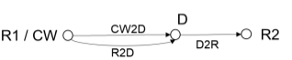 | CW node inside topology 1  ‘CW’ in CW2D and ‘R2’ in D2R are different  ‘CW’ in CW2D and ‘R1’ in R2D are same  ‘R1’ in R2D and ‘R2’ in D2R are different | Device 1, 2a | Case 1-1 (inside topology, DL)  Case 1-2 (inside topology, UL) | Same as CW
D1T1-A2 | CW inside topology | 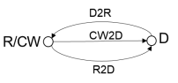 | CW node inside topology 1  Same ‘CW’ and ‘R’ node for CW2D, D2R and R2D | Device 1, 2a | Same as D1T1-A1 | Same as CW
D1T1-B | CW outside topology | 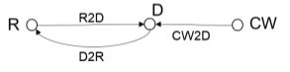 | CW node outside topology 1  ‘CW’ in CW2D and ‘R’ in D2R are different  ‘CW’ in CW2D and ‘R’ in R2D are different  ‘R’ in R2D and ‘R’ in D2R are same | Device 1, 2a | Case 1-4 (outside topology, UL) | Same as CW
D1T1-C | No CW | 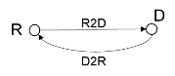 | No CW Node. | Device 2b | N/A | UL
D2T2-A1 | CW inside topology | 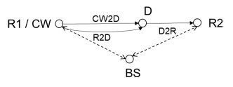 | CW node inside topology 2  ‘CW’ in CW2D and ‘R2’ in D2R are different  ‘CW’ in CW2D and ‘R1’ in R2D are same  ‘R1’ in R2D and ‘R2’ in D2R are different  BS communicates with R1 and R2 | Device 1, 2a | Case 2-2 (inside topology, UL) | Same as CW
D2T2-A2 | CW inside topology | 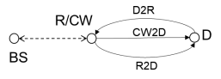 | CW node inside topology 2  Same ‘CW’ and ‘R’ node for CW2D, D2R and R2D  BS communicates with R | Device 1, 2a | Same as D2T2-A1 | Same as CW
D2T2-B | CW outside topology | 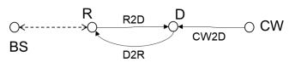 | CW node outside topology 2  ‘CW’ in CW2D and ‘R’ in D2R are different  ‘CW’ in CW2D and ‘R’ in R2D are different  ‘R’ in R2D and ‘R’ in D2R are same  BS communicates with R | Device 1, 2a | Case 2-3 (outside topology, DL)  Case 2-4 (outside topology, UL) | Same as CW
D2T2-C | No CW | 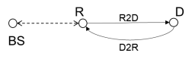 | No CW Node.  BS communicates with R | Device 2b | N/A | FFS
Note: This table is for the case where D2R is in the same spectrum as CW2D.

4.2.2 Evaluation assumptions
The following table of coverage evaluation assumptions for link-level simulation is considered. (M) indicates a value mandatory for evaluation, (O) indicates optional for evaluation. If there are any differences between devices, they are for evaluation purposes only.
Table 4.2.2-1: Coverage evaluation assumptions for link-level simulation

No. | Parameters |  | Assumptions
R2D/D2R common parameters
[0a] | Carrier frequency |  | Refer to link budget template
[0b] | SCS |  | 15 kHz as baseline
[0c] | Block structure |  | Blocks as agreed in 9.4.2.3, or other blocks reported by companies
[0d] | Channel model |  | R2D:  For D2T2:  BS pathloss model is reused for intermediate UE with antenna height = 1.5 m  [0D]-Alt1: InF-DL NLOS, with TDL-A  [0D]-Alt2: InH-Office LOS, with TDL-D  For D1T1:  InF-DH NLOS, with TDL-A  D2R:  For D2T2:  BS pathloss model is reused for intermediate UE with antenna height = 1.5 m  [0D]-Alt1: InF-DL NLOS, with TDL-A  [0D]-Alt2: InH-Office LOS, with TDL-D  For D1T1:  InF-DH NLOS, with TDL-A
[0e] | Delay spread |  | An RMS delay spread of 30 ns (M) and [150] ns (O) is considered for TDL-A channel model.  An RMS delay spread of 30 ns is considered for TDL-D channel model.
[0f] | Device velocity |  | 3 km/h
[0g] | Number of Tx/Rx chains for Ambient IoT device |  | 1
[0h1] | BS | Number of antenna elements | 2 or 4
[0h2] | BS | Number of TXRUs | 2 or 4
[0j1] | Intermediate UE | Number of antenna elements | 1 or 2
[0j2] | Intermediate UE | Number of TXRUs | 1 or 2
[0m] | Reference data rate |  | 1 kbps (M)  5 - 7 kbps (M)  48 - 60 kbps (O)  0.1 kbps for message size of 20 bits or 96 bits (O)  Other data rates can be reported by companies  Note 1: Companies to report the exact data rate.  Note 2: The exact data rate is close to the values listed above.  Note 3: The exact data rate is calculated by dividing the total message size (excluding CRC) by the total transmission time including applicable overheads(e.g., CRC, pre/mid/post-ambles if present).  Note 4: The exact data rate may be related to coding scheme, repetition and etc.  Note 5: All data rates considered are for evaluation purpose only
[0n] | Message size |  | {20 bits, 96 bits, 400 bits} are considered for message size.  Note 1: companies to report the M value and chip length used for each message size  Note 2: CRC is not included for the message size
[0p] | BLER target |  | 1%, 10%
[0q] | Sampling frequency |  | Companies to report the sampling frequency (e.g., 1.92Msps or other feasible values if any)  Initial SFO (Sampling Frequency Offset) (Fe):  (M) Randomly select a value from the range of [0.1 ~ 1] *10^4 ppm for device 2,  (M) Randomly select a value from the range of [0.1 ~ 1] * 10^5 ppm for device 1,  (O) Randomly select a value from the range of [0.1 ~ 1] *10^5 ppm for device 2,  FFS: Optionally evaluate a fixed value SFO for device 1 and 2  Note: For random selection, the value is randomly selected per simulation drop, according to a uniform distribution  Note: Above values are only for sampling purpose.  FFS other values  Note: Above assumptions are only for LLS evaluation purpose only for R2D and D2R.  The timing drift ΔT over a time T is modelled as ΔT = ±Fe * T.  Note: Accuracy can be improved after clock calibration for at least device 2. FFS applicable for device 1  Note: SFO after clock calibration can be applied to Fe.  FFS other models  CFO for device 2b:  100 ppm (M)  200 ppm (O)  1000 ppm (O, only as initial CFO)  Drift rate of TBD ppm/s  Note: Above assumptions are for LLS evaluation purpose only
[0r] | Device 1/2a/2b |  | Options are as follows,  Device 1, RF-ED  Device 2a, RF-ED  Device 2b, RF-ED/IF-ED/ZIF
R2D specific parameters
[1a] | Transmission bandwidth |  | 180 kHz as baseline. Other larger values are not precluded.
[1b] | ED bandwidth |  | The ED bandwidth is the bandwidth for calculating the noise/interference (if any) power:  For evaluations, the value(s) of ED bandwidth is 20 MHz for RF-ED, [180] kHz for IF/ZIF receiver.  Note: this does not imply that a A-IoT device supports sampling clock rate as large as RF ED bandwidth.
[1c] | BB LPF |  | [X]-order Butterworth/RC filter with cutoff frequency at half of R2D transmission bandwidth.  Companies to report X = {3, 5}.
[1d] | Waveform |  | OOK waveform generated by OFDM modulator
[1e] | Modulation |  | OOK  Companies to report, e.g., OOK-1, OOK-4 with M chips per OFDM symbol
[1f] | Line code |  | Companies to report, e.g., Manchester, PIE
[1g] | FEC |  | No FEC as baseline
[1h] | ADC bit width |  | 1-bit for device 1  4-bit for device 2
[1j] | Detection/decoding method for Line code |  | Companies to report
D2R specific parameters
[2a1] | Transmission bandwidth |  | [2a1]-Alt1 (M):  DSB  X kHz is considered for D2R transmission bandwidth.  The value is for two sidebands, i.e., the total transmission bandwidth for DSB is X kHz  [2a1]-Alt2:  SSB  X kHz is considered for D2R transmission bandwidth.  The value is for one sideband, i.e., the total transmission bandwidth for SSB is X kHz.  For device 2b only, FFS for device 2a.  X = {[15 (M)], [180 (O)]}, other values are not precluded and reported by companies
[2a2] | [OOK/BPSK/BFSK chip rate] |  | Companies to report
[2a3] | Receiver bandwidth |  | D2R receiver bandwidth is the bandwidth used at the reader side to filter out the D2R signals for calculating noise and interference (if any) power.  Assume the receiver matches the transmitter's modulation, i.e., to receiver uses SSB when transmitter uses SSB, receiver uses DSB when transmitter uses DSB.  Companies to report the value, and further down-selection of the values and DSB/SSB is not precluded.
[2b] | Waveform (CW) |  | Companies to report waveform, e.g., unmodulated single tone, multi-tone(multiple unmodulated single tone)
[2d] | Modulation |  | Companies to report modulation, e.g., OOK, BPSK, BFSK
[2e] | Line code |  | Companies to report, e.g., Manchester encoding, FM0 encoding, Miller encoding, no line coding
[2g] | FEC |  | Companies to report, e.g., CC, No FEC
[2h] | ADC bit width |  | Companies to report, e.g., 11-bit
[2j] | D2R receiver |  | Companies to report, e.g., coherent receiver / non-coherent receiver
 | Other assumptions
[3a] | Other assumptions |  | To be reported by company
[3b] | Note: Companies to report required SINR/SNR/CINR/CNR according to BLER target.

The following layouts are used for evaluation purposes.
Table 4.2.2-2: Assumptions on layout for D1T1 and D2T2
Parameter | Assumptions for D1T1 | Assumptions for D2T2
Scenario | InF-DH | InH-office | InF-DL
Hall size | 120x60 m | 120 x50 m | 300x150 m
Room height | 10 m | 3m | 10 m
Sectorization | None
BS deployment / Intermediate UE dropping | 18 BSs on a square lattice with spacing D, located D/2 from the walls.  L=120m x W=60m; D=20m  BS height = 8 m  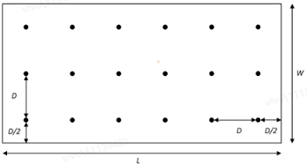 | L=120m x W=50m;  Intermediate UE height = 1.5 m  FFS: Intermediate UE dropping | L=300m x W=150m;  Intermediate UE height = 1.5 m  FFS: Intermediate UE dropping
Device distribution | Device Height= 1.5 m  A-IoT devices drop uniformly distributed over the horizontal area | Device Height= 1.5 m  A-IoT devices drop uniformly distributed over the horizontal area  FFS: which devices are involved in the evaluations | Device Height= 1.5m  A-IoT devices drop uniformly distributed over the horizontal area  FFS: which devices are involved in the evaluations
Device mobility (horizontal plane only) | 3 kph | 3 kph | 3 kph

4.3 Link budget

4.3.1 Receiver sensitivity
The study uses the following definitions for receiver sensitivity.
Budget-Alt1: Receiver sensitivity is derived by a predefined threshold and no link-level simulation is needed for link budget calculation
The results rely on the received sensitivity and maximum transmit power, and directly calculate the maximum distance / pathloss based on these values and other related parameters. The link-level simulation performances, such as required SINR, can be satisfied for such case and no link-level simulation is needed for link budget calculation.

Budget-Alt2: Receiver sensitivity is derived by required SINR which is given by LLS results
The results rely on link-level simulation results, e.g., required SINR which corresponds to detail LLS assumptions (e.g., BW, coding, data rate). And based on the required SINR, the received sensitivity can be calculated and then the maximum distance / pathloss can be derived.
Note: For noise power, a noise figure value needs to be provided.

4.3.2 Link budget template
Link budget is calculated according to the following Table 4.3.2-1. (M) denotes the value is mandatory to be evaluated. (O) denotes the value can be optionally evaluated.
Table 4.3.2-1: Link budget template
No. | Item | Reader-to-Device | Device-to-Reader
(0) System configuration
[0A] | Scenarios | D1T1-A1/A2/B/C  D2T2-A1/A2/B/C | D1T1-A1/A2/B/C  D2T2-A1/A2/B/C
[0A1] | CW case | N/A | 1-1/1-2/1-4/2-2/2-3/2-4
[0B] | Device 1/2a/2b | Device 1/2a/2b | Device 1/2a/2b
[0C] | Center frequency (MHz) | 900MHz (M), 2GHz (O) | 900MHz (M), 2GHz (O)
[0D] | Topology/Pathloss model | For D2T2:  BS pathloss model is reused for intermediate UE with antenna height = 1.5 m  [0D]-Alt1: InF-DL NLOS  [0D]-Alt2: InH-Office LOS  For D1T1:  InF-DH NLOS | For D2T2:  BS pathloss model is reused for intermediate UE with antenna height = 1.5 m  [0D]-Alt1: InF-DL NLOS  [0D]-Alt2: InH-Office LOS  For D1T1:  InF-DH NLOS
(1) Transmitter
[1D] | Number of Tx antenna elements / TxRU/ Tx chains modelled in LLS | For BS:  2(M) or 4(O) antenna elements for 0.9 GHz  For Intermediate UE:  1(M) or 2(O) | 1
[1E] | Total Tx Power (dBm) | For BS in DL spectrum for indoor  - [1E]-R2D-Alt1: 33dBm(M),  - [1E]-R2D-Alt2: 38dBm(O),  - [1E]-R2D-Alt3: 24dBm(M)  - Companies to report if PSD constraints are imposed (company to report the condition for applying PSD constraints in Row [5A])  For UL spectrum for indoor,  - [1E]-R2D-Alt4:23dBm (M)  - [1E]-R2D-Alt5:26dBm(O) | For device 1/2a: (see note 1)  - [1E]-D2R-Alt1: For scenarios ‘B’, the device Tx Power is calculated by CW received power which can be derived by at least CW2D distance (m) value and other related factors.  - [1E]-D2R-Alt2: For scenarios ‘A1’ and ‘A2’, the device Tx Power is calculated by assuming CW2D pathloss = D2R pathloss.  For device 2b: For scenarios ‘C’  - [1E]-D2R-Alt3: -20 dBm(M)  - [1E]-D2R-Alt4: -10 dBm(O)
[1E1] | CW Tx power (dBm) | N/A | For scenario ‘A1’, ‘A2’ and ‘B’  - Report a value from the candidate values [1E]-R2D-Alt1 / [1E]-R2D-Alt2 / [1E]-R2D-Alt3 from [1E]-R2D if CW in DL spectrum  - Report a value from the candidate values [1E]-R2D-Alt4 / [1E]-R2D-Alt5 from [1E]-R2D if CW in UL spectrum.  Note: only applicable for device 1/2a
[1E2] | CW Tx antenna gain (dBi) | N/A | Company to report, the value equals:  - UE Tx ant gain, or  - BS Tx ant gain  Note: Only applicable for device 1/2a
[1E3] | CW2D distance (m) | N/A | For scenarios ‘B’  D1T1-B:  - 5m,  - 10m,  - 20m  - CW2D distance is derived assuming CW node is located with the same position as ‘R1’ in ‘A1’ scenario. (See note 1)  D2T2-B:  - 5m,  - 10m,  FFS other values  For scenarios ‘A1’ and ‘A2’:  Calculated (see note 1), (i.e., CW2D distance is calculated by assuming CW2D pathloss = D2R pathloss)  Note 1: Only applicable for device 1/2a.  Note 2: Companies to report which value(s) are evaluated.
[1E4] | CW2D pathloss (dB) | N/A | Calculated (see note1)  Note 1: Only applicable for device 1/2a  Note 2: For CW2D pathloss model, use the same pathloss model as used for R2D/D2R.
[1E5] | CW received power (dBm) | N/A | Calculated (see note1)  Note: Only applicable for device 1/2a
[1F] | Transmission Bandwidth used for the evaluated channel (Hz) | 180kHz(M),  360kHz(O),  1.08MHz(O) | Refer to LLS table [1a]
[1G] | Tx antenna gain (dBi) | For BS for indoor, 6 dBi(M), 2dBi(M)  For intermediate UE, 0 dBi | For A-IoT device, 0dBi
[1H] | Ambient IoT backscatter loss (dB) due to Modulation factor | N/A | OOK: 6 dB  PSK: 0 dB  FSK: Y dB  It is applicable for device 1 and 2a.  Companies to report and justify their assumptions for Y.  Companies to report in row 3D if they assume any additional related loss.
[1J] | Ambient IoT on-object antenna penalty | N/A | 0.9dB or 4.7dB
[1K] | Ambient IoT backscatter amplifier gain (dB) | N/A | 10 dB (M)  15 dB (O)  Note: Only for device 2a
[1N] | Cable, connector, combiner, body losses, etc. (dB) | For BS, X dB, X <=3 to be reported by companies with justification provided in row 5A  For intermediate UE, 1 dB | N/A
[1M] | EIRP (dBm) | Calculated (see Note 1)  FFS: any limitation of the EIRP subject to future discussion | Calculated (see Note 1)
(2) Receiver
[2A] | Number of receive antenna elements / TxRU / chains modelled in LLS | Same as [1D]-D2R | Same as [1D]-R2D
[2B] | Bandwidth used for the evaluated channel (Hz) | Refer to LLS table [1b] ED bandwidth | Refer to LLS table [2a] [receiver bandwidth?]
[2C] | Receiver antenna gain (dBi) | same as [1G]-D2R | Same as [1G]-R2D
[2X] | Cable, connector, combiner, body losses, etc. (dB) | N/A | Same as [1N]-R2D
[2D] | Receiver Noise Figure (dB) | For RF-ED receiver  20dB, Device 2  FFS other values  For IF/ZIF receiver  15dB, Device 2 | For BS as reader: 5dB  For intermediate UE as reader: 7dB
[2E] | Thermal Noise power spectrum density (dBm/Hz) | -174 | -174
[2F] | Noise Power (dBm) | Calculated (see Note 1) | Calculated (see Note 1)
[2G] | Required SNR/CNR | Reported by companies for Budget-Alt2 | Reported by companies for Budget-Alt2
[2H] | Ambient IoT on-object antenna penalty | 0.9 dB or 4.7 dB | Not applicable
[2J] | Budget-Alt1/ Budget-Alt2 | Budget-Alt1/ Budget-Alt2 (see note1) | Budget-Alt2
[2K] | CW cancellation (dB) | N/A | Companies to report for scenario A2/A1/B for BS and intermediate UE.  Notes:  - Only applicable for device 1/2a  - The value provided is for the unmodulated single-tone CW. The impact of a multi-tone CW, e.g., assuming an [X] dB difference, is FFS
[2K1] | Remaining CW interference (dB) | N/A | Calculated (see Note 1)  Note: only applicable for device 1/2a
[2K2] | Receiver sensitivity loss(dB) | N/A | Calculated (see Note 1)  Note: only applicable for device 1/2a
[2L] | Receiver Sensitivity (dBm) | For Budget-Alt1  For device 1 (RF-ED), for example:  {-30 dBm, -36 dBm, -40 dBm, etc}  For device 2 (RF-ED), for example:  {-40 dBm, -45 dBm, etc}  For Budget-Alt2  Calculated (see note1) | Calculated (see Note 1)  Note 2L: the receiver sensitivity includes the receiver sensitivity loss [2K2], i.e. after CW cancellation at least if ‘A2’ scenario is used
(3) System margins
[3A] | Shadow fading margin (dB) | For D1T1: 4 dB  For D2T2: 3dB for InH-LOS  7.2dB for InF-DL-NLOS | For D1T1: 4 dB  For D2T2: 3dB for InH-LOS  7.2dB for InF-DL-NLOS
[3B] | polarization mismatching loss (dB) | 3 dB | 3 dB
[3C] | BS selection/macro-diversity gain (dB) | 0 dB  FFS: other values are not precluded  Note: only applicable for D1T1 | 0 dB  FFS: other values are not precluded  Note: only applicable for D1T1
[3D] | Other gains (dB) (if any please specify) | Reported by companies with justification | Reported by companies with justification
(4) MPL / distance
[4A] | MPL (dB) | Calculated (see Note 1) | Calculated (see Note 1)
[4B] | Distance (m) | Calculated (see Note 1) | Calculated (see Note 1)
（5）Other
[5A] | Other notes | Companies to report | Companies to report

Note 1: Calculated values are derived according to the following.
[1E3]
- For scenarios where CW2D distance is calculated by assuming CW2D pathloss = D2R pathloss, [1E3] is derived by assuming pathloss is [1E4] and use the pathloss formula as agreed.
[1E4]
- For scenarios where CW2D distance is calculated by assuming CW2D pathloss = D2R pathloss
- [1E4] = 0.5* ( [1E1] + [1E2] - [1N](R2D) + [2C] (R2D) - [2H](R2D) - 2*[3A] - 2*[3B] +[3D](R2D) + [1K] - [1H] + [1G] - [1J] + [2C] - [2X] - [2L] + [3C] + [3D] )
- [1K] is only for device 2a
- Otherwise
- [1E4] is derived according to pathloss formula by assume distance is [1E3]
[1E5]
- [1E5] = [1E1] + [1E2] - [1N](R2D) - [1E4] + [2C] (R2D) - [2H](R2D) - [3A] - [3B] + [3D](R2D)
[1E]
- [1E] = [1E5]+ [1K] - [1H]
- [1K] is only for device 2a
[1M]:
- For R2D,
- [1M] = [1E] + [1G] - [1N]
- For D2R
- [1M] = [1E] + [1G] - [1J]
[2F]:
- [2F] = [2D] + [2E] +lin2dB([2B])
[2G]
- For the R2D LLS for ED, CINR/CNR is reported, where CINR/CNR is defined as the ratio of signal power spectral density in the transmission bandwidth to the noise and interference (if any) power spectral density in the device ED channel bandwidth.
- For R2D ZIF receiver, report the same metrics (i.e., CNR/CINR, signal transmission bandwidth, ED bandwidth) as agreed for RF-ED/IF receiver.
- For the D2R LLS, the SINR/SNR is reported and it is defined as the ratio of signal power to noise and interference (if any) power in the receiver bandwidth. Receiver bandwidth is the bandwidth used at the reader side to filter the D2R signals for calculating noise and interference (if any) power.
- On/off keying backscatter loss (including DC removal loss) is not taken into account in the LLS and is included in link budget table [1H].
[2J]
- For R2D link in the coverage evaluation, for device 1
- Budget-Alt1 is used (note: receiver architecture is RF ED)

- For R2D link in the coverage evaluation for device 2,
- Budget-Alt1 is used if receiver architecture is RF ED
- Budget-Alt2 is used if receiver architecture is IF/ZIF ED
Note A: this does not preclude to have LLS for device 1 and 2 R2D link with RF-ED if needed.
Note B: For device 2 R2D link with RF-ED, Budget-Alt1 is mandatory, Budget-Alt2 is optional.
Note C: this does not imply all M values are achievable with the sensitivity given by Budget-Alt1 for RF ED
Note D: For device 2 with an RF ED-based receiver on the R2D link, if the receiver sensitivity derived from Budget-Alt2, assuming a noise figure of [X dB], exceeds the receiver sensitivity based on Budget-Alt1, then Budget-Alt2 is applied.
[2K1]:
- [2K1] = [1E1] + [1E2] -[1N](R2D) + [2C] - [2X] - [2K]
[2K2]:
- $\left[2K2\right]=lin2dB\left(1+\frac{dB2lin([2K1])}{dB2lin([2F])}\right)$
[2L]:
- For R2D and Budget-Alt2,
- [2L] = [2G] - lin2dB([2B] / [1F]) + [2F]
Note E: The term ‘lin2dB([2B] / [1F])’ is applied due to scaling from CNR/CINR to SNR/SINR.
- For D2R,
- [2L] = [2G] + [2F] + [2K2], device 1/2a
- [2L] = [2G] + [2F], device 2b
[4A]
- For R2D
- [4A] = [1M] + [2C] - [2H] - [2L] - [3A] - [3B] + [3C] + [3D]
- For D2R
- [4A] = [1M] + [2C] - [2X] - [2L] - [3A] - [3B] + [3C] + [3D]
[4B]
- [4B] is derived by assuming pathloss is [4A] and using the pathloss formula as agreed.

4.4 R2D waveform generation
With reference to the R2D waveform described in Clause 6.1.1.x, for evaluation purposes the waveform for DFT-s-OFDM is generated as follows:
1. The time domain OOK signal is the M chips of one OFDM symbol.
2. A chip is represented (e.g. upsampled) by L samples
- Companies to report L
3. An N’-points DFT is performed on the samples of one OFDM symbol to obtain the frequency domain signal.
- Companies to report N’, e.g. N’=128 or equal to X
4. Map the frequency domain signal obtained by N’-points DFT to the X subcarriers of B_{tx,R2D}.
- Companies report how to map and report X
5. An N-points IDFT is performed to obtain the time domain signal.
- Companies to report N, and how value was selected
Note: Companies report whether/how CP samples are added.

5 Ambient IoT device architectures

5.1 ~1 µW devices (Device 1)
The architecture of such a device is summarised in Figure 5.1-1, with the blocks described as follows.
- Antenna could be either shared or separate for RF energy harvester and receiver/transmitter.
- Matching network is to match impedance between antenna and other components (including RF energy harvester and receiver related blocks).
- RF energy harvester can include rectifier performing RF signal (AC) to DC conversion.
- Energy storage (e.g., capacitor) stores harvested energy from RF energy harvester.
- Power management unit (PMU) manages storing energy to energy storage from energy harvester and supplying power to active component blocks which needs power supply.
- Digital BB logic includes functional blocks like encoder, decoder, controller, etc.
- Memory can include two types of memory: 1) Non-Volatile Memory (NVM) such as EEPROM for permanently storing device ID, etc, and 2) registers for temporarily keeping any information required for its operation only while energy is available in energy storage.
- Clock generator provides required clock signal(s).
- Reception related blocks
- RF BPF for improving selectivity.
- Depending on implementation, it may not exist. RAN4 RF requirement (if any, e.g., ACS) and peak power consumption target also need to be considered.
- RF Envelope Detector converts RF signal to baseband.
- BB LPF can filter out harmonics and high frequency components to improve input signal quality to comparator.
- Depending on implementation, it may not exist. Presence of BB LPF is assumed for the study.
Comparator determines high/low of input signal.
- Transmission related blocks
- Backscatter modulator switches impedance to modulate backscattered signal with transmitted signal from BB logic. Waveform/modulation type is FFS.
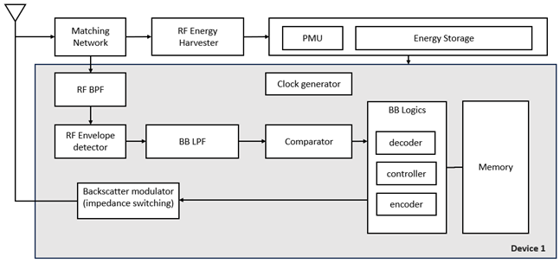
Figure 5.1-1: Architecture of device 1

5.2 ≤a few hundred µW devices (Device 2)

5.2.1 External carrier wave (Device 2a)
The architecture of device 2a is summarised in Figure 5.2.1-1, with the block described as follows.
- Antenna could be either shared or separate for RF energy harvester (if present) and receiver/transmitter.
- Matching network is to match impedance between antenna and other components (including RF energy harvester (if present) and receiver related blocks).
- Energy harvester.
- Energy storage (e.g., capacitor) stores harvested energy from energy harvester.
- Power management unit (PMU) manages storing energy to energy storage from energy harvester and suppling power to active component blocks which needs power supply.
- Digital BB logic includes functional blocks like encoder, decoder, controller, etc.
- Memory can include two types of memory: 1) Non-Volatile Memory (NVM) such as EEPROM for permanently storing device ID, etc, and 2) registers for temporarily keeping any information required for its operation only while energy is available in energy storage.
- Clock generator provides required clock signal(s).
- Reflection amplifier can amplify reflected backscattered signal.
- FFS study applicability of amplification of rx signal, power consumption.
- At least one of R2D/CW2D and D2R could be amplified by either reflection amplifier or LNA.
- Reception related blocks
- RF BPF filter for improving selectivity.
- Depending on implementation, it may not exist. RAN4 RF requirement (if any, e.g., ACS) and peak power consumption target also need to be considered.
- LNA for improving signal strength and sensitivity of receiver, if present.
- At least one of R2D/CW2D and D2R could be amplified by either reflection amplifier or LNA.
- RF envelope detector (RF-ED) detects envelope from RF signal.
- BB amplifier amplifies BB signal to improve signal strength.
- BB LPF can filter out harmonics and high frequency components to improve input signal quality to comparator/ADC.
- Depending on implementation, it may not exist.
- Comparator or N-bit ADC
- Transmission related blocks
- Backscatter modulator switches impedance to modulate backscattered signal with tx signal from BB logics.
- Large Frequency shifter (e.g., tens of MHz) for shifting backscattered signal from one frequency (e.g., FDD-DL frequency) to another frequency (e.g., FDD-UL frequency).

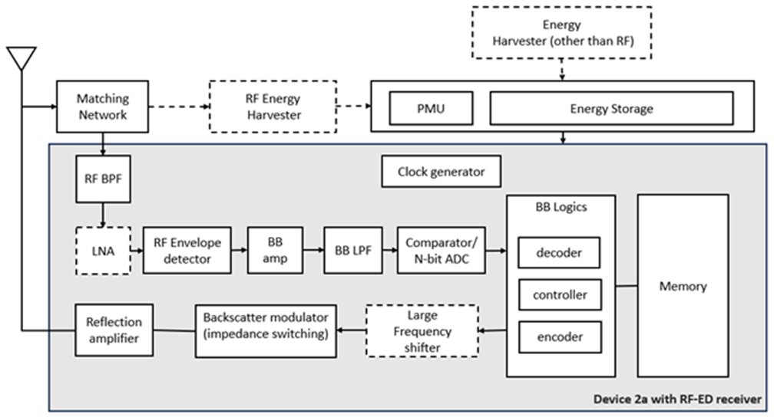
Figure 5.2.1-1: Architecture of device 2a

5.2.1.1 Reflection amplifier
For the reflection amplifier block, the following characteristics are considered for device 2a:
- Direction of amplification
- Uni-directional reflection amplifier (baseline) can amplify backscattered signal in D2R which can improve D2R link budget.
- Bi-directional amplifier can amplify both signal in R2D and backscatter signal in D2R at least when R2D and D2R are in the same spectrum.
- Bi-directional amplifier has higher complexity, higher noise figure, and reduced isolation between tx and rx path.
- Amplification gain ranges from 10 to 20 dB.
- Power consumption of reflection amplifier is in the range of a tens of uW to 100s of uW.
- Reflection amplifier can operate in FDD frequency bands.
- Reflection amplifier bandwidth can support 10s of MHz.
- Note: reflection amplifier can get unstable when the input power exceeds a certain value, which may be frequency-dependent.

5.2.1.2 Large frequency shifter
For the large frequency shifter block, it is observed that:
- Large frequency shift can be used in shifting reflected signal in tens of MHz, e.g., from FDD DL to FDD UL frequency or vice versa.
- Large frequency shift consumes 10s of uW to 100s of uW.
- Large frequency shift is not feasible for device 1.
- Large frequency shift requires a clock for IF generation which is accurate enough to avoid large guard band and interference to adjacent channels/bands.
- Large frequency shift requires image suppression and may require harmonics suppression
- Note: details of image suppression and harmonics suppression are not discussed in RAN1
- Large frequency shift may allow the reader to avoid implementing in-band full duplex capability for scenarios e.g., D1T1-A2 and D2T2-A2.
- Large frequency shift may result in [e.g., 5 kHz - 50 kHz] of frequency uncertainty in target frequency for clock accuracy of [e.g., 0.01% - 0.1%] assuming the large frequency shift range is 50 MHz
- FFS: whether large frequency shift is necessary and feasible for device 2a

5.2.2 Internally-generated carrier wave (Device 2b)

5.2.2.1 RF envelope detector receiver
The architecture of device 2b with an RF envelope detector receiver is summarised in Figure 5.2.2.1-1, with the blocks described as follows.
- Antenna could be either shared or separate for RF energy harvester (if present) and receiver/transmitter.
- Matching network is to match impedance between antenna and other components (including RF energy harvester (if present) and receiver related blocks).
- Energy harvester for harvesting energy from e.g., RF signal, solar, vibration/movement, temperature difference, etc
- Energy storage (e.g., capacitor) stores harvested energy from energy harvester.
- Power management unit (PMU) manages storing energy to energy storage from energy harvester and suppling power to active component blocks which needs power supply.
- Digital BB logic includes functional blocks like encoder, decoder, controller, etc.
- Memory can include two types of memory: 1) Non-Volatile Memory (NVM) such as EEPROM for permanently storing device ID, etc, and 2) registers for temporarily keeping any information required for its operation only while energy is available in energy storage.
- Clock generator provides required clock signal(s).
- Reception related blocks
- RF BPF filter for improving selectivity.
- Depending on implementation, it may not exist. RAN4 RF requirement (if any, e.g., ACS) and peak power consumption target also need to be considered.
- LNA for improving signal strength and sensitivity of receiver, if present
- RF envelope detector (RF-ED) detects envelope from RF signal.
- BB amplifier amplifies BB signal to improve signal strength.
- BB LPF can filter out harmonics and high frequency components to improve input signal quality to comparator/ADC.
- Depending on implementation, it may not exist.
- Comparator or N-bit ADC
- Transmission related blocks
- Tx Modulator: baseband bits are modulated according to modulation scheme. This block could be the part of BB logic.
- Digital to Analog Converter (DAC) converts digital signal to analog signal.
- Low pass filter for filtering out undesired signal
- Mixer performs up converting baseband signal to RF range.
- Local oscillator (LO) for carrier frequency generation
- FLL(/PLL) can be used for frequency synthesis
- Depending on implementation, FLL(/PLL) may not exist.
- Power amplifier (PA) amplifies tx signal, if present
- Details on transmitter related blocks depends on tx waveform/modulation.

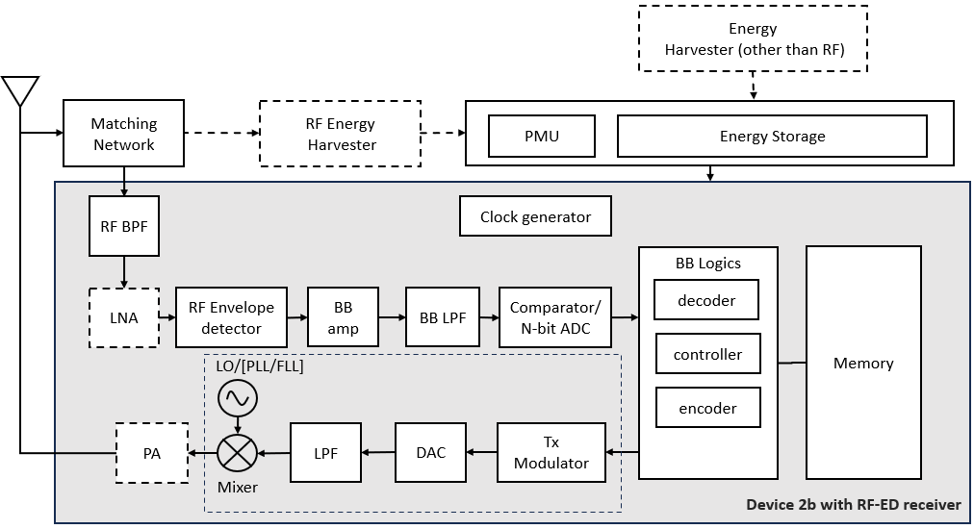
Figure 5.2.2.1-1: Architecture of device 2b with RF-ED receiver

5.2.2.2 IF envelope detector receiver
The architecture of device 2b with an IF envelope detector receiver is summarised in Figure 5.2.2.2-1, with the blocks described as follows.
- Antenna could be either shared or separate for RF energy harvester (if present) and receiver/transmitter
- Matching network is to match impedance between antenna and other components (including RF energy harvester (if present) and receiver related blocks)
- Energy harvester for harvesting energy from e.g., RF signal, solar, vibration/movement, temperature difference, etc.
- Energy storage (e.g., capacitor) stores harvested energy from energy harvester
- Power management unit (PMU) manages storing energy to energy storage from energy harvester and suppling power to active component blocks which needs power supply
- Digital BB logic includes functional blocks like encoder, decoder, controller, etc.
- Memory can include two types of memory: 1) Non-Volatile Memory (NVM) such as EEPROM for permanently storing device ID, etc, and 2) registers for temporarily keeping any information required for its operation only - while energy is available in energy storage
Clock generator provides required clock signal(s).
- Local oscillator (LO) for generating carrier frequency for Tx, or for generating carrier frequency offset by the IF for Rx
- FLL(/PLL) can be used for frequency synthesis
- One LO or separate LOs for Tx and Rx
- Reception related blocks
- RF BPF filter for improving selectivity
- Depending on implementation, it may not exist. RAN4 RF requirement (if any, e.g., ACS) and peak power consumption target also need to be considered
- LNA for improving signal strength and sensitivity of receiver, if present
- Mixer down converts RF signal to IF stage
- Depending on implementation, there could be one or two mixers for Rx and Tx
- IF amplifier amplifies IF signal
- IF filter for filtering out unwanted RF and LO signals
- IF envelope detector (IF-ED) detects envelope from IF signal.
- BB amplifier
- Depending on implementation, one or both of IF amplifier and BB amplifier may exist
- BB LPF can filter out harmonics and high frequency components to improve input signal quality to comparator/ADC
- Depending on implementation, it may not exist
- Comparator or N-bit ADC
- Note: image rejection is required
- Transmission related blocks
- Tx Modulator: baseband bits are modulated according to modulation scheme. This block could be the part of BB logic
- Digital to Analog Converter (DAC) converts digital signal to analog signal
- Low pass filter for filtering out undesired signal
- Mixer performs up converting baseband signal to RF range
- Power amplifier (PA) amplifies transmitted signal, if present
- Details of transmitter related blocks depends on e.g., waveform/modulation, etc.

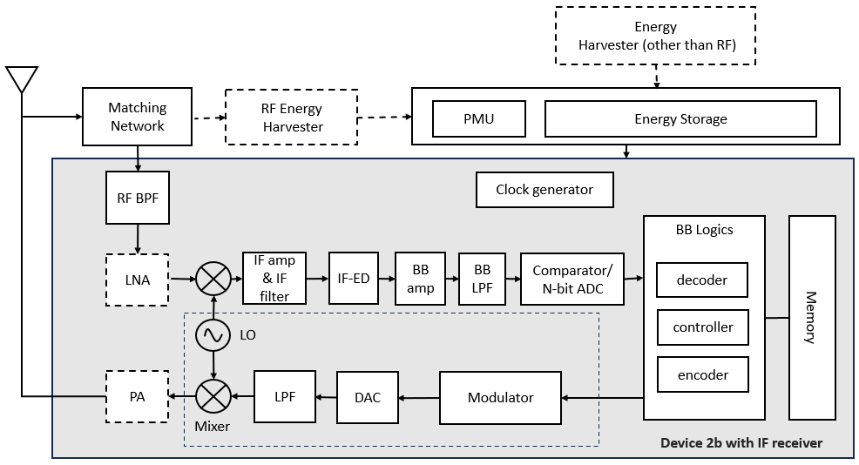
Figure 5.2.2.1-1: Architecture of device 2b with IF-ED receiver

5.2.2.3 ZIF receiver
The architecture of device 2b with a ZIF receiver is summarised in Figure 5.2.2.3-1, with the blocks described as follows.
- Antenna could be either shared or separate for RF energy harvester (if present) and receiver/transmitter
- Matching network is to match impedance between antenna and other components (including RF energy harvester (if present) and receiver related blocks)
- Energy harvester for harvesting energy from e.g., RF signal, solar, vibration/movement, temperature difference, etc
- Energy storage (e.g., capacitor) stores harvested energy from energy harvester.
- Power management unit (PMU) manages storing energy to energy storage from energy harvester and suppling power to active component blocks which needs power supply
- Digital BB logic includes functional blocks like encoder, detector, decoder, controller, etc.
- Memory can include two types of memory: 1) Non-Volatile Memory (NVM) such as EEPROM for permanently storing device ID, etc, and 2) registers for temporarily keeping any information required for its operation only while energy is available in energy storage
- Clock generator provides required clock signal(s).
- Local oscillator (LO) for generating carrier frequency for Tx and Rx
- FLL(/PLL) can be used for frequency synthesis
- One LO or separate LOs for Tx and Rx
- Reception related blocks
- RF BPF filter for improving selectivity
- Depending on implementation, it may not exist. RAN4 RF requirement (if any, e.g., ACS) and peak power consumption target also need to be considered
- LNA for improving signal strength and sensitivity of receiver, if present
- Mixer down converts RF signal to BB stage
- Depending on implementation, there could be one or two mixers for Rx and Tx
- BB amplifier amplifies BB signal
- BB LPF can filter out undesired frequency components to improve input signal quality to comparator/ADC.
- Depending on implementation, it may not exist
- Comparator or N-bit ADC
- Transmission related blocks
- Tx Modulator: baseband bits are modulated according to modulation scheme. This block could be the part of BB logic.
- Digital to Analog Converter (DAC) converts digital signal to analog signal.
- Low pass filter for filtering out undesired signal
- Mixer performs up converting baseband signal to RF range.
- Power amplifier (PA) amplifies transmitted signal, if present
- Details of transmitter related blocks depend on e.g., waveform/modulation, etc.

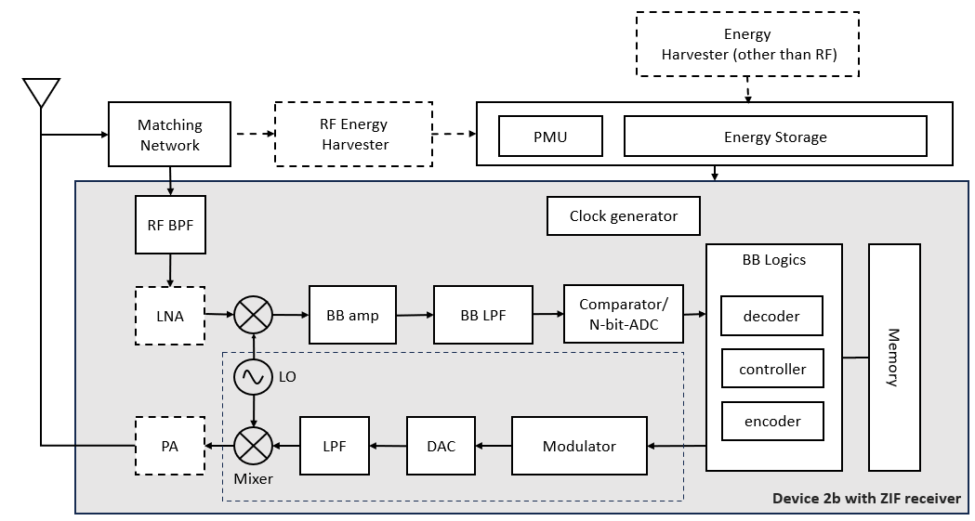
Figure 5.2.2.1-1: Architecture of device 2b with ZIF receiver

5.2.3 Clock(s)

Table 5.2.3-1: Descriptions of clocks/LOs
 | Description | Applicable  device types | Clock  speed | Power  consumption | Initial clock  accuracy | Accuracy after  clock sync / calibration | Clock drift
Purpose #1 of the clock | Sampling | Device 1, 2a, 2b | A few MHz | < [1] µW for device 1  FFS for device 2a/2b | [10⁴ - 10⁵] ppm for device 1  [10^{3 –} 10⁴] ppm for device 2a/2b | FFS (if applicable for device 1) | FFS
Purpose #2 of the clock | Small frequency shift | At least for device 1 and device 2a
[Purpose #3 of the clock] | [Time counting (if supported)] | [Device 1, 2a, 2b] | FFS | FFS the same or different for different devices | FFS | FFS (if applicable) | FFS
Purpose #4 of the clock | Large frequency shift (if supported for device 2a) | Device 2a | 10s of MHz | [10s] of µW | FFS | FFS | FFS
Purpose #5 of the clock | LO for carrier frequency (for up/down conversion) | Device 2b | e.g., [900] MHz | [10s - 100s] of µW | FFS |  | FFS
Note: It does not necessarily imply that different purposes of LOs/clocks correspond to separate discrete LOs/clocks, which is up to implementation.

6 Solutions for ambient IoT

6.1 Physical layer

6.1.0 General
The names of physical channels and signals used in this TR are for the sake of the study.
The study assumes that an A-IoT device has a single antenna for both communication (transmission/reception) and RF energy harvesting purposes.
The study defines repetition types as follows:
Block level: All the bits received from higher layers and/or physical layer (according to what is present) after CRC attachment (if used) are blockwise repeated Rblock times
Bit level type 1: Each bit after CRC attachment (if used) is repeated Rbit times
Bit level type 2: Each bit after both CRC attachment (if used) and FEC (if used) is repeated Rbit times
Chip level: Each chip after line coding (if used) or after square wave modulation (if used) is repeated Rchip time. NOTE: This is equivalent to extending the duration of each chip by Rchip times.

6.1.1 R2D
A dedicated physical broadcast channel, e.g. PBCH-like, and reference signals including at least DMRS, PTRS, CSI-RS/TRS, are not considered for R2D.

6.1.1.x R2D waveform, modulation and numerology
An OFDM-based OOK waveform with subcarrier spacing of 15 kHz is studied for R2D, with OOK-1 for single-chip per OFDM symbol transmission, and OOK-4 for M-chip per OFDM symbol transmission, starting from the definitions in TR 38.869 [4]. For this waveform, the start of R2D transmission from the reader perspective is assumed to be aligned with the boundary of an NR OFDM symbol (including the CP) for in-band/guard-band operation.
For CP handling, the following candidate methods are studied, on the basis of e.g., CP impact on R2D timing acquisition, and decoding & performance of PRDCH, reader and device implementation complexities, interference between R2D and NR DL/UL if in the same NR band, spectrum efficiency.
Method Type 1: Removal of CP at device without specified transmit-side.
Method Type 2: Ensure the CP insertion of OFDM-based waveform will not introduce false rising/falling edge between the last OOK chip in OFDM symbol (n-1) and the first OOK chip in OFDM symbol n.
For Method 1, two ways that CP location/length can be determined are studied:
Alt M1-1: Device assumes same CP length for each OFDM symbol, i.e. does not distinguish exact CP length among different OFDM symbols
Alt M1-2: Duration between transition edges is utilized by device to determine CP location/length, i.e. if the duration appears to be invalid based on known chip duration
For Method 2, two approaches regarding subcarrier orthogonality are studied:
Alt M2-1: Method Type 2 retains subcarrier orthogonality, i.e. CP is copied from the end of an OFDM symbol.
Alt M2-1-1: The first OOK chip(s) and the last OOK chip(s) in an OFDM symbol are the same.
Alt M2-1-2: Ensure a transition edge occurs only at the start or only at the end of the CP, and no transition edge occurs during the CP.
Alt M2-2: Method Type 2 does not retain subcarrier orthogonality.

6.1.1.x R2D line coding
The line codes studied for R2D are Manchester encoding and PIE.
For Manchester encoding, the bit-to-chip mapping is: bit 0→chips{10}, bit 1→chips{01}.

6.1.1.x R2D channel coding, CRC
PRDCH without FEC is studied as the baseline, with evaluations performed by comparison to this baseline. The study assumes PRDCH can attach a CRC, where the baseline design is using a 6-bit or 16-bit CRC with polynomials as per TS 38.212 [5]. A baseline of no CRC attachment is also included.

6.1.1.x R2D bandwidths
The study defines the following bandwidths for R2D:
- Transmission bandwidth, B_{tx,R2D} from a reader perspective: The frequency resources used for transmitting R2D. For an OFDM-based waveform with subcarrier spacing of 15 kHz, B_{tx,R2D} ≤ [12] PRBs.
- Occupied bandwidth, B_{occ,R2D} from a reader perspective: The frequency resources used for transmitting R2D, and potential guard band.
- B_{occ,R2D} ≥ B_{tx,R2D}.
Table 6.1.1.x-1 is a starting point for study of M values and the associated minimum B_{tx,R2D} value. The reader can use any transmission bandwidth greater than or equal to the minimum B_{tx,R2D} value.
Note: Depending on further study, the maximum value of M may be less than 32.
Table 6.1.1.x-1: Starting point for M values and the associated minimum B_{tx,R2D} value
M | Minimum B_{tx,R2D} # of PRBs
1 | 1
2 | 1
4 | 1
6 | 1
8 | 2
12 | 2
16 | 2
24 | 2
32 | 3

6.1.1.x PRDCH
For R2D, the only physical channel is PRDCH, which carries any higher-layer payload (including system information, if defined), and L1 R2D control information, if defined. PRDCH is studied via the blocks shown in Figure 6.1.1.x-1, where other sections give their detailed descriptions.
Figure 6.1.1.x-1: PRDCH generation

6.1.1.x R2D start timing
An R2D timing acquisition signal (R-TAS), immediately preceding the transmission of PRDCH, is included at least for timing acquisition and indicating the start of R2D transmission in the time domain. An R-TAS structure using a preamble is studied, in which a start-indicator part provides the start of the R2D transmission, and immediately precedes a clock-acquisition part which is used to determine the OOK chip duration of the subsequent PRDCH transmission. The preamble is not part of PRDCH.
For the R-TAS start indicator part, an ON/OFF pattern i.e., high/low voltage transmission, is applied.

6.1.1.x R2D end timing
To determine or derive the end of PRDCH transmission, the following options are studied:
Option 1: R2D postamble immediately follows the PRDCH to indicate the end of the PRDCH.
Option 2: Based on R2D control information.

6.1.1.x Scheduling of R2D
For R2D reception, the following information potentially can be explicitly/implicitly indicated to the device via the corresponding PRDCH:
- ID associated with device(s) intended for the reception of R2D, potentially including all devices (if supported)
For each information, it is for further study whether higher-layer signaling and/or L1 R2D control signaling is used.

6.1.2 D2R
Reference signals including DMRS, PTRS, SRS, are not considered for D2R. CSI feedback and autonomous SR are not considered for L1 D2R control information.

6.1.2.x Waveform and modulation
For D2R by backscattering, the waveform is provided by the carrier wave, see Clause 6.7.
For all devices, the following D2R baseband modulations are studied:
- OOK
- Binary PSK
- Binary FSK, as MSK (and not GMSK)
OOK and BPSK for baseband modulation are feasible for D2R for all devices. It is for further study whether MSK is feasible for all devices.

6.1.2.x D2R line coding
The line codes studied for R2D are Manchester encoding FM0 encoding, Miller encoding, and no line coding.
For Manchester encoding, the bit-to-chip mapping is: bit 0→chips{10}, bit 1→chips{01}.
For FM0 encoding, according to Figure 6-8 and Figure 6-9 of [6].
For Miller encoding, according to Figure 6-12 of [6].

6.1.2.x D2R channel coding, repetition, CRC
For D2R, convolutional codes are studied, with comparisons to the case of no FEC. The LTE convolutional code polynomials are a reference, and other designs studied subject to:
- Constraint length, K = 8 or K = 7 or K = 6 or K = 4.
- Mother code-rate, R = 1/6, 1/4, 1/3, 1/2.
The study assumes PDRCH can attach a CRC, where the baseline design is using a 6-bit or 16-bit CRC with polynomials as per TS 38.212 [5]. A baseline of no CRC attachment is also included.
For definitions of repetition types, see Clause 6.1.0. For D2R, at least block-level and bit-level repetition type 1 and type 2 are studied.

6.1.2.x D2R bandwidths
The following bandwidths for D2R are defined for the purpose of the study:
- Transmission bandwidth, B_{tx,D2R}: The frequency resources scheduled by a reader for a D2R transmission from one device.
- Occupied bandwidth, B_{occ,D2R}: The transmission bandwidth plus the potential associated intra A-IoT guard-bands totalling B_{guard,D2R}. Note: this guard band is not for coexistence with NR/LTE.
- B_{occ,D2R} ≥ B_{tx,D2R}.

6.1.2.x PDRCH
For D2R, a physical channel PDRCH carries any higher-layer payload, the response transmitted from device to reader during the contention-based access procedure, and L1 D2R control information, if defined. PDRCH is studied via the blocks shown in Figure 6.1.2.x-1, where other sections give their detailed descriptions.
Figure 6.1.2.x-1: PDRCH generation
Scheduling information of PDRCH transmission is provided by a corresponding PRDCH.

6.1.2.x D2R start timing
A D2R timing acquisition signal (D-TAS), preceding each PDRCH, is included at least for timing acquisition, indicating the start of the D2R transmission in the time domain, and studied potentially for SFO estimation, CFO estimation, channel estimation, and interference estimation. A D-TAS structure using a preamble is studied. The preamble is not part of PDRCH.

6.1.2.x D2R end timing
For the reader to acquire the end of PDRCH transmission, the following options are studied:
Option 1: D2R postamble immediately follows the PDRCH
Option 2: Based on control information

6.1.2.x D2R midamble
The necessity of a midamble is studied at least for the purpose of performing timing/frequency tracking or channel estimation or interference estimation.

6.1.2.x D2R multiple access
Time-domain multiple access, and frequency domain multiple access at least by using a small frequency-shift in baseband are studied. Whether code-domain multiple access is feasible and necessary for all devices is FFS.
For OOK and BPSK, small frequency shifts are studied:
- For applying with Manchester line codes
Option 1: By repetition of the codewords within the same time duration corresponding to an information bit. FFS how to define this repetition.
Option 2: By multiplying the Manchester codeword with a square wave corresponding to the small frequency-shift.
Companies to report how they perform multiplying for option 2.
- For applying with Miller line codes, according to Figure 6-13 of [6].
- For FM0, small frequency shift is not defined
- If no D2R line code is used, by using a square-wave corresponding to the small frequency-shift.
- Potential purposes include:
- FDMA of D2R, if supported
- CW interference avoidance, if supported
Note: Small frequency shifts for D2R are studied for the same potential purposes for MSK.

6.1.2.x Scheduling of D2R
For D2R scheduling, the following information potentially can be explicitly/implicitly indicated to the device via the corresponding PRDCH:
- Time domain resources
- Frequency domain resources
- MCS-like information
- Chip duration
- ID associated with device(s)
- Repetitions
For each information, it is for further study whether higher-layer signaling and/or L1 R2D control signaling is used.

6.1.3 Timing relationships
A-IoT processing time aspects are studied in terms of the following timing relationships:
T_{R2D_min}: Minimum time between a R2D transmission and the corresponding D2R transmission following it.
T_{D2R_min}: Minimum time between a D2R transmission and the corresponding R2D transmission following it.
T_{D2R_max}: Maximum time between the D2R transmission and the corresponding R2D transmission following it, so that the R2D transmission timing is expected to be within [T_{D2R_min}, T_{D2R_max}], when a R2D transmission in response to a D2R transmission is expected for A-IoT Msg2 response to A-IoT Msg1 for the A-IoT device. See clause 6.3 for message descriptions.
T_{R2D_R2D_min}: Minimum time between two different consecutive R2D transmissions to the same A-IoT device.
T_{D2R_D2R_min}: Minimum time between two different consecutive D2R transmissions from the same A-IoT device.
For the time interval between a R2D transmission and the corresponding D2R transmission following it, there are two options studied:
Option 1: Define a maximum time T_{R2D_max} between a R2D transmission and the corresponding D2R transmission following it, so that the device transmits D2R transmission within [T_{R2D_min}, T_{R2D_max}].
Option 2: The corresponding D2R transmission timing T_{R2D} following a R2D transmission is determined based on the control information in the R2D transmission, where T_{R2D} ≥ T_{R2D_min}.

6.1.4 Random access
Editor’s note: Whether to retain this clause in the RAN1 part, or merge it into Clause 6.2 with RAN2 is TBD, once further agreements and text are available.
From the perspective of the physical layer, at least when a response is expected from multiple devices that are intended to be identified, an A-IoT contention-based access procedure initiated by the reader is used, for which at least slotted-ALOHA based access and FDMA, are studied. The study of FDMA includes how the frequency domain resources for Msg1 are allocated, and how a device determines that frequency-domain resource allocation.
The response transmitted from the device to the reader during this procedure is transmitted on PDRCH.

6.2 Device (un)availability
The following directions, not for down-selection, are studied regarding the potential impact of device unavailability due to energy harvesting:
Direction 1: Reader does not provide information to a device regarding when the device may become available/unavailable.
Direction 2: Reader can provide information to a device based on which the device may become available/unavailable.

6.2.1 Direction 1 solution details
Table 6.2.1-x: Details from Source X
Source | Details
Source X | Solution description  Observations or Analysis or Evaluations  Specification impacts, if any

Table 6.2.1-y: Details from Source Y
Source | Details
Source Y | Solution description  Observations or Analysis or Evaluations  Specification impacts, if any

…

6.2.2 Direction 2 solution details
Table 6.2.2-x: Details from Source X
Source | Details
Source X | Solution description  Observations or Analysis or Evaluations  Specification impacts, if any

Table 6.2.2-y: Details from Source Y
Source | Details
Source Y | Solution description  Observations or Analysis or Evaluations  Specification impacts, if any

…

6.3 Protocol stack and signalling procedures

6.3.1 General aspects and overall procedure
The study aims that the design on the A-IoT air interface between reader and A-IoT device is common and fully reused for Topology 1 and Topology 2. The difference of topologies is transparent to the A-IoT devices and has no impact on A-IoT devices. Unless explicitly stated, the descriptions in clause 6.3 apply to all A-IoT device types and both Topology 1 and Topology 2.
Figure 6.3.1-1 Overall AS procedures between A-IoT device and reader
The overall AS procedures can be formulated as:
- Step A: A-IoT paging. Based on the service request, the reader sends the A-IoT paging message indicating device(s) that need to respond. See clause 6.3.3.
NOTE 1: In the clause 6.3, the term of “A-IoT paging message” is equal to the “(initial) trigger message”. For simplification, only the former is used.
- Step B: D2R data (device ID) transmission. Triggered A-IoT device(s) perform the device ID transmission via the A-IoT random access procedure or without using the A-IoT random access procedure. See clause 6.3.4 (and 6.3.5).
- Step C1: Possible R2D data transmission (e.g., for sending the command). See clause 6.3.5.
- Step C2: Possible D2R data transmission (e.g., the corresponding response to command). See clause 6.3.5.
Then, above AS procedure can support indoor inventory and indoor command use cases by the following manners:
- For the detailed use case of “inventory-only”, it is supported by the procedure with Step A and Step B as baseline.
- For the detailed use case of “inventory and command”, it is supported by the procedure with Step A, Step B, Step C1 and Step C2, as baseline.
NOTE 2: For the use case of “inventory and command”, it does not imply that the A-IoT paging message includes both the inventory and command and it does not imply the inventory and command are received by the reader at the same time from upper layer.
- For the detailed use case of “command-only”:
- It can be also supported by the baseline procedure with Step A, Step B, Step C1 and Step C2.
- In addition, another candidate to support this use case is following, whose feasibility still depends on the conclusion from [7] and [8]:
- Step A’: A-IoT paging. Based on the service request, the reader sends the A-IoT paging message including the command, indicating device(s) to process/respond the command.
- Step C2: Possible D2R data transmission (e.g., the device ID or the corresponding response to command), via the A-IoT random access procedure or without using the A-IoT random access procedure.

6.3.2 Protocol stack and functionality aspects

For A-IoT, it is assumed the commands (e.g., read/write/disable) and/or inventory information are carried by A-IoT radio interface as the upper layer data. As to the protocol stack for A-IoT radio interface between A-IoT device and reader, it is assumed:
- RRC layer is not supported
- SDAP layer is not supported
- PDCP layer is not supported
- RLC layer is not supported
- A-IoT MAC layer is supported
- A-IoT physical layer is supported
Editor’s Note: Based on the study of the required functionalities, it is FFS if a new AS protocol on top of A-IoT MAC layer is needed.
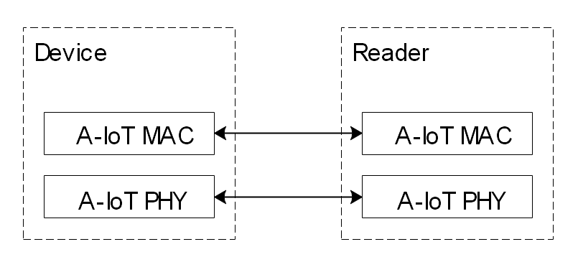
Figure 6.3.2-1 Protocol stack for A-IoT radio interface between A-IoT device and reader
As to the A-IoT required functionalities, the following functionalities are supported:
- A-IoT paging (see clause 6.3.3)
- A-IoT random access procedure (see clause 6.3.4)
- A-IoT data transmission (see clause 6.3.5)
As to the A-IoT required functionalities, at least the following functionalities are NOT supported (see TS 38.300 [9] for references for any legacy NR functionality):
- AS security (The AS layer design assumes no support of AS security, unless the study in [8] further concludes differently.)
- RRC states
- RRC connection management
- RRM L3 measurement reporting
- Mobility
- ASN.1 encoding/decoding
- Periodical system information and MIB
- Tracking/RAN area update procedure
- Per-packet QoS and per-QoS flow at AS level
- HARQ
- RLC ARQ/AM
- AS-layer (above physical layer) RLC-like/ARQ-like retransmission
- AS-layer (above physical layer) repetition
NOTE 1: It is not precluded that the reader and A-IoT device send the “payload” again as new transmission from A-IoT MAC perspective.
- Multiple A-IoT logical channels for upper layer data
- Legacy NR SR
- Legacy NR BSR

6.3.3 A-IoT paging
In A-IoT AS layer, the A-IoT paging functionality is to use A-IoT paging message to indicate device(s) that need to respond.
As to the A-IoT paging message, the identifier may be required to identify the device/group of devices in this trigger message (e.g., for the case of reaching a single or a group of devices). Following cases are studied:
- The A-IoT paging message containing an identifier of a single A-IoT device
- The A-IoT paging message containing a group ID that maps to multiple A-IoT devices
- The A-IoT paging message that does not contain any identifier, i.e., indicating all A-IoT devices that can receive the A-IoT paging message need to respond
- The A-IoT paging message containing multiple identifiers of A-IoT devices. The need for this use case is still to be confirmed/dependent according to the conclusion in [7].
NOTE 1: The details of the above identifier and group ID and also the use case/scenario are studied in [7].
As to the A-IoT paging message, it can additionally indicate the information from which the device(s) can determine the resource(s) to be used for D2R response message(s).
For A-IoT device paging functionality, it is understood that the legacy paging message, legacy paging occasion and legacy DRX from NR are not supported (See TS 38.300 [9] for references for any legacy NR functionality). From RAN2 perspective, it is assumed that the A-IoT device can receive as long as there is enough energy.
It is supported that the reader can send multiple (subsequent) A-IoT paging messages that are associated with the same service request from the CN. The duplicated response from devices for the same service request should be avoided.

6.3.4 A-IoT random access procedure
A-IoT random access procedure is used for the Ambient IoT device(s) to access the network for data transmission.
The A-IoT random access procedure is triggered by the reader, including triggering the access for a single A-IoT device, group of A-IoT devices, or all A-IoT devices under the coverage of the reader.
The slotted-ALOHA is the baseline for A-IoT random access procedure.
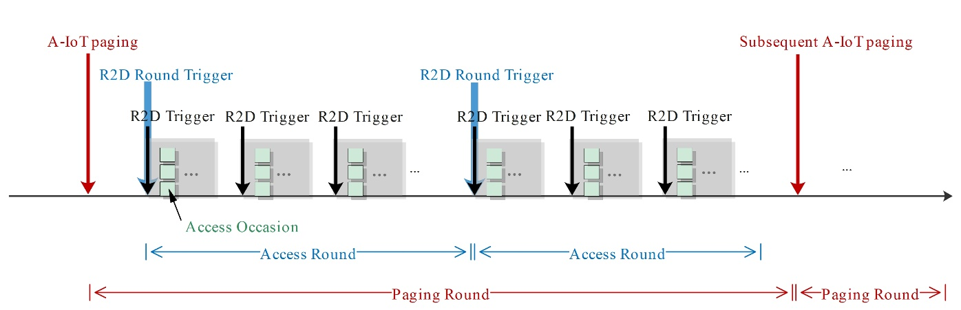
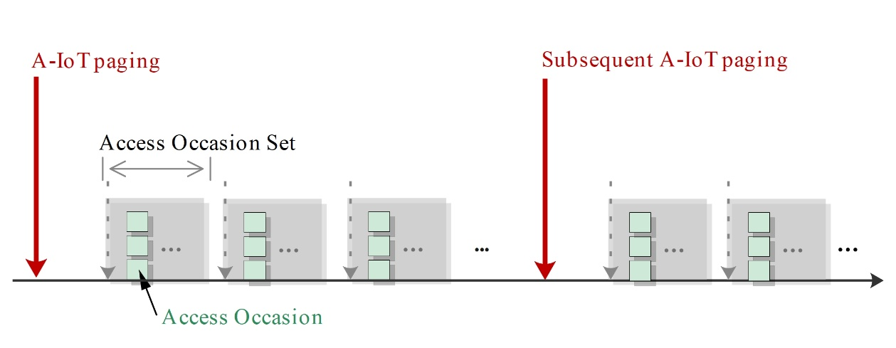
Figure 6.3.4-1 General framework of slotted-ALOHA for A-IoT random access procedure
Access occasion: An opportunity of time-frequency resource for A-IoT device(s) to perform access (e.g., transmitting the A-IoT Msg1 by the device).
Access occasion set: A set of access occasion(s) for different A-IoT device(s), which is scheduled via the R2D by the reader.
[Access round: One access round consists a certain amount of access occasions for different devices, which are assigned by the reader via one R2D message (e.g., [R2D Round Trigger message]).]
[Paging round: One paging round consists one or multiple access rounds, which is initiated by the A-IoT paging message. One service request may associate with multiple paging rounds.]
Editor’s Note: The above terminologies/definitions and demonstration figure subject to future agreements.
- It is to be further studied on whether “Access round” and “Paging round” are the same and whether each is needed, i.e. further discussion on need of separate R2D message to initiate the access round and on the need of (multiple) access rounds;
- It is up to RAN1 design on the details how one set of time/frequency resources are scheduled by reader.
When the A-IoT device is selected to respond in accordance to the clause 6.3.3, the A-IoT device performs the following procedure:
- Step 1: Random access type (i.e. contention-free or contention-based) and access occasion/resource determination:
- If the random access is contention-free access:
- Selects the indicated D2R occasion/resource;
- Skips the contention resolution in Step 2 and performs the data transmission in accordance to clause 6.3.5.
- If the random access is contention-based random access:
- Performs access occasion/resource determination/selection: [FFS];
- Performs the Step 2 for contention resolution.
- Step 2: Contention resolution of contention-based random access:
- There are two candidate solutions being studied for the contention resolution, as below:
- Solution 1: A-IoT Msg1 without data
- A-IoT Msg1: When the A-IoT device identifies the start of its own access occasion, it sends one 16-bit random ID generated by the A-IoT device to the reader.

- A-IoT Msg2: The reader responds with the successfully received random ID.
If the A-IoT device receives the A-IoT Msg2 including a random ID, which is the same as the previously transmitted one in A-IoT Msg1, it considers the contention resolution as successful.

- Solution 2: A-IoT Msg1 with data
- A-IoT Msg1: When the A-IoT device identifies the start of its own access occasion, it sends the A-IoT Msg1 including the upper layer data, which can be the device ID and/or any other upper layer data, in addition to one 16-bit random ID generated by the A-IoT device to the reader.

- A-IoT Msg2: The reader may respond with the successfully received random ID.
If the A-IoT device receives the A-IoT Msg2 including a random ID, which is the same as the previously transmitted one in A-IoT Msg1, it considers the contention resolution as successful.
NOTE 1: The random ID is randomly generated by the A-IoT device.
NOTE 2: The A-IoT Msg2 is used for contention resolution, since it is assumed that the size of random ID in A-IoT Msg1 should be sufficient for contention resolution purpose. It is assumed that, with the sufficient range for random ID, the probability of multiple A-IoT devices selecting the same access occasion and the same random ID for A-IoT Msg1 transmission will be sufficiently low.
NOTE 3: It is up to the reader implementation whether A-IoT Msg2 is sent in random access Solution 2. It can be further studied when A-IoT Msg2 is needed in random access Solution 2.

After the A-IoT device considers the contention resolution as successful if the contention-based random access is used, or if the contention-free access is used, it may perform the upper layer data transmission with the reader, which can be the device ID and/or any other upper layer data, if any, in accordance to clause 6.3.5.

6.3.5 A-IoT data transmission
Editor’s Note: This clause is to capture the studies related to the A-IoT data transmission functionalities (also to give the reference to clause 6.3.2 on the protocol stack), e.g., AS ID for scheduling purposes, the data transmission failure, need/handling of segmentation, information visible to the reader, message size report, energy status report etc. For the latter assistant information, it can be further considered whether a separate sub-clause is needed. For the information visible to reader from CN, it can be further considered whether we put it in other sub-clause of 6.3.
Editor’s Note: It is understood that the subsequent R2D transmission after the D2R transmission does not need to be always sent. The usage (e.g., failure/success indication)/presence of this subsequent R2D transmission is to be further studied. This is to be captured after RAN2 makes clear conclusions.
The potential use of the following assistant information are studied (the need of each is still to be studied/decided):
- The energy status report from the A-IoT device to the reader, in case A-IoT device does not have energy for the follow-up data transmission
- A simple message size report to the reader
The following information are considered useful to be visible to the reader from CN:
- The A-IoT service type (e.g., inventory, command)
- Whether the service is targeted for one or more than one A-IoT devices
- The approximate number of target A-IoT devices of this service (if available)

6.3.6 Topology 2 aspects on the interface between UE reader and RAN
For Topology 2, the architecture/protocol stack options in [7] are studied (also corresponding to the studies in clause 6.4.2.1), while no new AS layer architecture/protocol stack options will be studied:
- RRC based solution: A-IoT upper layer information is explicitly forwarded via NR Uu RRC message.
- NAS based solution: A-IoT upper layer information is transmitted over UE reader's NAS message.
- UP based solution: A-IoT upper layer information is transmitted as UE reader's user plane data.
It is assumed that the intermediate UE authorization is performed by upper layers, according to [7] and [8].
The radio resources used by A-IoT radio interface between the A-IoT device and UE reader are controlled by the network.
The UE reader in coverage of BS scenario is supported.

6.4 RAN architecture aspects
Editor’s note 1: Corresponds to the second RAN3 objective in the SID, to identify RAN architecture aspects, including whether support for split architecture is necessary.
This clause attempts to identify and describe architectural elements necessary to define a RAN architecture for support of Ambient IoT embedded in the overall 5G system architecture in support of topology 1 and topology 2 (as defined in TR 38.848 [2]).
Editor’s Note 2: What functionalities are hosted by the 5GS for A-IoT is TBD.
This chapter also attempts to identify a functional split between RAN and CN.
The logical system architecture for A-IoT consists of the following architectural elements:
A-IoT device: Equipment with characteristics outlined e.g. in TS 22.369 [10] and TR 38.848 [2].
Editor’s Note 3: Further details FFS, if any.
A-IoT RAN: Hosts certain functions for A-IoT as part of the functional split between RAN and CN.
Editor’s Note 4: Further details regarding A-IoT functions hosted in the A-IoT RAN and the respective functional split to be decided by RAN2, RAN3 and SA2.
A-IoT radio: Radio interface between A-IoT device and A-IoT RAN node in topology 1 and between A-IoT device and A-IoT-enabled UE in topology 2.
Editor’s Note 5: Further details on A-IoT radio to be discussed by RAN1 and RAN2.
A-IoT CN: Hosts certain functions for A-IoT as of the functional split between RAN and CN.
NOTE: the details of A-IoT CN are subject to SA2.
Editor’s Note 6: Further details regarding A-IoT functions hosted in the A-IoT CN and the respective functional split to be decided by RAN2, RAN3 and SA2.
XX interface: Interface between the A-IoT RAN and the A-IoT CN on which certain A-IoT specific functions are performed.
Editor’s Note 7: The functions represented by the XX interfaces are FFS. It is also FFS whether this interface represents a new logical interface or is equal to NG. E.g. for topology 1 it may only represent a single interface instance, e.g. a new interface between A-IoT RAN and A-IoT CN, for topology 2 it might represent either 2 interface instances, one instance for NG and one instance “XX” for a new interface between A-IoT CN and A-IoT RAN, or one instance for NG alone.
Common reader function: A function that communicates with the A-IoT device by means of A-IoT radio.
Editor’s Note 8: Further details on Common reader function is to be discussed by RAN1 and RAN2.
A-IoT RAN node function: A function that contains e.g. the control of the A-IoT radio resources used towards the A-IoT device.
Editor’s Note 9: further details are FFS. Note that “control of A-IoT radio resources” does not necessarily imply dynamic configuration of resources but could also rely on static assignment of resources by means of OAM. Aspects concerning coordination of the Upper Layer functions (e.g. Inventory, Command) e.g. in case these functions have to be performed over a multitude of instances of the Common Reader Function are FFS.

6.4.1 Support of Topology 1
Figure 6.4.1-1 depicts a logical system architecture for topology 1, where the Common reader function and A-IoT RAN node function are deployed within an A-IoT RAN.
Figure 6.4.1-1 Logical system architecture for topology 1
In Topology 1, the XX interface could be based on NG or a new interface carried over NG or a new interface.
Figure 6.4.1-2 shows the Protocol stack for Topology 1, assuming a SCTP-based transport:
Figure 6.4.1-2. Protocol Stack for Topology 1
Editor’s Note 1: Figure 6.3.1-2 serves as a starting point for further discussions.
For topology 1, the XXAP is terminated at an A-IoT RAN node.
Editor’s Note 2: the signalling transport for XXAP is FFS.
Editor’s Note 3: The protocol stack does not detail how A-IoT upper layer information is transported over XXAP, details are pending on SA2 agreements. And the A-IoT CN may include AMF and A-IoT related functions which is also up to SA2 decision.
Editor’s Note 4: aspects of interaction between upper layer information exchange and XXAP in order to trigger the A-IoT RAN node functions are FFS.

6.4.2 Support of Topology 2
Figure 6.4.2-1 depicts a logical system architecture for topology 2, where the Common reader function is located at an A-IoT-enabled UE, and the A-IoT RAN node function is located at an A-IoT-enabled gNB.
The following definitions apply:
A-IoT-enabled gNB: A gNB supporting A-IoT RAN node function, which is able to communicate with the A-IoT enabled UE via NR Uu interface.
A-IoT-enabled UE: A UE supporting Common reader function, which is able to communicate with the A-IoT device via the A-IoT radio interface.
Figure 6.4.2-1 Logical system architecture for topology 2
Editor’s Note 1: Figure 6.3.2-1 doesn’t illustrate the protocol between A-IoT enabled UE and A-IoT CN, if needed, the figure needs to be revised in case such is defined by SA2.
Editor’s Note 2: In Topology 2, the XX interface could be based on NG or a new interface carried over NG or a new interface. XX signaling could be transported via XX-C or XX-U, which is FFS.
Editor’s Note 3: The A-IoT CN could include AMF and A-IoT related functions. This is up to SA2 decision.
Editor’s Note 4: The A-IoT enabled gNB performs radio resource management for A-IoT related radio resources, details are pending on RAN1 and RAN2 mechanisms.

6.4.2.1 Solutions for Topology 2
To support Topology 2, the following solutions are to be studied for conveying A-IoT upper layer information:
- RRC based solution. With this solution, A-IoT CN applies A-IoT upper layer information explicitly over XXAP signaling. A-IoT upper layer information is then relayed explicitly to/from the A-IoT-enabled UE via NR Uu RRC.
- NAS based solution. With this solution, there is no explicit termination of A-IoT upper layer information at A-IoT-enabled gNB. A-IoT upper layer information is transmitted over A-IoT enabled UE's NAS.
- UP based solution. With this solution, there is no explicit termination of A-IoT upper layer information at A-IoT-enabled gNB. A-IoT upper layer information is transmitted as A-IoT-enabled UE's user plane data.
Editor’s note 1: How to enable radio resource control, i.e. trigger A-IoT RAN node functions for above solutions is FFS.
Editor’s note 2: Depiction and further details of the options above are FFS

6.5 Impacts on CN-RAN interface
Editor’s note: Corresponds to the first RAN3 objective in the SID, to identify necessary impacts on signaling and procedures for CN-RAN interface.

6.5.1 Information exchanged between A-IoT CN and A-IoT RAN

6.5.1.1 Inventory
Inventory can be sent by the A-IoT CN for a single device, or a group of devices, or all devices.
The Inventory Request from the A-IoT CN to the A-IoT RAN, may include the following:
(1) A-IoT Device Identification (to find a single device, a group of devices, or all devices)
Note 1: The definition of this identification is out of RAN3 scope.
Editor’s Note 1: It is FFS whether A-IoT RAN needs to interpret/store/process it.
(2) Scope of inventory request (e.g., a certain area in which the inventory is to be triggered)
Multiple individual A-IoT Device IDs (one ID per device) can be provided to the A-IoT CN via a single Inventory Report.
Editor’s Note 2: It is up to SA2 whether device ID is sent transparent or not.

6.5.1.2 Command
Command can be sent by the A-IoT CN for a single device.
Editor’s Note 1: it is FFS for command on a group of devices, or all devices.
Editor’s Note 2: it is FFS whether A-IoT RAN can remain agnostic of the type of request from the A-IoT CN (need to differentiate command and inventory)

6.5.2 Signaling and Procedures for Topology 1

6.5.2.1 Candidate procedures for A-IoT Inventory for Topology 1
Editor’s note 1: Future discussions on A-IoT Inventory will take place based on the following message flows, working on the content of the messages including ownership, associated functions, scope, etc.

Figure 6.5.2.1-1: Message flow for A-IoT Inventory in Topology 1

6.5.3 Signaling and Procedures for Topology 2

6.5.3.1 Candidate procedures for A-IoT Inventory for Topology 2
Editor’s note 1: Future discussions on A-IoT Inventory will take place based on the following message flows, working on the content of the messages including ownership, associated functions, scope, etc.

Figure 6.5.3.1-1: Message flow for A-IoT Inventory in Topology 2 (if RRC-based solution is used)

Figure 6.5.3.1-2: Message flow for A-IoT Inventory in Topology 2 (if NAS/UP based solution is used)
Editor’s note 2: how and where to depict signalling suitable for triggering A-IoT RAN node functions for A-IoT radio resource management needs further discussions for direct communication between A-IoT CN and A-IoT-enabled UE.

6.6 Coexistence of ambient IoT and NR/LTE

6.6.1 Regulation consideration

6.6.2 Co-existence scenarios and cases
The coexistence evaluation is conducted considering the different scenarios listed in Table 6.6.2-1
Table 6.6.2-1: Co-existence scenarios
Deployment scenario No. (Case No.) | Topology | Spectrum
1-1(a/b/c/d) | D1T1-A2- NR UE only outdoor | R2D: DL  CW2D and D2R: DL
1-2(a/b/c/d) | D1T1-A2- NR UE indoor | R2D: DL  CW2D and D2R: DL
2-1(e/f/c/d) | D1T1-B- NR UE only outdoor | R2D: DL  CW2D and D2R: UL
2-2(e/f/c/d) | D1T1-B- NR UE indoor | R2D: DL  CW2D and D2R: UL
3 (Optional)(e/f/c/d) | D1T1-B- NR UE indoor | R2D: UL  CW2D and D2R: UL
4-1(e/f/g/h) | D2T2-A2- NR UE only outdoor | R2D: UL  CW2D and D2R: UL
4-2(e/f/g/h) | D2T2-A2- NR UE indoor | R2D: UL  CW2D and D2R: UL
5-1(a/b/g/h) | D2T2-B- NR UE only outdoor | R2D: UL  CW2D and D2R: DL
5-2(a/b/g/h) | D2T2-B- NR UE indoor | R2D: UL  CW2D and D2R: DL

The main co-existence scenario considered for ambient IoT is D1T1 and D2T2. The deployment parameters are described in Table 6.6.3.1-1.
The co-existence evaluation captures cases where NR and A-IoT (Reader/device) are both victim and aggressor networks. It is to evaluate impact on legacy NR networks if A-IoT is introduced in indoor scenario, also to understand impact of the legacy NR network on A-IoT system. The co-existence cases are listed in Table 6.6.2-2.
Table 6.6.2-2: Co-existence cases
Case No. | Aggressor | Victim | note
a | Device | NR DL | D2R
b | NR DL | reader | D2R
c | Reader | NR DL | R2D
d | NR DL | device | R2D
e | Device | NR UL | D2R
f | NR UL | reader | D2R
g | Reader | NR UL | R2D
h | NR UL | device | R2D

6.6.3 Co-existence evaluation assumptions

6.6.3.1 Deployment
Simulation assumptions related to network layout is captured for D1T1 and D2T2 in Table 6.6.3.1-1.
Table 6.6.3.1-1. Deployment parameters for D1T1 and D2T2
Parameter | D1T1 | D2T2
Carrier frequency | 900 MHz (Band n8)
BW for NR | 10MHz with 15KHz SCS
BW for A-IOT system | 180kHz, for 15kHz SCS
Waveform (R2D) | OOK waveform generated by OFDM modulator
Waveform (CW) | Unmodulated single tone
A-IoT DL power control | No
A-IoT UL power control | No
Traffic model | Full buffer
Frequency reuse | 1
NR BS deployment (outdoor), i.e. scenario 1-1 and 1-2 | Hexagonal grid, 19 macro sites, 3 sectors per site with wrap around, 1 A-IOT indoor scenario per sector  the minimum 2D distance between macro BS and indoor factory center is set as 100m.  Inter-NR BS distance: 750m  NR BS height: 25m
NR BS deployment (indoor), i.e. scenario 2-1 and 2-2 | NR indoor BS deployed co-site with A-IoT indoor reader;  NR indoor BS ISD as 20m;  NR indoor Min BS-UE distance: 0m;  NR indoor UE uniformly distributed.  NR indoor BS Tx power assumed [24] dBm  Antenna pattern of A-IoT reader is reused.  The self-interference cancellation of R2D in UL for co-located scenario can be reported by interested company.
A-IoT reader deployment / Intermediate UE dropping | For D1T1-A2 and D1T1-B:  18 A-IoT readers on a square lattice with spacing D, located D/2 from the walls.  L=120m x W=60m; D=20m  Reader height = 8 m  Room height = 10m  2 A-IoT readers are activated in one drop as baseline. Minimum distance between active readers: 60m as baseline | For D2T2-A2 and D2T2-B:  The intermediate UEs selected from the fixed positions.  L=120m x W=50m; D=20m  Intermediate UE height = 1.5 m  Room height = 3m  Number of intermediate UE for simulation: 2 UE at one drop. Minimum distance between intermediate UEs: 60m as baseline
CW deployment | For D1T1-A2 and D2T2-A2, CW and A-IoT reader are collocated.  For D1T1-B and D2T2-B, CW topology layout is the same as A-IoT reader. For each device, the nearest CW node will be activated during the simulation, and CW node is not co-located with any activated reader
Device distribution | Device Height= 1.5 m  A-IoT devices drop uniformly distributed over the horizontal area  Number of A-IoTs = Total area × activated density (1.5 A-IOT devices/m²)  1 active A-IoT device under one reader at one drop  Minimum distance between reader and device is 1m
NR UE dropping | For NR UE only outdoor, uniformly distributed outdoor.  For NR UE indoor, uniformly distributed, Option1: 10% indoor, 90% outdoor, Option2: 100% indoor  UE number:  - DL active UE: 1 UE per cell  - UL active UE: 3 UE per cell
NR BS Inter-site distance | MCL of 70 dB
Pathloss model | $$PL= {PL}_{b}+{PL}_{tw}+{PL}_{in}+N(0, σ_{P}^{2})$$  - PL_{in} = 0.5 * d2D-in where d2D-in is the distance to nearest factory/office boundary on the line between Tx and Rx point. Set maximum value of d2D-in as [25m] as optional
Pathloss model | PL_{b} :  NLOS and LOS in TR38.901  NR BS – NR UE: Uma  Outdoor NR UE – A-IoT reader/ device: Umi  Device – A-IoT reader: InF-DH  Indoor NR UE – device: InH-Office  Indoor NR UE –A-IoT reader: InF-DH |  | PL_{b} :  NLOS and LOS in TR38.901  NR BS – NR UE: Uma  Outdoor NR UE – intermediate UE/ device: Umi  Device – Intermediate UE: InH-Office  Indoor NR UE – device: InH-Office  Indoor NR UE – intermediate UE: InH-Office
O2I penetration loss | High penetration loss as in TR 38.901

6.6.3.2 NR BS/ A-IoT reader/ intermediate UE/ CW RF characteristics
The NR BS and A-IoT reader are defined for two different antenna configurations as illustrated in Table 6.6.3.2-1 and Table 6.6.3.2-2. Assumptions related to CW RF characteristics relevant for different deployment scenarios are captured in Table 6.6.3.2-4.
Table 6.6.3.2-1: NR BS RF parameters
NR BS Parameter | Values for evaluation
Macro-BS Tx power (dBm) | 46
BS antenna gain (dBi) and antenna pattern | Antenna Array Geometry：BS point at fixed beam direction: vertical: θtilt + 90°, horizontal: 0, 120, 240 °  Antenna pattern (horizontal) (For 3-sector cell sites with fixed antenna patterns):  $A_{H}\left(ϕ\right)=-\min\left[12{\left(\frac{ϕ}{ϕ_{3dB}}\right)}^{2},A_{m}\right]$ $φ_{3dB}$ = 65 degrees, A_{m} = 25 dB  Antenna pattern (vertical) (For 3-sector cell sites with fixed antenna patterns):  $A_{V}\left(θ\right)=-\min\left[12{\left(\frac{θ-{90°-θ}_{etilt}}{θ_{3dB}}\right)}^{2},SLA_{v}\right] θ_{3dB}$ = 10 degrees, SLA_{v} = 25 dB, $θ_{etilt}$= 9 degrees  Combining method in 3D antenna pattern: $A\left(φ,θ\right)=-min⁡\{-\left[A_{H}\left(φ\right)+A_{V}\left(θ\right)\right], A_{m}\}$  BS antenna gain (dBi) (including feeder loss:15
Height of macro NR BS (m) | 25
NR Macro-BS Noise Figure(dB) | 5
Network location | outdoor
ACLR | Option 1: 30dBc, Option 2: 17dBc

Table 6.6.3.2-2: A-IoT reader RF parameters
A-IoT reader parameters | Values for evaluation
A-IoT reader total Tx power | 33 dBm
A-IoT reader receiver Noise Figure (dB) | 10
A-IoT reader antenna gain (dBi) | 6
ACLR | ACLR of legacy NB -IOT gNB (i.e. ACLR1:40dB，ACLR2:50dB)
ACS | Same as legacy NR BS
Antenna configuration | Antenna Array Geometry：equals to omni-directional antenna pattern in GCG in horizontal  Antenna pattern (horizontal): $A_{H}\left(ϕ\right)=-\min\left[12{\left(\frac{ϕ}{ϕ_{3dB}}\right)}^{2},A_{m}\right]$, $φ_{3dB}$ = 90°, A_{m} = 15 dB  Antenna pattern (horizontal):$A_{V}\left(θ\right)=-\min\left[12{\left(\frac{θ-90°}{θ_{3dB}}\right)}^{2},SLA_{v}\right]$, $θ_{3dB}$= 90°, SLA_{v} = 15 dB  Combining method in 3D antenna pattern: $A\left(φ,θ\right)=-min⁡\{-\left[A_{H}\left(φ\right)+A_{V}\left(θ\right)\right], A_{m}\}$  BS antenna gain (dBi) (including feeder loss): 6

Table 6.6.3.2-3: Intermediate UE RF parameters
intermediate UE parameters | Values for evaluation
Intermediate UE total Tx power (dBm) | 23
Gain of antenna intermediate UE (dBi) | 0
Intermediate UE receiver Noise Figure (dB) | 9
Antenna configuration | Omni directional antenna

Table 6.6.3.2-4: CW RF parameters
CW parameters | D1T1 | D2T2
Tx power (dBm) | If UL spectrum is used, UE Tx power is assumed, i.e. 23dB  If DL spectrum is used, A-IoT reader Tx power is assumed, i.e. 33 dBm | Intermediate UE Tx power is assumed.
Antenna gain | Same as A-IoT reader | Same as intermediate UE

6.6.3.3 NR UE/ A-IoT device RF characteristics
Assumptions relevant for modelling the NR UE and A-IoT device RF characteristics are captured in Table 6.6.3.3-1 and Table 6.6.3.3-2.
Table 6.6.3.3-1: NR UE RF parameters
NR UE Parameter | Values for evaluation
UE TX power in dBm | -40 to 23
NR UE Antenna gain (dBi) | 0
Height of UE antenna (m) | 1.5
NR UE ACLR（dB） | 30
NR UE Noise Figure（dB） | 9
Antenna configuration | Omni direction antenna

Table 6.6.3.3-2: A-IoT device RF parameters
A-IoT device parameters | Device 1 | Device 2a
A-IoT device effective antenna gain per Tx or Rx branch (dBi) | 0 | [0]
A-IoT device reflection （backscatter）loss (dB) | OOK: -6 dB | OOK: -6 dB
A-IoT device power gain of reflection amplifier (dB) | N/A | 10(M)
A-IoT Device receiver sensitivity (dBm)  Use this value to determine whether device can camp on the cell. | -36 | [-45]
A-IoT device noise figure (dB) | 24 | [20]
Guard band | 0PRB | 0PRB

6.6.4 Co-existence simulation methodology

6.6.4.1 Coexistence evaluation methodology
The coexistence evaluation methodology can be summarized as:
1) Aggressor and victim network are generated. NR UEs and A-IoT devices are distributed as described by parameter assumptions.
2) UEs are associated to BS based on coupling loss, and A-IoT devices are associated to A-IoT reader or intermediate UE based on coupling.
3) Once association is done, round robin scheduling is used.
4) For inter-system interference (between A-IoT and NR):
- If SINR degradation is smaller than and equal to [1] dB, it can be considered that inter-system interference is negligible.
- If SINR degradation is larger than [1] dB, consider the criteria: Outage percentage consider SINR level with [10%] BLER
- Note: For SINR degradation, SINR refers to the 5% and 50% CDF SINR
5) For intra-system interference (between A-IoT and A-IoT): Outage percentage consider SINR level with [10%] BLER

6.6.4.2 SINR definition
SINR definition for D2R:
- SINR includes CW interference is used as the baseline reference for co-existence evaluation for CW reader.
$$baseline SINR=\frac{received wanted signal power}{\left(noise + intra_system interference\right)+\left(residual CW interference after cancellation\right)}$$
- SINR is calculated as total power ratio:
$$SINR=\frac{received wanted signal power}{\left(noise + intra_system interference + inter_system interference\right)+\left(residual CW interference after cancellation\right)}$$

The noise and intra-system interference are within total receiver bandwidth, and the residual CW interference after cancellation is in linear scale.

SINR definition for R2D:
- signal power of device to the noise and interference within 10 MHz is baseline assumption
- Consider [180 kHz] noise and interference bandwidth after BB LPF as optional

6.6.4.3 Coupling loss
The Coupling Loss (CL) is defined as the loss in signal between NR BS-to- NR UE, A-IoT reader -to- A-IoT device and intermediate UE -to- A-IoT device. CL is defined as the loss including propagation loss and antenna gains.

6.6.5 Co-existence evaluation results

6.6.6 Summary of co-existence evaluation

6.7 RF requirements study

6.7.1 System parameters

6.7.2 Ambient IoT BS

6.7.3 Intermediate node (UE)

6.7.4 Ambient IoT Device

6.7.4.1 Device 1

6.7.4.2 Device 2a

6.7.4.3 Device 2b

6.7.5 Feasibility study

6.8 Characteristics of carrier-wave waveform

6.8.1 CW transmission
For the case that D2R backscattering is transmitted in the same carrier as CW for D2R backscattering, and for topology 1, the following cases for CW transmission are studied:
Case 1-1: CW is transmitted from inside the topology, transmitted in DL spectrum
Case 1-2: CW is transmitted from inside the topology, transmitted in UL spectrum
Case 1-4: CW is transmitted from outside the topology, transmitted in UL spectrum
The observations shown in Table 6.8.1-1 are made regarding these cases.
Table 6.8.1-1: Observations on CW transmission cases for topology 1
CW Transmission case | Observations
Case 1-1 | - No need for BS to support full-duplex capability in DL spectrum for scenario A1  - Spatial isolation is possible for scenario A1, reducing the received CW interference power at BS side.  - Cross-link interference handing for CW at BS side for scenario A1.  - BS needs to support full-duplex capability (including self-interference suppression for CW) in DL spectrum for scenario A2.  - Higher CW transmission power can be assumed in the DL spectrum than that of in the UL spectrum.
Case 1-2 | - No need for BS to support full-duplex capability in UL spectrum for scenario A1  - Spatial isolation is possible for scenario A1, reducing the received CW interference power at BS side.  - Cross-link interference handing for CW at BS side for scenario A1.  - BS needs to support full-duplex capability (including self-interference suppression for CW) in UL spectrum for scenario A2.  - Lower CW transmission power can be assumed in the UL spectrum than that of in the DL spectrum.
Case 1-4 | - No need for BS to support full-duplex capability in UL spectrum  - Spatial isolation is possible, reducing the received CW interference power at BS side.  - Cross-link interference handing for CW at BS side.  - Estimation of CW interference may be needed for successful D2R reception (i.e., at BS).  - Lower CW transmission power can be assumed in the UL spectrum than that of in the DL spectrum.

For the case that D2R backscattering is transmitted in the same carrier as CW for D2R backscattering, and for topology 2, the following cases for CW transmission are studied:
Case 2-2: CW is transmitted from inside the topology (i.e., intermediate UE), transmitted in UL spectrum
Case 2-3: CW is transmitted from outside the topology, transmitted in DL spectrum
Case 2-4: CW is transmitted from outside the topology, transmitted in UL spectrum
The observations shown in Table 6.8.1-2 are made regarding these cases.
Table 6.8.1-2: Observations on CW transmission cases for topology 2
CW Transmission case | Observations
Case 2-2 | - No need for intermediate UE to support full-duplex capability in UL spectrum for scenario A1  - Spatial isolation is possible for scenario A1, reducing the received CW interference power at intermediate UE side.  - Cross-link interference handling for CW at intermediate UE side for scenario A1.  - Intermediate UE needs to support full-duplex capability (including self-interference suppression for CW) in UL spectrum for scenario A2.  - Lower CW transmission power can be assumed in the UL spectrum than that of in the DL spectrum.
Case 2-3 | - No need for intermediate UE to support full-duplex capability in DL spectrum  - Spatial isolation is possible, reducing the received CW interference power at intermediate UE side.  - Cross-link interference handling for CW at intermediate UE side.  - Estimation of CW interference may be needed for successful D2R reception (i.e., at intermediate UE).  - Higher CW transmission power can be assumed in the DL spectrum than that of in the UL spectrum.
Case 2-4 | - No need for intermediate UE to support full-duplex capability in UL spectrum  - Spatial isolation is possible, reducing the received CW interference power at intermediate UE side.  - Cross-link interference handling for CW at intermediate UE side.  - Estimation of CW interference may be needed for successful D2R reception (i.e., at intermediate UE).  - Lower CW transmission power can be assumed in the UL spectrum than that of in the DL spectrum.

6.8.2 CW characteristics
Candidates for the CW for D2R backscattering are waveforms consisting of:
Waveform 1: A single-tone unmodulated sinusoid, also referred to as 'a single tone'.
Waveform 2: Two single tones.
Table 6.8.2-1 captures observations on the above CW waveform candidates.
Table 6.8.2-1: Observations and/or comparisons of CW waveform candidates
CW waveform characteristics | Waveform 1 compared to Waveform 2  NOTE 1: Waveform 1 without frequency hopping  NOTE 2: Waveform 2 with both tones from the same CW node | …
D2R reception performance | Waveform 2 provides [0, 8] dB frequency diversity gain compared to waveform 1 at 1% or 10% BLER in a fading channel for a 1Rx receiver and a 1Tx CW transmitter, at least depending on the gap between the two tones and the channel's coherence bandwidth.  In a TDL-A fading channel with 30ns delay spread  - For the gap between [75KHz, 900KHz], the frequency diversity gains at 1% BLER target observed by 6 sources are within [0, 1.5] dB, and the frequency diversity gains at 10% BLER target observed by 3 sources are almost 0dB.  - For the gap between [1.08MHz, 4.2MHz], the frequency diversity gains at 1% BLER target observed by 6 sources are within [3, 5.8] dB, and the frequency diversity gains at 10% BLER target observed by 3 sources are within [0.4, 2.5] dB.  - For the gap between [5MHz, 10MHz], the frequency diversity gains at 1% BLER target observed by 5 sources are within [5, 8] dB, and the frequency diversity gains at 10% BLER target observed by 5 sources are within [1.3, 4] dB.  In a TDL-D fading channel with 30ns delay spread  - For 10MHz gap, 1 source [11] observed 0.7 dB@1%BLER and -0.2dB@10%BLER frequency diversity gain. (Note: loss due to the power split in TDL-D)  In a TDL-A fading channel with 150ns delay spread  - For the gap is 180Khz, the frequency diversity gains at 1% BLER target observed by 2 sources are within [1, 3] dB, and the frequency diversity gains at 10% BLER target observed by 2 sources are within [0, 2.5] dB.  - For the gap is 2.16MHz, the frequency diversity gains at 1% BLER target observed by 2 sources are within [7, 8] dB, and the frequency diversity gains at 10% BLER target observed by 2 sources are within [2.5, 5.5] dB.  - For the gap is 5MHz, the frequency diversity gains at 1% BLER target observed by 2 sources are within [7, 8] dB, and the frequency diversity gains at 10% BLER target observed by 2 sources are within [2.5, 3] dB.  Note: The total transmission power is assumed the same for both waveforms. | …
Spectrum utilization of backscattered signal corresponding to the CW waveforms | For the D2R transmission bandwidth corresponding to the CW waveforms, waveform 2 requires twice the frequency domain resources for D2R transmission of waveform 1, if the frequency gap between the two tones is no smaller than the transmission bandwidth of the corresponding D2R transmission. | …
CW interference suppression at D2R receiver | Waveform 2 requires additional complexity if RF interference cancellation is used at least with CW waveform reconstruction, and requires individual cancellation for each of the tones, e.g. two RF or IF narrow-band bandpass filters.  Note: RF interference cancellation is needed when the received CW interference power exceeds the blocking threshold of the receiver. | …
Relative complexity of CW generation | Waveform 2 leads to higher PAPR of the generated CW, which impacts the implementation of the power amplifier in the CW node. | …

For the gap between two tones to be able to leverage frequency diversity gain, the bandwidth and spectrum characteristics of the D2R transmission, and the channel coherence bandwidth, should be taken into account.
The following CW waveform characteristics which would need control of the CW node(s) are identified:
- When CW is transmitted or not transmitted
- Transmission Power
- Frequency resources

6.9 Locating ambient IoT devices

6.9.x General
Editor’s note: Corresponds to the third RAN3 objective in the SID, to identify potential solutions for locating an Ambient IoT device with no specification impact, e.g., reusing existing user location report, or minimal specification impact to convey location information to core network.
A-IoT device location information may be used for the following purposes:
(a) improving the A-IoT operation itself, e.g. by A-IoT CN sending a Command to one or more readers (e.g., the last reader(s)) associated to the device rather than sending it blindly.
(b) providing location information to the consumer of the A-IoT service.
Locating an Ambient IoT device at “reader ID granularity” is useful for both purposes.
For topology 1, A-IoT RAN node ID can be considered as a location of A-IoT device. For topology 2, UE ID of the A-IoT-enabled UE can be considered as a location of A-IoT device.
Editor’s Note 1: How to know the “reader” location is FFS. Whether to use more than one “readers” within one A-IoT RAN for location purposes is FFS.
Editor’s Note 2: Signalling details on how to provide the location information of the A-IoT device to the A-IoT CN needs further study.
Editor’s Note 3: Introducing finer granularity for locating an Ambient device besides the “reader ID granularity” needs further study.
Editor’s Note 4: Analysing the gap between the positioning requirements in the SID and the feasibility for A-IoT devices.

6.9.x Proximity determination
Editor’s note: Proximity determination may be in a 6.9.x sub-clause, or another arrangement, depending on how the study proceeds.
Proximity determination is feasible with either of the two following solutions. Potential specification impact or not will not be determined in this study item.
Solution 1: If the reader successfully receives D2R transmission from the device in response to R2D transmission, then the device is determined as near to the reader.
Solution 2: If the reader successfully receives D2R transmission from the device in response to R2D transmission, then the device is determined as near to the reader based on measurements at the reader side.
Proximity determination based on device-side measurements is not considered.

7 Evaluations

7.1 Coverage evaluations
For an evaluation scenario:
- For each link i,
- Step 1: Obtain the required SINR for the physical channels under target scenarios and service/reliability requirements if Budget-Alt2 is used for this link i.
- Step 2: Obtain the receiver sensitivity using the method Budget-Alt1 (if a predefined threshold is assumed to derive the receiver sensitivity) or Budget-Alt2 (if no predefined threshold is assumed to derive the receiver sensitivity). See Clause 4.3.1 for the Budget definition.
- Step 3: Obtain the coverage performance for link i based on the receiver sensitivity from step 2 and link budget template.
- The coverage results for each link are provided.

7.2 Latency evaluations

7.2.1 Singe device latency

7.2.2 Inventory completion time for multiple devices
For the inventory-only use case, the, inventory completion time for multiple A-IoT devices is defined as the time a reader successfully completed the inventory process for at least 99% of all A-IoT devices within the coverage of the reader, assuming device density of 1.5 devices per m². See Annex A for other per-source evaluation assumptions that were used.
Note: The study does not define a target for this inventory completion time.

8 Conclusions and recommendations

End of Change

