**3GPP TSG RAN WG 2 Meeting #126 R2-24xxxxx**

**Fukuoka, Japan, 20th - 24th May, 2024**

**Source:** Fujitsu

**Title:** Summary of [Post125bis][519][R18 Mob] Power Control Parameters after LTM cell switch (Fujitsu)

**Agenda Item:** 7.4.x

**Document for:** Discussion and decision

# 1 Introduction

This document is a summary of:

* [Post125bis][519][R18 Mob] Power Control Parameters after LTM cell switch (Fujitsu)

Scope: Collect RAN2 input in order to determine impacts and make decision as requested in R1 LS R1-2403683.

Intended outcome: Report

Intended three weeks

The rapporteur sets two phases of discussions.

* The first phase (Deadline Wednesday 8th May, 6:00UTC): discuss pros and cons of approaches/options proposed by RAN1 and which approach/option is preferable/acceptable.
* The second phase (Deadline Friday 10th May, 6:00UTC): decide which approach/option RAN2 adopts and discuss tentative text proposals.

Company contact persons for this discussion are invited to fill one entry in the table below:

|  |  |  |
| --- | --- | --- |
| Company | Name | Email Address |
| Fujitsu (rapporteur) | Takako Sanda | sanda.takako @ fujitsu.com |
| Ericsson | Antonino Orsino | antonino.orsino@ericsson.com |
| ZTE | Fei Dong | Dong.fei@zte.com.cn |
| OPPO | Xin You | youxin@oppo.com |
|  |  |  |
|  |  |  |
|  |  |  |
|  |  |  |

# 2 Background

RAN2 receives an LS from RAN1 on the identification of the power control parameters after LTM cell switch [1]. In the LS, RAN1 points out that it is unclear how the UE would acquire the power control parameters associated with *CandidateTCI-State*/*CandidateTCI-UL-State* applied to the UL transmission after LTM cell switch till *TCI-state*/*TCI-UL-State* is indicated at the target cell. This is because power control parameters are not included under *LTM-TCI-Info-r18* in the current RRC specification [2]. To solve this issue, RAN1 proposes two approaches.

|  |
| --- |
| <Proposed approaches from RAN1>   * Approach 1   + For UL transmission after cell switch and before the serving cell TCI state is indicated, UE applies power control parameter in the *ul-powerControl-r17* of the *TCI-State* or the *TCI-UL-State*, if configured, corresponding to the *CandidateTCI-State* or the *CandidateTCI-UL-State* indicated in the LTM Cell Switch Command. Otherwise, *ul-powerControl-r17* configured in *BWP-UplinkDedicated* of the target cell is applied. * Approach 2   + Introduce necessary RRC parameters for power control under LTM configurations. |

RAN1 also provides additional proposals for each approach.

|  |
| --- |
| <If the approach 1 is taken>  It would be necessary to capture in RAN2 specifications the linkage between *CandidateTCI-State*/*CandidateTCI-UL-State* and *TCI-state*/*TCI-UL-State* for the same cell.  The linkage has been agreed in RAN1#115 as follows, but RAN1 does not capture it in their specifications:  Agreement  UE may expect that:   * For a candidate cell, the configuration of an LTM TCI state in ltm-DL-OrJointTCI-StateToAddModList-r18 and ltm-ul-TCI-ToAddModList-r18 is same as its counterpart in dl-OrJointTCI-StateList-r17 and ul-TCI-ToAddModList-r17 of the first active BWP in ServingCellConfig, at least in terms of TCI state ID, the corresponding qcl-Type1 and qcl-Type2 for the DL or joint TCI state or referenceSignal for the UL TCI state. * The LTM TCI state(s) in ltm-DL-OrJointTCI-StateToAddModList-r18 and ltm-ul-TCI-ToAddModList-r18 of a candidate cell is a subset of serving cell TCI state(s) in dl-OrJointTCI-StateList-r17 and ul-TCI-ToAddModList-r17 of the same cell. |

|  |
| --- |
| <If the approach 2 is taken>  The following parameters need to be newly added: it is noted that the final check/decision is up to RAN2.   * Under LTM-TCI-Info-r18,   + uplink-PowerControlToAddModList-r18　SEQUENCE (SIZE (1.. maxNrofCandidateUL-TCI-r18)) OF Uplink-powerControl-r18　　　OPTIONAL,　 -- Need N   + uplink-PowerControlToReleaseList-r18 SEQUENCE (SIZE (1.. maxNrofCandidateUL-TCI-r18)) OF Uplink-powerControlId-r18　　OPTIONAL,　 -- Need N   + Field description: Configures UL power control parameters for PUSCH, PUCCH and SRS when field unifiedTCI-StateType is configured for this serving cell. * Under Uplink-powerControl-r18   + Uplink-powerControlId-r18 ::= INTEGER(1.. maxNrofCandidateUL-TCI-r18)   + p0AlphaSetforPUSCH-r18　　　 P0AlphaSet-r17　OPTIONAL, -- Need R   + p0AlphaSetforPUCCH-r18　　　 P0AlphaSet-r17　OPTIONAL, -- Need R   + p0AlphaSetforSRS-r18　　　　 P0AlphaSet-r17　 OPTIONAL　-- Need R * Under CandidateTCI-State-r18,   + ul-powerControl-r18 Uplink-powerControlId-r18 OPTIONAL,　 -- Need R   + Field description: Configures power control parameters for PUCCH, PUSCH and SRS of the LTM candidate that includes this CandidateTCI-State * Under CandidateTCI-UL-State-r18,   + ul-powerControl-r18 Uplink-powerControlId-r18 OPTIONAL,　 -- Need R   + Field description: Configures power control parameters for PUCCH, PUSCH and SRS of the LTM candidate that includes this CandidateTCI-UL-State   Also, RAN1 sees the necessity to define a default behaviour when this *ul-powerControl-r18* under *LTM-TCI-Info-r18* for a candidate cell is not configured, e.g.   * UE is expected to be configured either *ul-powerControl-r18* under *LTM-TCI-Info-r18* in *LTM-Candidate-r18* for a candidate cell or *ul-powerControl-r18* under *BWP-UplinkDedicated* in *ServingCellConfig* for the candidate cell. |

Based on the approaches, RAN1 asks RAN2 to take either option.

|  |
| --- |
| <Proposed options from RAN1>  Option 1: Capture the RAN1 agreement on the linkage between TCI states for candidate cell(s) and those for target cell(s) in RAN2 specification(s) for approach 1  Option 2: Introduce the new RRC parameters above for approach 2 |

# 3 Discussion

## 3.1 Phase 1

In this phase, companies are invited to discuss pros and cons of approaches/options proposed by RAN1 and which approach/option is preferable/acceptable.

The rapporteur’s view is as follows:

- Approach 1/Option 1: Pros is simpler and less specification impact than approach 2/option 2. Cons is there may be some delay between receiving LTM cell switch command and identifying power control parameter compare with approach 2/option 2.

- Approach 2/Option 2: Pros is delay between receiving LTM cell switch command and identifying power control parameter may be smaller than approach 1/option 1. Cons is specification impact, which includes the determination of a default behaviour when this *ul-powerControl-r18* under *LTM-TCI-Info-r18* for a candidate cell is not configured, is larger than approach 1/option 1.

As a reference, images of approach 1 and approach 2 are illustrated in Figure 1 and Figure 2 in Appendix, respectively.

The rapporteur kindly asks companies to provide your opinion in the following question.

**Q1: What do you think is the pros and cons of the approach 1/option 1?**

|  |  |  |
| --- | --- | --- |
| Company | Pros | Cons |
| Ericsson |  | If we go for Approach 1, this means that UE needs to decode and read the LTM candidate configuration in advance (even before the LTM cell switch is received) and this is something that we always avoided so far. I guess that it would be good to keep the same principle also now and not mandate the UE to decode and read the LTM candidate in advance, if the UE does not want to.  Even worst, if we agree that with Approach 1 the UE is not mandated to read the LTM candidate cell in advance, this means that the LTM cell switch procedure may be delayed and this is not acceptable.  A further cons is that the linkage between the LTM-TCI-Info and the existing power control parameters in the legacy TCI-UL-State is not that immediate and how to do this need to be discussed. |
| Nokia |  | In approach 1 the UE is expected to derive the parameters from the TCI states of the candidate target cell. Thus, a linkage between CandidateTCI-State/CandidateTCI-UL-State and TCI-state/TCI-UL-State of the candidate target cell is required. |
| ZTE |  | If the linkage of the TCI state list between outside and inside shall be introduced, the flexibility of the NW configuration is restricted. |
| OPPO | Option 1 is simpler and RAN1 has already agreed the linkage between CandidateTCI-State/CandidateTCI-UL-State and TCI-state/TCI-UL-State of the candidate target cell.  And UE anyway need to determine the CG resources/RACH resources that contained in LTM candiadte cell configuration, we don’t think there will be additioal delay for identifying power control parameters. |  |
|  |  |  |
|  |  |  |

**Q2: What do you think is the pros and cons of the approach 2/ option 2?**

|  |  |  |
| --- | --- | --- |
| Company | Pros | Cons |
| Ericsson | We can keep the principle that UE does not need to decode and read the LTM candidate cell in advance.  The LTM cell switch will not be delayed as the UE will have already such info at the time when the LTM cell switch is received.  Specification impact is not much (contrary to what is mentioned in Figure 2 as we would need to add only a new power control field in CandidateTCI-UL-State and we can completely re-use the legacy IE (therefore there is no need to create new Rel-18 IEs). |  |
| Nokia | Approach 2 addresses the issue by adding UL power Control in *CandidateTCI-State* and *CandidateTCI-UL-State*, with the required parameters provided in the RAN1 LS. It is a simpler solution without creating any configuration constraints. |  |
| ZTE | Approach 2 is just to reuse the power control introduced method in R17 feMIMO. It is a legacy behavior which is simpler from specification point of view. |  |
| OPPO |  | With option2, additioal and redundent singalling overhead will be introduced.  And there is still necessity to define a default behaviour when this *ul-powerControl-r18* under *LTM-TCI-Info-r18* for a candidate cell is not configured, which cause additioal spec impact. |
|  |  |  |
|  |  |  |

**Q3: Do you propose any other approaches/options to solve the issue?**

|  |  |
| --- | --- |
| Company | Comments |
| Ericsson | We think that the implementation of approach 2 is not correct. The right implementation woudl be this one below:  – *CandidateTCI-State*  The IE *CandidateTCI-State* defines a TCI states configuration which associate one or more reference signal with a corresponding quasi-colocation (QCL) type.  ***CandidateTCI-State* information element**  -- ASN1START  -- TAG-CANDIDATETCI-STATE-START  CandidateTCI-State-r18 ::= SEQUENCE {  tci-StateId-r18 TCI-StateId,  qcl-Type1-r18 LTM-QCL-Info-r18,  qcl-Type2-r18 LTM-QCL-Info-r18 OPTIONAL, -- Need R  pathlossReferenceRS-Id-r18 PathlossReferenceRS-Id-r17 OPTIONAL, -- Need R  ul-powerControl-r18 Uplink-powerControlId-r17 OPTIONAL -- R  ...  }  LTM-QCL-Info-r18 ::= SEQUENCE {  referenceSignal-r18 CHOICE {  ssb-Index SSB-Index,  csi-RS-Index NZP-CSI-RS-ResourceId  },  qcl-Type-r18 ENUMERATED {typeA, typeB, typeC, typeD},  ...  }  -- TAG-CANDIDATETCI-STATE-STOP  -- ASN1STOP  – *CandidateTCI-UL-State*  The IE *CandidateTCI-UL-State* defines an uplink TCI states configuration.  ***CandidateTCI-UL-State* information element**  -- ASN1START  -- TAG-CANDIDATETCI-UL-STATE-START  CandidateTCI-UL-State-r18 ::= SEQUENCE {  tci-UL-StateId-r18 TCI-UL-StateId-r17,  referenceSignal-r18 CHOICE {  ssb-Index SSB-Index,  csi-RS-Index NZP-CSI-RS-ResourceId  },  pathlossReferenceRS-Id-r18 PathlossReferenceRS-Id-r17 OPTIONAL, -- Need R  ul-powerControl-r18 Uplink-powerControlId-r17 OPTIONAL -- R  ...  }  -- TAG-CANDIDATETCI-UL-STATE-STOP  -- ASN1STOP  We can discuss what is the UE behaviour when these fields are not present and whether some conditional presence is needed (as for the legacy fields), but the ASN.1 impact is just this one. |
| Nokia | Agree with Ericsson, the ASN.1 suggestion from RAN1 LS can be simplified. |
| ZTE | Agree with Ericsson |
|  |  |
|  |  |
|  |  |

**Q4: Which approach/option (including other approaches/options) do you prefer?**

|  |  |  |
| --- | --- | --- |
| Company | Approach | Comments |
| Ericsson | Approach 2 | The big benefits or approach 2 are that UE does not need to decode and read the LTM candidate configuration before receiving the LTM cell switch command and also that the LTM cell switch execution is not delayed because of this.  As for the spec impact, we believe that is very small and thus acceptable. Approach 1 maye not have ASN.1 impact but the linkage between the existing LTM-TCI-Info and the power control parameter in the legacy TCI state IEs is very complex to specify. |
| Nokia | Approach 2 |  |
| ZTE | Approach 2 |  |
|  |  |  |
|  |  |  |
|  |  |  |

## 3.2 Phase 2

TBA

# 4 Conclusion

TBA

# 5 References

1. R1-2403683, " LS on the identification of the power control parameters after LTM cell switch"
2. TS 38.331 v18.1.0

# Appendix

Figure 1 and Figure 2 illustrate images of approach 1 and approach 2 respectively.

<Approach 1>

For UL transmission after cell switch and before the serving cell TCI state is indicated, UE applies power control parameter in the *ul-powerControl-r17* of the *TCI-State* or the *TCI-UL-State*, if configured, corresponding to the *CandidateTCI-State* or the *CandidateTCI-UL-State* indicated in the LTM Cell Switch Command. Otherwise, *ul-powerControl-r17* configured in *BWP-UplinkDedicated* of the target cell is applied. It would be necessary to capture in RAN2 specifications the linkage between *CandidateTCI-State*/*CandidateTCI-UL-State* and *TCI-state*/*TCI-UL-State* for the same cell.

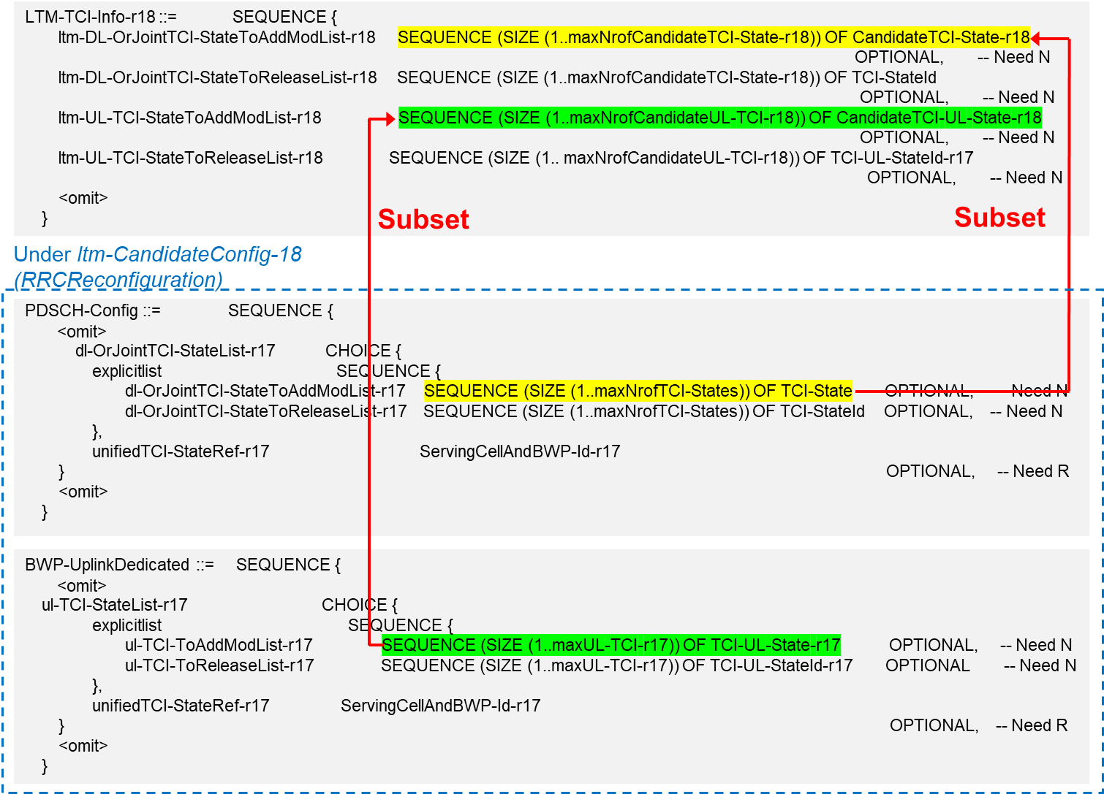

Figure : Approach 1

<Approach 2>

Introduce necessary RRC parameters for power control under LTM configurations. A default behaviour when this ul-powerControl-r18 under LTM-TCI-Info-r18 for a candidate cell is not configured will also need to be specified.

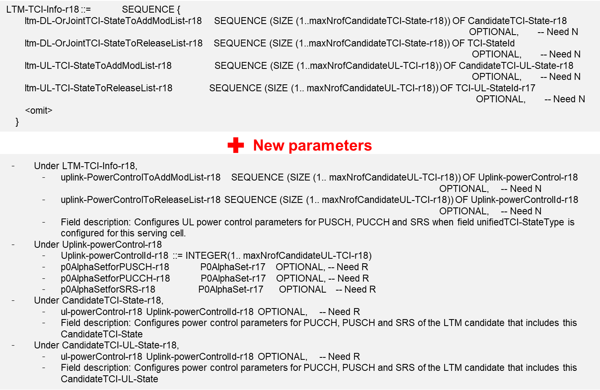

Figure : Approach 2