**3GPP TSG RAN WG 2 Meeting #126 R2-24xxxxx**

**Fukuoka, Japan, 20th - 24th May, 2024**

**Source:** Fujitsu

**Title:** Summary of [Post125bis][519][R18 Mob] Power Control Parameters after LTM cell switch (Fujitsu)

**Agenda Item:** 7.4.x

**Document for:** Discussion and decision

# 1 Introduction

This document is a summary of:

* [Post125bis][519][R18 Mob] Power Control Parameters after LTM cell switch (Fujitsu)

Scope: Collect RAN2 input in order to determine impacts and make decision as requested in R1 LS R1-2403683.

Intended outcome: Report

Intended three weeks

The rapporteur sets two phases of discussions.

* The first phase (Deadline Wednesday 8th May, 6:00UTC): discuss pros and cons of approaches/options proposed by RAN1 and which approach/option is preferable/acceptable.
* The second phase (Deadline Friday 10th May, 6:00UTC): decide which approach/option RAN2 adopts and discuss tentative text proposals.

Company contact persons for this discussion are invited to fill one entry in the table below:

|  |  |  |
| --- | --- | --- |
| Company | Name | Email Address |
| Fujitsu (rapporteur) | Takako Sanda | sanda.takako @ fujitsu.com |
|  |  |  |
|  |  |  |
|  |  |  |
|  |  |  |
|  |  |  |
|  |  |  |
|  |  |  |

# 2 Background

RAN2 receives an LS from RAN1 on the identification of the power control parameters after LTM cell switch [1]. In the LS, RAN1 points out that it is unclear how the UE would acquire the power control parameters associated with *CandidateTCI-State*/*CandidateTCI-UL-State* applied to the UL transmission after LTM cell switch till *TCI-state*/*TCI-UL-State* is indicated at the target cell. This is because power control parameters are not included under *LTM-TCI-Info-r18* in the current RRC specification [2]. To solve this issue, RAN1 proposes two approaches.

|  |
| --- |
| <Proposed approaches from RAN1>   * Approach 1   + For UL transmission after cell switch and before the serving cell TCI state is indicated, UE applies power control parameter in the *ul-powerControl-r17* of the *TCI-State* or the *TCI-UL-State*, if configured, corresponding to the *CandidateTCI-State* or the *CandidateTCI-UL-State* indicated in the LTM Cell Switch Command. Otherwise, *ul-powerControl-r17* configured in *BWP-UplinkDedicated* of the target cell is applied. * Approach 2   + Introduce necessary RRC parameters for power control under LTM configurations. |

RAN1 also provides additional proposals for each approach.

|  |
| --- |
| <If the approach 1 is taken>  It would be necessary to capture in RAN2 specifications the linkage between *CandidateTCI-State*/*CandidateTCI-UL-State* and *TCI-state*/*TCI-UL-State* for the same cell.  The linkage has been agreed in RAN1#115 as follows, but RAN1 does not capture it in their specifications:  Agreement  UE may expect that:   * For a candidate cell, the configuration of an LTM TCI state in ltm-DL-OrJointTCI-StateToAddModList-r18 and ltm-ul-TCI-ToAddModList-r18 is same as its counterpart in dl-OrJointTCI-StateList-r17 and ul-TCI-ToAddModList-r17 of the first active BWP in ServingCellConfig, at least in terms of TCI state ID, the corresponding qcl-Type1 and qcl-Type2 for the DL or joint TCI state or referenceSignal for the UL TCI state. * The LTM TCI state(s) in ltm-DL-OrJointTCI-StateToAddModList-r18 and ltm-ul-TCI-ToAddModList-r18 of a candidate cell is a subset of serving cell TCI state(s) in dl-OrJointTCI-StateList-r17 and ul-TCI-ToAddModList-r17 of the same cell. |

|  |
| --- |
| <If the approach 2 is taken>  The following parameters need to be newly added: it is noted that the final check/decision is up to RAN2.   * Under LTM-TCI-Info-r18,   + uplink-PowerControlToAddModList-r18　SEQUENCE (SIZE (1.. maxNrofCandidateUL-TCI-r18)) OF Uplink-powerControl-r18　　　OPTIONAL,　 -- Need N   + uplink-PowerControlToReleaseList-r18 SEQUENCE (SIZE (1.. maxNrofCandidateUL-TCI-r18)) OF Uplink-powerControlId-r18　　OPTIONAL,　 -- Need N   + Field description: Configures UL power control parameters for PUSCH, PUCCH and SRS when field unifiedTCI-StateType is configured for this serving cell. * Under Uplink-powerControl-r18   + Uplink-powerControlId-r18 ::= INTEGER(1.. maxNrofCandidateUL-TCI-r18)   + p0AlphaSetforPUSCH-r18　　　 P0AlphaSet-r17　OPTIONAL, -- Need R   + p0AlphaSetforPUCCH-r18　　　 P0AlphaSet-r17　OPTIONAL, -- Need R   + p0AlphaSetforSRS-r18　　　　 P0AlphaSet-r17　 OPTIONAL　-- Need R * Under CandidateTCI-State-r18,   + ul-powerControl-r18 Uplink-powerControlId-r18 OPTIONAL,　 -- Need R   + Field description: Configures power control parameters for PUCCH, PUSCH and SRS of the LTM candidate that includes this CandidateTCI-State * Under CandidateTCI-UL-State-r18,   + ul-powerControl-r18 Uplink-powerControlId-r18 OPTIONAL,　 -- Need R   + Field description: Configures power control parameters for PUCCH, PUSCH and SRS of the LTM candidate that includes this CandidateTCI-UL-State   Also, RAN1 sees the necessity to define a default behaviour when this *ul-powerControl-r18* under *LTM-TCI-Info-r18* for a candidate cell is not configured, e.g.   * UE is expected to be configured either *ul-powerControl-r18* under *LTM-TCI-Info-r18* in *LTM-Candidate-r18* for a candidate cell or *ul-powerControl-r18* under *BWP-UplinkDedicated* in *ServingCellConfig* for the candidate cell. |

Based on the approaches, RAN1 asks RAN2 to take either option.

|  |
| --- |
| <Proposed options from RAN1>  Option 1: Capture the RAN1 agreement on the linkage between TCI states for candidate cell(s) and those for target cell(s) in RAN2 specification(s) for approach 1  Option 2: Introduce the new RRC parameters above for approach 2 |

# 3 Discussion

## 3.1 Phase 1

In this phase, companies are invited to discuss pros and cons of approaches/options proposed by RAN1 and which approach/option is preferable/acceptable.

The rapporteur’s view is as follows:

- Approach 1/Option 1: Pros is simpler and less specification impact than approach 2/option 2. Cons is there may be some delay between receiving LTM cell switch command and identifying power control parameter compare with approach 2/option 2.

- Approach 2/Option 2: Pros is delay between receiving LTM cell switch command and identifying power control parameter may be smaller than approach 1/option 1. Cons is specification impact, which includes the determination of a default behaviour when this *ul-powerControl-r18* under *LTM-TCI-Info-r18* for a candidate cell is not configured, is larger than approach 1/option 1.

As a reference, images of approach 1 and approach 2 are illustrated in Figure 1 and Figure 2 in Appendix, respectively.

The rapporteur kindly asks companies to provide your opinion in the following question.

**Q1: What do you think is the pros and cons of the approach 1/option 1?**

|  |  |  |
| --- | --- | --- |
| Company | Pros | Cons |
|  |  |  |
|  |  |  |
|  |  |  |
|  |  |  |
|  |  |  |
|  |  |  |

**Q2: What do you think is the pros and cons of the approach 2/ option 2?**

|  |  |  |
| --- | --- | --- |
| Company | Pros | Cons |
|  |  |  |
|  |  |  |
|  |  |  |
|  |  |  |
|  |  |  |
|  |  |  |

**Q3: Do you propose any other approaches/options to solve the issue?**

|  |  |
| --- | --- |
| Company | Comments |
|  |  |
|  |  |
|  |  |
|  |  |
|  |  |
|  |  |

**Q4: Which approach/option (including other approaches/options) do you prefer?**

|  |  |  |
| --- | --- | --- |
| Company | Approach | Comments |
|  |  |  |
|  |  |  |
|  |  |  |
|  |  |  |
|  |  |  |
|  |  |  |

## 3.2 Phase 2

TBA

# 4 Conclusion

TBA

# 5 References

1. R1-2403683, " LS on the identification of the power control parameters after LTM cell switch"
2. TS 38.331 v18.1.0

# Appendix

Figure 1 and Figure 2 illustrate images of approach 1 and approach 2 respectively.

<Approach 1>

For UL transmission after cell switch and before the serving cell TCI state is indicated, UE applies power control parameter in the *ul-powerControl-r17* of the *TCI-State* or the *TCI-UL-State*, if configured, corresponding to the *CandidateTCI-State* or the *CandidateTCI-UL-State* indicated in the LTM Cell Switch Command. Otherwise, *ul-powerControl-r17* configured in *BWP-UplinkDedicated* of the target cell is applied. It would be necessary to capture in RAN2 specifications the linkage between *CandidateTCI-State*/*CandidateTCI-UL-State* and *TCI-state*/*TCI-UL-State* for the same cell.

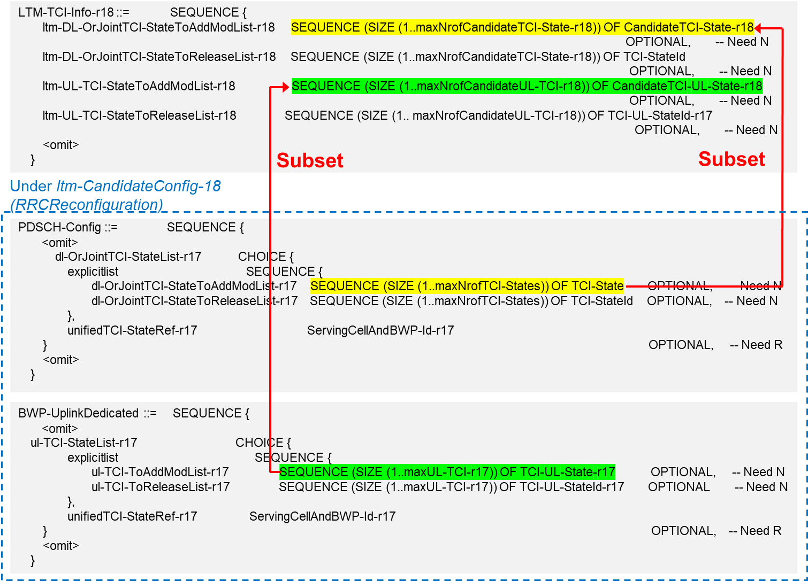

Figure : Approach 1

<Approach 2>

Introduce necessary RRC parameters for power control under LTM configurations. A default behaviour when this ul-powerControl-r18 under LTM-TCI-Info-r18 for a candidate cell is not configured will also need to be specified.

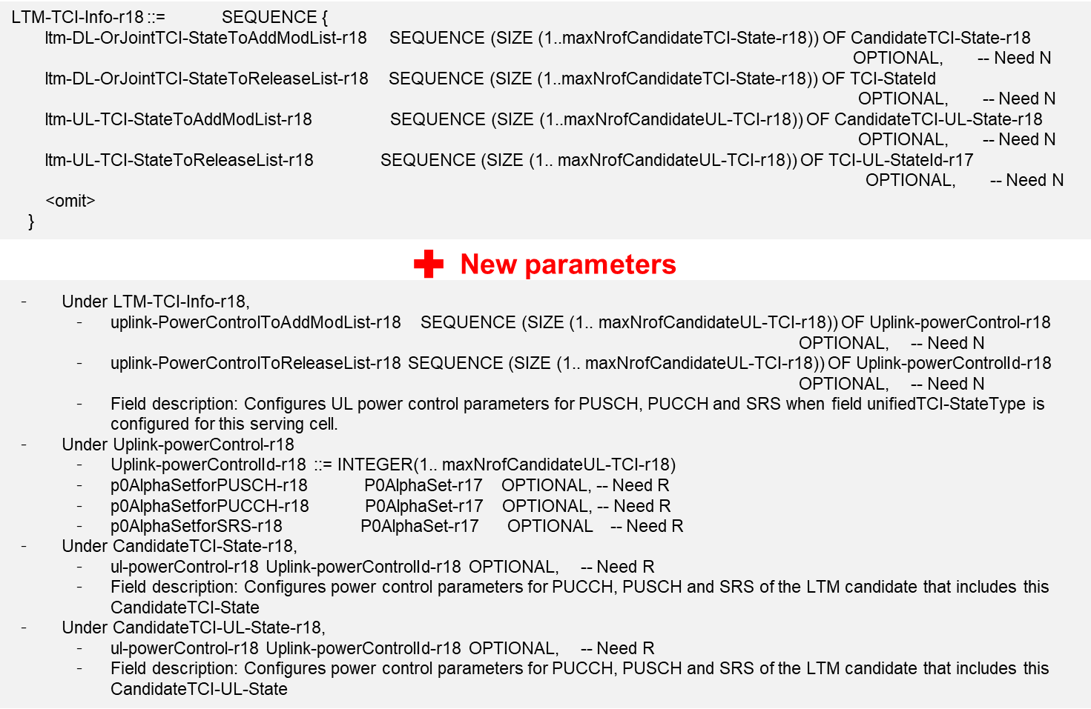

Figure : Approach 2