**3GPP TSG RAN Meeting #102 RP-232884**

**Edinburgh, Scotland, December 11-15, 2023**

**Agenda Item:**  **9.3.1.6**

**Source: ZTE**

**Title:** **Summary for NR network-controlled repeaters**

**WI code(s): NR_netcon_repeater**

**leading WG: RAN1**

**Release: Rel-18**

### 1 Introduction

To improve performance of conventional RF repeaters with the capability to receive and process side control information from the network, the Rel-17 study item 940083 “Study on NR Network-controlled Repeaters” identified the necessary enhancement with candidate solutions [1]. This work item [2] specifies the signalling and behaviour for side control information (i.e., beamforming, UL-DL TDD operation and ON-OFF information, control plane signalling and procedures, and solutions for network-controlled repeater management.

### 2 Description

### 2.1 Structure of Network-controlled repeater

The network-controlled repeater comprises a NCR-MT and a NCR-Fwd as depicted in Figure 2.1-1.

The NCR-MT is an entity with partial UE functionality and to communicate with the gNB (e.g., receiving the side control information, SCI) via control link based on the NR Uu interface. A list of allowed gNB cell(s) or forbidded gNB cell(s) may be configured to NCR-MT. According to the received side control information from gNB, The NCR-Fwd is to perform the amplifying-and-forwarding of signals between gNB and UE via the backhaul link and access link, respectively.

In addition, as the in-band repeater, only the NCR-Fwd’s operation on signals associated to the cell that the NCR-MT is connected is intended to be controlled by gNB via the SCI.

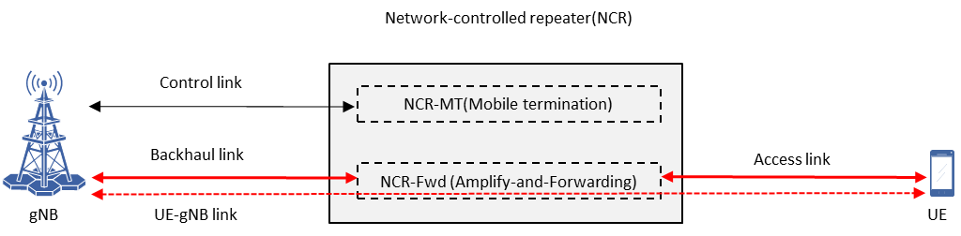

Figure 2.1-1: Conceptual model of network-controlled repeater.

### 2.2 Side control information indication

**For DL-UL TDD information:**

The DL-UL configuration of the NCR-Fwd follows the DL-UL configuration (i.e., DL or UL slots/symbols determined by *tdd-UL-DL-ConfigurationCommon* or *tdd-UL-DL-ConfigurationDedicated,* if configured) of control link of NCR-MT. For the timing determination of backhaul link, the NCR-Fwd’s backhaul link DL/UL timing follows the NCR-MT’s DL/UL frame timing

**For beam indication:**

For the access link, the beam used by the NCR-Fwd is represented by the “beam Index” in the received signalling in either periodic, semi-persistent or aperiodic way. The time resource when the associated beam is applied is indicated together with the beam information. For the periodic beam indication, this information is configured by RRC signalling. Additional MAC CE signalling is used to indicate the information based on the received RRC signalling for semi-persistent beam indication. For aperiodic indication, the DCI format 2-8 is used to indicate beam index directly with the associated time resource, which is based on the RRC configuration. In addition, the details (e.g., characteristics) of physical beam(s) may be provided by OAM to the gNB and the NCR for operation.

For the backhaul link, the beam is determined by the specified rules unless the dedicated beam configuration (i.e., MAC CE) is indicated.

**For ON-OFF information:**

The “ON-OFF” information is implicitly determined by received beam indication. The NCR-Fwd is assumed in “ON” state, i.e., performing the amplifying-and-forwarding in access link and backhaul link, only over the time resources when the corresponding beam information is received by the NCR-MT. In addition, the NCR-Fwd is assumed in “OFF” state if specific conditions (e.g., beam failure or RLF on the control link occurs) are satisfied.

### 2.3 Repeater management

For the repeater management, the NCR identification and authorization are supported.

NCR identification is performed in RAN by sending the NCR indication information to the serving gNB. The AMF (e.g., selected by gNB) provides NCR authorization information to the gNB.

### 3 References

[1] TR 38.867 Study on NR network-controlled repeaters (Rel-18).

[2] RP-232886 WI on NR network-controlled repeaters

[3] RP-232854 Status report of WI NR network-controlled repeaters

[4] RP-232479 Introduction of Rel-18 - NR Network-controlled Repeaters (RAN1 CRs), RAN#101

[5] RP-23xxxx Introduction of Rel-18 - NR Network-controlled Repeaters (RAN2 CRs), RAN#102

[6] RP-23xxxx Introduction of Rel-18 - NR Network-controlled Repeaters (RAN3 CRs), RAN#102

[6] RP-23xxxx Introduction of Rel-18 - NR Network-controlled Repeaters (RAN4 CRs), RAN#102