3GPP TSG-RAN WG2 Meeting #125 R2-240xxxx

Athens, Greece, 26 February – 01 March 2024

**Agenda item: 7.4.5**

**Source: Nokia, Nokia Shanghai Bell**

**Title: Rel-19 Mobility Enhancements**

**WID/SID: NR_Mob_enh2-Core - Release 18**

**Document for: Discussion**

# 1 Introduction

We have email discussion assigned to RAN2:

* [Post124][560][feMob] (Nokia)

Scope: Conditional to TSG RAN decision, On objective 7.

Intended outcome: Agreeable LS out to R4, report

Deadline: Long

The work for further enhanced mobility WI [1] did progress as planned in RAN WGs apart from the following goal which is further discussed in this contribution:

|  |
| --- |
| ***NR Mob_enh2 Objective 7.***  *To study and specify how to reuse the IDLE/INACTIVE mode measurement results which are to be reported during and/or after RRC connection setup/resume in order to improve SCell/SCG setup delay [RAN4, RAN2], including:*   * + *Availability and validation of the IDLE/INACTIVE mode measurement results to be reported [RAN4]; and*   + *Definition of corresponding RRM requirements [RAN4]; and*   + *If necessary based on RAN4 outcome, definition of corresponding signalling support [RAN2].*     *Note 6~~5~~: RAN4 will coordinate in due course with RAN2 to start the work.*  *Note 7~~6~~: R4-2220415 serves as baseline for future work in RAN4*  *Note 8~~7~~: With exception of the above scenarios, enhancements on IDLE/INACTIVE mode measurements and on UE behavior in IDLE/INACTIVE mode are not in scope.* |

In the last Ran2 meeting in Chicago, unfortunately, RAN2 did not have sufficient information to progress on CRs and these are the notes from the meeting:

[R2-2313662](https://www.3gpp.org/ftp/tsg_ran/WG2_RL2/TSGR2_124/Docs/R2-2313662.zip) Report of [AT124][501][feMob] eEMR SCell setup delay (Nokia) Nokia

DISCUSSION

3.1

- Chair: it seems that X is mandatory for R18 behaviour, in discussions early in the week the feature was described as R16 EMR + validation.

- Nokia think this is not the case, think that R18 has two parts a) validation with X and b) continuing the measuremements longer.

- HW think X is mandatory for R18 behaviour. Apple agrees.

- Chair: It seems RAN2 cannot converge on the main character on the feature also for the “enhanced measurements”, Ericsson still think we can have a CR discussion. Can anyway attempt progess

3.2

- Nokia think that RAN4 has decided to not apply T331, i.e. UE would do measurements only based on dedicated config and not stop doing these.

- MTK think RAN4 never discuss T331, we should apply this as for R16 EMR. QC agrees with MTK. Apple agrees.

- Chair: also for this aspect, difference of opinions in RAN2

* If timer X is not configured the validation is not applied
* Conclusion: RAN2 cannot conclude the eEMR “enhanced measurements” either at current meeting, too many open points, (and late info from RAN4)

Way FORWARD

- Nokia proposes an email discussion to formulate questions to RAN4 on “enhanced measurements”, and the action on the LS would be conditional to plenary decision to extend.

- Ericsson agree to have email discussion.

- LGE think we should not have email discussion now but are ok to start one if TSG RAN agrees.

* Long email discussion starting after plenary conditional on extension, LS out to RAN4 on eEMR “enhanced measurements”

After RAN2 agreements, RAN4 made further agreements regarding on *release 18 existing measurements as* well as *release 18 enhanced measurements* but regardless RAN plenary agreed the following:

**RP-233968** **Result of offline discussion on Rel-18 Mobility enhancement extension**

related to RP-233252

Proposal 1: RP to approve the exception sheet in RP-233969. (1Q extension for mobility objective#7)

Proposal 2: RP to approve the revised WID in RP-233970. (No change on objective #7 but update the impacted

SPEC list).

Proposal 3: RP to approve the CR in RP-233971 to replace the 38.133 CR R4-2321641 (CR#3952) in RP-233362.

Proposal 4: RP to task RAN2/RAN4 to complete the R18 mobility WI objective#7 in 2024/Q1, focus on solution

based on existing measurement, as below:

• RAN2 to define time-based measurement result validation configuration based on RAN4 agreements.

• RAN2 signaling to enable reporting of cell reselection measurement or EMR for fast CA/DC setup.

• NOTE 1: RAN4 shall not work on any new requirements for this functionality in Rel-18. Only essential corrections

are allowed.

• NOTE 2: If RAN2 is not able to complete the work, the functionality will be removed from Rel-18.

• NOTE 3: Existing measurement means that no additional measurement is performed during RRC Setup/Resume

procedure.

RAN2 chair: NOTE 2: should say "to complete by Q1/24"

conclusion: proposal 4 is endorsed with the deadline Q1/24

**Observation 1:** RAN2 needs to define time-based measurement result validation configuration based on RAN4 agreements.

Corresponding exception sheet is in RP-233969 with following essential part:

|  |  |
| --- | --- |
| **Expected Completion Date:** | RAN#103 / March 2024 |
| **Service(s) impacted:** | NR Mobility |
| **Specification(s) affected:** | TS 38.331 (RAN2) |
| **Task(s) within work which are not complete:** | WI objective#7, focus on solution based on existing measurement, as below:   * RAN2 to define time-based measurement result validation configuration based on RAN4 agreements. * RAN2 signaling to enable reporting of cell reselection measurement or EMR for fast CA/DC setup. * NOTE 1: RAN4 shall not work on any new requirements for this functionality in Rel-18. Only essential corrections are allowed. * NOTE 2: If RAN2 is not able to complete the work, the functionality will be removed from Rel-18. * NOTE 3: Existing measurement means that no additional measurement is performed during RRC Setup/Resume procedure. |
| **Consequences if not included in Release 18:** | Essential functionality and signalling for SCell/SCG setup delay improvement are not supported. |

# 2 Contact Points

Respondents to the email discussion are kindly asked to fill in the following table.

|  |  |  |
| --- | --- | --- |
| Company | Name | Email Address |
| Nokia (Rapporteur) | Jarkko Koskela | Jarkko.t.koskela@nokia.com |
| MediaTek | Felix Tsai | Chun-Fan.tsai@mediatek.com |
| Ericsson | Cecilia Eklöf | cecilia.eklof@ericsson.com |
|  |  |  |
|  |  |  |
|  |  |  |
|  |  |  |
|  |  |  |
|  |  |  |
|  |  |  |
|  |  |  |
|  |  |  |
|  |  |  |

# 3 Discussion

## 3.1 RAN4 Status

RAN4 provided LS R2-2313883 on this issue with following information:

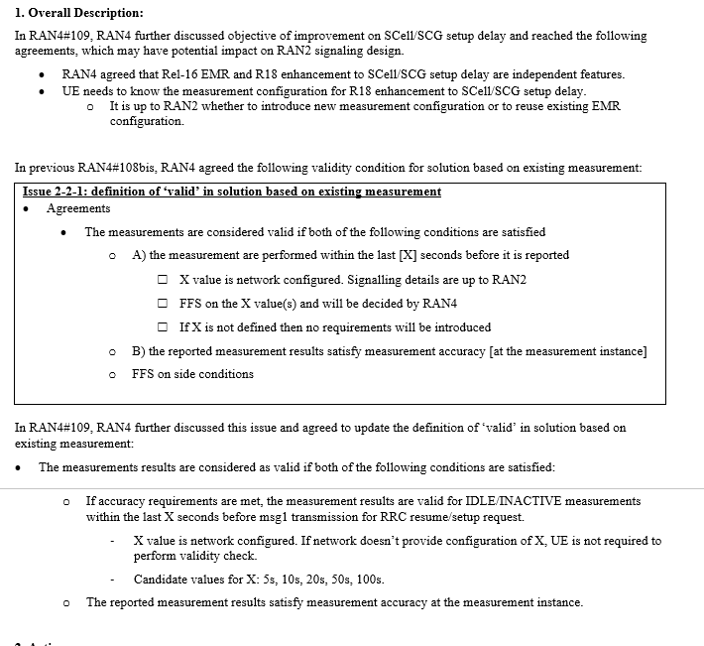

RAN4 has completed the core-part and will work next on performance requirements as described in the TU allocation. Corresponding full RAN4 bigCR agreed in plenary is: [RP-233971](https://www.3gpp.org/ftp/TSG_RAN/TSG_RAN/TSGR_102/Docs/RP-233971.zip).

**eEMR**

In order to clarify the RAN4 aspects to RAN2, we explain the underlying assumptions of the RAN4 feature for existing measurements solution: Assumption of the reported measurements is that UE does not perform new measurements starting from, and during RRCSetup/Resume procedure and while in CONNECTED mode. Time-based validation criteria is used.

Furthermore it seems that the solution should also work without a dependency to Rel-16 EMR for the UEs that do not support Rel-16 EMR. This is also seen in the RAN4 CR ([RP-233971](https://www.3gpp.org/ftp/TSG_RAN/TSG_RAN/TSGR_102/Docs/RP-233971.zip)):

[For a UE which supports [solution based on existing measurement] but not *idleInactiveNR-MeasReport-r16* or *idleInactiveEUTRA-MeasReport-r16* the UE shall support the idle mode CA measurements on the serving cell, and carriers configured for idle mode CA/DC measurement and meet corresponding measurement requirements defined in clause 4.2.2.The UE physical layer shall be capable of reporting SS-RSRP and SS-RSRQ measurements of the carriers configured to higher layers, with measurement accuracy as specified in clauses 10.1.4B and 10.1.5B and 10.1.9B and 10.1.10B, respectively]

This is also explicitly captured in the R4-2321398 (way forward document):

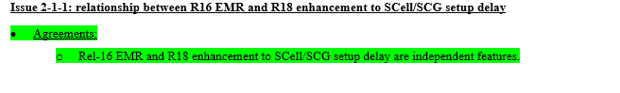

**Observation 1:** Configuration for Rel-18 features eEMR with time based validation should work independently, but also together with Rel-16 EMR.

Timer value X in the [RP-233971](https://www.3gpp.org/ftp/TSG_RAN/TSG_RAN/TSGR_102/Docs/RP-233971.zip) is not yet settled thus we need to get that information from RAN4 before we can finalize that part:

**Observation 2:** RAN4 has selected 5s, 10s, 20s, 50s, 100s as current candidate values.

RAN4 has agreed the following in RAN4#104-e, and the agreement was reflected later in the WID as a note.

|  |
| --- |
| **<** **RAN4#104-e Agreement>:**  Enhancements on UE behavior in IDLE/INACTIVE mode are not in the scope   * The following aspects can be further studied * Using measurement results obtained during IDLE/INACTIVE mode for measurements during RRC connection procedure   + Note: enhancements on IDLE/INACTIVE mode measurement are not in the scope |

**Observation 3:** According to WID and RAN4 in RAN4#104-e agreement, enhancements on UE behavior in IDLE/INACTIVE mode are not in the scope

Then regarding the validation timer configuration:

|  |
| --- |
| * Agreements   + The measurements are considered valid if both of the following conditions are satisfied     - A) the measurement are performed within the last [X] seconds before it is reported       * X value is network configured. Signalling details are up to RAN2       * FFS on the X value(s) and will be decided by RAN4       * If X is not defined then no requirements will be introduced     - B) the reported measurement results satisfy measurement accuracy [at the measurement instance]     - FFS on side conditions   In RAN4#109, Following was agreed:   * The measurements results are considered as valid if both of the following conditions are satisfied:   + If accuracy requirements are met, the measurement results are valid for IDLE/INACTIVE measurements within the last X seconds before msg1 transmission for RRC resume/setup request.     - X value is network configured. If network doesn’t provide configuration of X, UE is not required to perform validity check.     - Candidate values for X: 5s, 10s, 20s, 50s, 100s.   + The reported measurement results satisfy measurement accuracy at the measurement instance. |

The configuration of rel-18 eEMR needs to also consider the scenario where X is not configured but UE is able to still report measurements.

**Observation 5:** According to RAN4 agreements, X value can be left as not configured, but UE shall still be able to report measurement results

Regarding UE capabilities for this feature there is way forward in RAN4 as can be seen in the R4-2321398 but not final decisions have been made yet:

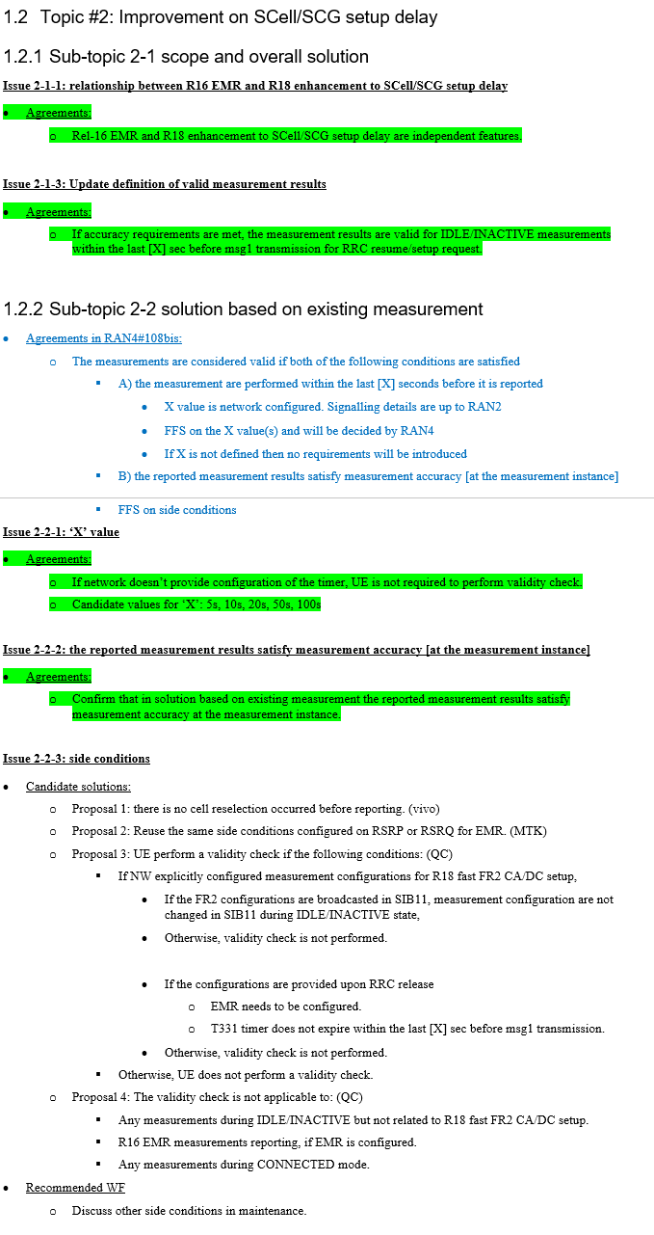

Alhtough rapporteur would not expect any critical impact from RAN4 apart from corresponding ASN.1 changes needed to capture features/capabilities.

**Observation 6:** RAN2 needs to get final UE capabilities/features to finalize CRs

# 3 Discussion on the LS to RAN4

Based on current RAN4 status on existing measurement it seems RAN2 can work on CRs by ensuring R18 eEMR solution is independent from R16 EMR solution. In practice this would mean that we need to be able to configure R18 EMR (i.e. timer based validation) without R16 EMR. Likely it is simplest to have separate procedural text for R18 EMR in order to avoid complex interactions but those details are not part of this email discussion and we leave this up to companies to contribute for next meeting.

Would there be some aspects that need clarifications from RAN4 how to make CRs? Possibly following clarifications are needed:

1. It seemed that one should be able to configure R18 existing measurements (e.g. validation timer) without R16 EMR. But do we need to be able to configure validation timer for R16 EMR reporting as well or just for R18 existing measurements solution?
2. And do we need to be able to report R18 existing measurement results separately from R16 EMR results i.e. NW can configure both measurements (R16 EMR and R18 existing measurements) same time and UE can report both?

It seemed Ran4 discussion did not really limit any combinations thus it might be that we need to support all the combinations?

**Question 1**: What aspects we need to clarify with RAN4 in order to finalize CRs in RAN2?

|  |  |  |
| --- | --- | --- |
| Answers to Question 1 | | |
| Company | Yes/No | Technical Arguments |
| MediaTek |  | In general, we think that the feature becomes clearer after RP discussion. So, if RAN2 could have good consensus, it seems no need to send LS to RAN4.  Based on the exception sheet in RP-233969, it is our understanding that we are going to have two eEMR features introduced for this objective:   * Feature 1 – R16 EMR + Validation timer * Feature 2 – Reporting of cell reselection measurement + Validation timer   Release 18 eEMR could work without R16 EMR (Feature 2) or could work together with R16 EMR (Feature 1). We think this align with RAN4 agreement and O1 below from rapporteur.   * Observation 1: Configuration for Rel-18 features eEMR with time based validation should work independently, but also together with Rel-16 EMR.   For potential clarifications point 1, we understand validation timer could be configured for R16 EMR (Feature 1).  For potential clarifications point 2, we don’t see the need to report R16 EMR result together with R18 eEMR. Feature 1 is basically changing the R16 EMR reporting criteria, it makes no sense to report (non-validated) R16 EMR result in this case. Feature 2 is for UE that does NOT support R16 EMR so it could only report cell reselection targets. If EMR is supported, NW has flexibility to configure the candidate to be the same as cell reselection target or not. So, it is not necessary to configure Feature 1 and Feature 2 together.  The detail signaling for Feature 1 and Feature 2 could be discussed based on contributions. We expect RAN2 to make decision directly in the coming meeting without waiting the replied LS from RAN4. |
| Ericsson |  | We agree with MediaTek’s summary and think we should proceed accordingly. We don’t think an LS to RAN4 is needed. |
| Xiaomi |  | Agree with MediaTek. And the LS to RAN4 may not be needed.  For the combination of Rel-16 EMR and Rel-18 eEMR, we think if Rel-16 EMR is supported, the network can configured the Feature 1 ( R16 EMR + Validation timer ), else the network can configured the Feature 2 (Reporting of cell reselection measurement + Validation timer) for Rel-18 eEMR. And, we also don’t think it is necessary to report Rel-16 EMR (without validation) and Feature 1 (R16 EMR with validation) simultaneously and to configure Feature 1 and Feature 2 together. |
|  |  |  |
|  |  |  |
|  |  |  |
|  |  |  |
|  |  |  |
|  |  |  |
|  |  |  |
|  |  |  |
|  |  |  |
|  |  |  |

Then there are couple observations that need to be ensured that RAN4 makes agreements so that RAN2 can conclude CRs (as discussed in previous section:

**Observation 7:** We need to ensure with RAN4 that they provide final value range for the timer X (candidate values of 5s, 10s, 20s, 50s, 100s)

**Observation 8:** RAN2 needs to get final UE capabilities/features to finalize CRs

**Question 2**: Do you agree that we need to get responses to observations 7 and 8 from RAN4 and also reminded in the LS?

|  |  |  |
| --- | --- | --- |
| Answers to Question 2 | | |
| Company | Yes/No | Technical Arguments |
| MediaTek |  | We agree that RAN4 should provide configuration of the value for timer X and the feature table.  However, for feature table, R4 is already discussing this and no need R2 LS to trigger. For timer X, R4 already told us candidate values are {5s, 10s, 20s, 50s, 100s}, and we could have ASN.1 configuration based on this conclusion. Not sure what addition is needed. It could be an enum structure and NW just configure one of the candidate values to the UE. |
| Xiaomi |  | For RAN4 features, we can wait RAN4’s progress. And for the timer X, candidate values can be considered for the ASN.1 design. |
|  |  |  |
|  |  |  |
|  |  |  |
|  |  |  |
|  |  |  |
|  |  |  |
|  |  |  |
|  |  |  |
|  |  |  |
|  |  |  |
|  |  |  |

**Proposal 1:** Agree to send LS to RAN4 based on provided draft in the Annex (TO BE UPDATED ONCE WE GET UNDERSTANDING WHAT WE WANT TO CLARIFY – see above questions)

# References

1. RP-223520 Rel. 18 Further NR mobility enhancements Work Item Description

# LS DRAFT TO RAN4

**3GPP TSG-RAN WG2 Meeting #125 R2-240xxxx**

**Athens, Greece, 26 February – 01 March 2024**

**Title: [DRAFT]** LS on existing measurement solutions for eEMR

**Response to:** -

**Release:** Release 18

**Work Item:** NR_Mob_enh2-Core

**Source:** Nokia [TSG RAN WG2]

**To:** TSG RAN WG4

**Cc:**

**Contact Person:**

**Name:** Jarkko Koskela

**E-mail Address:** jarkko.t.koskela@nokia.com

**Send any reply LS to: 3GPP Liaisons Coordinator,** [**mailto:3GPPLiaison@etsi.org**](mailto:3GPPLiaison@etsi.org)

**Attachments:** -

**1. Overall Description:**

RAN plenary instructed RAN WGs to complete CRs by RAN#103 (March 2023) for existing measurement solution. RAN2 is working on CRs and would like to get some clarifications and finalization of parameters to ensure CRs can be made in time.

RAN2 understands that one needs to be able to configure R18 EMR (time based validation) without R16 EMR based on RAN4 agreements. RAN2 will work with this assumption.

Then RAN2 would like to highlight that we need to get also final value range for timer X (validation timer) as well as any capabilities for the feature in order to make corresponding capability CRs.

**2. Actions:**

**To RAN4 group.**

**ACTION:** RAN2 respectfully asks RAN4 to provide responses well before end of RAN2#125 in order for RAN4 to finalize CRs as instructed by RAN

**3. Date of Next TSG-RAN WG2 Meeting:**

RAN2#125bis from 2024-04-15 to 2024-04-19 China, CN

RAN2#126 from 2024-05-20 to 2024-05-24 Fukuoka, Japan