3GPP TSG-RAN WG2 Meeting #124 R2-23xxxxx
Chicago, IL, US, November 13 – 17, 2023

Agenda item: 7.2.1
Source: Qualcomm Incorporated
Title: Summary of [Post124][413][POS] Rel-18 positioning 38.305 CR (Qualcomm)
Document for: Discussion and Decision

1. Introduction
This document summarizes the following email discussion:
- [Post124][413][POS] Rel-18 positioning 38.305 CR (Qualcomm)
Scope: Finalise and check the Rel-18 positioning 38.305 CR.
Intended outcome: Agreed CR
Deadline: Short (for RP)

The Stage 2 from RAN2#124 (R2-2312786) has been updated (version _v07; changes were made as Word User "_v07"):
- Alignments with latest Stage 3 CRs:
- Addition of sections 8.12.3.1.2.1a and 8.12.3.1.2.2a
- Additions of sections 8.15 (and sub-sections)

2. Comments on _v07 of the running CR
Companies are invited to provide their comments on the current version (_v07) of the 38.305 CR in the table below.
Company | Section (in _v07) | Comments | Rapporteur Comments
CEWiT | 7.12 | Since multiple UE roles are agreed to be indicated in the discovery metafield, the SL server UE discovery and selection can be performed in step 2 itself if UE1 does not support SL Server UE functionality.  The following figure shall be considered.  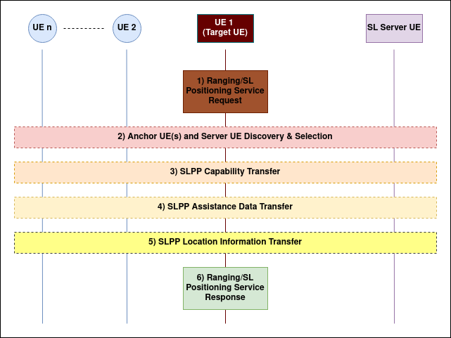

3. Summary of Open Issues
 | Section | Issue | Way Forward
1 | 7.3 Service Layer Support using combined LPP and NRPPa Procedures | Editor's Note: FFS whether the below sections require updates for sidelink positioning .Will be updated later, depended on SA2 progress. | Furter updates will be handled in the maintenace phase and/or company contributions, dependent on SA2 progress.
2 | 7.3A Service Layer Support for Sidelink Positioning | Editor's Note: The below sub-clauses may need further alignment/confirmation with e.g., SA2 23.273. | Furter updates will be handled in the maintenace phase and/or company contributions, dependent on SA2 progress.
3 | 7.12 General UE-only sidelink positioning and ranging procedure | Editor's Note: The above is a transcript of clause 6.8 in TS 23.586. However, there may be some concerns with this general procedure (as discussed in multiple contributions to previous RAN2 meetings), e.g., with steps 2 or 3 which probably should include also the SL Server UE, etc. Therefore, the above is FFS. | Furter updates will be handled in the maintenace phase and/or company contributions, dependent on SA2 progress.
4 | 8.10.3.1.3.1  8.12.3.1.3.1 | Editor's Note: FFS which Multi-RTT measurements are performed within the time windows.  Editor's Note: FFS which DL-TDOA measurements are performed within the time windows. | Will be updated later, based on LPP progress.
5 | 8.15 SL positioning and ranging | TBD | Furter updates will be handled in the maintenance phase and/or company contributions.

