3GPP TSG-RAN WG2 Meeting #123bis R2-231xxxx
2023 Xiamen, China, October 9th – 13th, 2023

Agenda Item: 7.25.1
Source: Apple
Title: Open issues for SCell FR2 Enhancement (Apple)
Document for: Discussion and Decision

Introduction
On RAN4 WI of FR2 unknown SCell activation enhancement, RAN2 made the following agreement in RAN2#123bis meeting, but how to capture it in spec is still FFS.
RAN2#123bis Agreements:
1. If the network activates multiple SCells within same MAC CE the UE may send only one measurement report.

This document is to collect company’s view on the spec work. If consensus can be reached, the proposals can be reflected in the running CR directly.
- [POST123bis][020][SCell Activation] Running CR (Apple)
Intended outcome: Review running CR to be endorsed in meeting
Deadline: Long

Please provide your comments before October 27th 0100 UTC.

Contact Points
Rapporteur encourages the participating delegates to provide their contact information in this table.
Company | Name | Email Address
Huawei, HiSilicon | Rui Wang | wangrui46@huawei.com
Xiaomi | Shukun Wang | Wangshukun3@xiaomi.com
CATT | Tangxun | tangxun@catt.cn
Ericsson | Tony | antonino.orsino@ericsson.com
ZTE | Xiaohui Song | song.xiaohui@zte.com.cn
Qualcomm | Punyaslok Purkayastha | punyaslo@qti.qualcomm.com

Discussion

Measurement configuration
Whether the measurement configuration is per CG or per SCell is still FFS.
Editor Note 1: FFS on whether the reporting configuration with the reportType set to reportOnScellActivation is associated with a CG or a SCell (servingCellMO).

Two options may have different spec impact especially in the case of multiple SCell activation in one MAC CE.

Option 1: Measurement configuration is per SCell
- Configuration
    - Understanding
One measurement ID is associated with one report config and one serving MO.
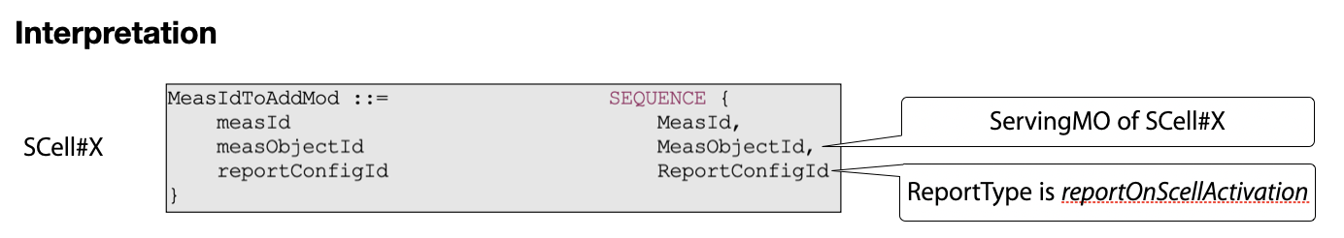
    - Spec impact
There is no impact on the current signalling in running CR.
- Reporting
    - Understanding
When multiple SCells are activated by one MAC CE, it’s possible that multiple measurement reports will be triggered according to current description in running CR.
Therefore, we should clarify in spec that only one measurement report may be transmitted if multiple report can be initiated by one MAC CE, and which measurement report to be sent can be up to UE implementation.
    - Spec impact
One NOTE is added to clarify that only one measurement report can be transmitted by one SCell activation MAC CE. The TP is provided based on the draft CR being reviewed.

5.5.4 Measurement report triggering

5.5.4.1 General
……
If AS security has been activated successfully and if an indication is received by lower layer that an SCell is activated by a MAC CE, the UE shall:
1> for each measId included in the measIdList within VarMeasConfig:
2> if reportType is set to reportOnActivation:
3> if the activated SCell fulfills the measurement requirements as specified in TS 38.133 [14]:
4> include a measurement reporting entry within the VarMeasReportList for this measId;
4> set the numberOfReportsSent defined within the VarMeasReportList for this measId to 0;
5> initiate the measurement reporting procedure, as specified in 5.5.5.
NOTE: If multiple measurement reports may be initiated by one SCell activation MAC CE, only one measurement report is allowed to be transmitted.

Question 1a: For Option 1 (per SCell config), do you agree with understanding and the corresponding spec impact analysis on configuration part?
Configuration:
- Understanding: one measurement ID is associated with one report config and one serving MO;
- Spec impact analysis: no impact on the current signalling in running CR.

Company | Understanding | Spec impact | Comments
Huawei, HiSilicon | Agree | Agree | The existing signaling can already indicate which Scell can trigger the measurement report upon Scell activation by associate the MO of the serving cell and the new report type.
Xiaomi | Agree | Agree
Nokia | Not agree | Agree | Assuming there is only one indication from lower layers per MAC CE then there is no way to trigger more than one report? Thus likely nothing needed?
CATT | Agree | Agree
Ericsson | Agree | Agree
ZTE | Agree | Agree
Qualcomm | Agree | Agree, please see comments | We think that the multiple SCell activation case needs to be considered as, e.g., below:  “If AS security has been activated successfully and if an indication is received from lower layer that at least one SCell is activated by a MAC CE, the UE shall, for each of the activated SCells:  - for each measId included in the measIdList …”.  [Rapp] If we go for option1, the proposed change is clear and should be considered in the CR.  We think that the following clause should be removed from the running CR: “if the activated SCell fulfills the measurement requirements as specified in TS 38.133 [14]”.  These requirements are the usual requirements for measurement reporting, and since we do not have such a clause in the spec for legacy measurement reporting, e.g., for event-triggered measurement reporting, there is no need for such a clause here.  [Rapp] RAN4 has agreed in their WF (R4-2314446) to introduce a new section to capture the requirement for this enhancement. So it should be no issue if we refer to RAN4 spec, and current wording on this part should be ok.  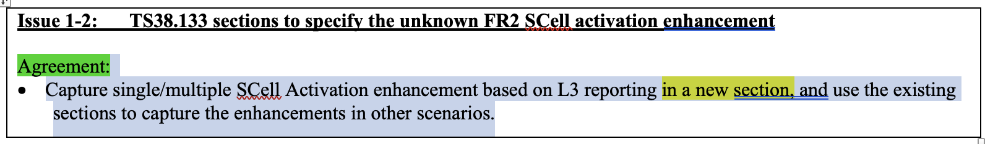
Apple | Agree | Agree

Question 1b: For Option 1 (per SCell config), do you agree with understanding and the corresponding spec impact analysis on reporting part?
Reporting:
- Understanding: Only one measurement report may be transmitted if multiple report can be triggered by one MAC CE, and which measurement config is used to trigger can be up to UE implementation.
- Spec impact analysis: add a NOTE as above TP for section 5.5.4.1.
NOTE: If multiple measurement reports may be initiated by one SCell activation MAC CE, only one measurement report is allowed to be transmitted.

Company | Understanding | Spec impact | Comments
Huawei, HiSilicon | Agree | Agree | We are ok to capture the UE behaviour (when a MAC CE actives multiple Scell configured with the new reportType, the UE can report only one measurement report) in a NOTE or in normative text.
Xiaomi | Agree | Agree
Nokia | Agree | Not Agree | Not sure why we need a NOTE for this. Assuming there is only one indication from lower layers per MAC CE then there is no way to trigger more than one report? Thus likely nothing needed?
CATT | Agree | Not agree | A Note is not sufficient, specified UE behaviour is better. When a Scell activation MAC CE includes multiple Scells, UE only reports one measurement report which includes measurement results of all activated Scells.
Ericsson | Agree | Not agree | We are not sure why something is needed. Wouldn’t be enought to leave this to the NW and UE implementation.  One possible network implementation can configure this indication only for one measID while a possible UE implementation may send only one measurement report, even if multiple SCells are activated at the same time.  I think we should not restrict neither the network nor the UE behaviour in this case.
ZTE | Not Agree | Not Agree | It is not enough to only have a note.  If the configuration is per SCell, multiple measurement identities may be triggered at the same time. In this case, in order to enable that only one measurement report is sent, the specific UE behaviors need to be captured in the specification.
Qualcomm | Agree, please see comments | Please see comments | Part of the statement in the “Understanding” has been already agreed in RAN2 #123-bis, i.e., that the UE may transmit only one measurement report even if multiple SCells are activated by the MAC CE. For transmission of only one measurement report, whether it can be done by UE implementation or by a mechanism defined by the spec seems to be an open question.  There does not seem to be any need for the Note.
Apple | Agree | Agree | About the NOTE, it can be also captured in the chairman notes.

[Summary of Option 1]
For option 1 (measurement configuration per SCell), based on rapporteur’s understanding of the comments from companies, rapporteur understands that we can agree with the following understandings:
- Configuration: One measurement ID is associated with one report config and one serving MO, and current spec description is fine;
- Reporting: Only one measurement report may be transmitted if multiple report can be triggered by one MAC CE, and which measurement config is used to trigger can be up to UE implementation (FFS whether to capture the UE implementation in spec).

Option 2: Measurement configuration is per CG
- Configuration
    - Understanding
<Measurement object>
One measurement ID is associated with one report config and not associated with any MO. UE ignores the measurement object.
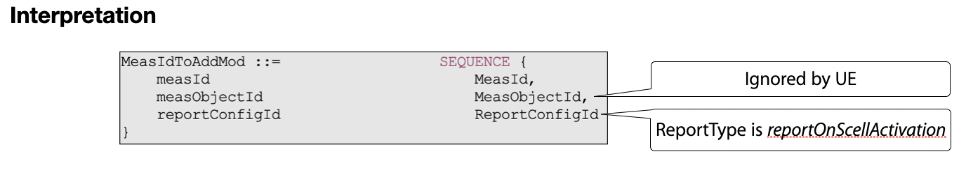
Understanding 1: UE ignores the measurement object in the CG specific measurement configuration.
<Trigger SCell list>
Amongst the multiple SCells in a CG, UE may not support the measurement report on all SCells of the CG, and network may just want to enable it on some specific SCell(s). In order for network to indicate which SCell(s) the new report is applicable for, we need to consider introducing a triggering SCell list in measurement report configuration for such control.
Without the configuration of triggering SCell list, UE has to check all the newly activated SCells based on its capability which will increase the UE burden.
Understanding 2: For SCell level control, new triggering SCell list should be introduced in CG specific measurement configuration.
    - Spec impact
Case a) With SCell level control, new triggering SCell list will be introduced under the report configuration, and the TP is as below.
ReportOnScellActivation-r18 ::= SEQUENCE {
rsType NR-RS-Type,
reportQuantityRS-Indexes MeasReportQuantity,
maxNrofRS-IndexesToReport INTEGER (1..maxNrofIndexesToReport),
includeBeamMeasurements BOOLEAN,
triggeringSCellList SEQUENCE (SIZE (1..maxNrofSCells)) OF SCellIndex OPTIONAL -- Need R
}
Case b) Without SCell level control, there is no further spec impact.

- Reporting
    - Understanding
When multiple SCells are activated by one MAC CE, only one measurement report will be triggered and transmitted according to current description in running CR.
Case a) With SCell level control, UE only triggers the new measurement report when the newly activated SCell is in the trigger SCell list.
Case b) Without SCell level control, UE triggers the new measurement report on all newly activated SCell by each SCell activation MAC CE.
    - Spec impact
Case a) With SCell level control, the TP is provided below based on the draft CR being reviewed.

5.5.4 Measurement report triggering

5.5.4.1 General
……
If AS security has been activated successfully and if an indication is received by lower layer that an SCell is activated by a MAC CE, the UE shall:
1> for each measId included in the measIdList within VarMeasConfig:
2> if reportType is set to reportOnActivation:
3> if the activated SCell is in the triggeringSCellList and fulfills the measurement requirements as specified in TS 38.133 [14]:
4> include a measurement reporting entry within the VarMeasReportList for this measId;
4> set the numberOfReportsSent defined within the VarMeasReportList for this measId to 0;
5> initiate the measurement reporting procedure, as specified in 5.5.5.
Case b) Without SCell level control, there is no spec impact.

Question 2a: For Option 2 (per CG config), do you agree with the following understanding 1 and the corresponding spec impact analysis on configuration part?
Configuration:
- Understanding 1: UE ignores the measurement object in the CG specific measurement configuration.
- Spec impact analysis: no impact on the current signalling in running CR.

Company | Understanding 1 | Spec impact analysis | Comments
Huawei, HiSilicon | Agree | See comments | We understand the intention is to say reusing the existing MeasIdToAddMod can avoid further asn.1 change, apart from the potential change to reportCOnfig, e.g. Scell list, which we agree, but the UE behaviour of how to ignore the measurement object for the measID associated with the new report type should be clearly captured in the spec.
Xiaomi |  |  | I can understanded the intention.  I think we can define a new object as MeasObjectCLI, to inlcude all possible FR2 SCell.  It can ensure the same RRM framework, i.e., one MO + one MR = one Measurment config.
Nokia | possibly not agree |  | UE triggers report per MAC CE activation – not separately per SCells. So we find this bit confusing what is being discussed here.
CATT | Agree | See comments | If we specify that the indication from MAC is for the whole scell activation MAC CE, not in a per Scell way, then there is no further spec impact.
Ericsson |  | See comment | We prefer to have as less change as possible to the current measurement framework and if thing can work with what we already have, we don’t see any benefit in have a new handling.
ZTE | Agree | Agree | We can specify that the UE needs to ignore measurement object if reportType is set to reportOnActivation.  However, we also note that in the LTE and NR UAV height based measurement reporting, the UE behavior of ignoring measurement object was not specified.  Thus, we are okay to go either way.
Qualcomm | Please see comments | Please see comments | Regarding Understanding 1, we agree with Huawei that the UE behavior regarding ignoring the measurement object for the measID associated with the new report type should be captured in the spec, and thus there is spec impact.  In our understanding, one question that remains to be answered is how the network indicates whether the SCell activation MAC CE is for activation of unknown SCell(s) or for activation of SCell(s) that are all known. In the latter case, the UE activates the indicated SCell(s) but does not need to send measurement report to the network, and the MAC layer at the UE does not need to indicate to the RRC layer at the UE to transmit a measurement report. In the former case, the UE activates the indicated SCell(s) and also transmits a measurement report.  We think that, upon receiving the MAC CE, for the UE to check for each indicated SCell whether it is known or unknown could take considerable amount of time, since the number of configured SCells could be quite large (up to 31, according to the RRC spec).
Apple | Agree | Agree

Question 2b: For Option 2 (per CG config), do you support SCell level control and agree with the understanding 2 and spec impact on configuration part?
Configuration:
- Understanding 2: For SCell level control, new triggering SCell list is introduced in CG specific measurement configuration.
- Spec impact analysis: Introduce triggeringSCellList in the report configuration with SCell level control.
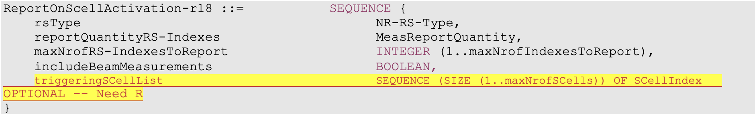

Company | SCell level control | Understanding 2  /Spec impact | Comments
Huawei, HiSilicon | We agree with rapporteur that per Scell config may be useful | See comments | We are wondering whether this Scell list is to be mandatory for the new report type? otherwise, how does the UE undertand which Scell can trigger the new report when the Scell list is absent should be discussed and captured in spec clearly.  [Rapp] Agree that how to understand the absence of the SCell list (if it’s optionally configured) should be captured in spec.  The simple way should be like this : if no SCell is provided, UE can assume any SCell activation can trigger this measurement reporting.
Nokia | Not agree | Not agree | We don’t need any extra control here – When MAC CE is received UE reports all the serving cells. This level of control is totally unnecessary.
CATT | Not agree | Not agree | We don’t see a strong motivation to further distinguish which Scell can trigger the early L3 measurement report or not.
Ericsson | Not agree | Not agree | We should strive to re-use what we already have without having fancy enhancements.
ZTE | Agree | Agree | The benefit of SCell level control is that:  - When some SCells are activated via MAC CE, the UE does not need to send measurement report to the network, which reduces the signaling overhead. One possible use case is that: The UE is configured with PCell, SCell 1 and SCell 2, and PCell and SCell1 are co-located. Only when SCell2 is activated, the UE needs to report measurement results.  In addition, we think the triggeringSCellList is optional provided. If absent, this feature is applicable for all SCells.
Qualcomm | Do not agree | Please see comments | We think that the issue with the triggering SCell list in RRC configuration is that an SCell becoming unknown is “dynamic” rather than “semi-static”. Thus, this mechanism is not helpful.
Apple | Agree | Agree

Question 2c: For Option 2 (per CG config), if you support SCell level control, do you agree with the following understanding and the spec impact on reporting part?
Reporting:
- Understanding: UE only triggers new measurement report when the newly activated SCell is in trigger SCell list.
- Spec impact: TP is provided below based on the draft CR being reviewed.

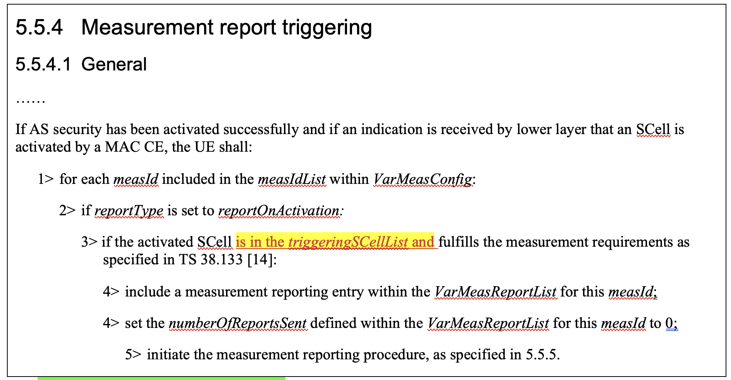

Company | Understanding | Spec impact | Comments
Huawei, HiSilicon | Agree | See comments | Same question as above, whether this Scell list can be absent?
ZTE | Agree | See comments | - Considering the triggeringSCellList is optional, we suggest to add ‘if configured’, as follows:  If the activated SCell(s) is in the triggeringSCellList, if configured, and fulfills the measurement requirements as specified in TS 38.133[14]  - One MAC CE can activate multiple SCells at the same time, thus, we suggest:  If AS security has been activated successfully and an indication is received by lower layer that SCell(s) is activated by a MAC CE:
Apple | Agree | Agree | Share ZTE’s view.

Question 2d: For Option 2 (per CG config), if you donot support SCell level control, do you agree with the following understanding and the spec impact analysis on reporting part?
Reporting:
- Understanding: UE triggers new measurement report on all newly activated SCell by each SCell activation MAC CE.
- Spec impact analysis: no impact on the current signalling in running CR.

Company | Understanding | Spec impact? | Comments
Nokia | Confusing understanding | Agree that no spec impact | When MAC CE is received UE reports all the serving cells – exactly similar to what is currently done for all measurement reporting. UE always reports all serving cells. No need to modify that.
CATT |  |  | Our view is that one Scell activation MAC CE triggers one measurement report.
Ericsson |  |  | Each time that a SCell MAC CE is sent to the UE, the MAC should inform the RRC layer to trigger a measurement report. This I guess should be rather clear, also according to what RAN4 is designing.
ZTE |  |  | We think:  UE triggers new measurement report on all newly activated SCell by one SCell activation MAC CE.
Qualcomm | Please see comments | Please see comments | In this case the question is how the UE transmits only one measurement report.
Apple | Agree | Agree

[Summary of Option 2]
For option 2 (measurement configuration per CG), based on rapporteur’s understanding of the comments from companies, rapporteur understands that we can agree with the following understandings:
- Configuration: UE ignores the measurement object in the CG specific measurement configuration, and it should be specified in the spec;
- Reporting: One SCell activation MAC CE can only trigger one measurement report based on the CG specific measurement configuration. Majority view is not to introduce the SCell control.
  - Without SCell control in measurement configuration, UE initiates the measurement report when SCell activation MAC CE is received.
  - With the SCell control in measurement configuration, UE initiates measurement report only when the received SCell activation MAC CE includes the newly activated SCell in trigger SCell list;

Preference on the options

Question 3: Which option do you support regarding the measurement configuration?
- Option 1: per SCell configuration
- Option 2: per CG configuration without SCell control
- Option 3: per CG configuration with SCell control (i.e. introduce the triggering SCell list)

Company | Preference | Comments
Huawei, HiSilicon | Option 1 | Option 1 is clean, and can achieve the same goal of option 3 with much less spec impact. To us, option 2/3 let UE ignore the configured measurement object, which is not preferred.
Xiaomi | Option 1 | Prefer option 1 on the table. Or:  Option 4: Define a new object as MeasObjectCLI, to inlcude all possible FR2 SCell. It can ensure the same RRM framework, i.e., one MO + one MR = one Measurment config.
Nokia | Option 2 | Option 2 is current CR – That is preferred. We don’t really see any need for scell specific control. What would be even the usecase. No need to start optimizing this as UE will anyway always report all serving cells.
CATT | Option 2 | The target is to send one L3 measurement report upon the reception of Scell activation MAC CE, so the indication from MAC is per MAC CE, not per Scell, and also there is only one measID for this purpose (UE ignores the measObject, and no need to add a list of Scells in the reportConfig).
Ericsson | Option 1, but ok with Option 2 | Our preference would be to have Option1 but without any note for the reporting. This is just to leave this to a possible UE implementation.  Option 2 is okay, since is currently supported in the running CR, but we should not further optimizing with the SCell control.
ZTE | Option 3 > Option 2 | The drawback of option 1 is that:  If multiple SCells are configured, lots of measurement identities are consumed. This may severely impact UE measurement capability, since the measurement identity resource is limited.  Response to Huawei:  In the LTE/NR UAV height based measurement, the action that the UE ignores the configured measurement object is already supported.
Qualcomm | Option 1 | Option 1 is our current preference, though it seems some work is still needed so that the UE transmits only one measurement report.
Apple | Option 1, 2 | Both solutions have little or no changes to the current CRs and can be supported.  We can try to support both option 1 and option 2 based on the measurement object configuration.  - If the MO is one of the SCell’s servingMO, UE can only trigger the measurement report based on the corresponding SCell activation;  - Otherwise, UE can trigger measurement report by any SCell activation.

[Summary of company’s preference]
Company’s views are quite diverse between Option 1 (SCell specific config) and Option 2 (CG specific config without SCell control).
- Option 1: 5
- Option 2: 5
- Option 3: 1
According to the rapporteur’s understanding, almost all companies think that the description in current running CR is good enough and do not want to make many changes. Company’s views are quite diverse between Option 1 and Option 2. And for both option 1 and option 2, the CR will not introduce ASN.1 changes, only slight procedure changes. Therefore, Rapporteur’s suggests providing CRs for two options, and request RAN2 for down selection in the meeting.
For Option 1- SCell specific configuration, the change is in section 5.5.4.1 as below:
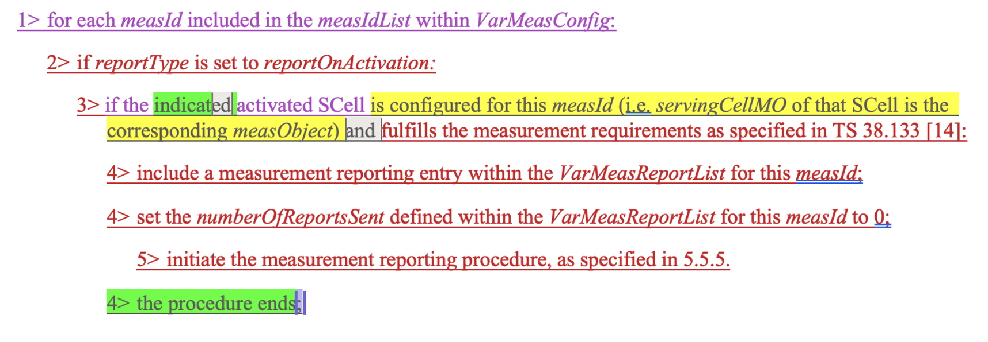

For Option 2 - CG specific configuration, the change is in section 5.5.4.1 as below:
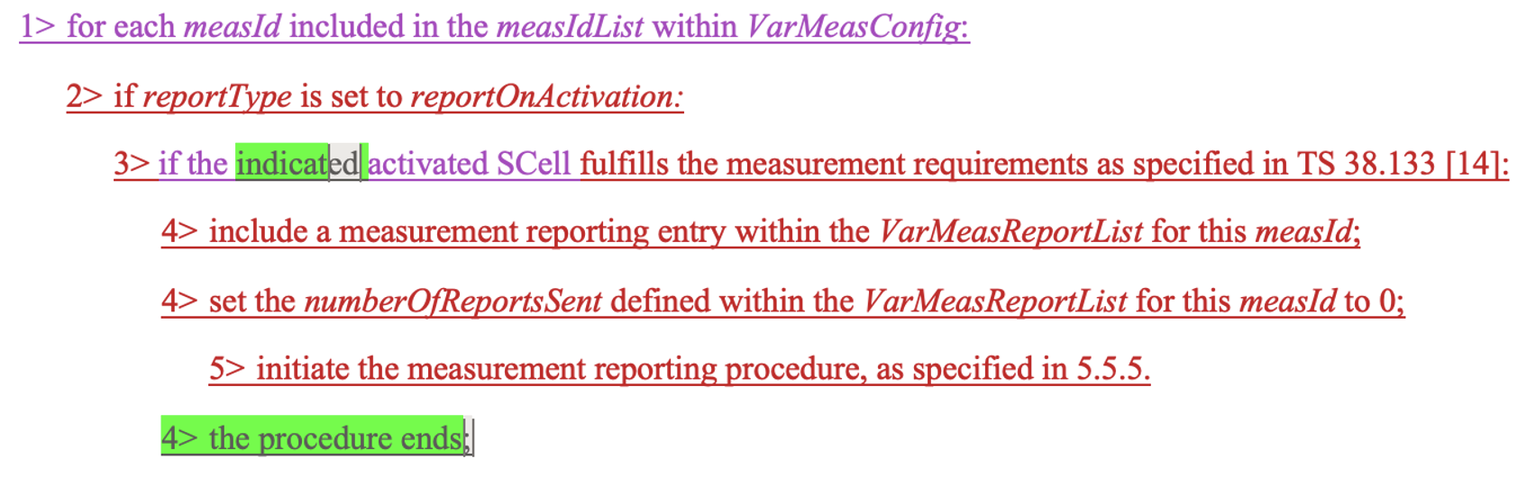

Between two options, the common part is marked in green, and the delta part in Option 1 is highlighted in yellow. And the difference between two options from UE operation part is as below:
- For Option 1: Only activation of the SCell with the configuration can trigger the measurement report;
- For Option 2: Activation of any SCell can trigger the measurement report.
Since RAN4 intention to introduce this measurement is just for some specific SCells, Option 1 is more aligned with RAN4 intention.
Proposal 1: Propose RAN2 to down select between Option 1 and Option 2 for the measurement configuration, starting from the perspective of the RAN4 intention to introduce the mechanism.

Interaction between RRC and MAC

Question 4: Do you think it’s necessary to specify the interaction between RRC and MAC for this measurement reporting?
- Option 1: Not specify it, and it’s up to UE implementation.
- Option 2: Specify it with general description.
Note: if option 2 is your preference, please provide which you prefer to specify in detail.
Company | Preference | Comments
Huawei, HiSilicon | Option 1
Xiaomi | Option 2 | The L2 command, i.e., MAC CE, will trigger a L3 report. The sentense is need to connect L2 procedure and L3 procedure for the whole L3 reporting procedure.  There are also some case in spec:  ===e.g.1: 38.331==  1> if ta-Report is configured with value enabled and the UE supports TA reporting:  2> indicate TA report initiation to lower layers;  ======= e.g.1: 38.321===========  A Timing Advance report (TAR) shall be triggered if any of the following events occur:  - upon indication from upper layers to trigger a Timing Advance report;  ======suggested change in 38.321 for this topic =========  We think it is not clear which layer (RRC or MAC or PHY) can determine the below conditions:  Cond 1: At least one SCell is activated from deactivated state;➔(MAC)  Cond 2: The SCell meeting Cond 1 is unknown FR2 SCell; ➔ (MAC)  Cond 3: The L3 measurement result for FR2 SCell meeting Cod 1/2 after SCell activation command are valid. ➔(RRC)  So at least, the MAC shoud notify RRC about the scell list meeting cond 1  ==========  5.9 Activation/Deactivation of SCells  ==omit some text===  3> (re-)initialize any suspended configured uplink grants of configured grant Type 1 associated with this SCell according to the stored configuration, if any, and to start in the symbol according to rules in clause 5.8.2;  3> trigger PHR according to clause 5.4.6.  2> if an FR2 SCell was deactivated prior to receiving this SCell Activation/Deactivation MAC CE or this Enhanced SCell Activation/Deactivation MAC CE and the FR2 SCell is activated by this MAC CE; and  2> if the FR2 SCell is unknown cell as specified in TS 38.133 [11]; and  3> indicate the measurement report trigger and this FR2 SCell to the upper layers.  1> else if an SCell Activation/Deactivation MAC CE or an Enhanced SCell Activation/Deactivation MAC CE is received deactivating the SCell; or  ============
Nokia | either or | As long as it is clear a single MAC CE used for activation only triggers one indication to RRC to avoid multiple measurement reports to be sent.
CATT | Prefer option 1 | Whether a to-be-activated Scell is a FR2 unknown Scell with available measurement results can be determined by RRC layer, so if the the interaction between RRC and MAC needs to be specified, MAC only needs to indicate a Scell activation MAC CE is received. This can also be handled by UE implementation.
Ericsson | Option 2 | For completeness of the procedure, it would be nice to specify that MAC informs RRC layer about the reception of the SCell activation MAC CE.  In particular, the only indication we need are the following:  - RRC indicates to MAC that a the new indication has been configured for at least a measID  - MAC indicates to RRC that an SCell activation MAC CE has been received (only if RRC informed previously that the new indication has been configured for at least a measID).
ZTE | Option 2 | According to RAN4’s agreements, the measurement reporting procedure would be triggered if the following conditions are met:  - The reception of SCell activation command;  - The UE has valid L3 measurement results available but not reported for the unknown SCell to be activated.  It is clear that:  Cond (1) is known by MAC layer;  Cond (2) is known by RRC layer.  Thus, the coordination between MAC layer and RRC layer is needed.  The general procedure is as follows:  - Step 1: Upon configuring measurement configuration related to this feature, the RRC layer indicates the MAC layer to enable reporting.  - Step 2: Upon receiving SCell activation command, the MAC layer reports to RRC layer.  - Step 3: Upon releasing measurement configuration related to this feature, the RRC layer indicates the MAC layer to disable reporting.  Specifically:  #TS 38.331:  5.5.2.2 Measurement identity removal  The UE shall:  - for each measId included in the received measIdToRemoveList that is part of the current UE configuration in VarMeasConfig:  2> if the reportType is set to reportOnActivation in the reportConfig associated with this measId:  3> indicate to lower layer to disable reporting for fast SCell activation.  2> remove the entry with the matching measId from the measIdList within the VarMeasConfig;  2> remove the measurement reporting entry for this measId from the VarMeasReportList, if included;  2> stop the periodical reporting timer or timer T321 or timer T322, whichever one is running, and reset the associated information (e.g. timeToTrigger) for this measId.  NOTE: The UE does not consider the message as erroneous if the measIdToRemoveList includes any measId value that is not part of the current UE configuration.  5.5.2.3 Measurement identity addition/modification  The network applies the procedure as follows:  - configure a measId only if the corresponding measurement object, the corresponding reporting configuration and the corresponding quantity configuration, are configured.  The UE shall:  1> for each measId included in the received measIdToAddModList:  ==omit some text===  2> if the reportType is set to reportOnActivation in the reportConfig associated with this measId:  3> indicate to lower layer to enable reporting for fast SCell activation.  #TS 38321:  5.9 Activation/Deactivation of SCells  The MAC entity shall for each configured SCell:  ==omit some text===  1>if receiving the indication for fast SCell activation from upper layers:  2> if receiving SCell Activation/Deactivation MAC CE or an Enhanced SCell Activation/Deactivation MAC CE :  3> if FR2 SCell(s) was deactivated prior to receiving this SCell Activation/Deactivation MAC CE or this Enhanced SCell Activation/Deactivation MAC CE and the FR2 SCell(s) is activated by this MAC CE:  4> report to the upper layers.  Resonse to Xiaomi:  - In our understanding, the MAC layer can not determine whether an SCell is unknown or not alone.  [Xiaomi] yes, you are right. I once think the MAC know the FR2 Unknow information from PHY.  - We think the reporting from MAC to RRC is per MAC CE, rather than per SCell.  [Xiaomi] It is fine to us.
Qualcomm | Option 2
Apple | Either | For option 2, we can take ZTE’s suggestion as baseline.

[Summary]
Majority view is to support to specify the interaction between MAC and RRC interaction.
Proposal 2: Specify the SCell activation indication from MAC to RRC is in MAC CE level (i.e. not in SCell level) if SCell activation triggered measurement is configured.
During the discussion, the common understanding is that the SCell activation indication from MAC to RRC is per MAC CE level not per SCell level. Therefore, propose to agree the following TP of MAC and RRC spec to reflect the interaction between MAC and RRC layer.
Proposal 3: For the interaction between RRC and MAC, agree the following RRC TP and MAC TP.
#TP of TS 38.331:

5.5.2.3 Measurement identity addition/modification
The network applies the procedure as follows:
- configure a measId only if the corresponding measurement object, the corresponding reporting configuration and the corresponding quantity configuration, are configured.
The UE shall:
1> for each measId included in the received measIdToAddModList:
……
2> if the reportType is set to reportOnActivation in the reportConfig associated with this measId:
3> configure the SCell activation indication to lower layers.

5.5.4 Measurement report triggering

5.5.4.1 General
……
If AS security has been activated successfully and if an SCell activation indication is received by lower layer that includes all the newly activated SCells by a MAC CE, the UE shall:

#TP of TS 38.321:

5.9 Activation/Deactivation of SCells
……
When the indication for SCell activation is received from upper layers, the MAC entity shall:
1> if SCell Activation/Deactivation MAC CE or an Enhanced SCell Activation/Deactivation MAC CE is received activating the SCell(s):
2> if SCell(s) was deactivated prior to receiving this SCell Activation/Deactivation MAC CE or this Enhanced SCell Activation/Deactivation MAC CE:
3> indicate to upper layers SCell(s) activation indication and this SCell(s).

Conclusion
According to the analysis in section 2, we propose that:
<Measurement configuration>
Proposal 1: Propose RAN2 to down select between Option 1 and Option 2 for the measurement configuration, starting from the perspective of the RAN4 intention to introduce the mechanism.
Following are the RRC TPs in two options (highlight part is the change introduced in the options)
TP for Option 1- SCell specific configuration (in section 5.5.4.1)

TP for Option 2 - CG specific configuration (in section 5.5.4.1)

<Interaction between RRC and MAC>
Proposal 2: Specify the SCell activation indication from MAC to RRC is in MAC CE level (i.e. not in SCell level) if SCell activation triggered measurement is configured.
Proposal 3: For the interaction between RRC and MAC, agree the following RRC TP and MAC TP:
#TP of TS 38.331:

5.5.2.3 Measurement identity addition/modification
The network applies the procedure as follows:
- configure a measId only if the corresponding measurement object, the corresponding reporting configuration and the corresponding quantity configuration, are configured.
The UE shall:
1> for each measId included in the received measIdToAddModList:
……
2> if the reportType is set to reportOnActivation in the reportConfig associated with this measId:
3> configure the SCell activation indication to lower layers.

5.5.4 Measurement report triggering

5.5.4.1 General
……
If AS security has been activated successfully and if an SCell activation indication is received by lower layer that includes all the newly activated SCells by a MAC CE, the UE shall:

#TP of TS 38.321:

5.9 Activation/Deactivation of SCells
……
When the indication for SCell activation is received from upper layers, the MAC entity shall:
1> if SCell Activation/Deactivation MAC CE or an Enhanced SCell Activation/Deactivation MAC CE is received activating the SCell(s):
2> if SCell(s) was deactivated prior to receiving this SCell Activation/Deactivation MAC CE or this Enhanced SCell Activation/Deactivation MAC CE:
3> indicate to upper layers SCell(s) activation indication and this SCell(s).

