3GPP TSG-RAN WG2 Meeting #123bis R2-231xxxx
2023 Xiamen, China, October 9th – 13th, 2023

Agenda Item: 7.25.1
Source: Apple
Title: Open issues for SCell FR2 Enhancement (Apple)
Document for: Discussion and Decision

Introduction
On RAN4 WI of FR2 unknown SCell activation enhancement, RAN2 made the following agreement in RAN2#123bis meeting, but how to capture it in spec is still FFS.
RAN2#123bis Agreements:
1. If the network activates multiple SCells within same MAC CE the UE may send only one measurement report.

This document is to collect company’s view on the spec work. If consensus can be reached, the proposals can be reflected in the running CR directly.
- [POST123bis][020][SCell Activation] Running CR (Apple)
Intended outcome: Review running CR to be endorsed in meeting
Deadline: Long

Please provide your comments before October 27th 0100 UTC.

Contact Points
Rapporteur encourages the participating delegates to provide their contact information in this table.
Company | Name | Email Address

Discussion

Measurement configuration
Whether the measurement configuration is per CG or per SCell is still FFS.
Editor Note 1: FFS on whether the reporting configuration with the reportType set to reportOnScellActivation is associated with a CG or a SCell (servingCellMO).

Two options may have different spec impact especially in the case of multiple SCell activation in one MAC CE.

Option 1: Measurement configuration is per SCell
- Configuration
    - Understanding
One measurement ID is associated with one report config and one serving MO.
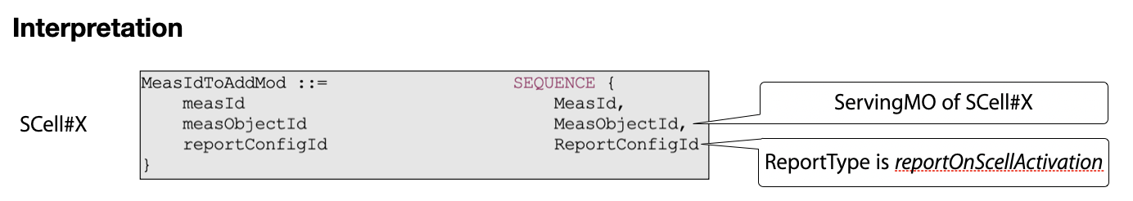
    - Spec impact
There is no impact on the current signalling in running CR.
- Reporting
    - Understanding
When multiple SCells are activated by one MAC CE, it’s possible that multiple measurement reports will be triggered according to current description in running CR.
Therefore, we should clarify in spec that only one measurement report may be transmitted if multiple report can be initiated by one MAC CE, and which measurement report to be sent can be up to UE implementation.
    - Spec impact
One NOTE is added to clarify that only one measurement report can be transmitted by one SCell activation MAC CE. The TP is provided based on the draft CR being reviewed.

5.5.4 Measurement report triggering

5.5.4.1 General
……
If AS security has been activated successfully and if an indication is received by lower layer that an SCell is activated by a MAC CE, the UE shall:
1> for each measId included in the measIdList within VarMeasConfig:
2> if reportType is set to reportOnActivation:
3> if the activated SCell fulfills the measurement requirements as specified in TS 38.133 [14]:
4> include a measurement reporting entry within the VarMeasReportList for this measId;
4> set the numberOfReportsSent defined within the VarMeasReportList for this measId to 0;
5> initiate the measurement reporting procedure, as specified in 5.5.5.
NOTE: If multiple measurement reports may be initiated by one SCell activation MAC CE, only one measurement report is allowed to be transmitted.

Question 1a: For Option 1 (per SCell config), do you agree with understanding and the corresponding spec impact analysis on configuration part?
Configuration:
- Understanding: one measurement ID is associated with one report config and one serving MO;
- Spec impact analysis: no impact on the current signalling in running CR.

Company | Understanding | Spec impact | Comments

Question 1b: For Option 1 (per SCell config), do you agree with understanding and the corresponding spec impact analysis on reporting part?
Reporting:
- Understanding: Only one measurement report may be transmitted if multiple report can be triggered by one MAC CE, and which measurement config is used to trigger can be up to UE implementation.
- Spec impact analysis: add a NOTE as above TP for section 5.5.4.1.
NOTE: If multiple measurement reports may be initiated by one SCell activation MAC CE, only one measurement report is allowed to be transmitted.

Company | Understanding | Spec impact | Comments

Option 2: Measurement configuration is per CG
- Configuration
    - Understanding
<Measurement object>
One measurement ID is associated with one report config and not associated with any MO. UE ignores the measurement object.
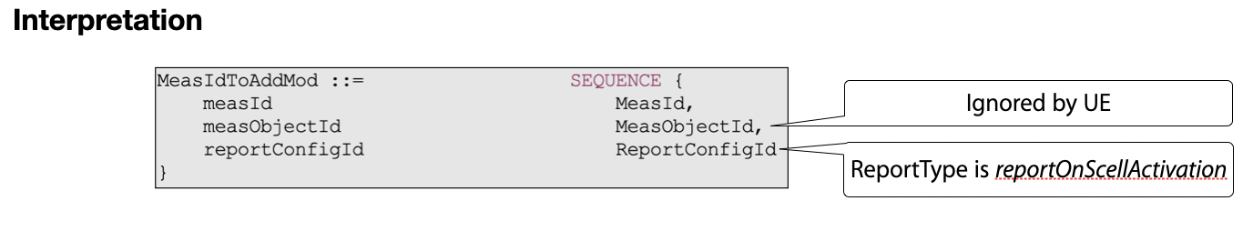
Understanding 1: UE ignores the measurement object in the CG specific measurement configuration.
<Trigger SCell list>
Amongst the multiple SCells in a CG, UE may not support the measurement report on all SCells of the CG, and network may just want to enable it on some specific SCell(s). In order for network to indicate which SCell(s) the new report is applicable for, we need to consider introducing a triggering SCell list in measurement report configuration for such control.
Without the configuration of triggering SCell list, UE has to check all the newly activated SCells based on its capability which will increase the UE burden.
Understanding 2: For SCell level control, new triggering SCell list should be introduced in CG specific measurement configuration.
    - Spec impact
Case a) With SCell level control, new triggering SCell list will be introduced under the report configuration, and the TP is as below.
ReportOnScellActivation-r18 ::= SEQUENCE {
rsType NR-RS-Type,
reportQuantityRS-Indexes MeasReportQuantity,
maxNrofRS-IndexesToReport INTEGER (1..maxNrofIndexesToReport),
includeBeamMeasurements BOOLEAN,
triggeringSCellList SEQUENCE (SIZE (1..maxNrofSCells)) OF SCellIndex OPTIONAL -- Need R
}
Case b) Without SCell level control, there is no further spec impact.

- Reporting
    - Understanding
When multiple SCells are activated by one MAC CE, only one measurement report will be triggered and transmitted according to current description in running CR.
Case a) With SCell level control, UE only triggers the new measurement report when the newly activated SCell is in the trigger SCell list.
Case b) Without SCell level control, UE triggers the new measurement report on all newly activated SCell by each SCell activation MAC CE.
    - Spec impact
Case a) With SCell level control, the TP is provided below based on the draft CR being reviewed.

5.5.4 Measurement report triggering

5.5.4.1 General
……
If AS security has been activated successfully and if an indication is received by lower layer that an SCell is activated by a MAC CE, the UE shall:
1> for each measId included in the measIdList within VarMeasConfig:
2> if reportType is set to reportOnActivation:
3> if the activated SCell is in the triggeringSCellList and fulfills the measurement requirements as specified in TS 38.133 [14]:
4> include a measurement reporting entry within the VarMeasReportList for this measId;
4> set the numberOfReportsSent defined within the VarMeasReportList for this measId to 0;
5> initiate the measurement reporting procedure, as specified in 5.5.5.
Case b) Without SCell level control, there is no spec impact.

Question 2a: For Option 2 (per CG config), do you agree with the following understanding 1 and the corresponding spec impact analysis on configuration part?
Configuration:
- Understanding 1: UE ignores the measurement object in the CG specific measurement configuration.
- Spec impact analysis: no impact on the current signalling in running CR.

Company | Understanding 1 | Spec impact analysis | Comments

Question 2b: For Option 2 (per CG config), do you support SCell level control and agree with the understanding 2 and spec impact on configuration part?
Configuration:
- Understanding 2: For SCell level control, new triggering SCell list is introduced in CG specific measurement configuration.
- Spec impact analysis: Introduce triggeringSCellList in the report configuration with SCell level control.
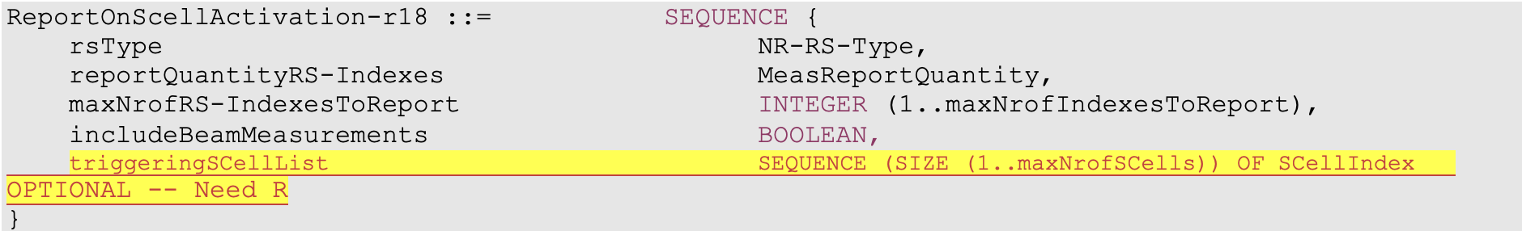

Company | SCell level control | Understanding 2  /Spec impact | Comments

Question 2c: For Option 2 (per CG config), if you support SCell level control, do you agree with the following understanding and the spec impact on reporting part?
Reporting:
- Understanding: UE only triggers new measurement report when the newly activated SCell is in trigger SCell list.
- Spec impact: TP is provided below based on the draft CR being reviewed.

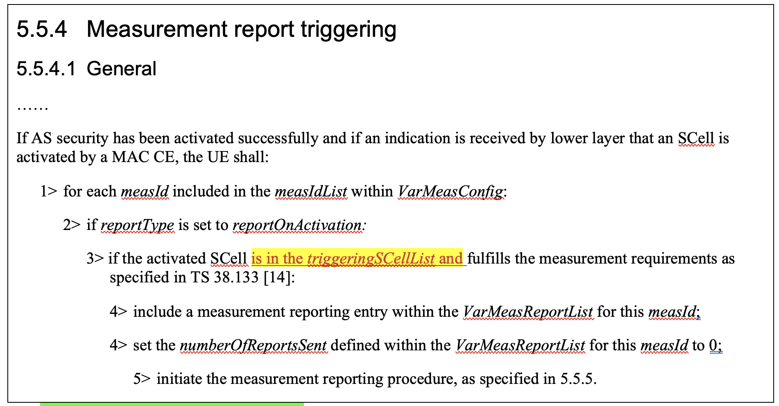

Company | Understanding | Spec impact | Comments

Question 2d: For Option 2 (per CG config), if you donot support SCell level control, do you agree with the following understanding and the spec impact analysis on reporting part?
Reporting:
- Understanding: UE triggers new measurement report on all newly activated SCell by each SCell activation MAC CE.
- Spec impact analysis: no impact on the current signalling in running CR.

Company | Understanding | Spec impact? | Comments

Preference on the options

Question 3: Which option do you support regarding the measurement configuration?
- Option 1: per SCell configuration
- Option 2: per CG configuration without SCell control
- Option 3: per CG configuration with SCell control (i.e. introduce the triggering SCell list)

Company | Preference | Comments

Interaction between RRC and MAC

Question 4: Do you think it’s necessary to specify the interaction between RRC and MAC for this measurement reporting?
- Option 1: Not specify it, and it’s up to UE implementation.
- Option 2: Specify it with general description.
Note: if option 2 is your preference, please provide which you prefer to specify in detail.
Company | Preference | Comments

Conclusion
According to the analysis in section 2, we propose that:
.

