3GPP TSG-RAN WG2 #123bis R2-xxxxx

Xiamen, China, 9 Oct – 13 Oct 2023

Agenda Item: 7.21.1

Source: Huawei, HiSilicon

Title: Summary of [Post123][802][R18CEenh-CP] CP open issues (HW)

Document for: Decision

# 1 Introduction

This document aims at discussing the following RAN2#123 Post discussion.

* **[Post123][802][CE_enh] CP running CR and open issue discussion (HW)**

Scope:

* Update the running CR and get feedback on the CR so that an updated version can be submitted to next meeting
* Identify any open issues and solutions for these for CP (including finalisation of the details of fallback)

Intended outcome: Running UP CR and list of proposals to agree

Deadline: Long

|  |  |  |
| --- | --- | --- |
| **Company** | **Name** | **Email** |
| Samsung | Anil Agiwal | anilag@samsung.com |
|  |  |  |
|  |  |  |
|  |  |  |
|  |  |  |
|  |  |  |
|  |  |  |
|  |  |  |
|  |  |  |

# 2 CP open issues

2.1 MSG1-based SI request remining issues

At RAN2#123 meeting, RAN2 agreed to have seprate SI-RequestConfig for MSG1 repetitions as below but the details are FFS:

|  |
| --- |
| **=> For MSG1-based SI request with MSG1 repetition, separate SI-RequestConfig is introduced (details are FFS)**  **=> From the RRC configuration point, RAN2 to allow that MSG1 resource with repetition of MSG1-based SI request is NOT configured but MSG1 resource with repetition of MSG3-based SI request is configured.**  **=> from RRC procedure of on-demand SI request point, the UE shall follow MSG1-based SI request without MSG1 repetition even if MSG1 resource with repetition is configured for MSG3-based SI request.** |

In this subsection, the moderator intends to discuss the details of configurations and applicability of MSG1-based SI request with MSG1 repetition.

2.1.1 MSG1-based SI request configuration details

Note that currenly the MSG1-based SI request resource is configured by SI-RequestConfig IE as shown below:

|  |
| --- |
| SI-RequestConfig ::= SEQUENCE {  rach-OccasionsSI SEQUENCE {  rach-ConfigSI RACH-ConfigGeneric,  ssb-perRACH-Occasion ENUMERATED {oneEighth, oneFourth, oneHalf, one, two, four, eight, sixteen}  } OPTIONAL, -- Need R  si-RequestPeriod ENUMERATED {one, two, four, six, eight, ten, twelve, sixteen} OPTIONAL, -- Need R  si-RequestResources SEQUENCE (SIZE (1..maxSI-Message)) OF SI-RequestResources  }  SI-RequestResources ::= SEQUENCE {  ra-PreambleStartIndex INTEGER (0..63),  ra-AssociationPeriodIndex INTEGER (0..15) OPTIONAL, -- Need R  ra-ssb-OccasionMaskIndex INTEGER (0..15) OPTIONAL -- Need R  } |

According to the online comments, the moderator understand that there was a concern on the increased number of SI-RequestConfig required for repetition number 2, 4 and 8 especially considering UL/SUL. In total, there are 4 options available from the perspective of ASN.1 structure. It is also noted that the discussed approaches are common to NUL/SUL, RedCap and Positioning.

* **Option 1**: Separate SI-RequestConfig is configured for different repetition number (2,4,8) per UL carrier. With this option, different RACH-ConfigGeneric can be configured with separate RO resources.

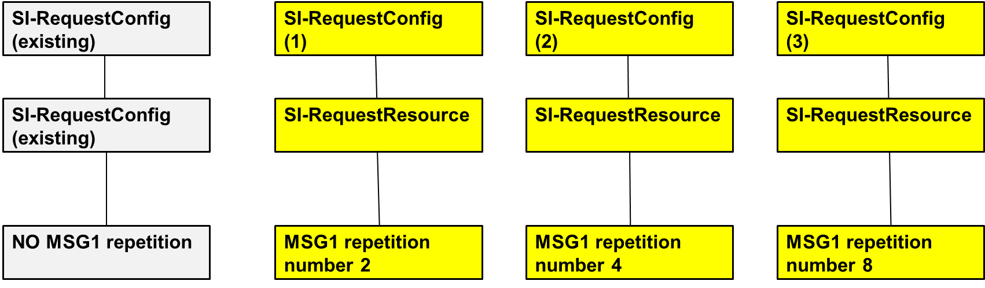

* **Option 2**: Separate SI-RequestResources is configured for different repetition number (2,4,8) per UL carrier, under a common SI-RequestConfig (i.e. new SI-Request Config). With this options, separate RO can be configured by different ra-ssb-OccasionMaskIndex.

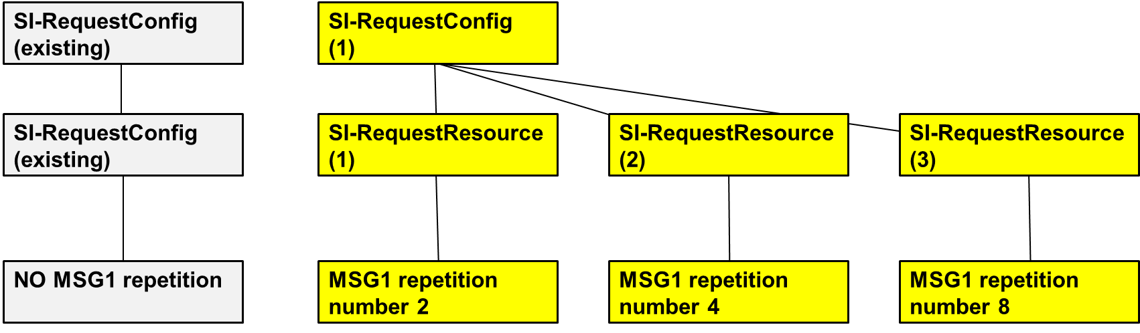

* **Option 3**: Separate SI-RequestConfig is configured for all repetition number (2,4,8) per UL carrier. With this option, MSG1 resource is separate from legacy MSG1-based SI request, but is common to different repetition number (2,4,8), i.e. separate RO for different repetition number is not supported.

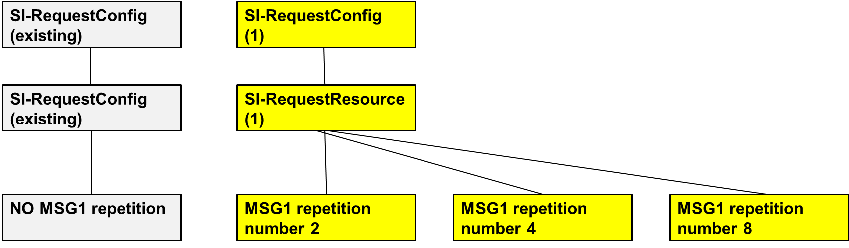

* **Option 4**: Separate SI-RequestResources is configured for all repetition number (2,4,8) per UL carrier, under a common SI-RequestConfig (i.e. legacy SI-Request Config). With this option, MSG1 resource is separate from legacy MSG1-based SI request, but common between different repetition number (2,4,8) , i.e. separate RO for differenet repetition number is not supported.

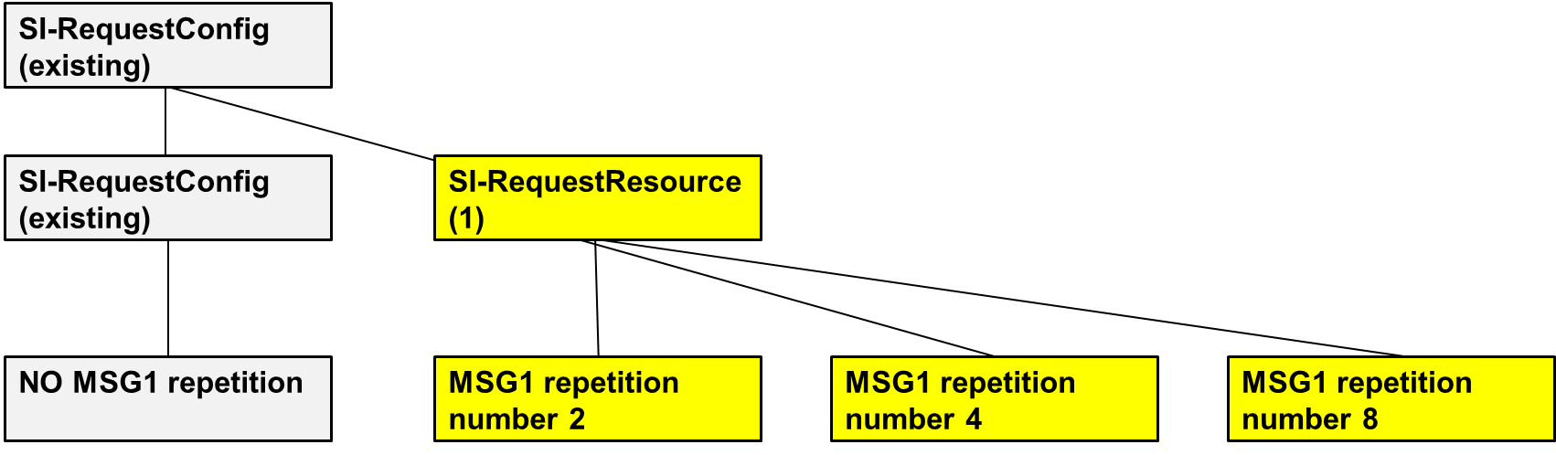

The modorater think that Option 3 and 4 can be used to reduce the number of MSG1 resources partition fragment, but is not aligned with the agreement for normal RA (i.e. non-SI request based RA) with MSG1 repetiton in which separate RO between different repetition number should be allowed from signalling and the agreed CBRA framework of MSG1 repetition where the repetition number is determined by the UE. Beside Option 4 is not aligned with the agreement for which separate SI-RequestConfig is agreed. Thus Option 3 and 4 are not considered. But the moderator also observes that Option 1 and 2 are relevant to UP discussions on modelling of RA partition framework of different repetition number based on some offline check with email discussion moderator (ZTE). Thus the moderator suggests companies to consider two issues together.

**=> For a RACH partition associated with multiple Msg1 repetition numbers, the parameters defined in RACH-ConfigGeneric IE (except preambleReceiveTargetPower and powerRampingStep) are common for those repetition numbers. This will reuse existing IE. We will allow different ROs to be used for different repetitions in the signalling. If this complicates the RRC with option 2.2 too much we can revisit that agreement**

**Question 1: Do companies think which option is preferred for configuring the MSG1 resource with repetition for MSG1 based SI request?**

|  |  |  |
| --- | --- | --- |
| **Company** | **Options** | **Comments** |
| Samsung | Option 1 | For each repetion number Preambles/ROs combination is different. So option 3 and 4 are not acceptable.  Amongst Option 1 and option 2, option 1 is simple and follows the legacy design principle. Same approach was used when SI request configuration for redcap, POS was introduced. Do not see the need to introduce new mechanism/concept. |
|  |  |  |
|  |  |  |
|  |  |  |
|  |  |  |
|  |  |  |
|  |  |  |
|  |  |  |
|  |  |  |
|  |  |  |
|  |  |  |
|  |  |  |

2.1.2 NUL/SUL,RedCap and Positioning applicability details

Some companies raised another comment to consider MSG1-based SI request with MSG1 repetition for NUL/SUL, Redcap and Positioning. The modorater think RedCap, NUL/SUL and positioning may also have the coverage issue with MSG1, e.g. when UE is in cell edge, so it seems unnecessary to differentiate the cases so far. However, the workload of RRC spec is also important to consider. The current procedure of MSG1-based SI request is organized in the processing order as follows:

5.2.2.3.3 Request for on demand system information

1. Carrier selection between SUL and NUL, if configured, according to MAC spec; to select the corresponding MSG1 resource;

2. If the UE is a RedCap UE, to check if initialUplinkBWP-Redcap is configured; to select the corresponding MSG1 resource;

3. If the UE is not a RedCap UE, to determine to trigger MSG1-based or MSG3-based; to select the corresponding MSG1 resource;

5.2.2.3.3a Request for on demand positioning system information

1. Carrier selection between SUL and NUL, if configured, according to MAC spec for POS SI;

2. If the UE is a RedCap UE, to check if initialUplinkBWP-Redcap is configured for POS SI;

3. If the UE is not a RedCap UE, to determine to trigger MSG1-based or MSG3-based for POS SI.

The moderator understands that the RRC spec impact to support of NUL/SUL, RedCap and Positioning is mainly on the configuration of corresponding MSG1 resource and procedure to select the corresponding MSG1 resource. However, regardless of options in Question 1, the moderator think the RRC spec complexity is manageable and it seems can be agreeable from CE perspective in RAN2. For NUL/SUL, it has been agreed that MSG1 repetition can be applicable to SUL and NUL.

**Agreements**

* **RAN2 assumes that MSG1 repetition can be applicable to NUL**
* **RAN2 assumes that MSG1 repetition can be applicable to SUL**

**Question 2: Do companies agree that MSG1 based SI request with MSG1 reqetition for NUL/SUL, RedCap and Positioning can be supported from CE perspective in RAN2?**

|  |  |  |
| --- | --- | --- |
| **Company** | **Yes or No** | **Comments** |
| Samsung | Yes |  |
|  |  |  |
|  |  |  |
|  |  |  |
|  |  |  |
|  |  |  |
|  |  |  |
|  |  |  |
|  |  |  |
|  |  |  |
|  |  |  |
|  |  |  |

2.2 CFRA remaining issues

2.2.1 CFRA resource configuration details

Currently the CFRA resource can be associated with either SSB or CSI-RS as below:

|  |
| --- |
| CFRA ::= SEQUENCE {  occasions SEQUENCE {  rach-ConfigGeneric RACH-ConfigGeneric,  ssb-perRACH-Occasion ENUMERATED {oneEighth, oneFourth, oneHalf, one, two, four, eight, sixteen}  OPTIONAL -- Cond Mandatory  } OPTIONAL, -- Need S  resources CHOICE {  ssb SEQUENCE {  ssb-ResourceList SEQUENCE (SIZE(1..maxRA-SSB-Resources)) OF CFRA-SSB-Resource,  ra-ssb-OccasionMaskIndex INTEGER (0..15)  },  csirs SEQUENCE {  csirs-ResourceList SEQUENCE (SIZE(1..maxRA-CSIRS-Resources)) OF CFRA-CSIRS-Resource,  rsrp-ThresholdCSI-RS RSRP-Range  }  },  ...,  [[  totalNumberOfRA-Preambles INTEGER (1..63) OPTIONAL -- Cond Occasions  ]]  }  CFRA-SSB-Resource ::= SEQUENCE {  ssb SSB-Index,  ra-PreambleIndex INTEGER (0..63),  ...,  [[  msgA-PUSCH-Resource-Index-r16 INTEGER (0..3071) OPTIONAL -- Cond 2StepCFRA  ]]  }  CFRA-CSIRS-Resource ::= SEQUENCE {  csi-RS CSI-RS-Index,  ra-OccasionList SEQUENCE (SIZE(1..maxRA-OccasionsPerCSIRS)) OF INTEGER (0..maxRA-Occasions-1),  ra-PreambleIndex INTEGER (0..63),  ...  } |

For association between SSB and RO for CFRA with MSG1 repetition, the modorater think that it should be supported since the association for CBRA can be reused. However for association with CSI-RS case, it may have RAN1 impact since CFRA RO to be associated with CSI-RS is configured by ra-OccassionList IE while it seems not fully touched in RAN1. Regarding RAN1 already finished the WID, the moderator would suggest not to consider it in RAN2 for RRC configurations.

**Question 3: Do companies agree that the association between CSI-RS and CFRA resource for MSG1 repetition is not supported from RAN2 perspective.**

|  |  |  |
| --- | --- | --- |
| **Company** | **Yes or No** | **Comments** |
| Samsung | Yes | We are ok to not support this. |
|  |  |  |
|  |  |  |
|  |  |  |
|  |  |  |
|  |  |  |
|  |  |  |
|  |  |  |
|  |  |  |
|  |  |  |
|  |  |  |
|  |  |  |

2.2.2 CHO support

RAN2 already agreed CFRA with MSG1 repetition can be applicable to HO case with the following conclusion:

**=> NW indicates ONE MSG1 repetition number applicable for CFRA MSG1 repetition by RRC for Reconfiguration with sync.**

The moderator note that some company proposed that RAN2 should confirm CFRA with Msg1 repetition is applicable to Conditional Handover case [1]. However, the moderator understand the agreement above doesn't exclude CHO where NW only configures MSG1 resource for one repetition numer, i.e. not allow to configure multiple MSG1 resources for different repetition number and UE to choose the applicable MSG1 resource. Company are invited to share your view on below question.

**Question 4: Do companies agree that CFRA with MSG1 repetition is applicable to CHO under the assumption that NW indicates ONE MSG1 repeition number applicable for CFRA MSG1 repetition?**

|  |  |  |
| --- | --- | --- |
| **Company** | **Yes or No** | **Comments** |
| Samsung | No | CFRA configuration for CHO case is similar to BFR case where CFRA configuration is provided in advance and configuration is used much later when certain conditions are met. So just indication one repetition number for CHO case is not sufficient. Multiple repetitions number and selection based on RSRP is needed for CHO case. |
|  |  |  |
|  |  |  |
|  |  |  |
|  |  |  |
|  |  |  |
|  |  |  |
|  |  |  |
|  |  |  |
|  |  |  |
|  |  |  |
|  |  |  |

2.3 CBRA remaining issues

At RAN2#123 meeting, RAN2 agreed that all MSG1 repetition numbers are treated as a single feature but within the feature different repetition number as treated as different RA type.

On the other hand, for a feature combiantion, a RA resource set is currently configured including:

* a preamble set are mandatorily configured for a feature combination via *startPreambleForThisPartition* and *numberOfPreamblesPerSSB-ForThisPartition* in FeatureCombinationPreambles IE.
* A RO set are configured in FeatureCombinationPreambles IE for a feature combination via *ssb-SharedRO-MaskIndex*. If *ssb-SharedRO-MaskIndex* is absent, all ROs for the *RACH-ConfigCommon* with this feature combination can be used.

|  |
| --- |
| FeatureCombinationPreambles-r17 ::= SEQUENCE {  featureCombination-r17 FeatureCombination-r17,  startPreambleForThisPartition-r17 INTEGER (0..63),  numberOfPreamblesPerSSB-ForThisPartition-r17 INTEGER (1..64),  ssb-SharedRO-MaskIndex-r17 INTEGER (1..15) OPTIONAL, -- Need S  groupBconfigured-r17 SEQUENCE {  ra-SizeGroupA-r17 ENUMERATED {b56, b144, b208, b256, b282, b480, b640,  b800, b1000, b72, spare6, spare5,spare4, spare3, spare2, spare1},  messagePowerOffsetGroupB-r17 ENUMERATED { minusinfinity, dB0, dB5, dB8, dB10, dB12, dB15, dB18},  numberOfRA-PreamblesGroupA-r17 INTEGER (1..64)  } OPTIONAL, -- Need R  separateMsgA-PUSCH-Config-r17 MsgA-PUSCH-Config-r16 OPTIONAL, -- Cond MsgAConfigCommon  msgA-RSRP-Threshold-r17 RSRP-Range OPTIONAL, -- Need R  rsrp-ThresholdSSB-r17 RSRP-Range OPTIONAL, -- Need R  deltaPreamble-r17 INTEGER (-1..6) OPTIONAL, -- Need R  ...  } |

2.3.1 Separate preambles configurations details

Separate preambles are agreed to support for MSG1 repetition number 2, 4 and 8. If treating different repetition numbers as single feature, the moderator think that preamble subset for a repetition number should be separately and mandatorily configured inside the preamble set for the feature combination in which MSG1 repetitions is configured as shown in below figure.

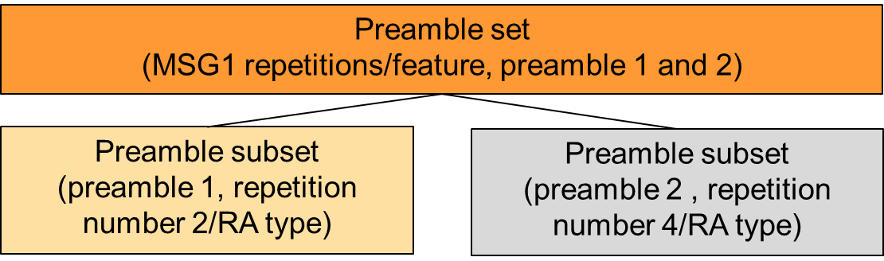

Hence, for different RA type, i.e. repetition number 2, 4 and 8, except the existing startPreambleForThisPartition and numberOfPreamblesPerSSB-ForThisPartition for a feature comibiantion, new startPreamble IE and numberOfPreamblesPerSSB IE inside FeatureCombinationPreambles-r17 IE should be also introduced for each repetition number. Company are invited to share your view on below question.

**Question 5: Do companies agree that startPreamble IE and numberOfPreamblesPerSSB IE inside FeatureCombinationPreambles-r17 IE is needed for repetition number 2, 4 and 8, respectively, for separate preambles configurations from RAN2 CE perspective?**

|  |  |  |
| --- | --- | --- |
| **Company** | **Yes or not** | **Comments** |
| Samsung | - | The main intention of creating the RA partition was to have separate ROs/Preambles configuration for each partition. Now it seems we are creating subpartition within a partition. This does not seem a clean design. |
|  |  |  |
|  |  |  |
|  |  |  |
|  |  |  |
|  |  |  |
|  |  |  |
|  |  |  |
|  |  |  |
|  |  |  |
|  |  |  |
|  |  |  |

2.3.2 Separate RO configuration details

At last meeting, RAN2 agreed to allow different ROs to be used for different repetitions in the signalling as the below:

|  |
| --- |
| **=> For a RACH partition associated with multiple Msg1 repetition numbers, the parameters defined in RACH-ConfigGeneric IE (except preambleReceiveTargetPower and powerRampingStep) are common for those repetition numbers. This will reuse existing IE. We will allow different ROs to be used for different repetitions in the signalling. If this complicates the RRC with option 2.2 too much we can revisit that agreement** |

The moderator thinks this also depends on how to support the fallback which will be discussed in UP email discussion so no question is listed here.

2.3.3 Other parameters

At RAN2#123 meeting, RAN2 discussed which parameter inside RACH-ConfigGeneric IE is common between different repetition number and made some agreement. For other parameters which is outside the RACH-ConfigGeneric IE the modorater also saw some proposal in [5] on RAN2 to confirm that preamble Group B can be configured for Msg1 repetition and a separate RSRP threshold for SSB selection can be configured for an Msg1 repetition type. Furthermore some companies also mentioned in RAN2#123 email discussion summary that the other parameters (e.g. *groupBconfigured* IE, *rsrp-ThresholdSSB* IE, *deltaPreamble* IE in *FeatureCombinationPreambles* IE as showed below) should also be discussed whether they are common or not.

|  |
| --- |
| msgA-RSRP-Threshold-r17 RSRP-Range OPTIONAL, -- Need R  rsrp-ThresholdSSB-r17 RSRP-Range OPTIONAL, -- Need R  deltaPreamble-r17 INTEGER (-1..6) OPTIONAL, -- Need R |

The moderator think if they are common, the signalling overhead and RRC complexity is further reduced. Company are invited to share your view.

**Question 6: Do companies agree that *groupBconfigured*, *rsrp-ThresholdSSB*, *deltaPreamble* IE in *FeatureCombinationPreambles* are common for repetition number 2, 4 and 8 from RAN2 CE perspective?**

|  |  |  |
| --- | --- | --- |
| **Company** | **Yes or not** | **Comments** |
| Samsung | Yes |  |
|  |  |  |
|  |  |  |
|  |  |  |
|  |  |  |
|  |  |  |
|  |  |  |
|  |  |  |
|  |  |  |
|  |  |  |
|  |  |  |
|  |  |  |

2.4 UE capability

Some companies [2][3] proposed to have UE capability for MSG1 repetition in their contribution. There are two issues to discuss:

1. whether to introduce separate UE capability for different repetition number;

2. whether to introduce separate UE capability for CBRA and CFRA with MSG1 repetition.

The moderator checked RAN1 agreement and find that RAN1 has following agreement on UE capability for coverage enhancement.

|  |  |  |  |  |  |  |  |  |  |  |  |  |  |  |  |  |  |  |  |  |  |  |  |  |  |  |  |  |  |  |  |  |  |  |  |  |  |  |  |  |  |  |
| --- | --- | --- | --- | --- | --- | --- | --- | --- | --- | --- | --- | --- | --- | --- | --- | --- | --- | --- | --- | --- | --- | --- | --- | --- | --- | --- | --- | --- | --- | --- | --- | --- | --- | --- | --- | --- | --- | --- | --- | --- | --- | --- |
| **Agreement**   * Introduce following FG  |  |  |  |  |  |  |  |  |  |  |  |  |  |  | | --- | --- | --- | --- | --- | --- | --- | --- | --- | --- | --- | --- | --- | --- | | 54. NR_cov_enh2 | 54-1 | PRACH coverage enhancements | Support of multiple PRACH transmissions [with the same Tx beam].  Support {2, 4, 8} for the number of multiple PRACH transmissions [with same Tx beams].  FFS whether to separate this FG for CBRA and CFRA |  | Yes |  | UE doesn’t support multiple PRACH transmissions [with the same Tx beam]. |  | N/A | N/A | N/A |  | Optional with capability signalling. |   **Agreement**   * Introduce following FGs  |  |  |  |  |  |  |  |  |  |  |  |  |  |  | | --- | --- | --- | --- | --- | --- | --- | --- | --- | --- | --- | --- | --- | --- | | 54. NR_cov_enh2 | 54-3 | Dynamic waveform switching | Support of dynamic waveform switching for DCI format 0_1/0_2[/0_3].  FFS whether to separate this FG for DCI 0_1/0_2[/0_3]  FFS whether to separate this FG for multi-PUSCH scheduling  FFS whether/how to separate this FG for single-carrier case and multiple-carrier case | FFS | Yes |  | Dynamic waveform switching is not supported | FFS | N/A | N/A | N/A |  | Optional with capability signaling. | | 54. NR_cov_enh2 | 54-3a | PHR enhancement for dynamic waveform switching | Reporting of power headroom information for an assumed PUSCH using target waveform different from waveform of actual PUSCH  FFS details |  |  |  |  |  |  |  |  |  |  | |

For UE capability for RPACH coverage enhancement, it has been agreed in RAN1 that separate UE capability for different repetition number is not needed and the issue 1 can be closed. However, it is FFS on whether to separate the UE capability for CBRA and CFRA. Regarding CFRA with MSG1 repetition is agreed by RAN2, this issue can be dicussed in RAN2. Companies are invited to share your view on below question.

**Question 7: Do companies think if separate UE capability for CBRA and CFRA with MSG1 repetition is introduced?**

|  |  |  |
| --- | --- | --- |
| **Company** | **Yes or No** | **Comments** |
| Samsung | No |  |
|  |  |  |
|  |  |  |
|  |  |  |
|  |  |  |
|  |  |  |
|  |  |  |
|  |  |  |
|  |  |  |
|  |  |  |
|  |  |  |
|  |  |  |

For FFS points of UE capability on waveform and PHR, they are more related to RAN1. The moderator think that RAN2 can just wait for them. No need to discuss.

2.5 Other issue

In case if any company see some issue worthy to be discussed in this email discussion, please provide it by below.

|  |  |  |
| --- | --- | --- |
| **Company** | **Issue** | **Comments** |
|  |  |  |
|  |  |  |
|  |  |  |
|  |  |  |
|  |  |  |
|  |  |  |

# 4 Conclusions

In this email discussion, we have discussed the CP aspects of MSG1 repetition with the folloinw proposals.

TBD

# 5 References

1. R2-2307115 Further Discussion on PRACH Repetition from CP vivo discussion Rel-18 NR_cov_enh2-Core
2. R2-2308068 Remaining CP issues for CE ZTE Corporation, Sanechips discussion Rel-18 NR_cov_enh2-Core
3. R2-2307437 Further NR Coverage Enhancements CP Discussion Ericsson discussion Rel-18 NR_cov_enh2
4. R2-2308670 Discussion on RRC aspect with MSG1 repetition Huawei, China Southern Power Grid, HiSilicon discussion NR_cov_enh2-Core
5. R2-2307115 Further Discussion on PRACH Repetition from CP vivo discussion Rel-18 NR_cov_enh2-Core