3GPP TSG-RAN WG2 Meeting #121bis-e R2-23xxxx
e-meeting, April 17- 26, 2023

Source: Qualcomm Incorporated
Title: [Draft] Summary of email discussion [Post121][043][NR17] Intraband ENDC UE cap (QC)
Document for: Decision
Agenda Item: x.x

Introduction
This document provides a summary for the following email discussion.
- [Post121][043][NR17] Intraband ENDC UE cap (QC)
Scope: Starting point R2-121 agreement discussion R2-2300142. Take into account BW and FW compatibility, can consider R4 discussion aspect if needed. Discuss, allow review/check, Conclude agreeable solution and LS out, alt identify points for discussion / decision.
Intended outcome: Report, draft LS out (to R4)
Deadline: Long
Companies are invited to provide their contact information for this email discussion.
Company | Delegate name | Email address
OPPO | Qianxi Lu | qianxi.lu@oppo.com

Discussion
This email discussion builds on top of the RAN2#121 discussion and agreement below.
R2-2300142 Discussion on UE capability ‘intraBandENDC-Support’ Qualcomm Incorporated discussion Rel-17 TEI17
R2-2301611 Discussion on intra-band EN-DC combination Huawei, HiSilicon discussion TEI17
- Both noted

DISCUSSION
- TMO support a new cap IE
- Apple think R4 has defined both for the current signalling. Think we can just follow the LS.
- MTK agree with P1, think that R4 proposal can be considered on top of current. Has concerns with new separation
- ZTE prefers proposal from QC to redefine current for DL and new for UL, think the new cap can be only
- Nokia think that introducing a new cap would make it easier. Wonder if we could avoid to support the mixed case. QC think it doesn’t exist.
- QC think that R4 solution is not forward compatible,
- Apple think R4 has analyzed and made the best solution. Nokia disagrees, think R4 didn’t have a good discussion on UE cap.
- MTK think that also FW compatibility is considered by RAN4.
- TMO think a non-backward change is risku but also think R4 are not the experts on UE cap signalling.
- ZTE think that with Huawei proposal we need two new capabilities.
- We introduce a new capability for UL intraBandENDC-Support-UL, and restrict the existing capability to DL.
  - Definitions
In this document, we use the following definitions.
Contiguous intra-band EN-DC
  - Intra-band EN-DC band combination where one LTE band entry and one NR band entry within the EN-DC band combination are contiguous.
  - Some examples below. The UE uses the number of band entries and bandwidth class signalling to differentiate those cases.
    - DC_48A_(n)48AA
    - DC_(n)48AA
    - DC_(n)48AC_n48A
Non-contiguous intra-band EN-DC
  - Intra-band EN-DC band combination where there is no pair of LTE band entry and NR band entry that is contiguous.
NOTE: Moderator ruled out the concept of “mixed” case as discussed in [2] based on offline comments from multiple companies.
  - New signalling solution
With the addition of new UE capability parameter for UL, say intraBandENDC-Support-UL, the following combinations of UE capabilities can be indicated.
intraBandENDC-Support (for DL) | intraBandENDC-Support-UL (for UL, new) | UE supports in DL/UL
Absent (Contiguous) | Contiguous | - Contiguous/Contiguous
Absent (Contiguous) | Non-contiguous | - Contiguous/Non-contiguous
Non-contiguous | Contiguous | - Non-contiguous/Contiguous
Non-contiguous | Non-contiguous | - Non-contiguous/Non-contiguous
Both | Contiguous | - Contiguous/Contiguous  - Non-contiguous/Contiguous
Both | Non-contiguous | - Contiguous/Non-contiguous  - Non-contiguous/Non-contiguous
Absent (Contiguous) | Both | - Contiguous/Contiguous  - Contiguous/Non-contiguous
Non-contiguous | Both | - Non-contiguous/Contiguous  - Non-contiguous/Non-contiguous
Both | Both | Further discussed below
RAN2 can discuss whether there is any missing case or whether there is any invalid combination, e.g. DL: Non-contiguous / UL: Contiguous, which can result in UL carrier without paired DL. One could have preference to keep the UE capability signalling generic to cover any potential cases.
Q1: Any invalid or missing case in the tables above?
Company | Any invalid or missing case? (Yes/No) | Comments / Additional explanation
OPPO | See comment | In our understanding, since the old field is for DL only, it means absence of the new field (as in legacy) = no restriction on UL, which can be interpreted for some BC:s as ‘both’, e.g., case-4 in R2-2300060 – as clarified in R2-2300141  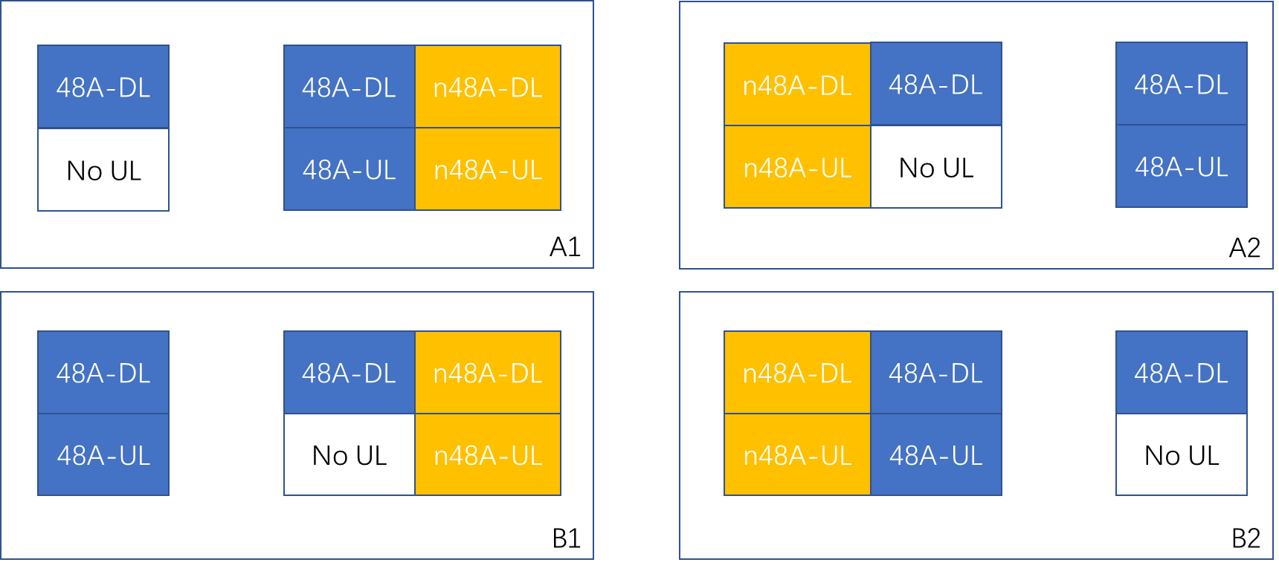  Figure 2 Possible configuration of DC_48A_(n)48AA+DC_(n)48AA,DC_48A_n48A  So we wonder whether the final 3 rows of the table above are really needed.  Besides, we wonder if the combo of “DL = Non-contiguous, UL=Contiguous’ really exists? And due to the same reason, whether it is unnecessary to have ‘DL=both, UL=contiguous’ given ‘DL = contiguous, UL=contiguous’ is already there.
When the UE indicates “both” for DL and UL, the following 4 cases are applicable. [2] discussed whether the UE may support only a subset of the cases; e.g. supports case 1 and case 2, but not others.
Case1 | Contiguous/Contiguous
Case2 | Non-contiguous/Non-contiguous
Case3 | Contiguous/Non-contiguous
Case4 | Non-contiguous/Contiguous
Q2: Can the UE support only a subset of the cases; e.g. supports case 1 and case 2, but not others.
Company | Yes/No | Comments / Additional explanation
OPPO | See comment | Firstly, if DL = non-contiguous, we wonder if case-4 really exist?  Secondly, if DL = contiguous, considering the case-3 in R2-2300060 is for the case where UE support UL = non-contiguous but not UL = contiguous (since otherwise, if UE will always support both, there is no need to introduce a UL-specific field), it seems reasonable to assume a UE supporting case-3 but not supporting case-1.  Then in case we understand there exists UE support case-3 but not case-1, just wonder how to solve the NBC issue, since legacy NW would not see the new UL field, may assume the UE supporting both case-1 and 3.
[2] concluded that it is indeed a possible UE implementation to support only a subset of the cases. One may argue that different cases can be signalled by different EN-DC band combination entries. However, RAN2 has been trying to avoid cases where duplicated band combination signalling is needed.
[2] further proposed to introduce a UE capability parameter of bitmap format to indicate the support for those 4 cases individually. The use of the bitmap parameter by the UE should be limited to the case where the UE indicates “both” for DL and UL.
Q3: Do companies agree to introduce a UE capability parameter of bitmap format to indicate the support for those 4 cases individually?
Company | Yes/No | Comments / Alternative solutions
OPPO | No | In practice, we understand typically either DL = contiguous or DL = non-contiguous for a BC, so not see it as a critical issue to optimize signaling overhead.

  - Other discussion points
Q4: Companies are invited to raise other discussion points.
Company | Comments

  - LS to RAN4
TBD

Conclusion
xxxxxx

References
[1] R2-2300060 LS on intraBandENDC-Support RAN4
[2] R2-2300142 Discussion on UE capability ‘intraBandENDC-Support’ Qualcomm Incorporated

