3GPP TSG-RAN WG2 #116bis-e R2-22xxxxx
E-meeting, 17 – 25 January 2022

Agenda item: 8.4.2.4
Source: Samsung (rapporteur)
Title: Summary of discussion [Post116bis-e][077][eIAB] 38321 (Samsung)
Document for: Discussion and decision

Introduction
This document captures the following discussion:
- [Post116bis-e][077][eIAB] 38321 (Samsung)
Scope: Updated running CR taking into account agreements of R2-116bis-e. Best effort review. Endorsement if possible. Capture TS related Open Issues, not captured elsewhere and suggest how to treat.
Intended outcome: Updated Running CR, reviewed, baseline for next meeting. TS related Open issue with suggestion how to treat.
Deadline: Short.

Section 2 captures individual companies’ comments on rapporteur’s draft running CR for the MAC spec, based on the baseline endorsed at RAN2#116bis-e and captured in R2-2201850, and the further agreements made at the same meeting (please see R2-2201876 for further info). The goal is to update the running MAC CR, and endorse the new iteration if possible.
A further goal is to capture any TS-related issues not captured elsewhere, and Section 3 captures this.

Running MAC CR
Companies are invited to comment on the running CR updated by the rapporteur and available at
www.3gpp.org / ftp / email_discussions / RAN2 / [RAN2#116bis-e] / [Post116bis-e][077][eIAB] 38321 (Samsung),
using the following table:

COMMENTS ON CR VERSION (FILE NAME LABELLED v0):
Company | Section comment relates to / General comment | Comment | Rapporteur’s response
Apple | 5.18.19 | For additional information on the timing modes, the additions for the timing case indications Case-1, Case-6, and Case-7 could be linked with a reference to TS 38.213, clause 14.  The IAB-MT on the child node may inform the parent IAB-DU or IAB-donor-DU about the number of guard symbols desired via the Desired Guard Symbols MAC CE. IAB-MT transmission timing modes are specified in TS 38.213 [6], clause 14.
ZTE | 5.18.18 | We suggest to add “respectively” after “related to Case-1 and Case-7 timing modes” to make it more clear.
ZTE | 5.18.19 | We suggest that the title of the table 5.18.19-1 is changed to “Switching scenarios and relevant guard symbols for Case-1 timing”.  And we suggest that the title of the table 5.18.19-2 is changed to “Switching scenarios and relevant guard symbols for Case-6 and Case-7 timing”
ZTE | 5.18.19 | - For the table 5.18.19-2, the switching scenarios in 5th and 6th bullets are the the same, i.e. DU Rx to MT Tx (Case-6). I assume that the one of them should be changed to DU Rx to MT Tx (Case-6).  - The switching scenarios in 7th and 8th bullets are the the same, i.e. DU Tx to MT Tx (Case-7). I assume that one of them should be changed to DU Rx to MT Tx (Case-7)  - Currently, case 1 timing mode is not indicated in switching scenarios in the table. We think that both timing modes needs to be indicated explicitly in the switching scenarios.  - As agreed in RAN1#107e meeting, the case H (Case #6 MT TX to/from Case #1 DU TX) is a working assumption rather than an agreement, as copied below. So we prefer to leave the two switch scenarios as FFS in the table until agreed in RAN1.  The MAC-CE signaling of Desired/Provided Guard Symbols is enhanced to optionally indicate the number of guard symbols required for switching between at least the following cases:  - A: Case #6 MT TX to/from Case #1 DU RX  - D: Case #7 MT TX (to support Case #7 at parent node) to/from Case #1 DU RX  - G: Case #7 MT TX (to support Case #7 at parent node) to/from Case #1 DU TX  - (Working Assumption) H: Case #6 MT TX to/from Case #1 DU TX  [Huawei]: See the table in our paper  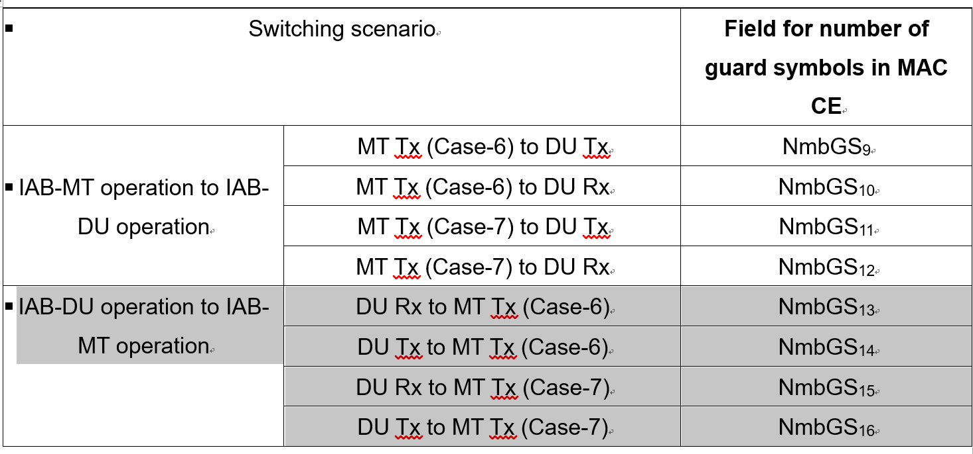
Huawei, HiSilicon | 5.18.18, 6.1.3.21 | Case-1 Timing Delta MAC CE  We prefer not to change the legacy MAC naming. This will cause the different terminology between R16 and R17 for the same MAC CE.  We can use “Timing Delta MAC CE” and “Case-7 Timing Delta MAC CE” as two MAC CE, and maybe add NOTE to clarify that “Timing Delta MAC CE” is actually only used in for case-1  Same comment to not changing legacy MAC CE name “Guard Symbols MAC CEs for Case-1 timing mode”
Huawei, HiSilicon | 6.1.3.21 | T_{delta_Case7}: This field indicates the value (0, 1, 2… 4095) used to control the amount of timing adjustment that MAC entity indicates  As for the R16 legacy T_{delta,} not the full range will be used. We need to use FFS for now, and wait for RAN1 further input, since it is still FFS in the RAN1 LS.

Open issues
If you have identified any TS38.321 related issues related to our eIAB work and not captured in the above running MAC CR discussion, please provide the details in the Table immediately below:
Company | Issue | Suggestion on how to treat it
Huawei, HiSilicon | We also need to add more MAC CEs as in the RAN1 LS. | Capture the EN to clarify there are more MAC CEs for eIAB to be captured, which can be done once RAN1 provides us the full parameter/values for those MAC CEs.

Conclusions

