3GPP TSG RAN2 #116-e R2-21xxxxx
Electronic Meeting, 1st – 12th Nov 2021

Agenda Item: 9.3: TEI17
Source: Qualcomm Inc. (rapporteur)
Title: Report on [Post115-e][203][TEI] Discussion on details of event-triggered logged MDT for LTE
Document for: Discussion and decision

1 Introduction
In [2]-[3], event-based measurements for logged MDT are proposed for LTE by replicating the event-triggered measurements in NR. The two event-based measurements are
- (i) event L1: UE performs logging of the measurements when the camped cell radio quality falls below a threshold, and
- (ii) OutOfService: UE performs logging of measurements when the UE enters any cell selection state.
The purpose of these two event-triggered measurements is to determine coverage issues with LTE, as the memory allocated for logged MDT is limited.
In [4]-[8], UE capability for this feature was proposed.
In RAN2#115-e meeting, RAN2 made the following agreements [1] based on contributions in [2]-[8]:
- Clear support but need to discuss more details (including whether this is sufficient). If we agree to the proposal, UE capability is needed.
- Further details discussed in post-meeting email discussion (Qualcomm)

This is the email discussion report of the following:

- [Post115-e][203][TEI17] Event triggered logged MDT for LTE (Qualcomm)
Scope: Discuss the details of event-triggered logged MDT for LTE (i.e. how it would work) and draft CRs accordingly.
Intended outcome: Report + draft CRs
Deadline: Long

Given that draft CRs may need to be updated/created based on the responses below, rapporteur suggests the following intermediate deadline:

Deadline for input to the questions below: October 7, 2021, 09:00 UTC

Deadline for input to updated draft CRs (to be shared later): October 21, 2021, 09:00 UTC

1.1 Contact Information:
Company | Contact Name | Email
Intel
CATT
Huawei, HiSilicon
Ericsson
Qualcomm | Umesh Phuyal | uphuyal <at> qti.qualcomm.com

2 Discussion
The discussion is mainly divided into two sections: Section 2.1 is for general discussion on the new events and procedures for event-triggered logged MDT for LTE. Section 2.2 is specific to the actual CRs.

2.1 General
During the online discussion, there was “clear support” to introduce event-triggered logged MDT for LTE. It was also understood that the baseline would be the two events (event L1 and OutOfService) with procedures similar to NR. Therefore, companies especially not agreeing with this general understanding are encouraged to provide there view and explanation. (Consistent with the online conclusion, no answer here will be interpreted as support.)
Question 1: Comment on introducing event-triggered logged MDT for LTE, taking two events (event L1 and OutOfService) from NR as baseline (with additional changes as identified below in other questions). Please explain, especially if you do not support (No answer here will be interpreted as support).
Company | Support/No Support | Comments
Intel | support | This seems useful information for the network to understand the coverage issue.
CATT | Support | The main mechanism of NR event-triggered Logged MDT can be reused for LTE.
Huawei, HiSilicon | Support
Ericsson | Support

In event-triggered measurement logging for outOfService in NR, UE logs the measurement only once after coming out of any cell selection state (see agreed CR in CR#2802, R2-2108968, first change in 5.5a.3.2). Rapporteur thinks LTE logged measurement should follow the same procedure. The CRs submitted in previous meeting may need update to address this. The following question is included here to make sure everyone is on the same page.
Question 2: Do you agree to keep the same behavior in the outOfService event-based measurement logging between LTE and NR, i.e. UE logs the camped cell information only once after coming out of any cell selection state?
Company | Yes/No | Comments
Intel | Yes
CATT | Yes
Huawei, HiSilicon | Yes
Ericsson | Agree to keep the UE behaviour as in NR (do not agree with ‘i.e. UE logs the camped cell information only once after coming out of any cell selection state’ ) | The text (‘i.e. UE logs the camped cell information only once after coming out of any cell selection state’) in the question is a bit confusing.  In NR, when the UE is configured with outOfService as the event criterion, the UE logs the last serving cell before entering the any cell selection state and the first cell after coming back from the any cell selection state.  Also, when the UE is in any cell selection state, then the UE performs the logging periodically at every loggingInterval and the logged information includes the previous serving cell information as per the existing procedural text.  Corresponding changes in NR specification for reference:  2> else if the reportType is set to eventTriggered, and eventType is set to outOfCoverage:  3> perform the logging at regular time intervals as defined by the loggingInterval in VarLogMeasConfig only when the UE is in any cell selection state;  3> upon transition from any cell selection state to camped normally state in NR:  4> if the RPLMN is included in plmn-IdentityList stored in VarLogMeasReport; and  4> if areaConfiguration is not included in VarLogMeasConfig or if the current camping cell is part of the area indicated by areaConfig of areaConfiguration in VarLogMeasConfig:  5> perform the logging at regular time intervals, as defined by the loggingInterval in the VarLogMeasConfig;  This behavior should be retained while introducing event triggered MDT in LTE.
Qualcomm | Yes | Regarding Ericsson’s comments: This question relates to NR CR in R2-2108968 (which is specific to “after coming back from any cell selection state” and is not related to “before entering” or while “in any cell selection state”):  Change#4:  It is clarified that the UE logs only once after coming back from any cell selection state to camped normally state if the UE is configured with OutOfCoverage event triggered logged MDT.  Basically, the intent was to say similar to this change in the NR CR:  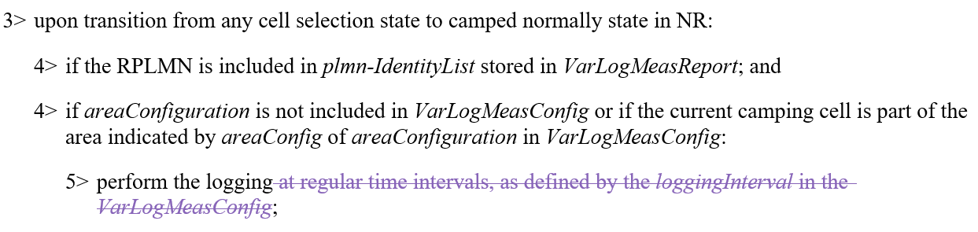  The LTE CR should be updated as following:  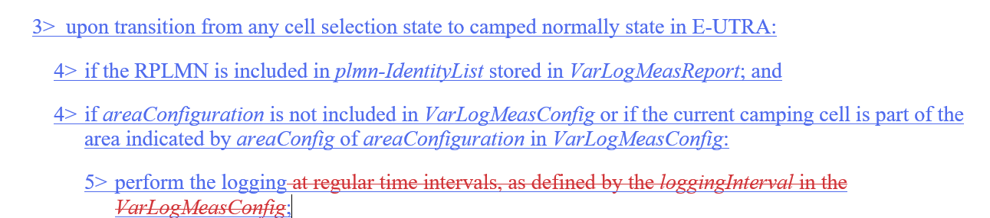

In [6], need for UE capability for this feature was discussed. RAN2 agreed that “If we agree to the proposal, UE capability is needed.” Further the corresponding 36.331 and 36.306 CRs propose one bit for UE capability.
Question 3: For indicating support for the two new event triggered measurement logging, should RAN2 add a single capability bit or two separate UE capability bits (for each event)?
Company | Single capability bit/ Two separate capability bits | Comments
Intel | Two | As two features seem different in implementation. Two bits seem to be more reasonable.
CATT | Single capability bit | In NR, only a single bit is defined for normal logged MDT (except for WLAN and BT), and a UE that supports logged measurements shall support both periodical logging and event-triggered logging. Therefore the possible 2 events for the event triggered logging introduced in the same release (Rel-17) of LTE only needs a single capability bit.
Huawei, HiSilicon | Either | In NR, the UE capability indication loggedMeasurements-r16 is coupled with both periodical logging and event-triggered logging. In LTE, the UE capability indication loggedMeasurementsIdle is coupled with periodical logging.  We slightly prefer single capability bit because both event triggered measurements are useful, and we also see the flexibility of having two bits.
Ericsson | Single capability bit | We do not see big impacts on the UE implementation side on keeping a single capability bit for both these events. If there is a good motivation why there should be two capability bits, we are happy to discuss.
Qualcomm | Two | The features are different in implementation. Two separate bits would be easier for implementation and testing.

One of the discussion scope is “details of event-triggered logged MDT for LTE (i.e. how it would work)”.
The assumption/intent so far seems to be that the procedures for the two new events in LTE would be same as in NR.
Companies are encouraged to provide any comments or clarification on the operation of the new events, specially if it is expected to be different from NR.
Question 4: Provide any comments or clarification on the operation of the new events, specially if it is expected to be different from NR.
Company | Comments (any difference from NR?)

As NR is still discussing on similar topics, further enhancements in NR cannot be ruled out. (See for example the CR related to Question 1 above.)
Assuming the baseline procedures for the two new events in LTE is assumed to be same as in NR, if there are further enhancements related to event-triggered logged MDT in NR in upcoming meetings, it may be beneficial to avoid longer discussions in the future and adopt the principle that those would be ported-back to LTE as well. Of course this would be just a “principle” and exact changes would need to be discussed and agreed case by case.
Question 5: Should RAN2 agree to the principle that if there are further enhancements related to event-triggered logged MDT in NR in upcoming meetings, those would be ported-back/adopted to LTE if possible?
Company | Yes/No | Comments
Intel | Yes | Agreement add a little flexibility > “that if there are further enhancements related to event-triggered logged MDT in NR in upcoming meetings, those would be ported-back/adopted to LTE if possible”
CATT | Maybe | We think this can be discussed on a case by case basis. So perhaps no need to have such general conclusion at the moment.
Huawei, HiSilicon | Maybe | We think the further enhancements should be discussed case by case.
Ericsson | Case by case | We would like to highlight one discussion from RAN2#115 meeting.  During the online session in NR SON-MDT WI Rel-16 corrections, an operator expressed interest in introducing logging of measurements when the UE is in ‘camped on any cell’ state. It was said that such an enhancement is too late for Rel-16 corrections but may be such enhancements could be discussed in this TEI related work directly as it is related to out of coverage related enhancements?
Qualcomm | Yes | As noted above, this should be just a “principle” and the exact changes would need to be discussed and agreed case by case.  Regarding comment/suggestion from Ericsson: at least we have not found any benefit of logging measurements of acceptable cells in ‘camped on any cell’ state. Logged MDT is used for coverage optimizations for the normal operation. Coverage optimization considering camped normally state and any cell selection state should be sufficient as it will optimize the coverage for both emergency services as well as normal services. But we are open to understand further what other benefits may be achieved by logging acceptable cell info and measurements.

2.2 CRs
This section is for comments on the previously submitted CRs, which may be useful for updating/drafting the CRs as required.
Given that this is a TEI17 item, rapporteur thinks there should be no more than one CR per impacted spec. This means following CRs should be merged, along with making further changes identified, if any, in conclusion of other questions (above or below):
- For TS 36.331: merge the CRs in [2] and [6]
- For TS 37.320: merge the CRs in [3] and [7]

Question 6: Any comment on merging [2]+[6] and [3]+[7] and making further changes identified, if any, in conclusion of other questions (above or below)? [Please avoid CR-specifc comments here, as there are questions for each CR below]
Company | Comments

For the actual changes in the CRs, please provide your comments in the respective tables below, including whether the corresponding CR is needed/not needed. These comments will be helpful to update the CRs as needed.

Question 7: Comments on CR for TS 36.304: [8] R2-2108560
Company | Comments

Question 8: Comments on CR for TS 36.306: [5] R2-2108557
Company | Comments

Question 9: Comments on CR for TS 36.331: [2] R2-2109027 + [6] R2-2108558
Company | Comments
Qualcomm | Change in 5.6.8.2 should be updated as follows:

Question 10: Comments on CR for TS 37.320: [3] R2-2109028 + [7] R2-2108559
Company | Comments

2.3 Other
Question 11: Anything else that is not covered by above questions? Please explain.
Company | Comments

3 Conclusion
[To be added later]

4 References
[1] R2-2108831 Report on LTE legacy, 71 GHz, DCCA, Multi-SIM and RAN slicing
[2] R2-2109027 Introduction of event-based trigger for LTE MDT logging, KDDI Corporation, CMCC, Telecom Italia, Samsung, Ericsson [36.331]
[3] R2-2109028 Introduction of event-based trigger for LTE MDT logging, KDDI Corporation, CMCC, Telecom Italia, Samsung, Ericsson [37.320]
[4] R2-2108556 Discussion on event triggered logged MDT for LTE, Huawei, HiSilicon
[5] R2-2108557 CR to 36.306 on event triggered logged MDT for LTE, Huawei, HiSilicon
[6] R2-2108558 CR to 36.331 on event triggered logged MDT for LTE, Huawei, HiSilicon
[7] R2-2108559 CR to 37.320 on event triggered logged MDT for LTE, Huawei, HiSilicon
[8] R2-2108560 CR to 36.304 on event triggered logged MDT for LTE, Huawei, HiSilicon

