GPP TSG-RAN WG2 Meeting #115-e R2-21xxxxx
Online, 9th – 27th August, 2021

Agenda Item: 8.5.3
Source: MediaTek Inc.
Title: Summary of [Post114-e][510][URLLC/IIoT] Open issues for UCE (Mediatek)
Document for: Discussion and decision

1 Introduction
This email discussion focusses on the remaining open issues associated with IIoT operation over unlicensed controlled environments (UCE), following the following agreements reached at R2#114e [1].
Agreements:
- When both of lch-based Prioritization and cg-RetransmissionTimer are configured, HARQ processes sharing between multiple CG configurations are allowed. No specification change is required.
- RAN2 confirm that neither autonomous transmission nor autonomous retransmission is triggered if UL grant is prioritized and LBT fails while AutonomousTx is configured and cg-RetransmissionTimer is not configured. No specification change is required.
- RAN2 confirm that autonomous retransmission is triggered if UL grant is prioritized and LBT fails while AutonomousTx is not configured and cg-RetransmissionTimer is configured. No specification change is required
- RAN2 confirm that autonomous retransmission is triggered if UL grant is prioritized and LBT fails while AutonomousTx and cg-RetransmissionTimer are configured. No specification change is required.
- RAN2 confirm that autonomous transmission is triggered if UL grant is deprioritized while AutonomousTx is configured and cg-RetransmissionTimer is not configured. No specification change is required.
- RAN2 confirm that autonomous transmission is triggered if the transmission of the obtained MAC PDU has not been completely performed and if UL grant is deprioritized while AutonomousTx and cg-RetransmissionTimer are configured. No specification change is required.
- The HARQ process is kept as pending even if a CG is de-prioritized while the HARQ state of the associated HARQ process is pending (i.e. MAC PDU hasn’t been transmitted). No specification change is required
- When cg-RetransmissionTimer and lch-basedPrioritization are configured, for overlapping CGs, the MAC entity prioritizes the initial transmission of higher priority data over autonomous retransmission of lower priority data. FFS how to implement this in Rel-17 after some of the Rel-16 discussion takes place

2 Discussion

2.1 Mechanism for HARQ process ID selection
In R2#112e, the following was agreed [2]:
- When cg-RetransmissionTimer is configured, Rel-16 NR-U mechanism is used for HARQ process ID and RV selection.
- When cg-RetransmissionTimer is not configured, Rel-16 URLLC mechanism may be used for HARQ process ID and RV selection.

This topic was discussed in [3], and RAN2 decided to wait for RAN1 to progress further on the topic before reaching a decision [1]. The discussion in RAN1 has progressed in R1#105e, with the following agreement [4]:
Agreement:
- Option 1 is taken in the following agreement:
Agreement:
Down-select one of the following options (target RAN1#104-e):
- Option 1: Both “CG-UCI based procedures” and “CG-DFI based procedures” are enabled or disabled for unlicensed using one RRC parameter i.e. cg-RetransmissionTimer-r16.
- Option 2-a: “CG-UCI based procedures” and “CG-DFI based procedures” are independently enabled or disabled for unlicensed using respective RRC parameter, i.e. new parameter X and cg-RetransmissionTimer-r16, respectively.
  - If cg-RetransmissionTimer-r16 is configured, “CG-UCI based procedures” should also be enabled by X.
- Note: Procedures based on CG-UCI rely on UE including CG-UCI in CG PUSCH at least as in Rel-16 where the values of the respective fields of CG-UCI are decided by UE.
- Note: Procedures based on CG-DFI rely on automatic re-transmission on CG configuration and reception of CG downlink feedback information (DFI) in DCI for re-transmissions

With the option that’s agreed in RAN1, effectively if cg-RetransmissionTimer is not used, the CG-UCI is also not used. From this agreement, it is fairly obvious that if cg-RetransmissionTimer is not configured, the NR-U mechanism for HARQ process ID and RV selection cannot be used, as the NR-U mechanism requires the use of CG-UCI. Therefore the rapporteur proposes the following modification to the earlier RAN2 agreement:
Proposal: When cg-RetransmissionTimer is not configured, Rel-16 URLLC mechanism is used for HARQ process ID and RV selection.
Question 1: Do companies agree with the modified proposal above? If not, please provide further details on how you foresee HARQ process ID selection to work alongside RAN1’s agreement.
Company | Yes/No | Comments
vivo | Yes | Agree with the rapporteur’s analysis.
TCL | Yes
Ericsson | Yes
Nokia | Yes
Lenovo | Yes
Samsung | Yes
Fujitsu | Yes
CATT | Yes | We agree this is a consequence of the RAN1 agreement
InterDigital | Yes
LG | Yes
Qualcomm | Yes
ZTE | Yes
III | Yes
OPPO | Yes

2.2 HARQ process ID selection details
The NR-U behaviour has been further clarified for Rel-16 as below [5]:
For configured uplink grants configured with cg-RetransmissionTimer, the UE implementation selects an HARQ Process ID among the HARQ process IDs available for the configured grant configuration. For HARQ Process ID selection, the UE shall prioritize retransmissions before initial transmissions.
This update to the specification clarifies that the statement ‘UE shall prioritize retransmissions before initial transmissions’ only applies to HARQ process ID selection done by the UE.

2.2.1 Single CG configuration
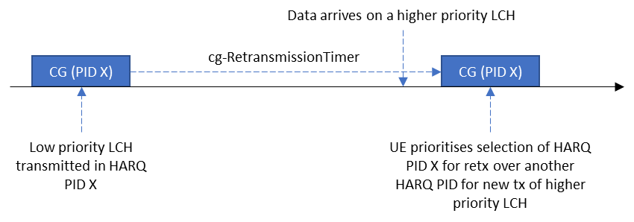
Figure 1: Rel-16 behaviour for HARQ PID selection with a single CG

In this section, we focus on the single CG configuration case. As per the Rel-16 agreement, the baseline behaviour for NR-U is as illustrated in Figure 1.
In case of IIoT operation in UCE, when lch-basedPrioritization and cg-RetransmissionTimer are jointly configured, the question is whether we need to change this baseline NR-U behaviour. This was discussed in [3] along with the various means to do so. Therefore, the following question is posed:
Question 2: What should the HARQ process ID selection behaviour be in the MAC entity for a single configured grant configuration, when lch-basedPrioritization and cg-RetransmissionTimer are both configured?
Option 1: No change to the Rel-16 baseline (MAC entity prioritises the selection of HARQ process IDs for retransmissions over the selection of HARQ processes for initial transmissions)
Option 2: MAC entity prioritises the selection of a free HARQ process ID (if available) to transmit higher priority data (if present).
Option 3: NW configures whether to follow Option 1 or Option 2
Option 4: Other (please explain)
Company | Preferred option(s) | Comments
vivo | Option1 | In our understanding the NW will map LCHs with similar priorities to a CG configuration. Hence, the benefit of applying lch-basedPrioritization mechanism among different HARQ processes associated with the CG configuration is limited.
TCL | Option1 | Prefer Rel-16 baseline, but open to other choices.
Ericsson | Option 1 | We do not see a need for any spec changes to Rel-16 behaviour. The network would configure different CGs for different LCHs, if there is a need for prioritization between different LCHs.  For option 2, as already stated by the rapporteur, there are further complexities, like what happens due to unavailability of HARQ process, e.g., flushing the existing retransmission HARQ buffers or exceptional retransmission of non-prioritized data.
Nokia | Option 1 but … | However, we think Rel-16 baseline behaviour should be modified slightly such that retransmission corresponding to MAC PDU without any data should not be prioritized. This is related to Q9.
Lenovo | Option 2 | We don’t think that it is sensible that a high priority PDU (URLLC) is delayed by the retransmission of a low priority PDU. The NR-U behaviour was discussed in Rel-16 without having URLCC traffic in mind. For URLLC traffic, a lot of enhancements have been introduced in order to ensure that high priority traffic meets the strict latency requirements by prioritization, pre-emption, etc. We think that an autonomous retransmission should be handled as any other CG transmission and hence UE shall perform the prioritization functionality also for autonomous retransmissions, i.e. retransmission triggered by LBT failure. For the case shown in the figure UE shall transmit the high priority data and postpone the autonomous retransmission to a later subsequent uplink configured grant satisfying the criteria for an autonomous retransmission.
Samsung | Option 1 | In Rel-16, we have introduced LCP restrictions, i.e. allowedCG-list and allowedPHYpriorityIndex for dedicated resource usage for each logical channel conveying URLLC/IIOT data. This means that a given configured grant’s allowed logical channels should be almost equal priority and have similar importance. Therefore, there is no need to differentiate HARQ processes.
Fujitsu | Option 1 | The baseline would be Rel-16.
CATT | Option 1 | There is a similar mechanism in R16 IIOT for autonomous transmissions of deprioritized PDUs in the same configured grant configuration, and it has not raised concerns.
InterDigital | Option 2 | This is the main use case for R17 UCE, whereby high priority URLLC data is transmitted before other pending retransmissions of lower priority. Otherwise high priority data can face starvation, and the service requirements won’t be met.  Mandating configuring a CG per priority and corresponding LCP restriction limits flexibility and can further lead to delays when the CG for the associated priority is not available.  Regarding Ericsson's comment on "further complexities, like what happens due to unavailability of HARQ process, e.g., flushing the existing retransmission HARQ buffers", that's not the proposal in option 2, as indeed initial transmissions are only possible if a HARQ process is available.
LG | Option 1 | LCH restriction is one of key features for URLLC to serve logical channel with different priorities differently. Thus, we see no point of configuring logical channel with different priorities to the same CG and further enhance the prioritization mechanism for such configuration. Furthermore, within the same CG, if higher priority data is selected to be transmitted, retransmission of de-prioritized transmission is not possible because the HARQ buffer is already replaced by prioritized transmission. That is contrast to the handling of de-prioritized transmission in Rel-16, i.e., autonomous transmission, which has not been justified well.
Qualcomm | Option 2 | We think high-priority URLLC data should be prioritized as a rule over low-priority data. This is the NR principle of prioritization to guarantee URLLC data is not delayed beyond PDB. We point to a few things:  - A high priority PDU should utilize an available CG whenever possible. It does not make sense for HP traffic latency to depend on whether they are contending with an initial LP transmission or a LP retransmission.  - Opposing companies point out that proper prioritization can be guaranteed by configuration of multiple CG restrictions. Multiple CGs is an optional UE capability. This means that the proposed configuration solution would only work optionally for some UEs. For UEs without that capability, the flexibility is severely limited for the scheduler as the available CG would likely only go to the highest priority traffic whereas all other deterministic periodic traffic would have to be dynamically scheduled.  - Multiple CGs carry overheads, so if a single CG solution is optimal for some use cases, we should not force the network to configure a CG for each priority as implied by some comments.  - Without this feature, the overall URLLC packet latency would depend on the state of the other transmissions and UE capability, which is not a desired behaviour.  - Even for multiple configured grants, two PDUs being allowed to use a configured grant does not necessarily mean that the NW intends that those PDUs have the same priority/importance. HARQ sharing was allowed in NR-U so that a failed PDU can use a different CG (than the one used in initial Tx) to quickly attempt a re-tx after an LBT failure. In that case, the NW may very well have periodic LP traffic and sporadic HP traffic, and allow the LP traffic to re-tx on the CG configured for the HP sporadic traffic. This is an important use case in IIoT and it is not a correct assumption that a good configuration always rules that out.
ZTE | Option 1 | We tend to share the same view that the LCH restriction can deal with the issue properly, we do not think of introducing a new mechanism for a possible barely happened case (i.e One CG is responsible for the data transmission with dissimilar priorities) is a smart decision, especially which may introduce the extra complexity for the transmission operation
III | Option 1 | We think no change to the Rel-16 baseline.
OPPO | Option 1 | We prefer to keep R16 as baseline, since it is the case for a single CG configuration and the LCH restriction can well deal with the issue mentioned.

2.2.2 Multiple overlapping CG configurations without shared HARQ processes
From [3], it was unclear whether the current specifications support the following agreed behaviour:
When cg-RetransmissionTimer and lch-basedPrioritization are configured, for overlapping CGs, the MAC entity prioritizes the initial transmission of higher priority data over autonomous retransmission of lower priority data. FFS how to implement this in Rel-17 after some of the Rel-16 discussion takes place
Therefore, we break the problem down further. In this section, we focus on the case where the UE is configured with multiple overlapping CGs, where HARQ processes are not shared between different CGs
In this scenario, the Rel-16 rule to prioritise selection of a HARQ PID for retransmission over a HARQ PID for a new transmission only applies within a CG configuration (as HARQ processes are not shared). Therefore, in the example shown in Figure 2, the UE chooses a HARQ PID X for CG1 and a different HARQ PID Y for CG2. Following this HARQ process selection procedure, LCH prioritisation rules determine whether CG1 or CG2 is transmitted, depending on which CG carries higher priority LCH data.

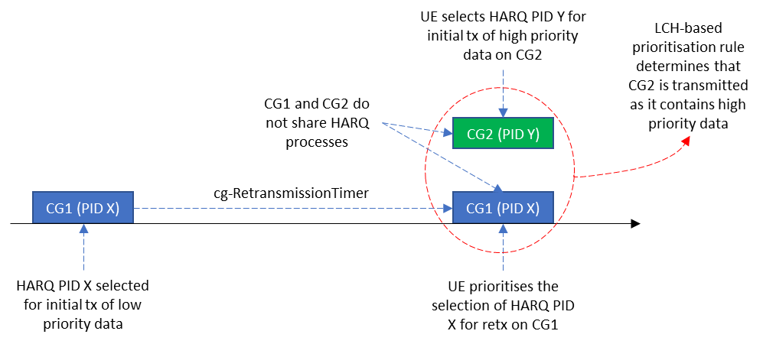
Figure 2: Multiple overlapping CGs without shared HARQ processes

Question 3: When lch-basedPrioritization and cg-RetransmissionTimer are configured, and multiple overlapping CGs do not share HARQ processes, do companies agree that the following behaviour is already supported by the current specifications:
- The HARQ PID selection rule (which may be updated as per Question 2) applies to HARQ PID selection for each CG occasion
- lch-basedPrioritization rules determine the CG that will be prioritised for transmission by the MAC entity
If not, please provide further details on how the current specifications would work.
Company | Yes/No | Comments
vivo | Yes
TCL | Yes
Ericsson | Yes
Nokia | Yes
Lenovo | Yes
Samsung | Yes
Fujitsu | Yes
CATT | Yes | In MAC specification, in Clause 5.4.1, the HPID selection and LCH-based prioritization procedures are performed sequentially, where the HPID selection is performed first, and then the LCH-based prioritization. Therefore, if the CGO selected for the autonomous retransmission overlaps with another CG, it can then be deprioritized by the LCH-based prioritization procedure.
InterDigital | Yes
LG | Yes
Qualcomm | Yes | The updated spec text implies the HARQ ID selection (from the available pool) would prioritize retransmission first, then the LCH priority would be compared after selection in case of overlap.
ZTE | Yes
III | Yes
OPPO | Yes

Question 4: As a follow-up to Question 3, do companies foresee the need for further changes to implement the following agreement for the case where HARQ processes are not shared between CGs? If yes, please explain what further changes are needed.
Agreement: When cg-RetransmissionTimer and lch-basedPrioritization are configured, for overlapping CGs, the MAC entity prioritizes the initial transmission of higher priority data over autonomous retransmission of lower priority data.
Company | Yes/No | Comments
vivo | No
TCL | No
Ericsson | No
Nokia | No
Lenovo | No
Samsung | No
Fujitsu | No | But we are open to discuss if there is unclarity in specifications.
CATT | No
InterDigital | No
LG | No
Qualcomm | No
ZTE | No
III | No
OPPO | No

2.2.3 Multiple overlapping CG configurations with shared HARQ processes
In this section, we focus on the case where the UE is configured with multiple overlapping CGs, where HARQ processes are shared between different CGs.
In the Rel-16 NR-U discussions, the case of overlapping configured grants were not considered. However, when lch-basedPrioritization is configured, overlapping configured grants can exist. Going through the current spec, the following specification conditions would be applicable in the case where cg-RetransmissionTimer and lch-basedPrioritization are both configured:
If cg-RetransmissionTimer is configured, retransmissions with the same HARQ process may be performed on any configured grant configuration if the configured grant configurations have the same TBS.
…
For configured uplink grants configured with cg-RetransmissionTimer, the UE implementation selects an HARQ Process ID among the HARQ process IDs available for the configured grant configuration. For HARQ Process ID selection, the UE shall prioritize retransmissions before initial transmissions.
…
NOTE 6: If the MAC entity is configured with lch-basedPrioritization and if there is overlapping PUSCH duration of at least two configured uplink grants whose priorities are equal, the prioritized uplink grant is determined by UE implementation.
When multiple overlapping CGs share HARQ processes and have the same TBS, the UE prioritises the selection of a HARQ PID that is for retransmission over the selection of a PID for a new transmission. Since both CGs prioritise the same HARQ PID, they carry the same data and the condition in Note 6 would apply, i.e. the UE implementation determines which CG is to be transmitted. This is illustrated in Figure 3 below.
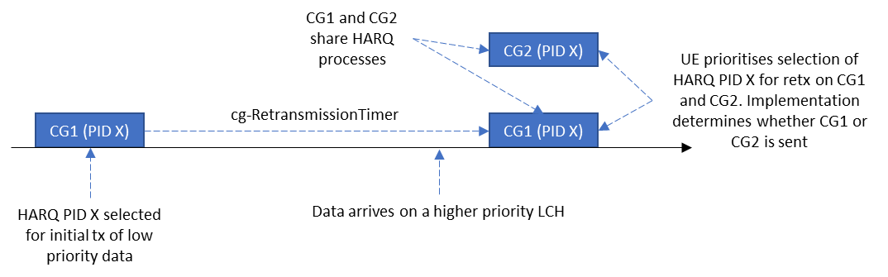
Figure 3: Current behaviour when multiple overlapping CGs share HARQ processes

Question 5: When HARQ processes are shared between multiple overlapping CG occasions with the same TBS, do companies agree that the same HARQ PID selection rule (which may be updated as per Question 2) applies to all CGs?
Company | Agree/Disagree | Comments (including the need for further specification changes)
vivo | Agree, but | We agree that the same HARQ PID selection rule should be applied to all CGs, but we do not agree that the same HARQ PID(i.e. PID X) is selected by CG1 and CG2 in the above Fig3.  Quotes from TS38.321:  For configured uplink grants configured with cg-RetransmissionTimer, the UE implementation selects an HARQ Process ID among the HARQ process IDs available for the configured grant configuration.  Let’s assume UE performs HARQ selection for CG1 before CG2 in the example illustrated in Fig3. When HARQ PID X is selected for CG1, the HARQ PID X is not available and cannot be selected for other CGs. Therefore, it is our understanding that the overlapping CGs can never select the same HARQ process.
TCL | Agree | Agree with vivo, the same HARQ PID selection rule should be applied, but the same HARQ PID selected for overlapping CGs does not work.
Ericsson | Agree | No need for further spec change. If the HARQ process is shared, then it means that there is no need to prioritize between these two CGs and so the illustration works.
Nokia | Agree | We also don’t think that the UE would select the same HARQ process ID for both CG1 and CG2 in practice, even if they are shared. But this is purely UE implementation issue.
Lenovo |  | We have the same understanding as Vivo that UE would not select the same HARQ process ID for both overlapping CGs. UE can select on which CG to transmit the autonomous retransmission. And a different HARQ Process ID is then chosen for the other CG.
Samsung | Agree | The text quoted by vivo, i.e. “available” did not consider the case that one HP is selected by a different CG occasion, since IIOT did not allow HPI sharing.  Anyway, we think the rapporteur’s understanding is correct.
Fujitsu | Agree | Similar view with comments above.
CATT | Agree but | We also agree with vivo that the figure is not 100% correct regarding the “double” allocation of the same HPID to different CGs. HARQ processes for autonomous retransmissions are assigned first and then the HARQ processes for new transmissions. This is because, when performing an autonomous retransmission, the NR-U protocol must first select a CG opportunity (CGO) where to perform the autonomous retransmission, and then it assigns this CGO to the autonomous retransmission by selecting for it the same HPID as the initial transmission. And this can, in principle, be initiated right after an LBT failure so is anterior to the processing of new transmissions.
InterDigital | Agree | The rule applies for all CGs that share the HARQ process, and implementation selects which CG
LG | Agree | HPID selection rule is applied to each of CG1 and CG2. In other words, the UE will select PID X to CG1 and CG2. Then, the UE will select which to send according to the NOTE 6. Consequently, the UE implementation will determine whether to send CG1 or CG2.
Qualcomm | Agree | Agree with rapporteur understanding on the current R16 behavior. The UE will pick a CG and perform autonomous re-tx on that CG using the same HARQ PID as the initial Tx. Which CG to pick is up to UE implementation.  Spec changes needed: Allow the network configuration to change this behaviour by allowing higher priority traffic to use on of the overlapping CGs to transmit HP traffic. This is in line with the previous RAN2 agreement=>“When cg-RetransmissionTimer and lch-basedPrioritization are configured, for overlapping CGs, the MAC entity prioritizes the initial transmission of higher priority data over autonomous retransmission of lower priority data.”. No good reason to make the NR-U rule carry over to the case where URLLC LCH priorities are configured.
ZTE | Agree,but | Agree with that the HARQ process ID selection is performed in a same way for all CGs. We also share the same view with VIVO, even though the HARQ process handling is in the same way among different CGs, but it seems so weird for UE to allocate two CG occasion of the same HARQ process ID. Therefore, for Q6, it is obvious, if one CG occasion is allocated with the HARQ ID X to perform re-transmission, then the other CG occasion shall be allocated with the ID other than x to perform the HP data transmission.  If lch-basedPrioritization is NOT configured, According to the note 6, in Rel16, it is up to UE implementation to perform either re-transmission of LP MAC PDU or new transmission of HP MAC PDU.  If lch-basedPrioritization is configured, according to the understanding from us in question 4, the initial transmission of the HP data shall be performed.
III | Agree | We share the same view with vivo. Not agree that the same HARQ process ID is selected by two overlapping CGs.
OPPO | Agree | Agree that the same HARQ PID selection rule applies to all CGs. It is possible the same HARQ process ID is selected by the overlapped CGs.

Question 6: If the answer to Q5 is yes, do companies agree that the same HARQ PID would be selected for all overlapping CG occasions and it is up to UE implementation to determine which CG is transmitted?
Company | Agree/Disagree | Comments (including the need for further specification changes)
vivo | Disagree | See our comments to Q5.
TCL | Disagree | The same HARQ PID for all overlapping CG would not work, further discussion in detail is needed for this case.
Ericsson | Agree | There is no need for further spec change. It is up-to UE implementation to determine which CG is transmitted. In other words, it does not matter what the UE has chosen as the HARQ process ID for the unused CG.
Nokia | Disagree on HARQ PID selection;  Agree on CG selection | We don’t think the UE would select the same HARQ PID for these overlapping CGs in this case. But anyway the UE implementation would only select one CG for transmission, so HARQ PID selection does not really affect. We do not foresee any specification impact in any case.
Lenovo | Disagree | We think that for the CG selection the URLLC intra-UE prioritization rules should be used, i.e. high priority data should be transmitted.
Samsung | Agree
Fujitsu | Agree | We understand that Q6 talks about CG selection and HARQ PID selection is not the matter.
CATT | Disagree | See answer to Q5.
InterDigital | Disagree | It does not necessarily need to be the same HARQ process for overlapping CGs, but agree that the UE implementation determines which CG to select and transmit on.
LG | Agree | After selecting the same HPID for all CGs, the UE implementation will select one of them. For the unselected CG, the selected HPID is after all unnecessary but the current specification reads like this and we see no problem with it.
Qualcomm | Agree | One of the CGs (chosen by the UE) would be used for autonomous retransmission using the re-tx HARQ PID. From our view, how the UE allocates HARQ PID to the unused CG is not specified by the spec since the CG is dropped anyway.  Spec changes needed: Allow the network configuration to change this behaviour by allowing higher priority traffic to use on of the overlapping CGs to transmit HP traffic. This is in line with the previous RAN2 agreement=>“When cg-RetransmissionTimer and lch-basedPrioritization are configured, for overlapping CGs, the MAC entity prioritizes the initial transmission of higher priority data over autonomous retransmission of lower priority data.”. No good reason to make the NR-U rule carry over to the case where URLLC LCH priorities are configured.
ZTE | Disagree | See comments of Q5
III | Disagree
OPPO | Agree | No need for spec change.

2.3 Deprioritised UL grant when autoTx is not configured and CGRT is configured
At R2#113e [6], we reached the following agreement:
- AutoTx and CGRT are responsible for deprioritized MAC PDU and LBT-failed MAC PDU, respectively. If CGRT is not configured, LBT-failed MAC PDU is not retransmitted. If AutoTx is not configured, deprioritized MAC PDU is not retransmitted.
- the MAC entity stops cg-RetransmissionTimer when the CG resource associated with the timer is deprioritized due to LCH-based prioritization.
As per the current specifications, if the configuredGrantTimer is running and the cg-RetransmissionTimer is not running, the UE triggers autonomous retransmissions. Also, if the UE is not configured with autonomousTx, the configuredGrantTimer will run even if a MAC PDU is deprioritised.
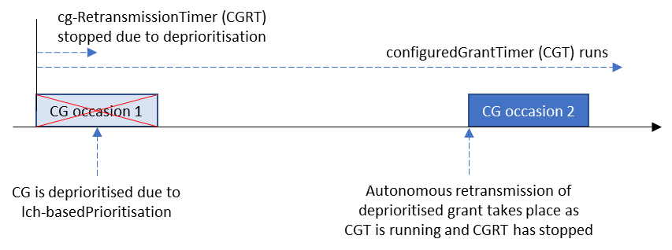
Figure 4: Current behaviour if cg-RetransmissionTimer is stopped when an UL CG is deprioritised

Therefore, if we follow the second agreement above, transmission of the deprioritised MAC PDU takes place on the next CG occasion as the cg-RetransmissionTimer would not be running, as illustrated in Figure 4 above. This behaviour contradicts the first highlighted agreement above i.e. ‘if AutoTx is not configured, deprioritized MAC PDU is not retransmitted’. This was discussed extensively in [3] with the following proposal made:
Proposal 10: (Out of 20, 7 for no preferred option, 11 for option 2, 2 for option 3, 1 for option1) RAN2 further discuss whether option 2 or no option is needed if UL grant is de-prioritized while AutonomousTx is not configured and cg-RetransmissionTimer is configured.
- Option 2. If a CG is not configured with autonomousTx, the cg-RetransmissionTimer is not stopped when the associated CG is deprioritized [13]
It should be noted that even if we follow option 2 above, it only delays the autonomous retransmission to after the expiry of the cg-RetransmissionTimer, but a retransmission of the deprioritised PDU will still take place in contradiction with the first highlighted agreement, i.e. ‘if AutoTx is not configured, deprioritized MAC PDU is not retransmitted’. This is illustrated in Figure 5 below.
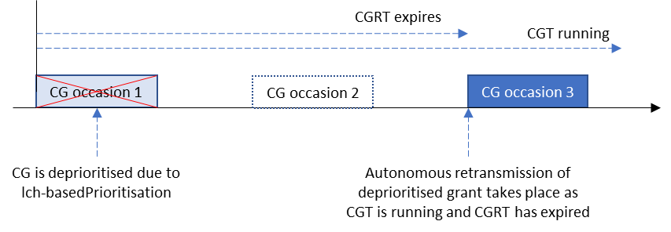
Figure 5: Current behaviour if cg-RetransmissionTimer is not stopped when an UL CG is deprioritised

Going back to first principles, it would be good to agree the expected UE behaviour, and the discussion on how to implement this behaviour in the specification can follow. Therefore the following question is posed:
Question 7: Which option do companies prefer?
Option 1: If autoTx is not configured, confirm the earlier agreement that a deprioritised MAC PDU is not retransmitted autonomously
Option 2: If autoTx is not configured, modify the earlier agreement to allow autonomous retransmission of a deprioritised MAC PDU
Company | Preferred option | Comments (reasons for preference, implementation details)
vivo | Option2 | In RAN2-113e, we reach the agreement that If AutoTx is not configured, deprioritized MAC PDU is not retransmitted.  In our understanding, the exact meaning of the agreement is if autoTx is not configured, deprioritised MAC PDU is not retransmitted according to the R16 URLLC autonomous transmission mechanism. As autoTx is configured to CG configuration to enable R16 URLLC autonomous transmission for deprioritised MAC PDU.  However, the autonomous retransmission in Fig4 and Fig5 is triggered by NR-U retransmission mechanism, which is enabled by configuring cg-RetransmissionTimer. Hence, we see no reason to disable autonomous retransmission according to the NR-U retransmission mechanism if cg-RetransmissionTimer is configured, no matter autoTx is not configured or not.
TCL | Option2
Ericsson | Option 2 | Firstly, the wording in option 2 should be clarified that “if AutoTx is not configured, deprioritized MAC PDU is not retransmitted by AutoTx mechanisms but can be retransmitted due to CGRT expired/stopped”.  Secondly, the previous agreement below  - the MAC entity stops cg-RetransmissionTimer when the CG resource associated with the timer is deprioritized due to LCH-based prioritization.  would stop the CGRT earlier than letting it to be expired. gNB may not prefer so since it may want to transmit a retransmission grant with a different MCS rather than relying on autonomous re-tx in the next CG. We are fine to further clarify the above agreement to implement the option 2 in the last email discussion [3]:  - the MAC entity stops cg-RetransmissionTimer when the CG resource associated with the timer is deprioritized due to LCH-based prioritization and CG is configured with autoTx.  This is the same as the option 2 in [3]:  If a CG is not configured with autonomousTx, the cg-RetransmissionTimer is not stopped when the associated CG is deprioritized [13]
Nokia | Option 2 | We think some clarifications are needed for the previous agreements. In particular:  - AutoTx and CGRT are responsible for deprioritized MAC PDU and LBT-failed MAC PDU, respectively. If CGRT is not configured, LBT-failed MAC PDU is not retransmitted. If AutoTx is not configured, deprioritized MAC PDU is not retransmitted.  For this agreement, we should clarify that the “deprioritized MAC PDU is not transmitted in subsequent CG based on AutoTX mechanism”  - the MAC entity stops cg-RetransmissionTimer when the CG resource associated with the timer is deprioritized due to LCH-based prioritization.  For this agreement, we should clarify that this behaviour of stopping CGRT is only applicable when AutoTX is configured.
Lenovo | Option 2 | We agree with Nokia
Samsung |  | The case of Figure 5 is a typical procedure of LBT failure by expiry of CGRT. Even though the uplink grant was de-prioritized, the autonomous retransmission occurs due to the LBT failure, not to de-prioritization.  We think “If AutoTx is not configured, deprioritized MAC PDU is not retransmitted.” means “de-prioritized MAC PDU is not transmitted by autoTx” I does not mean any of retransmission mechanisms (e.g. by autonomous retransmission or by dynamic grant) are prohibited. So, if LBT failure happens later, autonomous retransmission after CGRT expiry is a very natural behaviour. As we know, the case of CGRT expiry and CGT running can be always interpreted as LBT failure.  Anyway, we generally agree with Ericsson and Nokia’s suggestion that Option 2 in the last meeting  “Option 2. If a CG is not configured with autonomousTx, the cg-RetransmissionTimer is not stopped when the associated CG is deprioritize” resolves the problematic case that 1) LBT failure does not happen and 2) CGRT expires and CGT is running. We this this Option 2 is only needed.
Fujitsu | Option 2 | It is good to clarify the intention of agreement like Option 2.
CATT | Option 1 | Not only this agreement resulted from a long debate and was carefully written to capture the majority of views (with many companies compromising for it) but it also reflects the principle that cg-RetransmissionTimer and autonomousTx keep controlling the autonomous (re)transmissions of NR-U and IIOT, respectively, as in R16. Specifically, for deprioritized PDUs in R16 IIOT, it is important to leave to NW the freedom to disable the autonomous transmission feature to prevent an autonomous transmission to block a new transmission in the next CGO. This would indeed be undesired when a CG configuration is expected to only address initial transmissions of a periodic deterministic traffic (as captured for example in Table 5.2-1 of TS22.104) and as illustrated in the below figure. For such traffic type, the network could prefer to either handle the deprioritized PDU via gNB dynamic retransmission grant, or just abandon it if it would anyways result in the PDU to not meet the end-to-end latency requirement.  The original RAN2#112-e agreement can be captured in a simple manner by dedicating the NR-U autonomous retransmission branch in 38.321 Clause 5.4.1 to NR-U failure causes by preventing its usage by deprioritized PDUs:  1> if the MAC entity is not configured with lch-basedPrioritization, and the PUSCH duration of the configured uplink grant does not overlap with the PUSCH duration of an uplink grant received on the PDCCH or in a Random Access Response or the PUSCH duration of a MSGA payload for this Serving Cell:  2> set the HARQ Process ID to the HARQ Process ID associated with this PUSCH duration;  2> if, for the corresponding HARQ process, the configuredGrantTimer is not running and cg-RetransmissionTimer is not configured (i.e. new transmission):  3> consider the NDI bit for the corresponding HARQ process to have been toggled;  3> deliver the configured uplink grant and the associated HARQ information to the HARQ entity.  2> else if the cg-RetransmissionTimer for the corresponding HARQ process is configured and not running, then for the corresponding HARQ process:  3> if the configuredGrantTimer is not running, and the HARQ process is not pending (i.e. new transmission):  4> consider the NDI bit to have been toggled;  4> deliver the configured uplink grant and the associated HARQ information to the HARQ entity.  3> else if the previous uplink grant delivered to the HARQ entity for the same HARQ process was a configured uplink grant which was not deprioritized (i.e. retransmission on configured grant):  4> deliver the configured uplink grant and the associated HARQ information to the HARQ entity.
InterDigital | Option 1 | - Option 2 is the same as the option 3 excluded 2 meetings ago, which was about using NR-U framework to retransmit a deprioritized PDU. now rebranded as option 2.  - The implication of the already agreed Option 1 is that the network should configure AutoTx if it also configures LCH-based prioritization for the CG, to support the autonomous retransmission of the deprioritized PDU. It is not clear what use case requires configuring CGRT and LCH-based prioritization, but not AutoTx.  - Option 2 just delays the transmission of the deprioritized PDU, even though there's no failed LBT, rather than prevent it. So this proposal obviously does not implement the agreement but rather reverts it.  given there is no clear use case for this configuration, we think it’s better to stick to the current agreement.
LG | Option 2 | In our view, there was an intention from the previous agreement that further enhancement is not considered to cope with the LBT failure by autonomous transmission or deprioritized transmission by auto retransmission. It is not our understanding that the intention was to block the retransmission of de-prioritized transmission by any means if AutoTx is not configured.  In this regards, we prefer not to stop the cg-retransmissionTimer if CG is not configured with autoTx (option2 of question 9 in [3]). In our view, ‘not configuring AutoTx’ means the network wouldn’t let the UE autonomously retransmit but may still want dynamic retransmission. Note that in Rel-16, it was possible for the network to schedule dynamic retransmission if AutoTx is not configured because the configuredGrantTimer is still running when the CG is de-prioritized.
Qualcomm | Option 2 | Option 2 would perform the re-tx of the deprioritized PDU using the mechanism specified in the current spec., thus, it would be simpler to follow that than introducing new spec changes.
ZTE | Option 2 | In release 16, we have two independent autonomous retransmisssion types for NRU and NRIIOT respectively, so we understand, in rel-17, this question is about whether we need to keep these two retransmission mechanisms strictly independent with each other that is the deprioritized MAC PDU only can be retransmitted with the NRIIOT mechanism and the MAC PDU suffering from LBT issue and transmission issue only can be retransmitted with the NRU mechanism. To our understanding and as mentioned by a few companies above, option 2 is the current answer according to recent specification, which is minimizing the spec change and getting the benefits from the autonomous retransmission simultaneously, we think option 1 is not a good idea.
III | Option 2
OPPO | Option 2 | It can minimize the spec impact and resolve all concern in our mind.  For the similar reason, we echo the following clarification suggestion from Ericsson and Nokia,  - the MAC entity stops cg-RetransmissionTimer when the CG resource associated with the timer is deprioritized due to LCH-based prioritization and CG is configured with autoTx.

2.4 Others
Companies are encouraged to raise any issues that warrant further discussion in this section.
Company | Issue
OPPO | In our paper [R2-2105566], we raised the following two issues:  - In Rel-17, it is agreed that when both of lch-based Prioritization and cg-RetransmissionTimer are configured, HARQ processes sharing between multiple CG configurations are allowed. However, there is no restriction that all CGs sharing HARQ processes to be or not to be configured with autonomousTx simultaneously. As a result, the deprioritized MAC PDU will be flushed if the subsequent selected CG is not configured with autonomousTx but shares the same HARQ processes as the previous deprioritized CG. Accordingly, the data lost for the deprioritized CG will exist, which is not aligned with Rel-16 IIoT design principle. Thus, we propose RAN2 considers this issue, and agrees that no HARQ processes are shared among different CGs in case that both cg-RetransmissionTimer and autonomousTx are configured.  [Rapporteur] Captured in section 2.5.3 below  - During the previous email discussion [POST113bis-e] [505] [R17 IIoT] URLLC in UCE, we focus on two scenarios for harmonization operation: One is that UL grant is prioritized and LBT fails, and another is that UL grant is de-prioritized by e.g., CI-RNTI but LBT succeeds. In our understanding, the following case may also be considered: the CG is deprioritized and LBT fails. It may happen when the CG is firstly prioritized before LBT checking as a failure, and later the CG turns to be deprioritized due to e.g. CI-RNTI. Thus, we would like RAN2 to confirm whether this case is valid for UCE.  [Rapporteur] R2-2105566 mentions that there’s no issue with the MAC spec regarding this case. Therefore, is there any reason to discuss this further?  [OPPO] Our initial intention is to confirm whether it is a valid case. However, as you mentioned above, no spec impact is foreseen from our side to support this case. We are fine not to discuss it here.
Nokia | In our contribution R2-2105872, we have raised the following issue:  For HARQ process ID selection within a CG, regardless of whether LCH-based prioritization is configured or not, the UE should not prioritize the HARQ process for retransmission of an empty MAC PDU (e.g. the MAC PDU generated solely for UCI multiplexing). Such HARQ process should be deprioritized even if it is a retransmission. This is because:  - The empty MAC PDU does not contain useful data, and transmission of which causes unnecessary delay for new data in the buffer. This is very undesirable especially if the new data is URLLC or if there are some critical MAC CEs that need to be sent immediately.  - Transmission of empty MAC PDU potentially causes unnecessary interference to co-existing technologies in the shared spectrum.  - This cannot be solved by implementation as empty MAC PDU can occur in any CG, regardless what LCH or what HARQ process IDs are associated to the CG.  [Rapporteur] Captured in section 2.5.2 below
Ericsson | In Ericsson’s paper [R2-2105675], it is proposed that:  RAN2 does not introduce any spec enhancements regarding HARQ process sharing between CGs for the case when lch-basedPrioritization is configured  HARQ process sharing is only suited for the same priority data, i.e., not for the different priority data. The aim is to have more transmission opportunities from different CG configurations. If the HARQ process is shared with two CGs, parameters like TB size, MCS, and BLER target are the same and so quite strange to mix eMBB and URLLC traffic there.  Allowing HARQ process sharing contradicts with the network’s intention to configure lch-basedPrioritization in which different priority data is assumed to be separated on different CGs. This, additionally, would require complex specification changes which cannot be motivated, or eventually due to its complexity, the prioritization is left to UE implementation.  Unfortunately, lch-basedPrioritization is a per MAC entity configuration. It might be okay to allow HARQ process sharing of some CGs which intend to serve one level of LCH priority, while some other CGs for another level of LCH priority. Network ensures all the configurations are correct. Therefore, we don’t think there is any need to further discuss the corner cases, like the one identified by OPPO above and CATT (on the reflector), as the network has no intention to configure so.

2.5 Further questions raised in Phase 1

2.5.1 Multiple non-overlapping CG configurations with shared HARQ processes

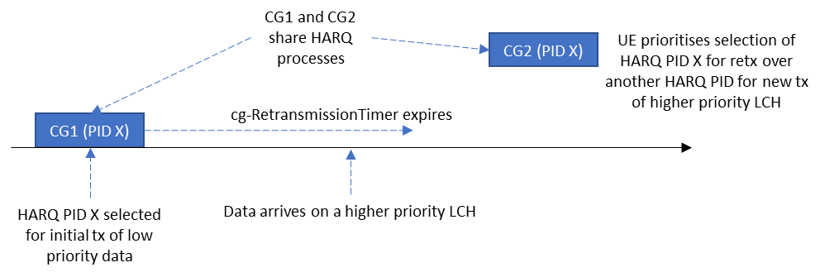
Figure 6: Current behaviour when non-overlapping CG occasions share HARQ processes
In [7], the scenario where non-overlapping CGs share HARQ processes is discussed. The current behaviour is to prioritise the selection of HARQ processes for retransmissions as illustrated in Figure 6, regardless of the CG. The paper argues that this violates the IIoT intra-UE prioritisation principle.
As can be seen, this problem is similar to that raised in Question 2, with the exception that the number of CG configurations are > 1. Therefore the same solution for HARQ process ID selection as agreed for Question 2 would also be applicable here.
Question 8: When HARQ processes are shared between multiple CG configurations with non-overlapping CG occasions and with the same TBS, do companies agree that the same HARQ PID selection rule (which may be updated as per Question 2) applies to all CGs? If not, please explain why this case needs to be treated differently and the details on the solution direction.
Company | Yes/No | Comments
Ericsson | Yes | HARQ process sharing is only suited for the same priority data, i.e., not for the different priority data. The aim is to have more transmission opportunities from different CG configurations. If the HARQ process is shared between two CGs, parameters like TB size, MCS, and BLER target are the same and so quite strange to mix eMBB and URLLC traffic there.  Thus, we don’t see any difference between this case and the case in question 2 (one CG configuration).
Nokia | Yes | By implementation we can avoid HARQ process ID sharing among CGs associated to different traffics with different priorities. So, the mentioned problem may not exist in practice.
Samsung | Yes | Agree with Ericsson and Nokia
Fujitsu | Yes | It is also our understanding that NW will avoid HARQ PID sharing among CGs delivering different priorities.
CATT | No | We disagree with Ericsson’s assumption. The key principle of HARQ sharing in NR-U is to allow a failed PDU (due e.g. to LBT failure) to make use of a CG opportunity in another CG configuration before a CG opportunity occurs in its own CG configuration. And such HARQ sharing could very well be done with a CG configuration addressing a higher priority, but non-deterministic, traffic so that data may or may not be available for transmission for the associated logical channel. Such case cannot be considered as a rare case or corner case, otherwise UL skipping would not have been designed at all. Therefore, our view is that in such case, the HARQ process can be shared between the two configured grant configurations, although serving different priority traffic, thus allowing the autonomous retransmission to take place in the “high priority CG” in absence of associated (high priority) traffic, but not in presence of such traffic.  This principle can be simply captured in MAC as follows:  5.4.2.2 HARQ process  […]  If cg-RetransmissionTimer is configured, retransmissions with the same HARQ process may be performed on any configured grant configuration if the configured grant configurations have the same TBS, and, when lch-basedPrioritization is configured, if no higher priority transmission, as specified in clause 5.4.1, could have taken place in the configured grant.
InterDigital | - | We can just rely on the network to configure HARQ sharing for CG configurations that can meet the same type of services. The selection rule applies for all CGs that share the same HARQ PID and TBS.
LG | Yes | Agree with Ericsson. The principle with LCP restriction is to configure different CG for different LCH if differentiation is required. If multiple CGs are assigned to one logical channel, the UE uses it in a union way, hence, see no big difference with single CG case. In this sense, if multiple CGs are commonly assigned to multiple logical channels, it is like a case where single CG is assigned to multiple logical channels and see no need of further prioritization for this.
Qualcomm | Yes but | We do not agree that HARQ sharing is strictly between same priority PDUs. HARQ sharing in NR-U is to allow a failed PDU to be transmitted on any available CG (not necessarily the next instance of the one attempted for the initial transmission, i.e., the same configured CG for initial Tx). It is also perfectly fine for the NW to configure HARQ sharing such that a HP CG can act as a fallback for LP periodic traffic in absence of HP traffic, otherwise idle resources would be unnecessarily reserved for any sporadic HP traffic which is wasteful. To conclude, HARQ sharing can be used for different priority PDUs, it is up to the NW whether to do this or not. No reason to change spec.  We argue that this is all the more reason to allow prioritization between initial transmissions and retransmissions for question 2. As a possible deployment would be to allow sharing to mitigate LBT failure. Once LCH prioritization in Q2 is introduced, mitigating LBT failure becomes secondary to complying with the LCH priorities. We do not see a reason why the network can’t have both.
III | Yes | Agree with Ericssion.
OPPO | Yes | We share the similar view as Ericsson.

2.5.2 HARQ process ID selection when an empty MAC PDU is sent
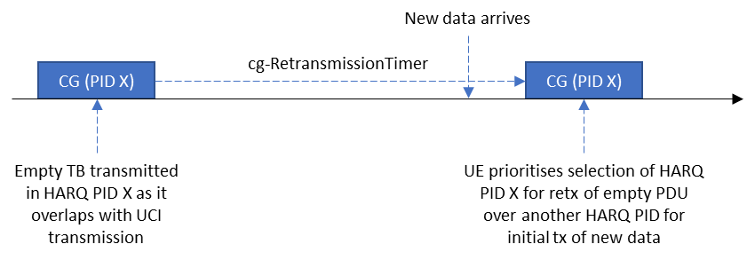
Figure 7: Current HARQ PID selection behaviour when an empty PDU is generated
In [8], the scenario where an empty PDU is sent is raised as illustrated in Figure 7. The MAC entity may generate an empty PDU in case UCI needs to be transmitted by L1. The paper argues that it is not sensible to prioritise selecting the HARQ process corresponding to this empty TB for retransmission over another HARQ process that could carry new data, in case autonomous retransmission is configured (regardless of whether LCH-basedPrioritisation is configured or not).
While the proposal makes sense, this is addressing a general issue with Rel-16 NR-U behaviour rather than addressing an IIoT specific problem. Therefore, the following question is posed:
Question 9: Should the Rel-16 NR-U behaviour be changed to prevent prioritising the selection of a HARQ process with an empty MAC PDU for autonomous retransmission (regardless of whether LCH-basedPrioritisation is configured or not)?
Company | Yes/No | Comments
Ericsson | No | Agree with the rapporteur that this is more related with a general Rel-16 NR-U behavior.  In addition, it is not an empty MAC PDU but a MAC PDU that may contain, a padding BSR and a periodic BSR indicating no available data. The MAC would not skip the grant if there is an aperiodic CSI requested for this PUSCH transmission, i.e., not only for the UCI related corrections.
Nokia | Yes | We would like to clarify that the term “empty” is coming from the data point of view. So, although the MAC PDU may still contain some outdated padding/periodic BSR, the number of MAC SDU is basically zero in this case.  We agree this behavior should be applicable regardless whether LCH-based prioritization is configured or not. Even if only eMBB is considered, it does not make sense to prioritize a MAC PDU without any meaningful data while delaying new data in the LCH buffer as well as potentially some more important MAC CEs; not to mention cases where IIoT/URLLC traffics are involved. Moreover, transmission of such MAC PDU without any data creates interference in shared spectrum unnecessarily.  Unlike the situation discussed in Q2, this cannot be solved by implementation via proper association of HARQ PID pool and LCH to each CG, because such valueless MAC PDU may be generated in any CG and stuck in HARQ buffer when pending, regardless what LCH or HARQ PID are associated to the CG. Hence, we think this is a crucial issue that should be resolved, especially for Rel-17 where IIoT/URLLC in NR-U is to be considered.
Lenovo | Comment | We are not sure that this needs to be addressed for Rel-16. However, we agree in general with Nokia, that “empty” MAC PDU may deserve some specific behaviour. An empty MAC PDU is solely generated for the purposes of UCI multiplexing in PHY. Since such empty MAC PDU is stored in the HARQ buffer, UE would perform some autonomous retransmission of the “empty” MAC PDU in certain conditions, i.e. if the UE cannot receive DFI until expiration of CGRT corresponding to the HARQ process. However autonomous retransmissions or retransmission scheduled by gNB (DCI based retransmissions) may not be useful especially when the UCI content multiplexed in this UCI-only TB may be no longer useful/valuable for the gNB, since the corresponding information such as HARQ-ACK or CSI may be already outdated or superseded. Therefore we would rather suggest that (autonomous) retransmissions are not supported for “empty”TBs, i.e. UCI-only TBs. In our understanding it would be much simpler if MAC flushes the HARQ buffer after the initial HARQ transmission of an empty MAC PDU which has been generated only for the purpose of UCI multiplexing.
Samsung | No | We think MAC CEs may be generated and contained in the MAC PDU. In this case, the MAC CEs shouldn’t be discarded.
Fujitsu | No | As rapporteur indicated, we also think that this is general Rel-16 NR-U behaviour and may not be considered issue. We understand the intention of this proposal, but we tend to think that this case may be infrequent and system can still work even if outdated padding/periodic BSR is reported to the gNB.
InterDigital | Yes | PDUs without data shouldn’t be prioritized over new higher priority data. We think option 2 of Q2 would also solve this issue.
LG | No | If lch-basedPrioritization is not configured, it would be NR-U specific issue and there seems to be no need of prioritizing higher priority data by not selecting retransmission of UCI-only TB.  If lch-basedPrioritization is configured, it may be complicated to look into the content of stored MAC PDU, which is to be retransmitted, to see whether it was for UCI-only TB or not whenever there is new data arrives while retransmission data is stored. So, if this case is really problematic, we want a simple method, e.g., not allowing retransmission of UCI-only TB at all.
Qualcomm | No but, | Agree with Interdigital. However, if option 2 in Q2 is not agreed to, we should not make an exception for the prioritization for UCI-only TB, since that will require the MAC to track the PDU content before retransmission and have a special prioritization rule for a type of TB, which is an unnecessary complication.
III | No
OPPO | No | Agree with companies that this is more related with Rel-16 NR-U issue, and the case may not happen very frequently. Also, there is still some MAC CE in the grant even if there is no data multiplexed in, thus it is not really “empty”. From the UE perspective, the required enhancement is complicated since it requires the UE to look into the content of stored MAC PDU, which is much beyond current logic.

2.5.3 AutonomousTx operation for multiple CG configurations with shared HARQ processes
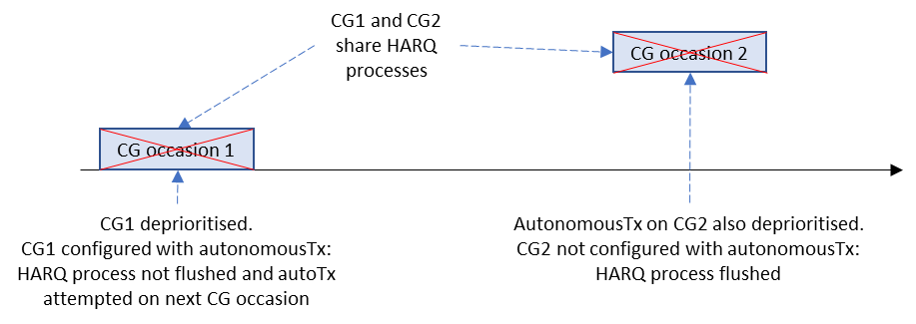
Figure 8: CGs with shared HARQ processes with different AutoTx configurations
In [9], the case where multiple configured grants with shared HARQ processes is discussed. The paper points out that in case some of the CGs are configured with autonomousTx while other CGs aren’t, data from a HARQ process will be flushed in case of a deprioritised transmission on a CG that is not configured with autonomousTx, as illustrated in Figure 8. The paper argues that such configurations should not be allowed.
The rapporteur would like to point out that the UE behaviour in this case is clearly defined, and we do not typically define NW behaviour in the specifications. Therefore the following question is posed:
Question 10: Do companies agree that it is up to the NW to appropriately configure CGs that share HARQ processes with autonomousTx?
Company | Yes/No | Comments
Ericsson | Yes | Additionally, we believe there is no need to introduce any spec enhancements regarding HARQ process sharing between CGs for the case when lch-basedPrioritization is configured.
Nokia | Yes | The gNB may choose not to configure AutoTX for a CG for the following reasons:  - The gNB does not think delay of data on this CG is critical, or  - The gNB is sufficiently capable to detect the existence of a MAC PDU even if the PUSCH is not completely transmitted.  Here we are talking about the cases wherein some CGs are configured with AutoTX while some CGs are not configured with AutoTX. Then, most likely AutoTX is not configured in one CG because of the first reason above, and AutoTX is configured because the data in another CG can be delay-sensitive. In such scenarios with mixed traffic types, why would a gNB allow these two CGs targeted for different types of traffics to share HARQ PIDs and create such problems? Therefore, we do not believe such problem would exist in practice, as it can be avoided by proper gNB implementation entirely.
Samsung | Yes
Fujitsu | Yes | The configuration illustrated in Fig.8 can be avoided by NW configuration. As implied above and as commented in Q8, NW will avoid HARQ PID sharing among CGs delivering different priorities.
CATT | No | We acknowledge that UCI is added at PHY level, and there is no autonomous handling by the UE of the “lost” UCI from the initial transmission. So it is correct that from MAC perspective, the retransmitted PDU will be an empty-PDU only that could potentially block the transmission of new data. We agree with the Rapporteur though that it is a R16 issue and so we propose addressing this topic from scratch in R16 UP.
InterDigital | Yes | We can just rely on the network to configure HARQ sharing and AutoTx for CG configurations that can meet the same type of services.
LG | Yes | Such configuration seems not desirable but it should be up to network implementation.
Qualcomm | Yes | Agree with rapporteur
III | Yes
OPPO | No | Based on the comments from companies for Q8 and even Q1, there is still some consideration that HARQ sharing is not strictly between same priority PDUs, i.e. the CGs with HARQ processing sharing may associate with LCHs with different LCH priorities. From this point of view, it is possible that the NW configures one CG with autonomousTx and another CG without autonomousTx even if they share the same HARQ process. If the deprioritized CG associates with the LCH with a high priority but the selected CG is not configured with autonomousTx, the data of this LCH will be flushed, which may introduce performance decreasing of this high priority traffic. Thus, if this configuration logic is agreed(based on the conclusion to Q8 and Q1), it is better to introduce the restriction in the following:  - In case that both cg-RetransmissionTimer and autonomousTx are configured, no HARQ processes are shared among different CGs.  On the other hand, if RAN2 agrees that HARQ sharing is strictly between same priority PDUs, it is still better to restrict that the CGs with HARQ process sharing are configured with/without autonomousTx simultaneously to assure the deprioritized MAC PDUs from different CGs are treated in the same principle.

3 Conclusion
To be generated following the conclusion of this email discussion

4 Contact information
Company | Name | email address
vivo | Boubacar | kimba@vivo.com
OPPO | Zhe Fu | fuzhe@OPPO.com
Nokia | Ping-Heng Wallace Kuo | Ping-Heng.Kuo@nokia.com
TCL | Hejun Wang | hejun.wang@tcl.com
Ericsson | Zhenhua Zou | zhenhua.zou@ericsson.com
Lenovo | Joachim Löhr | jlohr@lenovo.com
Samsung | Sangkyu Baek | sangkyu.baek@samsung.com
Fujitsu | Ohta Yoshiaki | ohta.yoshiaki@fujitsu.com
CATT | Pierre Bertrand | pierrebertrand@catt.cn
InterDigital | Faris Alfarhan | faris.alfarhan@interdigital.com
LG | SunYoung LEE | ssunyoung.lee@lge.com
Qualcomm | Sherif ElAzzouni | selazzou@qti.qualcomm.com
ZTE | Fei Dong | Dong.fei@zte.com.cn
III | YenChih Kuo | jasonkuo@iii.org.tw

5 References
- R2-21069xx - Report of 3GPP TSG RAN WG2 meeting #114-e (ETSI MCC)
- R2-2100001 - Report of 3GPP TSG RAN WG2 meeting #112-e (ETSI MCC)
- R2-2106396 - Summary of [POST113bis-e][505][R17 IIoT] URLLC in UCE (LG Electronics)
- Chair's Notes RAN1#105-e final.docx
- R2-2105865 - Clarification on prioritization of retransmission over initial transmission for HARQ PID selection in NR-U (Nokia)
- R2-2102601 - Report of 3GPP TSG RAN WG2 meeting #113-e (ETSI MCC)

