GPP TSG-RAN WG2 Meeting #115-e R2-21xxxxx
Online, 9th – 27th August, 2021

Agenda Item: 8.5.3
Source: MediaTek Inc.
Title: Summary of [Post114-e][510][URLLC/IIoT] Open issues for UCE (Mediatek)
Document for: Discussion and decision

1 Introduction
This email discussion focusses on the remaining open issues associated with IIoT operation over unlicensed controlled environments (UCE), following the following agreements reached at R2#114e [1].
Agreements:
- When both of lch-based Prioritization and cg-RetransmissionTimer are configured, HARQ processes sharing between multiple CG configurations are allowed. No specification change is required.
- RAN2 confirm that neither autonomous transmission nor autonomous retransmission is triggered if UL grant is prioritized and LBT fails while AutonomousTx is configured and cg-RetransmissionTimer is not configured. No specification change is required.
- RAN2 confirm that autonomous retransmission is triggered if UL grant is prioritized and LBT fails while AutonomousTx is not configured and cg-RetransmissionTimer is configured. No specification change is required
- RAN2 confirm that autonomous retransmission is triggered if UL grant is prioritized and LBT fails while AutonomousTx and cg-RetransmissionTimer are configured. No specification change is required.
- RAN2 confirm that autonomous transmission is triggered if UL grant is deprioritized while AutonomousTx is configured and cg-RetransmissionTimer is not configured. No specification change is required.
- RAN2 confirm that autonomous transmission is triggered if the transmission of the obtained MAC PDU has not been completely performed and if UL grant is deprioritized while AutonomousTx and cg-RetransmissionTimer are configured. No specification change is required.
- The HARQ process is kept as pending even if a CG is de-prioritized while the HARQ state of the associated HARQ process is pending (i.e. MAC PDU hasn’t been transmitted). No specification change is required
- When cg-RetransmissionTimer and lch-basedPrioritization are configured, for overlapping CGs, the MAC entity prioritizes the initial transmission of higher priority data over autonomous retransmission of lower priority data. FFS how to implement this in Rel-17 after some of the Rel-16 discussion takes place

2 Discussion

2.1 Mechanism for HARQ process ID selection
In R2#112e, the following was agreed [2]:
- When cg-RetransmissionTimer is configured, Rel-16 NR-U mechanism is used for HARQ process ID and RV selection.
- When cg-RetransmissionTimer is not configured, Rel-16 URLLC mechanism may be used for HARQ process ID and RV selection.

This topic was discussed in [3], and RAN2 decided to wait for RAN1 to progress further on the topic before reaching a decision [1]. The discussion in RAN1 has progressed in R1#105e, with the following agreement [4]:
Agreement:
- Option 1 is taken in the following agreement:
Agreement:
Down-select one of the following options (target RAN1#104-e):
- Option 1: Both “CG-UCI based procedures” and “CG-DFI based procedures” are enabled or disabled for unlicensed using one RRC parameter i.e. cg-RetransmissionTimer-r16.
- Option 2-a: “CG-UCI based procedures” and “CG-DFI based procedures” are independently enabled or disabled for unlicensed using respective RRC parameter, i.e. new parameter X and cg-RetransmissionTimer-r16, respectively.
  - If cg-RetransmissionTimer-r16 is configured, “CG-UCI based procedures” should also be enabled by X.
- Note: Procedures based on CG-UCI rely on UE including CG-UCI in CG PUSCH at least as in Rel-16 where the values of the respective fields of CG-UCI are decided by UE.
- Note: Procedures based on CG-DFI rely on automatic re-transmission on CG configuration and reception of CG downlink feedback information (DFI) in DCI for re-transmissions

With the option that’s agreed in RAN1, effectively if cg-RetransmissionTimer is not used, the CG-UCI is also not used. From this agreement, it is fairly obvious that if cg-RetransmissionTimer is not configured, the NR-U mechanism for HARQ process ID and RV selection cannot be used, as the NR-U mechanism requires the use of CG-UCI. Therefore the rapporteur proposes the following modification to the earlier RAN2 agreement:
Proposal: When cg-RetransmissionTimer is not configured, Rel-16 URLLC mechanism is used for HARQ process ID and RV selection.
Question 1: Do companies agree with the modified proposal above? If not, please provide further details on how you foresee HARQ process ID selection to work alongside RAN1’s agreement.
Company | Yes/No | Comments
vivo | Yes | Agree with the rapporteur’s analysis.
TCL | Yes
Ericsson | Yes

2.2 HARQ process ID selection details
The NR-U behaviour has been further clarified for Rel-16 as below [5]:
For configured uplink grants configured with cg-RetransmissionTimer, the UE implementation selects an HARQ Process ID among the HARQ process IDs available for the configured grant configuration. For HARQ Process ID selection, the UE shall prioritize retransmissions before initial transmissions.
This update to the specification clarifies that the statement ‘UE shall prioritize retransmissions before initial transmissions’ only applies to HARQ process ID selection done by the UE.

2.2.1 Single CG configuration
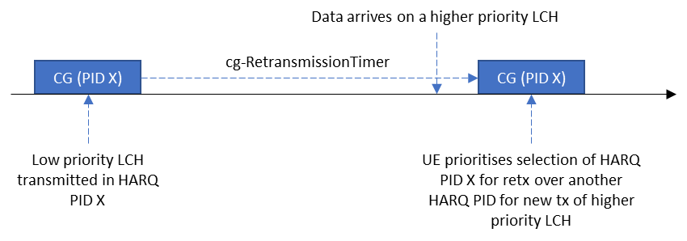
Figure 1: Rel-16 behaviour for HARQ PID selection with a single CG

In this section, we focus on the single CG configuration case. As per the Rel-16 agreement, the baseline behaviour for NR-U is as illustrated in Figure 1.
In case of IIoT operation in UCE, when lch-basedPrioritization and cg-RetransmissionTimer are jointly configured, the question is whether we need to change this baseline NR-U behaviour. This was discussed in [3] along with the various means to do so. Therefore, the following question is posed:
Question 2: What should the HARQ process ID selection behaviour be in the MAC entity for a single configured grant configuration, when lch-basedPrioritization and cg-RetransmissionTimer are both configured?
Option 1: No change to the Rel-16 baseline (MAC entity prioritises the selection of HARQ process IDs for retransmissions over the selection of HARQ processes for initial transmissions)
Option 2: MAC entity prioritises the selection of a free HARQ process ID (if available) to transmit higher priority data (if present).
Option 3: NW configures whether to follow Option 1 or Option 2
Option 4: Other (please explain)
Company | Preferred option(s) | Comments
vivo | Option1 | In our understanding the NW will map LCHs with similar priorities to a CG configuration. Hence, the benefit of applying lch-basedPrioritization mechanism among different HARQ processes associated with the CG configuration is limited.
TCL | Option1 | Prefer Rel-16 baseline, but open to other choices.
Ericsson | Option 1 | We do not see a need for any spec changes to Rel-16 behaviour. The network would configure different CGs for different LCHs, if there is a need for prioritization between different LCHs.  For option 2, as already stated by the rapporteur, there are further complexities, like what happens due to unavailability of HARQ process, e.g., flushing the existing retransmission HARQ buffers or exceptional retransmission of non-prioritized data.

2.2.2 Multiple overlapping CG configurations without shared HARQ processes
From [3], it was unclear whether the current specifications support the following agreed behaviour:
When cg-RetransmissionTimer and lch-basedPrioritization are configured, for overlapping CGs, the MAC entity prioritizes the initial transmission of higher priority data over autonomous retransmission of lower priority data. FFS how to implement this in Rel-17 after some of the Rel-16 discussion takes place
Therefore, we break the problem down further. In this section, we focus on the case where the UE is configured with multiple overlapping CGs, where HARQ processes are not shared between different CGs
In this scenario, the Rel-16 rule to prioritise selection of a HARQ PID for retransmission over a HARQ PID for a new transmission only applies within a CG configuration (as HARQ processes are not shared). Therefore, in the example shown in Figure 2, the UE chooses a HARQ PID X for CG1 and a different HARQ PID Y for CG2. Following this HARQ process selection procedure, LCH prioritisation rules determine whether CG1 or CG2 is transmitted, depending on which CG carries higher priority LCH data.

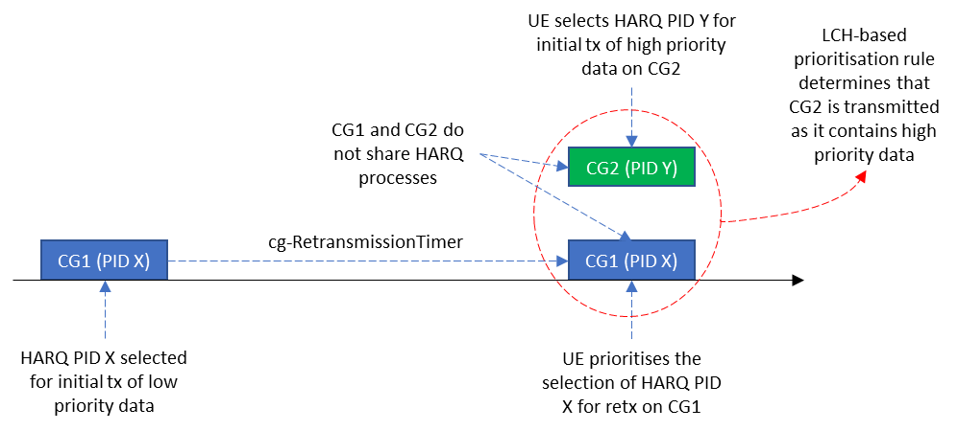
Figure 2: Multiple overlapping CGs without shared HARQ processes

Question 3: When lch-basedPrioritization and cg-RetransmissionTimer are configured, and multiple overlapping CGs do not share HARQ processes, do companies agree that the following behaviour is already supported by the current specifications:
- The HARQ PID selection rule (which may be updated as per Question 2) applies to HARQ PID selection for each CG occasion
- lch-basedPrioritization rules determine the CG that will be prioritised for transmission by the MAC entity
If not, please provide further details on how the current specifications would work.
Company | Yes/No | Comments
vivo | Yes
TCL | Yes
Ericsson | Yes

Question 4: As a follow-up to Question 3, do companies foresee the need for further changes to implement the following agreement for the case where HARQ processes are not shared between CGs? If yes, please explain what further changes are needed.
Agreement: When cg-RetransmissionTimer and lch-basedPrioritization are configured, for overlapping CGs, the MAC entity prioritizes the initial transmission of higher priority data over autonomous retransmission of lower priority data.
Company | Yes/No | Comments
vivo | No
TCL | No
Ericsson | No

2.2.3 Multiple overlapping CG configurations with shared HARQ processes
In this section, we focus on the case where the UE is configured with multiple overlapping CGs, where HARQ processes are shared between different CGs.
In the Rel-16 NR-U discussions, the case of overlapping configured grants were not considered. However, when lch-basedPrioritization is configured, overlapping configured grants can exist. Going through the current spec, the following specification conditions would be applicable in the case where cg-RetransmissionTimer and lch-basedPrioritization are both configured:
If cg-RetransmissionTimer is configured, retransmissions with the same HARQ process may be performed on any configured grant configuration if the configured grant configurations have the same TBS.
…
For configured uplink grants configured with cg-RetransmissionTimer, the UE implementation selects an HARQ Process ID among the HARQ process IDs available for the configured grant configuration. For HARQ Process ID selection, the UE shall prioritize retransmissions before initial transmissions.
…
NOTE 6: If the MAC entity is configured with lch-basedPrioritization and if there is overlapping PUSCH duration of at least two configured uplink grants whose priorities are equal, the prioritized uplink grant is determined by UE implementation.
When multiple overlapping CGs share HARQ processes and have the same TBS, the UE prioritises the selection of a HARQ PID that is for retransmission over the selection of a PID for a new transmission. Since both CGs prioritise the same HARQ PID, they carry the same data and the condition in Note 6 would apply, i.e. the UE implementation determines which CG is to be transmitted. This is illustrated in Figure 3 below.
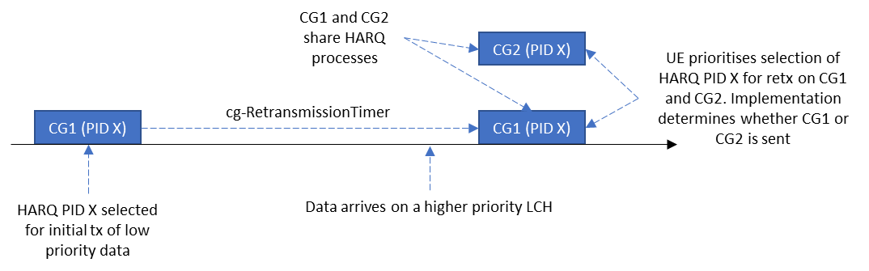
Figure 3: Current behaviour when multiple overlapping CGs share HARQ processes

Question 5: When HARQ processes are shared between multiple overlapping CG occasions with the same TBS, do companies agree that the same HARQ PID selection rule (which may be updated as per Question 2) applies to all CGs?
Company | Agree/Disagree | Comments (including the need for further specification changes)
vivo | Agree, but | We agree that the same HARQ PID selection rule should be applied to all CGs, but we do not agree that the same HARQ PID(i.e. PID X) is selected by CG1 and CG2 in the above Fig3.  Quotes from TS38.321:  For configured uplink grants configured with cg-RetransmissionTimer, the UE implementation selects an HARQ Process ID among the HARQ process IDs available for the configured grant configuration.  Let’s assume UE performs HARQ selection for CG1 before CG2 in the example illustrated in Fig3. When HARQ PID X is selected for CG1, the HARQ PID X is not available and cannot be selected for other CGs. Therefore, it is our understanding that the overlapping CGs can never select the same HARQ process.
TCL | Agree | Agree with vivo, the same HARQ PID selection rule should be applied, but the same HARQ PID selected for overlapping CGs does not work.
Ericsson | Agree | No need for further spec change. If the HARQ process is shared, then it means that there is no need to prioritize between these two CGs and so the illustration works.

Question 6: If the answer to Q5 is yes, do companies agree that the same HARQ PID would be selected for all overlapping CG occasions and it is up to UE implementation to determine which CG is transmitted?
Company | Agree/Disagree | Comments (including the need for further specification changes)
vivo | Disagree | See our comments to Q5.
TCL | Disagree | The same HARQ PID for all overlapping CG would not work, further discussion in detail is needed for this case.
Ericsson | Agree | There is no need for further spec change. It is up-to UE implementation to determine which CG is transmitted. In other words, it does not matter what the UE has chosen as the HARQ process ID for the unused CG.

2.3 Deprioritised UL grant when autoTx is not configured and CGRT is configured
At R2#113e [6], we reached the following agreement:
- AutoTx and CGRT are responsible for deprioritized MAC PDU and LBT-failed MAC PDU, respectively. If CGRT is not configured, LBT-failed MAC PDU is not retransmitted. If AutoTx is not configured, deprioritized MAC PDU is not retransmitted.
- the MAC entity stops cg-RetransmissionTimer when the CG resource associated with the timer is deprioritized due to LCH-based prioritization.
As per the current specifications, if the configuredGrantTimer is running and the cg-RetransmissionTimer is not running, the UE triggers autonomous retransmissions. Also, if the UE is not configured with autonomousTx, the configuredGrantTimer will run even if a MAC PDU is deprioritised.
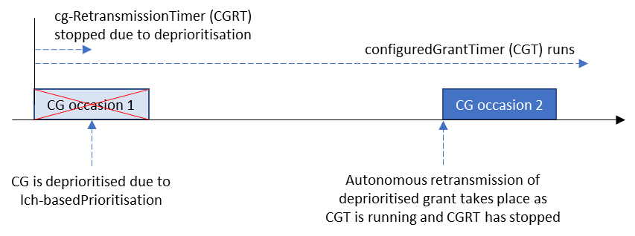
Figure 4: Current behaviour if cg-RetransmissionTimer is stopped when an UL CG is deprioritised

Therefore, if we follow the second agreement above, transmission of the deprioritised MAC PDU takes place on the next CG occasion as the cg-RetransmissionTimer would not be running, as illustrated in Figure 4 above. This behaviour contradicts the first highlighted agreement above i.e. ‘if AutoTx is not configured, deprioritized MAC PDU is not retransmitted’. This was discussed extensively in [3] with the following proposal made:
Proposal 10: (Out of 20, 7 for no preferred option, 11 for option 2, 2 for option 3, 1 for option1) RAN2 further discuss whether option 2 or no option is needed if UL grant is de-prioritized while AutonomousTx is not configured and cg-RetransmissionTimer is configured.
- Option 2. If a CG is not configured with autonomousTx, the cg-RetransmissionTimer is not stopped when the associated CG is deprioritized [13]

It should be noted that even if we follow option 2 above, it only delays the autonomous retransmission to after the expiry of the cg-RetransmissionTimer, but a retransmission of the deprioritised PDU will still take place in contradiction with the first highlighted agreement, i.e. ‘if AutoTx is not configured, deprioritized MAC PDU is not retransmitted’. This is illustrated in Figure 5 below.
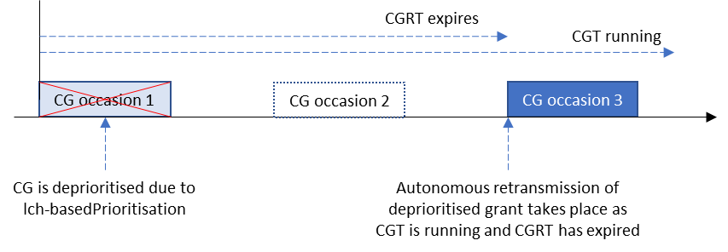
Figure 5: Current behaviour if cg-RetransmissionTimer is not stopped when an UL CG is deprioritised

Going back to first principles, it would be good to agree the expected UE behaviour, and the discussion on how to implement this behaviour in the specification can follow. Therefore the following question is posed:
Question 7: Which option do companies prefer?
Option 1: If autoTx is not configured, confirm the earlier agreement that a deprioritised MAC PDU is not retransmitted autonomously
Option 2: If autoTx is not configured, modify the earlier agreement to allow autonomous retransmission of a deprioritised MAC PDU
Company | Preferred option | Comments (reasons for preference, implementation details)
vivo | Option2 | In RAN2-113e, we reach the agreement that If AutoTx is not configured, deprioritized MAC PDU is not retransmitted.  In our understanding, the exact meaning of the agreement is if autoTx is not configured, deprioritised MAC PDU is not retransmitted according to the R16 URLLC autonomous transmission mechanism. As autoTx is configured to CG configuration to enable R16 URLLC autonomous transmission for deprioritised MAC PDU.  However, the autonomous retransmission in Fig4 and Fig5 is triggered by NR-U retransmission mechanism, which is enabled by configuring cg-RetransmissionTimer. Hence, we see no reason to disable autonomous retransmission according to the NR-U retransmission mechanism if cg-RetransmissionTimer is configured, no matter autoTx is not configured or not.
TCL | Option2
Ericsson | Option 2 | Firstly, the wording in option 2 should be clarified that “if AutoTx is not configured, deprioritized MAC PDU is not retransmitted by AutoTx mechanisms but can be retransmitted due to CGRT expired/stopped”.  Secondly, the previous agreement below  - the MAC entity stops cg-RetransmissionTimer when the CG resource associated with the timer is deprioritized due to LCH-based prioritization.  would stop the CGRT earlier than letting it to be expired. gNB may not prefer so since it may want to transmit a retransmission grant with a different MCS rather than relying on autonomous re-tx in the next CG. We are fine to further clarify the above agreement to implement the option 2 in the last email discussion [3]:  - the MAC entity stops cg-RetransmissionTimer when the CG resource associated with the timer is deprioritized due to LCH-based prioritization and CG is configured with autoTx.  This is the same as the option 2 in [3]:  If a CG is not configured with autonomousTx, the cg-RetransmissionTimer is not stopped when the associated CG is deprioritized [13]

2.4 Others
Companies are encouraged to raise any issues that warrant further discussion in this section.
Company | Issue
OPPO | In our paper [R2-2105566], we raised the following two issues:  - In Rel-17, it is agreed that when both of lch-based Prioritization and cg-RetransmissionTimer are configured, HARQ processes sharing between multiple CG configurations are allowed. However, there is no restriction that all CGs sharing HARQ processes to be or not to be configured with autonomousTx simultaneously. As a result, the deprioritized MAC PDU will be flushed if the subsequent selected CG is not configured with autonomousTx but shares the same HARQ processes as the previous deprioritized CG. Accordingly, the data lost for the deprioritized CG will exist, which is not aligned with Rel-16 IIoT design principle. Thus, we propose RAN2 considers this issue, and agrees that no HARQ processes are shared among different CGs in case that both cg-RetransmissionTimer and autonomousTx are configured.  [Rapporteur] Captured in section 2.5.3 below  - During the previous email discussion [POST113bis-e] [505] [R17 IIoT] URLLC in UCE, we focus on two scenarios for harmonization operation: One is that UL grant is prioritized and LBT fails, and another is that UL grant is de-prioritized by e.g., CI-RNTI but LBT succeeds. In our understanding, the following case may also be considered: the CG is deprioritized and LBT fails. It may happen when the CG is firstly prioritized before LBT checking as a failure, and later the CG turns to be deprioritized due to e.g. CI-RNTI. Thus, we would like RAN2 to confirm whether this case is valid for UCE.  [Rapporteur] R2-2105566 mentions that there’s no issue with the MAC spec regarding this case. Therefore, is there any reason to discuss this further?
Nokia | In our contribution R2-2105872, we have raised the following issue:  For HARQ process ID selection within a CG, regardless of whether LCH-based prioritization is configured or not, the UE should not prioritize the HARQ process for retransmission of an empty MAC PDU (e.g. the MAC PDU generated solely for UCI multiplexing). Such HARQ process should be deprioritized even if it is a retransmission. This is because:  - The empty MAC PDU does not contain useful data, and transmission of which causes unnecessary delay for new data in the buffer. This is very undesirable especially if the new data is URLLC or if there are some critical MAC CEs that need to be sent immediately.  - Transmission of empty MAC PDU potentially causes unnecessary interference to co-existing technologies in the shared spectrum.  - This cannot be solved by implementation as empty MAC PDU can occur in any CG, regardless what LCH or what HARQ process IDs are associated to the CG.  [Rapporteur] Captured in section 2.5.2 below
Ericsson | In Ericsson’s paper [R2-2105675], it is proposed that:  RAN2 does not introduce any spec enhancements regarding HARQ process sharing between CGs for the case when lch-basedPrioritization is configured  HARQ process sharing is only suited for the same priority data, i.e., not for the different priority data. The aim is to have more transmission opportunities from different CG configurations. If the HARQ process is shared with two CGs, parameters like TB size, MCS, and BLER target are the same and so quite strange to mix eMBB and URLLC traffic there.  Allowing HARQ process sharing contradicts with the network’s intention to configure lch-basedPrioritization in which different priority data is assumed to be separated on different CGs. This, additionally, would require complex specification changes which cannot be motivated, or eventually due to its complexity, the prioritization is left to UE implementation.  Unfortunately, lch-basedPrioritization is a per MAC entity configuration. It might be okay to allow HARQ process sharing of some CGs which intend to serve one level of LCH priority, while some other CGs for another level of LCH priority. Network ensures all the configurations are correct. Therefore, we don’t think there is any need to further discuss the corner cases, like the one identified by OPPO above and CATT (on the reflector), as the network has no intention to configure so.

2.5 Further questions raised in Phase 1

2.5.1 Multiple non-overlapping CG configurations with shared HARQ processes

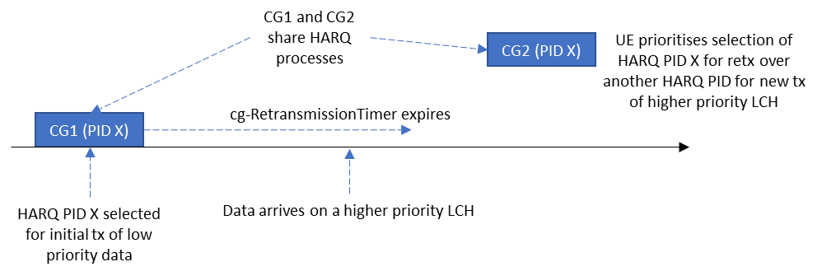
Figure 6: Current behaviour when non-overlapping CG occasions share HARQ processes
In [7], the scenario where non-overlapping CGs share HARQ processes is discussed. The current behaviour is to prioritise the selection of HARQ processes for retransmissions as illustrated in Figure 6, regardless of the CG. The paper argues that this violates the IIoT intra-UE prioritisation principle.
As can be seen, this problem is similar to that raised in Question 2, with the exception that the number of CG configurations are > 1. Therefore the same solution for HARQ process ID selection as agreed for Question 2 would also be applicable here.
Question 8: When HARQ processes are shared between multiple CG configurations with non-overlapping CG occasions and with the same TBS, do companies agree that the same HARQ PID selection rule (which may be updated as per Question 2) applies to all CGs? If not, please explain why this case needs to be treated differently and the details on the solution direction.
Company | Yes/No | Comments
Ericsson | Yes | HARQ process sharing is only suited for the same priority data, i.e., not for the different priority data. The aim is to have more transmission opportunities from different CG configurations. If the HARQ process is shared between two CGs, parameters like TB size, MCS, and BLER target are the same and so quite strange to mix eMBB and URLLC traffic there.  Thus, we don’t see any difference between this case and the case in question 2 (one CG configuration).

2.5.2 HARQ process ID selection when an empty MAC PDU is sent
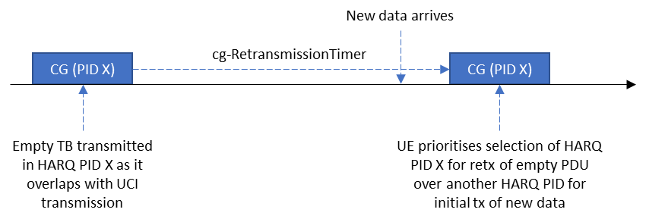
Figure 7: Current HARQ PID selection behaviour when an empty PDU is generated
In [8], the scenario where an empty PDU is sent is raised as illustrated in Figure 7. The MAC entity may generate an empty PDU in case UCI needs to be transmitted by L1. The paper argues that it is not sensible to prioritise selecting the HARQ process corresponding to this empty TB for retransmission over another HARQ process that could carry new data, in case autonomous retransmission is configured (regardless of whether LCH-basedPrioritisation is configured or not).
While the proposal makes sense, this is addressing a general issue with Rel-16 NR-U behaviour rather than addressing an IIoT specific problem. Therefore, the following question is posed:
Question 9: Should the Rel-16 NR-U behaviour be changed to prevent prioritising the selection of a HARQ process with an empty MAC PDU for autonomous retransmission (regardless of whether LCH-basedPrioritisation is configured or not)?
Company | Yes/No | Comments
Ericsson | No | Agree with the rapporteur that this is more related with a general Rel-16 NR-U behavior.  In addition, it is not an empty MAC PDU but a MAC PDU that may contain, a padding BSR and a periodic BSR indicating no available data. The MAC would not skip the grant if there is an aperiodic CSI requested for this PUSCH transmission, i.e., not only for the UCI related corrections.

2.5.3 AutonomousTx operation for multiple CG configurations with shared HARQ processes
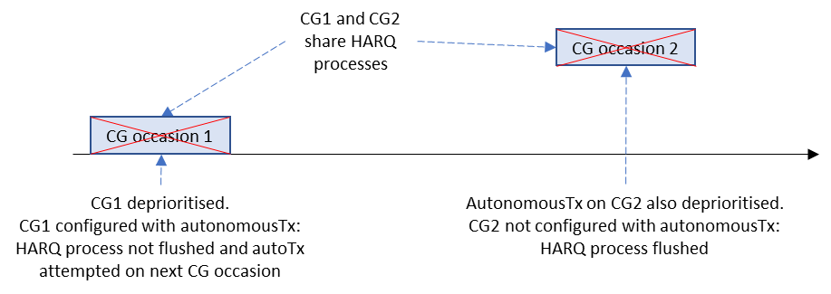
Figure 8: CGs with shared HARQ processes with different AutoTx configurations
In [9], the case where multiple configured grants with shared HARQ processes is discussed. The paper points out that in case some of the CGs are configured with autonomousTx while other CGs aren’t, data from a HARQ process will be flushed in case of a deprioritised transmission on a CG that is not configured with autonomousTx, as illustrated in Figure 8. The paper argues that such configurations should not be allowed.
The rapporteur would like to point out that the UE behaviour in this case is clearly defined, and we do not typically define NW behaviour in the specifications. Therefore the following question is posed:
Question 10: Do companies agree that it is up to the NW to appropriately configure CGs that share HARQ processes with autonomousTx?
Company | Yes/No | Comments
Ericsson | Yes | Additionally, we believe there is no need to introduce any spec enhancements regarding HARQ process sharing between CGs for the case when lch-basedPrioritization is configured.

3 Conclusion
To be generated following the conclusion of this email discussion

4 Contact information
Company | Name | email address
vivo | Boubacar | kimba@vivo.com
OPPO | Zhe Fu | fuzhe@OPPO.com
Nokia | Ping-Heng Wallace Kuo | Ping-Heng.Kuo@nokia.com
TCL | Hejun Wang | hejun.wang@tcl.com
Ericsson | Zhenhua Zou | zhenhua.zou@ericsson.com

5 References
- R2-21069xx - Report of 3GPP TSG RAN WG2 meeting #114-e (ETSI MCC)
- R2-2100001 - Report of 3GPP TSG RAN WG2 meeting #112-e (ETSI MCC)
- R2-2106396 - Summary of [POST113bis-e][505][R17 IIoT] URLLC in UCE (LG Electronics)
- Chair's Notes RAN1#105-e final.docx
- R2-2105865 - Clarification on prioritization of retransmission over initial transmission for HARQ PID selection in NR-U (Nokia)
- R2-2102601 - Report of 3GPP TSG RAN WG2 meeting #113-e (ETSI MCC)

