3GPP TSG-RAN WG2 #113-e Tdoc DocNumber

Electronic meeting, April 12th – April 20th 2021

Agenda Item: xxxx

Source: Ericsson

Title: [Post113-e][851][NR17 SON/MDT]  HO related SON changes (Ericsson)

Document for: Discussion, Decision

# 1 Introduction

This document captures the outcome of this email discussion:

* [Post113-e][851][NR17 SON/MDT]  HO related SON changes (Ericsson)

- Scope:

impacts of CHO failure on RLF report

impacts of DAPS HO failure on RLF report

the successful HO report

- All the not-treated cat-a and cat-b proposals in 2.1.1, 2.1.2 and 2.31 of R2-2102265 should be taken into account

Intended outcome: Report

Deadline: Long

Companies inputs to this email discussion are appreciated by the 24th March 2021 1100 UTC.

# 2 Discussion

According to the scope of this email discussion, the following SON topics are treated in this document:

* CHO
* DAPS
* Successful HO Report

Rapporteur also notes that contributions submitted at RAN2#113 and summarized in R2-2102265 are taken into account in the following questions.

## 2.1 CHO

### 2.1.1 Scenarios

Related to scenarios, the following agreements have been already taken by RAN2:

|  |
| --- |
| **From RAN2#111:**  => The following scenarios are considered:  1) Successful CHO and HO (i.e. no failure happens). FFS consideration in RAN2/3  2) Unsuccessful CHO due to late CHO execution.  3) Unsuccessful CHO after CHO execution.  4) Successful or Unsuccessful CHO after unsuccessful CHO or handover failure. |

**From RAN2#112**

Focused scenarios:

In case of successive CHO related failures, the UE stores and reports both RLF related information in the RLF report. The successive failure referred above, includes at least the following scenarios.

a. A UE that has CHO configuration declares RLF in the source cell. The UE selects for connection re-establishment a configured candidate CHO target cell. The UE fails to re-establish to the selected CHO candidate cell.

b. A UE that has CHO configuration executes the CHO towards the target cell upon fulfilling the configured condition and experiences a HO failure. The UE selects for connection re-establishment a configured candidate CHO target cell. The UE fails to re-establish to the selected CHO candidate cell.

c. A UE that has CHO configuration executes the normal HO towards the target cell and experiences a HO failure. The UE selects for connection re-establishment a configured candidate CHO target cell. The UE fails to re-establish to the selected CHO candidate cell using CHO procedure.

Note: other scenarios still can be discussed.

Additional scenarios to consider for CHO were described in [1] and [4] submitted at RAN2#112. Rapporteur proposes to discuss which of those scenarios should be taken into account in this WI.

The following table summarizes new possible CHO scenarios that RAN2 can consider, as well as the scenarios already agreed. As proposed in [4], scenarios are cathegorized in:

* Too late CHO
* Too early CHO
* CHO To wrong cell

Rapporteur´s note: Rapporteur believes that some of these scenarios may overlap between each other, and that new or legacy parameters used to represent one scenario may be used to represent other scenarios. However, Rapporteur would like to invite companies at this stage to just assess the validity of such scenarios. Which new or legacy parameters can be (re)used to address such scenarios, can be discussed in a later stage.

**Q1: Companies are invited to provide comments (if any) to the below table of CHO scenarios. Companies are also invited to include any additional scenario if missing**.  
**Please also see the Annex 5 for the detailed flow charts.**

Table 1: CHO scenarios

|  |  |  |  |  |  |  |  |
| --- | --- | --- | --- | --- | --- | --- | --- |
| **Macro scenario** | **Sub-scenario** | **Reason for failure** | **1st Re-establishment** | **2nd Re-establishment** | **Trigger for HO** | **Description** | **Comments** |
| Too late CHO | 1a | RLF in source | Successful reestablishment in candidate CHO cell | - | - | * The UE received a CHO configuration from a source cell. * The RLF occurs in the source cell before CHO execution conditions for any of the candidate cells are fulfilled. * The UE selects for reestablishment one of the candidate CHO target and successfully performs a reestablishment to such candidate CHO target cell | [QC] Should it be consider under successful HO reporting ot RLF reporting?  [oppo]: Ok to consider, RLF has occurred in source cell, it can not be categrized to successful handover report.  [Ericsson]: Agree with Oppo. There was an RLF in source, so it should be considered under RLF-Report  [Nokia] If indeed this is re-establishment and not CHO recovery . Since the handover is eventually successful but a failure happened, the RLF related info should be part of successful HO report. The RLF report can be retrieved from the UE via RRCReconfigurationComplete message. |
| 1b | RLF in source | Unsuccessful reestablishment in candidate CHO cell | Successful in non-candidate CHO cell | - | * The UE received a CHO configuration from a source cell. * The RLF occurs in the source cell before CHO execution conditions for any of the candidate cells are fulfilled. * The UE selects for reestablishment one of the candidate CHO target, but the reestablishment in such cell fails. * The UE then successfully performs a reestablishment in a non-candidate CHO target cell | [Nokia] This sounds like CHO recovery, in which case this is Wrong cell preparation, Cell C should have been (Also) prepared as CHO candidate |
| 1c | RLF in source | Unsuccessful reestablishment in candidate CHO cell | Unsuccessful in non-candidate CHO cell or no suitable cell found | - | * The UE received a CHO configuration from a source cell. * The RLF occurs in the source cell before CHO execution conditions for any of the candidate cells are fulfilled. * The UE selects for reestablishment one of the candidate CHO target, but the reestablishment in such cell fails. * The UE then performs a reestablishment in a non-candidate CHO target cell but it also fails, or it does not find a suitable cell | [QC] No need to differentiate between 1b, 1c, and 1d. In the legacy HO also, similar situation can happen, where RLF may happen at the source then UE performs reeastbalishmnet and fails but we donot treat reeastbalishment failure. We should stick to the similar philoshphy of RLF reporting in CHO.  [Ericsson] The legacy behavior as stated by QC is not completely correct. In the legacy, if the reestablishment fails, then the UE includes the reconnectCellId in the RLF report whereas if the reestablishment is successful, then the reconnectCellID is not included in the RLF report. This aids the network to identify how to use the reestablishment cell identity included in the RLF report.  [Nokia]: This sounds more like Coverage hole and no CHO optimization is going to improve the situation |
| 1d | RLF in source | (Un)Successful reestablishment in non-candidate CHO cell | - | - | * The UE received a CHO configuration from a source cell. * The RLF occurs in the source cell before CHO execution conditions for any of the candidate cells are fulfilled. * The UE selects for reestablishment a non-candidate CHO cell | [Rapporteur´s note]: for simplicity, the cases of successful/unsuccessful reestablishment in non-candidate CHO cell was not splitted in two separate scenarios, since both scenarios are already covered in legacy.  [oppo]: the successful reestablished case should be investigated, since in such case, the cell in which successful reestablishment has been performed should be considered as a potential qualified CHO candidate cell.  For un-successful re-establishement case, it does not make sense to send the feedback towards the network.  [Ericsson]: Not sure we understand the comment from Oppo above. Even if the reestablishment fails, the UE reports anyway the reestablishmentCellId, as per current legacy specification, i.e. the reestablishmentCellId is the cell in which the UE attempted the reestablishment, and if that fails the UE also appends reconnectCellId to the RLF-Report, otherwise it does not append anything. Hence, the scenario is already covered by legacy. The new feedback to the network can be an indication that the UE was configured with CHO, e.g. list/measurement of candidate cells, etc (see questions in Section 2.1.2)  [Nokia]  This sounds more like wrong cell  preparation |
| 1e | RLF in source | No suitable cell found | - | - | * The UE received a CHO configuration from a source cell. * The RLF occurs in the source cell before CHO execution conditions for any of the candidate cells are fulfilled. * The UE does not find a suitable cell (neither CHO candidate, nor non-CHO candidate) | [QC] This is considered in the CEF reporting. No need to consider it here.  [oppo]: we wonder in such case, what should we expect to feedback towards the network for further optimiation  [Ericsson]: Not sure we understand the comment from QC. This scenario is already covered in RLF-Report. This is about a connected mode related link failure whereas the CEF is about inactive/idle state related connection establishment failure.  Regarding Oppo´s comment, the new feedback to the network can be an indication that the UE was configured with CHO, e.g. list/measurement of candidate cells, etc (see questions in Section 2.1.2), so that the NW can understand that even if the UE was configured with CHO, the UE did not select any suitable cell for reestablishment.  [Nokia]  Coverage hole, same as case 1d |
| 1f | [Nokia] RLF In source (no CHO targets prepared) | Successful reestablishment in non-prepared cell |  |  | * The RLF occurs in the source cell before a CHO configuration is received by the UE   The UE successfully reestablishes to a cell different then the Source cell | [Nokia] CHO to this cell was prepared too late |
| 1g | [Nokia] No failure but T310 running | - | - |  | * The UE received a CHO configuration from a source cell.   The CHO to the prepared cell is sucessful but T310 was running in the UE | [Nokia] CHO too late execution or preparation |
| Too early CHO | 2a | HOF/early RLF in target | (Un)Successful reestablishment in source cell | - | CHO | * The UE receives the CHO configuration from a source cell and executes the HO in one of the candidate CHO target cell. * The UE experiences an HOF or RLF shortly after HO completion, and selects the source cell as a reestablishment cell | [QC] RLF reporting wise, it doesn’t matter whether UE reestbalished to the source cell or a third cell. Only the ReestbalishmentPCell ID will be source cell ID here.  [Ericsson]: We agree with QC comment. The classification used here “too early”/”too late”/”wrong cell” is from NW perspective, i.e. for the NW to classify a certain failure. Note that this is the same classification already adopted in legacy.  [Nokia] HOF AFTER CHO completion cannot happen, only after execution upon T304 expiry. Secondly, we assume that the UE receives and executes CHO (not legacy HO). The scenario CHOF+ RE src CHO could also be **too early CHO preparat** |
| 2b | HOF in target | Unsuccessful reestablishment in candidate CHO target cell | (Un)Successful Reestablishment in source cell | CHO | * The UE receives the CHO configuration from a source cell and executes the HO in one of the candidate CHO target cell. * The UE experiences an HOF, it then selects for reestablishment a candidate target cell but it also fails * The UE selects for reestablishment the source cell | [QC] second reestablishment shouldn’t matter.  [Nokia] In our view, the wording should be changed from ‘re-establish in candidate CHO target cell’ to ‘CHO recovery’. In this case we again address a too early CHO preparati |
| 2c | RLF in target shortly after successful CHO | Successful re-establishment to target cell |  |  | * The UE receives the CHO configuration from a source cell and executes and successfuly completes CHO in one of the candidate CHO target cell. * The UE expiriences RLF shortly after * The UE successfully re-establishes in the same CHO target cell | [Nokia] The case is a too early CHO execution to the target cell. |
| 2d | CHO failure in target cell | Succcesful re-establishment in target cell |  |  | * The UE receives the CHO configuration from a source cell and executes the CHO in one of the candidate CHO target cell. * The UE expiriences a CHO failure (T304 expiry) * The UE successfully re-establihses in the targte cell | [Nokia] Too early CHO execution to target cell |
| CHO to wrong cell | 3a | HOF/early RLF in target | Successful reestablishment in another candidate CHO target cell | - | CHO | * The UE receives the CHO configuration from a source cell and executes the HO in one of the candidate CHO target cell. * The UE experiences an HOF or RLF shortly after the HO completion, and successfully reestablishes in another candidate target cell | [QC] Should it be consider under successful HO reporting ot RLF reporting?  [Ericsson]: There was a failure, hence it should be under RLF reporting.  [Nokia] in the case the UE succesfuly completes CHO to a candidate cell, the previos CHO configuration will be released  so CHO recovery is not possible, just regular re-establishment |
| 3b | HOF/early RLF in target | (Un)Successful reestablishment in non-candidate CHO target cell different from the source cell | - | CHO | * The UE receives the CHO configuration from a source cell and executes the HO in one of the candidate CHO target cell. * The UE experiences an HOF, and selects for reestablishment a non-candidate target cell | [QC] Similar to response to 1c. There is no need for the statistic of second reestablishment failure, therefor this can be consider under 3e. Or, this is the supper set of 3e.  [Ericsson]:Not sure how this scenario can be merged with 3e. If the UE attempts reestablishment twice rather than once, it should be captured the two cells IDs in which the UE attempted the reestablishment. |
| 3c | HOF/early RLF in target | Successful reestablishment in another candidate CHO target cell | - | Ordinary HO | * The UE receives the CHO configuration from a source cell * Before executing such CHO, the UE receives an ordinary HO command * The UE experiences an HOF or RLF shortly after the HO completion, and successfully reestblishes in another candidate CHO target cell | [oppo]: in such scenario, the network should optimize the measurement reporting threshold for the ordinary HO. Not sure if it fall into the scope of R17 SON.  [Ericsson]: Simply, for this scenario the UE should just include indication that the cell in which the UE reestablished was a CHO cell, even if the UE executed the ordinary HO command.  [Nokia]: Combined cases should be discussed later |
| 3d | HOF/early RLF in target | No suitable cell found | - | CHO | * The UE receives the CHO configuration from a source cell and executes the HO in one of the candidate CHO target cell. * The UE experiences an HOF or RLF shortly after the HO completion, and it does not find any suitable cell (neither CHO candidate, nor non-CHO candidate) | [QC] Conisder in CEF reporting.  [oppo]: if no suitable cell is found after HOF, then it means that the UE should not perform any CHO in the first place. No need for any further optimization.  [Ericsson]: As for most of the scenarios here, it is just enough if the UE reuses the legacy procedures to represent this scenario and adds an indication indicating that the UE was configured with CHO at the time of failure, e.g. list/measurement of candidate cells, etc (see questions in Section 2.1.2). So that the NW can understand that even if the UE was configured with CHO, the UE did not select any suitable cell for reestablishment.  [Nokia] Sounds like coverage hole |
| 3e | HOF in target | Unsuccessful reestablishment in candidate CHO target cell | (Un)Successful reestablishment in a non-candidate CHO cell different from the source or no suitable cell found | CHO | * The UE receives the CHO configuration from a source cell and executes the HO in one of the candidate CHO target cell. * The UE experiences an HOF * The UE selects for reestablishment a candidate CHO target cell which fails * The UE performs a reestablishment in a non-candidate CHO cell, or it does not find any suitable cell | [Rapporteur]: Already agreed |
| 3f | HOF in target | Unsuccessful reestablishment in candidate CHO target cell | (Un)Successful reestablishment in a non-candidate CHO target cell different from the source or no suitable cell found | Ordinary HO | * The UE receives the CHO configuration from a source cell * Before executing such CHO, the UE receives an ordinary HO command * The UE experiences an HOF * The UE selects for reestablishment a candidate CHO target cell which fails * The UE performs a reestablishment in a non-candidate CHO cell, or it does not find any suitable cell | [Rapporteur]: Already agreed |
| 3g | [Nokia] RLF in source cell | Re-establishment in non candidate cell | - | CHO | * The UE receives the CHO configuration from a source cell * Before executing such CHO, the UE experiences an RLF in the souce cell   The UE successfully re-establishes in a non candidate cell |  |
| 3h | [Nokia] RLF in source cell | CHO recovery to candidate cell and RLF shortly after | Re-establishment in non candidate cell | CHO | * The UE receives the CHO configuration from a source cell * Before executing such CHO, the UE experiences an RLF in the souce cell * The UE successfullydoes CHO recovery to the prepared candidate cell * The UE expiriences RLF shortly after   The UE successfully re-establishes in a non candidate cell |  |
|  | 3i | [Nokia] RLF in source cell | CHO recovery failure to candidate cell and RLF shortly after | Re-establishment in non candidate cell | CHO | * The UE receives the CHO configuration from a source cell * Before executing such CHO, the UE experiences an RLF in the souce cell * The UE attempts  CHO recovery to the prepared candidate cell but fails * The UE successfully re-establishes in a non candidate cell |  |

Given the above scenarios, companies are now asked to indicate which of the above CHO scenarios should be consider as valid, and hence studied in the WI.

**Q2: Which of the above CHO-related scenarios should be taken into account by RAN2 in the SON WI?**

|  |  |  |
| --- | --- | --- |
| **Company** | **Scenarios (e.g. all, 1a, 3b, etc)** | **Comments** |
| **Qualcomm** | 1a, (1b, 1c, and 1d should be merged, we donot consider statistics of 2nd reestbalishment). (2a and 2b should be merged, we we donot consider statistics of 2nd reestbalishment). 3a, (3b and 3e need to be merged, we donot consider statistics of 2nd reestbalishment), 3c, 3f. | 1e is considered under CEF reporting, no need to consider in RLF reporting. 3d is consider under CEF reporting. 1a and 3a should be consider under successful HO reporting, as the HO is successful considering same RRCReconfiguration. |
| **oppo** | 1a-d, 2a-d, 3a,3b |  |
| Ericsson | All scenarios | In our view, all scenarios are valid. All of them builds on the already existing RLF-Report content and by adding just few new parameters we can basically capture implicitly all of them, with little standardization effort. |
|  |  |  |
| **Nokia** | All, except combined scenarios (CHO and HO) | For completeness and correct KPI definition, all scenarios that can mapped to this root cause should be taken into account.  It should also be clearly stated in each scenario description if re-establishment is pure re-establishment or CHO recovery.  In our view RAN2 shouldn’t eliminate any of the possible scenarios, as this is purely Network task to decide on a conclusion of possible scenario from the received report. Thus, by agreeing to only some of the selected scenarios, RAN2 would impose limitation to NW implementation on root cause analysis. |
| **Sharp** | All | All scenario can be considerred. And we agree with Ericsson that by adding just few new parameters on current RLF-report, we can basically capture implicitly all of them |
| **ZTE** | 1a, 1b-1d can be merged and UE attempt in the cell other than source cell in second reestablishment procedure;  2a,2b can be merged;  3b, 3d is fine | 1b-1d can be merged there are all source RLF before execution and UE fails to reestablish in CHO candidate cell no need to differentiate second reestablishment outcome; but we’d like to highlighted for too late case the attempted cell in second reestablishment should be a cell other than source cell otherwise it could be too early CHO.  1e seems to be a normal RLF;  Similar to previous comment, the outcome of second reestablishment doesn’t matter which shall be able to differentiate from RLF content;  3a and 3c can be considered but it seems that 3a and 3c shall be discussed in successful HO report; |
|  |  |  |

### 2.1.2 CHO-Related Parameters

Related to CHO parameters, the following has been agreed in previous meetings:

**From RAN2#112:**

The following time information is as part of the UE RLF report:

Time between the first CHO execution and the corresponding CHO command received at UE at least in the CHO failure case.

FFS: The following time information is as part of the UE report:

c. The time elapsed since receiving the CHO configuration until the immediate HO reception or execution.

d. Timeline relationship between two consecutive RLF reports for cases of successful or unsuccessful CHO after unsuccessful CHO or handover failure

e. Time between the UE receiving the CHO command and RLF

f. UE reports the time elapsed since CHO execution until connection failure

g. In case of multiple failures case, UE includes the time elapsed since CHO execution until connection failure (TimeConnFailure) and time elapsed since the last radio link or handover failure (TimeSinceFailure) in each RLF-Report

h. The time between CHO execution and successful reestablishment to a third cell after CHO failure towards the candidate target cell selected at CHO execution

i. The time elapsed since CHO configuration until the immediate HO reception or execution

Agreements:

The following cells’ related cell and beam measurements are included in the RLF report associated to CHO failure:

a. Source cell of the CHO. FFS the detail on cell ID. Try our best to reuse the existing information.

b. The target cell towards which the CHO was executed, if CHO related condition was satisfied. FFS the detail on cell ID. Try our best to reuse the existing information.

c. The cell in which the re-establishment is performed after the CHO failure or source RLF. Try our best to reuse the existing information. FFS on the related measurements.

FFS: Candidate target cells as configured in the CHO configuration.

RLF-report shall contain information to differentiate an ordinary HO failure from the CHO failure and CHO recovery failure. FFS: implicit indication vs explicit indication.

**From RAN2#113:**

1 Include in the RLF report the “Time elapsed since CHO execution until connection failure”. How to convey this information is FFS. (email discussion 886, Qualcomm)

2 Reuse the following legacy timers in the RLF report also for CHO: timeUntilReconnection, timeSinceFailure.

3 In the RLF report for CHO, the UE includes of the latest radio measurement results. FFS: to indicate whether or not it is candidate target cell. (email discussion 887, Ericsson)

UE reports "Time elapsed since CHO execution until connection failure" implicitly or explicitly, i.e. UE either explicitly provides the aforementioned timing information or provides sufficient information for the network to compute it.

=> Continue the discussion ”UE shall include the latest radio measurement results of the candidate target cells in the RLF-report.” through email. (Ericsson)

=> Before agreeing on including an indication indicating whether a neighbor cell, included as part of neighbor cell measurement result, is associated to a CHO candidate target cell or not, RAN2 waits RAN3 to confirm whether the source cell can keep the UE context, at least up to the point the RLF-report is received by the source cell. Draft LS to RAN3 for this.(#899, Ericsson)

A number of parameters were proposed by different companies in contributions submitted to RAN2#113, and that have not been discussed or agreed yet. The following sections are meant to describe such parameters and for companies to provide their view/support.

#### 2.1.2.1 Radio measurements-related parameters for RLF-Report

The below list contains the possible radio-related measurements that were proposed in contributions submitted to RAN2#113 and partly already addressed in the email discussion R2-2101451 Post RAN2#112.

Companies are invited to review the description of the below radio-measurements and include any other additional radio-measurement, if missing

|  |  |  |
| --- | --- | --- |
| **#** | **Measurement** | **Comments on the definition** |
| A | Configured CHO execution condition(s), e.g. A3 and/or A5 event configuration, of the candidate target cells and the corresponding TTT value [5][6] | [QC] This will make RLF report unnecessarily bulky.  [Nokia] depends on RAN3 answer on LS on UE context. If the Source still has the UE context, this information is not needed. |
| B | Fulfilled CHO execution condition(s), e.g. A3 and/or A5 event configuration, for the cell(s) in which CHO execution was triggered. [5][7] | [QC] This will make RLF report unnecessarily bulky.  [Nokia] only makes sense in the case that two events are used as CHO execution condition. We would extend the definition also to CHO that was not triggered before a failure (too late execution). |
| C | Latest radio measurement results of the candidate target cells [7][8][9][6] | [Rapporteur]: For this, RAN2 agreed “Continue the discussion ”UE shall include the latest radio measurement results of the candidate target cells in the RLF-report.” through email. (Ericsson)” |
| D | In case of dual event CHO execution configuration, log additional information about evaluated conditions:  the first satisfied event or condition, the time difference between the triggering of the two events or conditions, the measurements of the second condition when the first condition met, | [Nokia] this information would be useful for constructing a timeline of the dual event evaluation. |

Companies are now invited to indicate their preference for the inclusion of the above radio-related measurements and also provide the reasons for their preference (e.g. by indicating for which of the scenarios listed in Table 1 a certain parameter can be beneficial).

**Q3: Which of the above radio-related measurements need to be included in the RLF report?**

|  |  |  |
| --- | --- | --- |
| **Company** | **Preferred option (e.g. A, B)** | **Comments** |
| **Qulacomm** | None | **While details of C is dicussed whether UE should have the similar behaviour for measurement reporting of the neighboring cell. In our understnading, we prefere the similar behaviour for neighboring cell measurement and candidate cell can be member of that. For A and B, we prefer to Avoid making RLF report unnecessarily bulky.** |
| **oppo** | A,B,C | **If CHO execution condition is set per UE per MO, then they should be inlcuded in the RLF report for the network to optimize the condition, according to the measurement results obtained.** |
| **CMCC** | A,B,C | **The information is helpful for network to optimize corresponding configuration.** |
| **Ericsson** | A, C | **On C:** C is needed because it allows the network to figure out the radio qualities of the various candidate target cells. By knowing that, the network can for example exclude some cells from the list of candidate target cells, thereby reducing the resource wastage due to CHO.  **On A/B:** we prefer A over B, because with C and A, it is possible to derive B. |
| [Nokia] | B,D | B is needed for dual CHO execution event in order to determine which event configuration needs to be updated, may be also referring to a CHO that was configured but not triggered. A is only needed if Source no longer has the context.  C is already included in the current spec and the Source can link the neighbor measurements with the candidate cell IDs (based either on UE context or on A). |
|  |  |  |
| **Sharp** | C | For A and B, we understand the actual condition configuration may not be UE-specific, it may be known to the network even if the UE context has been released by the network, so no need for UE to report.  For C, we understand the candidate target cells refer to all configured candidate cells. It is benefitial for the network to know which cells are configured as candidates and the related measurement results at failure. It can be used to optimize the candidate cell configuration. |
| **ZTE** | ABC, and  candidate target cell id is included together with measurements | **We think it is useful for NW to know the condition UE used for CHO execution together with the measurements NW can optimize the CHO configuration, also the candidate target cell id shall be included but I guess it is covered by the measurement results.** |

#### 2.1.2.2 Timer-related parameters for RLF-Report

The below list contains timer-related CHO parameters that were proposed in contributions submitted to RAN2#113 and partly already addressed in the email discussion R2-2101451 Post RAN2#112.

Companies are invited to review the description and include any other additional timer-related CHO parameter, if missing.

|  |  |  |  |  |
| --- | --- | --- | --- | --- |
| **#** | **Timer** | **Start time (for time related measurements)** | **End time (for time related measurements)** | **Comments on the definition** |
| A | Timeline relationship between two consecutive RLF reports for cases of successful or unsuccessful CHO after unsuccessful CHO or handover failure [4] | Time of declaring first RLF / HOF | Time of declaring second RLF/HOF | [QC] As discussed in [886], we need to comeup with a system design that avoid unnecessary duplication. |
| B | Time between the UE receiving the CHO command and RLF | Time of received CHO configuration | Time of declaring RLF in the source cell. | [QC] As discussed in [886], we need to comeup with a system design that avoid unnecessary duplication. |
| C | Time elapsed between the first CHO execution and the corresponding latest CHO configuration received for the selected target cell [6][8][5] | Time of received CHO configuration | Time of CHO execution | [QC] As discussed in [886], we need to comeup with a system design that avoid unnecessary duplication.  [Rapporteur]: Agreed in RAN2#112 |
| D | Time elapsed between CHO execution until the first HOF [11] | Time of executing the first CHO | Time of first HOF | [QC] As discussed in [886], we need to comeup with a system design that avoid unnecessary duplication. |
| E | CHO interruption time | Time of executing the first CHO | Time of HO completion or successful reestablishment | [QC] This can be computed using other timing information. |
| .... |  |  |  |  |

Companies are now invited to indicate their preference for the inclusion of the above timer-related information and also provide the reasons for their preference (e.g. by indicating for which of the scenarios listed in Table 1 a certain parameter can be beneficial).

**Q4: Which of the above other timer-related CHO parameters need to be included in the RLF report?**

|  |  |  |
| --- | --- | --- |
| **Company** | **Preferred option (e.g. A, B)** | **Comments** |
| **Qualcomm** | Need a detailed system design to avoid duplication | Should be left to new TDoc submissions. |
| **oppo** | A,C,D | Regarding B/C/D, we insist on including C and D, B could be derived from C and D: C was already agreed in RAN2 #112e meeting (We are confused why we need to discusse it in this email discussion). D is key for determine if the CHO was a too late/too early/HO to wrong cell case. We prefer to include it explicitly in the CHO related RLF report.  Regarding E, it could be derived from timeUntilRecoonection and the agreed D, no need to capture it explicitly. |
| **CMCC** | A | A is helpful and could not be derived from other timers. |
| **Ericsson** | B, C (agreed in RAN2#113), D | **On A:** It is not clear what is the added value of including it, since the network cannot do much to minimize the time between the two reestablishment attempts.  **On B:** is needed because if RLF occurs before the UE executes the CHO, the NW would not know for how long resources were reserved in target cells. Since it has been already agreed that this timer will be present in case of HOF, it seems natural to have it also for the case of RLF with no CHO execution. It is not clear how this time can be derived from C and D given that in this case, the UE did not execute at all the CHO.  **On C**: already agreed in RAN2#113.  **On D**: D has the same functionality as the timeConnFailure with the only difference that the starting point is the CHO execution rather than the reception of the *reconfigurationWithSync.* The same IE, i.e. timeConnFailure, can be adopted with a clarification in the field description for the case of CHO. This can be however discussed later on in the WI.  **On E**: it does not seem to be so interesting in case of CHO failure |
| Nokia | A,B, E, D | C was already agreed  Agree with Ericsson on B  D could be computed as (B-C) |
|  |  |  |
| **Sharp** | C,D | C is already agreed.  We consider D is also already agreed with the agreement “Include in the RLF report the “Time elapsed since CHO execution until connection failure”.”  E can be derived from other time information. |
| **ZTE** | A | A and together with existing timers and agreed timer in previous meeting we can derive the rest of the information needed |

#### 2.1.2.3 Other CHO-related parameters for RLF-Report

The below list contains other CHO-related parameters that were proposed in contributions submitted to RAN2#113 and partly already addressed in the email discussion R2-2101451 Post RAN2#112.

Companies are invited to review the description and include any other additional CHO-related parameter, if missing.

Rapporteur´s note: For some of the below parameters, e.g. the list of candidate cell IDs, RAN2 has sent an LS to RAN3 asking whether the network can “remember” the CHO cells. So it is suggested waiting their reply before agreeing such parameters. Nevertheless, companies are invited to reiterate their views.

|  |  |  |
| --- | --- | --- |
| **#** | **Parameter** | **Comments on the definition** |
| A | Indication of whether a measured neighbour cell included in the existing measResultNeighCells was a CHO candidate cell or not . | [QC] Depends on RAN3 response. |
| B | Indication of whether the cell in which the UE re-established after CHO failure or RLF was a CHO candidate cell [7][11][6] | [QC] Depends on RAN3 response.  [Nokia] If cell was CHO candidate, the UE can do CHO recovery and the network would know |
| C | Indication of whether the target cell in which the UE experienced a HO failure was a CHO candidate cell | [Rapporteur]: This is for the case in which the UE executed a normal HO, while it was configured with CHO  [QC] Depends on RAN3 response. |
| D | List of candidate cells IDs [10][7][5][6] | [QC] Depends on RAN3 response. Even if RAN3 disagree on our LS, A should be sufficient, network want to know which target cell was good. It can be figured out from A. |
| E | List of candidate cell IDs satisfying the CHO execution trigger condition and the execution condition used when the first HO was triggered | [QC] Depends on RAN3 response. Even if RAN3 disagree on our LS, A should be sufficient, network want to know which target cell was good. It can be figured out from A.  [Nokia] Unclear definition |
| F | Indication/differentiation on what kind of HO this was by means of (e.g) a flag. This would also be helful in case the UE was configured with two HO types at the same time (e.g. CHO and HO) | [QC] Need further study, whether an explicit indication is required. |
| G | CHOCellId, to indicate the selected CHO cell after the first connection failure and before the reestablishment [11] | [QC] Agree.  [Nokia] Unclear definition |
| ... |  |  |

Companies are now invited to provide their support on the inclusion of the above CHO-related parameters and also for which of the scenarios listed in Table 1 the parameters can be beneficial.

**Q5: Which of the above other CHO-related parameters need to be included in the RLF report?**

|  |  |  |  |
| --- | --- | --- | --- |
| **Company** | **Preferred option (e.g. A, B)** | **Scenarios (e.g. 1a, 3b, etc)** | **Comments** |
| **Qualcomm** | G | Merged 1b, 1c, and 1d. Merged 2a and 2b, Merged 3b and 3e, and 3f. |  |
| **oppo** | A,B,D,E |  | C is not needed in such scenario. The CHO related threshold should not be tuned, since the threshold is set with no problem so that CHO was not triggered given the result of HO towards the same cell was failed. |
| **CMCC** | A,B,D,E,G |  | Also related to the LS to RAN3, could be discussed after receiving the Reply LS. |
| **Ericsson** | A, D and E (if option C in Q3 is not agreed)  G |  | If the list of candidate target cell IDs is provided, then the NW can figure out:   * Which of the cells in measResultNeighCells were candidate target cells * Whether the reestablished cell was a CHO cell * Whether the target cell was a CHO cell   However if C in Q3 is included, then A, D seems redundant.  **On E**: if option C in Q3 is selected we do not need it. However, if option C in Q3 is not selected it would be beneficial to know at least which of the candidate target cells satisfied the CHO triggering conditions. That would be needed to limit the number of configured CHO cells.  **On B**: If D is included or C in Q3 is included, then B can be derived by comparing the list of candidate cells with the reestablishment cell ID  **On G**: This is needed because in case the UE performs a second reestablishment attempt (after the first reestablishment failure), then there is the need to know the cell in which the UE attempted this second reestablishment. |
| Nokia | F, Possibly A |  | A,B, C and D are all linked to LS reply from RAN3, better wait for answer. F needed for backwards compatibility when combined HOs will be configured (e.g. CHO + DAPS). |
|  |  |  |  |
| **Sharp** | B,D,E,G |  |  |
| **ZTE** | All |  | A~C is needed to differentiate the CHO case from normal HO, but it is ffs whether implicit or explicit indication is neede, which actually related to the RLF report design, if separate IE is used for consecutive RLF/HOF, than whether the selected cell is a candidate CHO cell shall be easy to tell based on the CHO content.  D is expected to be reported together with the cell measurements;  As for F we prefer explicit indication; |
|  |  |  |  |

### 2.1.3 Signalling model

The signalling model was discussed in the email discussion Post RAN2#112 [2], and eventually in RAN2#113, the following FFS was left:

|  |
| --- |
| **From RAN2#113:**  Signalling model for RLF report:  FFS: Separate IEs/fields within the existing RLF-report are used to represent the second HOF. Also consider the second HO is successful case together. What measurements also need to be considered. |

The intention of this signalling model, is that whenever the UE generates an RLF report while being configured with CHO configuration, the UE represents in such RLF report both the event associated to the first RLF/HOF and the event associated to the second reestablishment attempt (which can be successful or unsuccessful) in a CHO candidate cell.

Given tha that a larger number of companies supported the above signalling modeled, Rapporteur would like to ask the following:

**Q6: Is it ok to assume the following signalling model for the RLF report?:**

* **In case the UE generates an RLF report while being configured with a CHO configuration, separate IEs within the existing RLF-report are used to represent the second (un)successful reestablishment attempt in a candidate CHO cell.**

|  |  |  |
| --- | --- | --- |
| **Company** | **Yes/No/Postpone** | **Comments** |
| **Qualcomm** | Yes |  |
| **oppo** | Yes |  |
| **CMCC** | Yes |  |
| **Ericsson** | Yes | This seems to be the simplest design option. |
| Nokia | No | Since there are two failures and they are connected, we need to include a dedicated set of IE entries each (e.g.  cause value, measurements,location information etc). These could be then be included in  one bigger RLF report. |
| Sharp | Yes |  |
| **ZTE** | Yes | It is helpful for NW to obtain the complete failure information within one RLF-report request. |
|  |  |  |

## 2.2 DAPS

### 2.2.1 Scenarios

Related to scenarios, the following agreements have been already taken by RAN2:

**From RAN2#112:**

Agreements:

In case of successive failures associated to DAPS, the UE stores and reports both failure related information(FFS the details of the information). The successive failure referred above, includes the following scenarios:

UE declares RLF on the source cell while performing the DAPS towards the target cell and declares HOF towards the target cell.

**From RAN2#113:**

Following DAPS HO scenarios are considered:

a. Failed DAPS handover to the target cell but successfully fallback to source

b. UE declares RLF on the source cell before successfully DAPS handover towards target cell

Besides those agreed scenarios, other possible scenarios were addressed in various contributions submitted at RAN2#113, e.g. [8][12][13][14][15][16][4].

The following table summarizes new possible DAPS scenarios that RAN2 can consider, as well as the scenarios already agreed.

**Q7: Companies are invited to provide comments (if any) to the below table of DAPS scenarios. Companies are also invited to include any additional scenario if missing**.  
**Please also see the Annex 6 for the detailed flow charts.**

Table 2: DAPS scenarios

|  |  |  |  |  |  |  |
| --- | --- | --- | --- | --- | --- | --- |
| **Macro scenario** | **Sub-scenario** | **Failure in source** | **Failure in target** | **Fallback  (i.e. the UE transmits FailureInformation message with FailureInfoDAPS to source cell)** | **Description** | **Comments** |
| Too late DAPS | 1a | RLF | - | N/A | * The UE gets an RLF while configured with DAPS bearers, before receiving a HO command | [Rapporteur]: Already agreed. It seems that too late DAPS scenarios can be handled as legacy too late HO, since unlike CHO, the RLF happens before the reception of HO command. |
| 1b | RLF after fallback | HOF | Yes | * The UE executes the DAPS HO to the target but it fails * The UE falls-back to the source cell * The UE experiences an RLF after the fallback | [QC] I believe this is still the case of too early DAPS.  [Ericsson]: This seems to be both “too early” and “too late”.  [Nokia] could this also be wrong cell? Scenario not present in RAN3 |
| 1c | [Nokia] RLF | - | N/A | * The UE starts the execution of  DAPS HO to the target * Before DAPS HO is successful, the UE experiences an RLF in the source cell   The UE continues DAPS HO without source link and is successful | [Nokia] RAN scenario case 2 |
| Too early DAPS | 2a | - | HOF | Yes | * The UE executes the DAPS HO to the target but it fails * The UE falls-back to the source cell | [Rapporteur]: Already agreed |
| 2b | - | Early RLF after HO completion before daps-sourceRelease | N/A | * The UE executes the DAPS HO to the target, and it succeeds * The UE experiences an RLF in the target after the HO completion and before the daps configuration is released * The UE reestablishes to the source cell | [QC] I am wondering if there is any usecase from RAN2 perspective to differentiate 2b and 2c.  [Ericsson]: They are two possible different scenarios, which may have different impact in the UE. In 2b, UE is still receiving DL packets from the source, while in the second case not. Hence, the impact of the RLF can be different on UE performances.  [Nokia] could also be wrong cell? |
| 2c | - | Early RLF after HO completion after daps-sourceRelease | N/A | * The UE executes the DAPS HO to the target, and it succeeds * The UE experiences an RLF in the target after the HO completion and after the daps configuration is released * The UE reestablishes to the source cell |  |
| 2d |  |  |  |  |  |
| DAPS to wrong cell | 3a | RLF during HO | HOF | No | * The UE executes the DAPS HO to the target but it fails * While doing HO, the UE also experiences an RLF in the source * The UE reestablishes in the a third cell different from source and target | [Rapporteur]: Already agreed  [Nokia] RAN3 case 5/6 , could also be too late DAPS |
| 3b | - | Early RLF after HO completion before *daps-SourceRelease* | N/A | * The UE executes the DAPS HO to the target, and it succeeds * The UE experiences an RLF in the target after the HO completion and before the daps configuration is released * The UE reestablishes to a third cell, different from source and target or it does not find any suitable cell | [QC] No. Considered under CEF report.  [Ericsson]: Not clear why this should be under CEF. This is a connected mode failure and CEF is about idle/inactive state connection establishment failures |
| 3c | - | Early RLF after HO completion after *daps-SourceRelease* | N/A | * The UE executes the DAPS HO to the target, and it succeeds * The UE experiences an RLF in the target after the HO completion and after the daps configuration is released * The UE reestablishes to a third cell, different from source and target or it does not find any suitable cell | [QC] No. Considered under CEF report.  [Ericsson]: Same comment as above |
| 3d |  |  |  |  |  |
| 3e |  |  |  |  |  |

Given the above scenarios, companies are now asked to indicate which of the above DAPS scenarios should be consider as valid, and hence studied in the WI.

**Q8: Which of the above DAPS-related scenarios should be taken into account by RAN2 in the SON WI?**

|  |  |  |
| --- | --- | --- |
| **Company** | **Scenarios (e.g. all, 1a, 3b, etc)** | **Comments** |
| **Qualcomm** | 1a, 1b, 2a, (merged 2b and 2c), 3a | **No need to differentiate 2b and 2c. No need to consider 3b and 3c.** |
| **oppo** | 2b,3b (OK), 2c,3c (maybe) | Regarding 1b, If too late why UE fails back to the source cell? We think it is a corner case that in the too late DAPS HO, UE experiences HOF towards the target cell.  Regarding 2c, Maybe. If UE has sufficient time to release the daps configuration before RLF, should it be categorized to the too early DAPS? Similar concern for 3c. |
| **CMCC** | all |  |
| **Ericsson** | all | Similar to CHO, in our view, all scenarios are valid. All of them builds on the already existing RLF-Report content and by adding just few new parameters we can basically capture implicitly all of them, with little standardization effort. |
| **Nokia** | all | Alignment with RAN3 needed |
|  |  |  |
| **Sharp** | all |  |
| **ZTE** | 1a, 1b  2a, 3a | As for 1b, it could be to wrong which depends on the resteblishment cell after RLF at source, but this can be discussed further  2b-2c is similar to too-early normal HO, UE will store the latest RLF report in the target cell, it seems no further enhancement is needed. Whether daps-sourceRelease is released or not doesn’t matter in this case since the HO is completed, and UE cannot fallback to source regardless.  For 3b-3c, similar comments as 2b-2c. |

### 2.2.2 DAPS-Related Parameters

Related to CHO parameters, the following has been agreed in previous meetings:

**From RAN2#112:**

Agreements:

At least the following cells’ related cell and beam measurements are included in the UE report associated to DAPS failure (try to reuse existing information):

a. Source cell of the DAPS

b. Target cell of the DAPS

A number of parameters were proposed by different companies in contributions submitted to RAN2#113, and that have not been discussed or agreed yet. The following sections are meant to describe such parameters and for companies to provide their view/support.

#### 2.2.2.1 Radio measurements-related parameters for RLF-Report

The below list contains the possible radio-related measurements that were proposed in contributions submitted to RAN2#113 and already summarized in the summary document [1].

Companies are invited to review the description of the below radio-measurements and include any other additional radio-measurement, if missing.

|  |  |  |
| --- | --- | --- |
| **#** | **Measurement** | **Comments on the definition** |
| A | Measurements of neighbour cells when HOF or RLF occurs [12][8][13] | [QC] RLF report already includes this. |
| B | Measurements for PCell of the target gNB [12][8][13][17] | [QC] RLF report already includes this.  [Rapporteur]: This is already agreed in RAN2#112 (see agreement captured at the beginning of this section) |
| C | Measurements for PCell of the source [12][8][13][17] | [QC] RLF report already includes this.  [Rapporteur]: This is already agreed in RAN2#112 (see agreement captured at the beginning of this section) |
| D | HO interruption time [8] | [QC] This can be obtained using other timing information in the RLF report. |
| E | Amount of duplicates received by the UE [8] | [QC] Network should know this and left it to network implementation. Furthermore, during the DAPS, source and target might not be duplicating the DL packets rather sending different packets. This should be handled on network implementation. |
| … |  |  |

Companies are now invited to indicate their preference for the inclusion of the above radio-related measurements and also provide the reasons for their preference (e.g. by indicating for which of the scenarios listed in Table 2 a certain parameter can be beneficial).

**Q9: Which of the above radio-related measurements need to be included in the RLF report?**

|  |  |  |
| --- | --- | --- |
| **Company** | **Preferred option (e.g. A, B)** | **Comments** |
| **Qualcomm** | None |  |
| **oppo** | A,B,C | **Regarding D, it is doubtful to what exent the duration of HO interruption for different HOs in different scenario may differ, given proper HO configuraiton.**  **Regarding E, the amount of duplicates received by the UE depend not only on the duration of DAPS implementation, but also the rate of downlink data transmission.** |
| **CMCC** | A,B,C |  |
| **Ericsson** | A, B (already agreed), C (already agreed) | **D and E are not needed in case of RLF.** |
| Nokia | D,E | A, B and C already supported by RLF report |
|  |  |  |
| **Sharp** | A,B,C | We are not clear what the network can do when it gets D and E. |
| **ZTE** | A~D | **For A-C we can reuse the existing parameters included in RLF report.**  **D is needed if cannot derived based on the timer info in RLF report, which is helpful for NW to evaluate the DAPS HO performance.** |

#### 2.2.2.2 Timer-related parameters for RLF-Report

The below list contains timer-related DAPS parameters that were proposed in contributions submitted to RAN2#113 and included in the summary document [1].

Companies are invited to review the description and include any other additional timer-related DAPS parameter, if missing.

|  |  |  |  |  |
| --- | --- | --- | --- | --- |
| **#** | **Timer** | **Start time (for time related measurements)** | **End time (for time related measurements)** | **Comments on the definition** |
| A | Time elapsed since DAPS HO execution until RLF occurs in source cell before fallback [13][10] | Time of executing DAPS HO | Time of declaring RLF in source before fallback | [QC] IF we first fix the diffinition of *timeConnFailure* for DAPS. We may need the introduction of a single time to cover all A, B, C, and D. |
| B | Time elapsed since DAPS HO execution until RLF occurs in source cell after fallback | Time of executing DAPS HO | Time of declaring RLF in source after fallback |  |
| C | The elapsed time between the execution of DAPS and RLF in target cell [13] | Time of executing DAPS HO | Time of declaring RFL in target cell |  |
| D | The elapsed time between first failure in source (or target) and second failure in target (or source) while performing the DAPS HO [11] | Time of first failure in source (or target) | Time of second failure in target (or source) |  |
| … |  |  |  |  |

Companies are now invited to indicate their preference for the inclusion of the above time-related parameters and also provide the reasons for their preference (e.g. by indicating for which of the scenarios listed in Table 2 a certain parameter can be beneficial).

**Q10: Which of the above other timer-related DAPS parameters need to be included in the RLF report?**

|  |  |  |
| --- | --- | --- |
| **Company** | **Preferred option (e.g. A, B)** | **Comments** |
| **Qualcomm** | depends | IF we first fix the diffinition of *timeConnFailure* for DAPS. We need the introduction of a single time to cover all A, B, C, and D. All others can be computed using *timeConnFailure* and one new timing information. |
| **oppo** | depends | Partially agree with Qualcomm. Firstly we need to find if the legacy timer like timeConnFailure could be resued or extended to the use case of DAPS, as what we have done to the CHO. |
| **CMCC** | depends | Existing timers may be reused. |
| **Ericsson** | A, B, C | First of all, we should avoid to make too much changes to legacy timers, e.g. timeConnFailure. That timer is used to capture “too early HO” when the UE gets an RLF in the target after successful HO. If the same timer is used to capture all the scenarios above, it will not only be difficult to capture the new DAPS/CHO scenarios, but it may also break the legacy, i.e. it will not be possible to distinguish the new DAPS/CHO scenarios from the classical “too early HO”.  **On A**: This is needed to allow the network to know for how long the source connection was kept during the DAPS HO, so basically for how long the UE could receives packets from both legs.  **On B**: This is needed, because when the scenario of RLF after fallback occurs, the UE needs to somehow indicate that this RLF occurred after a fallback not after successful HO. Otherwise, the network may classify this scenario as “too early HO”, while in fact it is a “too late HO”.  **On C**: For this timer, the timeConnFailure can be reused, i.e. the time elapsed from RRCReconfigurationWithSync reception until RLF in target cell, with the understanding that there will be a flag indicating that the last HO was a DAPS HO, i.e. parameter D in next Q11 question.  **On D**: it does not seem interesting to know the time difference between the two failures |
| Nokia | A,B,C, D |  |
| **Sharp** |  | Agree with OPPO, we can discuss whether and how to reuse timeConnFailure timer in DAPS. |
| **ZTE** | A-C can be covered by timeConnFailure | UE can include the timeConnFailure without differentiate which cell the RLF is detected.  D is not clear to us. While performing DAPS HO, the first failure can only in source which is RLF, therefore it is covered in A... |
|  |  |  |
|  |  |  |

#### 2.2.2.3 Other DAPS-related parameters for RLF-Report

The below list contains other CHO-related parameters that were proposed in contributions submitted to RAN2#113 and partly already addressed in the email discussion R2-2101451 Post RAN2#112.

Companies are invited to review the description and include any other additional DAPS-related parameter, if missing.

|  |  |  |
| --- | --- | --- |
| **#** | **Parameter** | **Comments on the definition** |
| A | DAPS failure order, to indicate whether the failure between the UE and the source cell occurs before the one between the UE and the target cell. [11] | [QC] No need. The tming information will convey this.  [oppo]: No, agree with Qualcomm we need to investigate the usage of timer firstly.  [Nokia]: could be useful for root cause analysis |
| B | Indication if fallback was performed [8] | [QC] No need. RLF report content will be sufficient.  [oppo]: No. if fallback was experierenced, RLF@source cell will be logged  [Nokia] if fallback is successful the Source receives the FailureInformation message and knows. If fallback is not successful, it is a second failure that is agreed to be encoded. New cause value may be needed |
| C | RLF-cause of the RLF occurred in the source cell while performing a DAPS HO | [QC] Yes.  [oppo]: Yes |
| D | Explicit indicator for DAPS handover failure [8][18][15][11][13][9] | [QC] Yes. For DAPS we need explicit indicator. By setting DAPS failure, we allow UE to include the RLF cause in the RLF report.  [oppo]: Yes |
| E | Implicit indicator [16] |  |
| ... |  |  |

Companies are now invited to indicate their preference for the inclusion of the above other DAPS-related parameters and also provide the reasons for their preference (e.g. by indicating for which of the scenarios listed in Table 2 a certain parameter can be beneficial).

**Q11: Which of the above other DAPS-related parameters need to be included in the RLF report?**

|  |  |  |
| --- | --- | --- |
| **Company** | **Preferred option (e.g. A, B)** | **Comments** |
| **Qualcomm** | C and D |  |
| **oppo** | C, D |  |
| **CMCC** | C, D |  |
| **Ericsson** | B, C, D | **On B:** this is needed, otherwise if the UE only logs the DAPS HO failure, it will be ambiguous, if after such a failure the UE triggered a legacy reestablishment or fell it back to source  **On C:** Needed to indicate the cause of the RLF in source  **On D:** This is needed to differentiate the legacy HO from the DAPS HO. |
| **Nokia** | A,D |  |
| **Sharp** | A,C,D | We are not sure whether A can be derived by other timer information for all scenario, if not, A is needed. |
| **ZTE** | B,C.D |  |

### 2.2.3 Signalling model

Related to the signalling model, the following left was left in RAN2#112:

|  |
| --- |
| **From RAN2#112:**  FFS: For the case of failed DAPS handover to the target cell but successful fallback to source, no further information is needed in the legacy FailureInformation message. |

Intention of the above signalling model is to limit the amount of information transferred within the FailureInformation message, which is used by the UE to signal the fallback to the source cell. Since the signal is likely to be sent when the UE is in poor coverage conditions, it is important to make it as light as possible.

**Q12: Is it ok to assume that in case of DAPS HO fallback to source cell, no further information are included in the existing FailureInformation message?**

|  |  |  |
| --- | --- | --- |
| **Company** | **Yes/No/Postpone** | **Comments** |
| **Qualcomm** | Include RLF report in a container of failureInformation | RLF report should be added as the part of failureInformation. Such that network can no the cause of failure and take appropriate action. |
| **oppo** | No | RLF related information of DAPS HOF could be replaced by subsequent newly occurred RLF related information, if it is not retrieved by the network in time, it will be lost. |
| **Ericsson** | Yes | FailureInformation is a critical message sent, likely sent when the UE is already in poor coverage conditions. Hence, it is very important to keep its size at minimum. |
| Nokia | No | Failure information message could be enhanced with new IE to aid Source cell: measurements of neighbor cells, HOF related information, RA info |
| **Sharp** | No | RLF information can be included in FailureInformation message to avoid lost of this RLF information in the case as mentioned by OPPO. |
| **ZTE** | Yes | FailureInformation is designed to carry minimum information to guarantee successful delivery, so that we prefer to not enhance failureInformation. In our understanding FailureInformation it self can served as a implicit indication to NW that UE has available rlf report to fetch, based on the failureInformation received together with the cell measurements reported NW can decide whether to request the RLF-report or not. |
|  |  |  |
|  |  |  |

## 2.3 Successful HO Report

### 2.3.1 Scenarios

Scenarios for Successful HO report were addressed in various contributions submitted at RAN2#113, e.g. [8][12][13][14][15][16][4].

The following table summarizes the possible scenarios for HO Success Reports that RAN2 can consider, as well as the scenarios already agreed.

**Q13: Companies are invited to provide comments (if any) to the below table of successful HO scenarios. Companies are also invited to include any additional scenario if missing**.

Table 3: Scenarios for HO success reports

|  |  |  |  |  |  |
| --- | --- | --- | --- | --- | --- |
| **Macro scenario** | **Sub-scenario** | **Source** | **Target** | **Description** | **Comments** |
| Ordinary HO | 1a | NR cell | NR cell | UE successfully performs an intra-RAT HO | [QC] Agree |
| 1b | NR cell | LTE cell | UE successfully performs an inter-RAT HO | [QC] We may postpone inter-system inter-RAT while consider intra-system inter-RAT. |
|  |  |  |  |  |
| CHO | 2a | UE executes CHO | - | UE successfully performs a CHO towards a candidate target | [QC] Agree |
| 2b | Ordinary HO for a CHO-configured UE | - | UE is configured with CHO, but before executing it, it receives an ordinary HO command and successfully performs it | [QC] Agree |
| 2c | Successful HO while initial failure | - | UE is configured with CHO, the first attempt fails while UE recover using the CHO configuration in successive attempt | [QC] Agree  [Ericsson]: In our view, this is not a successful HO scenario, since the UE failed the HOF. This scenario is also already covered in e.g. scenario 2a) 3a) 3b), etc. in section 2.1.1 |
| DAPS | 3a | No RLF during DAPS HO | - | UE successfully performed a DAPS HO towards the target cell. No RLF is experienced in the source cell while performing DAPS | [QC] Agree |
| 3b | RLF during DAPS HO | - | UE successfully performed a DAPS HO towards the target cell. RLF is experienced in the source cell while performing DAPS | [QC] Agree |
| … |  |  |  |  |

Given the above scenarios, companies are now asked to indicate which of the above HO success scenarios should be consider as valid, and hence studied in the WI.

**Q14: Which of the above HO success-related scenarios should be taken into account by RAN2 in the SON WI?**

|  |  |  |
| --- | --- | --- |
| **Company** | **Scenarios (e.g. all, 1a, 3b, etc)** | **Comments** |
| **Qualcomm** | All including 2c. |  |
| **oppo** | 1a,1b,2a,2b,3b | **Regarding 1a and 1b, in such cases, RACH experience of the moment of performing HO could be further optimized.**  **Regarding 2a, CHO/DAPS handover related configuraiton, e.g., CHO execution conditions, number of CHO candidate cells, reserived resources, could be further optimized.**  **Regarding 2b, the successfully HO target cell should be added as the candidate cells, or the CHO execution threshold should be optimized.**  **Regarding 3b, The moment of transmission of DAPS HO command could be further optimized.** |
| **CMCC** | All |  |
| **Ericsson** | All, except 2c) which is not a HO success scenario | As for CHO and DAPS, in our view, all scenarios are valid. Likely, with few new parameters we can basically capture all of them.  For 2c) that is a valid scenario, but it is already covered in e.g. scenario 2a) 3a) 3b), etc. in section 2.1.1. That is because, according to legacy procedure, whenever there is an HOF, that is represented in the RLF report, irrespective of whether the reestablishment is successful or not. |
| Nokia |  | Our understanding was that successful HO report will be generated in case of failure events during HO. If no failure happens, no report is generated. The report should cover all HO types (HO, CHO, DAPS) |
|  |  |  |
| **Sharp** | all |  |
| **ZTE** | All | We believe all scenarios mentioned above can be considered for successful HO report, but considering the work load, it is preferred to prioritize the discussion on normal HO case and we can comeback for CHO and DAPS case since the general design shall be similar. |

### 2.3.2 Triggering conditions for storing HO success report

One issue addressed by many contributions is when the UE should log the HO success report. In the following is a list of possible events:

|  |  |  |
| --- | --- | --- |
| **#** | **Triggering condition** | **Comments on the definition** |
| A | The UE logs the HO success report only if it does not get RLF in the target after successful HO completion | [QC] No. Depends on whether we want to consider 2C under successful HO reporting or Handover failure reporting.  [Nokia] unclear definition, once HO is complete, the successful HO report should be available for that HO if there is anything to report. |
| B | The UE logs the HO success report if, while doing HO, T310 value exceeds a threshold | [QC] Agree. |
| C | The UE logs the HO success report if, while doing HO, T312 value exceeds a threshold | [QC] Agree. |
| D | The UE logs the HO success report if, while doing HO, N310 value exceeds a threshold | [QC] Agree. |
| E | The UE logs the HO success report if, while doing HO, T304 exceeds a threshold | [QC] Agree. |
| F | The UE logs the HO success report if the beam(s) configured with CFRA for the RACH to the target, are not the best beams at the time of HO. | [QC] No. |
| G | The UE logs the HO success report BFD/BFR related beam measurements are poor (Qin/Qout exceeds a threshold) | [QC] No. |
| H | In case of DAPS, if the UE gets an RLF in the source while doing DAPS | [QC] Agree. But it is subcase of 1B. |
| I | The UE logs the HO success report if the HO interruption time is too large | [QC] No. This is not indicative of lower layer issue. |
| J | Transmission power of the UE reaches the maximum UE transmission power | [QC] No. This is not indicative of lower layer issue. |
| K | RA procedure delay is too large | [QC] No. |
| L | Count of Beam Failure Indication exceeds a threshold | [QC] No. |
| M | Count Of Beam Failure Recovery exceeds a threshold | [QC] No. |
| … |  |  |

Companies are now invited to indicate their preference for the above triggering conditions and also provide the reasons for their preference (e.g. by indicating for which of the scenarios listed in Table 3 a certain triggering condition is needed).

**Q15: Which of the above triggering conditions for the storing of the HO success report need to be considered?**

|  |  |  |
| --- | --- | --- |
| **Company** | **Preferred option (e.g. A, B)** | **Comments** |
| **Qualcomm** | B, C, D, E, H |  |
| **oppo** | B,E,H,,K |  |
| **CMCC** | B,C,D,E,H,L,M |  |
| **Ericsson** | A (to be discussed)  B, C, D, E, F, H, | For A, it should be discussed what to do in case the UE gets an RLF right after successful HO completion. In this case, if the target had already fetched the successful HO report, the source assumes that the HO was successful, however, it can happen that the UE right after successful HO completion experiences an RLF, e.g. due to “too early HO”. How to aid the network to prevent this scenario? |
| Nokia | - | The successful HO report should be generated if any (near) failure  happens during HO without additional thresholds: beam failure, T310/T312/T304 was running. |
|  |  |  |
| **Sharp** | B,C,E,H |  |
| **ZTE** | B,C ,F, H | B and C targeting for the case Radio link is bad while f targeting for the case RA configuration is sub-optimal, which are all within the scope agreed for successful HO during SI phase. In case RLF detected in source during DAPS HO, UE loss the chance to fallback which can be seen as a risky case also. |

### 2.3.3 HO Success-related parameters

Related to parameters to include in the HO success reports, the following has been agreed so far:

**From RAN2#113**

Agreements:

Contents of the HO success report:

The source cell and target cell related identifiers and measurements are to be included in the successful HO report.

The following tables contains the parameters mentioned in various contributions submitted at RAN2#113. In particular, the parameters have been divided into three HO categories , i.e. ordinary HO, CHO, and DAPS. Please note that some parameters have been repeated across the three HO categories, since they may beneficial in multiple scenarios.

#### 2.3.3.1 Radio measurements/RLM

The below list contains radio measurements and RLM related info to be included in the HO success report and that were proposed in contributions submitted to RAN2#113.

|  |  |  |  |
| --- | --- | --- | --- |
| **Macro scenario** | **#** | **Description** | **Comments** |
| Ordinary HO | A1 | Latest radio link quality of neighbour cells before HO command was received | [QC] No. if no lower layer issue is detected UE donot log SHO report.  Yes, if lower layer issue is setected. For example, based on N310 status.  [oppo] No. For each HO attempt, UE needs to report the neighbour cell measurement results when reporting condition is met. We don’t think there is big difference between the measurement results performed before HO command received and when the reporting condition is met.  [Rapporteur]: If agreed, A1 can also be considered for DAPS and CHO, see B9/C6.  [Nokia] we don’t expect these to be significantly different than the ones in the MR that triggered the HO |
| A2 | Flag to indicate RLM issues in source cell before HO command reception | [QC] RRM measurement should be sufficient.  [oppo] Support, RRM measurement might not be sufficient |
| A3 | Ra-InformationCommon as in RA report | [ZTE]:This information is needed when SHO is stored in case of sub-optimal RACH configuration |
| … |  |  |
| CHO | B1 | Latest radio link quality of source cell before HO command was received | [QC] No. if no lower layer issue is detected UE donot log SHO report.  Yes, if lower layer issue is setected. For example, based on N310 status.  [oppo]: No. For each CHO attempt, UE must have reported the neighbour cell measurement results when reporting condition is met. We don’t think there is big difference between the measurement results performed before HO command received and when the reporting condition is met. |
| B2 | The radio quality of source cell after RACH towards target cell succeeded | [QC] No. if no lower layer issue is detected UE donot log SHO report.  [oppo]: confused with the intention. UE already successfully accomplished the RACH procedure.  [Nokia] can this still be measured? Source would be released |
| B3 | Latest radio measurement results of the candidate target cells | [QC] No. if no lower layer issue is detected UE donot log SHO report.  Yes, if lower layer issue is setected. For example, based on N310 status.  [oppo]: Yes, to filter out the unqualified candidate target cells for future UE with similar moving trajectory. |
| B4 | Fullfilled CHO execution condition(s), e.g. A3 and/or A5 event configuration, for the cell(s) in which CHO execution was triggered.an ordinary HO command and successfully performs it | [QC] No. Avoid making SHO report bulky.  [oppo]: No. The network should be interested in filtering out the unqualified CHO candidate cells. |
| B5 | Configured CHO execution condition(s), e.g. A3 and/or A5 event configuration, of the candidate target cells | [QC] No. Avoid making SHO report bulky.  [oppo]: Yes, but only for the unqualified CHO candidate cells |
| B6 | List of candidate cell IDs satisfying the CHO execution trigger condition and the execution condition used | [QC] Agree. If we agree on 2c. |
| B7 | List of candidate cell IDs not satisfying the CHO execution trigger condition and the execution condition used | [QC] No.  [oppo]: Yes. The network should be interested in filtering out the unqualified CHO candidate cells. |
| B8 | The radio quality of source cell when ConditionalReconfiguration is received before conditional handover execution condition is satisfied | [QC] Yes. if lower layer issue is detected between the reception and execution of RRCReconfiguration.  [oppo]: Yes. We understand the purpose is to further optimize the target cell CHO related threshold. The threshold should be set lower if UE has already suffererd from radio link problem towards the source cell. |
| B9 | Same as A1, i.e. latest radio link quality of neighbour cells when HO was executed |  |
| B10 | Same as A3 |  |
| … |  |  |
| DAPS | C1 | Latest radio link quality of source cell before HO command was received | [QC] No. if no lower layer issue is detected UE donot log SHO report.  Yes, if lower layer issue is setected. For example, based on N310 status.  [oppo] Yes, for optimizing the HO command reception time. |
| C2 | The radio quality of source cell after RACH towards target cell succeeded | [QC] No. if no lower layer issue is detected UE donot log SHO report.  [oppo]: No. Doutbt for the usefulness. We understand C2 and C3 are needed jointly to find a optimized solution enables the network to find a perfect measurement reporting condition for 0 ms UP data transmission during HO. However, such implementation might result in tuning the measurement reporting condition forth and back |
| C3 | The radio quality of target cell after RACH towards target cell succeeded | [QC] No. if no lower layer issue is detected UE donot log SHO report.  [oppo]: No, see comments in C2 |
| C4 | Flag to indicate RLM issues in source cell during DAPS HO | [QC] RRM measurement should be sufficient.  [oppo]: Yes,support this |
| C5 | Flag to indicate RLM issues in source cell before HO command reception | [QC] RRM measurement should be sufficient.  [oppo]: Yes, support this |
| C6 | Same as A1 |  |
| C7 | Same as A3 |  |
| … |  |  |

Companies are now invited to indicate their preference for the inclusion of the above radio-related measurements and also provide the reasons for their preference (e.g. by indicating for which of the scenarios listed in Table 3 a certain parameter can be beneficial).

**Q16: Which of the above radio-related measurements need to be included in the HO success report?**

|  |  |  |
| --- | --- | --- |
| **Company** | **Preferred option (e.g. A1, B1, C1, etc)** | **Comments** |
| **Qualcomm** | B6 and B8. A1, B1, B3, C1 depnds if lower layer issue is already detected prior to the reception of RRCReconfiguration. |  |
| **oppo** | A2, B3, B5, B7, B8, C1, C4, C5 |  |
| **CMCC** | A2, B3, B5, B6, B7,B8, C1, C4, C5 |  |
| **Ericsson** | A1, A2  B3, B5, B9  B6, B7 (if B3 not agreed),  C1, C4, C5, C6 | **On A1/B9/C6:** The HO success report is not triggered at each and every HO. It is only triggered when there are some issues witht HO procedure (see Q17). Hence it makes sense to include the RRM experienced in conjuction with the HO, i.e.  **On A2:** A2 is needed to know which specific issue was experienced by the UE with respect to the source.  **On B3/B5**: As for A1, it allows the network to figure out the radio qualities of the various candidate target cells, when the HO procedure is problematic. By knowing that, the network can for example, exclude some cells from the list of candidate target cells, thereby reducing the resource wastage due to CHO. For B5, we have both B3 and B5, then B8 can be derived implicitly.  **On B6/B7**: This might be needed especially if B3 is not agreed, to aid the NW to get to know which cells were good/bad candidates.  **On B8**: If have both B3 and B5, then B8 can be derived implicitly, so it does not seem to be needed.  **On C1**: This is needed to determine the quality of the source during the DAPS HO.  **On C4/C5**: This flag is needed during the DAPS HO. Before the DAPS is triggered not clear what is the advantage. C5 is basically same as A2. |
| **Sharp** | A1,B3,B5,B7,B8,C2,C4 |  |
| **ZTE** | A1, B1, B8, when SHO is stored in case bad radio link  C1, C4  A3,B10,C7 | the RACH resource used is needed to stored when SHO is stored in case sub-optimal RA configuration |
|  |  |  |
|  |  |  |

#### 2.3.3.2 Timer-related parameters

The below list contains timer related info to be included in the HO success report and that were proposed in contributions submitted to RAN2#113.

|  |  |  |  |
| --- | --- | --- | --- |
| **Macro scenario** | **#** | **Description** | **Comments** |
| Ordinary HO | A1 | T304 elapsed time | [QC] NO.  [oppo]: for RACH optimization, No maybe |
| A2 | T310 elapsed time | [QC] NO.  [oppo]: Yes for optimizing the moment of receiving the HO command |
| A3 | T312 elapsed time | [QC] NO.  [oppo] No |
| A4 | HO interruption time, i.e. time elapsed between last received packet in the DL (last transmitted packet in the UL) in source cell, and first received packet in the DL (transmitted packet in the UL) in the target cell | [QC] Okay.  [oppo] No |
| … |  |  |
| CHO | B1 | Same as A1 | [QC] NO.  [oppo]: No need. UE determines when to implement CHO |
| B2 | Same as A2 | [QC] NO.  [oppo]: Yes for optimizing the CHO related threshold. |
| B3 | Same as A3 | [QC] NO.  [oppo]: No |
| B4 | Same as A4 | [QC] Okay.  [oppo] No |
| B5 | Time elapsed between the CHO execution towards the target cell and the corresponding latest CHO configuration received for the selected target cell | [QC] Okay.  [oppo]: Y for determining how long the resource should be reserved |
| B6 | Same as A4 | [QC] Okay  [Ericsson]: This is the same as B4. |
| DAPS | C1 | Same as A1 | [QC] NO.  [oppo]: No |
| C2 | Same as A2 | [QC] NO.  [oppo]: Yes for optimizting the moment of receiving the HO command |
| C3 | Same as A3 | [QC] NO.  [oppo]: No |
| C4 | Same as A4 | [QC] Okay.  [oppo]:No |
| C5 | Same as A4 | [QC] Okay.  [Ericsson]: This is the same as C4. |

Companies are now invited to indicate their preference for the inclusion of the above time-related paramters and also provide the reasons for their preference (e.g. by indicating for which of the scenarios listed in Table 3 a certain parameter can be beneficial).

**Q17: Which of the above timer-related parameters need to be included in the HO success report?**

|  |  |  |
| --- | --- | --- |
| **Company** | **Preferred option (e.g. A1, B1, C1, etc)** | **Comments** |
| **Qualcomm** | A4, B4, B5, B6, C4, and C5 |  |
| **oppo** | A2 B2 B5 C2 |  |
| **CMCC** | A2, B2,B5, C2 |  |
| **Ericsson** | A2, A4  B4, B5  C4 | **On A2:** A1 and A3 are maybe not very critical. But T310 can be beneficial since that is an indication of how severe were the physical layer problems  **On A4:** That is needed to allow the network to know whether for example it is beneficial to configure DAPS to reduce the HO interruption time, or not.  **On B4/C4**: Same as A4.  **On B5**: This is needed to determine for how long resources were reserved. |
| **Sharp** | A2,B2,B5, C2 |  |
| **ZTE** | A2,A3, B2,B3,C4 |  |
|  |  |  |

#### 2.3.3.3 Other HO success report parameters

The below list contains other possible parameters to be included in the HO success report and that were proposed in contributions submitted to RAN2#113.

|  |  |  |  |
| --- | --- | --- | --- |
| **Macro scenario** | **#** | **Description** | **Comments** |
| Ordinary HO | A1 | Status of RLC retransmission counter before HO | [QC] NO.  [oppo] no |
| A2 | Location Information | [QC] May be.  [oppo] yes, but only for the scenarios where such IE is useful |
| … |  |  |
| CHO | A1 | Same as A1 | [QC] NO.  [oppo] No |
| A2 | Same as A2 | [QC] May be.  [oppo] yes, but only for the scenarios where such IE is useful |
| … |  |  |
| DAPS | C1 | Same as A1 | [QC] NO.  [oppo] No |
| C2 | Status of RLC retransmission counter during DAPS HO | [QC] NO.  [oppo] No |
| C3 | Same as A2 | [QC] May be.  [oppo] yes, but only for the scenarios where such IE is useful |
| C4 | Amount of duplicates received during DAPS HO | [QC] NO.  [oppo] No |
| … |  |  |

Companies are now invited to indicate their preference for the inclusion of the above parameters and also provide the reasons for their preference (e.g. by indicating for which of the scenarios listed in Table 3 a certain parameter can be beneficial).

**Q18: Which of the above parameters need to be included in the HO success report?**

|  |  |  |
| --- | --- | --- |
| **Company** | **Preferred option (e.g. A1, B1, etc)** | **Comments** |
| **Qualcomm** | A2 (may be) |  |
| **oppo** | A2 | Yes, but only for the scenarios where such IE is useful |
| **CMCC** | A1, A2 | **Parameters for CHO and DAPS could be sidcussed later.** |
| **Ericsson** | A2, B2, C3, C4 | **On A2/B2/C3**: location information might be beneficial to know the area in which the problematic HO occurred.  **On C4:** DAPS comes with the cost that duplicates are unnecessarily transmitted to the UE. The network does not know how many duplicates were actually received by the UE since the source and target legs may experience different radio conditions. For example, if many duplicates were received by the UE, this means that the radio conditions were very good throughout the HO procedure, so the network may for example delay the HO to reduce the amount of duplicates. |
| **Sharp** | A1, and maybe A2 | We also think ordinary HO scenario can be discuss firstly**.** |
| **ZTE** | A2 |  |
|  |  |  |
|  |  |  |

# 3 Conclusion

To be updated

# 4 References

1. R2-2102265, Summary of AI 8.13.2, Ericsson
2. R2-2101451, [Post112-e][853][NR R17 SON/MDT] R17 Information needed in UE report for CHO cases (Ericsson), Ericsson
3. [R2-2100191](https://www.3gpp.org/ftp/tsg_ran/WG2_RL2/TSGR2_113-e/Docs/R2-2100191.zip), [Further Consideration on CHO and DAPS Mobility Enhancement](https://ericsson.sharepoint.com/R2-2100191.zip), CATT
4. [R2-2101251](https://www.3gpp.org/ftp/tsg_ran/WG2_RL2/TSGR2_113-e/Docs/R2-2101251.zip), [Discussion on handover related SON aspects](https://ericsson.sharepoint.com/R2-2101251.zip), Huawei, HiSilicon
5. [R2-2101102](https://www.3gpp.org/ftp/tsg_ran/WG2_RL2/TSGR2_113-e/Docs/R2-2101102.zip), [SON Enhancements for CHO](https://ericsson.sharepoint.com/R2-2101102.zip), Lenovo, Motorola Mobility
6. [R2-2101639](https://www.3gpp.org/ftp/tsg_ran/WG2_RL2/TSGR2_113-e/Docs/R2-2101639.zip), [SON Enhancement for CHO](https://ericsson.sharepoint.com/R2-2101639.zip), CMCC
7. [R2-2100711](https://www.3gpp.org/ftp/tsg_ran/WG2_RL2/TSGR2_113-e/Docs/R2-2100711.zip), [Discussion on RLF report in CHO case](https://ericsson.sharepoint.com/R2-2100711.zip), SHARP Corporation
8. [R2-2101438](https://www.3gpp.org/ftp/tsg_ran/WG2_RL2/TSGR2_113-e/Docs/R2-2101438.zip), [CHO- and DAPS-related aspects of SON](https://ericsson.sharepoint.com/R2-2101438.zip), Ericsson
9. [R2-2101586](https://www.3gpp.org/ftp/tsg_ran/WG2_RL2/TSGR2_113-e/Docs/R2-2101586.zip), [Consideration on RLF report enhancements for CHO and DAPS](https://ericsson.sharepoint.com/R2-2101586.zip), ZTE Corporation, Sanechips
10. [R2-2100191](https://www.3gpp.org/ftp/tsg_ran/WG2_RL2/TSGR2_113-e/Docs/R2-2100191.zip), [Further Consideration on CHO and DAPS Mobility Enhancement](https://ericsson.sharepoint.com/R2-2100191.zip), CATT
11. [R2-2101251](https://www.3gpp.org/ftp/tsg_ran/WG2_RL2/TSGR2_113-e/Docs/R2-2101251.zip), [Discussion on handover related SON aspects](https://ericsson.sharepoint.com/R2-2101251.zip), Huawei, HiSilicon
12. [R2-2101640](https://www.3gpp.org/ftp/tsg_ran/WG2_RL2/TSGR2_113-e/Docs/R2-2101640.zip), [SON Enhancement for DAPS](https://ericsson.sharepoint.com/R2-2101640.zip), CMCC
13. [R2-2100697](https://www.3gpp.org/ftp/tsg_ran/WG2_RL2/TSGR2_113-e/Docs/R2-2100697.zip), [Discussion on scenarios, signalling and content for DAPS HO report](https://ericsson.sharepoint.com/R2-2100697.zip), vivo
14. [R2-2101602](https://www.3gpp.org/ftp/tsg_ran/WG2_RL2/TSGR2_113-e/Docs/R2-2101602.zip), [RLF Enhancements for DAPS HO](https://ericsson.sharepoint.com/R2-2101602.zip), Samsung
15. [R2-2101103](https://www.3gpp.org/ftp/tsg_ran/WG2_RL2/TSGR2_113-e/Docs/R2-2101103.zip), [SON Enhancement for DAPS Handover](https://ericsson.sharepoint.com/R2-2101103.zip), Lenovo, Motorola Mobility
16. [R2-2100780](https://www.3gpp.org/ftp/tsg_ran/WG2_RL2/TSGR2_113-e/Docs/R2-2100780.zip), [Discussion on RLF report for DAPS](https://ericsson.sharepoint.com/R2-2100780.zip), SHARP Corporation
17. [R2-2100776](https://www.3gpp.org/ftp/tsg_ran/WG2_RL2/TSGR2_113-e/Docs/R2-2100776.zip), [Discussion on successful handover report](https://ericsson.sharepoint.com/R2-2100776.zip), NTT DOCOMO, INC.
18. [R2-2101343](https://www.3gpp.org/ftp/tsg_ran/WG2_RL2/TSGR2_113-e/Docs/R2-2101343.zip), [SON aspects of DAPS HO and Fast MCG Recovery Optimizations](https://ericsson.sharepoint.com/R2-2101343.zip), QUALCOMM INCORPORATED

# 5 Annex - CHO scenarios flow charts

**Figures concerning failure scenarios involving Conditional HO**

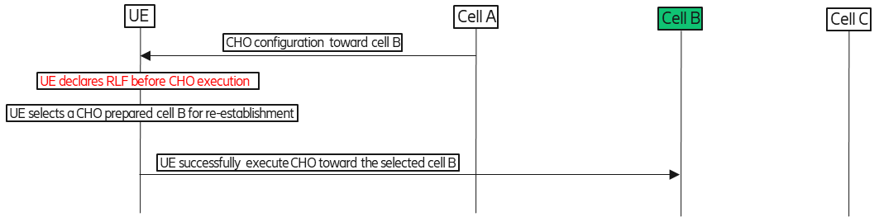

Figure 1: Too Late HO:1a

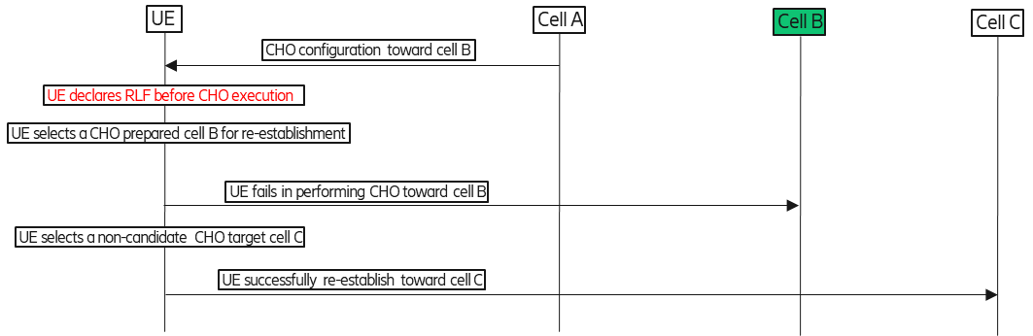

Figure 2: Too Late HO:1b

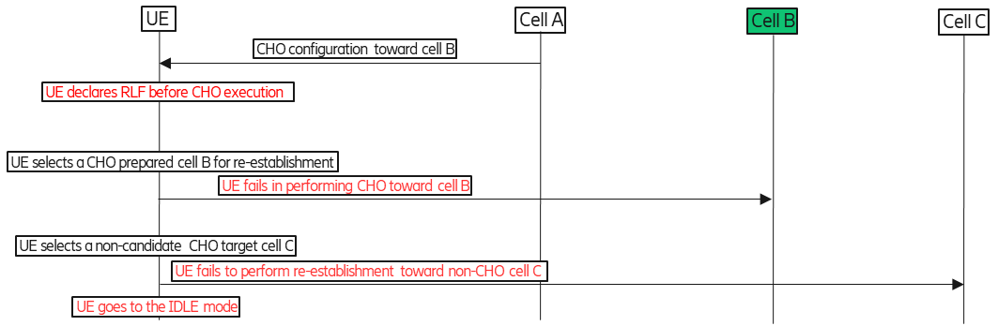

Figure 3-1: Too Late HO:1c- failure in re-establishment

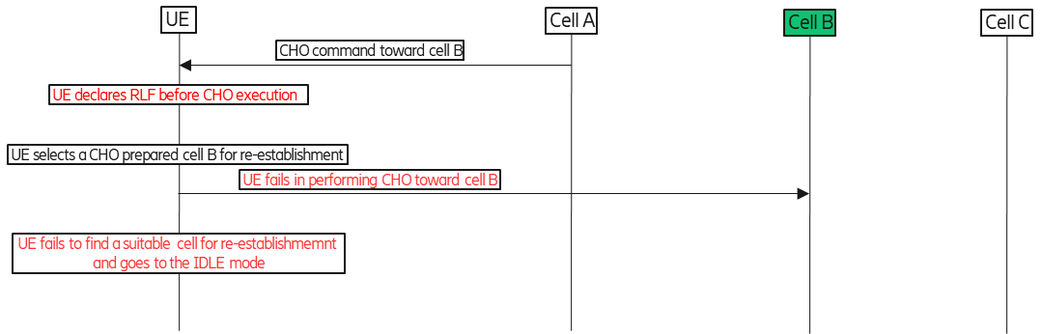

Figure 3-2: Too Late HO:1c- failure in finding a suitale cell.

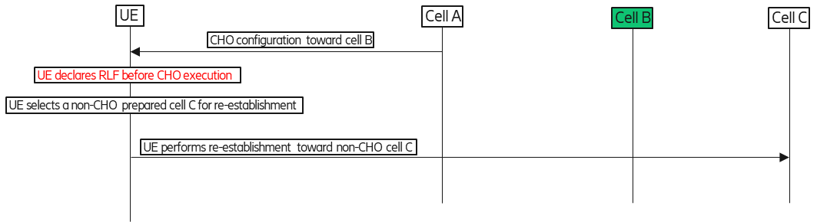

Figure 4: Too Late HO:1d

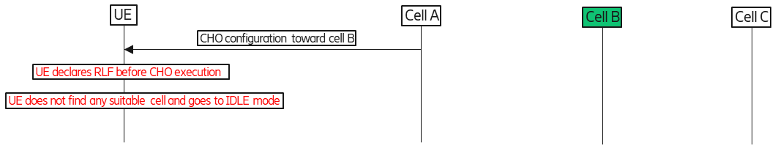

Figure 5: Too Late HO:1e

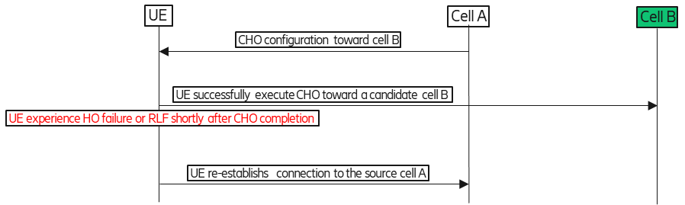

Figure 6: Too Early HO: 2a

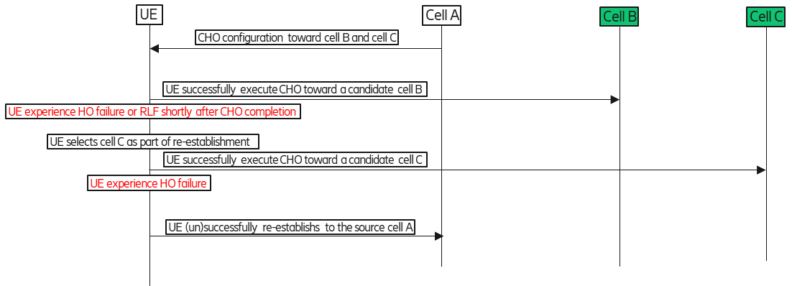

Figure 7: Too Early HO:2b

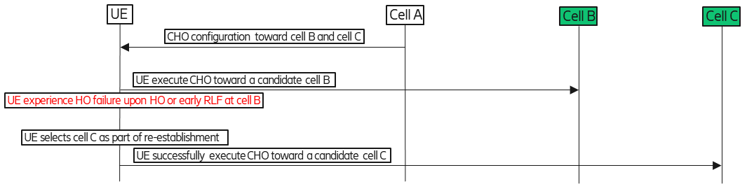

Figure 8: CHO to wrong cell:3a

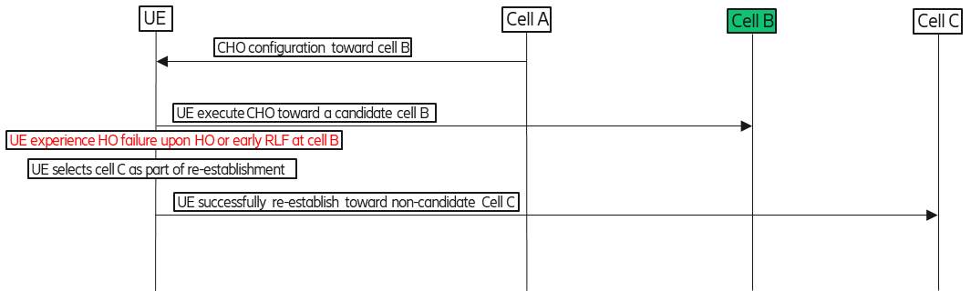

Figure 9: CHO to Wrong Cell:3b

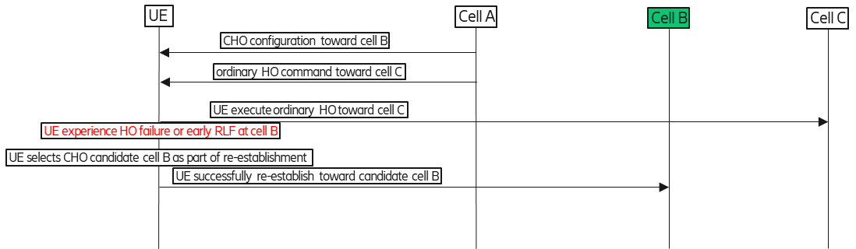

Figure 10: CHO to Wrong cell: 3c

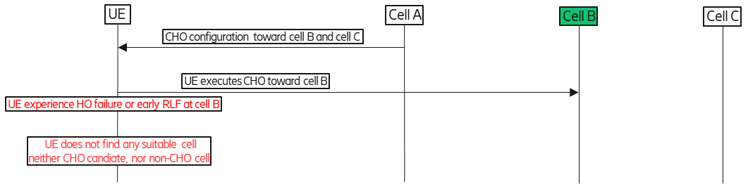

Figure 11: CHO to wrong cell: 3d

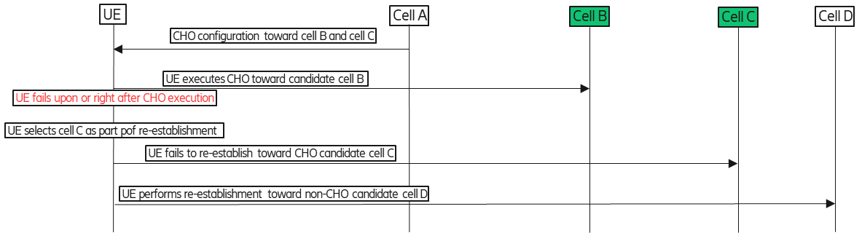

Figure 12-1: CHO to wrong cell: 3e – reestablishment toward non-CHO candidate cell

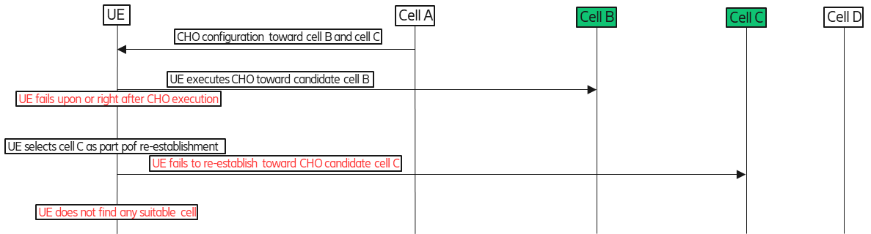

Figure 12-2: CHO to wrong cell: 3e – not finding any suitable cell

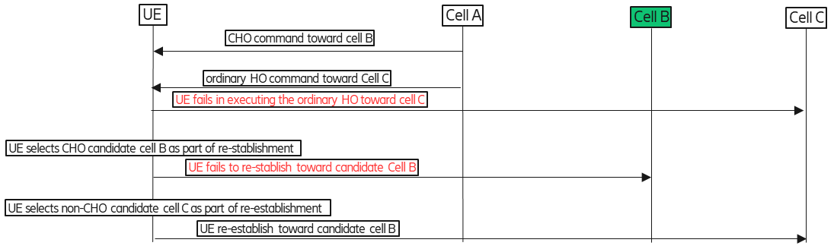

Figure 13-1: CHO to wrong cell: 3f – reestablishment toward non-CHO candidate cell

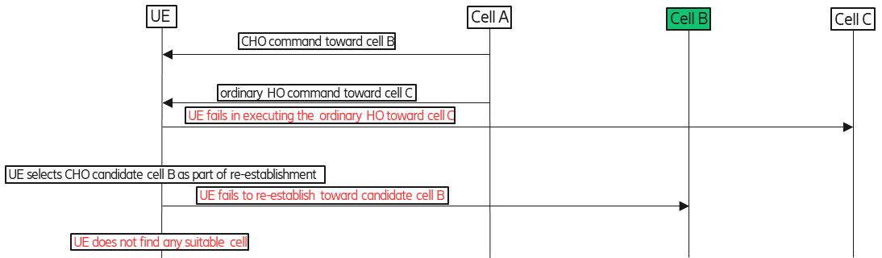

Figure 13-2: CHO to wrong cell: 3f – not finding any suitable cell

# 6 Annex – DAPS scenarios flow charts

**Figures concerning failure scenarios involving DAPS HO**

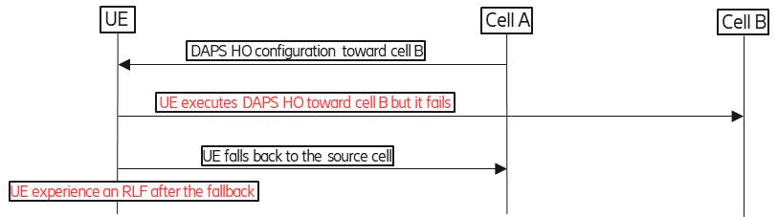

Figure 14: Too Late DAPS: 1b – RLF after DAPS

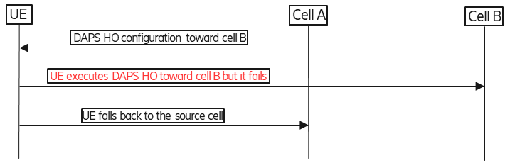

Figure 15: Too Early DAPS: 2a

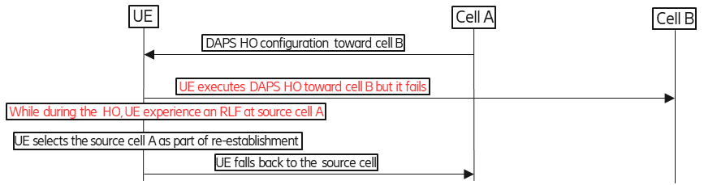

Figure 17: Too Early DAPS: 2b: Early RLF after HO completion before daps-sourceRelease

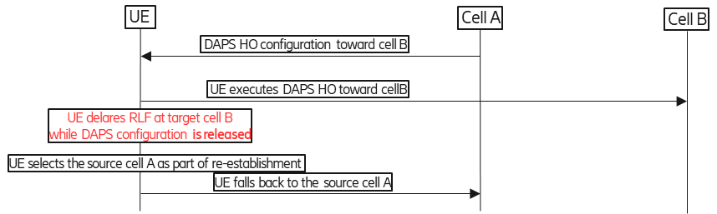

Figure 18: Too Early DAPS: 2c - Early RLF after HO completion after daps-sourceRelease

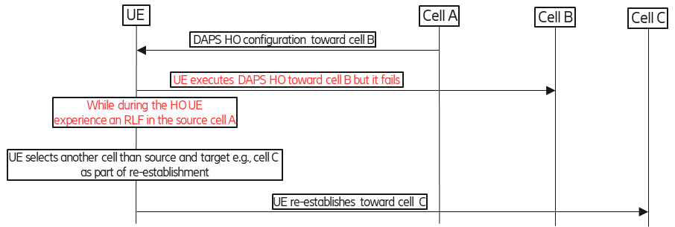

Figure 19: DAPS to Wrong cell: 3a - RLF during HO

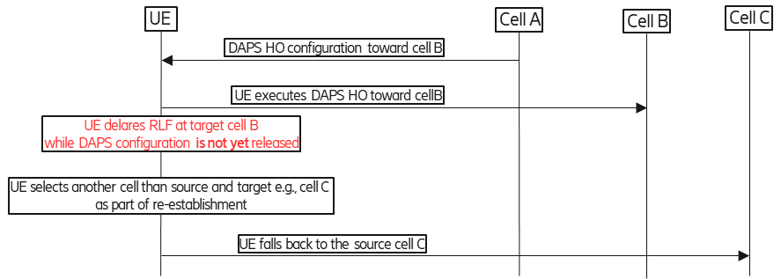

Figure 20: DAPS to Wrong cell: 3b - Early RLF after HO completion before daps-SourceRelease

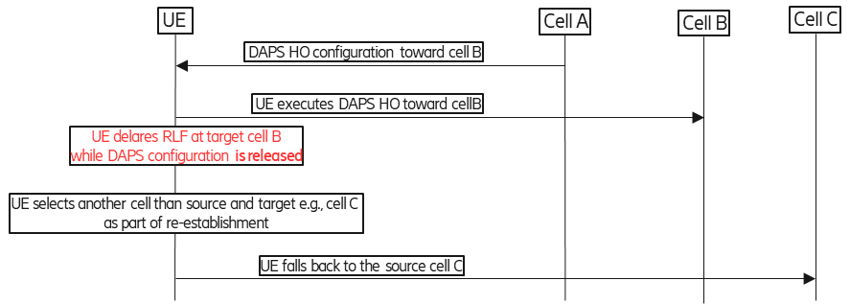

Figure 21: DAPS to Wrong cell: 3c - Early RLF after HO completion after daps-SourceRelease