3GPP TSG-RAN WG2 Meeting #113bis-e draftR2-210xxxx

Elbonia, 12th-20th April, 2021

**Agenda item: 8.10.3.3**

**Source: Intel Corporation**

**Title: Report of [post113-e][108][NTN] SMTC and measurement gap (Intel)**

**WID/SID: NR_NTN_solutions-Core - Release 17**

**Document for: Discussion and Decision**

# Introduction

This document captures measurement related proposals submitted in RAN2#113-e ([1]-[9]) for further discussion as described in this email discussion:

* [POST113-e][108][NTN] SMTC and measurement gaps (Intel)

Scope: Based on RAN2#113-e contributions, discuss measurement framework, SMTC and measurement gaps

Intended outcome: email discussion summary

Deadline: Long

This email discussion is divided in two phases:

* **Phase I** with the deadline on Tuesday March 23 1100 UTC (3am PST) for companies to provide their views.
* **Phase II** with deadline on Friday March 26 1100 UTC (3am PST) for companies to provide their views on the summary and suggested proposals.

# Discussion

The following agreements were made for measurement in Rel-17 NTN WI:

Agreements

1. Reconfiguration with sync is the baseline for connected mode mobility in NTN (the use of legacy RLF and re-establishment mechanism are not excluded)
2. The CHO can be used in NTN for both moving cell and fixed cell scenarios, and the CHO procedure and execution condition defined in Rel-16 is the baseline for NTN CHO.

3. NTN specific CHO execution condition can be further discussed.

**4. The existing measurement framework (e.g. measurement configuration, execution and reporting) is the baseline, and all the existing measurement criteria and event can be used in NTN. Support for new measurement is not excluded.**

**5. Legacy SSB periods (as in TN) shall be supported in NTN**

Agreements via email - offline 106:

1. **RAN2 understanding that UE shall not be forced to detect the SSB burst outside the corresponding configured SMTC window in NTN, just like the principle in TN.**

Agreements:

1. **SMTC and gap configuration in NTN are configured based on the timing of PCell**
2. **RAN2 can first identify the scenarios and discuss how serious the impact is before addressing any enhancement for SMTC configuration in NTN.**
3. **RAN2 can’t assume that the network will always have UE accurate location info for SMTC window configuration in NTN**
4. **UE along with the network in NTN should also have the same understanding of the timing, including the timing for measurement gap, to avoid any un-synchronized scheduling between UE and the network, just like the way we have in TN**

## Issue identification

In NTN, due to different propagation delay from different satellites to different UEs, the SMTC duration may have different timing at different UEs. Figure 1 (left side) illustrates an example of 3 different satellite cells and 2 UEs [1]. For simplicity, it is assumed that for all 3 cells, the SMTCs are sent at the same time with the same periodicity. The table below in Figure 1 (right side) depicts the timing of the SMTC window for both UEs and for all cells.

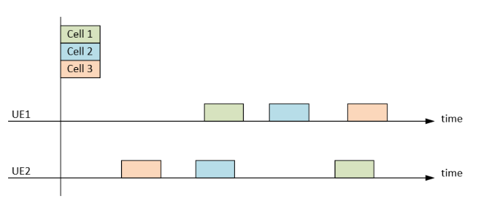

**Figure 1: example of 3 satellite cells and two UEs in different locations [1]**

The following exemplary scenario [1] assumes that T1 represents the time when SMTC was transmitted at the network side and Pij is the propagation delay between UE i and cell j. Figure 1 (right side) shows that UE 1 measures cell 1 SMTC at T1+P11 while UE 2 measures cell 1 SMTC at T1+P21. If a given UE needs to perform measurement, the measurement gap will need to cover the serving cell and neighbor cell SMTC window considering the propagation delays between different cells and the UEs. Otherwise, the UE will miss the measurement. The minimum propagation delay is 4ms and maximum is 541.46ms; this range tells us that the legacy measurement gap window cannot cover the large range of propagation delay.

Moreover, it is also indicated in [2] that static SMTC window duration is insufficient to accommodate propagation delay variability between serving and neighbor cells towards a stationary UE.

1. **Do companies agree that there may be an issue with the SMTC configuration and UE measurement gap configuration for NTN scenarios considering the different propagation delays between different cells and UEs? justify your response and if you agree, please add foreseen RAN2 impacts.**

|  |  |  |
| --- | --- | --- |
| **Company** | **Yes/No** | **Comments** |
|  |  |  |
|  |  |  |
|  |  |  |
|  |  |  |
|  |  |  |

## SMTC configuration

Assuming that companies agree on the issue explained in Discussion point 1), this section discusses how to address the concerns raised for the SMTC configuration. The following list includes solutions proposed by companies:

1. Rely on network implementation.
2. Enhancements of SMTC configuration [4][6][7]:
   1. Multiple SMTC configurations with multiple offsets [4][7].
   2. Single SMTC configuration per group cell [6][7].
   3. Other approaches.
3. Transmit additional number of SSBs [2][5]
   1. Target cell may increase them during the cell switch time [2].
   2. An additional SSB close in time to the existing SSB [5].
4. Other approaches.

The following discussion points 2-5 address each of the solutions listed above separately to have better understanding on how they work and whether they may solve or not the concern raised for the SMTC configuration.

### Option 1) Rely on network implementation

For Option 1), NTN relies on network implementation to provide a suitable SMTC configuration (i.e. no change of SMTC configuration is required for NTN). This option 1) relies on legacy features to address the related issue for NTN.

1. **Do companies think that option 1) “rely on network implementation” is a preferable approach to solve the issue described in Discussion point 1)? Please justify your response.**

|  |  |  |
| --- | --- | --- |
| **Company** | **Yes/No** | **Comments** |
|  |  |  |
|  |  |  |
|  |  |  |
|  |  |  |
|  |  |  |

### Option 2) Enhancements of SMTC configuration

For option 2), the SMTC configuration is enhanced for NTN scenarios. Different sub-options have been proposed on how to enable this:

1. Multiple SMTC configurations with multiple offsets [4][7].
2. Single SMTC configuration per group cell [6][7].
3. Other approaches.

For option 2.a), it is explained in [4] that separate SMTC can be configured per neighbour satellite, with each corresponding to a separate offset of the measurement window. Therefore, network can configure the offset of the measurement window by considering the propagation delay difference between serving satellite and neighbour satellite.

For option 2.b), it is explained in [6] that SMTC should be configured per NTN cell or group of NTN cells, not per frequency.

It was also proposed that network can provide a list of cells that need +/- offset to the SMTC configured by smtc1 in [7], which we understand that it may be aligned to both options, 2.a) and 2.b).

1. **Do companies think that option 2) “enhancements of SMTC configuration” is a preferable approach to solve the issue described in Discussion point 1)? Please justify your response indicating, if possible, your reasoning to support (or not) each of the proposed options.**

|  |  |  |
| --- | --- | --- |
| **Company** | **Yes/No** | **Comments** |
|  |  |  |
|  |  |  |
|  |  |  |
|  |  |  |
|  |  |  |

### Option 3) Transmit additional number of SSBs

For Option 3), NTN increases or provides additional number of transmitted SSBs [2][5]. Different sub-options have been proposed on how to enable this:

1. For earth-fixed cell scenario, the target cell may increase the number of transmitted SSBs during the cell switch time [2].
2. An additional SSB close in time to the existing SSB can be configured to ensure that at least one neighbour cell SSB will always fall within the serving cell measurement window (SMTC/measurement gap) [5]. This is explained as a non-uniform SSB burst pattern.
3. **Do companies think that option 3) “transmit additional SSBs” is a preferable approach to solve the issue described in Discussion point 1)? Please justify your response indicating, if possible, your reasoning to support (or not) each of the proposed options.**

|  |  |  |
| --- | --- | --- |
| **Company** | **Yes/No** | **Comments** |
|  |  |  |
|  |  |  |
|  |  |  |
|  |  |  |
|  |  |  |

### Option 4) Other approaches

1. **Companies are welcome to add other solutions if previous ones are not suitable.**

|  |  |  |
| --- | --- | --- |
| **Company** | **Solution 4.x)** | **Description of new solutions and/or comments** |
|  |  |  |
|  |  |  |
|  |  |  |
|  |  |  |
|  |  |  |

## Measurement gap configuration

Assuming that companies agree on the issue explained in Discussion point 1), this section discusses how to address the concerns raised for the measurement gap configuration. TS 38.331 defines in *MeasGapConfig* that the measurement gap length (*mgl*) can be 1.5, 3, 3.5, 4, 5.5, 6ms, and in Rel-16 also added 10, 20ms. The following list includes solutions proposed by companies:

1. Rely on network implementation [1]
2. Extended measurement gap window [1][3].
3. Multiple measurement gap patterns [1][4][6].
4. Periodic adjustment of measurement gap [7].
5. Up to UE implementation [1]
6. Other approaches.

The following discussion points 6-11 address each of the solutions listed above separately to have better understanding on how they work and whether they may solve or not the concern raised for the measurement gap configuration.

### Solution 1) Rely on network implementation

For solution 1), it is left up to the network to ensure that the SSB frequency/duration overlaps with the UE measurement window taking, or not, into account the different propagation delays from the configured satellites to the different UEs. This solution 1) relies on legacy features to address the related issue for NTN.

1. **Do companies think that solution 1) “rely on network implementation” is a preferable approach to solve the issue described in Discussion point 1)? Please justify your response.**

|  |  |  |
| --- | --- | --- |
| **Company** | **Yes/No** | **Comments** |
|  |  |  |
|  |  |  |
|  |  |  |
|  |  |  |
|  |  |  |

### Solution 2) Extended measurement gap window

Solution 2) allows the network to configure a longermeasurement gap window to accommodate multiple propagation delay from the configured satellite to be measured by the UE [1][3]. The motivation of extending the measurement gap window is to cover legacy occurrences of the required SSBs of neighbour satellites. On other hand, extending the measurement gap duration beyond current standardized limits will increase UE energy consumption and limit network scheduling flexibility and end user data rates, as explained in [2]. Therefore, this solution increases the chances of legacy SSBs to lay within the measurement gap window in trade-off of efficiency. It is pointed in [7] that this solution results in more interruption in UL/DL transmissions.

1. **Do companies think that solution 2) “extended measurement gap window” is a preferable approach to solve the issue described in Discussion point 1)? Please justify your response.**

|  |  |  |
| --- | --- | --- |
| **Company** | **Yes/No** | **Comments** |
|  |  |  |
|  |  |  |
|  |  |  |
|  |  |  |
|  |  |  |

### Solution 3) Multiple measurement gap patterns

Solution 3) allows the network to configure multiple measurement gap patterns to a single UE [1][4][6]. This solution 3 is aligned to the work ongoing in RAN4 to enable operation of multiple measurement gaps in Rel-17 NR. It is also explained in [6] that measurement gap can be configured per NTN cell or group of NTN cells, instead of only per UE or per FR. It is pointed in [7] that this solution results in more interruption in UL/DL transmissions which is the similar to extending measurement gap window.

1. **. Do companies think that solution 3) “multiple measurement gaps” is a preferable approach to solve the issue described in Discussion point 1)? Please justify your response.**

|  |  |  |
| --- | --- | --- |
| **Company** | **Yes/No** | **Comments** |
|  |  |  |
|  |  |  |
|  |  |  |
|  |  |  |
|  |  |  |

### Solution 4) Periodic adjustment of measurement gap

Solution 4) proposes that network provides a periodic adjustment of measurement gap [7]. For example, a time period is defined where no MGTA is applied (e.g., for measurement in LEO) and the other time period is defined where MGTA is applied (e.g., for measurement in GEO or TN) as shown in Figure below. This would reduce the signalling required for updating the measurement gap.



**Figure 2. Issue of differential propagation delays in SMTC and measurement gap configuration [7]**

1. **Do companies think that solution 4) “Periodic adjustment of measurement gap” is a preferable approach to solve the issue described in Discussion point 1)? Please justify your response**

|  |  |  |
| --- | --- | --- |
| **Company** | **Yes/No** | **Comments** |
|  |  |  |
|  |  |  |
|  |  |  |
|  |  |  |
|  |  |  |

### Solution 5) Up to UE implementation

Solution 5) leaves the handling up to UE implementation. For this solution, the UE may have to skip measurements or skip reception of data if UE were to perform measurements which are outside of the measurement gap window, i.e. adjusting measurement gap. UE may also take into account for the propagation delay. It is important to highlight that RAN2 agreed “*RAN2 understanding that UE shall not be forced to detect the SSB burst outside the corresponding configured SMTC window in NTN, just like the principle in TN*.” On other hand, the UE autonomous adjustments of the SMTC window would still require that the network is notified about any window change to facilitate scheduling, as explained in [2]. This solution 5) relies on legacy features to address the related issue for NTN.

1. **Do companies think that solution 5 “up to UE implementation” is a preferable approach to solve the issue described in Discussion point 1)? Please justify your response**

|  |  |  |
| --- | --- | --- |
| **Company** | **Yes/No** | **Comments** |
|  |  |  |
|  |  |  |
|  |  |  |
|  |  |  |
|  |  |  |

### Solution 6) Other approaches.

1. **Companies are welcome to add other solutions if previous ones are not suitable.**

|  |  |  |
| --- | --- | --- |
| **Company** | **Solution 6.x)** | **Description of new solutions and/or comments** |
|  |  |  |
|  |  |  |
|  |  |  |
|  |  |  |
|  |  |  |

## How network configures SMTC and measurement gap

The network requires to provide SMTC and measurement gap configuration that is overlapping with each other. Therefore, the network needs to account for the longer UE propagation delay in NTN scenarios. The following list includes options proposed by companies:

1. Rely on legacy operation [1]
2. UE assistance for network to properly (re)configure the SMTC and/or measurement gap [1][4][6][8]
   1. UE reports location information [1][6].
   2. UE reports propagation delay from neighboring cells [1][4][8]
   3. Other UE assistance information.
3. UE updates SMTC window based on relative movement of neighbor cell’s SSB [2].
4. Other approaches

The following discussion points 12-15 address each of the solutions listed above separately to have better understanding on how they work and whether they may be desirable or not for the network to configure correctly the SMTC window and the measurement gap.

### Option a) Rely on legacy operation

Option a) relies on existing SFTD mechanism [1]. This option a) relies on legacy features to address the related issue for NTN.

1. **Do companies think that option a) “rely on legacy operation” is a preferable approach for the network to configure correctly the SMTC window and the measurement gap? Please justify your response.**

|  |  |  |
| --- | --- | --- |
| **Company** | **Yes/No** | **Comments** |
|  |  |  |
|  |  |  |
|  |  |  |
|  |  |  |
|  |  |  |

### Option b) UE assistance for network to properly (re)configure the SMTC and/or measurement gap

For option b), UE assistance information is suggested for network to properly (re)configure the SMTC and/or measurement gap. Different sub-options have been proposed on how to enable this:

1. UE reports location information [1][6].
2. UE reports propagation delay from neighboring cells [1][4][8]
3. Other UE assistance information.

For Option b.1), UE reports location information so network can calculate/estimate propagation delay from neighboring cells [1] [6]. However, it was also pointed in [2] that the usage of UE location to configure and update SMTC configuration frequently is not feasible.

For Option b.2), UE reports propagation delay from neighboring cells [1][4][8]. It is clarified in [4] that the propagation delay difference in service link can be calculated by UE utilizing UE location information and ephemeris, and the feeder link propagation delay difference can be acquired by the gNB. However, it was also pointed in [2] that a UE cannot rely on its own location and ephemeris to configure and update SMTC windows, because it will lack information on varying feeder link delay.

1. **Do companies think that option b) “UE assistance for network to properly (re)configure the SMTC and/or measurement gap” is a preferable approach for the network to configure correctly the SMTC window and the measurement gap? Please justify your response indicating, if possible, your reasoning to support (or not) each of the proposed options.**

|  |  |  |
| --- | --- | --- |
| **Company** | **Yes/No** | **Comments** |
|  |  |  |
|  |  |  |
|  |  |  |
|  |  |  |
|  |  |  |

### Option c) UE updates SMTC window based on relative movement of neighbor cell’s SSB

For Option c) a UE can track the relative movement of neighbor cell’s SSB within the SMTC window and update the window when the time-wise movements exceed a threshold [2]. This is explained in [2] with the exemplary scenario shown in Figure 2. Assume the UE is configured with an SMTC window for measuring a neighbor cell’s SSB. At time 1, the UE receives the SSB and detects that the SSB is further than a threshold (*thr*) from the center of the SMTC window. Therefore, the UE moves the time-wise location of the SMTC window prior to the next measurement instance. When the UE has detected the need to move the window, it will also have to notify the network about the window movement such that UE and network has the same understanding of the SMTC window’s time-wise location. At time 2 the SSB is received, by the UE, and noted to be within the threshold, i.e. no SMTC window update is needed.

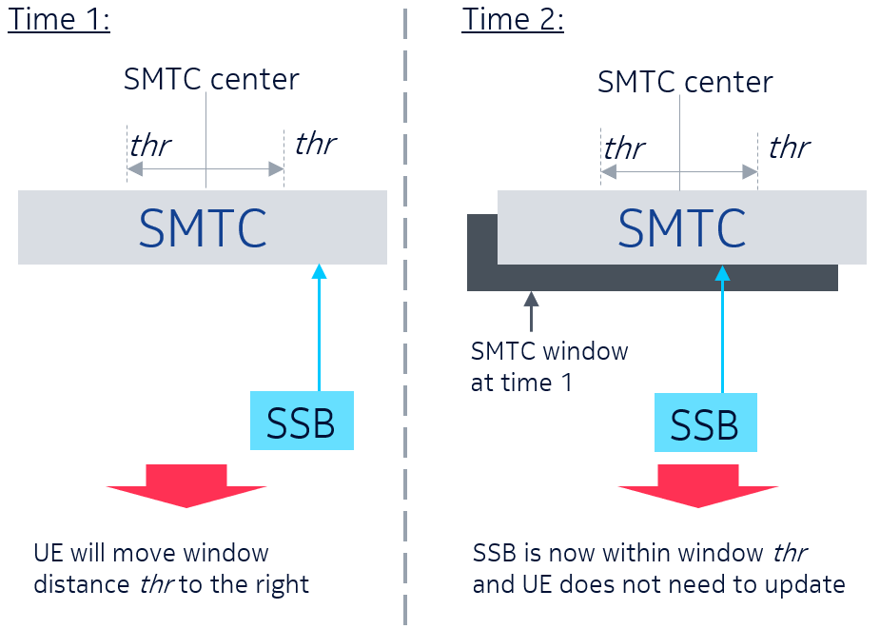

**Figure 3. Example of UE autonomous tracking of neighbor cell's SSB location within SMTC window [2]**

1. **Do companies think that option c) “UE updates SMTC window based on relative movement of neighbor cell’s SSB” is a preferable approach for the network to configure correctly the SMTC window and the measurement gap? Please justify your response.**

|  |  |  |
| --- | --- | --- |
| **Company** | **Yes/No** | **Comments** |
|  |  |  |
|  |  |  |
|  |  |  |
|  |  |  |
|  |  |  |

### Option d) Other approaches.

1. **Companies are welcome to add other solutions if previous ones are not suitable.**

|  |  |  |
| --- | --- | --- |
| **Company** | **Option d.x)** | **Description of new solutions and/or comments** |
|  |  |  |
|  |  |  |
|  |  |  |
|  |  |  |
|  |  |  |

## RRM requirements

In NTN, the chances of measuring neighboring cells may be small due to propagation delay. The UE may miss measurements when SMTC duration is not aligned with the measurement gap. In addition, the propagation delay to different cells changes over time due to the mobility of both UE and satellite. Therefore, the measurement gap window configuration may need to change over time. This makes it even harder for the UE to measure during SMTC window of the neighboring cells. On summary, it may be difficult for the NTN UE to achieve the same RRM requirements as in TN [1][7].

1. **Do companies think that UE RRM requirements for NTN should be changed in comparison to legacy TN ones? please indicate your preference and whether RAN4 should be contacted on this regard.**

|  |  |  |
| --- | --- | --- |
| **Company** | **Yes/No** | **Comments** |
|  |  |  |
|  |  |  |
|  |  |  |
|  |  |  |
|  |  |  |

# Conclusions

<To be updated>

# References

1. R2-2100384 Measurement framework to support NTN Intel Corporation 3GPP TSG-RAN WG2 Meeting #113e
2. R2-2100530 On SMTC and measurement gaps for NTN Nokia, Nokia Shanghai Bell 3GPP TSG-RAN WG2 Meeting #113e
3. R2-2100336 Consider on measurement in NTN system CATT 3GPP TSG-RAN WG2 Meeting #113e
4. R2-2100164 Discussion on mobility management for connected mode UE in NTN OPPO 3GPP TSG-RAN WG2 Meeting #113e
5. R2-2100258 Efficient Configuration of SMTC and Measurement Gaps in NR-NTN MediaTek Inc. 3GPP TSG-RAN WG2 Meeting #113e
6. R2-2100580 Further considerations on CHO, location reporting, and measurement window in NTN LG 3GPP TSG-RAN WG2 Meeting #113e
7. R2-2100745 SMTC and measurement gap configuration Qualcomm Incorporated 3GPP TSG-RAN WG2 Meeting #113e
8. R2-2101128 Considerations on measurements in NTN Lenovo, Motorola Mobility 3GPP TSG-RAN WG2 Meeting #113e
9. R2-2101859 SMTC and measurement gap configuration in NTN Rakuten Mobile, Inc 3GPP TSG-RAN WG2 Meeting #113e

# Annex: companies’ point of contact

|  |  |  |
| --- | --- | --- |
| **Company** | **Point of contact** | **Email address** |
| Intel Corporation | Marta Martinez Tarradell | [marta.m.tarradell@intel.com](mailto:marta.m.tarradell@intel.com) |
|  |  |  |
|  |  |  |
|  |  |  |