3GPP TSG-RAN WG2 Meeting #112e R2-20xxxxx
Online, 2-13 November 2020

Agenda item: X.X.X
Source: Nokia, Nokia Shanghai Bell
Title: [DRAFT] E-mail discussion: [Post111-e][924][R17 URLLC/IIoT] Propagation delay for TSN (Nokia)
WID/SID: NR_IIOT_URLLC_enh
Document for: Discussion and Decision

1 Introduction
This document aims to collect views from companies for the following email discussion agreed during RAN2 #111e:
- [Post111-e][924][R17 URLLC/IIoT] Propagation delay for TSN (Nokia)
1st phase: Agree on baseline scenarios and then for each scenario the high-level breakdown on the delay components and agree on assumptions. Identify the aspects that RAN1 should investigate
2nd phase: Identify the set of possible options to continue investigating and how they address each component
Intended outcome: report to next meeting
Deadline: Long

For the first phase, we aim to agree on baseline scenarios that will be examined in this WI. Furthermore, for each scenario, we should reach a consensus on the assumption of the Uu interface time synchronization error budget from a high-level E2E time synchronization error budget breakdown. This can form the basis for identifying any aspect that would require further investigation by RAN1. These would serve as a foundation for work relating to potential propagation delay compensation enhancement. Remarkably, the scope of the first phase coincides with a latest LS from RAN1 (R1-2007446), which indicates that RAN1 already identified two use cases from TS 22.104:
User-specific clock synchronicity accuracy level | Number of devices in one Communication group for clock synchronisation | 5GS synchronicity budget requirement  (note) | Service area | Scenario
2 | Up to 300 UEs | ≤900 ns | ≤ 1000 m x 100 m | - Control-to-control communication for industrial controller
4 | Up to 100 UEs | <1 µs | < 20 km² | - Smart Grid: synchronicity between PMUs

Besides, the LS R1-2007446 also request RAN2 to provide feedback on Uu interface error budget for each of the two use cases, this fits the objectives of this email discussion. Hence, the first phase of this email discussion will use RAN1 agreements as the basis.
For the second phase, we should identify the options of propagation delay compensation that we will further investigate.

2 Phase-1 Discussion: Use Cases, Scenarios, and Assumptions on Synchronization Error Budget

2.1 Use Cases and Scenarios
The scenarios for accurate time synchronizations are provided in TS 22.104 Table 5.6.2-1, and are copied below. As aforementioned, RAN1 has already agreed two of the use cases for further study, which are highlighted in the table below:
Table 1 - Clock synchronization service performance requirements for the 5G System
User-specific clock synchronicity accuracy level | Number of devices in one Communication group for clock synchronisation | 5GS synchronicity budget requirement  (note) | Service area | Scenario
1 | Up to 300 UEs | ≤900 ns | ≤ 100 m x 100 m | - Motion control  - Control-to-control communication for industrial controller
2 | Up to 300 UEs | ≤900 ns | ≤ 1000 m x 100 m | - Control-to-control communication for industrial controller
3 | Up to 10 UEs | < 10 µs | ≤ 2500 m² | - High data rate video streaming
3a | Up to 100 UEs | <1 µs | ≤10 km² | - AVProd synchronisation and packet timing
4 | Up to 100 UEs | <1 µs | < 20 km² | - Smart Grid: synchronicity between PMUs
5 | Up to 10 UEs | < 50 µs | 400 km | - Telesurgery and telediagnosis
NOTE: The clock synchronicity requirement refers to the clock synchronicity budget for the 5G system, as described in Clause 5.6.1.

Question 1: In addition to use cases identified by RAN1 (Highlighted in Table 1), do you think RAN2 should further study any other use cases listed in TS 22.104? If so, please provide the additional use cases you consider should be studied and arguments why.
Company | Comments
Nokia | No  We think the use cases identified by RAN1 are sufficient for Rel-17.

Aligned with the agreed assumptions on one Uu (smart grid) and two Uu interfaces (control-to-control) as listed in LS R1-2007446, we can consider two placements of the 5G GM for the control-to-control use case. These are illustrated in Figure 1. In one case, the TSC GM is connected to a device behind the 5GS CN and the E2E accuracy budget would apply from the time-stamping entity at the NW-TT to the time-stamping entity at the DS-TT. The other placement is that the TSC GM is connected to a device behind the UE, where the 5GS E2E budget applies from DS-TT timestamping entity at the source UE to the DS-TT timestamping entity at the target UE. The smart grid use-cases is different as the TSC GM is the 5G GM (or similar TD), so in this case the 5GS E2E accuracy is from the 5G GM to the DS-TT at a UE, as illustrated in Figure 2. These 5G GM placements for different use cases could be considered as the baseline scenarios.
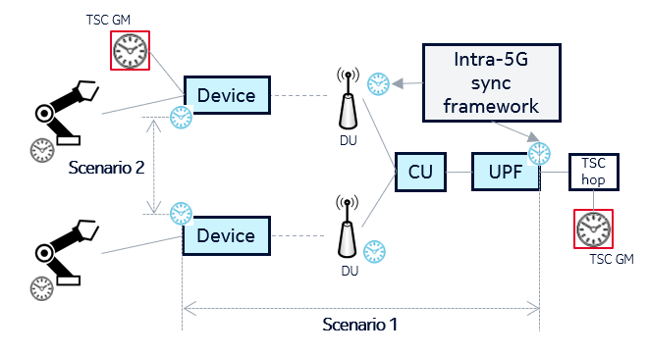
Figure 1. Illustration of the control-to-control use case with two possible scenarios (Scenario 1 and 2) to consider.
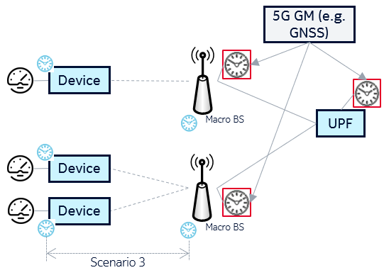
Figure 2. Illustration of the smart grid use case and a corresponding scenario (Scenario 3).
Question 2: Based on the two use cases identified by RAN1, which of the following scenarios should be considered as the baseline?
- Scenario 1: In the control-to-control communication use case, where TSC devices behind a target UE are synchronized to any TD, from a GM behind the CN. The 5GS introduced error is caused by the relative time-stamping inaccuracy at the NW-TT and the DS-TTs.
- Scenario 2: In the control-to-control communication use case, where TSC devices behind a target UE are synchronized to any TD, from a GM behind the UE. The 5GS introduced error is caused by the relative time-stamping inaccuracies at the involved DS-TTs.
- Scenario 3: In the smart grid use case, where the TSC devices behind a target UE are synchronized to the 5G GM TD. The 5GS introduced error is caused by the synchronization of the 5G clock to the DS-TT.
- Scenario 4: Other
Company | Scenario |  |  |  | Comments
 | 1 | 2 | 3 | 4
Nokia | V | V | V |  | We think Scenario 1, 2 and 3 should be considered as baseline.

2.2 High-level 5GS E2E Synchronization Budget Breakdown
In the LS R1-2007446. RAN1 has requested RAN2 to provide some information on the error budget in the Uu interface. The budget for the Uu interface depends on how much error could be consumed in other segments of the E2E path, as also mentioned in e.g. [7], [8], [16], [5], [16] and [3]. In particular, on top of the network-side error, it has also been mentioned that the UE-side would introduce an error and hence needs to be taken into account as a part of the E2E path error budget. Taking [3] as a starting point, the E2E path could be broken into three components, as illustrated in Figure 1, which could include:
- RAN / Uu interface – Account for the time synchronization errors introduced by the Uu interface i.e. between the UE and the gNB. This includes the aspects of antenna alignment errors, ReferenceTimeInfo delivery, SFN estimation including the impact on propagation delay (PD) compensation. Here we also include errors introduced by the gNB architecture splits (e.g. use of gNB-CU and gNB-DU).
- Network – Accounts for the time synchronization errors caused between the GM and the gNB. When the 5G GM source is shared between the UPF and the gNB, the synchronization error involved in this, should also be accounted for here. In case of split architecture, the gNB is a gNB-CU.
- Device – Accounts for the time synchronization errors introduced by the device implementation for maintaining the 5G clock at the DS-TT and potentially also the device output interface to the TSC devices connected to the device.

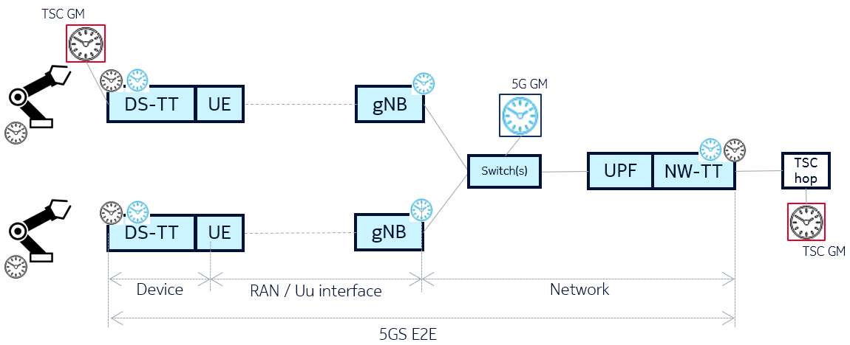
Figure 3. Possible breakdown of the 5GS E2E path
Question 3: Do you agree that the 5GS E2E synchronization budget could be split into three parts namely Device, Uu interface and Network? If the answer is No, please provide proposals for alternative approach.

Company | Comments
Nokia | Yes  We think this is a sensible way to evaluate the budget in different segments of the E2E path, and hence determine the propagation delay compensation scheme to be introduced.

All subsequent questions of Phase-1 are based on the above assumption where the 5GS E2E synchronization budget is split into Device, Uu interface and Network parts.

2.3 Assumption on Error Budget for Network Part
Several papers have proposed to capture a budget for a network related part of the 5GS E2E budget. For example, [8] and [16] have proposed that at least 100ns inaccuracy should be assumed for the network part, whereas some other papers (e.g. [7] and [5]) have mentioned the importance of network part budget. In [3], for example, two separate network part inaccuracies are proposed, one for each use case. There could be at least two options for the network part budget, as described below.
In the first option, particularly for the control-to-control use case, a single 5G GM clock source (e.g. from a GNSS receiver or a TSC GM) is distributed to the gNB and UPF (NW-TT) with a (g)PTP framework. It is assumed that the 5G GM clock source, UPF and gNB are located within the same facility and potentially within the same rack. The connection between UPF (NW-TT) and gNB is assumed to span over maximum four (g)PTP capable hops relative to the 5G GM. According to The RAN3 LS in R3-187252 this can introduce a maximum error of TE<|4 ∙40ns|, corresponding to an error within ±80ns.

In the second option, specifically for the smart grid use case, multiple 5G GM clock instances (of the same time-domain, e.g. from multiple GNSS receivers) are distributed in the service area (e.g. one at each gNB and one at the UPF). With the multiple 5G GM clock sources (of the same reference), provided throughout the scenario, the NW accuracy does not depend on the path between the 5GS components, but on the synchronization error between two 5G GM clock instances (e.g. GNSS receivers). Considering the 5G GM instance is provided by GNSS receivers, according to R3-187252 the maximum error between the GNSS receivers is 200ns, which translates to a time synchronization error range of maximum ±100ns.

Question 4: Do you agree to use the above two options as the network part budget, i.e. ±100ns for the smart grid and ±80ns for the control-to-control use case related scenarios respectively? If not, please provide your views on the network part budget for the considered use cases and scenarios. Please also indicate if any additional error components to be considered.
Company | Comments
Nokia | Yes  We are fine with having two network budgets for the two use cases. For simplicity we can also assume ±100ns for both use cases. Per scenario this means that:  Scenario 1 is the control-to-control use case, where the time synchronization error is between DS-TT and the NW-TT. Here the network budget of e.g. ±80ns applied.  Scenario 2 is the control-to-control use case, where the time synchronization error is between a DS-TT and another DS-TT. We assume only a single gNB is involved, which means that the network budget could be kept at ±80ns.  Scenario 3 is the smart grid use case where the time synchronization error is between a gNB and the DS-TT. Here the network budget of ±100ns applied.

As per Section 2.1, scenario 2 states time synchronization error between two DS-TT in control-to-control use case, where UEs can belong to same or different cell, and might have a different realization of the 5G clock, e.g. because the number of hops to synchronize the gNB with the 5G GM can be different.
Question 5: Can it be assumed that the involved UEs in scenario 2, will be connected to different gNBs and if so, what can we expect of relative 5G GM synchronization error between two gNBs?
Company | Comments
Nokia | No  We consider it likely that a single gNB with multiple gNB-DU is deployed if synchronization accuracy is the priority. As the termination point of the network budget would then be the gNB-CU, the network part is irrelevant for this scenario. However, the relative inaccuracy between the involved gNB-DU should be accounted for in the Uu interface assumptions (see Question 13).

2.4 Assumption on Error Budget for Device Part
The device part is intended to capture the device introduced time synchronization errors. Such errors could be the DS-TT clock instance maintenance or at the DS-TT output interfaces.
Question 6: What error component do you see should be accounted for in the device part and what assumptions can be made on the required device budget?
Company | Comments
Nokia | Input from device vendors would be appreciated.

Question 7: What can we assume of device part budget for each scenario described in Question 2?
Company | Comments
Nokia | Scenario 1 and 3, only one device is involved in the E2E path. One option is to consider the device as a boundary clock with e.g. an uncertainty of ±40ns.  Scenario 2 two devices are involved in the E2E path and the device budget should be accounted twice. That is assuming that both the source and target device introduce a similar time synchronization magnitude. One option is to consider the device as a boundary clock with e.g. an uncertainty of ±40ns, so a total device budget of ±80ns.

2.5 Assumption on Error Budget for Uu Interface
According to TS 22.104 Table 5.6.2-1, the service area defined for control to control and smart grid use case is ≤ 1000 m x 100 m and < 20 km² respectively. However, the assumption on the deployment of BS in the service area will impact the maximum propagation delay to be expected and hence agreeing on this will be helpful in the continued discussions. Companies are requested to provide their views on the number of BS, the maximum cell size and eventually the maximum expected propagation delay to be expected in each use case.
Question 8: For each use case, how many BS can be expected to be needed, what is the maximum cell size to be expected and eventually what is the maximum propagation delay to be expected?
Company | Comments
Nokia | For the control-to-control, it is reasonable to use the deployment layout described in TS 38.901 Table 7.8-7 for indoor factory (copied in for convenience). In fact, two big halls each with a hall size of L=300m x W=150m could be used as a starting point.  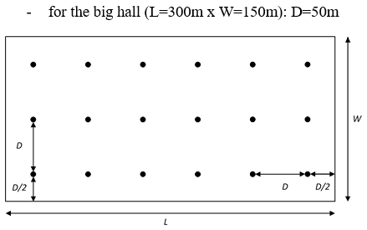  In this deployment the distance between BS are D=50m would give an expected maximum direct path between a UE and the nearest BS of 35m and hence the maximum expected propagation delay would be ~120ns. The corresponding calibration exercises in R1-1909704 reveals that even with this number of BS, the experienced coupling gain can in some cases give challenging signal conditions, so we would consider this number of BS to be a minimum.  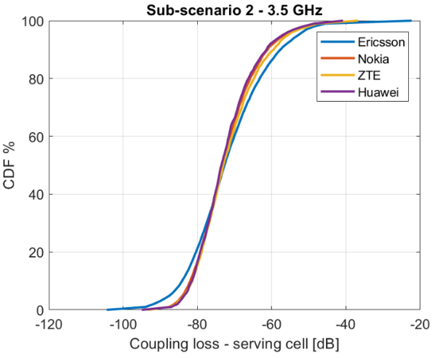  For the smart grid scenarios, we propose that any cell sizes supported by NR should also be supported for the smart grid use case. Hence we consider it reasonable to assume a standard hexagonal cellular grid with 1732m ISD. This would give an expected cell radius of about 1200m and hence a corresponding direct propagation path delay of about 4000ns.

Another important assumption when evaluating the Uu interface time synchronization accuracy is the assumption on the sub-carrier spacing. In the LS R1-2007446 it has been agreed to evaluate both 15 and 30 kHz for both use cases.
Question 9: Do you agree to use 15 kHz and 30 kHz sub-carrier spacing in the evaluations of the Uu interface time synchronization accuracy for all scenarios?
Company | Comments
Nokia | Yes  We are fine by using the RAN1 agreement as a baseline for the evaluations for time synchronization budgets.

Moreover, according to RAN1 agreements, one and two Uu interfaces are considered for the control-to-control and smart grid use cases respectively.
Agreements:
- For 5GS synchronicity budget requirement,
  - One Uu interface is assumed for smart grid.
  - Two Uu interfaces are assumed for control-to-control.

Question 10: Do you agree on the assumptions on the involved number of Uu interfaces in the considered scenarios?
Company | Comments
Nokia | Yes

While discussing the scenario where two Uu interfaces are involved, it should be considered if the involved Uu interfaces require a similar time synchronization accuracy budget. For instance, the UE deployment can cause different propagation delays, or even that propagation delay compensation is only applies for one or none of the Uu interfaces.
Question 11: When two Uu interfaces are involved, do you agree that the two Uu interfaces should be assumed to use the same time synchronization accuracy budget?
Company | Comments
Nokia | Yes,  In this case, we would have to assume the worst case assumption.  One worst case assumption is if propagation delay compensation is needed for both Uu interfaces.  Another one, if propagation delay compensation is not needed for both Uu interfaces, the worst case is that one UE is located very close to a TRP, and the other is located furthest away possible from a TRP.

Related to Question 5 and 6 on the network part budget, the Uu interface budget part could account for a relative error between TRPs (assuming that between gNBs are accounted for in the network part).
Question 12: Should the Uu interface part account for an error between TRPs? And if so, what can be assumed on the maximum time synchronization error between TRPs?
Company | Comments
Nokia | Yes  Here we would assume that the TAE requirement given in 38.104 bounds the maximum synchronization error between any two any two antenna-connectors.

Finally, please indicate if anything is missing or should be considered in this Phase-1 of the email discussion and if RAN2 thinks there are any additional aspects which RAN1 should consider.
Question 13: Please indicate if anything additional should be considered in Phase-1 discussion.
Company | Comments

Question 14: Any aspects that RAN1 has not yet considered that RAN2 thinks that RAN1 should consider?
Company | Comments
Nokia | No

3 Phase-2 Discussion: Options for Propagation Delay Compensation
TBD

4 Conclusions
TBD

References
[1] R2-2007999 Consideration on Time Synchronization for TSN in R17 CMCC
[2] R2-2006719 IIoT Enhancements for Support of Time Synchronization Intel Corporation
[3] R2-2006922 Discussion on enhancements for support of propagation delay compensation for accurate time synchronization Nokia, Nokia Shanghai Bell
[4] R2-2006906 Propagation Delay Compensation for Reference Timing Delivery Qualcomm
[5] R2-2006701 Enhancements for support of time synchronization Ericsson
[6] R2-2006635 Discussion on Time Synchronization in Rel-17 CATT
[7] R2-2006697 Discussion on enhancements for support of time synchronization Huawei, HiSilicon
[8] R2-2006831 Enhancements for time synchronization in TSN ZTE Corporation, Sanechips, China Southern Power Grid Co., Ltd
[9] R2-2006864 Topics for time synchronization in IIoT Fujitsu
[10] R2-2007141 Consideration of TSN time synchronization enhancements OPPO
[11] R2-2007145 Discussion on the TSN enhancements vivo
[12] R2-2007294 Discussion on uplink time synchronization for TSN NTT DOCOMO INC.
[13] R2-2007475 Considerations on time synchronization enhancement Lenovo, Motorola Mobility
[14] R2-2007611 On propagation delay compensation MediaTek Inc.
[15] R2-2007627 Enhancements for support of time synchronization Sequans Communications
[16] R2-2008033 Discussion on support of time synchronization LG Electronics Inc.
[17] R2-2008059 Enhancements for Timing Synchronization Samsung

