3GPP TSG-RAN WG2 #112-e R2-20xxxxx
Electronic meeting, 2nd – 13th November, 2020

Agenda Item: x.x.x
Source: Rapporteur (Ericsson)
Title: Summary of [Post111-e][912][REDCAP] TP for the TR (Ericsson)
Document for: Discussion, Decision

Introduction
The document summarizes the following discussion:
- [Post111-e][912][REDCAP] TP for the TR (Ericsson)
Scope: Draft a TP for the TR based on the meeting agreements
Intended outcome: email discussion summary and draft TR
Deadline: Long

The email discussion has two parts:
- Phase 1: Collection of input for TR update/revision, based on the feedback and suggestions provided in this document (Oct 9th)
- Phase 2: Final DL for all feedback, for further discussion on revision of the draft TR text details (Oct 15th)

Two documents are provided: This document, the template for company inputs, and the actual draft TR 38.875 (based on v0.0.2) [1] with additional TP suggestions based on the agreements so far. Companies are respectfully asked to provide their input in this document and not directly in the draft TR in the first phase.

Discussion
Draft TR 38.875 [1] includes at least the following sections/clauses to which RAN2 should provide input to:
- 8 UE power saving
  - 8.3 Extended DRX for RRC Inactive and/or Idle
  - 8.4 RRM relaxation for stationary devices
- 10 Definition and constraining of reduced capabilities
  - 10.1 Definition of reduced capabilities
  - 10.2 Constraining of reduced capabilities
- 11 UE identification and access restrictions
  - 11.1 UE identification
  - 11.2 Access restrictions

The above sections contain further subsections for feature description, analysis of coexistence with legacy UEs and specification impacts and power saving and performance analysis for power saving related features. As all of the details have not yet been analysed or discussed, this discussion focuses mainly on subsections for “Description of the feature”, see [1].
In the following sections the companies are asked to provide feedback and/or TPs for the draft TR 38.875 [1] based on the RAN2 agreements and discussion until now. The rapporteur company has provided some initial text suggestions for general descriptions based on existing specification text and agreements which companies are welcome to comment.

UE power saving section
Extended DRX
In RAN2#111-e the following agreements were made on UE power saving:
For extended DRX:
- For power saving, for now RAN2 studies extended DRX for idle and inactive modes and RRM relaxation for stationary RedCap devices, and input to be provided to TR 38.875.
- RAN2 study eDRX mechanism for both RRC_IDLE and RRC_INACTIVE in this SI. ‎
- For RRC_INACTIVE, the DRX cycle is extended to 10.24s as baseline.
- For RRC_IDLE, the DRX cycle is at least extended to 10.24s. FFS on further extension ‎beyond 10.24s.
- For RRC_IDLE and/or RRC_INACTIVE, if the NR DRX cycle range is extended beyond 10.24s, the LTE ‎eDRX mechanism beyond 10.24s (e.g., PTW, PH, etc.) is used as baseline when NR eDRX cycle is configured beyond 10.24s.
FFS:
- For RRC_IDLE and/or RRC_INACTIVE, FFS on baseline mechanism when the configured NR eDRX cycle is less or equal to 10.24s

Based on the agreements, RAN2 has agreed to study extended DRX for both RRC_IDLE and RRC_INACTIVE, and as baseline the extended DRX cycle is introduced up to 10.24 s for both states. It is under study/discussion whether and how long extension is done beyond 10.24 s for each of the states.
The following is suggested as the initial text to be added to clause 8.3.1 Description of the feature (under 8.1 Introduction to UE power saving), see also draft TR [1]:

8.3.1 Description of feature
In LTE / EPC, the UE may be configured with and extended DRX (eDRX) cycle. The UE may operate in extended DRX only if the UE is configured by upper layers and the cell indicates support for eDRX in System Information. In RRC_IDLE the eDRX cycle has maximum value of 2621.44 seconds (43.69 minutes) (for NB-IoT the maximum is 10485.76 seconds or 2.91 hours). Hyper SFN (H-SFN) is broadcasted by the cell and increments by one when SFN wraps around. Paging Hyperframe (PH) refers to the H-SFN in which the UE starts monitoring paging DRX during a Paging Time Window (PTW).
For RedCap UEs in NR, extended DRX cycles can be introduced at least up to 10.24 s for both RRC_IDLE and RRC_INACTIVE. If extension beyond 10.24 s is specified, similar mechanism as in LTE is expected to be feasible including use of H-SFN, PH and PTW.

The first paragraph above is adopted from TS 36.304, the second paragraph from TS 36.300 and the third paragraph is new text based on the agreements.
The companies are asked to provide feedback on the above suggestion for baseline text and provide further input, if feasible at this point:
Company | Is the above baseline text agreeable? | Feedback / TP suggestions

For eDRX, RAN2 is expected to provide analysis of eDRX power saving in section 8.3.2. Two submitted Tdocs provided analysis of potential eDRX gain:
- R2-2006913 (Ericsson): Model based on TR 38.840 and example results of eDRX in RRC_IDLE and RRC_INACTIVE up to 48 min eDRX cycle. Figure 1:

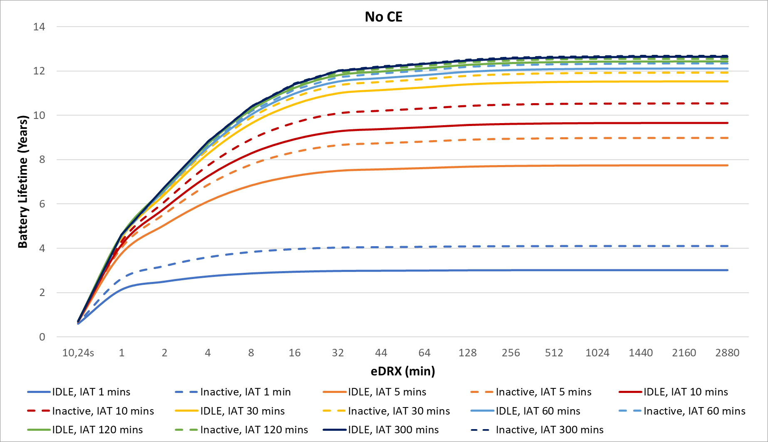

- R2-2007494 (MediaTek): Model based on TR 38.840 and example results on relative gain vs I-DRX up to 2.9 h eDRX cycle. Table 2:

Table 2 Example power savings that can be achieved with eDRX
Scenario | T_{I-DRX} (ms) | T_{eDRX} (ms) | PTW length (ms) | % Savings with eDRX compared to I-DRX
High SINR | 2560 | 10,485,760 | 2560 | 29.02
High SINR | 1280 | 10,485,760 | 1280 | 44.99
High SINR | 320 | 10,485,760 | 320 | 76.59
Low SINR | 2560 | 10,485,760 | 2560 | 51.35
Low SINR | 1280 | 10,485,760 | 1280 | 67.86
Low SINR | 320 | 10,485,760 | 320 | 89.41

As no other explicit results were provided, the above results could be used as the baseline in section 8.3.1. Further input and revisions, if provided, can then be taken into account in later updates to TR 38.875.

Question: Is it agreeable to use the results from R2-2006913 and R2-2007494 as baseline in section 8.3.1 Analysis of eDRX power consumption? [Baseline referring to no further input to 8.3.1 is excluded]
Company | Yes / No | Feedback / comments

Above discussion considers sections 8.3.1 and 8.3.2 in the TR, companies are welcome to provide feedback on the other sections under 8.3 on eDRX:
Company | Any other input to section 8.3 (extended DRX) in the TR?

RRM relaxation
There were no agreements on RRM relaxation, thus no text proposal is provided, however companies are welcome to provide early suggestions or TPs to section 8.4 RRM relaxation for stationary devices:
Company | Input to section 8.4 (RRM relaxation) in the TR, if any?

Definition and constraining of reduced capabilities section
In RAN2#111-e the following agreements were made on definition and constraining of reduced capabilities:
- RAN2 studies, and provides input to TR 38.875, on whether and how it can be ensured RedCap UEs are used only for intended use cases. This may require coordination with other WGs (e.g. RAN3 / SA / CT).
- At least for device type identification and access restriction (including initial access), the network needs to know whether the UE is redCap UE or not. FFS on whether based on explicit or implicit signalling.
- The existing UE capabilities framework is used as baseline to indicate the capabilities of a RedCap UE (this does not imply anything on the reporting of the device type, if the need for a device type will be agreed)
- The number of device types should be minimised, to reduce market fragmentation, and introduced only where essential to control UE accesses and differentiate them from legacy R15/R16 and non-Redcap R17 UEs, (e.g. number of Tx/Rx antennas, maximum supportable BW, etc.). The exact composition of the set of L1 capabilities of the device type can be discussed by RAN1
- Discuss in normative phase on whether to signal (and in case how) a Device type and its associated capabilities (the reduced set of capabilities) is captured in specifications, and whether device type is indicated as part of UE capability
FFS:
- Whether reduction of upper layer capabilities should be considered is FFS (in any case no email discussion until the next meeting on this)

Based on the agreements, the following is suggested as the initial text to be added to clause 10.1.1 Description of the feature (under 10.1 Definition and constraining of reduced capabilities), see also draft TR [1]:

10.1.1 Description of feature
As a baseline, the existing UE capabilities framework is used to indicate the capabilities of reduced capability UEs. In NR, the UE capabilities do not rely on UE categories, which is a concept used in LTE/E-UTRAN, and UE categories associated to fixed peak data rates are only defined for marketing purposes and not signalled to the network. The network determines the UL and DL data rate supported by a UE from the supported band combinations and from the baseband capabilities. The UE reports its UE radio access capabilities which are static at least when the network requests.
Different device types for RedCap UEs should be introduced only where essential to for example control UE accesses and differentiate them from legacy UEs and UEs which are not RedCap UEs. The number of different UE types should be minimised.
Editor’s note: The details and numbers of device types is FFS and discussion should be coordinated between RAN1/RAN2.

The first paragraph above is adopted from TS 38.300 clauses 7.5 and 14 and the RAN2 agreements. The second paragraph is new text based on the agreements.
The companies are asked to provide feedback on the above suggestion for baseline text and provide further input, if feasible at this point:
Company | Is the above baseline text agreeable? | Feedback / TP suggestions

Company | Any other input to section 10.1 in the TR?

In the TR, for constraining reduced capabilities section 10.2 Constraining of reduced capabilities should describe the feature and analyse coexistence and impacts. There were not concrete agreements on this part during RAN2#111-e, but it was discussed this functionality may require coordination with other WGs. For now, there is no text suggestion provided but companies are welcome to provide any early suggestions:
Company | Input to section 10.2 in the TR, if any?

UE identification and access restrictions section
In RAN2#111-e the following agreements were made related to UE identification and access restrictions (the first agreement was also listed above in section 2.2):
- At least for device type identification and access restriction (including initial access), the network needs to know whether the UE is redCap UE or not. FFS on whether based on explicit or implicit signalling.
- An indication in system information is needed to indicate whether a REDCAP UE can camp on the cell. FFS whether the indication is explicit or implicit.
- UAC mechanism also apply to REDCAP UEs.
- System information indicates whether REDCAP operation is allowed/barred on a frequency. FFS reuse the legacy intraFreqReselection or introduce separate flag
- Further discuss enhancement of UAC for REDCAP UEs, including e.g.:
a. define new Access Identity for REDCAP UEs
b. define new Access Categories for REDCAP UEs
(for any final decision we need to check with SA1 and/or CT1)

For UE identification, to be described in the TR in section 11.1, the only related agreement is that the network should be aware whether the UE is a RedCap UE for e.g. access restriction. This is discussed in section 2.2 and no further suggestion is provided here, but companies are welcome to provide their views for section 11.1 in the draft TR:
Company | Input to section 11.1 in the TR, if any?

For access restrictions, based on the agreements, the following is suggested as the initial text to be added to clause 11.2.1 Description of the feature (under 11.2 Access restrictions), see also draft TR [1]:

11.2.1 Description of feature
NG-RAN supports overload and access control functionality such as RACH back off, RRC Connection Reject, RRC Connection Release and UE based access barring mechanisms.
For RedCap UEs, an indication in broadcast system information can be used to indicate whether a RedCap UE can camp on the cell or not.
Unified access control framework is specified in TS 22.261 and it applies to all UEs in RRC_IDLE, RRC_CONNECTED and RRC_INACTIVE for NR. This mechanism can also apply to RedCap UEs to control RedCap UEs accesses to the network.
Editor’s note: FFS on details of above, e.g. explicit or implicit indication in SI, details of UE access identifier and/or access categories for reduced capability UEs.

The first paragraph above is from TS 38.300 clause 7.4. The second paragraph is new text based on the agreements. The third paragraph is partly adopted form TS 38.300 clause 7.4 and based on the agreements.
The companies are asked to provide feedback on the above suggestion for baseline text and provide further input, if feasible at this point:
Company | Is the above baseline text agreeable? | Feedback / TP suggestions

Company | Any other input to section 11.2 in the TR?

Phase 2
TBD

Summary
TBD

References
- R2-200xxxx, (Draft) Update to TR 38.875, RAN2#111-e, Electronic meeting, August 2020.
- RP-201676, SR for Study of support of reduced capability NR devices, Ericsson, RAN#89e, Electronic meeting, September 14-18, 2020

Delegate contact information
Company | Delegate contact
COMPANY_NAME | NAME (email@address.com)

