3GPP TSG-RAN WG2 #112-e R2-200xxxx
Electronics, 26 October – 13 November, 2021

Agenda item: 6.4.3
Source: LG Electronics Inc. (Rapporteur)
Title: [POST111-e][707][V2X] CR update to new RAN1 decisions
Document for: Discussion and decision

Introduction
In this document, we trigger Phase 1 discussion of the following email discussion:
- [POST111-e][707][V2X] CR update to new RAN1 decisions (LG)
Discuss necessary changes to new RAN1 decisions and prepare agreeable MAC CR. Also can include unresolved issues from the discussion [AT111-e][705][V2X] and [AT111-e][706][V2X].
Intended outcome: Report
Deadline: Long

Deadline of Phase 1 discussion: October 8, 2020, 23:59 UTC
Note that the recent RAN1 agreements impacting on MAC specification are numbered by Rapporteur for RAN2 discussion.

New RAN1 agreements impacting on MAC specification

Agreement #1:
- For CG, when the maximum number of HARQ retransmissions for a TB is reached, the UE reports ACK/NACK based on the contents of PSFCH (i.e., the same behaviour as if the maximum number of retransmissions had not been reached).
  - No RAN1 spec impact is expected.

The agreement #1 is related to clause 5.22.1.3.2 of TS38.321 as shown below. Rapporteur thinks that the agreement #1 is only applied to transmission of a MAC PDU for which HARQ feedback is enabled due to ‘based on the contents of PSFCH’. No change to 38.321 is required for transmission of a MAC PDU for which HARQ feedback is disabled.

5.22.1.3.2 PSFCH reception
…
1> else if a MAC PDU has been obtained for a sidelink grant associated to the PUCCH transmission occasion in clause 5.22.1.3.1, the MAC entity shall:
2> if the most recent transmission of the MAC PDU was not prioritized as specified in clause 5.22.1.3.1a:
3> instruct the physical layer to signal a negative acknowledgement on the PUCCH according to clause 16.5 of TS 38.213 [6].
2> else if HARQ feedback has been disabled for the MAC PDU and next retransmission(s) of the MAC PDU is not required:
3> instruct the physical layer to signal a positive acknowledgement corresponding to the transmission on the PUCCH according to clause 16.5 of TS 38.213 [6].
2> else if HARQ feedback has been disabled for the MAC PDU and no sidelink grant is available for next retransmission(s) of the MAC PDU, if any:
3> instruct the physical layer to signal a negative acknowledgement corresponding to the transmission on the PUCCH according to clause 16.5 of TS 38.213 [6]
2> else:
3> instruct the physical layer to signal an acknowledgement corresponding to the transmission on the PUCCH according to clause 16.5 of TS 38.213 [6].
1> else:
2> instruct the physical layer to signal a positive acknowledgement on the PUCCH according to clause 16.5 of TS 38.213 [6].

Rapporteur thinks that if HARQ feedback is enabled, UE shall go to the green step. Thus, no change is required to reflect the agreement #1.
Proposal 1: No change to 38.321 is required to reflect the agreement #1:

Question 1A: Do you agree with Proposal 1?
Company | Yes/No | Comment
OPPO | No | We agree the part here does not need to be changed, but change is needed on other places as clarified in Q-1B below.
HW | Yes | Agree with rapporteur

Question 1B: If no, what/how should 38.321 need to be revised?
Company | Clause in 38.321 | Proposed revision
OPPO | 5.22.1.3.1a | In the following part:  1> if sl-MaxTransNum corresponding to the highest priority of the logical channel(s) in the MAC PDU has been configured in sl-CG-MaxTransNumList for the sidelink grant by RRC and the maximum number of transmissions of the MAC PDU has been reached to sl-MaxTransNum; or  1> if a positive acknowledgement to a transmission of the MAC PDU has been received according to clause 5.22.1.3.2; or  1> if negative-only acknowledgement was enabled in the SCI and no negative acknowledgement was received for the most recent (re-)transmission of the MAC PDU according to clause 5.22.1.3.2:  2> flush the HARQ buffer of the associated Sidelink process.  Based on the green part, as long as maximum re-tx number is reached, the buffer would be flushed, but according to RAN1 agreement, the UE may still report NACK to network, which means network may still schedule re-transmission SL grant, they are contradictory since that will lead to a case that the TX-UE has an empty buffer but has to send re-transmission since NACK is received from Rx-UE and re-tx grant is provided by network. So good to restrict it to HARQ disabled case, i.e.  1> if HARQ feedback has been disable and sl-MaxTransNum corresponding to the highest priority of the logical channel(s) in the MAC PDU has been configured in sl-CG-MaxTransNumList for the sidelink grant by RRC and the maximum number of transmissions of the MAC PDU has been reached to sl-MaxTransNum; or

Agreement #2:
- Conclusion:
  - RAN1 expects the remaining PDB provided by higher layers is smaller than the resource reservation period (not including 0ms) provided by higher layers
    - No RAN1 specification impact
The agreement #2 is related to LS in R2-2005977 from RAN2 related to the following RAN2 agreement:
47: RAN2 expects that RAN1 will discuss whether ReTX resources of a MAC PDU are reserved neither right on nor after new TX resource of the next MAC PDU for a configured sidelink grant reserved for a particular Sidelink process.
To Rappoteur’s understanding, RAN1 expects that a retransmission of MAC PDU only occurs within a resource reservation period with the agreement #2 because selection window for resource selection in PHY should be confined within the resource reservation period. Thus, RAN2 could agree that ReTX resources of a MAC PDU are reserved neither right on nor after new TX resource of the next MAC PDU for a configured sidelink grant reserved for a particular Sidelink process.
Proposal 2-1: ReTX resources of a MAC PDU are reserved neither right on nor after new TX resource of the next MAC PDU for a configured sidelink grant reserved for a particular Sidelink process.

Question 2A: Do you agree with Proposal 2-1?
Company | Yes/No | Comment
OPPO | Yes
HW | Yes

In addition, we could clarify in 5.22.1.1 of 38.321 that the remaining PDB should be smaller than the resource reservation period (not including 0ms) when the MAC entity creates a selected sidelink grant corresponding to transmissions of multiple MAC PDUs. Note that the agreement #2 is only applicable to transmissions of multiple MAC PDUs.
Proposal 2-2: The change to selection of the resource reservation interval is required to reflect the agreement #2:

Question 2B: Do you agree with Proposal 2-2?
Company | Yes/No | Comment
OPPO | Yes
HW | Yes

Question 2C: If Yes in 2B, do you agree with the following change to 38.321?
5.22.1.1 SL Grant reception and SCI transmission
…
1> if the MAC entity has selected to create a selected sidelink grant corresponding to transmissions of multiple MAC PDUs, and SL data is available in a logical channel:
…
2> if the TX resource (re-)selection is triggered as the result of the TX resource (re-)selection check:
3> select one of the allowed values configured by RRC in sl-ResourceReservePeriodList which are equal to or larger than the remaining PDB of SL data available in the logical channel and set the resource reservation interval, 𝑃rsvp_TX, with the selected value;

Company | Yes (possibly with revision) or No | Comment
OPPO | No | With the existing NOTE,  NOTE 4: How the MAC entity determines the remaining PDB of SL data is left to UE implementation.  It would be sufficient to revise it to reflect the agreement#2, e.g.,  NOTE 4: How the MAC entity determines the remaining PDB of SL data is left to UE implementation, which is expected to be smaller than the resource reservation period (not including 0ms).
HW | No | According to the RAN1 agreement, the selected value of the period can only be larger than the remaining PDB of the SL data available in the logical channel. If the selected value is equal to the remaining PDB then the last retransmission may be overlapped with the new transmission of the next MAC PDU.

Agreement #3:
- If periodic reservation is in use by a UE, and if pre-emption is enabled in a resource pool, the UE checks pre-emption for resources provided by MAC layer to L1, according to specified procedures
  - L1 expects that MAC layer provides resources intended for transmission of one TB, which can fit to resource selection window of current TB of the UE, and for which the relevant priority is available
  - If a resource is pre-empted, a re-selection for the pre-empted resource is triggered based on the specified step 1 and step 2 procedures,
    - with details up to UE implementations, including whether/how to set the reservation period in the re-selected resource
  - FFS in TP phase how/where to capture this in specification
    - During the pre-emption checking, j is up to Cresel-1

Rapporteur thinks that according to yellow part of the agreement #3, UE checks pre-emption only for resources reserved for transmission of one TB i.e. a MAC PDU created by LCP. Namely, UE is not expected to check pre-emption for any reserved resources reserved for potential MAC PDUs not created by LCP yet.
Proposal 3: UE checks pre-emption only for resource(s) reserved for one MAC PDU created by LCP.

Question 3A: Do you agree with Proposal 3?
Company | Yes/No | Comment
OPPO | No | Based on the bullet below  - FFS in TP phase how/where to capture this in specification  - During the pre-emption checking, j is up to Cresel-1  We believe the collision check for premption is not limited to a single MAC PDU, but has to be for “j is up to Cresel-1”, i.e., multiple MAC PDUs.  The text “MAC layer provides resources intended for transmission of one TB” is just to say that the target resource provided to L1 is limited to the current TB, but when collision check is performed, it has to consider the subsequent repetitions on different value of j.
HW | No | According to RAN1 agreement, there is no restriction that the TB must be already created by LCP but the relevant priority being available is enough. Therefore as when to create a MAC PDU is all up to UE implementation and even before the TB is generated the UE is able to know the priority of this TB as long as the UE knows which LCH(s) are going to be multiplexed in the TB but actually the TB has not been created.

Question 3B: If Yes in 3A, do you agree with the following change to 38.321?

5.22.1.2 TX resource (re-)selection check
…
1> if a resource(s) of the selected sidelink grant is indicated for re-evaluation by the physical layer as specified in clause 8.1.4 of TS 38.214 [7]; or
1> if any resource(s) of the selected sidelink grant for which a MAC PDU has been obtained in clause 5.22.1.3.1 is indicated for pre-emption by the physical layer as specified in clause 8.1.4 of TS 38.214 [7]; or

Company | Yes (possibly with revision) or No | Comment
OPPO | No | As replied to Q-3B
HW | No | See comments above.

In addition, RAN1#98bis previously made some agreements on re-evaluation and pre-emption as follows:
- Agreements on re-evaluation before transmission of SCI with reservation (resource allocation mode 2)
- Resource (re-)selection procedure supports re-evaluation of Step 1 and Step 2 before transmission of SCI with reservation
- The re-evaluation of the (re-)selection procedure for a resource reservation signalled in a moment ‘m’ is not required to be triggered at moment > ‘m – T3’ (i.e. resource reselection processing time needs to be ensured)
- Agreements on pre-emption mechanism (resource allocation mode 2)
- Support a resource pre-emption mechanism for Mode-2
- A UE triggers reselection of already signaled resource(s) as a resource reservation in case of overlap with resource(s) of a higher priority reservation from a different UE and, SL-RSRP measurement associated with the resource reserved by that different UE is larger than an associated SL-RSRP threshold
  - Only the overlapped resource(s) is/are reselected
As agreed in RAN1#98bis, re-evaluation is triggered for a resource which has been not indicated by a prior SCI while pre-emption is triggered for a resource which has been indicated by a prior SCI. The difference between re-evaluation and pre-emption was not specified in RAN1 specifications. Since both re-evaluation and pre-emption lead to reselection of the concerned resource, Rapporteur propose to clarify difference between re-evaluation and pre-emption in 38.321.

Question 3C: Do you agree with the following change to 38.321 to clarify difference between re-evaluation and pre-emption?

5.22.1.2 TX resource (re-)selection check
…
1> if a resource(s) of the selected sidelink grant is indicated for re-evaluation by the physical layer as specified in clause 8.1.4 of TS 38.214 [7] and has been not indicated by a prior SCI; or
1> if any resource(s) of the selected sidelink grant for which a MAC PDU has been obtained in clause 5.22.1.3.1 is indicated for pre-emption by the physical layer as specified in clause 8.1.4 of TS 38.214 [7] and has been indicated by a prior SCI; or

Company | Yes (possibly with revision) or No | Comment
OPPO | No | We believe that “indicated for re-evaluation by the physical layer as specified in clause 8.1.4 of TS 38.214 [7]” has included the pre-condition that the grant “has been not indicated by a prior SCI”, i.e., otherwise, for a grant has been indicated by a prior SCI, it should not be “indicated for re-evaluation” by physical layer. The same logic applies for pre-emption, i.e., “indicated for pre-emption by the physical layer as specified in clause 8.1.4 of TS 38.214 [7]” has included the pre-condition that the grant “has been indicated by a prior SCI”.  So a suggested change can be as follows  1> if a resource(s) of the selected sidelink grant which has not been indicated by a prior SCI is indicated for re-evaluation by the physical layer as specified in clause 8.1.4 of TS 38.214 [7]; or  1> if any resource(s) of the selected sidelink grant which has been indicated by a prior SCI is indicated for pre-emption by the physical layer as specified in clause 8.1.4 of TS 38.214 [7]; or
HW | Yes | We think OPPO and the rapporteur have the same understanding but the detailed wording is little bit different. We slightly prefer OPPO’s wording.

Agreement #4:
According to the agreed CR to 38.212 in R1-2007453, SCI format 2-A including Cast type indicator is used with HARQ operation when HARQ-ACK information includes ACK or NACK, when HARQ-ACK information includes only NACK, or when there is no feedback of HARQ-ACK information, while SCI format 2-B including Zone ID and communication range is used with HARQ operation when HARQ-ACK information includes only NACK, or when there is no feedback of HARQ-ACK information.
Thus, NACK-only HARQ feedback can be indicated by SCI not including Zone ID and communication range. Rapporteur thinks that change to clause 5.22.2.2.2 of TS38.321 is required for RX UE accordingly.
Proposal 4: The following change to 38.321 is required to reflect the agreement #4 for RX UE:

5.22.2.2.2 Sidelink process
…
1> if HARQ feedback is enabled by the SCI:
2> if negative-only acknowledgement is indicated by the SCI according to clause 8.4.1 of TS 38.212 [9]:
3> if UE's location information is available and distance beteween UE's location and the central location of the nearest zone indicated by the Zone_id in the SCI is smaller or equal to the communication range requirement in the SCI; or
3> if none of Zone_id and communication range requirement is indicated by the SCI; or
3> if UE's location information is not available:
4> if the data which the MAC entity attempted to decode was not successfully decoded for this TB and the data for this TB was not successfully decoded before:
5> instruct the physical layer to generate a negative acknowledgement of the data in this TB.

Question 4A: Do you agree with Proposal 4?
Company | Yes (possibly with revision) or No | Comment
OPPO | Yes
HW | Yes

Question 4B: If no in 4A, what/how should 38.321 need to be revised for RX UE?
Company | Clause in 38.321 | Proposed revision

Any other new RAN1 agreement impacting on MAC specifications?
Company | Concerned RAN1 agreement | Impacted clause and proposed revision

Unresolved Issues from [AT111-e][705][V2X]

Issue A: SL_RESOURCE_RESELECTION_COUNTER
SL_RESOURCE_RESELECTION_COUNTER is a UE variable used to reserve a selected sidelink grant for transmissions of multiple MAC PDUs in Sidelink resource allocation mode 2. This NR counter inherited from the LTE counter for the same purpose. Like in LTE, if PSSCH transmission corresponds to the last transmission of a MAC PDU, the Sidelink process decrements SL_RESOURCE_RESELECTION_COUNTER by 1 in NR. However, unlike in LTE sidelink resource allocation mode 4, HARQ feedback can be enabled in NR sidelink resource allocation mode 2. Thus, we would need to take into account the case when transmission of a MAC PDU terminates based on HARQ ACK, e.g. as pointed out in R2-2007094.
For NR sidelink, HARQ feedback can be based on either NACK-only or ACK-NACK. Thus, when HARQ feedback is enabled, transmission of a MAC PDU can be terminated by one of the following cases:
- if a positive acknowledgement to a transmission of the MAC PDU has been received; and
- if a negative-only acknowledgement was enabled in the SCI and no negative acknowledgement was received for the most recent (re-)transmission of the MAC PDU
Rapporteur proposes to discuss whether the above cases can decrement SL_RESOURCE_RESELECTION_COUNTER by 1 in Sidelink resource allocation mode 2.

Question A1: Do you agree to support the following behaviour?
- If a positive acknowledgement to a transmission of the MAC PDU has been received, the Sidelink process decrements SL_RESOURCE_RESELECTION_COUNTER by 1.
Company | Yes/No | Comment
OPPO | Yes for behaviour but no need for spec change | By reading the “reason for change” in R2-2007094,  “For the case when HARQ feedback is enabled, the UE will not be able to determine which transmission is the last transmission when packet is transmitted, so UE shall decrement the counter when ACK/NACK is received”,  we understand the existing condition of “if this transmission corresponds to the last transmission of the MAC PDU” has included not only the last transmission is due to ACK or no NACK received, but also the case where the maximum re-transmission number is reached (e.g., due to congestion control restriction) even though NACK is received from Rx-UE, so there is no need for this change.
HW | Yes

Question A2: Do you agree to support the following behaviour?
- If a negative-only acknowledgement was enabled in the SCI and no negative acknowledgement was received for the most recent (re-)transmission of the MAC PDU, the Sidelink process decrements SL_RESOURCE_RESELECTION_COUNTER by 1.
Company | Yes/No | Comment
OPPO | Yes for behaviour but no need for spec change | As replied above.
HW | Yes

Question A3: If yes in A1 and/or A2, how do you want to specify them in 38.321?
- Option 1: No change is needed because ‘the last transmission’ in 5.22.1.3.1a of 38.321 already includes the last transmission terminated by HARQ feedback.
1> if this transmission corresponds to the last transmission of the MAC PDU:
2> decrement SL_RESOURCE_RESELECTION_COUNTER by 1, if available.
- Option 2: the behaviour(s) in A1 and/or A2 should be clearly specified in 38.321, e.g.:
1> if a positive acknowledgement to a transmission of the MAC PDU has been received according to clause 5.22.1.3.2; or
1> if a negative-only acknowledgement was enabled in the SCI and no negative acknowledgement was received for the the most recent (re-)transmission of the MAC PDU according to clause 5.22.1.3.2:
2> decrement SL_RESOURCE_RESELECTION_COUNTER by 1, if available.
- Option 3: Other?
Company | Preferred option | Comment
OPPO | 1 | As replied above.
HW | Option 1 | We think “last transmission” already covers the above mentioned two cases. No additional changes are needed.

Issue B: Selection of retransmission resource(s)
It has been specified in 38.321 how to select resources in case retransmission resource(s) cannot be selected up to the selected number of HARQ retransmissions by ensuring that the resource(s) can be indicated by the time resource assignment of a prior SCI, how to select the time and frequency resources for one or more transmission opportunities from the available resources.
As discussed in R2-2008332, some company thinks that this behaviour can be left to UE implementation. One way to specify the concerned selection of retransmission resources is to replace the following normative text by a new NOTE:
Proposed new NOTE in 5.22.1.1 of 38.321:
If retransmission resource(s) cannot be selected up to the selected number of HARQ retransmissions by ensuring that the resource(s) can be indicated by the time resource assignment of a prior SCI, how to select the time and frequency resources for one or more transmission opportunities from the available resources is left for UE implementation.
Proposed removal of the normative text from 5.22.1.1 of 38.321
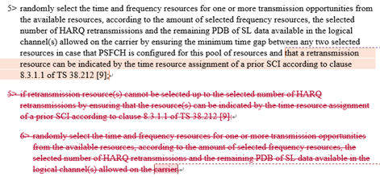
Note that this issue was discussed but finally noted at RAN2#111-e:
Proposal 3: Agree the following NOTE5 by removing the related normative text as captured in the CR. Or, RAN2 does not remove the related normative text in 5.22.1.1.
- Noted.

Question B1: Do you support removal of the concerned normative text (as shown in the red box above) and addition of the following NOTE?
NOTE: If retransmission resource(s) cannot be selected up to the selected number of HARQ retransmissions by ensuring that the resource(s) can be indicated by the time resource assignment of a prior SCI, how to select the time and frequency resources for one or more transmission opportunities from the available resources is left for UE implementation.
- Option Yes: Remove the concerned normative text and add the above NOTE.
- Option No: We keep the current normative text i.e. do not remove it.
Company | Yes/No | Comment
OPPO | Yes with comment on the NOTE | The change on the current text is needed:  - We understand the text is used to capture RAN1#101 agreement on “Step 2, a UE should/shall select resources so that HARQ retransmission resources can be reserved by a prior SCI, except that in case no resource can be found for reservation (e.g., based on the identified candidate set after Step 1) for a retransmission of a TB, the re-transmission can be transmitted on a resource that is not reserved”, but the two level-5 bullets are contradictory to each other, since the first one is to require the UE to ensuringthe condition of “a retransmission resource can be indicated by the time resource assignment of a prior SCI according to clause 8.3.1.1 of TS 38.212”, yet the second is to handle the case where the condition cannot be ensured, which leads to a level-6 bullet which is exactly the same as the first level-5 bullet except the condition which cannot be ensured.  - Furthermore, it is strange why the other condition “by ensuring the minimum time gap between any two selected resources in case that PSFCH is configured for this pool of resources” is missing in the level-6 bullet.  So we believe the key point here is: The UE has to fulfil the requirement “a retransmission resource can be indicated by the time resource assignment of a prior SCI according to clause 8.3.1.1 of TS 38.212” as much as possible, while keeping the other requirement as it was – so there is no need to differentiate the two cases for whether the condition can be achieved or not, i.e., the condition can be addressed separately without touching the other requirements.  - W.r.t. how to address the condition separately, we are open to the way either in R2-2008332 or the NOTE as proposed by rapporteur. If we go for the NOTE, one small comment as follows - Since the issues here seems independent of the number of re-transmission?  NOTE: If retransmission resource(s) cannot be selected up to the selected number of HARQ retransmissions by ensuring that the resource(s) can be indicated by the time resource assignment of a prior SCI, how to select the time and frequency resources for one or more transmission opportunities from the available resources is left for UE implementation.  - Furthermore, the change has to be applied to 5.22.1.2 as well
HW | No | This note is not correct as according to RAN1 agreement, even though the condition “If retransmission resource(s) can be selected up to the selected number of HARQ retransmissions by ensuring that the resource(s) can be indicated by the time resource assignment of a prior SCI” cannot be fulfilled, the other conditions still need to be satisfied, e.g., the minimum time gap etc. Therefore, in this case, how to select the resource cannot be left to UE implementation. In addition, to solve the condition contradictory issue proposed by OPPO in R2-206585, We think we can update the text as below  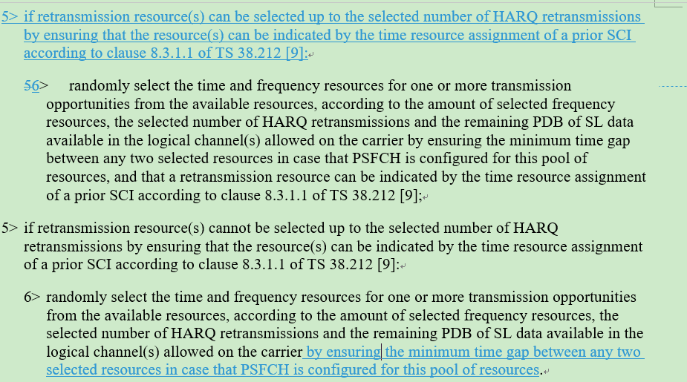

Issue C: Flushing soft buffer
RAN2 previously agreed the following in RAN2#108:
The Rx UE can flush the buffer of the HARQ process and consider it as available when a new transmission SCI is received for this HARQ process (for the existing source, destination ids, cast type and HARQ process id).
Thus, in 38.321, if the NDI has been toggled compared to the value of the previous received transmission or this is the very first received transmission, when there is a Sidelink process associated with the Sidelink identification information and the Sidelink process ID of the SCI, RX UE considers the Sidelink process as unoccupied and flushes the soft buffer for the Sidelink process.

5.22.2.2.1 Sidelink HARQ Entity
…
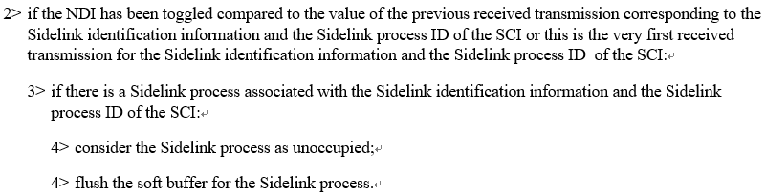

Meanwhile, as discussed in R2-2008332, some company thinks that ‘flush the soft buffer’ in 5.22.2.2.1 can be removed because RX UE will anyway replace an old TB by a new TB in the soft buffer, even without flushing. However, according to RAN2 agreement, both flushing and considering as unoccupied are needed.
Note that this issue was discussed but finally noted at RAN2#111-e:
Proposal 5: Confirm specification of ‘flush the soft buffer for the Sidelink process’ in 5.22.2.2.1 considering RAN2 agreement.
- Noted.

Question C1: Can we confirm the following RAN2 agreement and keep ‘flush the soft buffer of the Sidelink process’ in 38.321?
The Rx UE can flush the buffer of the HARQ process and consider it as available when a new transmission SCI is received for this HARQ process (for the existing source, destination ids, cast type and HARQ process id).
- Option Yes: We should keep ‘flush the soft buffer of the Sidelink process’ in 38.321’.
- Option No: We can remove ‘flush the soft buffer of the Sidelink process’ in 38.321’.
Company | Yes/No | Comment
OPPO | No | If checking the spec for downlink HARQ handling, there is no such harq buffer flushing operation, so we wonder what is the benefit to have this operation for sidelink, and thus wonder the reason for this agreement.  Unless we identify some negative effect that motivates this difference between DL-Rx and SL-Rx, we suggest to revert the agreement and remove the flushing operation here.
HW | Yes | We support to keep this bullet to better reflect the agreement. According to the agreement achieved in RAN2#108 meeting, both flushing and considering as unoccupied are needed.  The Rx UE can flush the buffer of the HARQ process and consider it as available when a new transmission SCI is received for this HARQ process (for the existing source, destination ids, cast type and HARQ process id).  We don’t think there is any problem to keep this bullet and if this bullet is deleted, we should firstly revisit the agreement and the proponents should give out some reasonable arguments to revisit the agreement and clarify if there is any significant bad impact on the functionality if flushing behaviour is kept.

Unresolved Issues from [AT111-e][706][V2X]

Issue D: UL/SL prioritization
Uplink transmission may overlap with V2X sidelink communication and/or NR sidelink communication, which requires intra-UE UL/SL prioritization. It has been understood since specification of LTE sidelink that UE should first check whether uplink transmission is prioritized and then if uplink transmission is not prioritized or UE cannot perform UL and SL simultaneously, UE should check whether sidelink transmission is prioritized.
Thus, UE should first check whether uplink transmission is prioritized in 5.4.2.2 of 38.321 for UL/SL prioritization. Then, if uplink transmission is not prioritized or UE cannot perform UL and SL simultaneously, UE should check whether sidelink transmission is prioritized in 5.22.1.3.1a of 38.321.

Question D1: Can we confirm the following UL/SL prioritization procedure is correct?
UE should first check whether uplink transmission is prioritized in 5.4.2.2 of 38.321 for UL/SL prioritization. Then, if uplink transmission is not prioritized or UE cannot perform UL and SL simultaneously, UE should check whether sidelink transmission is prioritized in 5.22.1.3.1a of 38.321.
Company | Yes/No | Comment
OPPO | Yes
HW | No | We don’t see strong motivation to clearly specify this order, we think this can be left to UE implementation whether to firstly check if UL is prioritized or if SL is prioritized

Question D2: If yes in D1, do you think that we need to clarify the procedure in D1 in 38.321?
Company | Yes/No | Comment
OPPO | No

Question D3: If yes in D2, do you agree the following change in 38.321?
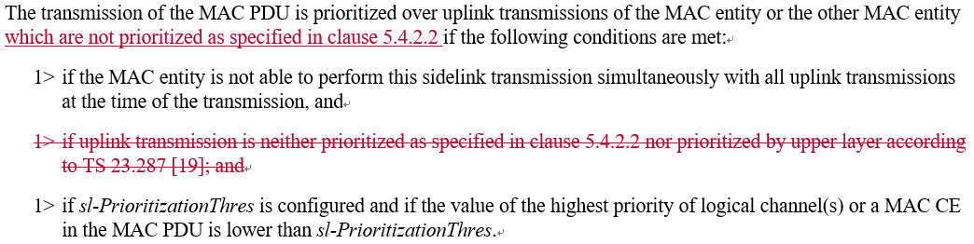
Company | Yes (possibly with revision) or No | Comment
OPPO | No | If we add this sentence, then this condition are repeated 3 times which is not necessary

In addition, when/how UL is prioritized is currently specified in 5.4.2.2 of 38.321, except the case when UL is prioritized by upper layer according to TS 23.287 which is specified in 5.22.1.3.1a of 38.321. This seems not aligned with other cases specified in 5.4.2.2 where UL is prioritized over SL.
Thus, we could change to 5.22.1.3.1a of 38.321 as follows and add the case when UL is prioritized by upper layer according to TS 23.287 to 5.4.2.2:
Proposal D: Specify ‘UL prioritization by upper layer according to TS 23.287’ in 5.4.2.2 of TS 38.321 and remove ‘the UL prioritization by upper layer’ from 5.22.1.3.1a of TS 36.321.

Question D4: Do you agree with Proposal D?
Company | Yes / No | Comment
OPPO | No | The condition “uplink transmission is not prioritized as specified in clause 5.4.2.2” should be removed because this has been addressed in following sentence in same clause:  1> if there is a MAC PDU to be transmitted for this duration in uplink, except a MAC PDU obtained from the Msg3 buffer or prioritized as specified in clause 5.4.2.2, and the sidelink transmission is prioritized over uplink transmission:  but the condition “prioritized by upper layer according to 23.287[19]” should be kept because this part should be applied for both intra and inter-RAT case
HW | No | We do see there is some problem here as in section 5.4.2.2 when determining UL is prioritized over SL we refer to section 5.22.1.3.1 to check if SL is prioritized which according to current spec refers back to section 5.4.2.2 to check if UL is prioritized. But we still prefer to keep current modelling i.e., do not clearly specify the order the UE determines the UL prioritization and SL prioritization. But some update on the text as shown below can be adopted.  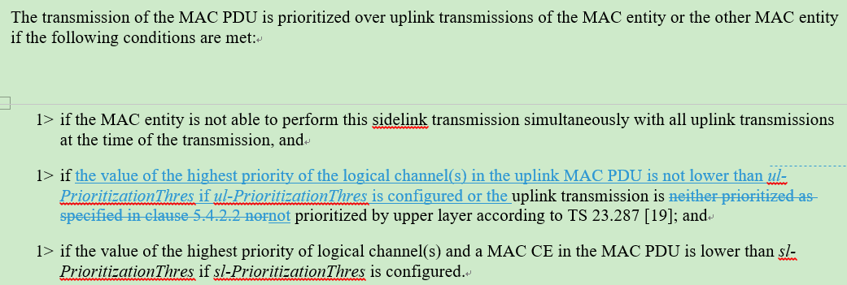

Question D5: If yes in D4, can we also have the same change in 36.321 for UL prioritization by upper layer?
Company | Yes / No | Comment
OPPO | No

Question D6: What else can be revised in 38.321 for UL/SL prioritization (if your proposal has already been discussed in [AT111-e][706][V2X])?
Company | Clause in 38.321 | Proposed revision
OPPO | 5.4.2.2 and 5.22.1.3.1a | For 5.4.2.2, according to 5.22.1.3.1a, if MAC entity can already simultaneously transmit uplink and sidelink, then NR sidelink will be deprioritized. So the redundant condition should be cleared. In addition we think the 2nd and 3rd change in CR R2-2008632 are not correct and should be revised due to same logic.

Conclusion and recommendation
In conclusion…

