**3GPP TSG-RAN WG2 Meeting #112Tdoc** **R2-19xxxx**

**Source: Ericsson (Email discussion rapporteur)**

**Title:** **[POST111e][910][NTN] Impacts of earth fixed and moving beams (Ericsson)**

**Agenda Item: x.x.x.x.x**

**Document for: Discussion**

# 1 Introduction

NTN Rel-17 WI was started in RAN2#111 and the following agreements were reached(excluding user plane).

Agreements:

1. RAN2 stick to WI scenarios: Any restriction, e.g. on the LEO altitude (if needed) could come from other groups.
2. From RAN2 perspective, the table 4.2-2 of [TR 38.821] is used as a baseline for the normative work, with the removal of the regenerative payload option
3. (as the WI is restricted to transparent payload) we assume that the feeder link will use NR (how the satellite is controlled is out of the scope of the WI)
4. RAN2 confirms the assumptions on the UE ground speed in the handheld and VSAT cases
5. In Rel-17, only UEs with GNSS capabilities are supported
6. Both Earth fixed and earth moving beam scenarios are considered with NGSO constellation.

Agreements via email - from offline 105:

1. Both soft and hard feeder link switchover (e.g. for Non GSO) are supported.

Note: This requires satellite to be connected to one NTN GW at a time (hard switch) or at least two NTN GWs simultaneously (soft switch).

1. RAN2 to start discussing enhancements for soft feeder link switchover and then solutions for hard feeder link switchover.

3. As part of the NR-NTN WI, the following stepped approach is proposed:

- Step 1: Assessment of the Rel-16 LCS framework/application protocols (3GPP TS 23.273, TS 29.572, TS 38.455, TS 38.305, in particular but not excluding other TS) and its applicability to NTN

- Step 2: Assess whether changes to the existing network-based location methods are needed and define them if needed

4. The NTN network based positioning of UE should provide an accuracy comparable with the network based UE location accuracy of terrestrial networks.

5. For TN/NTN mobility, the UE is not required to connect to both TN and NTN at the same time.

6. RAN2 to discuss about trigger(s) of TN / NTN mobility, once the Intra NTN mobility has sufficiently progressed. Intra NTN mobility refers to idle and connected mode mobility between NTN cells (e.g. intra or inter satellite).

7. Transparent HAPS is assumed with the IMT BS on the ground and the HAPS is a relay.

8. The RAN2 work plan described in R2-2007565 should be considered as a basis for work

9. The work plan should be based on the following prioritization principles:

- 1st priority: user plane, control plane (idle and connected)

- 2nd priority: NTN-TN service continuity, network based UE location

Agreements via email - from offline 106:

1. The network type (i.e. TN or NTN) should be known to UE. FFS whether to achieve this in an implicit or explicit way.
2. The existing cell reselection priority configuration can be taken as a baseline in NTN. FFS on any further enhancement.
3. Postpone the discussion on whether to introduce a new SIB until we have more progress on the content of NTN specific system information.

Agreements:

1. Cell selection / reselection in NR is the baseline in NTN idle mode procedure.
2. Satellite/HAPS ephemeris based cell selection and reselection should be defined for NTN (FFS what the term satellite/HAPS ephemeris actually means). FFS when this ephemeris based cell selection / reselection can be used. FFS whether UE location (and/or other information) based cell selection and reselection should be introduced for NTN
3. The satellite ephemeris should be provided to UE, at least for Satellite/HAPS ephemeris based cell selection and reselection (FFS what the term satellite/HAPS ephemeris actually means).

This email discussion was also agreed in RAN2#111 and the scope of the discussion is stated as below

* [POST111e][XXX][NTN] Impacts of earth fixed and moving beams (Ericsson)

Scope: Discuss RAN2 impacts of earth fixed and moving beams, both for idle and connected mode, for feeder link switch in both Earth moving and Earth fixed beam and for service link switch in Earth fixed beams case due to satellite switch. No discussion on measurement aspects

Intended outcome: email discussion summary

Deadline: Until next meeting

Initial DL for companies feedback is set Fri 9 th October in order to have proposed summary and review of that by 15th October

Connected mode mobility in NTN may be categorized into the following scenarios:

Scenario 1: Feeder link switch for earth fixed beam, with/without service link switch due to satellite switch

Scenario 2: Feeder link switch for earth moving beam, with/without service link switch due to satellite switch

Scenario 3: Service link switch for earth fixed beam due to satellite switch

Scenario 4: Connected mode mobility for earth moving beam when the beam no longer serves the UE

Scenario 5: Connected mode mobility for both earth moving and earth fixed beam due to UE movement

Specific aspects for mobility handling for scenarios 4 and 5 will be covered in email discussion [Post111-e][911][NTN] Connected mode aspects (ZTE)

This email discussion focuses on scenarios 1, 2 and 3 (although some aspects may be more general and applicable to other scenarios).

# 2 Feeder link switch

Both soft and hard feeder link switch have been considered during the SI. These can be described as follows:

**Soft feeder link switch** where the satellite can simultaneously support two feeder links: The key idea is that the satellite supports simultaneous transmissions of two feeder link signals during the switch to enable a smooth switch.

**Hard feeder link switch** where the satellite can only support one feeder link at a time. In this case, one GW drops the connection to the satellite before the next GW establishes the connection to the satellite.

In RAN2#111, it has been agreed to consider both soft and hard feeder link switch with priority for soft switch. Aspect that has not been discussed is whether feeder link switch has difference from RAN2 perspective for Earth moving and Earth fixed beams. Hence, we are including questions to check for this aspect.

Further, in TR 38.821, the following two cases were considered for the transparent LEO architecture:

* Case 1: Different gNB’s before and after the switch. In this case, the target gateway after feeder link switch is served by a different gNB compared to the source gateway.
* Case 2: Same gNB before and after the switch. In this case, the gateways before and after the switch are connected to the same gNB.

Whether both Case1 and Case 2 are feasible has not been discussed. Case 1 is along the lines of default assumption considered during the study item across WGs, however, Case 2 has also been captured in the TR and should be discussed now in WI.

The Case 2 is depicted in Figure 1. There can be possibly thousands of kilometres distance between GW1 and GW2. From this it follows that if there is one gNB serving via both GWs, there will be relatively long fiber or other connection between the GW and the gNB. As we are discussing transparent architecture, the Uu interface goes in this assumption via the fiber link, feeder link and the service link. This introduces additional and possibly unstable delay on the Uu as it is not over the air between the gNB and the GW.

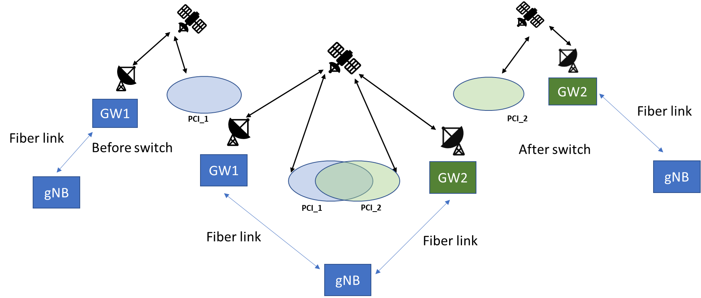

Figure 1

*Q2.1 Do companies see the assumption of Case 2, e.g. having one gNB serving via two GWs as a viable option?*

|  |  |
| --- | --- |
| Company | **Answer** |
| CATT | From technology perspective, we see some issues for case 2：  For Case2, gNB and GW can’t be put together, the complete Un delay consists of service link feederlink and fiber link. The feeder link delay is tracked by the serving GW, which means the serving GW has to frequently report the in time feederlink delay to gNB for at least TA compensation purpose. We think the additional complexity caused by fiber link feedback is not easy to achieve from implementation perspective. |
| MediaTek | We think Case 1 should be the default assumption. The delay and associated jitter could be relatively high for Case 2 in LEO, and therefore it does not appear to be a viable option. However, we welcome input from satellite operators on this aspect. |
| CMCC | If the cost of long-distance fiber is acceptable, then case 2 seems ok. |
| Huawei, HiSilicon | We don’t see Case 2 as a viable option.  The cost of thousands of kilometres fiber link could be very high, and it seems unnecessary to make such a deployment. |
| Panasonic | Although the distance between the gateway and gNB in the case 2 architecture could be quite long, as long as the variation of the feeder link delay is transparent to UE, it should manageable. Therefore we think both case 1 and case 2 can be supported. |
| BT | Based on the description, why should we assume there is always thousands of kilometres and therefore, remove this? |
| ITRI | We think case 1 and case 2 can be supported, and case 1 should be the default option. Though in case 2 the distance of fiber link could be quite long, the GWs are relay and the fiber link delay between a gNB and a GW should be a constant and would not be appeared to UE. |
| APT | No, if the fibre link has 1000 km long (which is an optimistic assumption, it shall be far longer in practice if we check how GW locations distribute by SpaceX) then its propagation delay would be up to 21.48ms. Both RAN1 and RAN2 did not consider this fibre link delay during NTN SI, and we agree Ericsson’s view that this case may not be supported (feasible) at this stage. |
| Sony | Case 1 should be supported by default.  On case 2, we think it is rare to have a gNB controlled by more than one GW. Typically, gNBs are national i.e. serve only people in one nation whilst Gateways are supranational because they form the ground segment of a supranational satellite network. |
| Nomor Research | From our perspective Case 1 should be the default assumption.  If there are thousands of kilometres of fiber link between GW and gNB, there should be an gNB split (gnB-DU at each GW, GW1 and GW2 share gNB-CU). |
| Thales | The case 2 represents a centralized architecture where 1 gNB is connected to several GW. It may introduce extra and unwanted delays on the Uu. Our view is that the case 1 should be used as baseline.  If case 2 is also to be considered, we propose to split the gNB into gNB-CU and gNB-DU. GW1 and GW2 will share the same CU, but each GW will have a co-located gNB-DU.  Also, the solutions that have been proposed to address the NTN feeder link switch over are applicable whether the NTN GWs are connected to the same gNB or to two distinct gNBs. |
| Ericsson | The assumption in Case 2 does not seem viable. Having Uu interface, which means e.g. HARQ feedback loop, over a long cable brings about additional RTT delay. Taking into account such delay is not straightforward especially when Uu in this case is not over the air as has been assumed in 3GPP. However, a gNB can serve two GWs if the GWs are co-located. In this case, as GWs are not 3GPP nodes, for RAN2, it does not make a difference. |
| Qualcomm | If all UEs are transferred to other satellites prior to feeder link switch, then Option 1 vs Option 2 is not a significant issue because RAN2 solution would support handover for both service link switch and feeder link switch cases.  But there may be use case such as ONLY gateway being deployed to remote areas and backhaul is anyway needed whether be it between gateway and gNB or gNB and core network. So we think both options are worth supporting. |
| LG | We agree to assume the case 1 as baseline, but option 2 should not be excluded. The fiber link would not be always thousands of kilometres long. On the contrary, sometimes the NTN gateways could locate at same spot and covers on opposite direction (e.g. one serves west side and the other serves east side). Also CU-DU split scenario proposed by Thales can be another example. |
| Loon, Google | Case 2 is of interest also from capacity of backhaul perspective. |
| Samsung | Yes, it is feasible/viable to have one gNB connected to multiple NTN-GWs. In particular, a typical gNB may be in the cloud infrastructure along with 5GC Network Functions. NTN-GWs would be distributed across the Earth’s surface. As an example, the distance between the East coast and the West coast in the U.S. is about 2800 miles or 4500 km. The speed of light in the fiber is about 2*10^8 m/s. If a gNB is in the middle of the U.S. communicating with two NTN-GWs, the transport delay between the g-NB and an NTN-GW is 11 ms. We expect multiple NTN-GWs and multiple gNBs across the target service area. Hence, the transport delay would generally be smaller than 11 ms. The processing delay in the optical switching network would add delay to this transport delay. A good infrastructure design would aim to reduce the gNB-NTN-GW delay. |
| Apple | From our view both cases 1 and 2 are possible and neither should be excluded. The fiber link does not always have to be assumed to be in the 1000 km range. However, Case 1 should be default. |
| Xiaomi | We think case 1 should be studied with priority. |
| OPPO | This is a deployment issue. We think Case 2 could be possible. |
| Spreadtrum | No. We don’t think case2 is viable way. |
| Lenovo | Case 1 should be considered as default and studied in priority. We think Case 2 is a rare case with little possibility of deployment. Even if Case 2 is possible, the delay and cost will be relatively high and different gNBs will be a better deployment option. |
| Nokia | In principle the architecture depicted in Fig. 1 can occur. However, we are also fine to limit the considerations to Case 1. Otherwise, the additional delay between gNB and NTN-GW is not predictable and would have to be compensated somehow. |
| NEC | Case 2 might be viable and manageable, and distributed DU at GW could be considered to reduce the delay management effort. |
| Intel | Case 1 should be the baseline. Case 2 doesn’t seem to be too practical given the distance is so long. |
| Sequans | No strong view, but if it is possible, we assume using disaggregated gNB with DUs next to GWs would be preferred (less overhead on transport, less RTD on Uu). |

*Q2.2 Do companies see any difference for feasibility for Case2 with assumption on Earth moving and Earth fixed beams?*

|  |  |
| --- | --- |
| Company | **Answer** |
| CATT | Yes we see some difference:  For earth fixed beam, it’s possible to achieve no feeder link switch if the overlapping is well designed between satellites.  But for moving beam, both soft and hard feeder link switch are possible subjected to satellite capability. |
| MediaTek | We see implementation difficulties in LEO, regardless of Earth fixed or Earth moving beams, because of sudden feeder link delay changes. |
| CMCC | We see no difference for the Case2 with assumption on Earth moving and Earth fixed beams. |
| Huawei, HiSilicon | The feasibility relies on the fiber link, so whether it is Earth moving or Earth fixed beams doesn’t matter. |
| Panasonic | Whether it is Earth moving or Earth fixed beams, it doesn’t impact the feasibility for Case 2, as long as the variation of the feeder link delay is transparent to UE. |
| BT | It is a matter of timing and not fix or moving beams. |
| ITRI | We see no difference for case2 feasibility with assumption on Earch moving and Earth fixed beams. |
| APT | No. the fibre link delay is lack of discussion, so no difference on Earth moving or Earth fixed. |
| Sony | We see no difference between earth moving and earth fixed beam. |
| Nomor Research | We see no difference for Case 2 with assumption on earth moving and earth fixed beams |
| Thales | We do not see any difference for feasibility for Case2 for earth fixed and earth moving beam |
| Ericsson | We do not see difference for the feasibility for Case 2 with assumption of Earth fixed/Earth moving beams.  For CATT: Even for fixed beams, one satellite cannot be connected to one GW more than part of the orbit, thus inevitably there will be feeder link switch. It may be possible to time this feeder link switch with service link switch (Scenario 3). |
| Qualcomm | Following a feeder link switch for a satellite, it would probably make sense to redirect any fixed cells for the satellite to new locations and to handover served UEs to fixed cells for other satellites. This can correspond to the “no feeder link switch” commented by CATT, where there would be a satellite and radio cells switch. However, moving radio cells can continue to move (with the satellite) and don’t need to be impacted in terms of coverage area. There is thus a difference between fixed versus moving cells. However, support of both types of cell should be feasible for both Cases (1 and 2). |
| LG | We do not see difference between moving beam and fixed beam for case 2. |
| Loon, Google | We don’t see any difference between earth fixed beams or earth moving beams for this use case |
| Samsung | For clarity, we suggest the use of the term (i) “Earth-fixed” beams where the beam is relatively fixed on Earth all the time, (ii) “quasi-Earth-fixed” beams where the beam is relatively fixed on Earth for a certain time period only (after which the beam illuminates another part of the Earth’s surface), and (iii) “Earth-moving” beams where the beam continuously illuminates a different part of the Earth’s surface from one instant to the next.  For both quasi-Earth-fixed beams and Earth-moving beams, Case 1 and Case 2 seem to be feasible. Case 1 would likely be more prevalent than Case 2. |
| Apple | We don’t see any difference between earth fixed and moving beams for this case. |
| Xiaomi | We see no difference for feasibility for Case2 with assumption on Earth moving and Earth fixed beams |
| OPPO | Earth moving or fixed beams mainly concern with service link, which seems independent of feeder link switch. Therefore Case 2 is applicable to both earth moving or fixed beams and we see no difference. |
| Spreadtrum | We see differences. For Earth fixed beam, case 2 can make a cell served by a satellite under same gNB after feeder link switch. But how to make timing be out of sudden change caused by feeder link switch is a tough task. |
| Lenovo | We see slight difference as for the moving cell the switch may affect UE’s experience and for the fixed cell there could be none. However such difference is implementation and Case 2 is a rare case so we better not spend time on this. |
| Nokia | Feeder link switch will occur for both Earth-fixed and Earth-moving, so not major difference seen. |
| Vodafone | Case 2 is possible, but we do not see practical implementation of this due to cost and added complexity , furthermore, from Regulatory perspective, both Gateways have to be in the same territory / country. |
| NEC | We do not see a difference for feasibility of case 2 to support earth moving and earth fixed beams. |
| Intel | We also see no difference between earth fixed beams or earth moving beams for both of the use cases. |
| Sequans | No |

Case 1 is depicted in Figure 2 for both Earth fixed(above) and Earth moving beams(below). Here, as gNBs are at the GW, the Uu interface is over the air via feeder link and then via service link. As discussed, the feeder link switch may be a soft switch or a hard switch. During the study item few issues were listed together with some solutions. As soft feeder link switch was agreed to be considered first, we take that first here in this discussion.

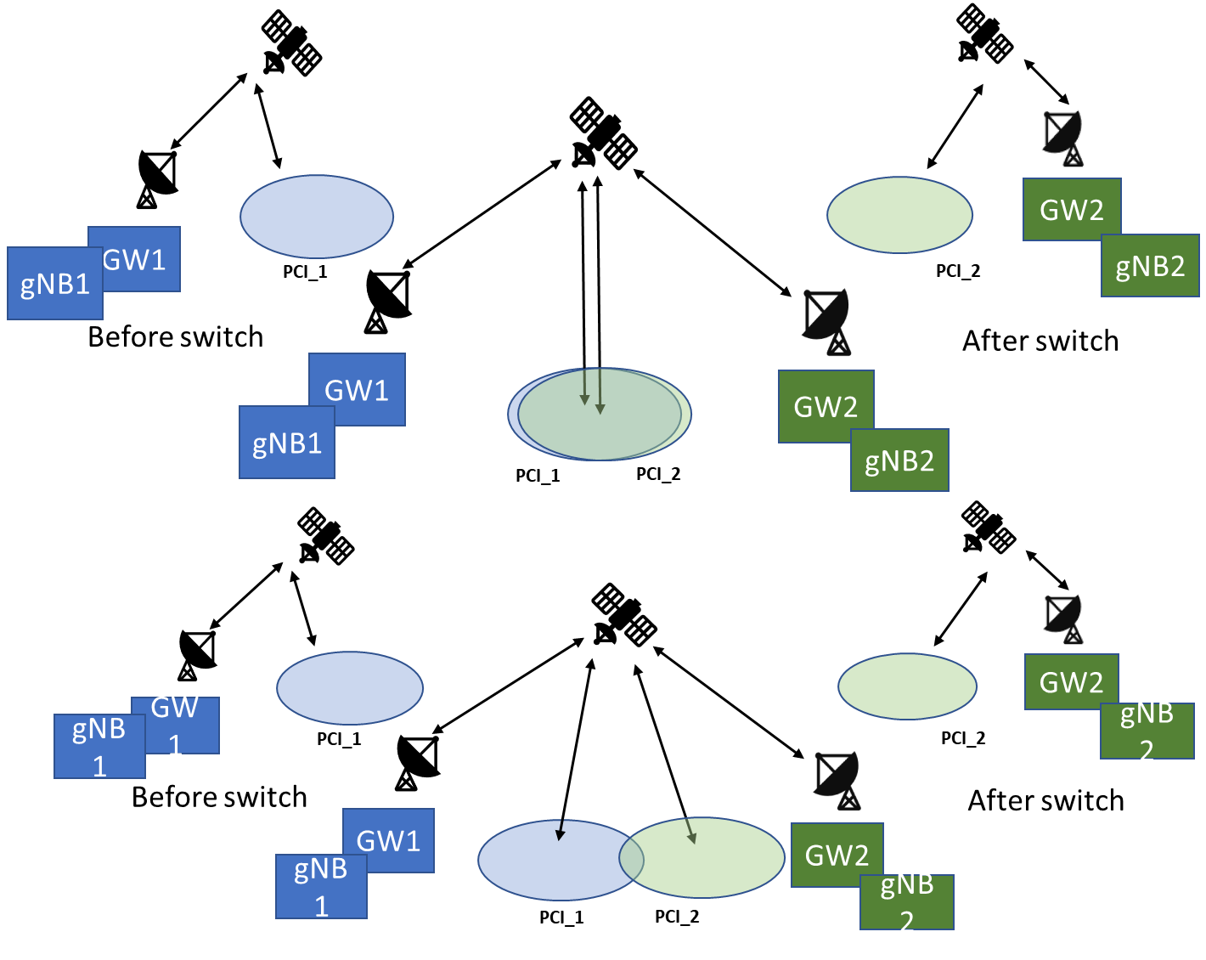

Figure 2 Soft feeder link switch for both Earth moving and Earth fixed beams

List of issues for *soft feeder link switch* include

* *Issue 1:* Many connected mode UEs need to be handed over within the duration of the feeder link switch
* *Issue 2:* Many idle mode UEs need to reselect another cell
* *Issue 3:* Packet forwarding delay due to long inter distance between gNBs
* *Issue 4:* Satellite capability of forwarding beams (cells) from two GWs simultaneously
* *Issue 5:* Satellite capability of supporting two feeder link connections simultaneously

*Q2.3 Companies to comment which issues need to be considered by RAN2 and whether there are additional issues to be considered by RAN2?* ***Further, please indicate if a difference Earth moving and Earth fixed beams is identified.***

|  |  |
| --- | --- |
| Company | **Answer** |
| CATT | Issue 1 and Issue 2 should be addressed by RAN2.  Issue3 is completely a RAN3 issue.  As for Issue 4 and Issue 5, Satellite capability requirement is different between soft and hard feeder link switch, gNB may need to decide which feeder link switch mechanism to use based on Satellite capability. But this judgement is more like a network implementation; no spec effort is needed to address issue 4 and issue 5.  Additional issue: at least new cell info exchange between the gNBs may be needed during feeder link switch.  The serving cell info generated by the source and the target gNBs. Exchange the info via Xn/NG interface, or leave it to pre configuration (OAM configuration). Anyway, for soft feeder link switch, this issue is out of RAN2 scope.  As mentioned in Q2.2, for earth fixed beam, it’s possible to achieve no feeder link switch if the overlapping is well designed between satellites, while for earth moving beam, feeder link switch still should be considered. |
| MediaTek | We think Issue 1, Issue 2 and Issue 3 are relevant for discussions in RAN2.  We think there is no difference between Earth fixed vs. Earth moving beams. |
| CMCC | The first two issues should be considered by RAN2.  Issue3 may be a challenge of RAN3.  Regarding the last two issues, it may be necessary to determine the switch solution(soft or hard switch)before discussing. And DAPS may be considered to be introduced into feeder link switch. |
| Huawei, HiSilicon | Issue 1 and 2 are in RAN2 scope.  Issue 3 should be discussed in RAN3, e.g. if Xn interface is available between gNBs for NTN.  Issue 4 and 5 have been covered by current assumption, i.e. soft feeder link switch already means these satellite capabilities are supported.  And no difference between Earth moving or Earth fixed beams is seen, as in this short period of time, the coverage of Cell 1 and Cell 2 are the same in both cases. |
| Panasonic | Issue 1 needs to be addressed in RAN2.  Issue 2 seems to have no signaling impact and therefore should be fine even if a lot of UEs reselect to another cell simultaneously. However, some solutions listed in Q4.2 are needed, which might be irrelevant to Issue2 but relevant to other idle mode issues.  Issue 3 is more relevant to RAN3. |
| BT | Issue 1 and issue 2 should be addressed in RAN2  Issue 3 should be considered in RAN3  Issue 4 and issue 5 are implicit with the scenario and how each satellite supports such features should be vendor specific. |
| ITRI | Issue 1 and 2 and 3 need to be discussed in RAN2. However, we don’t see difference between Earth fixed and Earth moving beams.  The value of packet forwarding delay is in RAN3 scope.  Issue 4 and 5 relates to satellite capabilities. |
| APT | No difference between Earth moving and fixed for Issue 1, 2, and 3. For issue 4 and 5, we may need some input from satcom companies.  Issue 1: Many connected mode UEs need to be handed over within the duration of the feeder link switch  [APT] this issue has been identified in Rel-16 NTN SI, so it makes sense to be considered by RAN2 in Rel-17 NTN WI  Issue 2: Many idle mode UEs need to reselect another cell   [APT] this sounds like meaningful enhancement to save some UE’s power if some assistant information is provided by NW.  Issue 3: Packet forwarding delay due to long inter distance between gNBs  [APT] this sounds a valid issue but lack discussion so far. |
| Sony | Issue 1 and 2 should be addressed in RAN2. |
| Nomor Research | Issue 1 and Issue 2 should be discussed in RAN2.  Issue 3 is more relevant to RAN3.  Issue 4 and Issue 5 is dependent on satellite capability. For soft feeder link switch, these capabilities are needed.  From our perspective, there is no difference between earth moving and earth fixed beams regarding these issues. |
| Thales | Issue 1 and 2 should be discussed by RAN2  Issue 3 is a RAN3 issue.  Issue 4 and 5 concern the capabilities of the satellite. They are implementation issues.  Regarding satellite capability of supporting two feeder link connections simultaneously It is true that such constraint can have an impact on the satellite cost. However, it shall also be acknowledged that the telecommunication satellite industry has been more and more driven by the payload flexibility. This allows the operators to adapt their satellite network deployment thorough the satellite lifespan depending on the regulation changes, the market changes, the evolution and maintenance of its ground segment (NTN GWs). As a consequence, satellite payloads with the aforementioned capabilities can be considered today as a common standard rather than an exception  The issues listed above are applicable for both earth fixed and moving beams scenarios |
| Ericsson | Issues 1 and 2 are clearly RAN2 issues. Issue 3 is more RAN3 issue but the impact may need to be taken into account when discussing RAN2 solutions for the soft feeder link switch. Issues 4 and 5 seem more like consequences for implementation from the soft feeder link switch assumption. We did not identify difference for the issues for Earth moving or Earth fixed beams. |
| Qualcomm | Mostly agree with other companies. Issue 1 and 2 should be discussed in RAN2. For issue 4 and 5, this is up to network. UE can support both soft and hard switch solutions.  However, we agree with CATT there could be little difference as for fixed cell depending on deployment, UE may not see feeder link switch if the satellite cell always takes over a new area after switching to new gateway. |
| LG | Issue 1 and 2 are completely RAN2 issues – burst UE mobility in idle/connected mode.  Issue 3 is RAN3 issue.  Issue 4 and 5 are satellite capability issues and could be addressed in RAN1. |
| Loon, Google | Issue 1 and 2 should be considered in RAN2  Issue 3 is RAN3  Issue 4 and 5 are vendor implementation specific and need not be specified in 3GPP |
| Samsung | We agree that Issues 1 to 5 highlighted above are important.  Different handover and cell reselection strategies are needed for a quasi-Earth-fixed beam and an Earth-moving beam. In particular, the signaling load and the processing load are distributed across time in the Earth-moving beam case due to the gradual transfer of UEs from one cell to another, leading to smaller peak loads. In contrast, the signaling load and the processing load can be quite high in the Earth-moving beam case due to the transfer of many UEs from one cell to another in a relatively short time period, leading to higher peaks compared to the Earth-moving beam case. |
| Apple | Issues 1 and 2 should be covered by RAN2.  Issue 3 by RAN3.  Issue 4 should be dealt with in RAN1.  For Issue 5, we can depend on network vendor implementations. |
| Xiaomi | We think issue 1 and issue 2 can be considered by RAN2. |
| OPPO | Issue 1 and 2 need to be discussed in RAN2, since they impact UE behaviors. |
| Spreadtrum | Issue 1 and issue 2 should be solved by RAN2. |
| Lenovo | Issue 1 and 2 are to be discussed in RAN2. Issue 3 is RAN3 but may have RAN2 impact. Issue 4 and 5 are network vendor implementation and no need to discuss in RAN2 or 3GPP.  For now we see no difference for earth fixed/moving cells in Issue 1 and 2. But solutions may consider some optimization to cope with cell movement during switch over. |
| Nokia | Agree with some of the preceding comments: Issue 1 and 2 should be addressed in RAN2. It needs to be considered in addition how well the feeder link switch delay can be compensated, i.e. how much time the UE will need to find new cells. Issue 1 and Issue 2 may depend on the feeder link delay pre-compensation assumptions. This shall be acknowledged.  Issue 3 shall be tackled in RAN3 primarily/initially. Issue 4 and 5 are somewhat embedded in the scenario we consider here (i.e. must be met to evaluate this case?).  Regarding Issue 1, specifically, what is the reason behind the necessity to hand over all the UEs within the duration of feeder link switch? |
| Vodafone | Issue 1 and 2 are critical and should be tackled first. |
| NEC | Issue 1 and issue 2 should be addressed in RAN2, and Issue 3 can be addressed jointly with RAN3.  We did not see difference between earth moving and earth fixed beam |
| Intel | Issue 1 and 2 should be discussed in RAN2.  Issue 3 is RAN3 issue although it should be considered if delay is too long, that may impact what solution to be considered in RAN2.  Issue 4 and 5 should be further discussed jointly with RAN1 and 4 related to satellite capability. |
| Sequans | Issue 1 and 2  Issue 3 is mainly RAN3 – RAN2 impact might be second priority.  Issues 4 and 5 are not relevant for RAN2. |

The hard feeder link switch is depicted in Figure 3

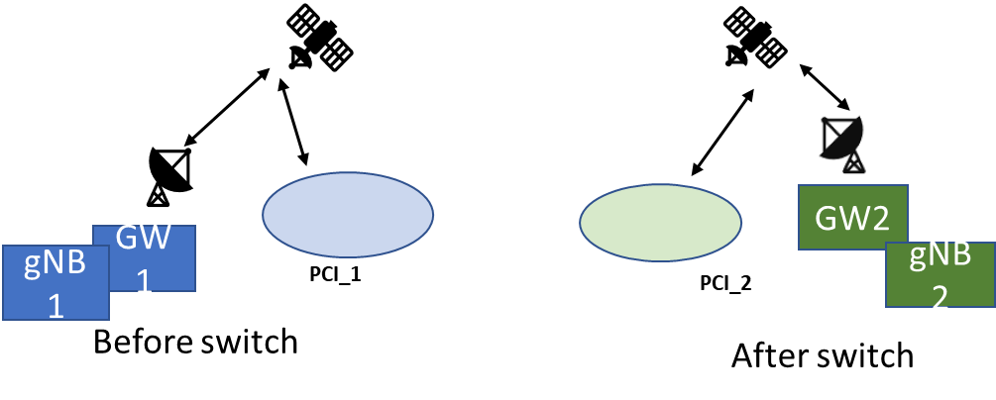

Figure 3 Hard feeder link switch

List of issues for *hard feeder link switch* include

* *Issue 6:* Many connected mode UEs need to be moved to next cell within the duration of the feeder link switch
* *Issue 7:* Many idle mode UEs need to reselect another cell
* *Issue 8:* Packet forwarding delay due to long inter distance between gNBs
* *Issue 9:* Service interruption due to tearing down one feeder&service link and building other

*Q2.4 Companies to comment which issues need to be considered by RAN2 and whether there are additional issues to be considered by RAN2?* ***Further, please indicate if a difference Earth moving and Earth fixed beams is identified.***

|  |  |
| --- | --- |
| Company | **Answer** |
| CATT | First of all, the same view as the answer to Q2.3, there could be no feeder link switch for earth fixed beams.  For earth moving beams, we understand all of the issues except Issue 8 listed above should be considered in RAN2. Additionally, we need to investigate whether CHO based solution could be adopted for hard feeder link switch, and whether need any precious timing control is needed or not. |
| MediaTek | We think Issue 6, Issue 7, Issue 8 and Issue 9 are relevant for discussions in RAN2.  We think there is no difference between Earth fixed vs. Earth moving beams. |
| CMCC | Issue8 may need inputs from RAN3, while the other three issues need to be studied by RAN2. |
| Huawei, HiSilicon | Issue 6, 7 and 9 should be discussed in RAN2.  Issue 8 can be left to RAN3. |
| Panasonic | Same as our earlier comments that Issue 6 should be addressed in RAN2 and Issue 8 is more relevant to RAN3; Issue 7 seems to have no signaling impact and hence we can leave it, however, some solutions listed in Q4.2 are needed as they are relevant to other idle mode issues.  For Issue 9, this can be also addressed in RAN2 by adopting the timestamp/timer-based CHO solution which makes it possible to align the timing between feeder link switching and HO execution. |
| BT | Issue 6 and issue 9 should be discussed in RAN2.  Issue 8 should be addressed in RAN3  Issue 7 even no signalling is involved, a device doing DRX may skip one or many satellites before it makes the reselection. Therefore, it should be included in RAN2. |
| ITRI | We think Issue 6, 7, 8, 9 need to be discussed in RAN2. There is no difference between Earth fixed and Earth moving beams are foreseen. |
| APT | No difference between Earth moving and fixed.  *Issue 6:* Many connected mode UEs need to be moved to next cell within the duration of the feeder link switch  *Issue 7:* Many idle mode UEs need to reselect another cell  *Issue 8:* Packet forwarding delay due to long inter distance between gNBs  [APT] issue 6, 7, and 8 are the same as the soft feeder link  *Issue 9:* Service interruption due to tearing down one feeder&service link and building other  [APT] it is unclear whether UE is in RRC_CONNECTED during hard feeder link switch. If yes, then some enhancement is needed. |
| Sony | Issue 6,7 and 9 should be addressed in RAN2. |
| Nomor Research | Issue 6, 7 and 9 should be discussed in RAN2.  Issue 8 is more relevant to RAN3.  From our perspective, there is no difference between earth moving and earth fixed beams regarding these issues. |
| Thales | Issue 6,7 and 9 should be addressed in RAN2.  Issue 8 is a RAN3 issue.  We do not see any difference regarding these issues for earth fixed and earth moving beam |
| Ericsson | Issue 6 seems relevant for hard feeder link switch as well even it is not that obvious if it is possible to maintain the RRC connection after the switch. Issue 7 is relevant for RAN2 and Issue 8 may have some implications, especially when considering whether RRC connection can be kept. Issue 9 is very linked to Issue 6 and they could be discussed together. We did not identify difference between Earth moving and Earth fixed beams. |
| Qualcomm | We agree issue 6,7 and 9 should be discussed in RAN2. |
| LG | Issue 6, 7 and 9 are RAN2 issues.  Issue 8 is RAN3 issue. |
| Loon, Google | 6, 7 and 9 should be discussed in RAN2  8 is RAN3  No difference between earth fixed or earth moving beams |
| Samsung | We agree that Issues 6 to 9 are important. The difference between the quasi-Earth-fixed beam case and the Earth-moving beam case would be similar to what we described in our response to Q2.3. The peak signaling and processing loads are expected to be higher in case of the quasi-Earth-fixed beams, and, special mechanisms are needed to reduce such peak loads. |
| Apple | Issues 6, 7 and 9 are to be dealt with in RAN2.  Issue 8 should be treated in RAN3. |
| Xiaomi | We think issues 6, 7 and 9 can be considered by RAN2. |
| OPPO | Issue 6, 7 and 9 need to be considered by RAN2. |
| Spreadtrum | Issue 6, 7 and 9 should be solved by RAN2.  Issue 8 may not exists for Earth fixed beam in case 2. However, RAN2 needs not to consider issue 8.  We do not see a difference between Earth moving and Earth fixed beams on this issue. |
| Lenovo | Issue 6, 7 and 9 are to be discussed in RAN2. Issue 8 is RAN3 but may have RAN2 impact.  For now we see no difference for earth fixed/moving cells in Issue 6, 7 and 9. But solutions may consider some optimization to cope with cell movement during switch over. |
| Nokia | Agree with Huawei: Issue 6, 7, 9 for RAN2, Issue 8 for RAN3.  The same concerns as we expressed in the answer to the previous question, i.e. it depends on the delay pre-compensation of the feeder link switch assumption.  A general question, regarding the assumptions preceding the Q2.4: How the UEs shall be moved during the ‘’feeder link switch duration’’, if in hard-switch case there is no such period actually (one feeder link is dropped before the new one is usable, there is just ‘’before’’ and ‘’after’’, as shown in the figure above)? |
| Vodafone | Realistically, we do not anticipate loss of coverage due to hard feeder switch and this is up to the Satellite service provide to ensure a consistent coverage, however, Issues 6, 7 and 9 should be studied further. |
| NEC | Issue 8 needs RAN3 work. All other issues are relevant to RAN2 discussion |
| Intel | Issue 6 and 7 should be discussed in RAN2.  Issue 8 should be discussed in RAN3  Issue 9 should be discussed in both RAN2 and 3.  No difference between earth fixed or earth moving beams |
| Sequans | Issue 6, 7 and 9.  Issue 8 is mainly RAN3 – RAN2 impact might be second priority. |

# 3 Service link switch for Earth fixed beams

During the study item RAN2 did not consider Earth fixed beam scenario as it was excluded from the study item plan and the TR 38.821 captures as follows:

## 7.4 Earth fixed cells vs Earth moving cells

Compared to LEO based Earth moving cells scenario where cells are moving on the ground, LEO based Earth fixed cells scenario refer to NTN that provide cells fixed with respect to a certain location on the Earth during a certain time duration. This can be achieved with NTN platforms generating steerable beams which footprint is fixed on the ground.

The same solutions identified for Earth moving cell scenario can also be applied for Earth fixed cell scenario, however whether specific solutions are necessary (or preferred) for each scenario can be further evaluated in the normative phase (See [74]).

One of the main aspects related to the Earth fixed beams is the service link switch depicted in Figure 4. Due to the movement of the non-GEO satellites in relation to the surface of the earth, at some point in time one satellite leaves and is not able to serve a certain geographical area.

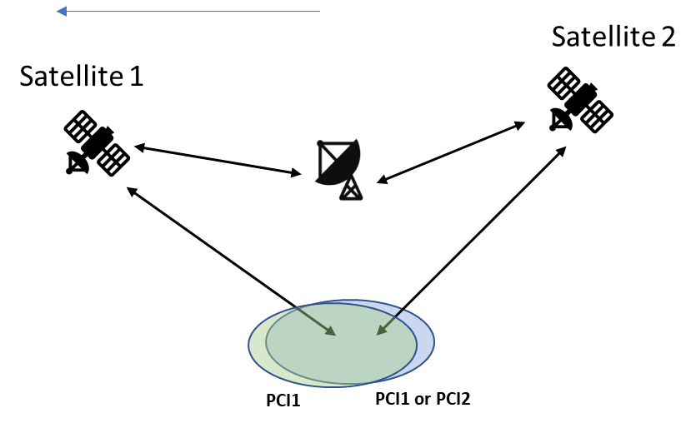

Figure 4 Service link switch for Earth fixed beams

It is possible to consider that the PCI via satellite 1 and satellite 2 can be same or different and these SSBs may be on same or different sync raster points. If the SSBs are on different sync raster point, the mobility during the service link switch is L3 mobility from RAN2 perspective. If these SSBs are on same raster point and PCI are different, the switch is again L3 mobility. If these SSBs have same PCI, the switch can be L1 switch if this option proves viable. However, this would require that the gNB would either repeat the SSB beams of the SSB burst via satellite 1 and satellite 2, or use only part of SSB beams via satellite 1 and part via satellite 2. The issues related to these are due to the delay and delay difference between feeder/service links for satellite 1 and satellite 2. Then, at the UE, it is not clear if the timing of the SSB beams within the same burst can be kept. Thus, if this option of having same PCI on same sync raster location is deduced to be viable from RAN2 perspective, RAN2 should send LS to RAN1 in order to ask for the viability from RAN1 perspective.

*Q3.1 Companies to consider the option of same PCI on same sync raster location via satellite 1 and satellite 2 to be a viable option? If so, do companies agree to send LS to as the viability from RAN1 perspective.*

|  |  |
| --- | --- |
| Company | **Answer** |
| CATT | As the satellites are moving over time, the delay difference between feeder/service links for satellite 1 and satellite 2 is variable, it’s hard to keep the SSB burst timing pattern as per-defined. More addition, we never discuss this scenario during SI phase. If companies want to discuss the feasibility from RAN1 perspective, we’re fine to ask RAN1. |
| MediaTek | The discussion of same PCI on same Sync raster location via different satellites should take place in RAN1, as this is a RAN1 topic. |
| CMCC | An LS to RAN1 to ask for the viability is acceptable to us. |
| Huawei, HiSilicon | We think this case is a viable option, and could be discussed in RAN2.  Since satellite is a repeater in this transparent architecture, and GW is responsible to take charge of satellite management. So the SSB and PCI are the same with the same gNB, and only repeater changes. This case could happen in fact. And we are ok to send a LS to RAN1 to ask for more input to assist RAN2’s design. |
| Panasonic | As having this option available is beneficial in terms of reducing the L3 mobility, we think it is good to send an LS to RAN1 and ask their options regarding the viability. |
| BT | BT agrees to send a LS to RAN1 since this is a perfect valid case that shall be discussed there. |
| ITRI | When SSB beams with same PCI on same sync raster point are transmitted via different satellites, the timing of SSB bursts relayed by different satellite would change over time. We are fine to send a LS to RAN1. |
| APT | Not sure. If the same PCI is provided by from two satellites, in this cell, UEs would require different common (cell specific) timing and frequency compensated or indicated by NW. This might be an issue. |
| Sony | We think this case is a feasible option and ok to send an LS to RAN1. |
| Nomor Research | Not sure, we have doubts that same PCI on same sync raster location via two satellites will work. Delays and frequency shift/Doppler are different from both satellites. |
| Thales | In earth fixed cell scenario, in case of satellite switch, a fixed cell area will be covered by the beam of the next satellite. In a short instance, a certain area is covered by 2 beams served by both satellites. The first cell will be replaced by the second cell.  The option of same PCI on same sync raster location via satellite 1 and satellite 2 is not a viable option. The delays and frequency shift/doppler on both service links/feeder links from satellite 1 and 2 are different. Clearly, this option will be seen by the UE as two different cells with equal PCI and frequency: This is a PCI collision.  For Earth fixed cell: Cells need to regularly change PCI (a different PCI for each serving satellite) to ensure simultaneous coverage from different satellites |
| Ericsson | We are ok to send the LS if RAN2 concludes the feasibility depends only on RAN1. However, the assumptions from RAN2 perspective should be clearly described. Do we assume same SSB beams repeated, or the SSB beams are split? Also, what are the assumption of data transmission via satellite 1 and satellite 2? |
| Qualcomm | We do not think this is viable. The physical configuration or the SIB would be different as RTD, beam pattern would be different. There could be Interference issue. But we are OK to ask RAN1. |
| LG | This issue should be addressed in RAN1 first. |
| Loon, Google | We don’t believe it is good to have the same PCI for two beams. The two beams can have different time/doppler offsets because of different path lengths. Whether or not the same PCI can be used is a physical layer issue that can be resolved only in RAN1, so support sending such an LS. In any case, for our design to be robust, we must allow the two satellites to have different PCIs. The important thing would be to minimize UE impact due to L3 mobility |
| Samsung | No. We prefer separate PCIs to facilitate independent radio resource management of the gNBs. |
| Apple | We think it would be good to send an LS to RAN1 for this case. |
| Xiaomi | We think this issue is in RAN1 scope and should be discussed in RAN1 first. |
| OPPO | Due to different delay for satellite 1 and satellite 2, the SSB burst sent from the gNB may not reach UE in the same burst any more. This may have some impact on UE procedures. We are not sure whether RAN2 can conclude this is viable or not, instead this should be discussed in RAN1 first.  We are ok for sending LS to RAN1, but the LS should not express any RAN2 views and should simply ask viability from RAN1’s perspective. |
| Spreadtrum | We do not think this is viable. But we are OK to send LS to RAN1. |
| Lenovo | We think this should be addressed by RAN1 first, but we can send an LS for further information. |
| Nokia | We have some doubts whether it is easily feasible to keep the SSB timing pattern fully aligned between the two satellites. Thus, even if such scenario without L3 HO is desired, it may not be realistically doable. Timing may be aligned for one specific point in the cell. The UEs distributed over different edges of the cell will encounter different RTTs. This in some case may lead to an RLF.  We are OK to leave this topic to RAN, with no necessity to send the LS, companies may address it in their papers without being triggered by RAN2. |
| Vodafone | From operational perspective, for a stationary UE, in a fixed geographical location, with a moving or stationary satellite cell on the ground, we require for the Cell ID to be fixed/unchanged. |
| NEC | From RAN2 point of view, it is beneficial to consider the option of same PCI on same sync raster location via satellite 1 and satellite 2. We support to send an LS to RAN1 and check the viability. |
| Intel | We think that different satellite should have different PCI. NTN should have NR as a baseline so the SSB on which sync raster location should not be discussed in RAN2. |
| Sequans | This is a RAN1 topic, it can be raised and discussed in RAN1 directly. |

List of issues for *service link switch* include

* *Issue 10:* Many connected mode UEs need to be handed over within the duration of the service link switch
* *Issue 11:* Many idle mode UEs need to reselect another cell

*Q3.2 Companies to comment which issues need to be considered by RAN2 and whether there are additional issues to be considered by RAN2?*

|  |  |
| --- | --- |
| Company | **Answer** |
| CATT | Both should be considered in RAN2  More addition, we think UE RRM procedure is also one of the key issues that should be addressed. |
| MediaTek | We think both Issue 10 and Issue 11 are relevant for RAN2 in Service Link switch. |
| CMCC | Both issue 10 and issue 11 need contributions from RAN2. |
| Huawei, HiSilicon | If L3 mobility is determined for service link switch case, both issues should be handled in RAN2. |
| Panasonic | Issue 10 should be addressed in RAN2, while Issue 11 seems to have no signaling impact. However, some solutions listed in Q4.2 are needed as they are relevant to other idle mode issues. |
| BT | Both, issue 10 and issue 11 should be discussed in RAN2. |
| ITRI | Both Issue 10 and 11 need to be considered in RAN2. |
| APT | Issue 10 and 11 are the same as the soft feeder link issue and shall be considered in RAN2. |
| Sony | Both issues 10 and 11 should be discussed in RAN2. |
| Nomor Research | Both, issue 10 and issue 11 should be discussed in RAN2. |
| Thales | Both issues should be discussed. The handover should be conditional handover because the handover by measurement will not work due to very similar signal received power from both satellites. Further, another issue for service link switch can be added: In Idle mode, a new solution is needed to inform UE that the new PCI is available for measurement and possible cell selection/reselection and which frequencies should be considered. Otherwise UE does not find the new cell in fast enough time leading to serving interruptions. |
| Ericsson | Both issues can be considered by RAN2. |
| Qualcomm | We agree with others both issues should be considered. |
| LG | Both issue 10 and 11 should be discussed in RAN2. |
| Loon, Google | Both issues should be discussed in RAN2 |
| Samsung | Peak signaling and processing loads need to be addressed through special mechanisms. |
| Apple | Both should be treated in RAN2. |
| Xiaomi | Both issues should be discussed in RAN2. |
| OPPO | Both issues affect UE behavior and should be considered by RAN2. |
| Spreadtrum | Does the question is on “mangy”? Service link switch will happen for UEs which are going to out of the current beam. We do not think the number of such UEs is very huge, considering the scenario is similar as high speed train in TN. |
| Lenovo | Issue 10 and 11 are to be discussed in RAN2. |
| Nokia | Agree with preceding comments, both should be considered in RAN2. |
| Vodafone | Both issues 10 and 11 should be addressed |
| NEC | Both issues should be discussed in RAN2.  In addition, as mentioned in Q3.1, the PCI may remain, then the issue would be only: - Service interruption due to tearing down one service link and building other |
| Intel | Both should be discussed in RAN2. |
| Sequans | Issues 10 and 11 |

# 4 Potential solutions

Potential solutions for ***connected mode UEs*** are listed below. Some solutions address the issue of spreading HO attempts of the UEs in time, some solutions leave that for the network to distribute when sending the HO command. Some solutions address assisting UE to find more easily the up coming new cell(PCI). Not all these solutions are mutually exclusive.

* *For Issue 1, 10:* Many connected mode UEs need to be handed over within the duration of the service link switch or soft feeder link switch
  + *Solution 1:* Conditional HO (Discussed further in email discussion [911])
  + *Solution 2:* HO with random access attempts distributed in time
  + *Solution 3:* Group HO, e.g. common part of HO command in SI and UE specific with UE specific signalling.
  + *Solution 4:* No enhancements for HO command/procedure, leave up to network implementation
* *Issue 6:* Many connected mode UEs need to be moved to next cell within the duration of the hard feeder link switch
  + *Solution 5:* Enhanced connection re-establishment procedures.
  + *Solution 6:* Conditional HO (Discussed further in email discussion [911])
* *For issue 3, 8:* Packet forwarding delay due to long inter distance between gNBs
  + *Solution 7:* Informing of the upcoming feeder link switch (the UE about PCI leaving and another PCI appearing due to feeder link switch)
    - stored at UE or via system information
  + *Solution 8:* HO command with information of the upcoming feeder link switch (the UE about PCI leaving and another PCI appearing due to feeder link switch)
  + *Solution 9:* Enhanced connection re-establishment procedures.
  + *Solution 10:* No enhancements for HO command/procedure, leave up to network implementation

*Q4.1 Do companies agree with the list of solutions to be studied for* ***connected mode UEs*** *in more detail and whether there are additional solutions to be considered?* ***Further, please indicate if a difference Earth moving and Earth fixed beams is identified.***

|  |  |
| --- | --- |
| Company | **Answer** |
| CATT | Firstly, we think Issue 1 belongs to feeder link switch, which should be put together with Issue 6, with this clarification, our view is given below：  For Issue 10, we agree to further study all the four solution listed here, but to clarify that UE location and satellite ephemeris based CHO is also in the scope.  For Issue 1 and Issue 6, we think solution 2 and solution3 are also applicable besides solution 5 and solution6.  As for Issue 3 and Issue 8, it’s totally a RAN3 issue, no RAN2 effort is identified.  As mentioned before, there can be no feeder link switch for earth fixed beam, while for earth moving beam has. For service link switch, no much differences are found between earth fixed beam and earth moving beam. |
| MediaTek | We prefer the following solutions for the issues:  Issue 1, 10: Solution 1, Solution 2, Solution 3 should be discussed and studied.  Issue 6: Solution 6 should be discussed and studied.  Issue 3, 8: Solution 10, i.e. leave up to network implementation. |
| CMCC | For issue1, solution 1 to solution 3 are enhancements to the existing HO mechanism, and the improvement of signaling overhead and latency may need to be evaluated.  Regarding Issue6, solution5 for connection re-establishment enhancements is demanded, while the signaling overhead and latency for CHO may need to further study.  Issue3 and issue8 may be the scope of RAN3. |
| Huawei, HiSilicon | We prefer the following solutions for the issues:  Issue 1, 10: Solution 1 could be discussed and studied, and if the transition period is long enough solution 4 is also feasible.  Issue 6: Solution 5 should be discussed and studied.  Issue 3, 8: Solution 10, i.e. leave up to network implementation. As Packet forwarding delay is strongly dependent on network deployment. |
| Panasonic | Agree with CATT that Issue 1 and Issue 6 should be grouped together (HO due to feeder link switch), while Issue 10 is a standalone group.  We agree the list of solutions for Issue 1, 6 and 10 (i.e., Solution 1 – 6), while we are not sure how RAN2 can reduce packet forwarding delay due to long distance between gNBs, via introducing Solution 7 – 10.  In our understanding, the listed solutions are equally important to the Earth moving beam and Earth fixed beam scenario. |
| BT | Issue 1, 10, solution 1, 2, 3 should be studied.  Issue 6 solution 5 should be considered for study. Solution 6 can be included in the issue 1, 10 solution 1 discussion.  Issue 3, 8 should be discussed by RAN3. |
| ITRI | Issue 1, 10: Solution 1 and solution 3 should be discussed and studied.  Issue 6: Solution 6 should be discussed and studied.  Issue 3, 8: The value of packet forwarding delay is in RAN3 scope. We think it should be RAN2 effort to study the enhancements of packet forwarding procedure. Solution 9 should be discussed and studied. |
| APT | Agree CATT |
| Sony | For issue 1 and 10, solution 1,2 and 3 should be studied.  For issue 6, solution 5 and 6 should be studied.  Issues 3,8 are in RAN3 scope. |
| Nomor Research | Issue 1, 10: solution 1, 2, 3 should be studied.  Issue 6: solution 5 and 6 should be discussed and studied  Issue 3 and 8 should be discussed by RAN3.  From our perspective, the solutions to discuss are applicable to earth fixed as well as earth moving beams. |
| Thales | Issue 1: Many connected mode UEs need to be handed over within the duration of the soft feeder link switch: Solution 1, 2, 3  Issue 10: Many connected mode UEs need to be handed over within the duration of the service link switch: Solution 1, 2, 3 should be discussed  Issue 6: Many connected mode UEs need to be moved to next cell within the duration of the hard feeder link switch: Solution 5and 6 should be discussed  Issue 3, 8 is RAN3 scope.  Proposed solutions are applicable for both earth fixed and moving beams scenarios |
| Ericsson | With the clarification that issue 1 and 10 assume two cells are covering an Earth location for a duration of a time and that issue 6 is for hard switch, we agree with the lists for Issues 1, 10 and 6. Further comment to Solution 1 is that some of the triggers that are being discussed stem from the use case for Issues 1 and 10 thus we think the CHO should be discussed in the context of Issues 1 and 10 and also 6.  For issue 3, 8, as it is more of RAN3 issue we feel no RAN2 solution is needed directly for that. However, when discussing solutions to Issues 1, 10 and 6, the implications of Issue 3,8 can be considered. |
| Qualcomm | For issue 1 and 10, solution 1 and solution 3 can be used in combination.  Issue 6 is not clear. If issue 6 is only feeder link switch but service link remains same, then solution 3 is also applicable. It is better to have common solution, i.e., solution 1 and 3. Solution 5 is not clear as moving of connected mode UEs should happen in a network-controlled way, e.g., handover.  Issue 3 and 8 should be discussed in RAN3. |
| LG | Issue 1 and 10: solution 1(CHO) can be discussed. We wonder group handover is really feasible - is it provided via broadcast signalling? It would be very complex to signal group of UEs via broadcast signalling.  Issue 6: We think CHO is the simple solution. If NTN-specific CHO is not enough, then we can discuss further for another solution.  Issue 3 and 8: We think solution 7 or 8 could be simple solution to inform the feeder link switch to the UEs. |
| Loon, Google | Issue 1, 10: 1,2, and 3  Issue 6: 6  Issue 3, 8: No strong opinion |
| Samsung | We think solutions for Issues 1, 10, and 6 can be combined and jointly considered to address the case of “transfer of a large of connected mode UEs.” In particular, signaling enhancements in the form of groupcast/multicast signaling in support of Solution 3 (Group HO), and pre-handover inter-gNB communications in advance of an impending handover (i.e., before the handover-triggering Measurement Report is received at the source gNB) will be helpful. Special mechanisms will be needed to reduce peak signaling and processing loads when an outgoing cell and the incoming cell have nearly-identical coverage (e.g., in case of quasi-Earth-fixed beams). |
| Apple | Issue 1, 10: Solutions 1, 2, 3 and even 4 all need to be discussed. We also feel that some combinations of these solutions can also be created for example 3 and 4 that can help reduce unnecessary UE signaling overheads.  Issue 6: Solution 5 should be discussed and studied.  Issue 3, 8: Solution 10 would be a good option. |
| Xiaomi | For issues 1 and 10, solutions 1, 2 and 3 should be studied.  For issue 6, solutions 5 and 6 should be studied. |
| OPPO | We think for Issue 1, Issue 10 and Issue 6, they can be addressed by all solutions from solution 1 to solution 6.  For Issue 3 and 8, leave it to RAN3. |
| Spreadtrum | For issue 1, we think that the problem is not on “many”. Solution 1 seems feasible.  For issue 10, there may be the problem of “many”. But we wonder how solution 3 can work. Even though the handover command can be broadcasted, there is still storm of signalling to complete the handover in the new cell.  For issue 6, solution 5 is feasible.  For issue 3 and 8, they are RAN3 scope. |
| Lenovo | For Issue 1, 10 as well as 6, we prefer to consider CHO (Solution 1 and 6) first for a unified solution. Solution 2, 3 and 5 are not excluded now as it may be necessary to cope with possible signalling storm.  Issue 3 and 8 should be discussed in RAN3 first.  For now we see no difference for earth fixed/moving cells in Issue 1, 10 and 6. But solutions may consider some optimization to cope with cell movement during switch over. |
| Nokia | Issue 1, 10: Solution 1 (CHO) and/or Solution 3 (Group HO) can be evaluated  For Issue 6, we are not sure how CHO alone can mitigate this problem? Maybe, similarly to what has been stated above, a combination of CHO and group HO can be considered?  Issue 3, 8: solution 8 seems to be the right candidate. However, it shall be first considered in RAN3, as suggested in one of the previous questions and favoured by most companies. |
| Vodafone | the highest priority in the described scenario must be Issue 1, 10.  Issue 6 is a complicated situation and in most cases may not be unnecessary: the question is how long is the anticipated Feeder Link Switch period?  This is an operational Issue.  Issue 3, 8 is a deployment and implementation issue |
| NEC | It is too early to exclude any solution at this moment, and other solution should also be welcome. we support to study all list solutions in detail. |
| Intel | Issue 1,10: solution 1 (with enhancement) and 3 can be considered  Issue 6: solution 6  Issue 3,8: should be discussed in RAN3 |
| Sequans | Issue 1, 10: 1,2, and 3  Issue 6: 5, 6  Issue 3, 8: should be discussed in RAN3 first |

Potential solutions for ***idle mode UEs*** are listed below. Again, these solutions may address same or different aspects and thus may or may not be mutually exclusive.

* *Issue 2, 7, 11:* Many idle mode UEs need to reselect another cell
  + *Solution 11:* Informing of the upcoming feeder link switch (the UE about PCI leaving and another PCI appearing due to feeder link switch)
    - stored at UE or via system information
  + *Solution 12:* UE does cell ranking and reselection based on
    - information of Solution 7
    - UE absolute location
    - UE location relative to serving satellite
    - Round trip time (RTT) for the satellite
    - Remaining dwell time(time left to be served) in a cell that is leaving or appearing

*Q4.2 Do companies agree with the list of solutions to be studied for* ***idle mode UEs*** *in more detail and whether there are additional solutions to be considered?* ***Further, please indicate if a difference Earth moving and Earth fixed beams is identified****.*

|  |  |
| --- | --- |
| Company | **Answer** |
| CATT | For solution11, paging indicator is also one candidate solution to informing of the upcoming feeder link switch, so we’d like to revise this bullet as follows.   * + - stored at UE or via system information or paging indicator   For solution 12, the second and third bullets, how it works if the two cell are fully overlapped as shown in figure-4? We’d like to revise solution12 as follows:   * + - information of Solution 7 stored at UE or via system information or paging indicator     - UE absolute location and/or satellite ephemeris     - Signal elevation to the serving satellite below a threshold or Signal elevation to the target satellite above a threshold     - UE location relative to serving satellite or to the target satellite     - Round trip time (RTT) for the satellite     - Remaining dwell time(time left to be served) in a cell that is leaving or appearing     - The target cell signal is available   As mentioned before, there can be no feeder link switch for earth fixed beam, while for earth moving beam has. For service link switch, no much differences are found between earth fixed beam and earth moving beam. |
| MediaTek | Issue 2, 7, 11: Solution 11, while reusing existing R-16 cell re-selection method.  UE’s location should NOT be used in idle mode, as it will significantly increase UE’s power consumption. Network can assist the UEs to select the suitable incoming cells by adjusting the Qoffset and Qoffsettemp values of neighbour cells and Qhyst and Qoffsettemp values of serving cells in cell ranking criteria, mentioned in Section 5.2.4.6 of 3GPP 38.304. |
| CMCC | Agree with the two solutions for idle UEs. And for solution12, satellite ephemeris and satellite type information(e.g. GEO or LEO) should also be considered. |
| Huawei, HiSilicon | Solution 11 is ok for us.  In solution 12, at least the bullet “information of Solution 7” can be further studied. |
| Panasonic | Issue 2, 7, and 11 seem to concern mainly about “too many UEs” reselecting another cell simultaneously, but we couldn’t understand how Solution 11 and 12 are able to avoid “too many UEs” reselecting another cell. Maybe some more clarifications are needed. |
| BT | The description says idle. Is this because a different solution is envisioned for inactive?  Issue 2, 7, 11 solution 11 assumes the PCI will change will this is not the only option as the PCI may remain the same as Q3.1. Idle mode when the PCI is the same should be considered unless it is guaranteed the switch is completely transparent.  Solution 12 in general requires more discussion. A UE in idle is not required to reselect each new satellite and we should avoid as many UL transmission as possible. Therefore, it requires more clarification in general. |
| ITRI | Both solution 11 and solution 12.  We think the purpose is to assist IDLE mode UE reselect a suitable cell efficiently. In solution 12, “information of Solution 7” could be considered as baseline. Other information may depend on UE capabilities. |
| APT | Agree both. |
| Sony | We agree to study solution 12. |
| Nomor Research | Agree to study both, solution 11 and solution 12. However, UE’s location should NOT be used in idle mode.  Agree with BT in terms of “A UE in idle is not required to reselect each new satellite and we should avoid as many UL transmission as possible.”  From our perspective, the solutions to discuss are applicable to earth fixed as well as earth moving beams. |
| Thales | Solution 11 combined with base lined TN reselection method should be studied.  Solution 12 is UE power consuming and could not work in certain scenarios. |
| Ericsson | We agree with the list. For Solution 12, there may be different details relevant depending on the assumption of Earth moving or fixed beams. For example, the UE location, RTT and remaining time left to be served may be more relevant for Earth fixed beams. |
| Qualcomm | Broadcast notification is not efficient. For fixed cell, simply barring mechanism in MIB by leaving cell can work. Stored information may not work as intended. Based on time/position and condition, gateway switch may take earlier or later than what UE has in stored information. But solution 12 should be general solution applicable for cell selection/re-selection. The “information of solution 7 (this seems to be solution 11)”, beam/satellite information and “remaining time or visibility duration” can be discussed. |
| LG | We are fine with both solutions, but it can be discussed separately in idle mode section or email discussion. |
| Loon, Google | For earth fixed cells, sol.11 seems useful and adequate.  For earth moving cells, sol.12 may be more appropriate. But agree with concerns on UE power impact raised by other companies. In particular location information should not be used as described by MediaTek |
| Samsung | The existing signal measurement (e.g., RSRP)-based cell reselection procedure is inadequate for an NTN. Different NTN types (e.g., GEOs vs. non-GEOs and quasi-Earth-fixed beams vs. Earth-moving beams) require different cell reselection criteria. Furthermore, accuracy/reliability of new measurements (e.g., elevation angle and location) may not be fully known until actual NTN deployments occur. Hence, we suggest creation of a flexible framework that allows flexible combining of one or more criterion (e.g., Neighbor RSRP + Source Elevation Angle and Neighbor RSRP and Distance from the center of the source Cell, Neighbor RSRP and Time Since Last Cell Reselection). The gNB can indicate in System Information what criteria the UE needs to combine based on the NTN and/or beam type. |
| Apple | Agree with LG here that both solutions should be discussed but in the idle mode section or email discussions. |
| Xiaomi | For the issue 7, many idle mode UEs need to reselect another cell when the feeder link is hard switched, we think the existing S and R criteria for NR could be reused since there is only one cell coverage.  For the issue 2, the existing S and R criteria for NR can be as baseline and the solution 11 also can be considered if the current S and R criteria can’t satisfy the requirements.  For the feeder link switch, we are not clear how the UE location and RTT can be used for cell selection and reselection.  For the issue 11, the above solutions can be further studied. |
| OPPO | First of all, we are not sure if “*Issue 2, 7, 11:* Many idle mode UEs need to reselect another cell” are really essential to be addressed. Unlike in connected mode (where signaling overhead related to many UE’s HO command and HO access is large), it seems that we don’t need to care about whether it is single idle UE or many idle UEs to do cell reselection.  Meanwhile, we can still discuss how to use ephemeris and UE location (which is FFS for now) to do cell reselection, as agreed in the last meeting. |
| Spreadtrum | For issue 2 and 7, we think that the solution 11 is feasible.  But for issue 11, only the UEs which are going to out of the beam will reselect to the next cell. So it can only be rely on measurement and UE location. |
| Lenovo | Both can be discussed but we slightly prefer Solution 11 combining with legacy reselection mechanism. Solution 12 is feasible but we should avoid introducing too many priority handling or cell ranking rules. |
| Nokia | Agree with OPPO, Panasonic’s concerns, i.e. how do these two solutions are actually addressing the issue of ‘’many Idle UEs reselecting to another cell’’? In addition, why is it so essential to inform the Idle UE about the upcoming feeder switch? I.e. wouldn’t the existing reselection mechanism work, even if with certain delay? Idle UEs do not require a lot of signalling capacity other than the NW tracking the UE’s RA/TA. |
| Vodafone | The change in Feeder Link should not alter the topology of the network and the PCI.  As stated previously, this will cause operational problems. |
| NEC | It is not a big issue to have many UEs reselecting to another cell. “No enhancement and leave to UE implementation” could be added into the list above. At the same time solution 11 is ok for us and the assistant information is likely needed anyway for connected mode UEs. |
| Intel | Solution 11 is preferred with further discuss detail.  We think it is important for the network to broadcast its route information to assist UE. |
| Sequans | We agree to study further both. |

Since solution 12 has several different potentionally different ranking or triggering conditions we have a question specific to solution 12 in order to progress on details.

* + *Solution 12:* UE does cell ranking and reselection based on
    - information of Solution 7(Informing of the upcoming feeder link switch (the UE about PCI leaving and another PCI appearing due to feeder link switch))
    - UE absolute location
    - UE location relative to serving satellite
    - Round trip time (RTT) for the satellite
    - Remaining dwell time(time left to be served) in a cell that is leaving or appearing

*Q4.3 Companies are asked to provide their preference of the suggested triggers based on applicability on feeder or service link switch use cases? Further, please indicate which triggers are seen as mutually exclusive and which could work together or work as options depending on exact problem to be solved.*

|  |  |
| --- | --- |
| Company | **Answer** |
| CATT | Based on revision of solution12, we think the following bullet is more easy to implement:   * + - information of Solution 7 stored at UE or via system information or paging indicator     - UE absolute location and/or satellite ephemeris     - UE location relative to serving satellite or to the target satellite     - The target cell signal is available   Exclusive triggers:   * + - information of Solution 7 stored at UE or via system information or paging indicator     - The target cell signal is available   Work together or work as options with Exclusive triggers:   * + - UE absolute location and/or satellite ephemeris     - UE location relative to serving satellite or to the target satellite   Satellite ephemeris and UE absolute location can be known by UE, but satellite beam footprint is more related to satellite antenna deployment, which can be relatively independent to Satellite ephemeris for details. For cell reselection , satellite beam footprint is more accurate than Satellite ephemeris, so UE absolute location and/or satellite ephemeris can just work as a supplementation. |
| MediaTek | UE’s location should NOT be used in idle mode, as it will significantly increase UE’s power consumption. |
| CMCC | We prefer to use UE location relative to serving satellite and satellite type information(e.g. GEO or LEO) as our comments to Q4.2. |
| Huawei, HiSilicon | At least the bullet “information of Solution 7” can be further studied.  For all other bullets, the UE location information has to be explicitly or implicitly used. We agree with MTK that this will increase UE’s power consumption. |
| Panasonic | For the service link switch case, we think the following triggers can facilitate UE’s determination on cell reselection. Other triggers can be FFS.   * information of Solution 7(Informing of the upcoming feeder link switch (the UE about PCI leaving and another PCI appearing due to feeder link switch)) * UE absolute location * UE location relative to serving satellite |
| BT | For idle/inactive mode, power saving for NTN UEs is a priority for us. Therefore, we’re in favour of solutions where UL signalling is not required. At the moment, anything related with position seems to require the UL to inform the network about the location.  Do we need different solutions when the PCI is kept than when it is not? |
| ITRI | For IDLE mode UE, “information of Solution 7” could be considered as baseline. Other information may depend on UE capabilities and would increase UE’s power consumption. |
| APT | Agree MTK |
| Sony | We think the following triggers should be considered.   * + - information of Solution 7(Informing of the upcoming feeder link switch (the UE about PCI leaving and another PCI appearing due to feeder link switch))     - UE absolute location     - UE location relative to serving satellite |
| Nomor Research | Use information of Solution 7 as a baseline.  As indicated above, from our perspective UE’s location should NOT be used in idle mode. |
| Thales | Agree with Mediatek |
| Ericsson | The information about next satellite/PCI covering a spot on Earth is related to the time left to be served. E.g. especially for service link switch, this time can be given as absolute time in system information. The location and RTT based ranking for cell selection might be needed for UE not to select too far away satellite such that initial RACH preamble is not compensated well enough. This is related to the issue discussed in RAN1 for initial access and RAN2 should take RAN1 progress into account. |
| Qualcomm | See our response in Q4.2, the “information of solution 7”, beam/satellite information and “remaining time or visibility duration” can be discussed. |
| LG | For idle mode UEs, we think absolute or relative UE location can be used for cell (re)selection configuration. However, we agree that it may bring much power consumption of UEs, so we can just use rough location information in order to determine in which part a UE is located in a cell coverage.(tens of kilometres accuracy would be enough) |
| Loon, Google | We also think that UE power consumption impact should be the central consideration in idle mode enhancements. |
| Samsung | We have reproduced here our response to Q4.2.  We suggest creation of a flexible framework that allows flexible combining of one or more criterion (e.g., Neighbor RSRP + Source Elevation Angle and Neighbor RSRP and Distance from the center of the source Cell, Neighbor RSRP and Time Since Last Cell Reselection). The gNB can indicate in System Information what criteria the UE needs to combine based on the NTN and/or beam type.  This framework will also simplify the work scope. We can decide what quantities to support (e.g., elevation angle and time since last cell reselection) and what combining method to allow (e.g., a logical “AND” to combine Neighbor RSRP and Source Elevation Angle). If we do not follow this approach, we will have too many trigger conditions.  Another good news is that we can also reuse this framework for handover measurements! |
| Apple | Information of solution 7 should be utilized. |
| Xiaomi | We think the information of solution 7 can be further studied.  We think UE location should be not used when UE does cell ranking, but it can be used when UE decide the target cell for reselection. For example, UE selects multiple target cells according to S-criterion and R-criterion and then decides only one target cell based on UE location and/or satellite ephemeris. |
| OPPO | For information of Solution 7 and remaining dwell time, we are not sure if they will help, as UE anyway needs to search and measure for candidate cells, and RSRP-based cell reselection is still needed as agreed in the last meeting.  For below information, they are somehow redundant and do not need to work together.   * UE absolute location * UE location relative to serving satellite * Round trip time (RTT) for the satellite   To make it work, we think the first two information should be:   * UE absolute location and satellite ephemeris * UE location relative to satellite |
| Spreadtrum | We think that “information of Solution 7” and “UE location relative to serving satellite” and “remaining dwell time(time left to be served) in a cell that is leaving or appearing” can be further discussed.  We think that UE does not need to get its location frequently because the UE’s movement is minor to the satellite movement. So the power consumption is not an issue.  As for Round trip time (RTT), we wonder how can this work. |
| Lenovo | If Solution 12 is to be considered, we think “information of Solution 7” can be useful.  For other bullets, we should avoid introducing too many cell ranking rules which leads to more power consumption while the effectiveness is uncertain. |
| Nokia | Agree with MTK regarding the need of UE’s location in IDLE mode and how it impacts the UE power savings. We would prefer to rely on the availability of the target cell’s signal and potentially what can be inferred from the satellite ephemeris. |
| Vodafone | The Cell Ranking should be left to implementation / deployment.  In some scenarios where appropriated it should be based on Cell’s availability and signal strength.  However, we need to reduce the power consumption of the UE when in NTN Coverage |
| NEC | We prefer to study:   * + - information of Solution 7(Informing of the upcoming feeder link switch (the UE about PCI leaving and another PCI appearing due to feeder link switch))     - Remaining dwell time(time left to be served) in a cell that is leaving or appearing   No sure how UE location/RTT information can be helpful for cell reselection in case of feeder or service link switch. |
| Intel | UE power consumption should be priority when considering idle mode enhancement. |
| Sequans | We also consider UE power consumption as the main driver in IDLE. |

# 5 Earth moving beams

Connected mode mobility for earth moving beams not concerning feeder link switch is handled in Connected mode aspects (ZTE) where measurements related aspects are handled as well

In this email discussion, similar to addressing a specific case for fixed beams, the specific aspect for Earth moving beams is the handling of tracking area update. During the study item, both hard and soft switch has been considered. The hard switch means that each cell can broadcast only on tracking area code. When this is combined with Earth fixed tracking area, it will create fluctuation at the boarder areas of these Earth fixed tracking areas. This hard TAI update is depicted in Figure 3.

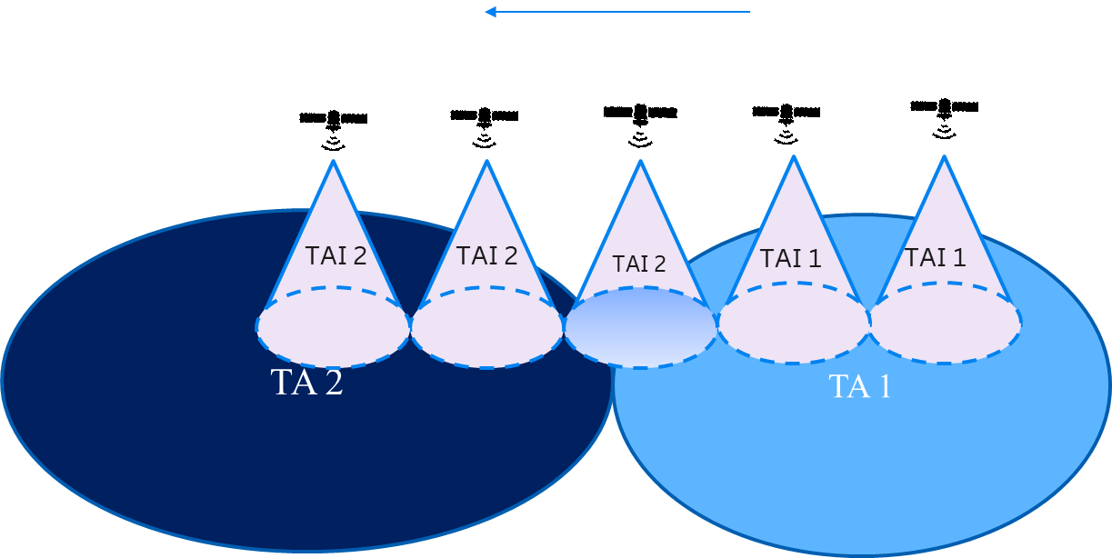

Figure 5 Tracking area update for Earth moving beams with hard TAI update

Soft TAI update requires the network to broadcast more than one TAI for a cell and PLMN.

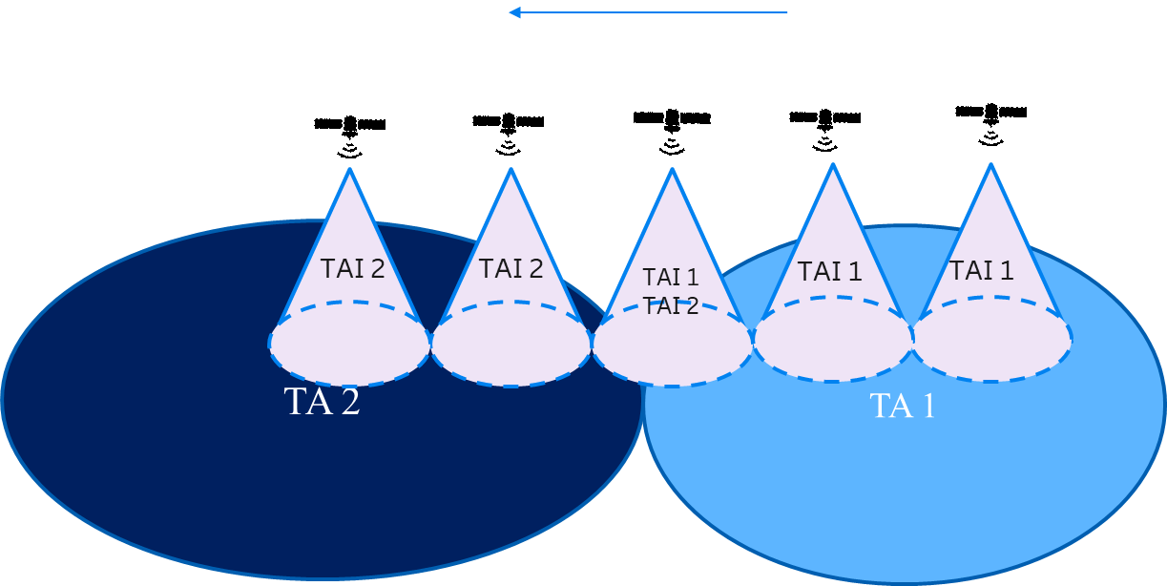

Figure 6 Tracking area update for Earth moving beams with soft TAI update

*Q5.1 Do companies have a preference on supporting either hard or soft TAI update, or both?*

|  |  |
| --- | --- |
| Company | **Answer** |
| CATT | Both of them are feasible, we slightly prefer the “Hard” TAI update.  As the “soft” TAI update requires some changes to the specification, and need more frequently update the system information, e.g. one cell broadcast TA1 🡪 TA 1+2 🡪 TA2. Yet another problem is that the higher number of TAIs a cell broadcasts, the higher paging load it is expected, causing load imbalance between cells.  While for the hard switch, only need to update the TAI of the cell from TA1 🡪 TA2, and no specification change is needed. For the any UE near the TA boarder, a list of the TAs which are expected to cover the UE could be configured as the Registration Area in order to prevent frequent occurrences of registration procedure due to camping in a cell which broadcasts a TA outside its Registration Area. |
| MediaTek | We prefer Soft TAI update, involving multiple TA codes per cell. We believe this will reduce the fluctuation and signalling load. |
| CMCC | Soft TAI update solution may be better than the hard TAI update solution in order to reduce TAU. |
| Huawei, HiSilicon | We prefer soft TAI update, which has less UE impact and system overhead. |
| Panasonic | We support both the hard and soft TAI update as they are both feasible. It should be up to network’s decision to use which option based on the overall consideration among the paging overheads, TAU overheads, and UE’s power consumption.  The frequent TAU caused by the hard TAI update option can be alleviated if gNB doesn’t trigger the SI update even when the broadcasted TAC value changes, or if the UE located at the TA boundary is registered to multiple TAs. |
| BT | Soft TAI update. Once soft TAI is defined, hard case seems to be a subcase. |
| ITRI | We support soft TAI update to reduce signalling overhead from both UE and network aspects. |
| APT | Prefer hard TAI update. To avoid heavy paging load. |
| Sony | We support both. |
| Nomor Research | Agree with BT. |
| Thales | We prefer soft TAI update with a list of TAC per cell to reduce TAU.  The hard TAU is a subcase of the soft TAU |
| Ericsson | We prefer soft TAI update in order to avoid the fluctuation. |
| Qualcomm | Soft TAI update should be considered to avoid unnecessary triggering of registration update by UEs which will add load to UEs and the network. The moving cell entering new TA2 (and leaving old TA1) shall not cause the registration update triggering to UEs who are within their fixed TA1 or TA2. In addition, the sudden transition of UEs from a TA1 to a TA2 with hard TAI update may cause problems for the 5GCN – e.g. if TA2 is forbidden to some UEs or is used for charging or regulatory services.  Therefore, the simplest solution is to broadcast multiple TAs in the TA boundary. However, this does not prevent an operator from deploying “hard TAI update” if preferred, since the logic to change TAI can be internal to gNBs. |
| LG | We prefer soft TAU which brings less UE impact. |
| Loon, Google | Soft TAI update is preferred |
| Samsung | We have a serious concern about a cell broadcasting multiple TAIs. TAs on Earth have irregular geographic areas. The gNB would need to frequently and aperiodically change TAIs in System Information (e.g., in SIB1). Depending upon the actual shapes of fixed-Earth TAs, the time between two instants requiring an update in SIB1 due to a different set of TAIs can often be within the SIB1 window of 160 ms. To facilitate implementation of an Earth-fixed Tracking Area and to avoid such complex TAI updates in SIB1, we suggest the concept of a Virtual Tracking Area (VTA), where the VTA corresponds to an Earth-fixed Tracking Area. In the VTA approach, the gNB transmits a single TAI in a cell like R16. The UE and the AMF have a mapping between the VTA and TAIs in different time windows. Predictable platform movements (e.g., LEO satellites) can be used to easily determine such mapping. The AMF registers the UE in a Virtual Registration Area (VRA) that consists of VTAs. The VRA is equivalent to the R16 TAI List. The UE compares the TAI broadcast in SIB1 with the set of TAIs associated with the VRA at the current instant. The UE does not send a Registration Request as long as the TAI in SIB1 is in the VRA. |
| Apple | We prefer soft TAI update as well to reduce registration update signaling from UE. |
| Xiaomi | We prefer Soft TAI update. |
| OPPO | The hard TAI update will cause fluctuation at the TA border area and will cause a lot of UEs to do location registration, which means a lot of signaling overhead.  The soft TAI update can avoid massive signaling overhead, though it has some standard impact.  We slightly prefer the soft TAI update. |
| Spreadtrum | Soft TAI update |
| Lenovo | Soft TAI update. |
| Nokia | We prefer a hard TAI switch due to the reasons described by CATT. Including the relevant TACs in the UE’s Registration Area (RA) should address the TAI border issue. In other case (in soft TAI update), broadcasting multiple TAIs will increase the paging load. |
| Vodafone | Traffic Area Update should be avoided as we have illustrated previously it has a very large signalling load on the network and in this case the NTN network.  The Tracking areas must be large to avoid such large signalling loads  However Soft TAI update could work better in practice, as during the transition stage of the satellite passing over an area, for a short duration, Two TAIs could be in use.  This is a deployment and implementation issue and strictly not a standards issue.  MNOs and Satellite service providers jointly arrive at a suitable and practical Tracking Areas to suit their networks’ needs. |
| NEC | Soft TAI update will cause paging imbalance and needs specification update to support it. Hard TAI update will create fluctuation at the border areas, which itself is not a problem. What we want to avoid is unnecessary TAU, which can be avoid by configure a RA including both TAI for UEs at the border areas. We prefer to take hard TAI update as baseline as it is supported without specification update. |
| Intel | We prefer soft TAI. |

# 5 Summary of proposals

TBA