**3GPP TSG-RAN WG2 Meeting #112Tdoc** **R2-19xxxx**

**Source: Ericsson (Email discussion rapporteur)**

**Title:** **[POST111e][910][NTN] Impacts of earth fixed and moving beams (Ericsson)**

**Agenda Item: x.x.x.x.x**

**Document for: Discussion**

# 1 Introduction

NTN Rel-17 WI was started in RAN2#111 and the following agreements were reached(excluding user plane).

Agreements:

1. RAN2 stick to WI scenarios: Any restriction, e.g. on the LEO altitude (if needed) could come from other groups.
2. From RAN2 perspective, the table 4.2-2 of [TR 38.821] is used as a baseline for the normative work, with the removal of the regenerative payload option
3. (as the WI is restricted to transparent payload) we assume that the feeder link will use NR (how the satellite is controlled is out of the scope of the WI)
4. RAN2 confirms the assumptions on the UE ground speed in the handheld and VSAT cases
5. In Rel-17, only UEs with GNSS capabilities are supported
6. Both Earth fixed and earth moving beam scenarios are considered with NGSO constellation.

Agreements via email - from offline 105:

1. Both soft and hard feeder link switchover (e.g. for Non GSO) are supported.

Note: This requires satellite to be connected to one NTN GW at a time (hard switch) or at least two NTN GWs simultaneously (soft switch).

1. RAN2 to start discussing enhancements for soft feeder link switchover and then solutions for hard feeder link switchover.

3. As part of the NR-NTN WI, the following stepped approach is proposed:

- Step 1: Assessment of the Rel-16 LCS framework/application protocols (3GPP TS 23.273, TS 29.572, TS 38.455, TS 38.305, in particular but not excluding other TS) and its applicability to NTN

- Step 2: Assess whether changes to the existing network-based location methods are needed and define them if needed

4. The NTN network based positioning of UE should provide an accuracy comparable with the network based UE location accuracy of terrestrial networks.

5. For TN/NTN mobility, the UE is not required to connect to both TN and NTN at the same time.

6. RAN2 to discuss about trigger(s) of TN / NTN mobility, once the Intra NTN mobility has sufficiently progressed. Intra NTN mobility refers to idle and connected mode mobility between NTN cells (e.g. intra or inter satellite).

7. Transparent HAPS is assumed with the IMT BS on the ground and the HAPS is a relay.

8. The RAN2 work plan described in R2-2007565 should be considered as a basis for work

9. The work plan should be based on the following prioritization principles:

- 1st priority: user plane, control plane (idle and connected)

- 2nd priority: NTN-TN service continuity, network based UE location

Agreements via email - from offline 106:

1. The network type (i.e. TN or NTN) should be known to UE. FFS whether to achieve this in an implicit or explicit way.
2. The existing cell reselection priority configuration can be taken as a baseline in NTN. FFS on any further enhancement.
3. Postpone the discussion on whether to introduce a new SIB until we have more progress on the content of NTN specific system information.

Agreements:

1. Cell selection / reselection in NR is the baseline in NTN idle mode procedure.
2. Satellite/HAPS ephemeris based cell selection and reselection should be defined for NTN (FFS what the term satellite/HAPS ephemeris actually means). FFS when this ephemeris based cell selection / reselection can be used. FFS whether UE location (and/or other information) based cell selection and reselection should be introduced for NTN
3. The satellite ephemeris should be provided to UE, at least for Satellite/HAPS ephemeris based cell selection and reselection (FFS what the term satellite/HAPS ephemeris actually means).

This email discussion was also agreed in RAN2#111 and the scope of the discussion is stated as below

* [POST111e][XXX][NTN] Impacts of earth fixed and moving beams (Ericsson)

Scope: Discuss RAN2 impacts of earth fixed and moving beams, both for idle and connected mode, for feeder link switch in both Earth moving and Earth fixed beam and for service link switch in Earth fixed beams case due to satellite switch. No discussion on measurement aspects

Intended outcome: email discussion summary

Deadline: Until next meeting

Initial DL for companies feedback is set Fri 9 th October in order to have proposed summary and review of that by 15th October

Connected mode mobility in NTN may be categorized into the following scenarios:

Scenario 1: Feeder link switch for earth fixed beam, with/without service link switch due to satellite switch

Scenario 2: Feeder link switch for earth moving beam, with/without service link switch due to satellite switch

Scenario 3: Service link switch for earth fixed beam due to satellite switch

Scenario 4: Connected mode mobility for earth moving beam when the beam no longer serves the UE

Scenario 5: Connected mode mobility for both earth moving and earth fixed beam due to UE movement

Specific aspects for mobility handling for scenarios 4 and 5 will be covered in email discussion [Post111-e][911][NTN] Connected mode aspects (ZTE)

This email discussion focuses on scenarios 1, 2 and 3 (although some aspects may be more general and applicable to other scenarios).

# 2 Feeder link switch

Both soft and hard feeder link switch have been considered during the SI. These can be described as follows:

**Soft feeder link switch** where the satellite can simultaneously support two feeder links: The key idea is that the satellite supports simultaneous transmissions of two feeder link signals during the switch to enable a smooth switch.

**Hard feeder link switch** where the satellite can only support one feeder link at a time. In this case, one GW drops the connection to the satellite before the next GW establishes the connection to the satellite.

In RAN2#111, it has been agreed to consider both soft and hard feeder link switch with priority for soft switch. Aspect that has not been discussed is whether feeder link switch has difference from RAN2 perspective for Earth moving and Earth fixed beams. Hence, we are including questions to check for this aspect.

Further, in TR 38.821, the following two cases were considered for the transparent LEO architecture:

* Case 1: Different gNB’s before and after the switch. In this case, the target gateway after feeder link switch is served by a different gNB compared to the source gateway.
* Case 2: Same gNB before and after the switch. In this case, the gateways before and after the switch are connected to the same gNB.

Whether both Case1 and Case 2 are feasible has not been discussed. Case 1 is along the lines of default assumption considered during the study item across WGs, however, Case 2 has also been captured in the TR and should be discussed now in WI.

The Case 2 is depicted in Figure 1. There can be possibly thousands of kilometres distance between GW1 and GW2. From this it follows that if there is one gNB serving via both GWs, there will be relatively long fiber or other connection between the GW and the gNB. As we are discussing transparent architecture, the Uu interface goes in this assumption via the fiber link, feeder link and the service link. This introduces additional and possibly unstable delay on the Uu as it is not over the air between the gNB and the GW.

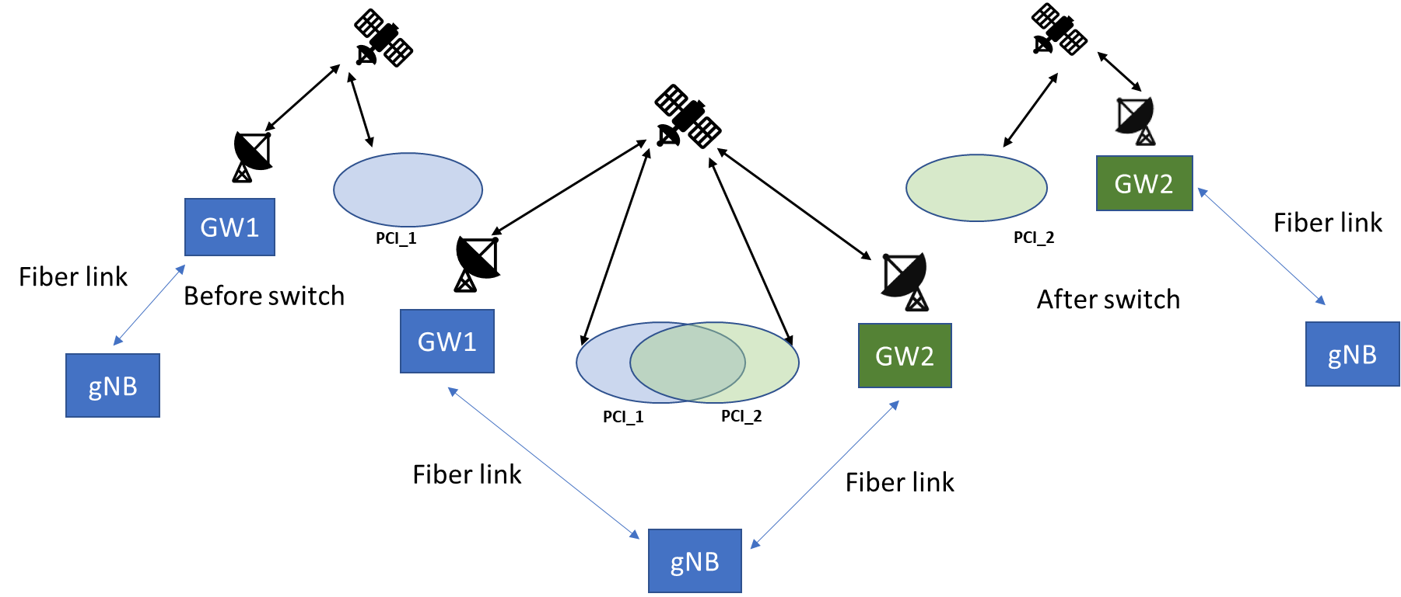

Figure 1

*Q2.1 Do companies see the assumption of Case 2, e.g. having one gNB serving via two GWs as a viable option?*

|  |  |
| --- | --- |
| Company | **Answer** |
| CATT | From technology perspective, we see some issues for case 2：  For Case2, gNB and GW can’t be put together, the complete Un delay consists of service link feederlink and fiber link. The feeder link delay is tracked by the serving GW, which means the serving GW has to frequently report the in time feederlink delay to gNB for at least TA compensation purpose. We think the additional complexity caused by fiber link feedback is not easy to achieve from implementation perspective. |
| MediaTek | We think Case 1 should be the default assumption. The delay and associated jitter could be relatively high for Case 2 in LEO, and therefore it does not appear to be a viable option. However, we welcome input from satellite operators on this aspect. |
| CMCC | If the cost of long-distance fiber is acceptable, then case 2 seems ok. |
| Huawei, HiSilicon | We don’t see Case 2 as a viable option.  The cost of thousands of kilometres fiber link could be very high, and it seems unnecessary to make such a deployment. |
| Panasonic | Although the distance between the gateway and gNB in the case 2 architecture could be quite long, as long as the variation of the feeder link delay is transparent to UE, it should manageable. Therefore we think both case 1 and case 2 can be supported. |
| BT | Based on the description, why should we assume there is always thousands of kilometres and therefore, remove this? |
| ITRI | We think case 1 and case 2 can be supported, and case 1 should be the default option. Though in case 2 the distance of fiber link could be quite long, the GWs are relay and the fiber link delay between a gNB and a GW should be a constant and would not be appeared to UE. |
| APT | No, if the fibre link has 1000 km long (which is an optimistic assumption, it shall be far longer in practice if we check how GW locations distribute by SpaceX) then its propagation delay would be up to 21.48ms. Both RAN1 and RAN2 did not consider this fibre link delay during NTN SI, and we agree Ericsson’s view that this case may not be supported (feasible) at this stage. |
| Sony | Case 1 should be supported by default.  On case 2, we think it is rare to have a gNB controlled by more than one GW. Typically, gNBs are national i.e. serve only people in one nation whilst Gateways are supranational because they form the ground segment of a supranational satellite network. |
| Nomor Research | From our perspective Case 1 should be the default assumption.  If there are thousands of kilometres of fiber link between GW and gNB, there should be an gNB split (gnB-DU at each GW, GW1 and GW2 share gNB-CU). |

*Q2.2 Do companies see any difference for feasibility for Case2 with assumption on Earth moving and Earth fixed beams?*

|  |  |
| --- | --- |
| Company | **Answer** |
| CATT | Yes we see some difference:  For earth fixed beam, it’s possible to achieve no feeder link switch if the overlapping is well designed between satellites.  But for moving beam, both soft and hard feeder link switch are possible subjected to satellite capability. |
| MediaTek | We see implementation difficulties in LEO, regardless of Earth fixed or Earth moving beams, because of sudden feeder link delay changes. |
| CMCC | We see no difference for the Case2 with assumption on Earth moving and Earth fixed beams. |
| Huawei, HiSilicon | The feasibility relies on the fiber link, so whether it is Earth moving or Earth fixed beams doesn’t matter. |
| Panasonic | Whether it is Earth moving or Earth fixed beams, it doesn’t impact the feasibility for Case 2, as long as the variation of the feeder link delay is transparent to UE. |
| BT | It is a matter of timing and not fix or moving beams. |
| ITRI | We see no difference for case2 feasibility with assumption on Earch moving and Earth fixed beams. |
| APT | No. the fibre link delay is lack of discussion, so no difference on Earth moving or Earth fixed. |
| Sony | We see no difference between earth moving and earth fixed beam. |
| Nomor Research | We see no difference for Case 2 with assumption on earth moving and earth fixed beams |

Case 1 is depicted in Figure 2 for both Earth fixed(above) and Earth moving beams(below). Here, as gNBs are at the GW, the Uu interface is over the air via feeder link and then via service link. As discussed, the feeder link switch may be a soft switch or a hard switch. During the study item few issues were listed together with some solutions. As soft feeder link switch was agreed to be considered first, we take that first here in this discussion.

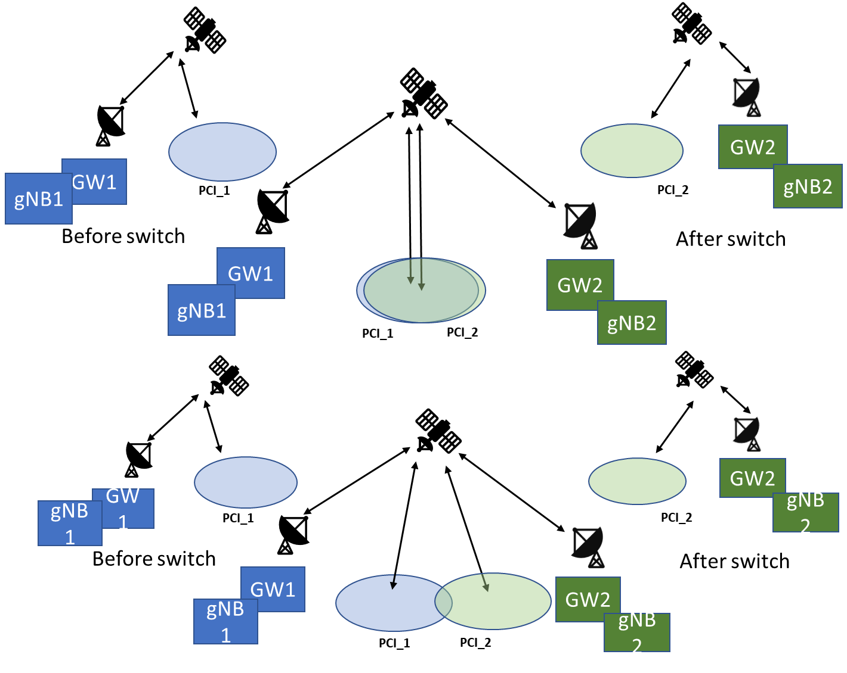

Figure 2 Soft feeder link switch for both Earth moving and Earth fixed beams

List of issues for *soft feeder link switch* include

* *Issue 1:* Many connected mode UEs need to be handed over within the duration of the feeder link switch
* *Issue 2:* Many idle mode UEs need to reselect another cell
* *Issue 3:* Packet forwarding delay due to long inter distance between gNBs
* *Issue 4:* Satellite capability of forwarding beams (cells) from two GWs simultaneously
* *Issue 5:* Satellite capability of supporting two feeder link connections simultaneously

*Q2.3 Companies to comment which issues need to be considered by RAN2 and whether there are additional issues to be considered by RAN2?* ***Further, please indicate if a difference Earth moving and Earth fixed beams is identified.***

|  |  |
| --- | --- |
| Company | **Answer** |
| CATT | Issue 1 and Issue 2 should be addressed by RAN2.  Issue3 is completely a RAN3 issue.  As for Issue 4 and Issue 5, Satellite capability requirement is different between soft and hard feeder link switch, gNB may need to decide which feeder link switch mechanism to use based on Satellite capability. But this judgement is more like a network implementation; no spec effort is needed to address issue 4 and issue 5.  Additional issue: at least new cell info exchange between the gNBs may be needed during feeder link switch.  The serving cell info generated by the source and the target gNBs. Exchange the info via Xn/NG interface, or leave it to pre configuration (OAM configuration). Anyway, for soft feeder link switch, this issue is out of RAN2 scope.  As mentioned in Q2.2, for earth fixed beam, it’s possible to achieve no feeder link switch if the overlapping is well designed between satellites, while for earth moving beam, feeder link switch still should be considered. |
| MediaTek | We think Issue 1, Issue 2 and Issue 3 are relevant for discussions in RAN2.  We think there is no difference between Earth fixed vs. Earth moving beams. |
| CMCC | The first two issues should be considered by RAN2.  Issue3 may be a challenge of RAN3.  Regarding the last two issues, it may be necessary to determine the switch solution(soft or hard switch)before discussing. And DAPS may be considered to be introduced into feeder link switch. |
| Huawei, HiSilicon | Issue 1 and 2 are in RAN2 scope.  Issue 3 should be discussed in RAN3, e.g. if Xn interface is available between gNBs for NTN.  Issue 4 and 5 have been covered by current assumption, i.e. soft feeder link switch already means these satellite capabilities are supported.  And no difference between Earth moving or Earth fixed beams is seen, as in this short period of time, the coverage of Cell 1 and Cell 2 are the same in both cases. |
| Panasonic | Issue 1 needs to be addressed in RAN2.  Issue 2 seems to have no signaling impact and therefore should be fine even if a lot of UEs reselect to another cell simultaneously. However, some solutions listed in Q4.2 are needed, which might be irrelevant to Issue2 but relevant to other idle mode issues.  Issue 3 is more relevant to RAN3. |
| BT | Issue 1 and issue 2 should be addressed in RAN2  Issue 3 should be considered in RAN3  Issue 4 and issue 5 are implicit with the scenario and how each satellite supports such features should be vendor specific. |
| ITRI | Issue 1 and 2 and 3 need to be discussed in RAN2. However, we don’t see difference between Earth fixed and Earth moving beams.  The value of packet forwarding delay is in RAN3 scope.  Issue 4 and 5 relates to satellite capabilities. |
| APT | No difference between Earth moving and fixed for Issue 1, 2, and 3. For issue 4 and 5, we may need some input from satcom companies.  Issue 1: Many connected mode UEs need to be handed over within the duration of the feeder link switch  [APT] this issue has been identified in Rel-16 NTN SI, so it makes sense to be considered by RAN2 in Rel-17 NTN WI  Issue 2: Many idle mode UEs need to reselect another cell   [APT] this sounds like meaningful enhancement to save some UE’s power if some assistant information is provided by NW.  Issue 3: Packet forwarding delay due to long inter distance between gNBs  [APT] this sounds a valid issue but lack discussion so far. |
| Sony | Issue 1 and 2 should be addressed in RAN2. |
| Nomor Research | Issue 1 and Issue 2 should be discussed in RAN2.  Issue 3 is more relevant to RAN3.  Issue 4 and Issue 5 is dependent on satellite capability. For soft feeder link switch, these capabilities are needed.  From our perspective, there is no difference between earth moving and earth fixed beams regarding these issues. |

The hard feeder link switch is depicted in Figure 3

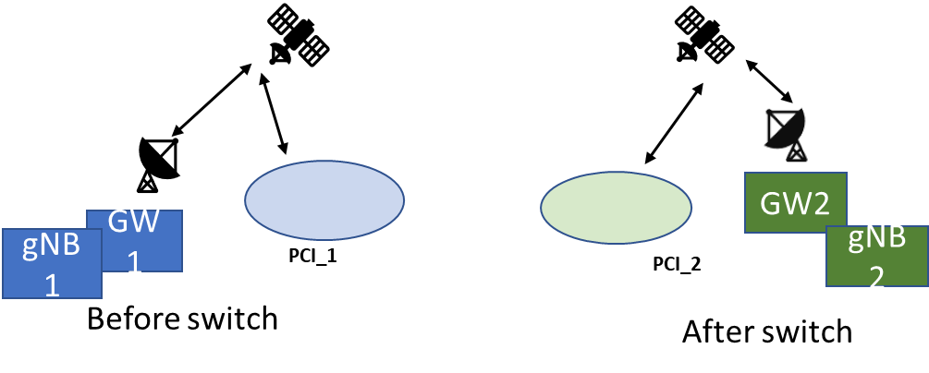

Figure 3 Hard feeder link switch

List of issues for *hard feeder link switch* include

* *Issue 6:* Many connected mode UEs need to be moved to next cell within the duration of the feeder link switch
* *Issue 7:* Many idle mode UEs need to reselect another cell
* *Issue 8:* Packet forwarding delay due to long inter distance between gNBs
* *Issue 9:* Service interruption due to tearing down one feeder&service link and building other

*Q2.4 Companies to comment which issues need to be considered by RAN2 and whether there are additional issues to be considered by RAN2?* ***Further, please indicate if a difference Earth moving and Earth fixed beams is identified.***

|  |  |
| --- | --- |
| Company | **Answer** |
| CATT | First of all, the same view as the answer to Q2.3, there could be no feeder link switch for earth fixed beams.  For earth moving beams, we understand all of the issues except Issue 8 listed above should be considered in RAN2. Additionally, we need to investigate whether CHO based solution could be adopted for hard feeder link switch, and whether need any precious timing control is needed or not. |
| MediaTek | We think Issue 6, Issue 7, Issue 8 and Issue 9 are relevant for discussions in RAN2.  We think there is no difference between Earth fixed vs. Earth moving beams. |
| CMCC | Issue8 may need inputs from RAN3, while the other three issues need to be studied by RAN2. |
| Huawei, HiSilicon | Issue 6, 7 and 9 should be discussed in RAN2.  Issue 8 can be left to RAN3. |
| Panasonic | Same as our earlier comments that Issue 6 should be addressed in RAN2 and Issue 8 is more relevant to RAN3; Issue 7 seems to have no signaling impact and hence we can leave it, however, some solutions listed in Q4.2 are needed as they are relevant to other idle mode issues.  For Issue 9, this can be also addressed in RAN2 by adopting the timestamp/timer-based CHO solution which makes it possible to align the timing between feeder link switching and HO execution. |
| BT | Issue 6 and issue 9 should be discussed in RAN2.  Issue 8 should be addressed in RAN3  Issue 7 even no signalling is involved, a device doing DRX may skip one or many satellites before it makes the reselection. Therefore, it should be included in RAN2. |
| ITRI | We think Issue 6, 7, 8, 9 need to be discussed in RAN2. There is no difference between Earth fixed and Earth moving beams are foreseen. |
| APT | No difference between Earth moving and fixed.  *Issue 6:* Many connected mode UEs need to be moved to next cell within the duration of the feeder link switch  *Issue 7:* Many idle mode UEs need to reselect another cell  *Issue 8:* Packet forwarding delay due to long inter distance between gNBs  [APT] issue 6, 7, and 8 are the same as the soft feeder link  *Issue 9:* Service interruption due to tearing down one feeder&service link and building other  [APT] it is unclear whether UE is in RRC_CONNECTED during hard feeder link switch. If yes, then some enhancement is needed. |
| Sony | Issue 6,7 and 9 should be addressed in RAN2. |
| Nomor Research | Issue 6, 7 and 9 should be discussed in RAN2.  Issue 8 is more relevant to RAN3.  From our perspective, there is no difference between earth moving and earth fixed beams regarding these issues. |

# 3 Service link switch for Earth fixed beams

During the study item RAN2 did not consider Earth fixed beam scenario as it was excluded from the study item plan and the TR 38.821 captures as follows:

## 7.4 Earth fixed cells vs Earth moving cells

Compared to LEO based Earth moving cells scenario where cells are moving on the ground, LEO based Earth fixed cells scenario refer to NTN that provide cells fixed with respect to a certain location on the Earth during a certain time duration. This can be achieved with NTN platforms generating steerable beams which footprint is fixed on the ground.

The same solutions identified for Earth moving cell scenario can also be applied for Earth fixed cell scenario, however whether specific solutions are necessary (or preferred) for each scenario can be further evaluated in the normative phase (See [74]).

One of the main aspects related to the Earth fixed beams is the service link switch depicted in Figure 4. Due to the movement of the non-GEO satellites in relation to the surface of the earth, at some point in time one satellite leaves and is not able to serve a certain geographical area.

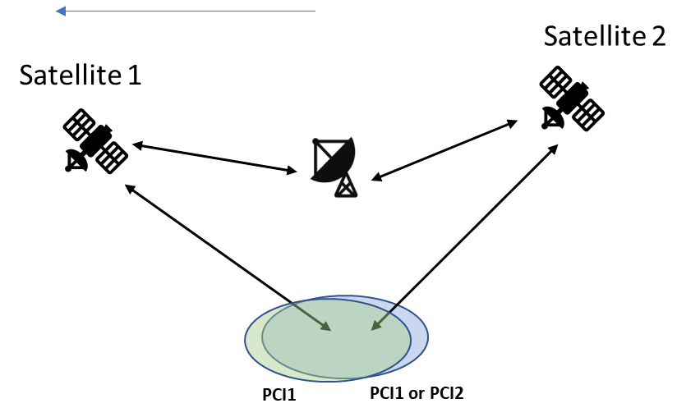

Figure 4 Service link switch for Earth fixed beams

It is possible to consider that the PCI via satellite 1 and satellite 2 can be same or different and these SSBs may be on same or different sync raster points. If the SSBs are on different sync raster point, the mobility during the service link switch is L3 mobility from RAN2 perspective. If these SSBs are on same raster point and PCI are different, the switch is again L3 mobility. If these SSBs have same PCI, the switch can be L1 switch if this option proves viable. However, this would require that the gNB would either repeat the SSB beams of the SSB burst via satellite 1 and satellite 2, or use only part of SSB beams via satellite 1 and part via satellite 2. The issues related to these are due to the delay and delay difference between feeder/service links for satellite 1 and satellite 2. Then, at the UE, it is not clear if the timing of the SSB beams within the same burst can be kept. Thus, if this option of having same PCI on same sync raster location is deduced to be viable from RAN2 perspective, RAN2 should send LS to RAN1 in order to ask for the viability from RAN1 perspective.

*Q3.1 Companies to consider the option of same PCI on same sync raster location via satellite 1 and satellite 2 to be a viable option? If so, do companies agree to send LS to as the viability from RAN1 perspective.*

|  |  |
| --- | --- |
| Company | **Answer** |
| CATT | As the satellites are moving over time, the delay difference between feeder/service links for satellite 1 and satellite 2 is variable, it’s hard to keep the SSB burst timing pattern as per-defined. More addition, we never discuss this scenario during SI phase. If companies want to discuss the feasibility from RAN1 perspective, we’re fine to ask RAN1. |
| MediaTek | The discussion of same PCI on same Sync raster location via different satellites should take place in RAN1, as this is a RAN1 topic. |
| CMCC | An LS to RAN1 to ask for the viability is acceptable to us. |
| Huawei, HiSilicon | We think this case is a viable option, and could be discussed in RAN2.  Since satellite is a repeater in this transparent architecture, and GW is responsible to take charge of satellite management. So the SSB and PCI are the same with the same gNB, and only repeater changes. This case could happen in fact. And we are ok to send a LS to RAN1 to ask for more input to assist RAN2’s design. |
| Panasonic | As having this option available is beneficial in terms of reducing the L3 mobility, we think it is good to send an LS to RAN1 and ask their options regarding the viability. |
| BT | BT agrees to send a LS to RAN1 since this is a perfect valid case that shall be discussed there. |
| ITRI | When SSB beams with same PCI on same sync raster point are transmitted via different satellites, the timing of SSB bursts relayed by different satellite would change over time. We are fine to send a LS to RAN1. |
| APT | Not sure. If the same PCI is provided by from two satellites, in this cell, UEs would require different common (cell specific) timing and frequency compensated or indicated by NW. This might be an issue. |
| Sony | We think this case is a feasible option and ok to send an LS to RAN1. |
| Nomor Research | Not sure, we have doubts that same PCI on same sync raster location via two satellites will work. Delays and frequency shift/Doppler are different from both satellites. |

List of issues for *service link switch* include

* *Issue 10:* Many connected mode UEs need to be handed over within the duration of the service link switch
* *Issue 11:* Many idle mode UEs need to reselect another cell

*Q3.2 Companies to comment which issues need to be considered by RAN2 and whether there are additional issues to be considered by RAN2?*

|  |  |
| --- | --- |
| Company | **Answer** |
| CATT | Both should be considered in RAN2  More addition, we think UE RRM procedure is also one of the key issues that should be addressed. |
| MediaTek | We think both Issue 10 and Issue 11 are relevant for RAN2 in Service Link switch. |
| CMCC | Both issue 10 and issue 11 need contributions from RAN2. |
| Huawei, HiSilicon | If L3 mobility is determined for service link switch case, both issues should be handled in RAN2. |
| Panasonic | Issue 10 should be addressed in RAN2, while Issue 11 seems to have no signaling impact. However, some solutions listed in Q4.2 are needed as they are relevant to other idle mode issues. |
| BT | Both, issue 10 and issue 11 should be discussed in RAN2. |
| ITRI | Both Issue 10 and 11 need to be considered in RAN2. |
| APT | Issue 10 and 11 are the same as the soft feeder link issue and shall be considered in RAN2. |
| Sony | Both issues 10 and 11 should be discussed in RAN2. |
| Nomor Research | Both, issue 10 and issue 11 should be discussed in RAN2. |

# 4 Potential solutions

Potential solutions for ***connected mode UEs*** are listed below. Some solutions address the issue of spreading HO attempts of the UEs in time, some solutions leave that for the network to distribute when sending the HO command. Some solutions address assisting UE to find more easily the up coming new cell(PCI). Not all these solutions are mutually exclusive.

* *For Issue 1, 10:* Many connected mode UEs need to be handed over within the duration of the service link switch
  + *Solution 1:* Conditional HO (Discussed further in email discussion [911])
  + *Solution 2:* HO with random access attempts distributed in time
  + *Solution 3:* Group HO, e.g. common part of HO command in SI and UE specific with UE specific signalling.
  + *Solution 4:* No enhancements for HO command/procedure, leave up to network implementation
* *Issue 6:* Many connected mode UEs need to be moved to next cell within the duration of the feeder link switch
  + *Solution 5:* Enhanced connection re-establishment procedures.
  + *Solution 6:* Conditional HO (Discussed further in email discussion [911])
* *For issue 3, 8:* Packet forwarding delay due to long inter distance between gNBs
  + *Solution 7:* Informing of the upcoming feeder link switch (the UE about PCI leaving and another PCI appearing due to feeder link switch)
    - stored at UE or via system information
  + *Solution 8:* HO command with information of the upcoming feeder link switch (the UE about PCI leaving and another PCI appearing due to feeder link switch)
  + *Solution 9:* Enhanced connection re-establishment procedures.
  + *Solution 10:* No enhancements for HO command/procedure, leave up to network implementation

*Q4.1 Do companies agree with the list of solutions to be studied for* ***connected mode UEs*** *in more detail and whether there are additional solutions to be considered?* ***Further, please indicate if a difference Earth moving and Earth fixed beams is identified.***

|  |  |
| --- | --- |
| Company | **Answer** |
| CATT | Firstly, we think Issue 1 belongs to feeder link switch, which should be put together with Issue 6, with this clarification, our view is given below：  For Issue 10, we agree to further study all the four solution listed here, but to clarify that UE location and satellite ephemeris based CHO is also in the scope.  For Issue 1 and Issue 6, we think solution 2 and solution3 are also applicable besides solution 5 and solution6.  As for Issue 3 and Issue 8, it’s totally a RAN3 issue, no RAN2 effort is identified.  As mentioned before, there can be no feeder link switch for earth fixed beam, while for earth moving beam has. For service link switch, no much differences are found between earth fixed beam and earth moving beam. |
| MediaTek | We prefer the following solutions for the issues:  Issue 1, 10: Solution 1, Solution 2, Solution 3 should be discussed and studied.  Issue 6: Solution 6 should be discussed and studied.  Issue 3, 8: Solution 10, i.e. leave up to network implementation. |
| CMCC | For issue1, solution 1 to solution 3 are enhancements to the existing HO mechanism, and the improvement of signaling overhead and latency may need to be evaluated.  Regarding Issue6, solution5 for connection re-establishment enhancements is demanded, while the signaling overhead and latency for CHO may need to further study.  Issue3 and issue8 may be the scope of RAN3. |
| Huawei, HiSilicon | We prefer the following solutions for the issues:  Issue 1, 10: Solution 1 could be discussed and studied, and if the transition period is long enough solution 4 is also feasible.  Issue 6: Solution 5 should be discussed and studied.  Issue 3, 8: Solution 10, i.e. leave up to network implementation. As Packet forwarding delay is strongly dependent on network deployment. |
| Panasonic | Agree with CATT that Issue 1 and Issue 6 should be grouped together (HO due to feeder link switch), while Issue 10 is a standalone group.  We agree the list of solutions for Issue 1, 6 and 10 (i.e., Solution 1 – 6), while we are not sure how RAN2 can reduce packet forwarding delay due to long distance between gNBs, via introducing Solution 7 – 10.  In our understanding, the listed solutions are equally important to the Earth moving beam and Earth fixed beam scenario. |
| BT | Issue 1, 10, solution 1, 2, 3 should be studied.  Issue 6 solution 5 should be considered for study. Solution 6 can be included in the issue 1, 10 solution 1 discussion.  Issue 3, 8 should be discussed by RAN3. |
| ITRI | Issue 1, 10: Solution 1 and solution 3 should be discussed and studied.  Issue 6: Solution 6 should be discussed and studied.  Issue 3, 8: The value of packet forwarding delay is in RAN3 scope. We think it should be RAN2 effort to study the enhancements of packet forwarding procedure. Solution 9 should be discussed and studied. |
| APT | Agree CATT |
| Sony | For issue 1 and 10, solution 1,2 and 3 should be studied.  For issue 6, solution 5 and 6 should be studied.  Issues 3,8 are in RAN3 scope. |
| Nomor Research | Issue 1, 10: solution 1, 2, 3 should be studied.  Issue 6: solution 5 and 6 should be discussed and studied  Issue 3 and 8 should be discussed by RAN3.  From our perspective, the solutions to discuss are applicable to earth fixed as well as earth moving beams. |

Potential solutions for ***idle mode UEs*** are listed below. Again, these solutions may address same or different aspects and thus may or may not be mutually exclusive.

* *Issue 2, 7, 11:* Many idle mode UEs need to reselect another cell
  + *Solution 11:* Informing of the upcoming feeder link switch (the UE about PCI leaving and another PCI appearing due to feeder link switch)
    - stored at UE or via system information
  + *Solution 12:* UE does cell ranking and reselection based on
    - information of Solution 7
    - UE absolute location
    - UE location relative to serving satellite
    - Round trip time (RTT) for the satellite
    - Remaining dwell time(time left to be served) in a cell that is leaving or appearing

*Q4.2 Do companies agree with the list of solutions to be studied for* ***idle mode UEs*** *in more detail and whether there are additional solutions to be considered?* ***Further, please indicate if a difference Earth moving and Earth fixed beams is identified****.*

|  |  |
| --- | --- |
| Company | **Answer** |
| CATT | For solution11, paging indicator is also one candidate solution to informing of the upcoming feeder link switch, so we’d like to revise this bullet as follows.   * + - stored at UE or via system information or paging indicator   For solution 12, the second and third bullets, how it works if the two cell are fully overlapped as shown in figure-4? We’d like to revise solution12 as follows:   * + - information of Solution 7 stored at UE or via system information or paging indicator     - UE absolute location and/or satellite ephemeris     - Signal elevation to the serving satellite below a threshold or Signal elevation to the target satellite above a threshold     - UE location relative to serving satellite or to the target satellite     - Round trip time (RTT) for the satellite     - Remaining dwell time(time left to be served) in a cell that is leaving or appearing     - The target cell signal is available   As mentioned before, there can be no feeder link switch for earth fixed beam, while for earth moving beam has. For service link switch, no much differences are found between earth fixed beam and earth moving beam. |
| MediaTek | Issue 2, 7, 11: Solution 11, while reusing existing R-16 cell re-selection method.  UE’s location should NOT be used in idle mode, as it will significantly increase UE’s power consumption. Network can assist the UEs to select the suitable incoming cells by adjusting the Qoffset and Qoffsettemp values of neighbour cells and Qhyst and Qoffsettemp values of serving cells in cell ranking criteria, mentioned in Section 5.2.4.6 of 3GPP 38.304. |
| CMCC | Agree with the two solutions for idle UEs. And for solution12, satellite ephemeris and satellite type information(e.g. GEO or LEO) should also be considered. |
| Huawei, HiSilicon | Solution 11 is ok for us.  In solution 12, at least the bullet “information of Solution 7” can be further studied. |
| Panasonic | Issue 2, 7, and 11 seem to concern mainly about “too many UEs” reselecting another cell simultaneously, but we couldn’t understand how Solution 11 and 12 are able to avoid “too many UEs” reselecting another cell. Maybe some more clarifications are needed. |
| BT | The description says idle. Is this because a different solution is envisioned for inactive?  Issue 2, 7, 11 solution 11 assumes the PCI will change will this is not the only option as the PCI may remain the same as Q3.1. Idle mode when the PCI is the same should be considered unless it is guaranteed the switch is completely transparent.  Solution 12 in general requires more discussion. A UE in idle is not required to reselect each new satellite and we should avoid as many UL transmission as possible. Therefore, it requires more clarification in general. |
| ITRI | Both solution 11 and solution 12.  We think the purpose is to assist IDLE mode UE reselect a suitable cell efficiently. In solution 12, “information of Solution 7” could be considered as baseline. Other information may depend on UE capabilities. |
| APT | Agree both. |
| Sony | We agree to study solution 12. |
| Nomor Research | Agree to study both, solution 11 and solution 12. However, UE’s location should NOT be used in idle mode.  Agree with BT in terms of “A UE in idle is not required to reselect each new satellite and we should avoid as many UL transmission as possible.”  From our perspective, the solutions to discuss are applicable to earth fixed as well as earth moving beams. |

Since solution 12 has several different potentionally different ranking or triggering conditions we have a question specific to solution 12 in order to progress on details.

* + *Solution 12:* UE does cell ranking and reselection based on
    - information of Solution 7(Informing of the upcoming feeder link switch (the UE about PCI leaving and another PCI appearing due to feeder link switch))
    - UE absolute location
    - UE location relative to serving satellite
    - Round trip time (RTT) for the satellite
    - Remaining dwell time(time left to be served) in a cell that is leaving or appearing

*Q4.3 Companies are asked to provide their preference of the suggested triggers based on applicability on feeder or service link switch use cases? Further, please indicate which triggers are seen as mutually exclusive and which could work together or work as options depending on exact problem to be solved.*

|  |  |
| --- | --- |
| Company | **Answer** |
| CATT | Based on revision of solution12, we think the following bullet is more easy to implement:   * + - information of Solution 7 stored at UE or via system information or paging indicator     - UE absolute location and/or satellite ephemeris     - UE location relative to serving satellite or to the target satellite     - The target cell signal is available   Exclusive triggers:   * + - information of Solution 7 stored at UE or via system information or paging indicator     - The target cell signal is available   Work together or work as options with Exclusive triggers:   * + - UE absolute location and/or satellite ephemeris     - UE location relative to serving satellite or to the target satellite   Satellite ephemeris and UE absolute location can be known by UE, but satellite beam footprint is more related to satellite antenna deployment, which can be relatively independent to Satellite ephemeris for details. For cell reselection , satellite beam footprint is more accurate than Satellite ephemeris, so UE absolute location and/or satellite ephemeris can just work as a supplementation. |
| MediaTek | UE’s location should NOT be used in idle mode, as it will significantly increase UE’s power consumption. |
| CMCC | We prefer to use UE location relative to serving satellite and satellite type information(e.g. GEO or LEO) as our comments to Q4.2. |
| Huawei, HiSilicon | At least the bullet “information of Solution 7” can be further studied.  For all other bullets, the UE location information has to be explicitly or implicitly used. We agree with MTK that this will increase UE’s power consumption. |
| Panasonic | For the service link switch case, we think the following triggers can facilitate UE’s determination on cell reselection. Other triggers can be FFS.   * information of Solution 7(Informing of the upcoming feeder link switch (the UE about PCI leaving and another PCI appearing due to feeder link switch)) * UE absolute location * UE location relative to serving satellite |
| BT | For idle/inactive mode, power saving for NTN UEs is a priority for us. Therefore, we’re in favour of solutions where UL signalling is not required. At the moment, anything related with position seems to require the UL to inform the network about the location.  Do we need different solutions when the PCI is kept than when it is not? |
| ITRI | For IDLE mode UE, “information of Solution 7” could be considered as baseline. Other information may depend on UE capabilities and would increase UE’s power consumption. |
| APT | Agree MTK |
| Sony | We think the following triggers should be considered.   * + - information of Solution 7(Informing of the upcoming feeder link switch (the UE about PCI leaving and another PCI appearing due to feeder link switch))     - UE absolute location     - UE location relative to serving satellite |
| Nomor Research | Use information of Solution 7 as a baseline.  As indicated above, from our perspective UE’s location should NOT be used in idle mode. |

# 5 Earth moving beams

Connected mode mobility for earth moving beams not concerning feeder link switch is handled in Connected mode aspects (ZTE) where measurements related aspects are handled as well

In this email discussion, similar to addressing a specific case for fixed beams, the specific aspect for Earth moving beams is the handling of tracking area update. During the study item, both hard and soft switch has been considered. The hard switch means that each cell can broadcast only on tracking area code. When this is combined with Earth fixed tracking area, it will create fluctuation at the boarder areas of these Earth fixed tracking areas. This hard TAI update is depicted in Figure 3.

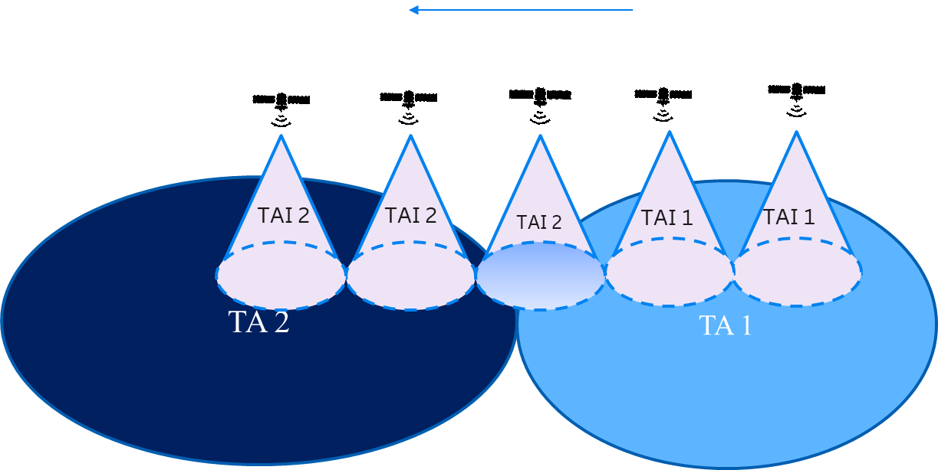

Figure 5 Tracking area update for Earth moving beams with hard TAI update

Soft TAI update requires the network to broadcast more than one TAI for a cell and PLMN.

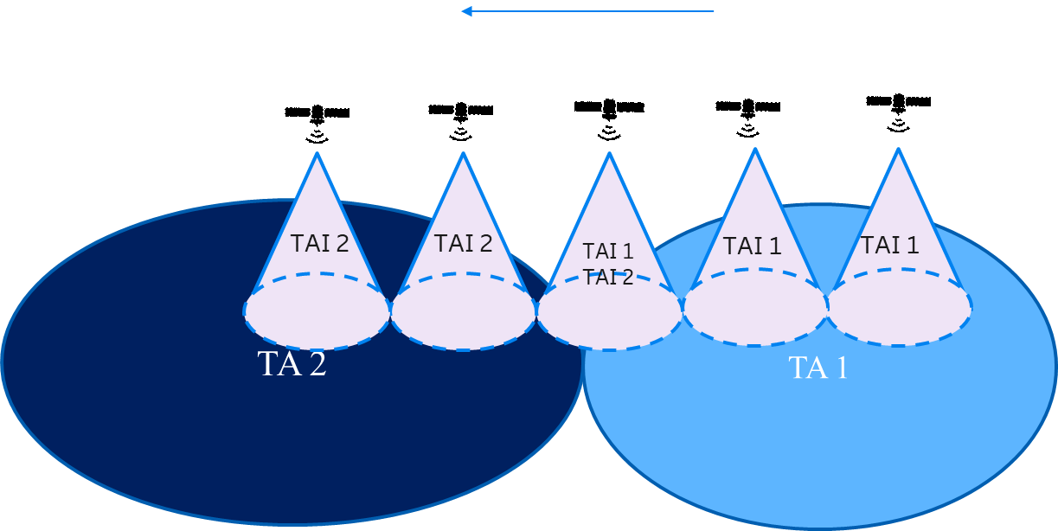

Figure 6 Tracking area update for Earth moving beams with soft TAI update

*Q5.1 Do companies have a preference on supporting either hard or soft TAI update, or both?*

|  |  |
| --- | --- |
| Company | **Answer** |
| CATT | Both of them are feasible, we slightly prefer the “Hard” TAI update.  As the “soft” TAI update requires some changes to the specification, and need more frequently update the system information, e.g. one cell broadcast TA1 🡪 TA 1+2 🡪 TA2. Yet another problem is that the higher number of TAIs a cell broadcasts, the higher paging load it is expected, causing load imbalance between cells.  While for the hard switch, only need to update the TAI of the cell from TA1 🡪 TA2, and no specification change is needed. For the any UE near the TA boarder, a list of the TAs which are expected to cover the UE could be configured as the Registration Area in order to prevent frequent occurrences of registration procedure due to camping in a cell which broadcasts a TA outside its Registration Area. |
| MediaTek | We prefer Soft TAI update, involving multiple TA codes per cell. We believe this will reduce the fluctuation and signalling load. |
| CMCC | Soft TAI update solution may be better than the hard TAI update solution in order to reduce TAU. |
| Huawei, HiSilicon | We prefer soft TAI update, which has less UE impact and system overhead. |
| Panasonic | We support both the hard and soft TAI update as they are both feasible. It should be up to network’s decision to use which option based on the overall consideration among the paging overheads, TAU overheads, and UE’s power consumption.  The frequent TAU caused by the hard TAI update option can be alleviated if gNB doesn’t trigger the SI update even when the broadcasted TAC value changes, or if the UE located at the TA boundary is registered to multiple TAs. |
| BT | Soft TAI update. Once soft TAI is defined, hard case seems to be a subcase. |
| ITRI | We support soft TAI update to reduce signalling overhead from both UE and network aspects. |
| APT | Prefer hard TAI update. To avoid heavy paging load. |
| Sony | We support both. |
| Nomor Research | Agree with BT. |

# 5 Summary of proposals

TBA