3GPP TSG-RAN WG2 Meeting #111e R2-2007517
Online, 17 – 28 August 2020

Agenda item: 4.5
Source: Nokia, Nokia Shanghai Bell
Title: Summary and discussion on [Post110e-][255][LTE CA] Clarification on non-contiguous CA capabilities (Nokia)
WID/SID: LTE_CA-Core - Release 12
Document for: Discussion and Decision

1 Introduction
TS36.331 specifically states that the UE capabilities for intra-band contiguous CA are agnostic to the order in which they are given within the intraBandContiguousCC-InfoList. However, for intra-band non-contiguous CA, this is less clear as the band combination capabilities are indicated differently (i.e. within different band entries for intra-band non-contiguous compared to within one band entry as for intra-band contiguous).
RAN2 discuss, since RAN2#109-e, how to interpet the UE capabilities will indicating support for a BC involving intra-band non-contiguous CA. This document collects observations and clarifications made so far. Further it aims to collect and conclude companies views on LTE non-contiguous CA capabilities, and the need to clarify their interpretation in TS36.331, based on the two set of CRs:
Tdoc(s), Title, Company
1) R2-2005186, R2-2005187, R2-2005188, R2-2005189, R2-2005190, “Clarification to UE capabilities for non-contiguous intra-band CA“ Nokia, Nokia Shanghai Bell, Qualcomm Incorporation

2) R2-2005481, R2-2005482, R2-2005483, R2-2005484, R2-2005485, R2-2005486, R2-2005487 “Clarification on UE capability for intra-band non-continuous CA”, Huawei, Hisilicon

2 Background
The issue has been originally identified in the input document to RAN2#109e in R2-2001134. To provide background information, we shortly refer to main discussion points in the Annex of this document.
As per the last observations on the topic, report of offline discussion [203] in RAN2#109bis-e concluded the CRs to clarify intra-band non-contiguous is handled as intra-band contiguous are agnostic to the order in which they are indicated in the band entries, for the CA of the same bandwidth class (R2-2003841).
The discussions, so far, led to the suggestion to include clarification on the intra-band contiguous CA capabilities in TS36.331 as follows:
NOTE 6a: UE capabilities for intra-band non-contiguous CA of the same bandwidth class are agnostic to the order in which they are indicated in the band entries. For example, UE supporting CA_xA_xA (i.e. intra-band non-contiguous 2DL CA on bandwidth class A) and indicating support for (4, 2) MIMO layers (i.e. 4-layer MIMO for the first band entry and 2-layer MIMO for the second band entry) also supports (2, 4) MIMO layers (i.e. 2-layer MIMO for the first band entry and 4-layer MIMO for the second band entry) for the same band combination without explicit indication.

3 Remaining interpretation issues
While, if the channel BW of the two blocks are the same (like for BCS 0 of 3A_3A in the table above), there could be no difference between the two blocks, and which block associates with 4 MIMO layer or 2 MIMO layer. UE could still “swap” the order of the capabilities like with intra-band contiguous CA. I.e. UE supporting CA 3A_3A (i.e. intra-band non-contiguous 2DL CA on bandwidth class A) and indicating support for (4, 2) MIMO layers (i.e. 4-layer MIMO for the first band entry and 2-layer MIMO for the second band entry) also supports (2, 4) MIMO layers (i.e. 2-layer MIMO for the first band entry and 4-layer MIMO for the second band entry).
However, the interpretation issue still exists at least in some cases for the intra-band non-contiguous BCs.

3.1 Remaining interpretation issue on different channel bandwidths of carriers
The interpretation of UE capabilities is still unclear when the related channel bandwidth is different for the two blocks.
Example 1: UE supports CA_3A_3A of BCS 1 (see Table 5.6A.1-3 below)
Network would interpret the first band entry as the one associated with the block of the first column in table 5.6A.1-3 of 36.101, while the second band entry as the one related to the second column.The lower frequency carrier (first 3A sub-block) can only be configured to up to 10 MHz bandwidth. The higher frequency carrier ( second 3A sub-block) can be configured to 20MHz bandwidth.
Then if UE indicates support for (2, 4) MIMO layers in a non-contiguous CA band combination for intra-band non-contiguous CA of the same bandwidth class, it would still support 4-layer MIMO in its Pcell
Even though, TS36.306 specifies: A MIMO capability applies to all carriers of a bandwidth class of a band in a band combination, the Example 1 makes it unclear whether UE indicating support for a BC involving intra-band non-contiguous CA with certain capabilities also supports any ordering of the capabilities between the non-contiguous entries. If the MIMO capabilities are not agnostic to the order in which they are indicated for intra-band non-contiguous band combinations, network may under-utilize the UE capabilities or require additional reconfigurations to utilize them fully.
Q1: Is it necessary to signal explicitly MIMO layers support for all carriers of a bandwidth class of a band in a band combination in case which BCS defines band entries of the same bandwidths?
Company | View
OPPO | No but with comment.  We understand the intention of this question is to compare between explicit-reporting-MIMO-layer and implicit-allowing-swapping – based on this understanding, since we agree with allowing swapping for same BW class case, there is no need to mandate UE to explicitly reporting the MIMO layer.  However, as replied in Q6, we wonder if the logic is applied to all capability dimension, i.e., not only for BW-class/UL-capability but also all other capability, i.e., only if all the other capability are the same, the MIMO layer capability can be swapped between entries.
HW | No, even though explicitly signalling the capability is the most straightforward method and can avoid any ambiguity, we still prefer to allow swapping under some cases to save signalling overhead.
Qualcomm | It is unclear why the question is relevant in case of intra-band non-contiguous. The CCs referred by “all carriers of a bandwidth class of a band” in a band combination would always mean intra-band contiguous CCs. Perhaps the question can be clarified by calling “band entry”.  The MIMO capability is per bandwidth class in r10, but in R12 it is per CC.  Take example of 3B_3B (so that there are more than one CC per band entry): it is already clear that, the per CC capabilities should be “swappable” across the CCs within one 3B entry.  On the other hand, it is not necessarily swappable from one CC in 3B entry#1 to a CC in 3B entry #2.  Regardless of the above, even for same BW / same BW class, (4layer256Q, 2layer1KQAM) cannot be interpreted as also supporting (2layer256Q, 4layer1KQAM).  For example, consider the same UE from example 1 which supports CA_3A-3A.  Say the UE reports the following capabilities (Original):  Band#1: {  Band/BC: 3A;  UL 256QAM: YES  DL 1024QAM: YES  DL layers: 4  }  Band #2: {  Band/BC: 3A;  UL 256QAM: NO;  DL 1024QAM: NO;  DL layers: 2  }  There are following possible (mis)interpretations of the “swap”.  SWAP#1:  Band#1 (3A): {  UL 256QAM: NO  DL 1024QAM: NO  DL layers: 2  }  Band #2 (3A):{  UL 256QAM: YES;  DL 1024QAM: YES;  DL layers: 4  }  SWAP#2:  Band#1 (3A): {  UL 256QAM: YES  DL 1024QAM: NO  DL layers: 2  }  Band#2 (3A): {  UL 256QAM: NO;  DL 1024QAM: YES;  DL layers: 4  }  SWAP#3:  Band#1 (3A): {  UL 256QAM: YES  DL 1024QAM: YES  DL layers: 2  }  Band#2 (3A): {  UL 256QAM: NO;  DL 1024QAM: NO;  DL layers: 4  }  From the above interpretations, following is the summary of our view:  - Original signalled capability should mean also support of SWAP#1. This is not clear today and needs clarification (for the intra-band non-contiguous case.)  - Original signalled capability does NOT mean support of SWAP#2. It seems to us that Huawei’s earlier comments meant this should be possible. But we think that is not the case.  - Original signalled capability does NOT mean support of SWAP#3. It seems the current CR text may be misinterpreted to mean this, but that should not be the intention and text should be clarified.  For simplicity, this is illustrated in the following set of figures:  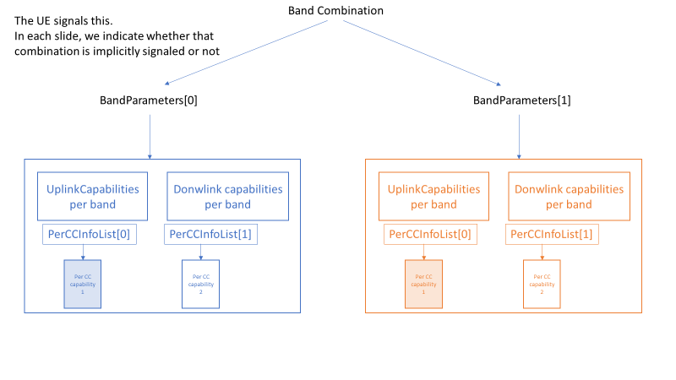  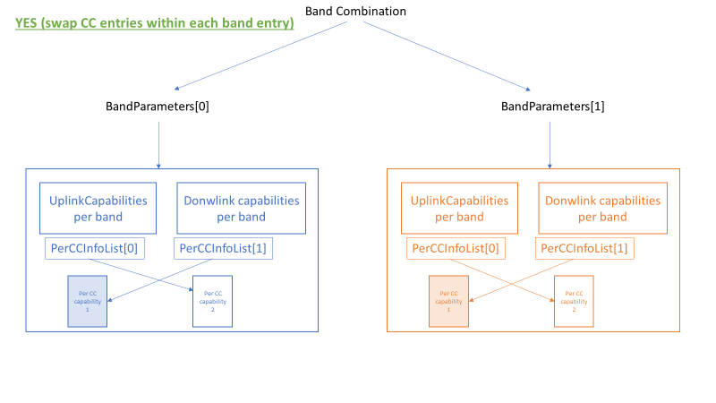 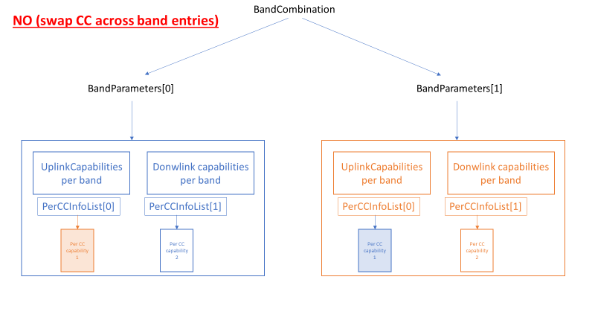  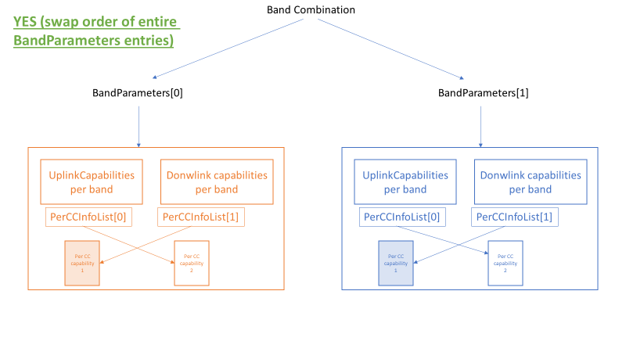 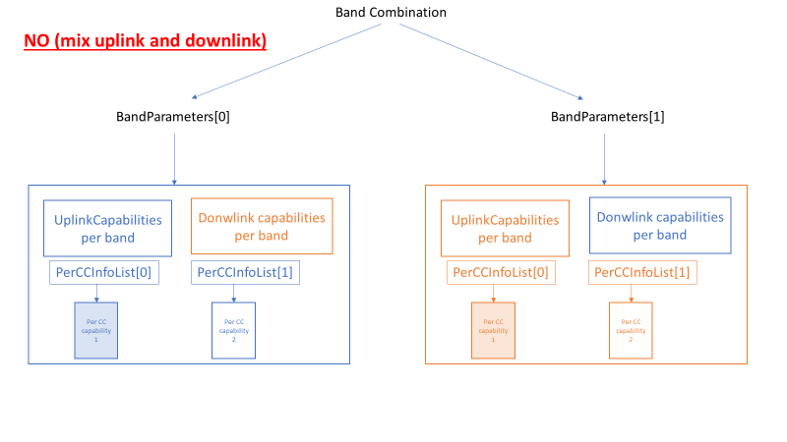  Therefore, after further thought, our view is the NOTE should be updated, e.g. as follows and no need to add example in the NOTE because this should be clear enough.  NOTE 6a: For multiple band entries BandParameters with the same bandEUTRA and same ca-BandwidthClassDL in a supported band combination, the UE capabilities indicated by BandParameters are agnostic to the order in which they are indicated in the bandParameterList.
Nokia | No.  We believe MIMO layers support can be swapped in some cases for carriers of a bandwidth class in case BCS defines band entries of the same bandwidth.  That would allow saving signalling overhead.

Q2: For the UE supporting intra-band non-contiguous CA, for which BCS allows band entries with different bandwidths, can the MIMO supported layers be swapped?
Company | View
OPPO | No.  In general, as commented after 109e and at 110e, we tend to believe the MIMO capability is coupled with other dimensions capability, including BW class. So if the capability at other dimensions are the same, swapping of MIMO capability is feasible. Otherwise, one cannot always assume the swapping is feasible, e.g., a (4,2) MIMO layer in combination of (A,C) BW-class, does not mean the UE support a combination of (2,4)+(A,C).
HW | No. Same view as OPPO.
Qualcomm | See Q1. As explained in Q1, even for same BW / same BW class, (4layer256Q, 2layer1KQAM) cannot be interpreted as also supporting (2layer256Q, 4layer1KQAM).
Nokia | No.  Swapping MIMO layers support for band entries with different bandwidths risk the UE capabilities are overestimated.

Q3: Is it necessary to signal explicitly MIMO layers support for all carriers of a bandwidth class of a band in a band combination in case which BCS defines entries with different bandwidths?
Company | View
OPPO | Yes.  Due to the same reason as replied to Q1, since we do not think swapping is feasible for different-BW-class case, explicit reporting is needed.
HW | Yes.
Qualcomm | It is already specified that swapping between the CCs within a band entry is possible.  What is missing is swapping across different band entries.  As long as whole set of capabilities for each band entry is taken for “swap”, no need to signal explicitly.  E.g. 4layers256Q, 2layer1KQAM = 2layer1KQAM, 4layers256Q.  Note that, this is not so far specified for intra-band non-contiguous sub-blocks (bands) corresponding to different band entries. What is shown in annex is for intra-band contiguous CCs. So, adding the proposed NOTE is helpful.
Nokia | Yes,  Swapping MIMO layers support for band entries with different bandwidths risk the UE capabilities are overestimated, while signalling the capabilities explicitly resolve the ambiguities.

Based on the companies feedback the following conclusion can be made:
Conclusion 1:
For the UE supporting intra-band non-contiguous CA, original signalled MIMO capability is coupled with other capability dimensions, including bandwidth/bandwidth class. For the UE supporting intra-band non-contiguous CA, if the capability at other dimensions are the same, swapping of MIMO capability across different band entries should be feasible. Swapping across band entries is feasible as long as concerns swapping of the whole set of capabilities for each band entry.
For the UE supporting intra-band non-contiguous CA, for which BCS allows band entries with different bandwidths, the MIMO supported layers cannot be swapped, i.e. the UE signals explicitly MIMO layers support per band entry.

3.2 Remaining interpretation issue on MIMO capability for uplink CA bandwidth class
The potential swapping of UE capabilities for intra-band non-contiguous CA of the same bandwidth class is still unclear when analyzed in relation to MIMO capabilities supported in uplink. The UE has to provide the supported uplink CA bandwidth class and the corresponding MIMO capability for at least one band in the band combination.
Example 2: UE supports CA_xA_xA where xA(DL&UL; 10MHz; 4-Layers)_xA(DL only; 10MHz; 2-Layers)
Network interprets DL1 supports 4 layers while DL2 supports 2 layers. In case swapping the capabilities is allowed, as per the conclusion that intra-band contiguous CA capabilities can be handles as agnostic to the order in which they are indicated in the band entries, for the CA of the same bandwidth class, it makes in unclear whether UE also supports any ordering of the capabilities in relation to uplink.
Q4: For the UE supporting intra-band non-contiguous CA, for which band entries in downlink are associated with different uplink carriers, can the number of MIMO supported layers be swapped?
Company | View
OPPO | No but with comment.  Similar as respond to Q2, we believe the MIMO capability swapping is only valid in case the capability of the other dimensions are the same, i.e., no essential difference between BW-class and UL-capability.  However, as replied in Q6, we wonder if the logic is applied to all capability dimension, i.e., not only for BW-class/UL-capability but also all other capability, i.e., only if all the other capability are the same, the MIMO layer capability can be swapped between entries.
HW | No. As we commented before, it is not feasible to swap the capability if one CC is a DL-only CC while the other CC is UL&DL CC, otherwise, it may exceed what the UE actually support and may lead to a drop of the link in the worst case
Qualcomm | If the whole set of capabilities for each band entry is swaped together (not only the MIMO layers, but also other capabilities including the uplink). I.e., the order in which the bands appear in the band combination does not matter.
Nokia | For instance, assuming number of MIMO supported layers swap between the band entry with UL carrier (UL & DL) and band entry without UL carrier (DL only) refer to different UL capabilities, we thing swapping MIMO layers support for DL band entries with different UL carriers risk the UE capabilities are interpreted in a wrong way, but we appreciate UE vendors views.

Q5: For the UE supporting intra-band non-contiguous CA, for which band entries in downlink are associated with the same uplink carriers, can the number of MIMO supported layers be swapped?
Company | View
OPPO | Yes.  As replied to Q2/4, if the capability of other dimensions are the same, it is feasible to swap the MIMO layer capability between band entries.
HW | Yes. This is based on the assumption the BW class of the band entries are the same.
Qualcomm | If the whole set of capabilities for each band entry is swaped together (not only the MIMO layers, but also other capabilities including the uplink). I.e., the order in which the bands appear in the band combination does not matter.
Nokia | Yes. It seems logical to have the possibility to swap

3.3 Interpreting UE capabilities intra-band non-contiguous BCs
To make the question more practical, are there any conditions, where the indicated MIMO UE capabilities for intra-band non-contiguous CA can be agnostic to the order in which they are indicated in the band entries. In case, the UE should always indicate its MIMO layer explicitly, this would require clarification in TS36.331 and/or TS36.306 to ensure specifications are clear about the UE capability indications intra-band non-contiguous CA band combinations.
Q6: Should the NOTE in TS36.331 reflect the UE always indicate its MIMO layer explicitly for intra-band non-contiguous CA?
Company | View
OPPO | As replied to Q1/Q4: We wonder if the logic is applied to all capability dimension, i.e., not only for BW-class/UL-capability but also all other capability, i.e., only if all the other capability are the same for different entries, the MIMO layer capability can be swapped. Otherwise, one may suspect whether there would be some coupling in-between, which makes the swapping of MIMO layer not always feasible.  So we are fine to clarify the possibility of MIMO layer swapping, but maybe good to clarify the premise is other capability are the same, e.g., including BW class and UL capability.
HW | We are not sure how to reflect this in the specification as we are not sure if there is any capability dimension besides BW class and UL capability also impacting the swapping. In addition, if some clarification is needed in the specification, not only the MIMO layer but also other per-band capability, e.g., supportedCSI-Proc should be considered as well.  It seems companies are having the same understanding on the capability reporting and until now there seems no feedback from the NW/UE product on this issue. So another alternative is to keep the specification as it is.
Qualcomm | See Answer in Q1.
Nokia | To avoid further misconceptions, we would support to have an update in 36.331 or/and 36.306 according to exact conditions that were discussed here (i.e. not too generic).

Based on the companies’ feedback, following conclusion is proposed:
Conclusion 2: Current TS36.306 and TS36.331 are not clyster clear on how to interpet the UE capabilities indicating support for a BC involving intra-band non-contiguous CA. There is a converging understanding based on RAN2 discussions according to Conclusion 1.
Proposal 1: Work out a NOTE proposal to TS36.331 based on the proposal given in this email discussion:
NOTE 6a: For multiple band entries BandParameters with the same bandEUTRA and same ca-BandwidthClassDL in a supported band combination, the UE capabilities indicated by BandParameters are agnostic to the order in which they are indicated in the bandParameterList.

3 Conclusion
Conclusion 1: For the UE supporting intra-band non-contiguous CA, original signalled MIMO capability is coupled with other capability dimensions, including bandwidth/bandwidth class. For the UE supporting intra-band non-contiguous CA, if the capability at other dimensions are the same, swapping of MIMO capability across different band entries should be feasible. Swapping across band entries is feasible as long as concerns swapping of the whole set of capabilities for each band entry.
For the UE supporting intra-band non-contiguous CA, for which BCS allows band entries with different bandwidths, the MIMO supported layers cannot be swapped, i.e. the UE signals explicitly MIMO layers support per band entry.

Conclusion 2: Current TS36.306 and TS36.331 are not clyster clear on how to interpet the UE capabilities indicating support for a BC involving intra-band non-contiguous CA. There is a converging understanding based on RAN2 discussions according to Conclusion 1.
Proposal 1: Work out a NOTE proposal to TS36.331 based on the proposal given in this email discussion:
NOTE 6a: For multiple band entries BandParameters with the same bandEUTRA and same ca-BandwidthClassDL in a supported band combination, the UE capabilities indicated by BandParameters are agnostic to the order in which they are indicated in the bandParameterList.

Annex
The issue has been originally identified in the input document to RAN2#109e in R2-2001134. To provide background information, we shortly refer to main discussion points there.

i MIMO layer capabilities for intra-band CA
Since UE may have certain different capabilities depending on the number of intra-band carriers, Rel-12 LTE introduced the possibility for UE the support for MIMO and CSI process capabilities for each intra-band contiguous band entry as defined in TS36.331

CA-MIMO-ParametersDL-v1270 ::= SEQUENCE {
intraBandContiguousCC-InfoList-r12 SEQUENCE (SIZE (1..maxServCell-r10)) OF IntraBandContiguousCC-Info-r12
}

IntraBandContiguousCC-Info-r12 ::= SEQUENCE {
fourLayerTM3-TM4-perCC-r12 ENUMERATED {supported} OPTIONAL,
supportedMIMO-CapabilityDL-r12 MIMO-CapabilityDL-r10 OPTIONAL,
supportedCSI-Proc-r12 ENUMERATED {n1, n3, n4} OPTIONAL
}

intraBandContiguousCC-InfoList  Indicates, per serving carrier of which the corresponding bandwidth class includes multiple serving carriers (i.e. bandwidth class B, C, D and so on), the maximum number of supported layers for spatial multiplexing in DL and the maximum number of CSI processes supported. The number of entries is equal to the number of component carriers in the corresponding bandwidth class. The UE shall support the setting indicated in each entry of the list regardless of the order of entries in the list.The UE shall include the field only if it supports 4-layer spatial multiplexing in transmission mode3/4 for a subset of component carriers in the corresponding bandwidth class, or if the maximum number of supported layers for at least one component carrier is higher than supportedMIMO-CapabilityDL-r10 in the corresponding bandwidth class, or if the number of CSI processes for at least one component carrier is higher than supportedCSI-Proc-r11 in the corresponding band.  This field may also be included for bandwidth class A but in such a case without including any sub-fields in IntraBandContiguousCC-Info-r12 (see NOTE 6). | -

Notable, the list of capabilities is agnostic to the order of the carriers, i.e. in case UE supports e.g. CA_3C with (2 ,4) MIMO layers (i.e. first carrier with 2 MIMO layers and second with 4 MIMO layers), UE also always supports CA_3C with (4, 2) MIMO layers (i.e. first carrier with 4 MIMO layers and second with 2 MIMO layers).
The same is not true for inter-band carrier aggregation, since each band entry is defined separately.
Further, we note that in TS36.306, there are some statements about the supported MIMO layers for a given band combination, as shown by below excerpt from sub-clause 4.3.5.2:
4.3.5.2 supportedBandCombination
This field defines the carrier aggregation, MIMO and MBMS reception capabilities (via MBSFN or SC-PTM) supported by the UE for configurations with inter-band, intra-band non-contiguous, intra-band contiguous carrier aggregation and without carrier aggregation. For each band in a band combination the UE provides the supported CA bandwidth classes and the corresponding MIMO capabilities for downlink. The UE also has to provide the supported uplink CA bandwidth class and the corresponding MIMO capability for at least one band in the band combination. Applicability of provisioning uplink CA bandwidth class for each band in the band combinations is defined in TS 36.101 [6]. A MIMO capability applies to all carriers of a bandwidth class of a band in a band combination. For bandwidth classes that include multiple component carriers (i.e. bandwidth classes B, C, D and so on), the UE may also indicate a separate MIMO capability that applies to each individual carrier of a bandwidth class of a band in a band combination.
From this, we would note that the highlighted sentence:” A MIMO capability applies to all carriers of a bandwidth class of a band in a band combination” implies that a MIMO Layer capability provided for a band with especially B,C,D bandwidth class applies to any carrier (e.g. from the lowest to the highest carrier frequency value) of that band in the respective bandwidth class. Based on this, one can understood that the order of the MIMO layers in a contiguous or non-contiguous band combination doesn’t matter, i.e. UE indicate (2, 4) MIMO layers would still always support also (4, 2) MIMO layers.

ii BCS capabilities for intra-band non-contiguous CA
However, in TS36.101 the ordering has some implications for the support of BCS, as shown in below excerpt from Table 5.6A.1-3 (with yellow highlighting added for emphasis)
Table 5.6A.1-3: E-UTRA CA configurations and bandwidth combination sets defined for non-contiguous intra-band CA (with two sub-blocks)
 |  | E-UTRA CA configuration / Bandwidth combination set
E-UTRACA configuration | Uplink CA configurations (NOTE 1) | Component carriers in order of increasing carrier frequency |  |  |  |  | Maximum aggregated  bandwidth [MHz] | Bandwidth combination set
 |  | Channel bandwidths for carrier [MHz] | Channel bandwidths for carrier [MHz] | Channel bandwidths for carrier [MHz] | Channel bandwidths for carrier [MHz] | Channel bandwidths for carrier [MHz]
CA_1A-1A | - | 5, 10, 15, 20 | 5, 10, 15, 20 |  |  |  | 40 | 0
CA_2A-2A | - | 5, 10, 15, 20 | 5, 10, 15, 20 |  |  |  | 40 | 0
CA_3A-3A | - | 5, 10, 15, 20 | 5, 10, 15, 20 |  |  |  | 40 | 0
 |  | 5, 10 | 5, 10, 15, 20 |  |  |  | 30 | 1
 |  | 5 | 3 |  |  |  | 10 | 2
 |  | 3, 5 | 5

The ordering of intra-band non-contiguous entries is relevant for the support of BCS.
Following these points, as per the report of offline discussion [203] in RAN2#109e, RAN2 note the following observations on differences of UE capabilities for intra-band contiguous and non-contiguous CA R2-2001736:
- Intra-band contiguous CA capabilities are all contained within a single band entry of a band combination, while intra-band non-contiguous CA capabilities require at least two band entries.
- For intra-band contiguous carriers, UE band combination capabilities specify that UE supports any ordering of the capabilities.
- (Based on TS36.101): The ordering of intra-band non-contiguous entries is relevant for the support of BCS.
- (Based on TS36.101): The ordering of BCS is not directly related to the MIMO capabilities.
FFS: if UE supports (2, 4) MIMO layers with CA_xA_xA, it will also support (4, 2) MIMO layers with CA_xA_xA.

