3GPP TSG-RAN WG2 Meeting #110-e R2-200xxxx
Electronic, 01 June - 12 June 2020
CR-Form-v11.2
CHANGE REQUEST
 | 38.331 | CR | 1705 | rev | - | Current version: | 16.0.0
For HELP on using this form: comprehensive instructions can be found at
http://www.3gpp.org/Change-Requests.

Proposed change affects: | UICC apps |  | ME | x | Radio Access Network | x | Core Network

Title: | Introduction on frequency separation class for DL-only FR2 spectrum
Source to WG: | Apple
Source to TSG: | R2
Work item code: | TEI16 |  |  |  |  |  |  | Date: |  | 2020-06-09
Category: | F |  |  |  |  |  |  | Release: |  | Rel-16
 | Use one of the following categories:  F (correction)  A (mirror corresponding to a change in an earlier release)  B (addition of feature),  C (functional modification of feature)  D (editorial modification)  Detailed explanations of the above categories can  be found in 3GPP TR 21.900. |  |  |  |  |  |  |  | Use one of the following releases:  Rel-8 (Release 8)  Rel-9 (Release 9)  Rel-10 (Release 10)  Rel-11 (Release 11)  Rel-12 (Release 12)  Rel-13 (Release 13)  Rel-14 (Release 14)  Rel-15 (Release 15)  Rel-16 (Release 16)
Reason for change: |  | According to the LSin R2-2006174 (R4-2009294) from RAN4, two agreements have been made in RAN WG4.  1) The legacy frequency separation class has been enhanced to up to 2400MHz, as shown below. The new frequency separation classes comprise of IV, V, VI, VII, VIII, IX.  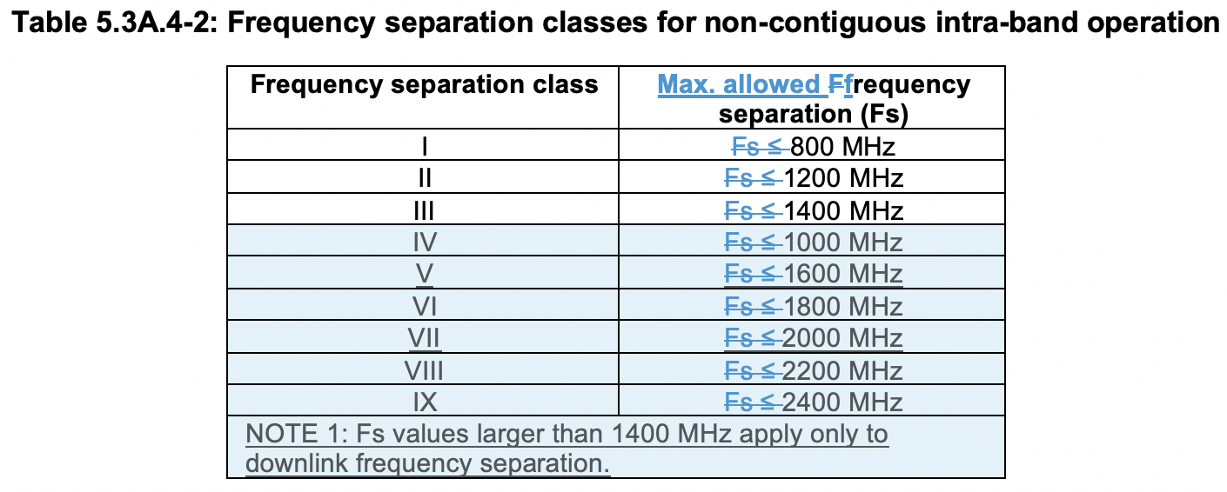  2) RAN4 has agreed on the introduction of frequency separation class for DL only spectrum for FR2. In details:  - DL-only spectrum is available for configuration of only DL CCs and not UL CCs.  - It is optional for the UE to implement DL-only spectrum  - UEs that implement DL-only spectrum must signal (Fsd)  - The spectrum covered by the DL-only frequency separation extends on one-side of the bidirectional spectrum in a contiguous manner with no frequency gap between the two.  - The bidirectional spectrum is defined as the UL/DL common spectrum in which the UE supports the configuration of uplink or downlink CCs and is signalled by UL and DL frequency separation.  - The combined downlink spectrum (DL Fs + Fsd) cannot exceed 2400 MHz.  - A UE may configure DL-only spectrum only if the combined downlink spectrum (DL Fs + Fsd) exceeds 1400 MHz  - The Fsd signalling shall be implemented in addition to the signalling of frequency separation (UL Fs and DL Fs).  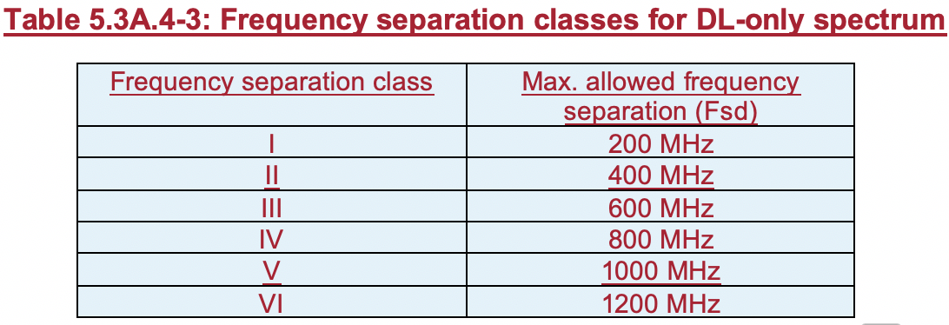  RAN2 spec should capture the two updates from RAN4 to reflect the agreements.
Summary of change: |  | 1) Introduce new fields to extend the Rel-15 frequency separation class to include the new classes: IV, V, VI, VII, VIII, IX.  2) Introduce a new Rel-16 field: intraBandFreqSeparation-DLOnlySpectrum-r16
Consequences if not approved: |  | The RAN4 agreements on frequency separation class are not reflected in RAN2 spec.
Clauses affected: |  | 6.3.3
 |  | Y | N
Other specs |  | X |  | Other core specifications |  |  | TS 38.306 CR 0358
affected: |  |  | X | Test specifications |  |  | TS/TR ... CR ...
(show related CRs) |  |  | X | O&M Specifications |  |  | TS/TR ... CR ...
Other comments:

<Start of modification 1>

6.3.3 UE capability information elements
<Unchanged part is omitted>

– FeatureSetDownlink
The IE FeatureSetDownlink indicates a set of features that the UE supports on the carriers corresponding to one band entry in a band combination.
FeatureSetDownlink information element
-- ASN1START
-- TAG-FEATURESETDOWNLINK-START

FeatureSetDownlink ::= SEQUENCE {
featureSetListPerDownlinkCC SEQUENCE (SIZE (1..maxNrofServingCells)) OF FeatureSetDownlinkPerCC-Id,

intraBandFreqSeparationDL FreqSeparationClass OPTIONAL,
scalingFactor ENUMERATED {f0p4, f0p75, f0p8} OPTIONAL,
crossCarrierScheduling-OtherSCS ENUMERATED {supported} OPTIONAL,
scellWithoutSSB ENUMERATED {supported} OPTIONAL,
csi-RS-MeasSCellWithoutSSB ENUMERATED {supported} OPTIONAL,
dummy1 ENUMERATED {supported} OPTIONAL,
type1-3-CSS ENUMERATED {supported} OPTIONAL,
pdcch-MonitoringAnyOccasions ENUMERATED {withoutDCI-Gap, withDCI-Gap} OPTIONAL,
dummy2 ENUMERATED {supported} OPTIONAL,
ue-SpecificUL-DL-Assignment ENUMERATED {supported} OPTIONAL,
searchSpaceSharingCA-DL ENUMERATED {supported} OPTIONAL,
timeDurationForQCL SEQUENCE {
scs-60kHz ENUMERATED {s7, s14, s28} OPTIONAL,
scs-120kHz ENUMERATED {s14, s28} OPTIONAL
} OPTIONAL,
pdsch-ProcessingType1-DifferentTB-PerSlot SEQUENCE {
scs-15kHz ENUMERATED {upto2, upto4, upto7} OPTIONAL,
scs-30kHz ENUMERATED {upto2, upto4, upto7} OPTIONAL,
scs-60kHz ENUMERATED {upto2, upto4, upto7} OPTIONAL,
scs-120kHz ENUMERATED {upto2, upto4, upto7} OPTIONAL
} OPTIONAL,
dummy3 DummyA OPTIONAL,
dummy4 SEQUENCE (SIZE (1.. maxNrofCodebooks)) OF DummyB OPTIONAL,
dummy5 SEQUENCE (SIZE (1.. maxNrofCodebooks)) OF DummyC OPTIONAL,
dummy6 SEQUENCE (SIZE (1.. maxNrofCodebooks)) OF DummyD OPTIONAL,
dummy7 SEQUENCE (SIZE (1.. maxNrofCodebooks)) OF DummyE OPTIONAL
}

FeatureSetDownlink-v1540 ::= SEQUENCE {
oneFL-DMRS-TwoAdditionalDMRS-DL ENUMERATED {supported} OPTIONAL,
additionalDMRS-DL-Alt ENUMERATED {supported} OPTIONAL,
twoFL-DMRS-TwoAdditionalDMRS-DL ENUMERATED {supported} OPTIONAL,
oneFL-DMRS-ThreeAdditionalDMRS-DL ENUMERATED {supported} OPTIONAL,
pdcch-MonitoringAnyOccasionsWithSpanGap SEQUENCE {
scs-15kHz ENUMERATED {set1, set2, set3} OPTIONAL,
scs-30kHz ENUMERATED {set1, set2, set3} OPTIONAL,
scs-60kHz ENUMERATED {set1, set2, set3} OPTIONAL,
scs-120kHz ENUMERATED {set1, set2, set3} OPTIONAL
} OPTIONAL,
pdsch-SeparationWithGap ENUMERATED {supported} OPTIONAL,
pdsch-ProcessingType2 SEQUENCE {
scs-15kHz ProcessingParameters OPTIONAL,
scs-30kHz ProcessingParameters OPTIONAL,
scs-60kHz ProcessingParameters OPTIONAL
} OPTIONAL,
pdsch-ProcessingType2-Limited SEQUENCE {
differentTB-PerSlot-SCS-30kHz ENUMERATED {upto1, upto2, upto4, upto7}
} OPTIONAL,
dl-MCS-TableAlt-DynamicIndication ENUMERATED {supported} OPTIONAL
}

DummyA ::= SEQUENCE {
maxNumberNZP-CSI-RS-PerCC INTEGER (1..32),
maxNumberPortsAcrossNZP-CSI-RS-PerCC ENUMERATED {p2, p4, p8, p12, p16, p24, p32, p40, p48, p56, p64, p72, p80,
p88, p96, p104, p112, p120, p128, p136, p144, p152, p160, p168,
p176, p184, p192, p200, p208, p216, p224, p232, p240, p248, p256},
maxNumberCS-IM-PerCC ENUMERATED {n1, n2, n4, n8, n16, n32},
maxNumberSimultaneousCSI-RS-ActBWP-AllCC ENUMERATED {n5, n6, n7, n8, n9, n10, n12, n14, n16, n18, n20, n22, n24, n26,
n28, n30, n32, n34, n36, n38, n40, n42, n44, n46, n48, n50, n52,
n54, n56, n58, n60, n62, n64},
totalNumberPortsSimultaneousCSI-RS-ActBWP-AllCC ENUMERATED {p8, p12, p16, p24, p32, p40, p48, p56, p64, p72, p80,
p88, p96, p104, p112, p120, p128, p136, p144, p152, p160, p168,
p176, p184, p192, p200, p208, p216, p224, p232, p240, p248, p256}
}

DummyB ::= SEQUENCE {
maxNumberTxPortsPerResource ENUMERATED {p2, p4, p8, p12, p16, p24, p32},
maxNumberResources INTEGER (1..64),
totalNumberTxPorts INTEGER (2..256),
supportedCodebookMode ENUMERATED {mode1, mode1AndMode2},
maxNumberCSI-RS-PerResourceSet INTEGER (1..8)
}

DummyC ::= SEQUENCE {
maxNumberTxPortsPerResource ENUMERATED {p8, p16, p32},
maxNumberResources INTEGER (1..64),
totalNumberTxPorts INTEGER (2..256),
supportedCodebookMode ENUMERATED {mode1, mode2, both},
supportedNumberPanels ENUMERATED {n2, n4},
maxNumberCSI-RS-PerResourceSet INTEGER (1..8)
}

DummyD ::= SEQUENCE {
maxNumberTxPortsPerResource ENUMERATED {p4, p8, p12, p16, p24, p32},
maxNumberResources INTEGER (1..64),
totalNumberTxPorts INTEGER (2..256),
parameterLx INTEGER (2..4),
amplitudeScalingType ENUMERATED {wideband, widebandAndSubband},
amplitudeSubsetRestriction ENUMERATED {supported} OPTIONAL,
maxNumberCSI-RS-PerResourceSet INTEGER (1..8)
}

DummyE ::= SEQUENCE {
maxNumberTxPortsPerResource ENUMERATED {p4, p8, p12, p16, p24, p32},
maxNumberResources INTEGER (1..64),
totalNumberTxPorts INTEGER (2..256),
parameterLx INTEGER (2..4),
amplitudeScalingType ENUMERATED {wideband, widebandAndSubband},
maxNumberCSI-RS-PerResourceSet INTEGER (1..8)
}

FeatureSetDownlink-v16xy ::= SEQUENCE {
intraBandFreqSeparationDL-v16xy FreqSeparationClass-v16xy OPTIONAL,
intraBandFreqSeparation-DLOnlySpectrum-r16 FreqSeparationClass-DLOnlySpectrum-r16 OPTIONAL
}

-- TAG-FEATURESETDOWNLINK-STOP
-- ASN1STOP

FeatureSetDownlink field descriptions
crossCarrierScheduling-OtherSCS
The UE shall set this field to the same value as crossCarrierScheduling-OtherSCS in the associated FeatureSetUplink (if present).
featureSetListPerDownlinkCC
Indicates which features the UE supports on the individual DL carriers of the feature set (and hence of a band entry that refer to the feature set). The UE shall hence include at least as many FeatureSetDownlinkPerCC-Id in this list as the number of carriers it supports according to the ca-BandwidthClassDL, except if indicating additional functionality by reducing the number of FeatureSetDownlinkPerCC-Id in the feature set (see NOTE 1 in FeatureSetCombination IE description). The order of the elements in this list is not relevant, i.e., the network may configure any of the carriers in accordance with any of the FeatureSetDownlinkPerCC-Id in this list.

<Unchanged part is omitted>

– FeatureSets
The IE FeatureSets is used to provide pools of downlink and uplink features sets. A FeatureSetCombination refers to the IDs of the feature set(s) that the UE supports in that FeatureSetCombination. The BandCombination entries in the BandCombinationList then indicate the ID of the FeatureSetCombination that the UE supports for that band combination.
The entries in the lists in this IE are identified by their index position. For example, the FeatureSetUplinkPerCC-Id = 4 identifies the 4th element in the featureSetsUplinkPerCC list.
NOTE: When feature sets (per CC) IEs require extension in future versions of the specification, new versions of the FeatureSetDownlink, FeatureSetUplink, FeatureSets, FeatureSetDownlinkPerCC and/or FeatureSetUplinkPerCC will be created and instantiated in corresponding new lists in the FeatureSets IE. For example, if new capability bits are to be added to the FeatureSetDownlink, they will instead be defined in a new FeatureSetDownlink-rxy which will be instantiated in a new featureSetDownlinkList-rxy list. If a UE indicates in a FeatureSetCombination that it supports the FeatureSetDownlink with ID #5, it implies that it supports both the features in FeatureSetDownlink #5 and FeatureSetDownlink-rxy #5 (if present). The number of entries in the new list(s) shall be the same as in the original list(s).
FeatureSets information element
-- ASN1START
-- TAG-FEATURESETS-START

FeatureSets ::= SEQUENCE {
featureSetsDownlink SEQUENCE (SIZE (1..maxDownlinkFeatureSets)) OF FeatureSetDownlink OPTIONAL,
featureSetsDownlinkPerCC SEQUENCE (SIZE (1..maxPerCC-FeatureSets)) OF FeatureSetDownlinkPerCC OPTIONAL,
featureSetsUplink SEQUENCE (SIZE (1..maxUplinkFeatureSets)) OF FeatureSetUplink OPTIONAL,
featureSetsUplinkPerCC SEQUENCE (SIZE (1..maxPerCC-FeatureSets)) OF FeatureSetUplinkPerCC OPTIONAL,
...,
[[
featureSetsDownlink-v1540 SEQUENCE (SIZE (1..maxDownlinkFeatureSets)) OF FeatureSetDownlink-v1540 OPTIONAL,
featureSetsUplink-v1540 SEQUENCE (SIZE (1..maxUplinkFeatureSets)) OF FeatureSetUplink-v1540 OPTIONAL,
featureSetsUplinkPerCC-v1540 SEQUENCE (SIZE (1..maxPerCC-FeatureSets)) OF FeatureSetUplinkPerCC-v1540 OPTIONAL
]]
[[
featureSetsDownlink-v16xy SEQUENCE (SIZE (1..maxDownlinkFeatureSets)) OF FeatureSetDownlink-v16xy OPTIONAL,
featureSetsUplink-v16xy SEQUENCE (SIZE (1..maxUplinkFeatureSets)) OF FeatureSetUplink-v16xy OPTIONAL
]]
}

-- TAG-FEATURESETS-STOP
-- ASN1STOP

<Unchanged part is omitted>

– FeatureSetUplink
The IE FeatureSetUplink is used to indicate the features that the UE supports on the carriers corresponding to one band entry in a band combination.
FeatureSetUplink information element
-- ASN1START
-- TAG-FEATURESETUPLINK-START

FeatureSetUplink ::= SEQUENCE {
featureSetListPerUplinkCC SEQUENCE (SIZE (1.. maxNrofServingCells)) OF FeatureSetUplinkPerCC-Id,
scalingFactor ENUMERATED {f0p4, f0p75, f0p8} OPTIONAL,
crossCarrierScheduling-OtherSCS ENUMERATED {supported} OPTIONAL,
intraBandFreqSeparationUL FreqSeparationClass OPTIONAL,
searchSpaceSharingCA-UL ENUMERATED {supported} OPTIONAL,
dummy1 DummyI OPTIONAL,
supportedSRS-Resources SRS-Resources OPTIONAL,
twoPUCCH-Group ENUMERATED {supported} OPTIONAL,
dynamicSwitchSUL ENUMERATED {supported} OPTIONAL,
simultaneousTxSUL-NonSUL ENUMERATED {supported} OPTIONAL,
pusch-ProcessingType1-DifferentTB-PerSlot SEQUENCE {
scs-15kHz ENUMERATED {upto2, upto4, upto7} OPTIONAL,
scs-30kHz ENUMERATED {upto2, upto4, upto7} OPTIONAL,
scs-60kHz ENUMERATED {upto2, upto4, upto7} OPTIONAL,
scs-120kHz ENUMERATED {upto2, upto4, upto7} OPTIONAL
} OPTIONAL,
dummy2 DummyF OPTIONAL
}

FeatureSetUplink-v1540 ::= SEQUENCE {
zeroSlotOffsetAperiodicSRS ENUMERATED {supported} OPTIONAL,
pa-PhaseDiscontinuityImpacts ENUMERATED {supported} OPTIONAL,
pusch-SeparationWithGap ENUMERATED {supported} OPTIONAL,
pusch-ProcessingType2 SEQUENCE {
scs-15kHz ProcessingParameters OPTIONAL,
scs-30kHz ProcessingParameters OPTIONAL,
scs-60kHz ProcessingParameters OPTIONAL
} OPTIONAL,
ul-MCS-TableAlt-DynamicIndication ENUMERATED {supported} OPTIONAL
}

SRS-Resources ::= SEQUENCE {
maxNumberAperiodicSRS-PerBWP ENUMERATED {n1, n2, n4, n8, n16},
maxNumberAperiodicSRS-PerBWP-PerSlot INTEGER (1..6),
maxNumberPeriodicSRS-PerBWP ENUMERATED {n1, n2, n4, n8, n16},
maxNumberPeriodicSRS-PerBWP-PerSlot INTEGER (1..6),
maxNumberSemiPersistentSRS-PerBWP ENUMERATED {n1, n2, n4, n8, n16},
maxNumberSemiPersistentSRS-PerBWP-PerSlot INTEGER (1..6),
maxNumberSRS-Ports-PerResource ENUMERATED {n1, n2, n4}
}

DummyF ::= SEQUENCE {
maxNumberPeriodicCSI-ReportPerBWP INTEGER (1..4),
maxNumberAperiodicCSI-ReportPerBWP INTEGER (1..4),
maxNumberSemiPersistentCSI-ReportPerBWP INTEGER (0..4),
simultaneousCSI-ReportsAllCC INTEGER (5..32)
}

FeatureSetUplink-v16xy ::= SEQUENCE {
intraBandFreqSeparationUL-v16xy FreqSeparationClass-v16xy OPTIONAL
}

-- TAG-FEATURESETUPLINK-STOP
-- ASN1STOP

FeatureSetUplink field descriptions
crossCarrierScheduling-OtherSCS
The UE shall set this field to the same value as crossCarrierScheduling-OtherSCS in the associated FeatureSetDownlink (if present).
featureSetListPerUplinkCC
Indicates which features the UE supports on the individual UL carriers of the feature set (and hence of a band entry that refers to the feature set). The UE shall hence include at least as many FeatureSetUplinkPerCC-Id in this list as the number of carriers it supports according to the ca-BandwidthClassUL, except if indicating additional functionality by reducing the number of FeatureSetUplinkPerCC-Id in the feature set (see NOTE 1 in FeatureSetCombination IE description). The order of the elements in this list is not relevant, i.e., the network may configure any of the carriers in accordance with any of the FeatureSetUplinkPerCC-Id in this list.

<Unchanged part is omitted>

– FreqSeparationClass
The IE FreqSeparationClass is used for an intra-band non-contiguous CA band combination to indicate frequency separation between lower edge of lowest CC and upper edge of highest CC in a frequency band.
FreqSeparationClass information element
-- ASN1START
-- TAG-FREQSEPARATIONCLASS-START

FreqSeparationClass ::= ENUMERATED {c1, c2, c3, ...}

FreqSeparationClass-v16xy ::= ENUMERATED {c4, c5, c6, c7, c8, c9}

-- TAG-FREQSEPARATIONCLASS-STOP
-- ASN1STOP

<Unchanged part is omitted>

– FreqSeparationClass-DLOnlySpectrum
The IE FreqSeparationClass-DLOnlySpectrum is used to indicate the frequency separation between lower edge of lowest CC and upper edge of highest CC of DL only spectrum in a frequency band.
FreqSeparationClass-DLOnlySpectrum information element
-- ASN1START
-- TAG-FREQSEPARATIONCLASS-DLOnlySpectrum-START

FreqSeparationClass-DLOnlySpectrum-r16 ::= ENUMERATED {c1, c2, c3, c4, c5, c6, ...}

-- TAG-FREQSEPARATIONCLASS-DLOnlySpectrum-STOP
-- ASN1STOP

