3GPP TSG-RAN WG2 Meeting #110 electronic R2-200xxxx
Electronic, 01 June - 12 June 2020
CR-Form-v11.2
CHANGE REQUEST
 | 38.306 | CR | 0358 | rev | - | Current version: | 16.0.0
For HELP on using this form: comprehensive instructions can be found at
http://www.3gpp.org/Change-Requests.

Proposed change affects: | UICC apps |  | ME | x | Radio Access Network | x | Core Network

Title: | Introduction on frequency separation class for DL-only FR2 spectrum
Source to WG: | Apple
Source to TSG: | R2
Work item code: | TEI16 |  |  |  |  |  |  | Date: |  | 2020-06-09
Category: | F |  |  |  |  |  |  | Release: |  | Rel-16
 | Use one of the following categories:  F (correction)  A (mirror corresponding to a change in an earlier release)  B (addition of feature),  C (functional modification of feature)  D (editorial modification)  Detailed explanations of the above categories can  be found in 3GPP TR 21.900. |  |  |  |  |  |  |  | Use one of the following releases:  Rel-8 (Release 8)  Rel-9 (Release 9)  Rel-10 (Release 10)  Rel-11 (Release 11)  Rel-12 (Release 12)  Rel-13 (Release 13)  Rel-14 (Release 14)  Rel-15 (Release 15)  Rel-16 (Release 16)
Reason for change: |  | According to the LSin R2-2006124 (R4-2008484) from RAN4, two agreements have been made in RAN WG4.  1) The legacy frequency separation class has been enhanced to up to 2400MHz, as shown below. The new frequency separation classes comprise of IV, V, VI, VII, VIII, IX.  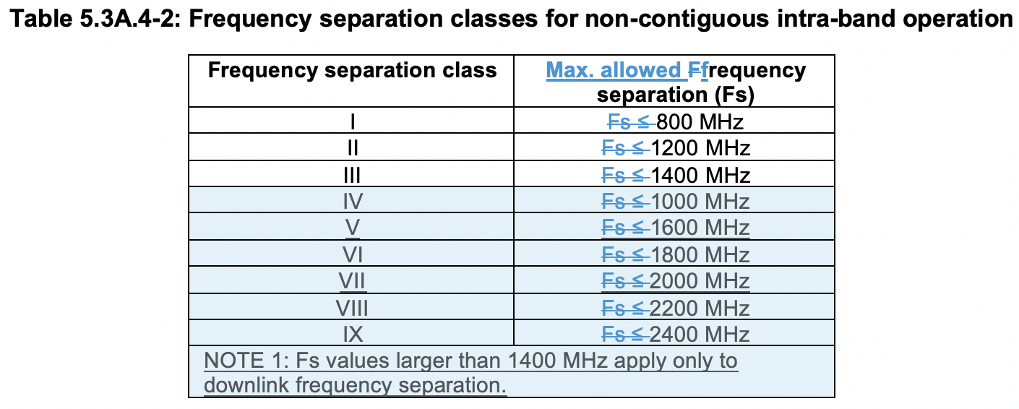  2) RAN4 has agreed on the introduction of frequency separation class for DL only spectrum for FR2. In details:  - The signalling of DL-only spectrum (Fsd) is optional.  - DL-only spectrum is available for configuration of only DL CCs and not UL CCs.  - The spectrum covered by the DL-only frequency separation extends on one-side of the bidirectional spectrum in a contiguous manner with no frequency gap between the two.  - The bidirectional spectrum is defined as the UL/DL common spectrum in which the UE supports the configuration of uplink or downlink CCs and is signalled by UL and DL frequency separation from Rel-15.  - The combined downlink spectrum (DL Fs + Fsd) cannot exceed 2400 MHz.  - The signalling shall be implemented in addition to the signalling of frequency separation (Fs) from Rel-15.  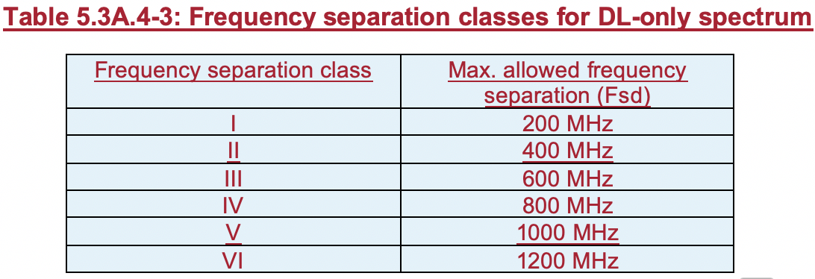  RAN2 spec should capture the two updates from RAN4 to reflect the agreements.
Summary of change: |  | 1) Extend the Rel-15 Frequency separation class to include the new classes: IV, V, VI, VII, VIII, IX.  2) Introduce a new Rel-16 field: intraBandFreqSeparation-DLOnlySpectrum-v16xy
Consequences if not approved: |  | The RAN4 agreements on frequency separation class are not reflected in RAN2 spec.
Clauses affected: |  | 4.2.7.5， 4.2.7.7
 |  | Y | N
Other specs |  | X |  | Other core specifications |  |  | TS 38.331 CR 1705
affected: |  |  | X | Test specifications |  |  | TS/TR ... CR ...
(show related CRs) |  |  | X | O&M Specifications |  |  | TS/TR ... CR ...
Other comments:

<Start of modification 1>

4.2.7.5 FeatureSetDownlink parameters
Definitions for parameters | Per | M | FDD-TDD  DIFF | FR1-FR2  DIFF
additionalDMRS-DL-Alt  Indicates whether the UE supports the alternative additional DMRS position for co-existence with LTE CRS. It is applied to 15kHz SCS and one additional DMRS case only. | FS | No | No | FR1 only
crossCarrierScheduling-OtherSCS  Indicates whether the UE supports cross carrier scheduling for the different numerologies with carrier indicator field (CIF) in DL carrier aggregation where numerologies for the scheduling cell and scheduled cell are different.  NOTE: Cross-carrier scheduling with different numerologies is not supported in this release of specification. | FS | No | No | No
csi-RS-MeasSCellWithoutSSB  Defines whether the UE can perform CSI-RSRP and CSI-RSRQ measurement as specified in TS 38.215 [13], where CSI-RS resource is configured for a cell that does not transmit SS/PBCH block. A UE that supports this feature shall also support scellWithoutSSB. | FS | No | No | No
dl-MCS-TableAlt-DynamicIndication  Indicates whether the UE supports dynamic indication of MCS table for PDSCH. | FS | No | No | No
featureSetListPerDownlinkCC  Indicates which features the UE supports on the individual DL carriers of the feature set (and hence of a band entry that refer to the feature set) by FeatureSetDownlinkPerCC-Id. The UE shall hence include as many FeatureSetDownlinkPerCC-Id in this list as the number of carriers it supports according to the ca-bandwidthClassDL. The order of the elements in this list is not relevant, i.e., the network may configure any of the carriers in accordance with any of the FeatureSetDownlinkPerCC-Id in this list. A fallback per CC feature set resulting from the reported feature set per DL CC is not signalled but the UE shall support it. | FS | N/A | No | No
intraBandFreqSeparationDL  Indicates DL frequency separation class the UE supports, which indicates a maximum frequency separation between lower edge of lowest CC and upper edge of highest CC in a frequency band, for intra-band non-contiguous CA within the bidirectional spectrum. The UE sets the same value in the FeatureSetDownlink of each band entry within a band. The values c1, c2,c3, c4-v16xy, c5-v16xy, c6-v16xy, c7-v16xy, c8-v16xy and c9-v16xy correspond to the values defined in TS 38.101-2 [3]. It is mandatory to report for UE which supports DL intra-band non-contiguous CA in FR2. | FS | CY | No | FR2 only
intraBandFreqSeparation-DLOnlySpectrum-r16  Indicates DL frequency separation class the UE supports for DL only spectrum, which extends on one-side of the bidirectional spectrum in contiguous manner with no frequency gap between the two. The UE sets the same value in the FeatureSetDownlink of each band entry within a band. The values c1, c2, c3, c4, c5 and c6 correspond to the values defined in TS38.101-2 [3]. The frequency separation class for DL-only spectrum (Fsd) reported with this field can be equal but not larger than the frequency separation class reported using intraBandFreqSeparationDL (DL Fs). The combined downlink spectrum from this field and from intraBandFreqSeparationDL (DL Fs + Fsd) cannot exceed 2400 MHz. A UE may report DL-only spectrum only if the combined downlink spectrum (DL Fs + Fsd) exceeds 1400 MHz. | FS | No | No | FR2 only
oneFL-DMRS-ThreeAdditionalDMRS-DL  Defines whether the UE supports DM-RS pattern for DL transmission with 1 symbol front-loaded DM-RS with three additional DM-RS symbols. | FS | No | No | Yes
oneFL-DMRS-TwoAdditionalDMRS-DL  Defines support of DM-RS pattern for DL transmission with 1 symbol front-loaded DM-RS with 2 additional DM-RS symbols and more than 1 antenna ports. | FS | Yes | No | Yes
pdcch-MonitoringAnyOccasions  Defines the supported PDCCH search space monitoring occasions. withoutDCI-gap indicates whether the UE supports PDCCH search space monitoring occasions in any symbol of the slot for Type 1-PDCCH common search space configured by dedicated RRC signaling, for a Type 3-PDCCH common search space, or for a UE-specific search space with the capability of supporting at least 44, 36, 22, and 20 blind decodes in a slot for 15 kHz, 30 kHz, 60kHz, and 120 kHz subcarrier spacing values respectively. withDCI-gap indicates whether the UE supports PDCCH search space monitoring occasions in any symbol of the slot with minimum time separation of two OFDM symbols for 15 kHz, four OFDM symbols for 30 kHz, seven OFDM symbols for 60 kHz with NCP, and 14OFDM symbols for 120kHz between two consecutive transmissions of PDCCH scrambled with C-RNTI, MCS-C-RNTI, or CS-RNTI for Type 1-PDCCH common search space configured by dedicated RRC signaling, for a Type 3-PDCCH common search space, or for a UE-specific search space, with the capability of supporting at least 44, 36, 22, and 20 blind decodes in a slot for 15 kHz, 30 kHz, 60kHz, and 120 kHz subcarrier spacing values respectively. | FS | No | No | No
pdcch-MonitoringAnyOccasionsWithSpanGap  Indicates whether the UE supports PDCCH search space monitoring occasions in any symbol of the slot with minimum time separation between two consecutive transmissions of PDCCH with span up to two OFDM symbols for two OFDM symbols or span up to three OFDM symbols for four and seven OFDM symbols. Value set1 indicates the supported value set (X,Y) is (7,3), value set2 indicates the supported value set (X,Y) is (4,3) and (7,3) and value set 3 indicates the supported value set (X,Y) is (2,2), (4,3) and (7,3). | FS | No | No | No
pdsch-ProcessingType1-DifferentTB-PerSlot  Defines whether the UE capable of processing time capability 1 supports reception of up to two, four or seven unicast PDSCHs for several transport blocks with PDSCH scrambled using C-RNTI, TC-RNTI, or CS-RNTI in one serving cell within the same slot per CC that are multiplexed in time domain only.  Note PDSCH(s) for Msg.4 is included. | FS | No | No | No
pdsch-ProcessingType2  Indicates whether the UE supports PDSCH processing capability 2. The UE supports it only if all serving cells are self-scheduled and if all serving cells in one band on which the network configured processingType2 use the same subcarrier spacing. This capability signalling comprises the following parameters for each sub-carrier spacing supported by the UE.  - fallback indicates whether the UE supports PDSCH processing capability 2 when the number of configured carriers is larger than numberOfCarriers for a reported value of differentTB-PerSlot. If fallback = 'sc', UE supports capability 2 processing time on lowest cell index among the configured carriers in the band where the value is reported, if fallback = 'cap1-only', UE supports only capability 1, in the band where the value is reported;  - differentTB-PerSlot indicates whether the UE supports processing type 2 for 1, 2, 4 and/or 7 unicast PDSCHs for different transport blocks per slot per CC; and if so, it indicates up to which number of CA serving cells the UE supports that number of unicast PDSCHs for different TBs. The UE shall include at least one of numberOfCarriers for 1, 2, 4 or 7 transport blocks per slot in this field if pdsch-ProcessingType2 is indicated. | FS | No | No | FR1 only
pdsch-ProcessingType2-Limited  Indicates whether the UE supports PDSCH processing capability 2 with scheduling limitation for SCS 30kHz. This capability signalling comprises the following parameter.  - differentTB-PerSlot-SCS-30kHz indicates the number of different TBs per slot.  The UE supports this limited processing capability 2 only if:  1) One carrier is configured in the band, independent of the number of carriers configured in the other bands;  2) The maximum bandwidth of PDSCH is 136 PRBs;  3) N1 based on Table 5.3-2 of TS 38.214 [12] for SCS 30 kHz. | FS | No | No | FR1 only
pdsch-SeparationWithGap  Indicates whether the UE supports separation of two unicast PDSCHs with a gap, applicable to Sub-carrier spacings of 30 kHz and 60 kHz only. For any two consecutive slots n and n+1, if there are more than 1 unicast PDSCH in either slot, the minimum time separation between starting time of any two unicast PDSCHs within the duration of these slots is 4 OFDM symbols for 30kHz and 7 OFDM symbols for 60kHz. | FS | No | No | No
scalingFactor  Indicates the scaling factor to be applied to the band in the max data rate calculation as defined in 4.1.2. Value f0p4 indicates the scaling factor 0.4, f0p75 indicates 0.75, and so on. If absent, the scaling factor 1 is applied to the band in the max data rate calculation. | FS | No | No | No
scellWithoutSSB  Defines whether the UE supports configuration of SCell that does not transmit SS/PBCH block. This is conditionally mandatory with capability signalling for intra-band CA but not supported for inter-band CA. | FS | CY | No | No
searchSpaceSharingCA-DL  Defines whether the UE supports DL PDCCH search space sharing for carrier aggregation operation. | FS | No | No | No
timeDurationForQCL  Defines minimum number of OFDM symbols required by the UE to perform PDCCH reception and applying spatial QCL information received in DCI for PDSCH processing as described in TS 38.214 [12] clause 5.1.5. UE shall indicate one value of the minimum number of OFDM symbols per each subcarrier spacing of 60kHz and 120kHz. | FS | Yes | No | FR2 only
twoFL-DMRS-TwoAdditionalDMRS-DL  Defines whether the UE supports DM-RS pattern for DL transmission with 2 symbols front-loaded DM-RS with one additional 2 symbols DM-RS. | FS | No | No | Yes
type1-3-CSS  Defines whether the UE is able to receive PDCCH in FR2 in a Type1-PDCCH common search space configured by dedicated RRC signaling, in a Type3-PDCCH common search space or a UE-specific search space if those are associated with a CORESET with a duration of 3 symbols. | FS | Yes | No | FR2 only
ue-SpecificUL-DL-Assignment  Indicates whether the UE supports dynamic determination of UL and DL link direction and slot format based on Layer 1 scheduling DCI and higher layer configured parameter UL-DL-configuration-dedicated as specified in TS 38.213 [11]. | FS | No | No | No
<Unchanged part is omitted>

4.2.7.7 FeatureSetUplink parameters
Definitions for parameters | Per | M | FDD-TDD  DIFF | FR1-FR2  DIFF
scalingFactor  Indicates the scaling factor to be applied to the band in the max data rate calculation as defined in 4.1.2. Value f0p4 indicates the scaling factor 0.4, f0p75 indicates 0.75, and so on. If absent, the scaling factor 1 is applied to the band in the max data rate calculation. | FS | No | No | No
crossCarrierScheduling-OtherSCS  Indicates whether the UE supports cross carrier scheduling for the different numerologies with carrier indicator field (CIF) in UL carrier aggregation where numerologies for the scheduling cell and scheduled cell are different. The UE shall set this field to the same value as crossCarrierScheduling-OtherSCS in the associated FeatureSetDownlink (if present).  NOTE: Cross-carrier scheduling with different numerologies is not supported in this release of specification. | FS | No | No | No
dynamicSwitchSUL  Indicates whether the UE supports supplemental uplink with dynamic switch (DCI based selection of PUSCH carrier). | FS | No | No | No
featureSetListPerUplinkCC  Indicates which features the UE supports on the individual UL carriers of the feature set (and hence of a band entry that refer to the feature set) by FeatureSetUplinkPerCC-Id. The UE shall hence include as many FeatureSetUplinkPerCC-Id in this list as the number of carriers it supports according to the ca-bandwidthClassUL. The order of the elements in this list is not relevant, i.e., the network may configure any of the carriers in accordance with any of the FeatureSetUplinkPerCC-Id in this list. A fallback per CC feature set resulting from the reported feature set per UL CC is not signalled but the UE shall support it. | FS | N/A | No | No
intraBandFreqSeparationUL  Indicates UL frequency separation class the UE supports, which indicates a maximum frequency separation between lower edge of lowest CC and upper edge of highest CC in a frequency band, for intra-band non-contiguous CA within the bidirectional spectrum. The UE sets the same value in the FeatureSetUplink of each band entry within a band. The values c1, c2, c3, c4-v16xy, c5-v16xy, c6-v16xy, c7-v16xy, c8-v16xy and c9-v16xy corresponds to the values defined in TS 38.101-2 [3]. Frequency separation classes larger than 1400MHz only apply to DL frequency separation. It is mandatory to report for UE which supports UL non-contiguous CA in FR2. | FS | CY | No | FR2 only
pa-PhaseDiscontinuityImpacts  Indicates incapability motivated by impacts of PA phase discontinuity with overlapping transmissions with non-aligned starting or ending times or hop boundaries across carriers for intra-band EN-DC, intra-band CA and FDM based ULSUP. | FS | No | No | No
pusch-ProcessingType1-DifferentTB-PerSlot  Indicates whether the UE capable of processing time capability 1 supports transmission of up to two, four or seven unicast PUSCHs for several transport blocks in one serving cell within the same slot per CC that are multiplexed in time domain only. | FS | No | No | No
pusch-ProcessingType2  Indicates whether the UE supports PUSCH processing capability 2. The UE supports it only if all serving cells are self-scheduled and if all serving cells in one band on which the network configured processingType2 use the same subcarrier spacing. This capability signalling comprises the following parameters for each sub-carrier spacing supported by the UE.  - fallback indicates whether the UE supports PUSCH processing capability 2 when the number of configured carriers is larger than numberOfCarriers for a reported value of differentTB-PerSlot. If fallback = 'sc', UE supports capability 2 processing time on lowest cell index among the configured carriers in the band where the value is reported, if fallback = 'cap1-only', UE supports only capability 1, in the band where the value is reported;  - differentTB-PerSlot indicates whether the UE supports processing type 2 for 1, 2, 4 and/or 7 unicast PUSCHs for different transport blocks per slot per CC; and if so, it indicates up to which number of CA serving cells the UE supports that number of unicast PUSCHs for different TBs. The UE shall include at least one of numberOfCarriers for 1, 2, 4 or 7 transport blocks per slot in this field if pusch-ProcessingType2 is indicated. | FS | No | No | FR1 only
pusch-SeparationWithGap  Indicates whether the UE supports separation of two unicast PUSCHs with a gap, applicable to Sub-carrier spacings of 15 kHz, 30 kHz and 60 kHz only. For any two consecutive slots n and n+1, if there are more than 1 unicast PUSCH in either slot, the minimum time separation between starting time of any two unicast PUSCHs within the duration of these slots is 2 OFDM symbols for 15kHz, 4 OFDM symbols for 30kHz and 7 OFDM symbols for 60kHz. | FS | No | No | No
searchSpaceSharingCA-UL  Defines whether the UE supports UL PDCCH search space sharing for carrier aggregation operation. | FS | No | No | No
simultaneousTxSUL-NonSUL  Indicates whether the UE supports simultaneous transmission of SRS on an SUL/non-SUL carrier and PUSCH/PUCCH/SRS on the other UL carrier in the same cell. | FS | No | No | No
supportedSRS-Resources  Defines support of SRS resources. The capability signalling comprising indication of:  - maxNumberAperiodicSRS-PerBWP indicates supported maximum number of aperiodic SRS resources that can be configured for the UE per each BWP  - maxNumberAperiodicSRS-PerBWP-PerSlot indicates supported maximum number of aperiodic SRS resources per slot in the BWP  - maxNumberPeriodicSRS-PerBWP indicates supported maximum number of periodic SRS resources per BWP  - maxNumberPeriodicSRS-PerBWP-PerSlot indicates supported maximum number of periodic SRS resources per slot in the BWP  - maxNumberSemiPersistentSRS-PerBWP indicate supported maximum number of semi-persistent SRS resources that can be configured for the UE per each BWP  - maxNumberSemiPersistentSRS-PerBWP-PerSlot indicates supported maximum number of semi-persistent SRS resources per slot in the BWP  - maxNumberSRS-Ports-PerResource indicates supported maximum number of SRS antenna port per each SRS resource | FS | Yes | No | No
twoPUCCH-Group  Indicates whether two PUCCH group in CA with a same numerology across CCs for data and control channel [at a given time] is supported by the UE. For NR CA, two PUCCH group is supported with the same numerology across NR carriers for data and control channel at a given time. For EN-DC, two PUCCH group is supported with the same numerology across NR carriers for data and control channel at a given time, wherein an NR PUCCH group is configured in FR1 and another NR PUCCH group is configured in FR2. | FS | No | No | No
ul-MCS-TableAlt-DynamicIndication  Indicates whether the UE supports dynamic indication of MCS table using MCS-C-RNTI for PUSCH. | FS | No | No | No
zeroSlotOffsetAperiodicSRS  Indicates whether the UE supports 0 slot offset between aperiodic SRS triggering and transmission, for SRS for CB PUSCH and antenna switching on FR1. | FS | No | No | No

