3GPP TSG-RAN WG2 #110b-e R2-200xxxx
E-meeting, June 2020

Agenda Item: x.x.x.x
Source: OPPO
Title: Summary of [Post109bis-e][954][V2X] SIB12 Overhead Reduction (OPPO)
Document for: Discussion, Decision

Introduction
RAN2 achieved following agreement at RAN2#109bis meeting:
Agreements on SIB12:
1: Introduce segmentation of SIB12 in RRC layer for both NR and LTE system.
Furthermore following email discussion is agreed to discuss potential optimization solution to reduce SIB12 size:
[Email discussion]: To discuss and conclude other options proposed in R2-2004075. If we cannot see majority companies’ views for each sub-options or if we cannot have reliable draft CR, we will rely on segmentation of SIB12 only in Rel-16 (OPPO)

Discussion
The size of SIB12 is mainly affected by those IEs which are either too big or repeat too many times or both. How many times an IE will repeat depends on either the length of the list or how deep the IE is buried within the whole IE structures. Taking IE SL-QoS-Profile-r16 for example, it will repeat NrofSLRB-r16* NrofSL-QFIs-r1 times (Note1). For IE SL-Priority-TxConfigIndex-r16 it will repeat NrofFreqSL-r16* NrofSL-BWPs-r16*( NrofTXPool-r16+1)*8.
Note: the parameter e.g. NrofSLRB-r16 in the paper is the configured length of the IE list whose maximum number is maxNrofSLRB-r16. The same assumption is taken for other similar parameters.
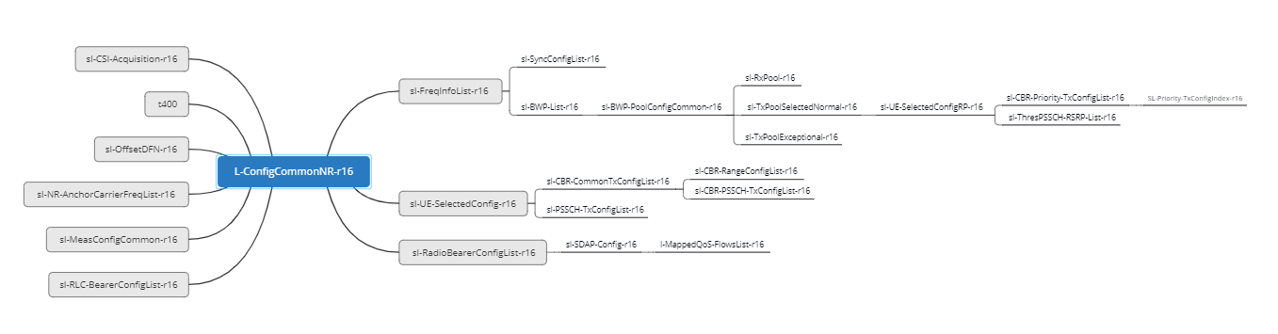
Figure 2-1 IE structure of SIB12 (partial IEs)
In Figure2-1 the IEs which impacts SIB12 size at most are listed. And the following table show the IE name, their repeat factors and estimated size:
level 1 IE list | level n IE list | Size of IE list(bit) | Repeat factors | Minimum factors | Typical factors
sl-FreqInfoList-r16 | IE size of sl-FreqInfoList-r16 except for below 5 IEs | 274 | 1 | 1 | 1
 | SL-SyncConfig-r16 | 90 | NrofFreqSL-r16*SL-SyncConfig-r16 | 1 | 4
 | SL-ResourcePool-r16(TX) except for  sl-CBR-Priority-TxConfigList-r16  and sl-ThresPSSCH-RSRP-List-r16 | 487 | NrofFreqSL-r16* NrofSL-BWPs-r16*( NrofTXPool-r16+1) | 2 | 5
 | sl-CBR-Priority-TxConfigList-r16 | 448 | NrofFreqSL-r16* NrofSL-BWPs-r16*( NrofTXPool-r16+1) | 2 | 5
 | sl-ThresPSSCH-RSRP-List-r16 | 496(Note1) | NrofFreqSL-r16* NrofSL-BWPs-r16*( NrofTXPool-r16+1) | 2 | 5
 | SL-ResourcePool-r16(RX) | 449 | NrofFreqSL-r16* NrofSL-BWPs-r16*NrofRXPool-r16 | 1 | 1
sl-UE-SelectedConfig-r16 | IE size of sl-UE-SelectedConfig-r16 except for below 3 IEs | 11 | 1 | 1 | 1
 | sl-PSSCH-TxConfigList-r16 | 69 | PSSCH-TxConfig-r1 | 1 | 8
 | sl-CBR-RangeConfigList-r16 | 7 | CBR-Config-r16*CBR-Level-r16 | 1 | 64
 | sl-CBR-PSSCH-TxConfigList-r16 | 46 | TxConfig-r16 | 1 | 16
sl-NR-AnchorCarrierFreqList-r16 |  | 22 | FreqSL-NR-r16 | 1 | 1
sl-EUTRA-AnchorCarrierFreqList-r16 |  | 14 | FreqSL-EUTRA-r16 | 1 | 1
sl-RadioBearerConfigList-r16 | IEs except for below 2 IEs | 17 | NrofSLRB-r16 | 1 | 12
 | SL-QoS-Profile-r16 | 129 | NrofSLRB-r16*NrofSL-QFIs-r1 | 1 | 48
 | sl-PDCP-Config-r16 | 9 | NrofSLRB-r16 | 1 | 12
SL-RLC-BearerConfig-r16 |  | 59 | SL-LCID-r16 | 1 | 12
sl-MeasConfigCommon-r16 |  | 98 | NrofSL-ObjectId-r16 | 1 | 1
sl-CSI-Acquisition -r16 |  | 1 | 1 | 1 | 1
sl-ZoneConfig-r16 |  | 11 | 1 | 1 | 1
sl-OffsetDFN-r16 |  | 11 | 1 | 1 | 1
t400 |  | 4 | 1 | 1 | 1
sl-MaxNumConsecutiveDTX-r16 |  | 3 | 1 | 1 | 1
sl-SSB-PriorityNR-r16 |  | 3 | 1 | 1 | 1
Table2-1
Note1: the size is calculated assuming CBR-Level-r16=8 (maxCBR-Level-r16=16)
Note2: the IE sizes in table 2-1 are adjusted according to endorsed 38.331 CR in R2-2004072

Optimization of SIB12 size issue
As indicated in table 2-1, the IEs in bold red are either of big size and/or repeated many times. Following parameters are assumed to estimate the SIB12 size:
Configured parameters | Typical values
NrofFreqSL-r16 | 1
NrofSL-BWPs-r16 | 1
NrofTXPool-r16 | 4
NrofRXPool-r16 | 1
NrofSLRB-r16 | 12
NrofSL-QFIs-r1 | 4
SL-LCID-r16 | 12
Table 2.1-1
The corresponding repeat factors are listed in the column “typical factors” of table 2-1. Based on this assumption SIB12 is estimated as 17360 bits. If some measures e.g. proposal 1/2/3 from paper [2] are taken into account then the SIB12 size can be reduced to be 8022 assuming:
1, IE SL-QoS-Profile-r16 is 33 bits assuming standardized PQI instead of non-standardized PCI is configured and IE sl-GFBR-r16 and sl-MFBR-r16 are both reduced from 33 bits to 6 bits as indicated in draft CR [4]
2, Table plus index approach is taken for IE SL-QoS-Profile-r16 where the length of the table is 16
3, IE SL-ThresPSSCH-RSRP-List-r16 and SL-CBR-Priority-TxConfigList-r16 is configured as cell level IE hence only one instance is counted instead of 5
The idea from [3] is to preconfigure sl-RadioBearerConfigList-r16 and sl-RLC-BearerConfigList-r16, in that case the SIB12 size can be further reduced to 6474 bits.
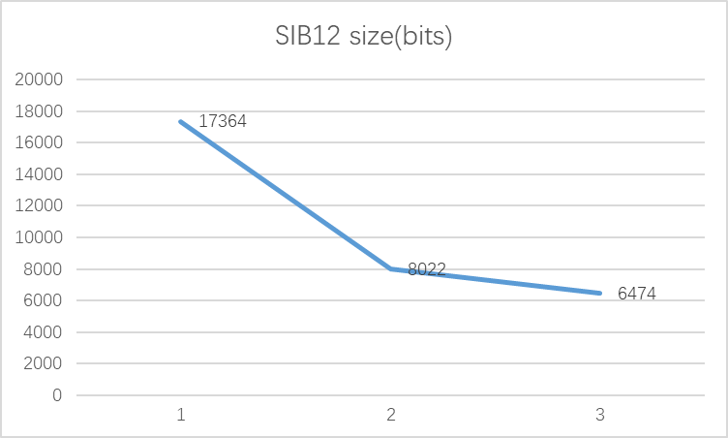
Figure 2.1-1 SIB12 size reduction
The outcome in Figure2.1-1 shows there is a big room for size optimization. In future the number of SLRB may not increase dramatically but the number of frequencies and the number of BWP per frequency will like increase when more spectrum are available for sidelink operation. In that case SIB12 size will increase mainly because of IE like TX resource pool.
Q1: Do you agree that SIB12 size need be optimized?
If you disagree, please elaborate your detail reason
Company | Agree/disagree | comments

Options to reduce SIB12 size
The key IE impacting SIB12 size are SL-QoS-Profile-r16, sl-CBR-Priority-TxConfigList-r16 and sl-ThresPSSCH-RSRP-List-r16 etc. During offline discussion [1] there are several solutions are listed on the table and they are not exclusive with each other by the nature.
Option 1: To introduce table + index approach for e.g. SL-QoS-Profile-r16
Option 2: To adjust the granularity of value range for e.g. sl-GFBR-r16 and sl-MFBR-r16
Option 3: To modify the depth of the IE within ASN.1 structure e.g. to configure sl-CBR-Priority-TxConfigList-r16 and/or sl-ThresPSSCH-RSRP-r16 per cell IEs or per BWP or per frequency IE
Option 4: to preconfigure IE e.g. for SL-QoS-Profile-r16
Option 5: to preconfigure IE but with default value in case of absence in the SIB e.g. for SL-QoS-Profile-r16
All the solutions try to keep balance between signalling overhead and flexibility.
Q2: Among listed 5 options, which option(s) do you prefer? Please also explain which IE(s) do you prefer for that selected option
Company | preferred option(s) | Detail explanation

Conclusion
We have the following proposals:
Proposal 1 xxx.

Reference
[1] R2-2004075 [AT109bis-e][704][V2X] SIB12/28 (OPPO) OPPO
[2] R2-2002651 Open issues on system information OPPO
[3] R2-2002828 Further Discussion on RRC Remaining Issues CATT
[4] R2-2002652_38331_CRyyyy_(REL-16)_Correct to fix SIB12 size issue for NR V2X.docx OPPO

