3GPP TSG-RAN WG2#110 eMeeting Tdoc R2-20xxxx

Online, 1st- x^{th} June 2020
Agenda Item: 7.0.1
Souce: Samsung
Title: Report of [Post109bis-e][932][LTE/NR/ASN.1] Resolution of review issues S003, S005, B002, S046 (Samsung/Ericsson))
Document for: Discussion and decision

Introduction
This document is the report of the following email discussion:
- [Post109bis-e][932][LTE/NR/ASN.1] Resolution of review issues S003, S005, B002, S046 (Samsung/ Ericsson)
Discuss how to resolve the review issues S003/S006/B002/S046 and identify how the cross-RAT IE usage should work.
Intended outcome: Discussion report and CRs to 36.331 (Samsung) and 38.331 (Ericsson)
Deadline: Long (until next meeting)

Some further clarification regarding the scope and time plan i.e. we plan to have 2 parts as follows:
- Part 1 (deadline Thu 14 May 12.00 UCT): discussion of different options
  - Some time to review proposed way forward i.e. should be concluded by Mon 18 May 12 UCT
- Part 2 (deadline Wed 20 May 8.00 UCT): Review of corresponding CRs to 36.331 and 38.332
  - To be ready for submission deadline

Discussion

Starting points
The e-mail discussed the handling of the V2X signalling transferred between UE and NR as introduced in R16. This concerns the following cases:
A: SidelinkUEInformation e.g. Request for Rx/ TX comm resource
B: SL-UE-AssistanceInformationNR i.e. grant assistance
C: Measurement events S1/ S2
D: Broadcast of SIB28
This e-mail focusses on cases A- C and that in general these may involve: a) configuration, b) UL signaling, c) further network response. The aim of the discussion is to conclude the signalling and preferably to do this in an aligned/ consistent manner that peferrably allows re-use for other similar cases that may arise in future.

Case | Config | UL signaling, contents | Subsequent response
A | No dedicated config (but triggering may relate to SIB28 contents) | NR message SidelinkUEInformation (E.g. request for Rx/ TX comm resource, reporting of QoS profile or SL failure) | LTE RRCConnectionReconfiguration, containing NR IE SL-ConfigDedicatedNR (info for SL mode 2 operation (TX resource selection by UE).
B | LTE RRCConnectionReconfiguration subfield otherConfig, contains LTE encoded config (configurdGrantAssistanceInfoReport) | NR IE SL-UE-AssistanceInformationNR  Grant assistance | LTE RRCConnectionReconfiguration, containing NR IE SL-ConfigDedicatedNR (info for CGType1)
C | LTE RRCConnectionReconfiguration (Under discussion: Mix of LTE and NR encoding e.g. LTE: MO, report config except some parameters e.g. NR encoding for thresh? | LTE message containing NR IE (details under discussion)? | Amount of resources indicated by SIB or dedicated signaling may be updated
D | LTE SIB28, containing NR SIB12

UL signalling
For UL signalling, discussion has mainly focussed on case A and B, but there has also beens some discussion for C

Case | UL signaling, contents | Approach in current CR | Alternatives discussed so far (including during R2#109bis)
A | S005: NR message SidelinkUEInformation | Introduce new LTE message SidelinkUEInformationNR message with mandatory field carrying NR message within container/ octet string | - Re-use ULInformationTransferMRDC  - Re-use LTE SidelinkUEInformation i.e. include octet string containing NR message
B | S003: NR IE SL-UE-AssistanceInformationNR  Grant assistance | Introduce new LTE message SidelinkUEInformationNR message with mandatory field carrying NR message within container/ octet string | - Re-use ULInformationTransferMRDC  - Re-use LTE UEAssistanceInformation i.e. include octet string containing NR IE
C | O310: NR IE for CBR measurments (SL-CBR-ResultsNR) | Re-use LTE MeasurmentReport message, by extension of IE MeasResults with field measResultListNR-SL. The corresponding IE concerns a list with each entry comprising:  - Pool-Id: LTE encoded  - CBR results: octet string containing NR IE SL-CBR-ResultsNR | - Transparent transfer of NR measurement information e.g. by re-using ULInformationTransferMRDC

Configuration

Case | UL signaling, contents | Approach in current CR | Alternatives discussed so far (including during R2#109bis)
B | Configuration for providing Grant assistance | Re-use of LTE RRCConnectionReconfiguration subfield otherConfig i.e. field extended by:  - configurdGrantAssistanceInfoReport: LTE encoded (Boolean) | None
C | B002/ S046/ O310: Configuration for CBR measurements | LTE RRCConnectionReconfiguration subfields re-used i.e. re-using measId and reportConfig while defining a new/ separate MeasObjectNR for SL. It is LTE encoded.  A new type of MO is defined i.e. MeasObjectNR-SL. It is LTE encoded and contains:  - carrierFreq: LTE encoding (ARFCN)  - resource pool list, for each entry comprising:  - pool ID (LTE encoded)  - resources to measure: NR encoded (i.e. octet string containing NR SL-ResourcePoolID)  ReportConfig is extended by:  - Event: LTE encoding (S1, S2)  - Event parameters: Threshold: NR encoding (octet string containing NR c1-Threshold) | Re-use LTE Reconfiguration by adding extension:  SL-MeasConfig: NR encoding i.e. octet string containing NR IE MeasConfig

Main comments/ suggestions:
- The NR V2X UL signalling carried within the container is not passed transparently but eNB actually decodes/ processes the concerned information. Correspondingly, it seems inappropriate to re-use of the message used for transparent transfer in case of MRDC. I.e. should avoid changing the operation for that MRDC message
- It would be good to limit specification changes i.e. both for 36.331 and 38.331. I.e. should change only if there is clear benefit (not just for matter of taste)
- LTE merely provides UL transfer and hence it seems inappropriate to use e.g. the UAI procedure as that typically includes functionality that does not apply e.g. a probibit timer, retransmision following mobility
- It seems good to consider all UL information together i.e. consider introduction of a new message to handle IRAT information that is not forwarded but processed by eNB (and use it for both SUI and UAI)
During R2#109bis there was a slight preference to not introduce any changes. It was however felt that some further discussion is desirable to ensure the signalling for the different cases is done in a consistent and future proof manner (i.e. also avoiding introduction of numerous additional messages in future).

Phase 1: Discussion of open issues

UL transfer of NR encoded assistance
For UL transfer, the following options are on the table (if other option is preferred, please add)
- Keep approach as in existing specification
- Transfer NR information using octet string container within corresponding LTE procedure (alternative suggested by Ericsson)
- (New) Define message/ procedure for transfer of other RAT information from UE to eNB used in case eNB processes concerned information (rather than transparently forwarding it)

Question 1: Which option to use for UL transfer of a) SidelinkUEInformationNR message and b) SL-UE-AssistanceInformationNR

Company | Prefered option | Remarks e.g. motivation/ considerations not mentioned so far
Ericsson | Option 2 | We believe that having the NR information as an OCTET STRING in the existing LTE message is a clen and easy solution to adopt. Current signalling, indeed, it lacks fundamental parts such as the sending on the message (why the sending of an NR message is done in the LTE spec???) and a not so clear procedural text for the UE.  Option 3 is also okay for us if majority of companies want to go for it. However, even if this solution may sound a good way to go for having a future proof solution, we do not foresee that this new message/procedure will be used for something else than sidelink. In this sense, Option 2 is is more simple.
OPPO | Option-3 | We do not think option-2 is a feasible since the triggering of NR-SUI/UAI message and the triggering of LTE-SUI/UAI message are different, and thus cannot be reused to carry the NR message within LTE corresponding message.  Option-3 is a clean and future proof method, which at least saves two message for now if we align the solution for the case A/B/C discussed here.
MediaTek | Option 1 or 3 | We don’t really see a big problem with the approach in the current CR; the NR sidelink is specified as part of 38.331, so a UE supporting it needs to take into account requirements from there anyway, and in this light we don’t find it unreasonable to refer to the NR spec for the procedure. If there is generally a desire to change from this, we slightly prefer option 3 for future-proofing and because it decouples the separate triggering conditions for the NR and LTE messages.
CATT | Option 1 or 3 | We think option 2 is not feasible, since the triggers of these two messages are different. Hence, we slightly prefer keep approach as in existing specification.‎  If majority views want to have some changes, then we slightly prefer option 3.
Huawei | Option 1, with possibile naming change | If the concern is just “sending of an NR message done in the LTE spec” which appears to be weired to companies, we may simply change the name of SidelinkUEInformationNR/UEassistanceInformationNR to, e.g., SidelinkUEInformationInterRAT/UEassistanceInformationInterRAT, which include octet strings referring to SidelinkUEInformationNR/ SL-UE-AssistanceInformationNR in TS 38.331. Then, logically this SidelinkUEInformationInterRAT can be regarded as an LTE message, which carries other RAT’s IE, similar logic as other message/IEs carrying cross-RAT info for Uu.  Some other illustrations from our side: although the SL related information reflects the information used in PC5, our understanding is that (at least logically) it should still be the Uu module/protocol which generates the SUI/UAI for SL of the other RAT (based on necessary inner-UE info exchange between UE’s Uu and PC5 modules/protocols), but Not the PC5 module/protocol itself that directly generates a Uu message/IE for SL. Because, in the inter-RAT Uu control of SL cases, it is anyway the eNB/gNB that directly decodes the SUI/UAI for SL of the other RAT, and so, as the peer entity, it should also be the UE’s Uu module/protocol that encodes/generates SUI/UAI for SL. Therefore, the contrainer is used in the inter-RAT Uu control of SL cases, referring to the RRC Spec of the other RAT, with the main motivation to avoid text duplication across Specs, but not with the same purpose as MR-DC case (that the module/protocol of the other RAT generates a message/IE, transparently passing it to the RAT of the serving RAT’s Uu).  Please kindly note (also for below Q2/3) that using containter referring to the IE of the RRC spec of another RAT to avoid text duplication in non-MR-DC cases is nothing new, and already applied in Rel-15 Spec (e.g. nr-RadioBearerConfig1/2 in the eLTE case), Here, for the inter-RAT Uu control of PC5 cases, we therefore just reuse some existing techniques without anything new invented.  For option 2, we echo some companies’ comments in [Offline-204], R2-2003843 that including SUI/UAI of NR in SUI/UAI of LTE in TS 36.331 and/or including the SUI/UAI of LTE in the SUI/UAI of NR in TS 38.331 do not work. At least, one funny thing is discovered: if one includes the SUI/UAI of NR in the SUI/UAI of LTE in TS 36.331 for “LTE Uu control of NR SL” case, then when he/she turns to TS 38.331 to include the SUI/UAI of LTE in the SUI/UAI of NR for the “NR Uu control of LTE SL” case, he/she will find that the SUI/UAI of NR in TS 38.331 includes the SUI/UAI of LTE which includes another SUI/UAI of NR  For option 3, we share Ericsson’s view that to introduce a brand new message+procedure just for future proof of SL related reporting is not strongly motivated. As per previous experience, enhancements of furture release SL will just be done as extension in SUL/UAI. Anyway, to introduce a new message, including all SUI, UAI and potentially inter-RAT CBR reporting, will lead to a number of discussions on the detailed procedure and ASN.1 design, and potentially big impacts to the spec. This is not desirable, especially considering no sufficient motivation.
vivo | Option 1 | Regarding the choice between option 1 and option 2, since the triggering condition of NR UL message and LTE UL message are independent from each other, option 2 needs additional procedural text to capture the different triggering conditions under cross-RAT case. Hence, we slightly prefer to keep the spec as it is.
Samsung | Option 3 | We prefer option 3 i.e:  - To use one message/ procedure for both cases  - To use a message/ procedure that from LTE perspective does nothing but transfer NR encoded information that eNB should process  We can call the message ULInformationTransferXX, with for XX use IRAT or NR. We can clarify the message is used for the concerned NR SL information
LG | Option 1 | No problem with current approach. We prefer to keep the current spec.

For the measurement reporting, the same approach can be used as for the other UL V2X information. Adopting such approach however seems appropriate only if the configuration is also done in a similar manner.

Configuration of CBR measurements
For configuration of CBR measurements, the following options are on the table (if other option is preferred, please add)
- Keep approach as in existing specification (i.e. somewhat strange mix of LTE and NR encoding)
- Transfer NR information using octet string container within corresponding LTE procedure (i.e. LTE Reconfiguration message)
- (New) Define a message/ procedure for DL transfer of other RAT information from eNB to UE to be used in case eNB generates concerned information (rather than eNB transparently forwarding IRAT info generated by other node)
Within the context of e-mail AT-xx, there was some discussion on the visibility of the pool identity. There seem to be 2 main options:
- The configuration and reporting is specified by NR signalling and procedures. In this approach there is no need to define a pool ID within LTE/ using LTE encoding
- The configuration and reporting is specified by LTE signalling and procedures. I.e. events are defined in LTE including the configuration and triggering conditions. Correspondingly, the setting of the measurement report is specified in LTE. In this case, it seems appropriate to define most/ all parameters in LTE (including a pool ID)
Question 2: Which option to use for transfer of the CBR measurement configuration
Company | Prefered option | Remarks e.g. motivation/ considerations not mentioned so far
Ericsson | Option 2 | Basically same comment as Q1.
OPPO | Option 2 | It helps to clean up the RRC specification, by put all inter-RAT things into the container, without any sacrifice on performance.  Please note even in option-1, where the intention is to have explicit encoding / procedural text in LTE spec, it finally turns out that as a mixed LTE and NR encoding.After the discussion till now, we have not identify clear motivation to go for that option, but only found unnecessary spec impact due to that.
MediaTek | Option 2 | We agree option 1 is a little bit strange in the mix of LTE and NR encoding. Option 3 is a bit awkward because it separates part of the measurement configuration into a different message. Option 2 seems to be the least bad approach.
CATT | Option 1 or 2 | We don’t think a big problem on option 1, but if majority view is option 2, we can follow it.
Huawei | Option 1 + B  (sorry for lengthy comments) | As our comment in Q1, it is eventually the Uu module/protocol that encodes/generates the reporting and decodes/reads the configuration for SL, not the PC5 module/protocol; so the whole inter-RAT CBR measuemrnt reporting procedure is something generally like this:  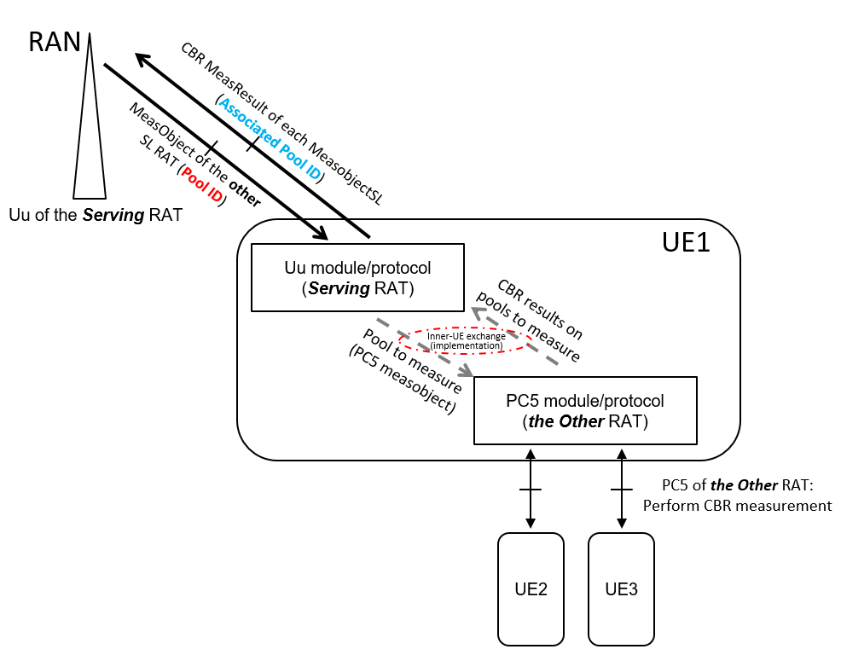  It should be pointed out that, it is basically the Uu module/protocol of the Serving RAT that reads the configurations for the inter-RAT CBR measurement reporting (especially pools to measure as the measObects for the SL of the Other RAT), and finally generates the CBR results to be reported for corresponding resource pools (i.e. associated measObjectSL) actually measured. In other words, it is the Uu of the Serving RAT that associates the CBR result to be reported with the right pool (MeasObjects) actually measured for the SL of the other RAT, and this association is precisely done by the pool ID included in both MeasObjectSL and MeasReults of CBR for the inter-RAT CBR meas and reporting case in current spec.  Actually, the above logic is very similar to the Inter-RAT measurement reporting in Uu, where it is the serving RAT’s Uu that reads/generates the configuration/reporting of the other RAT’s Uu, and in such cases, all measurement configuration and reporting results are encoded with explicit IEs in the current Spec, instead of using a container as in MR-DC cases. With respect to the “full-container” way proposed by above Option A (also in O310), it is actually to imitate the MR-DC cases which hold a different logic than the inter-RAT measumernt reporting cases above, because it is still the SN itself that configures the measurement and reporting for SN’s own RAT, and at the UE side, measurement decoding and generation of reporting results are totally done inside the module/protocol of the SN’ RAT (passing from/to the MN RAT via container).  As shown above, since the association of the CBR results to the right pool measured anyway needs to rely on pool ID by the Uu of Serving RAT, if we rely on “full contrainer” manner as Option A and completely remove pool IDs from the Spec from the inter-RAT CBR reporting cases, how should the UE’s Uu protocol/module do such association, with the pool ID itself completely disappearing in the spec?  Regarding also “i.e. somewhat strange mix of LTE and NR encoding” as in Option 1) above, we want to clarify again that the use of container is to mainly to avoid text duplication. Techinically, we can make all of them into explicit IE, by copying-pasting them from 3X.331 of the other RAT, but consequence may be tens of pages more including exactly the same texts from another Spec
vivo | Option 1 | We prefer to keep the current spec.
Samsung | Option 3 or 2 | Alike for UL, we prefer to use one message for the transfer of all DL-DCCH information that eNB generates and uses NR encoding. The container for this could either be within the LTE Reconfiguration message or we could introduce a DLInformationTransferXX message to reflect that from LTE perspective there is no further protocol handling (i.e. alike for UL)
LG | Option 1 | No problem with current approach. We prefer to keep the current spec.

UL transfer of CBR measurement results
For CBR measurement results, the same options as for other UL transfer cases are on the table (if other option is preferred, please add)
- Keep approach as in existing specification
- Transfer NR information using octet string container within corresponding LTE procedure (i.e. within MeasurementReport message)
- (New) Define message/ procedure for transfer of other RAT information from UE to eNB used in case eNB processes concerned information (rather than transparently forwarding it). I.e. same as used for NR encoded assistance information discussed in previous section

Question 3: Which option to use for transfer of the CBR measurement configuration
Company | Prefered option | Remarks e.g. motivation/ considerations not mentioned so far
Ericsson | Option 2 | Basically same comment as Q1.
OPPO | Option 3 | As replied to Q1.
MediaTek | See comment | In this case we don’t see a big difference between options 1 and 2; the approach of the current CR is to carry the measurement results in an OCTET STRING inside the LTE MeasurementReport message, which is basically what option 2 proposes as well. Is it correct that the only difference is whether the pool ID would be outside the container (option 1) or inside the container (option 2)? With this understanding, we would be OK with either of these options.  Option 3 seems a bit at odds with the modelling of the measurement system. This is not really “foreign RAT” information, it’s a measurement that was requested by the eNB being reported to the eNB by the UE under its control, i.e. it seems naturally to belong to the MeasurementReport message. We find option 3 less attractive here than for the SUI/UAI.
CATT | Option 1 | We prefer to keep approach as in existing specification. We don’t think there is a big problem.
Huawei | Option 1 | Same comments as to Q2.
vivo | Option 1 | We prefer to keep the current spec.
Samsung | Option 3 | Same remarks as for Q1
LG | Option 1 | No problem with current approach. We prefer to keep the current spec.

XX
Issue is illustrated below
Extract

Further comments/ suggestions can be added below.
Source | Comments/ suggestions
OPPO | For configuration of case-B (UAI message), OPPO raised that the configuaration can be implemented using container method, as described in R2-2002626/2627/2628 (DP and draftCR for 36.331/38.331), basically to put the otherconfig (containing the flag to enable SL assistance info report) as a container. In this way, it can further align with option-2 of Q2 (for CBR measurement configuration).
Rap
Huawei | Please all the RILs previously submitted to V2X WI but actually proposing solutions related to this email discussion be concluded and, if agreeable, included in the draft CR in this email discussion, and be treated in the ASN.1 review session in RAN2 #110e. V2X session has no time or plan to discuss them for a second time in V2X room.
Tab. X: Other general issues

Proposed conclusion N Bla

Phase 2: Issues regarding corresponding specification changes

X
Issue is illustrated below
Extract

Further comments/ suggestions can be added below.
Source | Comments/ suggestions
Qualcomm
Rap
Tab. X: Other general issues

Proposed conclusion N Bla

Conclusion & recommendation
This document includes a report of [Post109bis-e][932][LTE/NR/ASN.1] Resolution to review issues S003, S005, B002, S046 (Samsung/Ericsson). The report summarises the discussion regarding class 2 issues and includes the following proposals that RAN2 is requested to agreed:
Proposal 1

References
[1] R2-2003234 ASN.1 Review file (LTE, Word) Samsung
[2] R2-2003827 ASN.1 Review RIL (LTE, Excel) Samsung

