3GPP TSG-RAN WG2 Meeting #110-e R2-200xxxx

Elbonia, Online, 1 – 11 June

**Agenda item: TBD**

**Source: Nokia, Nokia Shanghai Bell**

**Title: E-mail discussion: [Post109bis-e][925][IAB] UE Cap (Nokia)**

**WID/SID: NR_IAB - Release 16**

**Document for: Discussion and Decision**

# 1 Introduction

After the discussion in RAN#87-e meeting, RAN WGs were given the following task:

* *RAN WGs to investigate which of the mandatory Rel-15 UE features (as defined in TR 38.822) can be optional for basic operation of [IAB] (and if found useful, for different classes of IAB-MTs as defined by RAN4).*
* *RAN WGs should strive to minimize specification impact.*

As a consequence, after the initial discussion during RAN2#109bis-e meeting, the following agreements with respect to IAB-MT capabilities were made:

|  |
| --- |
| * All optional features remain optional for IAB-MTs. * Clarification: EN-DC mode support is not mandatory for IAB-MT. * The following features are optional for IAB-MT:   **1. PDCP; 1-5: Short SN**  **3. MAC; 3-3: DRX**  **4. Measurements; 4-5: ANR**  **6. Inactive; 6-1: RRC Inactive**   * The following features are mandatory for IAB-MT:   **1. PDPC; 1-0 Basic PDCP procedures, at least for SRB, FFS for DRB related components**  **2. RLC; 2-0 Basic RLC procedures, 2-4 NR RLC SN size for SRB**  **3. MAC; 3-0 Basic MAC procedures**   * It is FFS if in general mandatory features with capability signaling are optional for IAB-MT. * It is FFS if UE capability signalling will be used at all for Wide Area MTs. * We consider a min set of features for wide area MT, and whether there may be a need for more mandatory features local area MT. |

To progress the topic, this e-mail discussion was agreed with the aim of defining a minimum set of mandatory Rel-15 UE features for Wide-Area IAB-MT and discussing the need for capability signalling and different options thereof.

* Post109bis-e][925][IAB] UE Cap (Nokia)

Scope: Characterization of minimum set of mandatory Rel-15 UE features for wide-range MT, discuss need for signalling options.  
Intended outcome: Report.   
Deadline : Next meeting. (20 May 2020)

# 2 Capabilities for wide area IAB-MT

## 2.1 Minimum set of capabilities for wide-area IAB-MT

This paragraph focuses only on Wide-Area IAB-MT. Local-Area IAB-MT is discussed separately in section 3.

Since IAB-MT is part of a network node, it was agreed that only the “minimum set of capabilities” should be mandatory. It was however indicated that the criteria for defining the minimum set are unclear. The approach, which was used in RAN4, as can be seen based on [1] and [2], was to decide based on whether the IAB-MT will be able to perform initial access in the cell. In other words, the minimum set of features could be defined as features which are required for IAB-MT to establish the RRC connection with the network. Once the connection is established and the connecting device is identified as an IAB-MT, the network may know other capabilities based on other means, e.g. based on OAM or based on capability signalling. Hence, it is proposed to follow the following definition of the minimum capability set when discussing IAB-MT features:

**Proposed criterium for defining the minimum set of IAB-MT capabilities: “Minimum set of IAB-MT capabilities should contain only these features which are indispensable for IAB-MT to perform initial access / establish an RRC connection with the network.“**

NOTE: As per RAN plenary guideline, we should also avoid a situation in which excluding the feature from the minimum set of capabilities would lead to the necessity of introducing another feature to replace it.

**Question 1: Do companies agree with the proposed criterium for defining the minimum set of capabilities for wide-area MTs? Is there anything else that should be considered?**

|  |  |
| --- | --- |
| Company | Comments |
| QC | This is not enough. The IAB-MT must be able to connect to OAM. OAM-connectivity can be obtained either via PDU session/PDN connection or via BH link. |

The following L2 features have already been agreed to be included in the minimum set of capabilities:



**Question 2: Are there any additional L2 features which should be part of the minimum set for Wide-Area IAB-MT capabilities? If yes, please provide a justification for each proposed feature.**

**NOTE: This question is about operational aspect of IAB and not about impact on capability signalling, which is discussed separately.**

|  |  |  |
| --- | --- | --- |
| Company | Additional required features | Justification |
| QC | 2-4 NR RLC SN size for SRB.  8. Idle/inactive UE procedures - System information acquisition  9-1 RRC buffer size  9.2 RRC processing time for  1) RRC establishment,  8) Initial security activation  9) counter check | 2-4 The UE feature list explicitly states: RAN2 decided only short RLC SN is used for SRB. Obviously, SRB needs to be supported.  8. Necessary for IAB-MT to access the network.  9.1 and 9.2 sub-bullets: Necessary to ensure interoperability for IAB-MT during network access. |
|  |  |  |

## 2.2 Capability signalling for Wide-Area IAB-MT

Another issue discussed in RAN2#109bis-e meeting was related to capability signalling of IAB-MT features. The proposals ranged from not having capability signalling for IAB-MT at all, to indicating that the capability signalling should be reused and should not be impacted by IAB. Some contributions, e.g. [3], were also discussing how to capture IAB-MT specificities in the specifications related to capabilities.

Considering that RAN2 agreed to have a minimum set of features mandatory for IAB-MT, and considering that this set of features can be different from the features which are mandatory for Rel-15 UEs, it is proposed to adopt the approach similar to the one proposed in [3] for capturing mandatory IAB-MT features:

**Proposal: Mandatory IAB-MT features (minimum set of capabilities) are defined (indicated) in a dedicated sub-section in TS 38.306.**

**Question 3: Do companies agree with the proposal? If not, please propose an alternative approach.**

|  |  |  |
| --- | --- | --- |
| Company | Yes/ No | Comments / alternative proposal |
| QC | Yes, for wide area MTs | RAN4 assumes that “wide-area IAB-MT” follow a planned deployment procedure with large inter-site distance similar to macro-cellular RAN node deployments. Under these assumptions, RAN4 can relax requirements for IAB-MTs. Such deployments should certainly be supported. The minimum mandatory IAB-MT features should relate to such “wide-area” deployment scenarios.  **Please keep in mind that the wide-area IAB-node is NOT the main goal of the IAB WI, which aims to support easy deployment of highly densified IAB networks with mechanisms to switch BH links in response to short-term blocking.** |

The minimum set of capabilities is the one that has to be unconditionally supported by all IAB-MTs and it is assumed that the network can assume support of those features for each device identified as an IAB-MT. Therefore, there is a question whether the support of IAB-MT mandatory features has to be signaled as a capability or can be deduced based on *iab-NodeIndication-r16* presence in RRCSetupComplete message.

**Question 3: Can the support of mandatory IAB-MT features (minimum set of capabilities) be deduced based on *iab-NodeIndication-r16* presence in RRCSetupComplete message or should it be signaled as a separate capability?**

|  |  |  |
| --- | --- | --- |
| Company | Answer | Comments / justification |
| QC | Yes | The mandatory features set for wide-area IAB-nodes will certainly be also mandatory for other IAB-nodes. The ***iab-NodeIndication-r16*** could indicate compliance with this minimum mandatory feature set. |

For the features outside the set of minimum IAB-MT capabilities, the similar question applies, i.e. how can the network (e.g. Donor CU) be aware of which features the IAB-MT supports. Two main proposals that were brought up include:

1. The features supported by IAB-MT are declared by the manufacturer/vendor and known in the network by configuration/OAM.
2. The UE capability signaling framework is reused.

**Question 4: Which of the approaches should be used for Wide-Area IAB-MT and why?**

|  |  |  |
| --- | --- | --- |
| Company | Answer | Comments / justification |
| QC | 1 | Wide-area IAB-nodes can be deployed as a macro-cellular network, and they can therefore follow macro-cellular deployment principles. |

# 3 Capabilities for Local-Area IAB-MT

During RAN4#94bis-e meeting, RAN4 agreed to introduce a second class of IAB-MT as Local-Area IAB-MT in addition to Wide-Area IAB-MT. Even though the criteria to define whether an IAB-MT belongs to the first or the second IAB-MT class are not yet entirely clear, from the discussion in RAN4, it can be seen that the achievable range of the communications and/or deployment scenario are the factors which are considered.

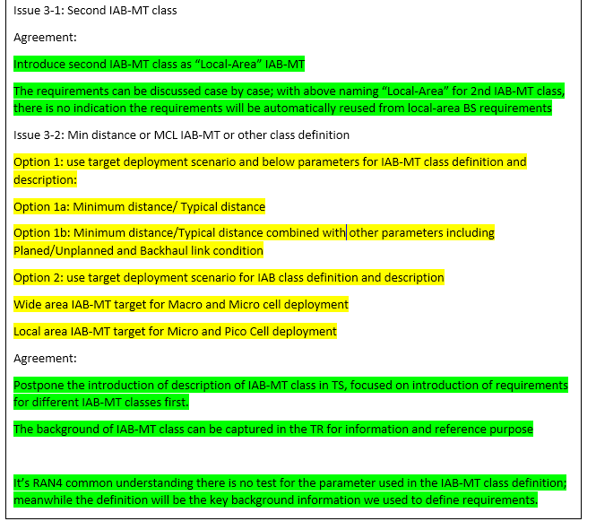

Based on the current status of IAB-MT classes definitions companies are requested to answer the following two questions.

**Question 5: Do you think there should be additional features included in the minimum set of capabilities for Local-Area IAB-MT, in addition to those defined for Wide-Area IAB-MT? If yes, please name these features and provide a justification.**

|  |  |  |
| --- | --- | --- |
| Company | Yes / No / Too soon to tell | Justification and comments |
| QC | Absolutely YES | The IAB WI aims to enable easy deployment of highly densified networks with self-backhauling functionality and means to switch backhaul links in response to short-term blocking. This “local-area” IAB-MT should certainly support this functionality.  The mandatory features for local IAB-MTs should include:  For IAB-MTs operating in ENDC:  0-0 Basic ENDC procedures  3) SN addition, modification, and release via RRC connection reconfiguration  4) Joint processing on the combined RRC messages  5) Failure handling (including both MN and SN)for IAB-MTs operating in ENDC  For IAB-MTs operating in SA:  0-7 PCell operation in FR2 for  Further:  4-1 Intra-NR measurements and reports for SA 4-2 Inter-NR measurements and reports while in LTE connected for ENDC  7-1 Handover  1) Intra frequency handover |
|  |  |  |

**Question 6: Do you think there should be any difference with the approach towards capability signalling for Local-Area IAB-MT as compared to the one used for Wide-Area IAB-MT?**

|  |  |  |
| --- | --- | --- |
| Company | Yes / No / Too soon to tell | Justification and comments |
| QC | YES | The WID claims that IAB allows “..**easier deployment of a dense network of self-backhauled NR cells**”.  The high density of nodes implies that IAB-nodes are “local-area” rather than “wide-area”. For a dense network, capability signalling can help easing deployment and should therefore be supported. |

# 4 Other issues related to IAB-MT capabilities

Companies are requested to raise other issues related IAB-MT capabilities aspect which fall into the scope of this e-mail discussion and which were not addressed by the questions in the previous sections.

|  |  |
| --- | --- |
| Company | Comments |
| QC | The introduction of capability signalling for RAN nodes is certainly a novelty. We need to recognize that it helps easing deployments and therefore provides operators with more flexibility to invest into network expansion. One would expect that this benefits both, operators as well as network vendors. From that perspective, companies in RAN2 should be supportive of capability signalling for IAB. |

# 5 Summary

TBD

# References

1. R4-2005608, *Draft LS on RAN4 IAB-MT feature list agreement*, Source: RAN4
2. R4-2005606, *WF on IAB-MT RAN4 Features*, Qualcomm Incorporated
3. R2-2003361, *Capability signalling for IAB*,Ericsson