1 Introduction
After a lot of testing it was decided to work again with “bubble-comments” but to use it with support of a few macros and specific view-settings in Word.
The macros can be found at the end of this document. They are fairly simple so that you will most probably understand quickly what they do before copying them e.g. into your Normal.dotm fiele. Of course, you use them at your own risk.

2 Step-By-Step

2.1 Getting the macros to work
We will not go into the details of how to use macros in Word. But in short, the steps are as follows:
- Go to the end of this document and copy the macro text
- In Word, press Alt-F11 to open the Visual Basic editor
- Locate the “Normal project”
- If not already present, create a “module” by right-clicking on “Normal”
- Choose that (or any existing) module on the left side and then paste the copied macro text into the window on the right side
It may then look as follows:
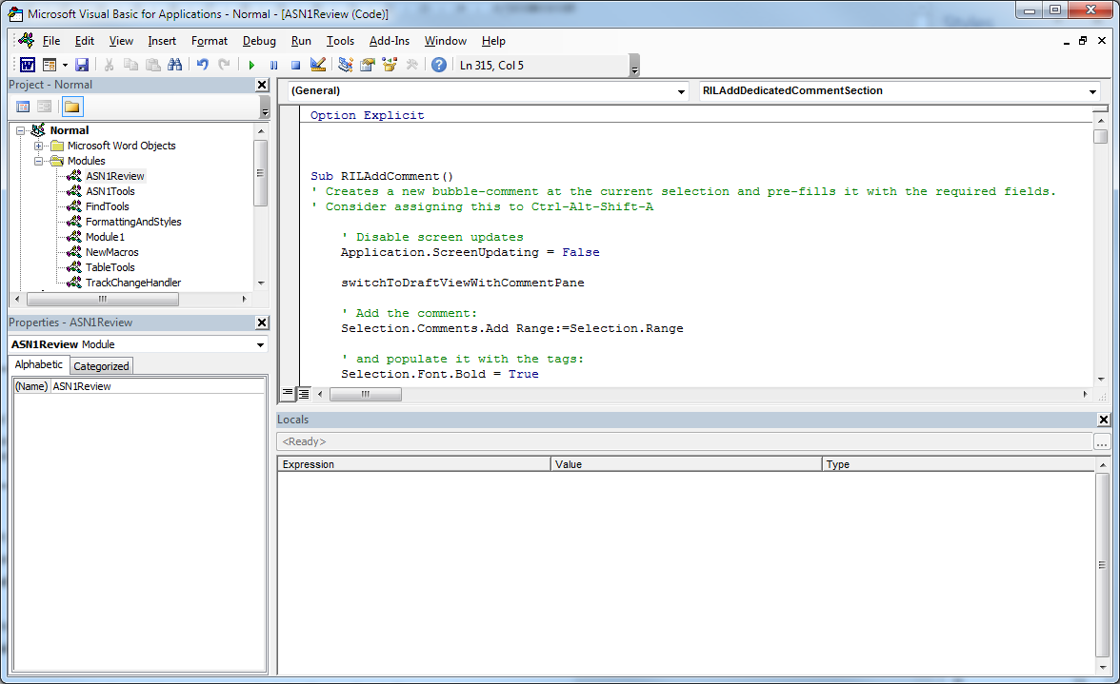

2.3 The correct view
When editing or viewing (large) comments in Print View or when opening a comment in draft view, Word opens by default the “Review Pane”. This view shows not only the review comments but also all tracked changes. The review pane is slow and not really usable for the ASN.1 review. However, when staying in draft view and when the “comment pane” is open, the review pane will usually remain closed. It is therefore suggested to ...
- Review in Normal View (also known as Draft View)
- View and edit comments in the “Comment Pane”
- Use the macro the macro “switchToDraftViewWithCommentPane()” to get the right view.

2.4 Adding new RIL items
It causes sometimes problems if several comments are associated with the same text in the document. To avoid this, a comment should be added to one or a few words – NOT to entire sections or paragraphs
- Comments should be added to one or a few words – NOT to entire sections or paragrpahs.
As mentioned above, review comments are captured in “bubble comments”. But to improve readability and searchability, they should follow a common pattern. To achieve this, we made a little macro called “RILAddComment”. Before calling it, make sure to set the author name in word correctly.
- Set the Author name in word to the name of your company and (optionally) your first name in parenthesis. E.g.: Ericsson (Henning).
The macro creating the actual RIL comment will then set a preliminary RIL tag and the “delegate” field accordingly.
- Use the macro “RILAddComment” to add a new review comment
When creating the RIL comment, you find yourself in the “Comment Pane” inside the newly created comment. Move the cursor a few lines up to fill the missing fields of this RIL entry. Detailed instructions on this point will be provided by the specification rappoerteur. But two important points should be given also here:
- Ensure that the RIL number begins with the letter identifying your company name (e.g. “E” for “Ericsson”) followed by a three digit number that is unique within your company.
- The red fields shall only be edited by the specification or work item rapporteur that moderates the review.
A short description of the identified issue and a proposed change should preferably be put directly into the comment. Since “Tracked Changes” are not supported inside comments, you may use colored/strike-through text or highlighting to show what you changed.
- Preferably add the proposed change into the comment

2.5 If needed: Additional sections or separate files
If the proposed change requires a more space than what you can fit into the RIL comment itself, you may add a section specific to your RIL-comment at the end of the document. The macro “RILAddDedicatedCommentSection” supports you in doing that: With your cursor placed into a RIL comment, execute the macro. It will create a new section at the end of the document and with the name of your RIL comment as heading. It will also add a hyperlink to your RIL comment by which you and others can quickly navigate from the comment to the new section. Note that all meta information shall still be in the comment itself.
- If the RIL comment does not have sufficient space, add a dedicated RIL-item section by the macro “RILAddDedicatedCommentSection”.
If even that separate section for not offer sufficient room for your change or if the problem analysis requires a lot of space, you may create a dedicated document. If so, indicate that in your RIL comment. Preferably add a (draft) document directly to FTP in a subfolder containing your RIL-item’s number.
- If you need even more space, create a separate document. Preferably store a draft in the sub-folder (in FTP) starting with the RIL-ID (e.g. E123) and add a relative hyperlink from the review comment to that file/folder.
To search for RIL comments or to find e.g. all RIL comments marked as “ToDisc” it is recommended to open the Navigation Pane, to use the search function therein and to click the “Result” button in the pane to get a clickable list of all matching items.
- Use the search function in the Navigation Pane, to navigate across and search for RIL items.
The resulting view including “Comment Pane” and “Navigation Pane” in “Result-view” is shown in the following figure:
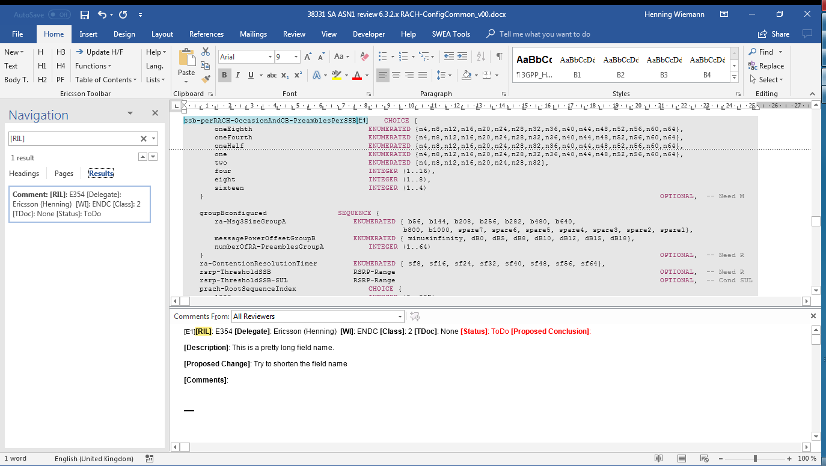

2.2 Adding Short-Cuts
You will probably use the macro for adding new RIL comments quite frequently. You may hence want to add a keyboard shortcut for this and other macros:
- In Word, right-click an empty area in any Ribbon and choose “Customize the Ribbon”. At the bottom of that window click “Keyboard Shortcuts: Choose”. On the upper left side choose “Macros”. Then choose a macro on the upper right side and assign a keyboard shortcut on the lower half. Don’t forget to “Assign” it before closing.

Recommended shortcuts could be:
Ctrl-Shift-Alt-A RILAddComment Add a new RIL comment at the current cursor position in the document
Ctrl-Shift-Alt-D RILAddDedicatedCommentSection Add a subsection at the end of the document (call while inside a RIL comment)
Ctrl-Shift-Alt-C switchToDraftViewWithCommentPane Setup the correct view to review and edit comments
Ctrl-Shift-Alt-E RILCommentsExtract Extract all RIL comments from the current file to a new Excel Worksheet

Annex - Macro souce code
Option Explicit

Sub RILAddComment()
' Creates a new bubble-comment at the current selection and pre-fills it with the required fields.
' Consider assigning this to Ctrl-Alt-Shift-A

correctSettings

RemoveBookmarksFromComments ' Comments in bookmarks are useless but can cause Word to delete all subsequent comments.

If (Selection.Information(wdInCommentPane)) Then
MsgBox "Please select a part of the main document first. RIL documents are not meant to be inside other (RIL-)comments", vbOKOnly, "Error"
Exit Sub
End If

If (Selection.StoryType <> wdMainTextStory) Then
MsgBox "Please select a part of the main document first. ", vbOKOnly, "Error"
Exit Sub
End If

' Disable screen updates
Application.ScreenUpdating = False

switchToDraftViewWithCommentPane

' Add the comment:
Selection.Comments.Add Range:=Selection.Range

' and populate it with the tags:
Selection.Font.Bold = True
Selection.TypeText text:="[RIL]"
Selection.Font.Bold = False
Selection.TypeText text:=": " & UCase(Application.UserInitials) & "xyz " ' & vbNewLine

Selection.Font.Bold = True
Selection.TypeText text:="[Delegate]"
Selection.Font.Bold = False
Selection.TypeText text:=": " & Application.UserName & " " ' & vbNewLine

Selection.Font.Bold = True
Selection.TypeText text:="[WI]"
Selection.Font.Bold = False
Selection.TypeText text:=": " ' & vbNewLine

Selection.Font.Bold = True
Selection.TypeText text:="[Class]"
Selection.Font.Bold = False
Selection.TypeText text:=": " ' & vbNewLine

Selection.Font.Bold = True
Selection.Font.ColorIndex = wdRed
Selection.TypeText text:="[Status]"
Selection.Font.Bold = False
Selection.TypeText text:=": "
Selection.TypeText text:="ToDo "
Selection.Font.ColorIndex = wdAuto
' Selection.TypeText text:=vbNewLine

Selection.Font.Bold = True
Selection.TypeText text:="[TDoc]"
Selection.Font.Bold = False
Selection.TypeText text:=": None " ' & vbNewLine

Selection.Font.Bold = True
Selection.Font.ColorIndex = wdRed
Selection.TypeText text:="[Proposed Conclusion]"
Selection.Font.Bold = False
Selection.TypeText text:=": "
Selection.Font.ColorIndex = wdAuto
Selection.TypeText text:=vbNewLine

Selection.Font.Bold = True
Selection.TypeText text:="[Description]"
Selection.Font.Bold = False
Selection.TypeText text:=": " & vbNewLine

Selection.Font.Bold = True
Selection.TypeText text:="[Proposed Change]"
Selection.Font.Bold = False
Selection.TypeText text:=": " & vbNewLine

Selection.Font.Bold = True
Selection.TypeText text:="[Comments]"
Selection.Font.Bold = False
Selection.TypeText text:=": " & vbNewLine

' Enable screen updates again
Application.ScreenUpdating = True
End Sub

Sub toggleCommentPane()
' Enables or disables the (old fashioned) comment pane.
' Consider assigning this to Ctrl-Alt-Shift-C
WordBasic.ViewAnnotations
End Sub

Sub goToNextComment()
' This macro jumps to the next comment in the document (if any). Unlike the in-built button, it does not open the review pane
' Consider assigning this to Ctrl-Alt-Shift-N
Application.ScreenUpdating = False
Selection.GoTo What:=wdGoToComment, Which:=wdGoToNext, Count:=1

switchToDraftViewWithCommentPane

' The following will never happen since the previous command enforces draft view
If ((ActiveWindow.View.Type = wdPrintView) And (WordBasic.ViewAnnotations = -1)) Then
' In Print View the comment pane does not update automatically.
' Hence, if the comment pane is visible, disable and enable it to jump to the right change.
WordBasic.ViewAnnotations
WordBasic.ViewAnnotations
End If
Application.ScreenUpdating = True
End Sub

Sub goToPreviousComment()
' This macro jumps to the previous comment in the document (if any). Unlike the in-built button, it does not open the review pane
' Consider assigning this to Ctrl-Alt-Shift-P
Application.ScreenUpdating = False
Selection.GoTo What:=wdGoToComment, Which:=wdGoToPrevious, Count:=1

switchToDraftViewWithCommentPane

' The following will never happen since the previous command enforces draft view
If ((ActiveWindow.View.Type = wdPrintView) And (WordBasic.ViewAnnotations = -1)) Then
' In Print View the comment pane does not update automatically.
' Hence, if the comment pane is visible, disable and enable it to jump to the right change.
WordBasic.ViewAnnotations
WordBasic.ViewAnnotations
End If

Application.ScreenUpdating = True
End Sub

Sub editComment()
' Opens the current/next comment at/after the current selection
Dim currentSelection As Range
Dim commentRange As Range

' Don't bother updating the screen:
Application.ScreenUpdating = False

Set currentSelection = Selection.Range
Set commentRange = Selection.Range

switchToDraftViewWithCommentPane

' Locate the next comment.
commentRange.Collapse direction:=wdCollapseStart
commentRange.MoveEnd Unit:=wdStory

If (commentRange.Comments.Count > 0) Then
commentRange.Comments(1).Edit
End If

' and then start displaying something again:
Application.ScreenUpdating = True
End Sub

Sub RILCommentsExtract()

Dim oneComment As Comment
Dim cText As String

Dim importHeading As VbMsgBoxResult

Dim nrofImportedComments As Integer
nrofImportedComments = 0

Dim skippedComments As String
skippedComments = ""

Dim ObjExcel As Object, ObjWorkBook As Object, ObjWorksheet As Object
Dim excelRow As Integer
excelRow = 1

importHeading = MsgBox("Would you like to see the headings of the sections in which each RIL comment was? If so, it may take quite a bit longer to run the macro.", vbYesNo, "Fast or detailed?")

Set ObjExcel = CreateObject("EXCEL.APPLICATION")
ObjExcel.Visible = True
Set ObjWorkBook = ObjExcel.Workbooks.Add
Set ObjWorksheet = ObjWorkBook.Worksheets(1)

With ObjWorksheet
.Activate
.Cells(excelRow, 1).Value = "ID"
.Cells(excelRow, 2).Value = "Delegate"
.Cells(excelRow, 3).Value = "Work Item"
.Cells(excelRow, 4).Value = "Class"
.Cells(excelRow, 5).Value = "TDoc"
.Cells(excelRow, 6).Value = "Status"
.Cells(excelRow, 7).Value = "Processed"
.Cells(excelRow, 8).Value = "Proposed Conclusion"
.Cells(excelRow, 9).Value = "Description"
.Cells(excelRow, 10).Value = "Proposed Change"
.Cells(excelRow, 11).Value = "Comments"
.Cells(excelRow, 12).Value = "Section"

End With

For Each oneComment In ActiveDocument.Comments
cText = oneComment.Range.text
cText = Replace(cText, Chr(5), "")
If (InStr(1, cText, "[RIL]", vbBinaryCompare) = 1) Then
' this comment is a RIL comment
With ObjWorksheet
excelRow = excelRow + 1
.Activate
.Cells(excelRow, 1).Value = extractRowsByTag(cText, "[RIL]:", "[")
.Cells(excelRow, 2).Value = extractRowsByTag(cText, "[Delegate]:", "[")
.Cells(excelRow, 3).Value = extractRowsByTag(cText, "[WI]:", "[")
.Cells(excelRow, 4).Value = extractRowsByTag(cText, "[Class]:", "[")
.Cells(excelRow, 5).Value = extractRowsByTag(cText, "[TDoc]:", "[")
.Cells(excelRow, 6).Value = extractRowsByTag(cText, "[Status]:", "[")
.Cells(excelRow, 7).Value = getColorCode(oneComment, 8, 10)
.Cells(excelRow, 8).Value = extractRowsByTag(cText, "[Proposed Conclusion]:", vbCr & "[")
.Cells(excelRow, 9).Value = extractRowsByTag(cText, "[Description]:", vbCr & "[")
.Cells(excelRow, 10).Value = extractRowsByTag(cText, "[Proposed Change]:", vbCr & "[")
.Cells(excelRow, 11).Value = extractRowsByTag(cText, "[Comments]:", vbCr & "[")
If (importHeading = vbYes) Then
.Cells(excelRow, 12).Value = Replace(getCurrentHeading(oneComment.Scope), vbTab, " ")
End If
End With
nrofImportedComments = nrofImportedComments + 1
Else
skippedComments = skippedComments & vbNewLine & "'" & Mid(cText, 1, min(30, Len(cText))) & "'"
End If
Next
beautifyExcelWorkbook ObjWorksheet
InputBox Prompt:="Skipped comments", Title:="Imported " & nrofImportedComments & " of " & ActiveDocument.Comments.Count & " comments.", Default:=skippedComments
End Sub

Function min(aFirstValue As Integer, aSecondValue As Integer) As Integer
If (aFirstValue < aSecondValue) Then
min = aFirstValue
Else
min = aSecondValue
End If
End Function

Function extractRowsByTag(aSourceText As String, aStartTag As String, anEndTag As String) As String
' Extracts from aSourceText the text in between aStartTag and anEndTag, i.e., without the two tags.
Dim startPos As Integer
Dim endPos As Integer
Dim length As Integer

extractRowsByTag = ""
startPos = InStr(1, aSourceText, aStartTag, vbBinaryCompare)
If (startPos > 0) Then
startPos = startPos + Len(aStartTag)
endPos = InStr(startPos, aSourceText, anEndTag, vbTextCompare)
If (endPos > 0) Then
endPos = endPos
Else
endPos = Len(aSourceText)
End If
length = endPos - startPos
If (length < 0) Then length = 0
extractRowsByTag = Trim(Mid(aSourceText, startPos, length))
End If
End Function

Function getColorCode(ByRef aComment As Comment, aStart As Integer, anEnd As Integer) As String
Dim aWorkRange As Range
Set aWorkRange = aComment.Range.Duplicate
aWorkRange.Collapse wdCollapseStart
aWorkRange.Move wdCharacter, aStart
aWorkRange.MoveEnd wdCharacter, anEnd - aStart

If (aWorkRange.HighlightColorIndex = wdNoHighlight) Then
getColorCode = ""
'aComment.Done = False
ElseIf (aWorkRange.HighlightColorIndex = wdBrightGreen) Then
getColorCode = "Done"
'aComment.Done = True
ElseIf (aWorkRange.HighlightColorIndex = wdGray25) Then
getColorCode = "NoChange"
'aComment.Done = True
ElseIf (aWorkRange.HighlightColorIndex = wdRed) Then
getColorCode = "ToDisc"
'aComment.Done = False
ElseIf (aWorkRange.HighlightColorIndex = wdYellow) Then
getColorCode = "ToDo"
'aComment.Done = False
Else
getColorCode = aWorkRange.HighlightColorIndex
End If
End Function

Sub switchToDraftViewWithCommentPane()
If (Not ActiveWindow.View.Type = wdNormalView) Then
' Close any review- or comment-pane if open:
ActiveWindow.View.SplitSpecial = wdPaneNone
' Then switch to normal view (draft) since that is the only safe way to
' prevent the ReviewPane from opening later
ActiveWindow.View.Type = wdNormalView
End If

' If the comment pane is currently not visible...
If (WordBasic.ViewAnnotations = 0) Then
' ... enable it.
WordBasic.ViewAnnotations 1
Else
WordBasic.ViewAnnotations 0
End If
End Sub

Sub showCurrentHeadingName()
MsgBox "Heading: " & getCurrentHeading(Selection.Range), vbOKOnly
End Sub

Function getCurrentHeading(aRange As Range) As String
getCurrentHeading = ""

Dim currentParagraph As Range
Set currentParagraph = aRange.Duplicate
currentParagraph.Expand Unit:=wdParagraph

Do While (Not isHeading(currentParagraph))
If (currentParagraph.Move(wdParagraph, -2) = 0) Then
' the range did not move. stop here to avoid deadlock
Exit Function
End If
currentParagraph.Expand Unit:=wdParagraph
Loop
If (isHeading(currentParagraph)) Then
getCurrentHeading = currentParagraph.text
End If
End Function

Function isHeading(aRange As Range) As Boolean
isHeading = False
If (Not aRange.Style Is Nothing) Then
If (InStr(1, aRange.Style.NameLocal, "Heading") = 1) Then
isHeading = True
End If
End If
End Function

Sub RILAddDedicatedCommentSection()
'
' To be executed while in a RIL comment. It adds a new heading (H2) to the end of this document
' with the RIL number as text. It adds also a hyperlink to that heading into the
' currently chosen comment.
'

Dim currentComment As Comment
Dim newHeadingRange As Range
Dim hyperlinkRange As Range
Dim rilTag As String

If (Not Selection.Information(wdInCommentPane)) Then
MsgBox "You must select a comment in the comment pane to add an in-line review section", vbOKOnly, "Error"
Exit Sub
End If

Set currentComment = Selection.Comments(1)

' Get and check RIL tag
rilTag = CleanText(extractRowsByTag(currentComment.Range.text, "[RIL]: ", "["))
If (rilTag = "") Then
MsgBox "This is apparently not a RIL comment, i.e., it does not contain a valid RIL ID."
Exit Sub
End If
If (InStr(1, rilTag, "xyz") > 0) Then
MsgBox "Assign a valid RIL number first. Otherwise, the hyperlinking will fail later"
Exit Sub
End If

' Go from comment to actual document and jump to the end.
ActiveDocument.Select
Selection.Collapse wdCollapseEnd
ActiveDocument.TrackRevisions = False

' Insert a new section of style "H2", fill the heading row and create a bookmark
Selection.TypeParagraph
Selection.Style = ActiveDocument.Styles("Heading 2")
Selection.TypeText text:=rilTag
Set hyperlinkRange = Selection.Range
hyperlinkRange.Expand Unit:=wdParagraph
Selection.TypeParagraph

' Add a bookmark to this heading
With ActiveDocument.Bookmarks
.Add Range:=hyperlinkRange, Name:="_" & rilTag
.DefaultSorting = wdSortByName
End With

' Go back to the comment
currentComment.Range.Select
Selection.Collapse wdCollapseEnd

Selection.TypeParagraph
Selection.TypeText text:="["
ActiveDocument.Hyperlinks.Add _
Anchor:=Selection.Range, _
Address:="", _
SubAddress:="_" & rilTag, _
ScreenTip:="", _
TextToDisplay:="DedicatedSection"
Selection.TypeText text:="]"
End Sub

Function CleanText(strInput As String) As String
Dim i As Long, strTemp As String

strInput = Trim(strInput)

Do Until (Asc(Left(strInput, 1)) > 65 And Asc(Left(strInput, 1)) < 90) Or _
(Asc(Left(strInput, 1)) > 97 And Asc(Left(strInput, 1)) < 122) Or Len(strInput) = 0
Select Case Asc(Left(strInput, 1))
Case 65 To 90, 97 To 122
Case Else: strInput = Mid(strInput, 2)
End Select
Loop

strTemp = Left(strInput, 1)

For i = 2 To Len(strInput)
Select Case Asc(Mid(strInput, i, 1))
Case 65 To 90, 97 To 122, 95, 48 To 57
strTemp = strTemp & Mid(strInput, i, 1)
End Select
Next
ExitF:
CleanText = strTemp
End Function

Function beautifyExcelWorkbook(aWorksheet As Object)
With aWorksheet
' column width
.Columns("A:G").EntireColumn.AutoFit
.Columns("H:H").ColumnWidth = 35
.Columns("I:I").ColumnWidth = 35
.Columns("J:J").ColumnWidth = 25
.Columns("K:K").EntireColumn.AutoFit

' text wrapping
.Columns("H:J").WrapText = True

.Columns("A:K").VerticalAlignment = xlTop
.Columns("C:F").HorizontalAlignment = xlCenter

.Rows("1:1").Font.Bold = True

.Rows("1:1").AutoFilter
End With
End Function

Function correctSettings()

' Disable automatic detection of language (reduces the risk of doing random
' language changes to a document)
Application.CheckLanguage = False

' Disable tracked changes
ActiveDocument.TrackRevisions = False

' Make sure that Word uses the user information as entered
' explicitly in word. Otherwise, all user names in tracked changes
' may screw up!
Application.Options.UseLocalUserInfo = True

End Function

Sub RemoveBookmarksFromComments()
' It happens that Bookmarks end up in such comments. Word does not complain about this while working with
' and saving the document. But when opening it later, the document may be corrupted.
' This macro removes all such bookmarks in Comments.

Dim oneComment As Comment
Dim oneBookmark As Bookmark

Dim nrofBookmarksInComments As Integer
nrofBookmarksInComments = 0
Dim nrofBookmarksInScope As Integer
nrofBookmarksInScope = 0

Dim commentsWithBoomarks As String
commentsWithBoomarks = ""
Dim commentsWithBookmarkInScope As String
commentsWithBookmarkInScope = ""

With ActiveDocument.Bookmarks
.DefaultSorting = wdSortByName
.ShowHidden = True
End With

For Each oneComment In ActiveDocument.Comments
If (oneComment.Range.Bookmarks.Count > 0) Then
For Each oneBookmark In oneComment.Range.Bookmarks
oneBookmark.Delete
nrofBookmarksInComments = nrofBookmarksInComments + 1
Next
commentsWithBoomarks = commentsWithBoomarks & "'" & Mid(oneComment.Range.text, 1, min(40, Len(oneComment.Range.text))) & "'" & vbNewLine
End If

' Search for bookmarks in the scope of the comment (where the comment is linked into the document)
' If (oneComment.Scope.Bookmarks.Count > 0) Then
' For Each oneBookmark In oneComment.Scope.Bookmarks
' oneBookmark.Delete
' nrofBookmarksInScope = nrofBookmarksInScope + 1
' Next
' commentsWithBookmarkInScope = commentsWithBookmarkInScope & "'" & Mid(oneComment.Range.text, 1, min(40, Len(oneComment.Range.text))) & "'" & vbNewLine
' End If
Next

If (nrofBookmarksInComments > 0) then
InputBox Prompt:="Comments with bookmarks may leed to data loss and were hence removed:", Title:="Deleted " & nrofBookmarksInComments & " bookmarks from comments.", Default:=commentsWithBoomarks
End if
' If (nrofBookmarksInScope > 0) then
' InputBox Prompt:="Comments in the scope of bookmarks may lead to data loss and were hence removed:", Title:="Deleted " & nrofBookmarksInScope & " bookmarks from comments' scope.", Default:=commentsWithBookmarkInScope
' End if

End Sub

