Agenda Item: 6
Source: ZTE, Sanechips
Title: LOS probability model in IIOT scenario

Introduction
3GPP RAN1 #97 meeting agreed a LOS probability model framework as following:
Proposal 7: Use a common LOS probability function for all sub-scenarios, with sub-scenario specific parameters:
${Pr}_{LOS,subsce}\left[d_{2D}\right]=\left\{\begin{aligned}p_{subsce},d_{2D}≤d_{subsce}\left[m\right] \\ e^{\left(-\frac{d_{2D}-d_{subsce}}{k_{subsce}}\right)}⋅p_{subsce},d_{2D}>d_{subsce}\left[m\right]\end{aligned}\right.$
Where
  - is the 2D distance between transmitter and receiver;
  - is the breakpoint distance
  - is the breakpoint LOS probability
  - is the exponential coefficient for corresponding sub-scenario
  - The parameter values for the different sub-scenarios is FFS, including:
    - how to merge results from different sources
    - whether the parameter values should be obtained from empirical curve-fitting or analytical considerations
    - whether the parameters should be dependent on the clutter density and size
This document further addresses the LOS probability model based on above RAN1 agreement and the earlier simulation work as well as modeling analysis.

LOS probability based on ray-tracing fitting
The ray-tracing simulation of LOS probability is applied to the IIOT scenario shown in Figure 2-1, which is also given by 5G-ACIA to trigger this IIOT channel model study-item. The whole indoor 3D space has the volume of 180m(L) x 80m(W) x 25m(H) and is partitioned into four areas:
- Area1 (storage area) contains
  - 3 metallic shelves, each of size 75m(L)x5m(W)x5.3m(H). There are metal objects on the shelves.
  - 2 AGVs, each of size 3.5m(L)x1.2m(W)x2.8m(H).
- Area2 (production area) contains
  - 13 production tables, each of size 32m(L)x2m(W)x1.5m(H). There are metal objects on the tables.
  - 32 robots, each of size 3m(L)x2m(W)x3.5m(H) but with different posture.
- Area3 (commission/office area):
  - 4 metal testing beds, each of size 38m(L)x0.6m(W)x2.2m(H) and with metallic objects on it.
  - 3 AGVs, each of size 0.8m(L)x0.6m(W)x1.0m(H).
  - Multiple offices with 5m office ceiling height and internal tables/chairs. The offices have gypsum plasterboard walls in-between but no wall towards commission area.
- Area4 (assembly area) contains
  - 3 transportation belts, with metallic objects on each.
  - 3 assembly panels, with metallic objects on each.
There are totally 7019 surfaces generated in the simulation.
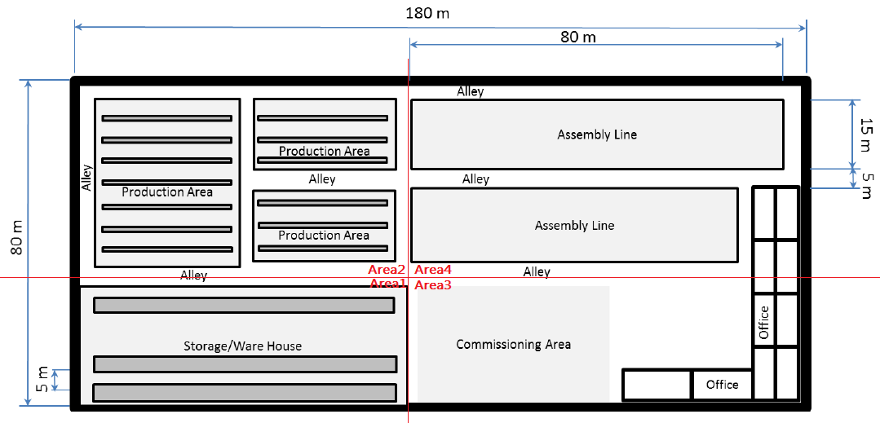
- Sub-scenario partition
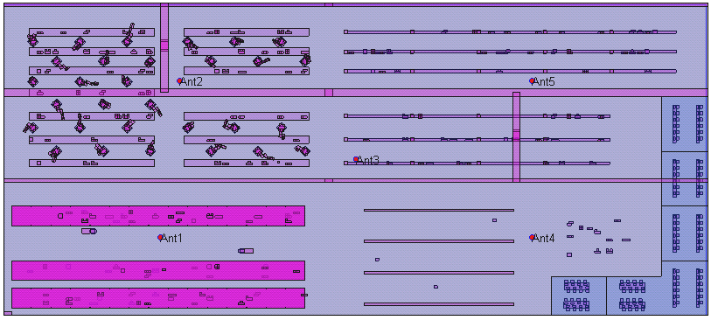
- Bird-eye 2D view of ray-tracing map
Figure 2-1 IIOT scenario map for ray-tracing simulation
Base stations with height selected from {2m, 10m, 15m and 22m} are located in 5 different 2D positions shown in Figure 2-1(b), and 1600 UEs of height =1.5m are uniformly distributed across the whole non-occupied floor space. For each sub-area, the LOS conditions are collected for the UEs in that sub-area but associating with base stations in all sub-areas.
The raw LOS probabilities of ray-tracing results and the corresponding empirical fitting curves are given in [3] and copied in Appendix A. The fitting curves are copied to Figure 2-2. The corresponding modelling parameters for the fitting curves are given in Table 2-1 and Table 2-2.

Table 2-1 Fitting curve parameters for embedded BS
 | Area1 | Area2 | Area 3 | Area4
k_{subsce} | 78 | 33 | 62 | 66
d_{subsce} | 1m | 1m | 1m | 1m
p_{subsce} | 1 | 1 | 1 | 1
Table 2-2 Fitting curve parameters for elevated BS
 |  | Area1 | Area2 | Area3 | Area4
k_{subsce} | BS @ 10m | 104 | 101 | 277 | 503
 | BS @ 15m | 94 | 148 | 314 | 530
 | BS @ 22m | 58 | 164 | 77 | 330
d_{subsce} |  | 1m | 6.25m | 6.96m | 7m
p_{subsce} |  | 0.6 | 1 | 1 | 1
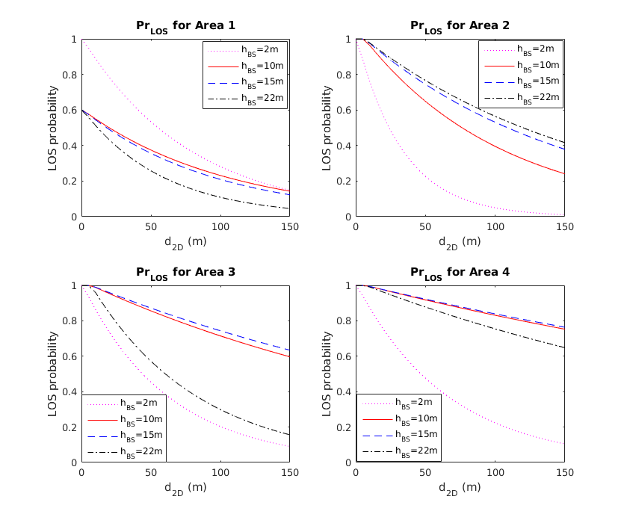
Figure 2-2 Ray-tracing fitting curves for LOS probability
It can be observed that, for the elevated BS case,
- In Areas {1,3,4}, LOS probabilities for BS heights of {10m, 15m} are similar, but are higher than that for BS height of 22m. This is because
  - The storage shelves in Area1 are tall and hollow – the line-of-sight from 22m-BS could be blocked by shelves but the line-of-sight from lower BS can pass through.
  - The offices in Area3 and Area4 have the ceiling of 5m high, and the UE’s in the offices may see line-of-sight to lower BS but not to 22m-high BS.
- In Area2, the higher the BS, the larger the LOS probability. This is because the production tables have the same height as UE height and therefore do not affect the LOS condition for the UE, and all the clutters above the UE height (robots) are not hollow.
- Except for Area3, the difference among LOS probabilities for BS heights of {10, 15, 22}m is not large. However, if the internal offices in Area3 also have walls towards the commission area, the LOS probabilities for {10,15}m-high BS may also reduce, getting closer to that of 22m-high BS.
Observation 1: For BS-elevated case, LOS probability could depend on BS height, but such dependency may not be monotone and the difference of LOS probability caused by different BS height is generally not large.
It is also observed that, for the BS-embedded case,
- Even though Area1 (with high storage shelves) has lower LOS probability than other areas for BS-elevated case, the Area1 has higher LOS probability than other areas for the BS-embedded case. This is because the BS in Area1 (i.e., Ant1 in Figure 2-1) is located in the open aisle, causing LOS to most of UEs in this sub-area, and the hollow shelves does not necessarily block LOS path from other 2m-high BSs in other sub-areas. The hollow clutter in this case seems to have the similarly contribution to LOS condition as the clutter lower than both BS and UE in BS-elevated case.
- The Area2 has the lowest LOS probability. This is due to a large portion of NLOS contribution by 2m-high BS in Area3 (i.e., Ant4 in Figure 2-1), which is blocked behind the higher testing bed in Area3.
Observation 2: For BS-embedded case, the LOS probability in one homogeneous sub-area could be influenced by the clutter deployment in a different sub-area, given the suggested IIOT scenario by 5G-ACIA is heterogeneous.
Observation 3: The sub-area with lower LOS probability for BS-elevated case does not necessarily have lower LOS probability for BS-embedded case.
For the purpose of sub-area classification based on clutter density, even though it is a common understanding that the clutter density is defined as the percentage of 2D-projection area for all the clutters, we think the clutter density in measuring the LOS probability can be somehow different from the clutter density measuring other channel model aspects such as pathloss and fast fading, due to at least the following facts:
- The hollow clutter and the solid clutter that have the same 2D projection area can have significantly different impacts to the LOS probability.
- The clutter that is no higher than the UE height does not indeed impact the LOS probability.
For the LOS probability model based on empirical fitting curve method, it is sufficient to define LOS probability for up to three clutter densities: low, medium and high. Based on LOS probabilities shown in Figure 2-2, we map the four simulation areas to the three clutter densities as following:
 | Embedded BS |  |  | Elevated BS
Clutter density | high | medium | low | high | medium | low
Sub-areas | Area2 | Area3 & Area4 | Area1 | Area1 | Area2 & Area3 | Area4
Proposal 1: For LOS probability model based on empirical fitting curve method,
- The dependency on BS height only distinguishes between BS elevated and BS embedded, but not any exact BS height.
  - For the BS elevated case, the model parameters take the average across different BS heights.
- The modelling parameters depend on up to three clutter densities: low, medium and high.
- The modelling parameters are given in table below.
 | BS embedded |  |  | BS elevated
Clutter density | high | medium | low | high | medium | low
k_{subsce} | 33 | 64 | 78 | 85 | 180 | 454
d_{subsce} | 1m | 1m | 1m | 1m | 7m | 7m
p_{subsce} | 1 | 1 | 1 | 0.6 | 1 | 1

LOS probability based on analytical model
An analytical model derived from simplified propagation geometry [4] is given below, as a function of 2D distance (d_{2D}) and clutter density (r).
$p_{LOS}\left(d_{2D},r\right)=\left\{\begin{matrix}{\left(1-r\right)}^{\frac{d_{2D}}{d_{clutter}}} & BS embedded \\ {\left(1-r\right)}^{\frac{d_{2D}}{d_{clutter}}∙\frac{h_{c}-h_{UT}}{h_{BS}-h_{UT}}} & BS elevated\end{matrix}\right.$ (1)
Denote
$A=\left\{\begin{matrix}\frac{1}{d_{clutter}} & BS embedded \\ \frac{1}{d_{clutter}}∙\frac{h_{c}-h_{UT}}{h_{BS}-h_{UT}} & BS elevated\end{matrix}\right.$ (2)
Then the equivalence between (1) and RAN1 agreed LOS probability formulation requires $k_{subsce}=\frac{-1}{A∙\ln\left(1-r\right)}$, $d_{subsce}=0$ and $p_{subsce}=1$. We see two potential issues on this modelling.
- For BS elevated case, the LOS probability increases as BS height (h_{BS}) increases. Although this can be true in some scenarios like in Area2 of Figure 2-1, it is not the general fact according to the ray-tracing simulation conclusion for other areas of Figure 2-1.
- For BS elevated case, forcing $p_{subsce}=1$ does not generally reflect the real situation where the clutter density is high. However, if $p_{subsce}≠1$, $p_{subsce}=e^{-\frac{d_{subsce}}{k_{subsce}}}$ has to hold in order to keep equation (1) compatible to RAN1 agreed formulation, which means at least one of $p_{subsce}$ and $d_{subsce}$ has to be dependent on BS height and clutter density because $k_{subsce}=\frac{-1}{A∙\ln\left(1-r\right)}$ is. However, there is no analytical work undergoing for such parameter dependency for $p_{subsce}$ and $d_{subsce}$.
Because the model in equation (1) has its own benefit of calculating LOS probability upon a given quantized clutter density, which could be useful in certain simulation setup, we propose to consider a modified version that is given below.
$p_{LOS}\left(d_{2D},r\right)=\left\{\begin{matrix}p_{subsce} & d_{2D}≤d_{subsce} \\ p_{subsce}∙{\left(1-r\right)}^{A∙\left(d_{2D}-d_{subsce}\right)} & d_{2D}>d_{subsce}\end{matrix}\right.$ (3)
The model in (3) only requires $k_{subsce}=\frac{-1}{A∙\ln\left(1-r\right)}$ to keep its equivalence to RAN1 agreed formulation where A follows equation (2). Note that $p_{subsce}$ and $d_{subsce}$ need to be function of r if they are clutter density dependent.
The modeling in both (1) and (3) are tested against the ray-tracing results for Area1 and Area2 of Figure 2-1, where the following parameters in Table 3-1 are assumed.
Table 3-1 Parameters used to test analytical model
 | r | $$p_{subsce}$$ | $d_{subsce}$ (m) | $d_{clutter}$ (m)⁽¹⁾ | h_{c} (m)⁽²⁾ | h_{BS} (m) | h_{UT} (m)
Area 1 | 0.35 | 1 (If h_{BS}=2)  0.6 (otherwise) | 1 | 15.1 | 5.2 | 2,10,15,22 | 1.5
Area 2 | 0.06 | 1 | 1 (If h_{BS}=2)  6.25 (otherwise) | 2.45 | 3.5 | 2,10,15,22 | 1.5
Note 1: $d_{clutter}$ is calculated as 1D horizontal width averaged over all horizontal surfaces, i.e., with N clutters
$$d_{clutter}=\sqrt{\frac{1}{N}\sum_{i=1}^{N}{\left(L_{i}∙W_{i}\right)}}$$
Note 2: h_{c} is calculated as
$$h_{c}=\frac{\sum_{i=1}^{N}{\left(L_{i}∙H_{i}+W_{i}∙H_{i}\right)}}{\sum_{i=1}^{N}{\left(L_{i}+W_{i}\right)}}$$
Where L_{i}, W_{i}, and H_{i} are the length, width and height of clutter i, respectively.
The testing comparisons in Figure 3-1 (for BS embedded case) and Figure 3-2 (for BS elevated case) show that the analytical model works better in Area 2, especially for BS-embedded case. However, the analytical model diverges from ray-tracing results in Area 1; it even shows the opposite dependency upon BS height in Area1.
Observation 4: The analytical model can give the LOS probability well-matching ray-tracing results in some scenarios, but not in all considered scenarios.
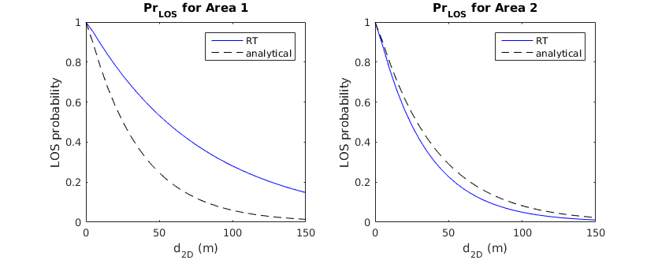
Figure 3-1 LOS comparison for BS embedded case
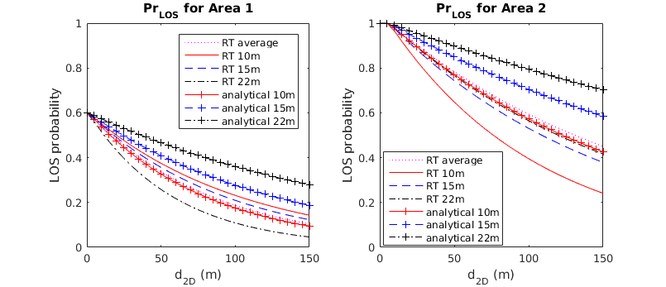
Figure 3-2 LOS comparison for BS elevated case
Proposal 2: For analytical LOS probability model, use following formula to calculate $k_{subsce}$, where r is the effective clutter density after removing the clutters no higher than UE, $d_{clutter}$ represents the clutter size, {$h_{c}$,$h_{BS}$,$h_{MS}$} are the heights of clutter, base station and terminal, respectively.
$$k_{subsce}=\left\{\begin{matrix}-\frac{d_{clutter}}{\ln\left(1-r\right)} & BS embedded \\ -\frac{d_{clutter}}{\ln\left(1-r\right)}∙\frac{h_{BS}-h_{UT}}{h_{c}-h_{UT}} & BS elevated\end{matrix}\right.$$
- $p_{subsce}$ and $d_{subsce}$ are FFS.

Conclusion
In this contribution, the LOS probability models are proposed based on simulation results in an indoor industry scenario with the following observations and proposals:
Observation 1: For BS-elevated case, LOS probability could depend on BS height, but such dependency may not be monotone and the difference of LOS probability caused by different BS height is generally not large.
Observation 2: For BS-embedded case, the LOS probability in one homogeneous sub-area could be influenced by the clutter deployment in a different sub-area, given the suggested IIOT scenario by 5G-ACIA is heterogeneous.
Observation 3: The sub-area with lower LOS probability for elevated-BS does not necessarily have lower LOS probability for embedded-BS.
Observation 4: The analytical model can give the LOS probability well-matching ray-tracing results in some scenarios, but not in all considered scenarios.
Proposal 1: For LOS probability model based on empirical fitting curve method,
- The dependency on BS height only distinguishes between BS elevated and BS embedded, but not any exact BS heights.
  - For the BS elevated case, the model parameters take the average across different BS heights.
- The modelling parameters depend on up to three clutter densities: low, medium and high.
- The modelling parameters are given in table below.
 | BS embedded |  |  | BS elevated
Clutter density | high | medium | low | high | medium | low
k_{subsce} | 33 | 64 | 78 | 85 | 180 | 454
d_{subsce} | 1m | 1m | 1m | 1m | 7m | 7m
p_{subsce} | 1 | 1 | 1 | 0.6 | 1 | 1
Proposal 2: For analytical LOS probability model, use following formula to calculate $k_{subsce}$, where r is the effective clutter density after removing the clutters no higher than UE, $d_{clutter}$ represents the clutter size, {$h_{c}$,$h_{BS}$,$h_{MS}$} are the heights of clutter, base station and terminal, respectively.
$$k_{subsce}=\left\{\begin{matrix}-\frac{d_{clutter}}{\ln\left(1-r\right)} & BS embedded \\ -\frac{d_{clutter}}{\ln\left(1-r\right)}∙\frac{h_{BS}-h_{UT}}{h_{c}-h_{UT}} & BS elevated\end{matrix}\right.$$
- $p_{subsce}$ and $d_{subsce}$ are FFS.

References
- R1-1907758, Summary of offline discussion on Study on Channel Modeling for Indoor Industrial Scenarios, Ericsson
- R1-1902112, About IIOT scenario, ZTE, Sanechips, BJTU, Tongji University
- R1-1907126, Discussion on LOS probability model in IIOT scenario , ZTE, Sanechips, BJTU
- R1-1907703, Views on the path loss and LOS probability, Ericsson

Appendix A. Ray tracing simulation results (from [3])
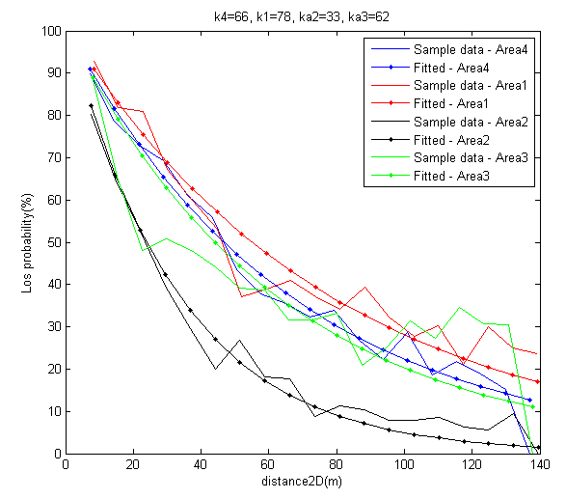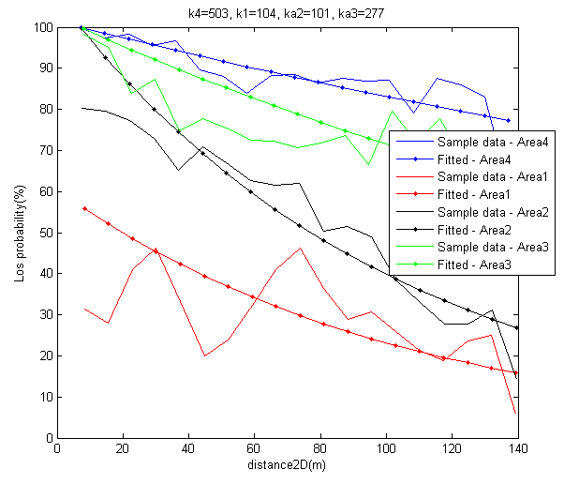
(a) h_{BS}=2m (b) h_{BS}=10m
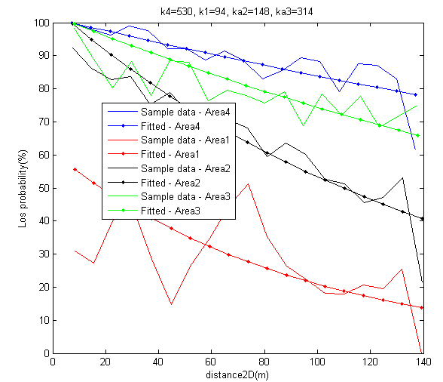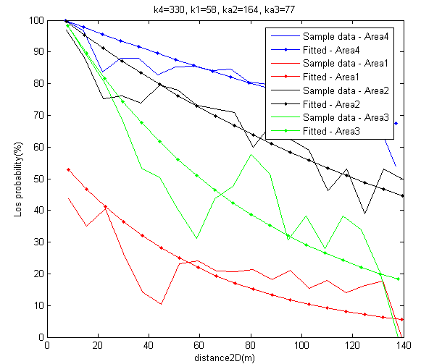
(c) h_{BS}=15m (d) h_{BS}=22m

Appendix B. More internal views of ray-tracing map
Area1
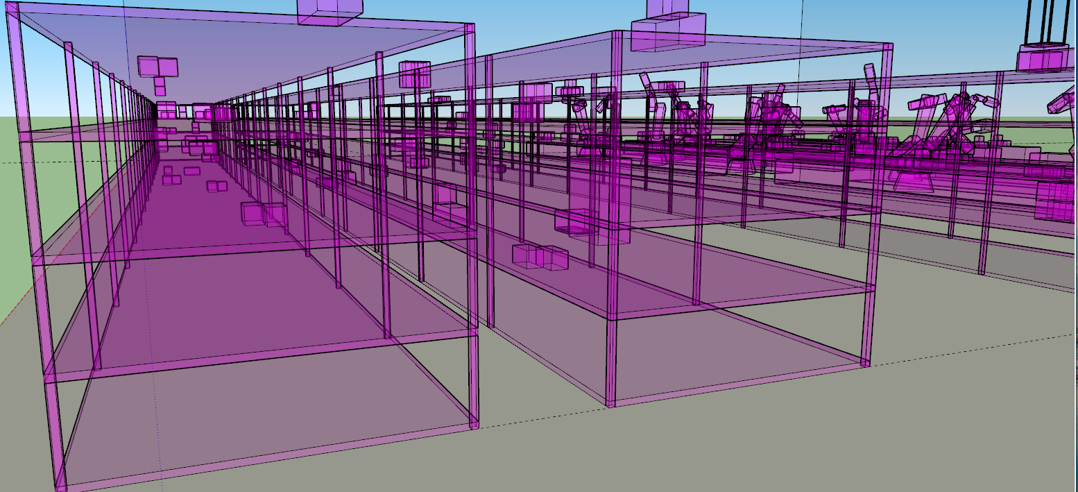
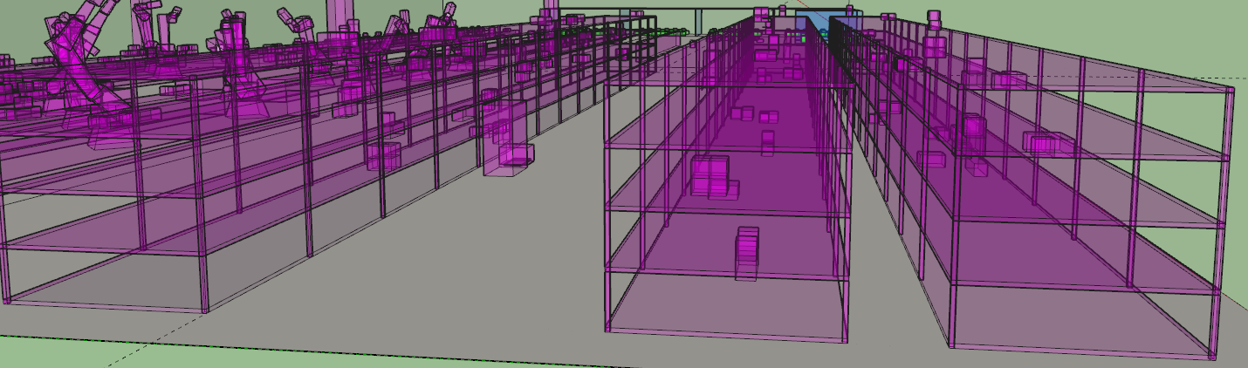
Area2
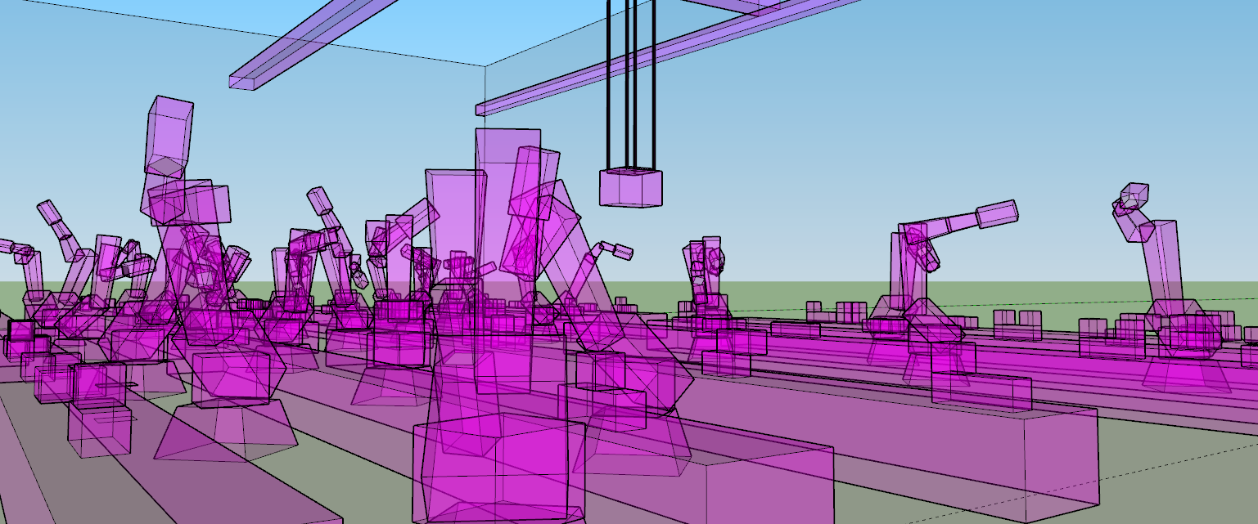
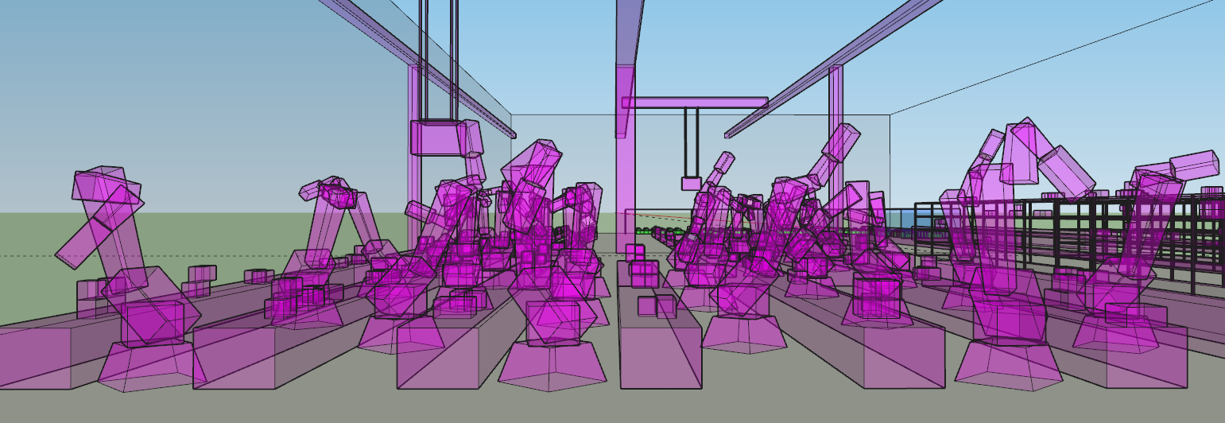
Area3
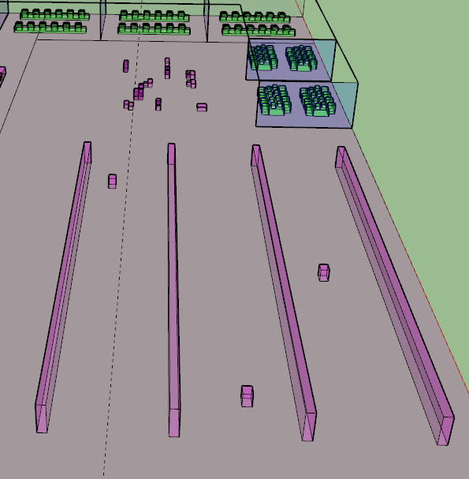
Area4
