3GPP TSG-RAN Meeting #103 RP-240060
Maastricht, The Netherlands, March 18 – 21, 2024

Title: Summary for NR NTN (Non-Terrestrial Networks) enhancements
Type: Work Item Summary
Agenda Item: 5.2 - TSG RAN WG2
Source: Thales
Contact: nicolas.chuberre@thalesaleniaspace.com

This document is a contribution to TR 21.918 ("Release 18 Description; Summary of Rel-18 Work Items"). It is meant to be endorsed by the RAN plenary.

Introduction

This set of Rel-18 RAN Work items related to "NR NTN (Non-Terrestrial Networks) enhancements" introduces enhancements for the support of non-terrestrial networks into the NR and NG-RAN architecture as defined in Rel-17 RAN2 led “NR-NTN-solutions” WI. These enhancements include:
- Offer increased uplink coverage performance especially when addressing commercial smartphones with -5.5 dBi antenna gain and 3 dB polarisation loss (per antenna port)
- Support of Geostationary Orbit (GSO) as well as non-Geostationary Orbit (NGSO) deployment scenarios in the [DownLink: 17.7 -20.2 GHz; UpLink: 27.5 – 30.0 GHz] frequency bands
- Support the verification by the network of the location (i.e. GNSS coordinates) reported by the UE assuming a single satellite in view in order to fulfil the regulatory requirements (e.g., Lawful intercept, emergency call, Public Warning System, …)
- Provide NTN-TN and NTN-NTN measurement, mobility and service continuity enhancements considering the NTN characteristics such as large propagation delay and satellite movement
- Define 30 MHz channel bandwidth for n256 and n255 for 5G NR-NTN and introduce the corresponding SAN and UE RF core requirements, limited to clause 5 (Operating Bands and Channel Arrangement) requirements for these specifications

WI ref | WI title | WI acronym |  | TDOC | Rapporteur(s)
941006 | NR NTN (Non-Terrestrial Networks) enhancements | NR_NTN_enh |  | RP-232669 | Nicolas Chuberre, Thales
941106 | Core part: NR NTN (Non-Terrestrial Networks) enhancements | NR_NTN_enh-Core | R2 | RP-232669 | Nicolas Chuberre, Thales
941206 | Perf. part: NR NTN (Non-Terrestrial Networks) enhancements | NR_NTN_enh-Perf | R2 | RP-232669 | Nicolas Chuberre, Thales
960091 | Study on requirements and use cases for network verified UE location for Non-Terrestrial-Networks (NTN) in NR | FS_NR_NTN_netw_verif_UE_loc | RP | RP-221820 | Thales
1000060 | 30 MHz Channel Bandwidth for NR NTN (non-terrestrial networks) in FR1 (frequency range 1) | NR_NTN_CBW_30MHz | R4 | RP-232647 | Dorin Panaitopol, THALES
1001060 | Core part: 30 MHz Channel Bandwidth for NR NTN (non-terrestrial networks) in FR1 (frequency range 1) | NR_NTN_CBW_30MHz-Core | R4 | RP-232647 | Dorin Panaitopol, THALES

Note: System aspects are covered in Rel-18 SA WI ”5GSAT_Ph2” and core networks aspects are covered in Rel-18 CT WI « 5GSAT_ph2-CT ».

Description

Compared to the solutions enabling NR/NG-RAN to support NTN, Release 18 has defined a set of enhancements which are described here after.

Uplink coverage enhancements

To improve NR uplink coverage in NTN, the following enhancements are introduced as part of the Rel-18 Work Item:
- PUCCH repetition for Msg4 HARQ-ACK:
- Supported number of transmissions are 1, 2, 4, 8.
  - If a single value from {2, 4, 8} is configured via SIB, the configured repetition factor is applied.
  - If multiple values from {1, 2, 4, 8} are configured via SIB, one of the multiple values is indicated in DAI field of DCI format 1_0 with CRC scrambled by TC-RNTI.
- The existing mechanism on repetition slot counting (as in section 9.2.6 of TS 38.213) is applied.
- Frequency hopping mechanism in R15/16/17 defined for PUCCH transmission for Msg4 HARQ-ACK, in every slot is applied.
- A RSRP threshold can be configured via SIB when the number of repetitions is configured by SIB. If the RSRP threshold is configured, UE capable of PUCCH repetition for Msg4 HARQ-ACK reports the capability of PUCCH repetition for Msg4 HARQ-ACK via Msg3 PUSCH only if measured RSRP is lower than the configured RSRP threshold. If the RSRP threshold is not configured, UE capable of PUCCH repetition for Msg4 HARQ-ACK reports the capability of PUCCH repetition for Msg4 HARQ-ACK via Msg3 PUSCH.
- The repetition factor applied to Msg4 HARQ-ACK is used also for any PUCCH transmission before dedicated PUCCH resource is provided.
- NTN-specific PUSCH DMRS bundling enhancement that enables DMRS bundling in presence of timing drift, whereby UE maintains phase continuity considering effects of transmission delay variation between UE and uplink time synchronization reference point to enable improved channel estimation.

NR-NTN deployment in above 10 GHz bands a.k.a FR2-NTN frequency range (17300 MHz – 30000 MHz)

To support NR NTN deployment in FR2-NTN using FDD duplexing mode, the following aspects were considered in Release-18:
- For operation in FR2-NTN, the value range in ms for K_offset and K-MAC shall be the same as for Rel-17 NR over NTN.
- For operation in FR2-NTN, use a reference SCS of 15 kHz for the indication of K_offset and K_MAC.
- For operation in FR2-NTN and for Rel-18, no additional MAC CE TCI application delay is introduced to facilitate mechanical beam steering with VSAT.
- For operation in FR2-NTN, for cell search procedure, Case D and Case E in TS 38.213 are used to allow FDD operation in bands defined by FR2-NTN without any update to SSB pattern.
- From RAN1 perspective, for operation in FR2-NTN, the granularity used for TA reporting is the same as corresponding to the reference subcarrier spacing applied for K_offset.
- For PRACH configuration for operation in FR2-NTN, Table 6.3.3.2-4 of TS 38.211 is used as baseline.

In Release-18, the following NTN operating bands in above 10 GHz for satellite networks (FR2-NTN) have been introduced:
n512¹ | 27.5 - 30.0 GHz | 17.3 - 20.2 GHz | FDD
n511² | 28.35 - 30.0 GHz | 17.3 - 20.2 GHz | FDD
n510³ | 27.5 - 28.35 GHz | 17.3 - 20.2 GHz | FDD
NOTE 1: This band is applicable in the countries subject to CEPT ECC Decision(05)01 and ECC Decision (13)01.
NOTE 2: This band is applicable in the USA subject to FCC 47 CFR part 25.
NOTE 3: This band is applicable for Earth Station operations in the USA subject to FCC 47 CFR part 25. FCC rules currently do not include ESIM operations in this band (47 CFR 25.202).

Moreover, the following VSAT classes and types have been introduced:
UE class | UE type | Type description
Fixed VSAT | 1 | Fixed VSAT supporting GSO and LEO with mechanical steering antenna.
Fixed VSAT | 2 | Fixed VSAT supporting GSO and LEO with electronical steering antenna.
Fixed VSAT | 3 | Fixed VSAT supporting LEO only with electronical steering antenna.
Mobile VSAT | 4 | Mobile VSAT supporting GSO with mechanical steering antenna.
Mobile VSAT | 5 | Mobile VSAT supporting GSO with electronical steering antenna.
Note: Assuming that UE has single beam towards one single satellite at a given time.

Network verified UE location

Release-18 introduced necessary enhancements to multi-RTT to support the network verified UE location in NTN assuming a single satellite in view.
The target accuracy for position verification purposes is as documented in clause « recommendations » of the 3GPP TR 38.882 (i.e. 10 km granularity).
For UE location verification based on multi-RTT with single satellite in NTN, at least the following UE and gNB measurements specified in [38.215] are reported: gNB receive-transmit time difference at the uplink time synchronization reference point, UE receive-transmit time difference, UE receive-transmit time difference subframe offset and DL timing drift.
The assistance information reported to the CN may include ephemeris information including accurate satellite position and velocity at the time of multi-RTT measurement, and common TA parameters (ta-Common, ta-CommonDrift, ta-CommonDriftVariant, Epoch time).

Note that network verified UE location is an optional UE feature. The verification is triggered by the CN and is up to the CN to decide when to trigger the procedure.

Mobility Management enhancements

Mobility management enhancements to ensure service continuity covers inter-satellite, inter-gNB, inter-RAT.

For the NTN to TN mobility, the NT network may broadcast NR and EUTRA TN cell coverage areas and cell information. The coverage information consists in a list of geographical TN areas, with associated frequency information. UE can reduce its power consumption by skipping TN measurement based on the TN coverage information.
For the TN to NTN mobility, the TN cell can broadcast NTN neighbour satellites ephemeris. The UE can use ephemeris to connect to the NT network.

Figure 4 RACH-less HO flow diagram

RACH-less handover is supported in NR NTN. It is a L3 mobility procedure that avoids a RACH procedure during the handover (between gNBs or during feeder/satellite switch), reducing random access congestion in the target cell.

Conditional handover associated to a time-based or a location-based trigger condition already introduced for quasi-Earth fixed cell is also supported for Earth-moving cell. For the location condition, the candidate cell’s reference location re-use the cell reselection procedure as the cell moves. A new event is introduced that includes a reference location and distance threshold for source and target cell. Moreover, for the time-based, the CHO procedure can be combined with the RACH-less HO procedure.

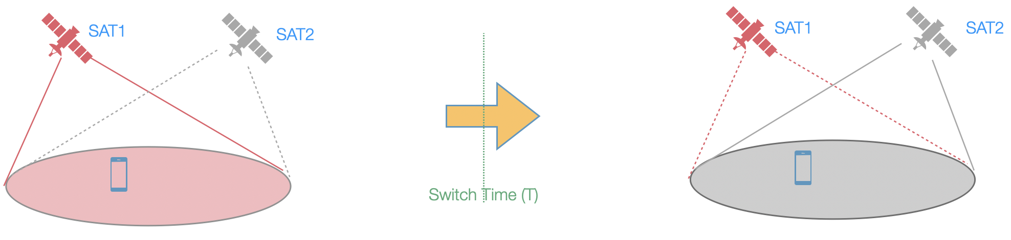
Figure 5 Satellite switch with re-sync for hard satellite switch case
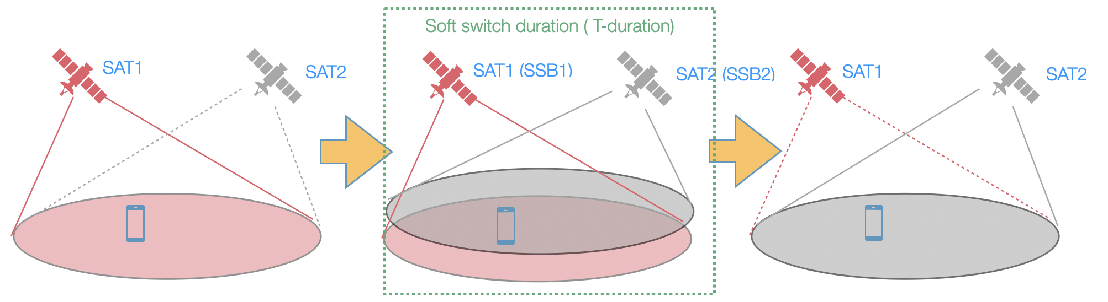
Figure 6 Satellite switch with re-sync for soft satellite switch case

Satellite switch with-resync allows the UE to synchronize with the target satellite without handover, i.e. no L3 mobility, no PCI change, upon both hard and soft satellite switch over in the quasi-Earth fixed scenario with the same SSB frequency and the same gNB. CHO can be configured simultaneously. In the soft switch case, the UE can start synchronizing with the target satellite before the source satellite ends to serve the cell without required to be connected to both satellites.

Channel bandwidth up to 30 MHz in FR1

In the previous the channel bandwidth was limited to 20 MHz in FR1 bands. With this release, channel bandwidth can be set up to 30 MHz for n256 and n255 frequency bands. The corresponding SAN and UE RF core requirements have been introduced however, limited to clause 5 (Operating Bands and Channel Arrangement) requirements. To support this channel bandwidth additional RF and RRM requirements need to be defined in a REL-independent way starting with REL-17.

References

RAN1
[1-1] TS 38.212 NR; Multiplexing and channel coding
[1-2] TS 38.213 NR; Physical layer procedures for control
[1-3] TS 38.214 NR; Physical layer procedures for data
[1-4] TS 38.215 NR; Physical layer measurements

RAN2
[2-1] TS 37.355 LTE positioning protocol (LPP)
[2-2] TS 38.300 NR; NR and NG-RAN Overall description; Stage-2
[2-3] TS 38.304 NR; User Equipment (UE) procedures in idle mode and in RRC Inactive state
[2-4] TS 38.305 NG Radio Access Network (NG-RAN); Stage 2 functional specification of User Equipment (UE) positioning in NG-RAN
[2-5] TS 38.306 NR; User Equipment (UE) radio access capabilities
[2-6] TS 38.321 NR; Medium Access Control (MAC) protocol specification
[2-7] TS 38.331 NR; Radio Resource Control (RRC); Protocol specification

RAN3
[3-1] TS 38.413 NG-RAN; NG Application Protocol (NGAP)
[3-2] TS 38.423 NG-RAN; NG-RAN; Xn Application Protocol (XnAP)
[3-3] TS 38.455 NG-RAN; NR Positioning Protocol A (NRPPa)

RAN4
[4-1] TS 38.101-5 NR; User Equipment (UE) radio transmission and reception, part 5: Satellite Access Radio Frequency (RF) and performance requirements
[4-2] TS 38.133 NR; Requirements for support of radio resource management
[4-3] TS 38.108 NR; Satellite Access Node radio transmission and reception
[4-4] TS 38.101-5 NR; User Equipment (UE) radio transmission and reception, part 5: Satellite Access Radio Frequency (RF) and performance requirements
[4-5] TR 38.863 NR; Solutions for NR to support non-terrestrial networks (NTN)

END

