3GPP TSG-SA WG6 Meeting #51-e S6-222807_Rev1
e-meeting, 10th – 19th October 2022 (revision of S6-22xxxx)

CR-Form-v12.2
CHANGE REQUEST
 | 23.434 | CR | 0133 | rev | - | Current version: | 18.2.0
For HELP on using this form: comprehensive instructions can be found at
http://www.3gpp.org/Change-Requests.

Proposed change affects: | UICC apps |  | ME | X | Radio Access Network |  | Core Network | X

Title: | Updating MBS with dynamic PCC
Source to WG: | S6
Source to TSG: | Huawei, Hisilicon
Work item code: | eSEAL2 |  |  |  |  |  | Date: |  |  | 2022-09-30
Category: | B |  |  |  |  |  | Release: |  |  | Rel-18
 | Use one of the following categories:  F (correction)  A (mirror corresponding to a change in an earlier release)  B (addition of feature),  C (functional modification of feature)  D (editorial modification)  Detailed explanations of the above categories can  be found in 3GPP TR 21.900. |  |  |  |  |  |  |  | Use one of the following releases:  Rel-8 (Release 8)  Rel-9 (Release 9)  Rel-10 (Release 10)  Rel-11 (Release 11)  …  Rel-16 (Release 16)  Rel-17 (Release 17)  Rel-18 (Release 18)  Rel-19 (Release 19)
Reason for change: |  | The MBS session update without dynamic PCC was agreed with an EN as below:  Editor's note: The MBS resource update procedure with dynamic PCC is FFS.  Now, SA2 already confirms the dynamic PCC procedure with N5 is applied. So this EN needs to be solved.
Summary of change: |  | Remove the above EN and introduce the procedure of updating MBS resources with dynamic PCC
Consequences if not approved: |  | Verticals cannot use 5G MBS with dynamic PCC via the SEAL.
Clauses affected: |  | 14.3.4A.3.1, 14.3.4A.3.3 (new)
 |  | Y | N
Other specs |  |  | X | Other core specifications |  |  |  | TS/TR ... CR ...
affected: |  |  | X | Test specifications |  |  |  | TS/TR ... CR ...
(show related CRs) |  |  | X | O&M Specifications |  |  |  | TS/TR ... CR ...
Other comments:
This CR's revision history:

/********************* First Change *********************/

14.3.4A.3.1 General
The VAL server can create one or several MBS sessions via the NRM server, based on certain service requirements, a certain service area, or the activity status of multicast MBS sessions. However, during the life cycle of the MBS sessions, the VAL server may need to trigger the update of the sessions via the NRM server to meet emerging needs, including the service requirements, service area related parameters.

/********************* Next Change *********************/

14.3.4A.3.3 Procedure for updating MBS resources with dynamic PCC rule
The procedure shown in figure 14.3.4A.3.3-1 presents an MBS session update procedure triggered by the NRM server to the 5GC, either directly or via NEF/MBSF. Based on the required updates to be done, the NRM server needs to interact with the MB-SMF to update the MBS service area and multicast activity status, with the PCF to update the required QoS requirements, or sequentially both to update all the above, as indicated in 3GPP TS 23.247 [39].
Pre-conditions:
- The NRM clients 1 to n are attached to the 5GS, registered and belong to the same active VAL service group.
- The NRM server has obtained the required information related to the MB-SMF, either locally configured or during initial session configuration.
- The MBS session is created with certain service requirements and optionally with a certain broadcast/multicast service area. The MBS session is announced to be associated with the VAL service group for group communication purposes.

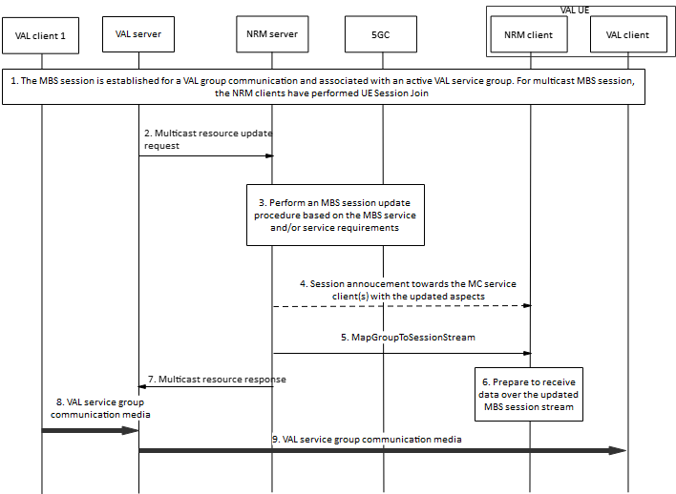
Figure 14.3.4A.3.3-1: MBS session update with dynamic PCC
1. An MBS session is established as described in 3GPP TS 23.247 [29] (either a multicast or a broadcast session), and associated with a certain active VAL service group for group communication purposes. In the case of a multicast MBS session, the NRM clients have already joined the session.
2. The VAL server invoke the multicast resource update request to the NRM server once the need has emerged to modify some aspects for the given MBS session under consideration. The updated parameters are included, e.g., service requirements, service area or both.
NOTE 1: The updated service area information is required for local MBS and for broadcast MBS services.
3. The NRM server, based on the update requirements from step 2, perform the MBS session update with PCC procedure towards the 5GS as described in 3GPP TS 23.247 [29].
4. The NRM server may initiate a session announcement towards the NRM clients associated with the ongoing session in order to announce the updated information if required, e.g., the updated service area or SDP information.
NOTE 2: The updated service area information is required for local MBS and for broadcast MBS services.
5. The NRM server sends an MapGroupToSessionStream over the MBS session providing the required information to receive the media related to the established VAL service group communication.
6. The NRM server returns the multicast resource update resonse to the VAL server.
7. The NRM clients process the received information over the MapGroupToSessionStream in order to receive the associated VAL media over the specific MBS session stream.
8. VAL client 1 sends media to the VAL server over unicast to be distributed for the established group communication.
9. The VAL server distributes the VAL media to the VAL clients 2 to n over the indicated streams.

/********************* End of Changes *********************/

