3GPP TSG-SA5 (Telecom Management)  S5-070213

Meeting SA5#51, 22 - 26 Jan 2007, Seville, SPAIN
CR-Form-v9.3
CHANGE REQUEST
 | 32.615 | CR | 0027 |  rev | - |  Current version: | 7.0.0 | 
For HELP on using this form look at the pop-up text over the  symbols. Comprehensive instructions on how to use this form can be found at http://www.3gpp.org/specs/CR.htm.

Proposed change affects:  | UICC apps |  | ME |  | Radio Access Network | X | Core Network | X

Title:  | Add Notification XML definition in BulkCMIRP
Source to WG:  | Huawei, Yangli (afi@huawei.com)
Source to TSG:  | S5
Work item code:  | OAM7-NIM |  |  |  |  |  |  | Date:  |  | 26/01/2007
Category:  | B |  |  |  |  |  |  | Release:  |  | Rel-7
 | Use one of the following categories:  F (correction)  A (corresponds to a correction in an earlier release)  B (addition of feature),  C (functional modification of feature)  D (editorial modification)  Detailed explanations of the above categories can  be found in 3GPP TR 21.900. |  |  |  |  |  |  |  | Use one of the following releases:  R97 (Release 1997)  R98 (Release 1998)  R99 (Release 1999)  Rel-4 (Release 4)  Rel-5 (Release 5)  Rel-6 (Release 6)  Rel-7 (Release 7)  Rel-8 (Release 8)
Reason for change:  |  | Notification XML definition is missing in 32.615.
Summary of change:  |  | Add BulkCMIRP Notification XML Definitions
Consequences if   not approved: |  | Notification of BulkCMIRP can’t be logged.
Clauses affected:  |  | 6, Annex F
 |  | Y | N
Other specs  |  |  | x | Other core specifications 
affected: |  |  | x | Test specifications
 |  |  | x | O&M Specifications
Other comments: 

1st Modified Section

6 BulkCMIRP Notification XML Definitions
This clause provides XML definitions of Notification Log IRP notifications as defined in [1].
The structure of the BulkCMIRP Notification XML Definitions is shown in graphical depiction below:
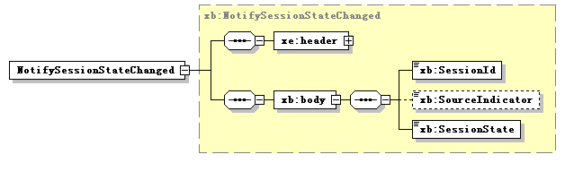

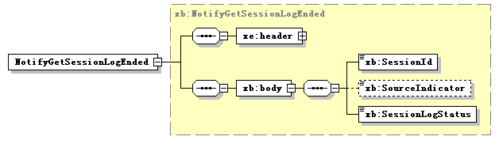
Note: The use of XML schema key word “sequence” to support IS-defined set (not sequence) is for the purpose of XML processor efficiency. This shall not imply the use of “sequence” in other technology.

Next Modified Section

Annex F (normative):
BulkCMIRP Notification XML schema (file name "bulkCMIRPNotif.xsd")
<?xml version="1.0" encoding="UTF-8"?>
<!--
3GPP TS 32.615 BulkCMIRP Notification XML Schema
bulkCMIRPNotif.xsd
-->
<schema xmlns:xb="http://www.3gpp.org/ftp/specs/archive/32_series/32.615#bulkCMIRPNotif" xmlns:xe="http://www.3gpp.org/ftp/specs/archive/32_series/32.305#notification" xmlns="http://www.w3.org/2001/XMLSchema" targetNamespace="http://www.3gpp.org/ftp/specs/archive/32_series/32.615#bulkCMIRPNotif" elementFormDefault="qualified" attributeFormDefault="unqualified">
<import namespace="http://www.3gpp.org/ftp/specs/archive/32_series/32.305#notification"/>
<simpleType name="SessionId">
<restriction base="string">
<minLength value="1"/>
</restriction>
</simpleType>
<simpleType name="SourceIndicator">
<restriction base="string">
<enumeration value="Resource Operation"/>
<enumeration value="management Operation"/>
<enumeration value="unknown"/>
</restriction>
</simpleType>
<simpleType name="SessionState">
<restriction base="string">
<enumeration value="Upload Failed"/>
<enumeration value="Upload Completed"/>
<enumeration value="Download Failed"/>
<enumeration value="Download Completed"/>
<enumeration value="Validation Failed"/>
<enumeration value="Validation Completed"/>
<enumeration value="Preactivation Failed"/>
<enumeration value="Preactivation Partly Realised"/>
<enumeration value="Preactivation Completed"/>
<enumeration value="Activation Failed"/>
<enumeration value="Activation Partly Realised"/>
<enumeration value="Activation Completed"/>
<enumeration value="Fallback Failed"/>
<enumeration value="Fallback Partly Realised"/>
<enumeration value="Fallback Completed"/>
</restriction>
</simpleType>
<simpleType name="SessionLogStatus">
<restriction base="string">
<enumeration value="GetSessionLog completed successfully"/>
<enumeration value="GetSessionLog completed unsuccessfully"/>
</restriction>
</simpleType>
<complexType name="NotifySessionStateChanged">
<complexContent>
<extension base="xe:Notification">
<sequence>
<element name="body">
<complexType>
<sequence>
<element name="SessionId" type="xb:SessionId"/>
<element name="SessionState" type="xb:SessionState"/>
<element name="SourceIndicator" type="xb:SourceIndicator" minOccurs="0"/>
</sequence>
</complexType>
</element>
</sequence>
</extension>
</complexContent>
</complexType>
<complexType name="NotifyGetSessionLogEnded">
<complexContent>
<extension base="xe:Notification">
<sequence>
<element name="body">
<complexType>
<sequence>
<element name="SessionId" type="xb:SessionId"/>
<element name="SessionLogStatus" type="xb:SessionLogStatus"/>
<element name="SourceIndicator" type="xb:SourceIndicator" minOccurs="0"/>
</sequence>
</complexType>
</element>
</sequence>
</extension>
</complexContent>
</complexType>
<element name="NotifySessionStateChanged" type="xb:NotifySessionStateChanged"/>
<element name="NotifyGetSessionLogEnded" type="xb:NotifyGetSessionLogEnded"/>
</schema>

End of modifications

Annex F (informative):
Change history
Change history
Date | TSG # | TSG Doc. | CR | Rev | Subject/Comment | Cat | Old | New
Dec 2006 | SA_34 | SP-060730 | 0026 | -- | Include IMS NRM IRP in the scope for Bulk CM IRP - Align with 32.612 | C | 6.3.0 | 7.0.0

