3GPP TS 28.708 V18.1.0 (2025-05)
Technical Specification
3rd Generation Partnership Project;
Technical Specification Group Services and System Aspects;
Telecommunication management;
Evolved Packet Core (EPC)
Network Resource Model (NRM)
Integration Reference Point (IRP);
Information Service (IS)
(Release 18)


The present document has been developed within the 3rd Generation Partnership Project (3GPP TM) and may be further elaborated for the purposes of 3GPP.
The present document has not been subject to any approval process by the 3GPP Organizational Partners and shall not be implemented.
This Specification is provided for future development work within 3GPP only. The Organizational Partners accept no liability for any use of this Specification.
Specifications and reports for implementation of the 3GPP TM system should be obtained via the 3GPP Organizational Partners' Publications Offices.

Keywords
EPC, NRM, IRP, Converged Management
3GPP
Postal address

3GPP support office address
650 Route des Lucioles - Sophia Antipolis
Valbonne - FRANCE
Tel.: +33 4 92 94 42 00 Fax: +33 4 93 65 47 16
Internet
http://www.3gpp.org
Copyright Notification
No part may be reproduced except as authorized by written permission.
The copyright and the foregoing restriction extend to reproduction in all media.

© 2025, 3GPP Organizational Partners (ARIB, ATIS, CCSA, ETSI, TSDSI, TTA, TTC).
All rights reserved.
UMTS™ is a Trade Mark of ETSI registered for the benefit of its members
3GPP™ is a Trade Mark of ETSI registered for the benefit of its Members and of the 3GPP Organizational Partners
LTE™ is a Trade Mark of ETSI registered for the benefit of its Members and of the 3GPP Organizational Partners
GSM® and the GSM logo are registered and owned by the GSM Association

Contents
Foreword 6
Introduction 6
1 Scope 7
2 References 7
3 Definitions and abbreviations 8
3.1 Definitions 8
3.2 Abbreviations 8
4 Model 9
4.1 Imported information entities and local labels 9
4.2 Class diagram 9
4.2.1 Relationships 9
4.2.2 Inheritance 13
4.3 Class definitions 16
4.3.1 EPDGFunction 16
4.3.1.1 Definition 16
4.3.2 MMEFunction 16
4.3.2.1 Definition 16
4.3.2.2 Attributes 16
4.3.2.3 Attribute constraints 16
4.3.2.4 Notifications 16
4.3.3 PCRFFunction 16
4.3.3.1 Definition 16
4.3.4 PGWFunction 17
4.3.4.1 Definition 17
4.3.4.2 Attributes 17
4.3.4.3 Attribute constraints 17
4.3.4.4 Notifications 17
4.3.5 ServingGWFunction 17
4.3.5.1 Definition 17
4.3.5.2 Attributes 17
4.3.5.3 Attribute constraints 17
4.3.5.4 Notifications 17
4.3.6 MMEPool 17
4.3.6.1 Definition 17
4.3.6.2 Attributes 18
4.3.6.3 Attribute constraints 18
4.3.7 MMEPoolArea 18
4.3.7.1 Definition 18
4.3.7.2 Attributes 18
4.3.7.3 Attribute constraints 18
4.3.8 Link_ENB_MME 18
4.3.8.1 Definition 18
4.3.9 Link_ENB_ServingGW 18
4.3.9.1 Definition 18
4.3.10 Link_EPDG_PCRF 18
4.3.10.1 Definition 18
4.3.11 Link_EPDG_PGW 19
4.3.11.1 Definition 19
4.3.12 Link_HSS_MME 19
4.3.12.1 Definition 19
4.3.13 Link_MME_MME 19
4.3.13.1 Definition 19
4.3.14 Link_MME_SGSN 19
4.3.14.1 Definition 19
4.3.15 Link_MME_ServingGW 19
4.3.15.1 Definition 19
4.3.16 Link_PCRF_ServingGW 19
4.3.16.1 Definition 19
4.3.17 Link_PCRF_PGW 19
4.3.17.1 Definition 19
4.3.18 Link_PGW_ServingGW 19
4.3.18.1 Definition 19
4.3.19 Link_SGSN_ServingGW 20
4.3.19.1 Definition 20
4.3.20 EP_RP_EPS 20
4.3.20.1 Definition 20
4.3.20.2 Attributes 20
4.3.20.3 Attribute constraints 20
4.3.20.4 Notifications 20
4.3.21 ExternalServingGWFunction 20
4.3.21.1 Definition 20
4.3.21.2 Attributes 20
4.3.21.3 Attribute constraints 20
4.3.21.4 Notifications 20
4.3.22 ExternalMMEFunction 21
4.3.22.1 Definition 21
4.3.22.2 Attributes 21
4.3.22.3 Attribute constraints 21
4.3.22.4 Notifications 21
4.3.23 IOC QCISet 21
4.3.23.1 Definition 21
4.3.23.2 Attributes 21
4.3.23.3 Attribute constraints 21
4.3.23.4 Notifications 21
4.3.24 MBMSGWFunction 21
4.3.24.1 Definition 21
4.3.24.2 Attributes 22
4.3.25 Link_MBMSGW_ENB 22
4.3.25.1 Definition 22
4.3.26 PGWCFunction 22
4.3.26.1 Definition 22
4.3.26.2 Attributes 22
4.3.26.3 Attribute constraints 22
4.3.26.4 Notifications 22
4.3.27 PGWUFunction 22
4.3.27.1 Definition 22
4.3.27.2 Attributes 22
4.3.27.3 Attribute constraints 22
4.3.27.4 Notifications 22
4.3.28 ServingGwCFunction 23
4.3.28.1 Definition 23
4.3.28.2 Attributes 23
4.3.28.3 Attribute constraints 23
4.3.28.4 Notifications 23
4.3.29 ServingGwUFunction 23
4.3.29.1 Definition 23
4.3.29.2 Attributes 23
4.3.29.3 Attribute constraints 23
4.3.29.4 Notifications 23
4.3.30 ExternalServingGwCFunction 23
4.3.30.1 Definition 23
4.3.30.2 Attributes 23
4.3.30.3 Attribute constraints 24
4.3.30.4 Notifications 24
4.3.31 ExternalServingGwUFunction 24
4.3.31.1 Definition 24
4.3.31.2 Attributes 24
4.3.31.3 Attribute constraints 24
4.3.31.4 Notifications 24
4.3.32 ExternalPGWCFunction 24
4.3.32.1 Definition 24
4.3.32.2 Attributes 24
4.3.32.3 Attribute constraints 24
4.3.32.4 Notifications 24
4.3.33 ExternalPGWUFunction 25
4.3.33.1 Definition 25
4.3.33.2 Attributes 25
4.3.33.3 Attribute constraints 25
4.3.33.4 Notifications 25
4.4 Attribute definitions 25
4.4.1 Attribute properties 25
4.5 Common notifications 27
4.5.1 Alarm notifications 27
4.52 Configuration notifications 27
Annex A (informative): Change history 28

Foreword
This Technical Specification has been produced by the 3rd Generation Partnership Project (3GPP).
The contents of the present document are subject to continuing work within the TSG and may change following formal TSG approval. Should the TSG modify the contents of the present document, it will be re-released by the TSG with an identifying change of release date and an increase in version number as follows:
Version x.y.z
where:
x the first digit:
1 presented to TSG for information;
2 presented to TSG for approval;
3 or greater indicates TSG approved document under change control.
y the second digit is incremented for all changes of substance, i.e. technical enhancements, corrections, updates, etc.
z the third digit is incremented when editorial only changes have been incorporated in the document.

Introduction
The present document is part of a TS-family covering the 3rd Generation Partnership Project Technical Specification Group Services and System Aspects, Telecommunication management; as identified below:
28.707: "Evolved Packet Core (EPC) Network Resource Model (NRM) Integration Reference Point (IRP); Requirements";
28.708: "Evolved Packet Core (EPC) Network Resource Model (NRM) Integration Reference Point (IRP); Information Service (IS)";
28.709: "Evolved Packet Core (EPC) Network Resource Model (NRM) Integration Reference Point (IRP); Solution Set (SS) definitions";
Configuration Management (CM), in general, provides the operator with the ability to assure correct and effective operation of the 3G network as it evolves. CM actions have the objective to control and monitor the actual configuration on the Network Elements (NEs) and Network Resources (NRs), and they may be initiated by the operator or by functions in the Operations Systems (OSs) or NEs.
CM actions may be requested as part of an implementation programme (e.g. additions and deletions), as part of an optimization programme (e.g. modifications), and to maintain the overall Quality of Service (QoS). The CM actions are initiated either as single actions on single NEs of the 3G network, or as part of a complex procedure involving actions on many resources/objects in one or several NEs.

1 Scope
The present document specifies Evolved Packet Core (EPC) network resource information that can be communicated between an IRPAgent and an IRPManager for telecommunication network management purposes, including management of converged networks. . It reuses relevant parts of the Generic NRM in 3GPP TS 28.622 [6], either by direct reuse or sub-classing, and in addition to that defines EPC specific Information Object Classes.
This document specifies the semantics and behaviour of information object class attributes and relations visible across the reference point in a protocol and technology neutral way. It does not define their syntax and encoding.
In order to access the information defined by this NRM, an Interface IRP such as the "Basic CM IRP" is needed (3GPP TS 32.602 [7]). However, which Interface IRP is applicable is outside the scope of the present document.

2 References
The following documents contain provisions which, through reference in this text, constitute provisions of the present document.
- References are either specific (identified by date of publication, edition number, version number, etc.) or non-specific.
- For a specific reference, subsequent revisions do not apply.
- For a non-specific reference, the latest version applies. In the case of a reference to a 3GPP document (including a GSM document), a non-specific reference implicitly refers to the latest version of that document in the same Release as the present document.
[1] 3GPP TS 32.101: "Telecommunication management; Principles and high level requirements".
[2] 3GPP TS 32.102: "Telecommunication management; Architecture".
[3] 3GPP TS 32.111-2: "Telecommunication management; Fault Management; Part 2: Alarm Integration Reference Point (IRP): Information Service (IS)".
[4] 3GPP TS 32.300: "Telecommunication management; Configuration Management (CM); Name convention for Managed Objects".
[5] 3GPP TS 32.600: "Telecommunication management; Configuration Management (CM); Concept and high-level requirements".
[6] 3GPP TS 28.622: "Telecommunication management; Generic Network Resource Model (NRM) Integration Reference Point (IRP); Information Service (IS)".
[7] 3GPP TS 32.602: "Telecommunication management; Configuration Management (CM); Basic Configuration Management Integration Reference Point (IRP): Information Service (IS)".
[8] 3GPP TS 28.702: " Telecommunication management; Core Network (CN) Network Resource Model (NRM) Integration Reference Point (IRP); Information Service (IS)".
[9] 3GPP TS 23.401: "GPRS enhancements for E-UTRAN access".
[10] 3GPP TS 28.705: "Telecommunication management; IP Multimedia Subsystem (IMS) Network Resource Model (NRM) Integration Reference Point (IRP): Information Service (IS)".
[11] 3GPP TS 28.658: "Telecommunication management; Evolved Universal Terrestrial Radio Access Network (E-UTRAN) Network Resource Model (NRM) Integration Reference Point (IRP); Information Service (IS)".
[12] 3GPP TS 23.402: "Architecture Enhancements for non-3GPP accesses".
[13] 3GPP TS 32.662: "Telecommunication management; Configuration Management (CM); Kernel CM; Information service (IS)".
[14] 3GPP TS 23.003: " Technical Specification Group Core Network and Terminals; Numbering, addressing and identification".
[15] 3GPP TR 32.816-160: "Telecommunication management; Study on management of Evolved Universal Terrestrial Radio Access Network (E-UTRAN) and Evolved Packet Core (EPC) ".
[16] 3GPP TS 36.300: "Evolved Universal Terrestrial Radio Access (E-UTRA) and Evolved Universal Terrestrial Radio Access Network (E-UTRAN); Overall description; Stage 2".
[17] 3GPP TS 36.331: "Evolved Universal Terrestrial Radio Access (E-UTRA); Radio Resource Control (RRC); Protocol specification".
[18] 3GPP TS 36.331: " Evolved Universal Terrestrial Radio Access Network (E-UTRAN); S1 Application Protocol (S1AP)".
[19] 3GPP TS 23.203: "Policy and charging control architecture”.
[20] 3GPP TS 32.302: "Telecommunication management; Configuration Management (CM); Notification Integration Reference Point (IRP): Information Service (IS)".
[21] 3GPP TS 28.541: "Management and orchestration of networks and network slicing; NR and NG-RAN Network Resource Model (NRM); Stage 2 and stage 3".
[22] Void
[23] 3GPP TS 23.214: "Architecture enhancements for control and user plane separation of EPC nodes".

3 Definitions and abbreviations

3.1 Definitions
For the purposes of the present document, the terms and definitions given in 3GPP TS 32.101 [1], 3GPP TS 32.102 [2], 3GPP TS 32.600 [5] and the following apply:
Association: See definition in TS 28.622 [6].
Managed Element (ME): See definition in TS 28.622 [6].
Managed Object (MO): See definition in TS 28.622 [6].
Management Information Model (MIM): also referred to as NRM - see the definition below.
Network Resource Model (NRM): See definition in TS 28.622 [6].

3.2 Abbreviations
For the purposes of the present document, the following abbreviations apply:
CIM Common Information Model
CUPS Control and User Plane Separation
EM Element Manager
eNodeB evolved NodeB
EPC Evolved Packet Core
ePDG evolved Packet Data Gateway
E-UTRAN Evolved Universal Terrestrial Radio Access Network
GPRS General Packet Radio System
IOC Information Object Class
IRP Integration Reference Point
IS Information Service
ME Managed Element
MIM Management Information Model
MME Mobility Management Entity
MO Managed Object
NE Network Element
NR Network Resource
NRM Network Resource Model
PCRF Policy and Charging Rules Function
P-GW PDN Gateway
PGW-C PDN Gateway Control plane function
PGW-U PDN Gateway User plane function
RDN Relative Distinguished Name (see 3GPP TS 32.300 [4])
S-GW Serving Gateway
SGW-C Serving Gateway Control plane function
SGW-U Serving Gateway User plane function
TMN Telecom Management Network
UML Unified Modelling Language

4 Model

4.1 Imported information entities and local labels
Label reference | Local label
TS 28.658 [11], information object class, ENBFunction | ENBFunction
TS 28.705 [10], information object class, HssFunction | HssFunction
TS 28.622 [6], information object class, Link | Link
TS 28.622 [6], information object class, ManagedElement | ManagedElement
TS 28.622 [6], information object class, ManagedFunction | ManagedFunction
TS 28.632 [8], information object class, SgsnFunction | SgsnFunction
TS 28.622 [6], information object class, SubNetwork | SubNetwork
TS 28.622 [6], information object class, EP_RP | EP_RP
TS 28.541 [21], information object class, ENGNBFunction | GNBFunction
TS 28.541 [21], information object class, ENGNBCUUPFunction | GNBCUUPFunction
TS 28.541 [21], information object class, AMFFunction | AMFFunction
TS 28.541 [21], information object class, EP_N26 | EP_N26

4.2 Class diagram

4.2.1 Relationships
This clause depicts the set of IOCs that encapsulate information relevant for this service. This clause provides the overview of the relationships of relevant classes in UML. Subsequent clauses provide more detailed specification of various aspects of these classes.
The figures below show the containment/naming hierarchy and the associations of the information object classes defined in the present document.
NOTE: The listed cardinality numbers represent transient as well as steady-state numbers, and reflect all managed object creation and deletion scenarios in all figures.
Each IOC is identified with a Distinguished Name (DN) according to 3GPP TS 32.300 [4] that expresses its containment hierarchy. As an example, the DN of an IOC representing a MME (3GPP TS 23.401 [9]) could have a format like:
SubNetwork=China, MeContext =MEC-Gbg-1, ManagedElement =MME-Gbg-1, MMEFunction=MME-1.
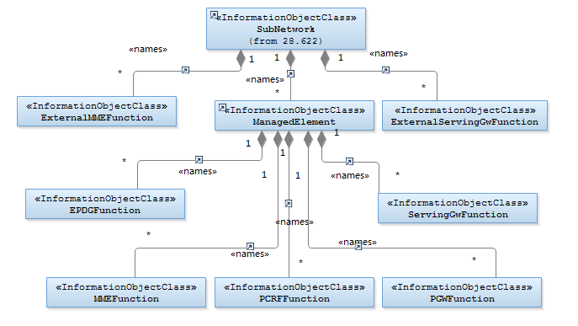

Figure 4.2.1-1: EPC NRM Containment/Naming Relationships
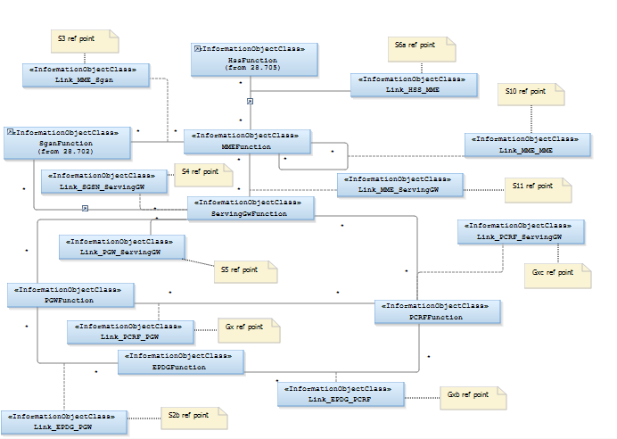

Figure 4.2.1-2: EPC NRM Containment/Naming and Association_1
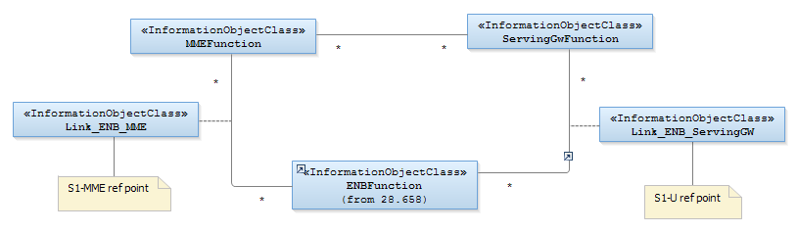
Figure 4.2.1-3: EPC NRM Containment/Naming and Association_2

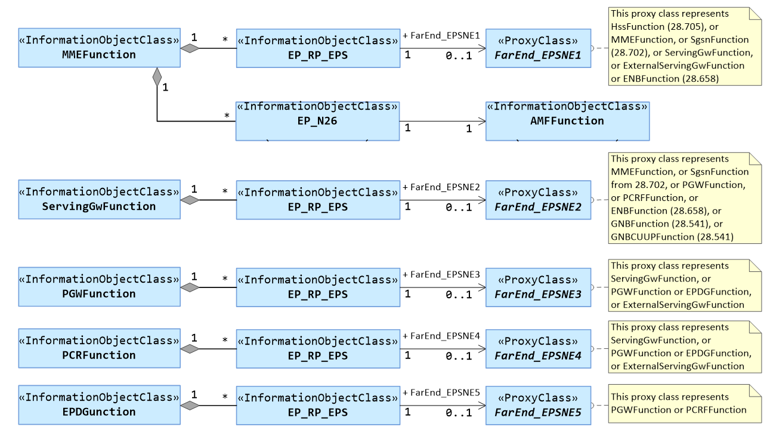

Figure 4.2.1-4: EPC NRM Containment/Naming and Association3
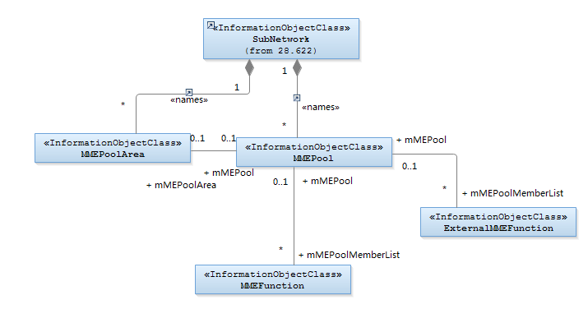

Figure 4.2.1-5 MME Pool Object Model of EPC NRM

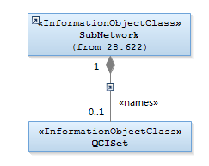
NOTE: Void.

Figure 4.2.1-6: EPC NRM Containment/Naming and Association 3
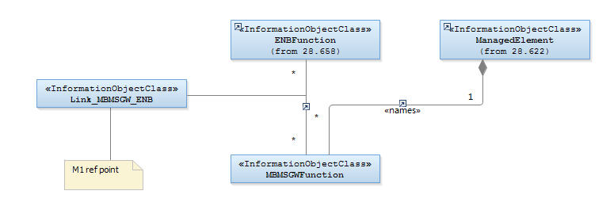

Figure 4.2.1-7: EPC NRM Containment/Naming and Association 4
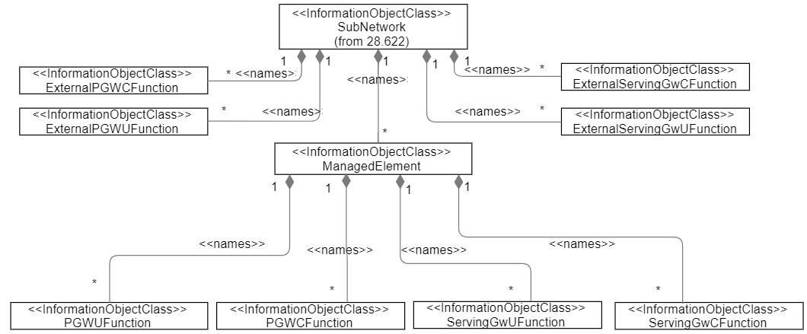

Figure 4.2.1-8: EPC NRM Containment/Naming and Association 4 for EPC CUPS
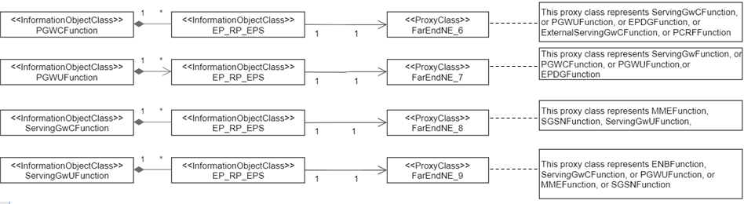

Figure 4.2.1-9: EPC NRM Containment/Naming and Association 5 for EPC CUPS

4.2.2 Inheritance
This clause depicts the inheritance relationships that exist between IOCs.
The figures below show the inheritance hierarchy for the EPC NRM.

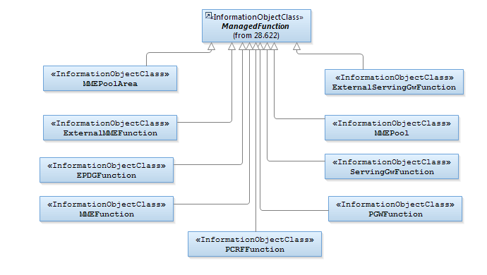
Figure 4.2.2-1: EPC NRM Inheritance Hierarchy_1
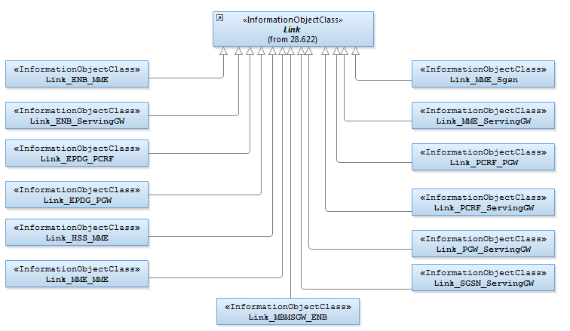
Figure 4.2.2-2: EPC NRM Inheritance Hierarchy_2

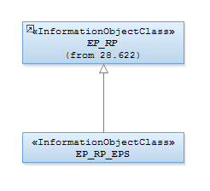

Figure 4.2.2-3: EPC NRM Inheritance Hierarchy_3
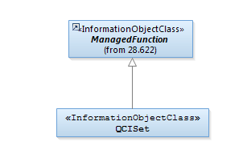

Figure 4.2.2-4: EPC NRM Inheritance Hierarchy_4
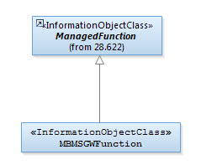
Figure 4.2.2-5: E-UTRAN NRM Inheritance Hierarchy_5
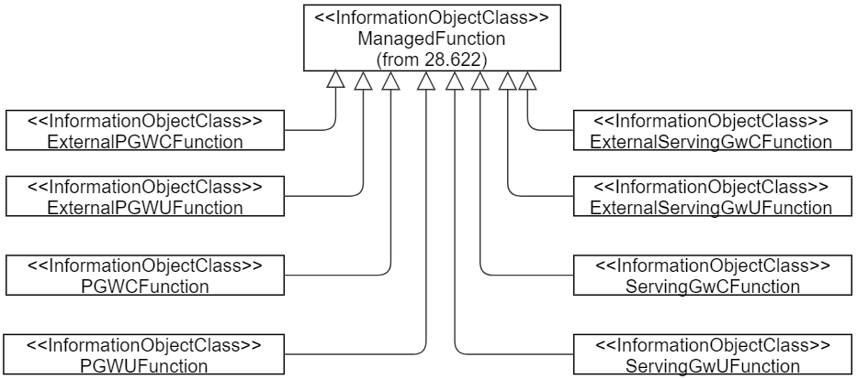
Figure 4.2.2-6: EPC NRM Inheritance Hierarchy 6 for EPC CUPS

4.3 Class definitions

4.3.1 EPDGFunction

4.3.1.1 Definition
This IOC represents ePDG functionality. For more information about the ePDG, see 3GPP TS 23.402 [12].

4.3.2 MMEFunction

4.3.2.1 Definition
This IOC represents MME functionality. For more information about the MME, see 3GPP TS 23.401 [9].

4.3.2.2 Attributes
Attribute Name | Support Qualifier | isReadable | isWritable | isInvariant | isNotifyable
pLMNIdList | M | M | - | - | M
mMEC | M | M | - | - | M
Attribute related to role
mMEPool | M | M | - | - | M

4.3.2.3 Attribute constraints
None.

4.3.2.4 Notifications
The common notifications defined in subclause 4.5 are valid for this IOC, without exceptions or additions.

4.3.3 PCRFFunction

4.3.3.1 Definition
This IOC represents PCRF functionality. For more information about the PCRF, see 3GPP TS 23.401 [9].

4.3.4 PGWFunction

4.3.4.1 Definition
This IOC represents PDN Gateway functionality. For more information about the PDN Gateway, see 3GPP TS 23.401 [9].

4.3.4.2 Attributes
Attribute Name | Support Qualifier | isReadable | isWritable | isInvariant | isNotifyable
pLMNIdList | M | T | T | F | T
tACList | O | T | T | F | T

4.3.4.3 Attribute constraints
None.

4.3.4.4 Notifications
The common notifications defined in subclause 4.5 are valid for this IOC, without exceptions or additions.

4.3.5 ServingGWFunction

4.3.5.1 Definition
This IOC represents Serving Gateway functionality. For more information about the Serving Gateway, see 3GPP TS 23.401 [9].

4.3.5.2 Attributes
Attribute Name | Support Qualifier | isReadable | isWritable | isInvariant | isNotifyable
pLMNIdList | M | M | - | - | M
tACList | M | M | - | - | M

4.3.5.3 Attribute constraints
None.

4.3.5.4 Notifications
The common notifications defined in subclause 4.5 are valid for this IOC, without exceptions or additions.

4.3.6 MMEPool

4.3.6.1 Definition
This IOC represents MME Pool. For more information about the MME Pool, see 3GPP TS 23.401 [9].Key concepts related to MME Pool are:
- An MME Pool consists of one or more MME nodes. A particular node can be a member of one and only one MME Pool.
- One MME Pool serves at most one MME Pool Area. One MME Pool Area can be served by at most one MME Pool.

4.3.6.2 Attributes
Attribute Name | Support Qualifier | isReadable | isWritable | isInvariant | isNotifyable
mMEGI | M | M | - | - | M
Attribute related to role
mMEPoolMemberList | M | M | M | - | M
mMEPoolArea | M | M | M | - | M

4.3.6.3 Attribute constraints
None.

4.3.7 MMEPoolArea

4.3.7.1 Definition
This IOC represents MME Pool Area. For more information about the MME Pool Area, see 3GPP TS 23.401 [9]. Key concepts related to MME Pool Area are:
- An MME Pool Area is defined as an area within which an UE may be served without the need to change the serving MME. It is a collection of complete Tracking Areas (TAs).
- A particular TA can be a member of one or more MME Pool Areas. In the latter case, the MME Pool Areas involved are called “overlapping MME Pool Areas”.

4.3.7.2 Attributes
Attribute Name | Support Qualifier | isReadable | isWritable | isInvariant | isNotifyable
tACList | M | M | - | - | M
pLMNIdList | O | M | - | - | M
Attribute related to role
mMEPool | M | M | M | - | M

4.3.7.3 Attribute constraints
None.

4.3.8 Link_ENB_MME

4.3.8.1 Definition
This IOC models the S1-MME reference point as defined in TS 23.401 [9].

4.3.9 Link_ENB_ServingGW

4.3.9.1 Definition
This IOC models the S1-U reference point as defined in TS 23.401 [9].

4.3.10 Link_EPDG_PCRF

4.3.10.1 Definition
This IOC models the Gxb reference point as defined in TS 23.402 [12].

4.3.11 Link_EPDG_PGW

4.3.11.1 Definition
This IOC models the S2b reference point as defined in TS 23.402 [12].

4.3.12 Link_HSS_MME

4.3.12.1 Definition
This IOC models the S6a reference point as defined in TS 23.401 [9].

4.3.13 Link_MME_MME

4.3.13.1 Definition
This IOC models the S10 reference point as defined in TS 23.401 [9].

4.3.14 Link_MME_SGSN

4.3.14.1 Definition
This IOC models the S3 reference point as defined in TS 23.401 [9].

4.3.15 Link_MME_ServingGW

4.3.15.1 Definition
This IOC models the S11 reference point as defined in TS 23.401 [9].

4.3.16 Link_PCRF_ServingGW

4.3.16.1 Definition
This IOC models the Gxc reference point as defined in TS 23.402 [12].

4.3.17 Link_PCRF_PGW

4.3.17.1 Definition
This IOC models the Gx reference point as defined in TS 23.401 [9].

4.3.18 Link_PGW_ServingGW

4.3.18.1 Definition
This IOC models the S5 reference point as defined in TS 23.401 [9].

4.3.19 Link_SGSN_ServingGW

4.3.19.1 Definition
This IOC models the S4 reference point as defined in TS 23.401 [9].

4.3.20 EP_RP_EPS

4.3.20.1 Definition
This IOC represents an end point of reference point in EPS as defined in TS 23.401 [9].

4.3.20.2 Attributes
Attribute Name | Support Qualifier | isReadable | isWritable | isInvariant | isNotifyable
farEndNeIpAddr | O | M | CM | - | M

4.3.20.3 Attribute constraints
Name | Definition
farEndNeIpAddr’s write qualifier | When the EP_RP_EPS object belongs to a different Domain Manager than the NE pointed by the farEndNeIpAddr attribute, the Write Qualifier of farEndNeIpAddr attribute is needed.

4.3.20.4 Notifications
The common notifications defined in subclause 4.1.6 of 3GPP TS 28.622[6] are valid for this IOC, without exceptions or additions.

4.3.21 ExternalServingGWFunction

4.3.21.1 Definition
This IOC represents SGW functionality controlled by another IRPAgent. For more information about the SGW, see 3GPP TS 23.401 [9].

4.3.21.2 Attributes
Attribute Name | Support Qualifier | isReadable | isWritable | isInvariant | isNotifyable
pLMNIdList | M | T | T | F | T
tACList | M | T | T | F | T

4.3.21.3 Attribute constraints
None.

4.3.21.4 Notifications
The common notifications defined in subclause 4.5 are valid for this IOC, without exceptions or additions.

4.3.22 ExternalMMEFunction

4.3.22.1 Definition
This IOC represents MME functionality controlled by another IRPAgent. For more information about the MME, see 3GPP TS 23.401 [9].

4.3.22.2 Attributes
Attribute Name | Support Qualifier | isReadable | isWritable | isInvariant | isNotifyable
pLMNIdList | M | T | T | F | T
mMEC | M | T | T | F | T
Attribute related to role
mMEPool | M | T | T | F | T

4.3.22.3 Attribute constraints
None.

4.3.22.4 Notifications
The common notifications defined in subclause 4.5 are valid for this IOC, without exceptions or additions.

4.3.23 IOC QCISet

4.3.23.1 Definition
This IOC represents a set of QCI as defined in section 6.1.7.2 of TS 23.203 [19].

4.3.23.2 Attributes
Attribute Name | Support Qualifier | isReadable | isWritable | isInvariant | isNotifyable
id | M | M | - | - | M
qCIList | M | M | M | - | M

4.3.23.3 Attribute constraints
Null.

4.3.23.4 Notifications
Name | Qualifier | Notes
notifyAttributeValueChange | See Kernel CM IRP (3GPP TS 32.662 [13])
notifyObjectCreation | See Kernel CM IRP (3GPP TS 32.662 [13])
notifyObjectDeletion | See Kernel CM IRP (3GPP TS 32.662 [13])

4.3.24 MBMSGWFunction

4.3.24.1 Definition
This IOC represents MBMS GW functionality. For more information about the MBMS GW, see 3GPP TS 36.300 [16].

4.3.24.2 Attributes
Attribute Name | Support Qualifier | isReadable | isWritable | isInvariant | isNotifyable
id | M | M | - | - | M

4.3.25 Link_MBMSGW_ENB

4.3.25.1 Definition
This IOC represents the M1 reference point as defined in 3GPP TS 36.300 [16].

4.3.26 PGWCFunction

4.3.26.1 Definition
This IOC represents PDN Gateway control plane functionality. For more information about the PGW-C, see 3GPP TS 23.214 [23].

4.3.26.2 Attributes
Attribute Name | Support Qualifier | isReadable | isWritable | isInvariant | isNotifyable
pLMNIdList | M | T | T | F | T
tACList | O | T | T | F | T

4.3.26.3 Attribute constraints
None.

4.3.26.4 Notifications
The common notifications defined in subclause 4.5 are valid for this IOC, without exceptions or additions.

4.3.27 PGWUFunction

4.3.27.1 Definition
This IOC represents PDN Gateway user plane functionality. For more information about the PGW-U, see 3GPP TS 23.214 [23].

4.3.27.2 Attributes
Attribute Name | Support Qualifier | isReadable | isWritable | isInvariant | isNotifyable
pLMNIdList | M | T | T | F | T
tACList | O | T | T | F | T

4.3.27.3 Attribute constraints
None.

4.3.27.4 Notifications
The common notifications defined in subclause 4.5 are valid for this IOC, without exceptions or additions.

4.3.28 ServingGwCFunction

4.3.28.1 Definition
This IOC represents Serving Gateway control plane functionality. For more information about the SGW-C, see 3GPP TS 23.214 [23].

4.3.28.2 Attributes
Attribute Name | Support Qualifier | isReadable | isWritable | isInvariant | isNotifyable
pLMNIdList | M | T | T | F | T
tACList | M | T | T | F | T

4.3.28.3 Attribute constraints
None.

4.3.28.4 Notifications
The common notifications defined in subclause 4.5 are valid for this IOC, without exceptions or additions.

4.3.29 ServingGwUFunction

4.3.29.1 Definition
This IOC represents Serving Gateway user plane functionality. For more information about the SGW-U, see 3GPP TS 23.214 [23].

4.3.29.2 Attributes
Attribute Name | Support Qualifier | isReadable | isWritable | isInvariant | isNotifyable
pLMNIdList | M | T | T | F | T
tACList | M | T | T | F | T

4.3.29.3 Attribute constraints
None.

4.3.29.4 Notifications
The common notifications defined in subclause 4.5 are valid for this IOC, without exceptions or additions.

4.3.30 ExternalServingGwCFunction

4.3.30.1 Definition
This IOC represents SGW-C functionality controlled by another IRPAgent. For more information about the SGW-C, see 3GPP TS 23.214 [23].

4.3.30.2 Attributes
Attribute Name | Support Qualifier | isReadable | isWritable | isInvariant | isNotifyable
pLMNIdList | M | T | T | F | T
tACList | M | T | T | F | T

4.3.30.3 Attribute constraints
None.

4.3.30.4 Notifications
The common notifications defined in subclause 4.5 are valid for this IOC, without exceptions or additions.

4.3.31 ExternalServingGwUFunction

4.3.31.1 Definition
This IOC represents SGW-U functionality controlled by another IRPAgent. For more information about the SGW-U, see 3GPP TS 23.214 [23].

4.3.31.2 Attributes
Attribute Name | Support Qualifier | isReadable | isWritable | isInvariant | isNotifyable
pLMNIdList | M | T | T | F | T
tACList | M | T | T | F | T

4.3.31.3 Attribute constraints
None.

4.3.31.4 Notifications
The common notifications defined in subclause 4.5 are valid for this IOC, without exceptions or additions.

4.3.32 ExternalPGWCFunction

4.3.32.1 Definition
This IOC represents PDN Gateway control plane functionality controlled by another IRPAgent. For more information about the PGW-C, see 3GPP TS 23.214 [23].

4.3.32.2 Attributes
Attribute Name | Support Qualifier | isReadable | isWritable | isInvariant | isNotifyable
pLMNIdList | M | T | T | F | T
tACList | O | T | T | F | T

4.3.32.3 Attribute constraints
None.

4.3.32.4 Notifications
The common notifications defined in subclause 4.5 are valid for this IOC, without exceptions or additions.

4.3.33 ExternalPGWUFunction

4.3.33.1 Definition
This IOC represents PDN Gateway user plane functionality controlled by another IRPAgent. For more information about the PGW-U, see 3GPP TS 23.214 [23].

4.3.33.2 Attributes
Attribute Name | Support Qualifier | isReadable | isWritable | isInvariant | isNotifyable
pLMNIdList | M | T | T | F | T
tACList | O | T | T | F | T

4.3.33.3 Attribute constraints
None.

4.3.33.4 Notifications
The common notifications defined in subclause 4.5 are valid for this IOC, without exceptions or additions.

4.4 Attribute definitions

4.4.1 Attribute properties
The following table defines the attributes that are present in several Information Object Classes (IOCs) of the present document.

Attribute Name | Documentation and Allowed Values | Properties
farEndNeIpAddr | The IP address(s) of the far end network entity to which the reference point is related.  The IP address can be either IPv4 or IPv6. | type: String  multiplicity: 1..*  isOrdered: N/A  isUnique: N/A  defaultValue: None  allowedValues: N/A  isNullable: True
mMEC | MME Identifier (MMEI) is constructed from an MME Group ID (MMEGI) and an MME Code (MMEC). The MMEC is unique within the MME pool area and, if overlapping pool areas are in use, unique within the area of overlapping MME pools. (Ref. 3GPP TS 23.003[14]) | type: Integer  multiplicity: 1  isOrdered: N/A  isUnique: N/A  defaultValue: None  isNullable: True
mMEGI | MME Identifier (MMEI) is constructed from an MME Group ID (MMEGI) and an MME Code (MMEC). The MMEGI is the unique identity of MME Pool within the context of PLMN. ( Ref.3GPP TS 23.003[14]).  Note:  An UE, supported by a cell, can connect to one out of a group of MMEs. The group consists of the MMEs supporting the tracking area for the cell limited to those that are connected to the serving eNB. The MME is identified by the combination PLMNID-MMEGI-MMEC. The combination is called GUMMEI. | type: Integer  multiplicity: 1  isOrdered: N/A  isUnique: N/A  defaultValue: None  isNullable: True
pLMNIdList | It is a list of PLMN-Id, PLMN-Id= Mobile Country Codes (MCC)|| Mobile Network Codes(MNC) (Ref. 3GPP TS 23.003[14])  The MMEPoolArea.pLMNIdList purpose is to identify the PLMNs (related to MMEFunction) the MME Pool is serving.  The MMEEunction.pLMNIdList purpose is as following. One operator may have several PLMN Ids and accordingly RAN broadcasts these Ids to enable UEs of different PLMN (i.e, UEs with different MNC in their IMSIs) to access its network. If CN node does not know this PLMN list, UEs of different PLMN than the one combined in MME might be treated as UEs from other operators. This will affect Location Update and Inter-MME handover procedures, and also the changing rate.  allowedValues: A list of at most six entries of PLMN Identifiers. The PLMN Identifier is composed of a Mobile Country Code (MCC) and a Mobile Network Code (MNC). | type: Integer  multiplicity: 1..*  isOrdered: N/A  isUnique: N/A  defaultValue: None  allowedValues: N/A  isNullable: True
qCIList | It is a list of QCI characteristic, which is a structure including the element QCI, Resource_Type, Priority, Packet_Delay_Budget and Packet_Error_Loss_Rate;  Wherein  - QCI representing the number of the QCI, is an integer;  - Resource_Type representing the Resource Type(GBR or Non-GBR) of the QC;  - Priority representing the Priority of QCI, is an integer;  - Packet_Delay_Budget representing the Packet Delay Budget of the QCI, is an integer with the unit of millisecond(ms);  - Packet_Error_Loss_Rate representing the Packet Error Loss Rate of the QCI, is a real.  ( Ref.3GPP TS 23.203[x]) | Refer to 3GPP TS 23.203[19]
tACList | It is the list of TAC of the MMEPoolArea that is used for traffic handling. Each TAC is provisioned over the S1 interface from the eNodeB, Ref 3GPP TS 36.413[18].  Note:  A cell can only broadcast one TAC. See TS 36.300 v8.4.0 [16], section 10.1.7 (PLMNID and TAC relation).  The Tracking Area Identity is constructed from the MCC (Mobile Country Code), MNC (Mobile Network Code) and TAC (Tracking Area Code). ( Ref.3GPP TS 23.401[9]) | type: Integer  multiplicity: 1..*  isOrdered: N/A  isUnique: N/A  defaultValue: None  allowedValues: N/A  isNullable: True
Attribute Name related to role | Documentation and Allowed Values | Properties
mMEPool | It is the DN of a MMEPool instance.  allowedValues: N/A | type: DN  multiplicity: 1  isOrdered: N/A  isUnique: True  defaultValue: None  isNullable: True
mMEPoolArea | It is the DN of a MMEPoolArea instance.  allowedValues: N/A | type: DN  multiplicity: 1  isOrdered: N/A  isUnique: True  defaultValue: None  isNullable: True
mMEPoolMemberList | It is the list of DNs of MMEFunction instances of the MMEPool.  allowedValues: N/A | type: DN  multiplicity: 1  isOrdered: N/A  isUnique: True  defaultValue: None  isNullable: True

4.5 Common notifications

4.5.1 Alarm notifications
This clause presents a list of notifications, defined in [3], that IRPManager can receive. The notification header attribute objectClass/objectInstance, defined in [20], would capture the DN of an instance of an IOC defined in this IRP specification.
Name | Qualifier | Notes
notifyAckStateChanged | See Alarm IRP (3GPP TS 32.111-2 [3])
notifyAlarmListRebuilt | See Alarm IRP (3GPP TS 32.111-2 [3])
notifyChangedAlarm | See Alarm IRP (3GPP TS 32.111-2 [3])
notifyClearedAlarm | See Alarm IRP (3GPP TS 32.111-2 [3])
notifyComments | See Alarm IRP (3GPP TS 32.111-2 [3])
notifyNewAlarm | See Alarm IRP (3GPP TS 32.111-2 [3])
notifyPotentialFaultyAlarmList | See Alarm IRP (3GPP TS 32.111-2 [3])

4.52 Configuration notifications
This clause presents a list of notifications, defined in [12], that IRPManager can receive. The notification header attribute objectClass/objectInstance, defined in [20], would capture the DN of an instance of an IOC defined in this IRP specification.
Name | Qualifier | Notes
notifyAttributeValueChange | See Kernel CM IRP (3GPP TS 32.662 [13])
notifyObjectCreation | See Kernel CM IRP (3GPP TS 32.662 [13])
notifyObjectDeletion | See Kernel CM IRP (3GPP TS 32.662 [13])

Annex A (informative):
Change history

Change history
Date | Meeting | TDoc | CR | Rev | Cat | Subject/Comment | New version
2014-06 | SA#64 | SP-140360 | 001 | - |  | remove the feature support statements | 11.1.0
2014-10 | - | - | - | - |  | Update to Rel-12 version (MCC) | 12.0.0
2016-01 | - | - | - | - |  | Update to Rel-13 version (MCC) | 13.0.0
2017-03 | - | - | - | - |  | Update to Rel-14 version (MCC) | 14.0.0
2018-06 | SA#80 | SP-180421 | 0007 | 1 | B | Update EPC NRM definitions to support management of EN-DC and 5G interworking | 15.0.0
2018-09 | SA#81 | SP-180829 | 0008 | 1 | B | NRM IOC changes for EPC CUPS | 15.1.0
2018-12 | SA#82 | SP-181050 | 0009 | 1 | F | CUPS NRM IOC error correction | 15.2.0
2020-07 | - | - | - | - | - | Update to Rel-16 version (MCC) | 16.0.0
2022-03 | - | - | - | - | - | Update to Rel-17 version (MCC) | 17.0.0
2024-04 | - | - | - | - | - | Update to Rel-18 version (MCC) | 18.0.0
2025-03 | SA#107 | SP-250150 | 0010 | 1 | F | Rel-18 CR TS 28.708 Update references to imported information entities for CN | 18.1.0

