**3GPP TSG-SA5 Meeting #145eS5-233477**

**15 August to 24 August 2022, E-meeting**

**Source: China Mobile**

**Title: pCR 28.912 issue#4.5.1 Intent report potential solution#1 enhancement**

**Document for: approval**

**Agenda Item: 6.7.3.2**

# 1 Decision/action requested

***The group is asked to discuss and agree on the proposal.***

# 2 References

[1] 3GPP TR 28.912 “Study on enhanced intent driven management services for mobile networks ” V1.2.0 (2023-03)

# 3 Rationale

Intent report potential solution # 1 provides feasible solutions for intent report. However, in the current solution, the conditions for generating intent reports can only be configured through the reportingPeriod parameter, and more complex intent report generation conditions cannot be supported. Moreover, in the current solution, the content of the intent report cannot be customized. Hence it is proposed to introduc report expectation as part of intent IOC, with which MnS consumer can express potential requirements for flexible customization on both the content selection and generation timing of intent report.

Minor corrections in Figure 4.5.2.1-1 is also proposed.

# 4 Detailed proposal

|  |
| --- |
| **Start of Modified** |

## 4.5 Issue#4.5: Intent Report

### 4.5.1 Description

In TS 28.312 [2], the Fulfilment information (including the intentFulfilmentinfo, expectationfulfilmentInfo and targetfulfilmentInfo) are defined for the MnS consumer to monitor the intent fulfilment information. The intent report also can contain the current and optional predicted value for performance indicated by corresponding expectation targets (e.g. WeakRSRPRatio for the weakRSRPRatioTarget, Average UL RAN UE Throughput for aveULRANUEThptTarget), which can be used by MnS consumer to validate whether the intent is really fulfilled and to evaluate whether the intent (especially for expectation targets) needs to be updated if needed (improve the target value when corresponding target is fulfilled or reduce the target value when corresponding target is not fulfilled or not fulfilled with the reason of target confliction). Besides, intent conflict information which send by MnS producer to MnS consumer is another type of intent report information. So, following are the three types of information needs to be monitored by MnS consumer:

* Intent Fulfilment information, which represents the properties of a specific fulfilment information for an aspect of the intent (i.e. either an expectation, a target or the whole intent). The detailed information see clause 6.2.1.3.6 in TS 28.312 [2].
* Achieved values for targets, which represent current performance values for corresponding expectation targets.
* Intent conflict information, which represents conflict type (i.e., intent conflict, expectation conflict and target conflict) and possible solution recommendation to address the conflicts.

Different MnS consumer may have different requirements for intent report (e.g. Some MnS consumer may want to have corresponding performance value information while others don't want, Different MnS consumer may want to calculate or monitor the performance value in different period).

While the report (with the current performance values for corresponding expectation targets) is provided at the end of each observation period, the consumer may also wish to know whether the fulfilment info was consistent for the entire observation period. For example, the intent expectation may be reported FULFILLED at the end of observation period. However, may be possible that within observation period the intent expectation was NOTFULFILLED. The consumer may wish to know this information. This information can be important for the MnS consumer to understand whether the observation period they specified need an update (e.g shortened) or not. Moreover, it helps the MnS consumer to understand whether their expectation is fulfilled during the entire observation period which also gives transparency to the MnS consumer to update their observation period and/or expectations targets specified in the intent.

**REQ-Intent_Driven_MnS_Report-1:** The intent driven MnS should have the capability to enable the MnS consumer to request intent report information.

**REQ-Intent_Driven_MnS_Report-2:** The intent driven MnS should have the capability to enable the MnS consumer to obtain intent report information with current performance value for corresponding expectation targets.

**REQ-Intent_Driven_MnS_Report-3:** The intent driven MnS should have the capability to enable the MnS consumer to obtain intent report information with intent fulfilment information.

**REQ-Intent_Driven_MnS_Report-4:** The intent driven MnS should have the capability to enable the MnS consumer to obtain intent report information with intent conflict information.

**REQ-Intent_Driven_MnS_Report_05:** The intent driven MnS should have capability enabling MnS consumer to specify the content of the report.

**REQ-Intent_Driven_MnS_Report_06:** The intent driven MnS should have capability enabling MnS consumer to configure the frequency, triggering events or other conditions of the intent reporting.

**REQ-Intent_Driven_MnS_Report_07:** The intent driven MnS should allow MnS consumers to receive reports, with different content and intervals.

**REQ-Intent_Driven_MnS_Report_08:** The intent driven MnS should allow MnS consumer to obtain reports with current values for specified expectation targets.

**REQ-Intent_Driven_MnS_Report_09:** The intent driven MnS should have capability enabling MnS consumer to obtain intent report information with current context information for corresponding expectation targets.

**REQ-Intent_Driven_MnS_Report_10:** The intent driven MnS should allow reports to contain information on whether the fulfilment info was consistent throughout the observation period.

**REQ-Intent_Driven_MnS_Report_11:** The intent driven MnS should have capability enabling MnS consumer to specify the content selection criteria of the report.

### 4.5.2 Potential solutions

#### 4.5.2.1 Potential solution#1

This solution extends the existing model in 28.312 [2] by adding new attributes to the Intent IOC to indicate what is to be observed, and a new IntentReport IOC to enable the MnS consumer to obtain the intent report information.

The following specific changes would be made:

* Extend the Intent <<IOC>> with the following attributes:

- "reportingPeriod", represents MnS consumer's requirements for the reporting period. The performance value for corresponding Expectation Targets will be reported at the end of each period.

* Introduce the IntentReport <<IOC>> to represent the intent fulfilment information, intent conflict information and current performance values for the Expectation Targets in the associated Intent. The MnS consumer can use the "getMOIAttributeValue" operation to query the IntentReport <<IOC>> to obtain the intent report information and/or subscribe the "notifyMOIAttributeValueChanges" notification to obtain the intent report information The IntentReport <<IOC>> includes the following attributes:

- "intentReference", to reference (DN) the associated Intent instance.

- “reportIndicator”, to enable/disable (Boolean) reporting for associated Intent instance

- "intentFulfimentInfo", to represent the fulfilment information for intent, intent expectation and expectation targets. For detailed information see clause 6.2.1.3.6 in TS 28.312[2].

- "intentConflictInfo", to represent the intent conflict information that should be informed to the MnS consumer. For detailed intent conflict information see clause 4.2.2.

- "TargetAchieveValues", to represent the current performance value for the ExpectationTargets.

- “lastUpdated”, timestamp (DateTime) of latest update

* Extend the allowedValues of the ExpectationVerb attribute in the IntentExpectation<dataType>>. The current allowedValues are DELEVER and ENSURE, and a new allowedValue Report is added to represent the requirements of MnS consumers for intent report. By using the existing expectation targets mechanism, to specify under which conditions the MnS producer is expected to create and distribute the corresponding intent report.

This could result in NRM for Intent Reporting as follows:

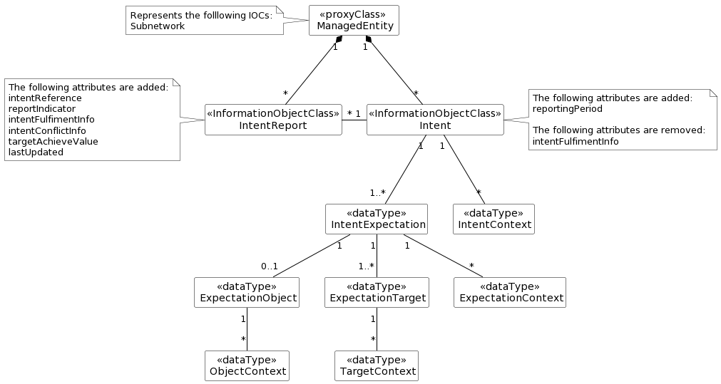

Figure 4.5.2.1-1

Observations on this approach

* Different MnS consumers can query different attributes of IntentReport to obtain corresponding Intent instance report information.
* Different MnS consumers can subscribe to attribute value change notifications for IntentReport <<IOC>> to obtain the notification for different intent report information.

Several benefits are listed below for the solution:

* Separates the intent expectation information (generated by MnS consumer) and intent monitor information (generated by MnS producer).
* MnS consumer can manage Intent instance and IntentReport instances separately.
* Intent <<IOC>> is aligned with intent definition (expectations including requirements, goals and constraints given to a 3GPP system)
* MnS consumer can express requirements for flexible content selection criteria and reporting timing of intent report by using report expectation.

|  |
| --- |
| **End of Modified** |