**3GPP TSG-SA5 Meeting #148e *S5-233468***

Electronic meeting, Online, 17 -25 April 2023

**Source: Huawei, Ericsson**

**Title: pCR TR 28.925 Update solution and add conclusion and recommendation for issue#12 illustration of using MnS in management reference model in TS 32.101**

**Document for: Approval**

**Agenda Item: 6.8.1.1**

# 1 Decision/action requested

***Discuss and approve on the proposal.***

# 2 References

[1] 3GPP TR 28.925 enhancement of service based management architecture v0.a.0

[2] 3GPP TS 32.101: "Telecommunication management; Principles and high level requirements".

# 3 Rationale

The current solution for Issue#12 in TR 28.925 [1] is plain worded and may bring difficulties to readers to fully understand how the interoperability between different entities in TS 32.101 (e.g. Enterprise Systems, NM, EM, etc.) is supported by management services. Therefore, a figure, which illustrates the use of MnS in management reference model, is added in the solution. Also, it is proposed to add corresponding conclusion and recommendation.

# 4 Detailed proposal

This document proposes the following changes in TR 28.925 [1].

|  |
| --- |
| **1st Change** |

## 4.12 Issue#12: illustration of using MnS in management reference model in TS 32.101

### 4.12.1 Description

In TS 32.101[3], Clause 5.1 illustrates themanagement reference model which shows the Operations Systems interfacing with other systems. An Operations System supports management interfaces to other systems.



Figure 1: Management reference model

A number of management interfaces in a PLMN are identified in figure 1, namely:

1) between the Network Elements (NEs) and the Element Manager (EM) of a single PLMN Organisation;

2) between the Element Manager (EM) and the Network Manager (NM) of a single PLMN Organisation;

NOTE: In certain cases, the Element Manager functionality may reside in the NE in which case this interface is directly from NE to Network Manager). These management interfaces are given the reference name Itf-N and are the primary target for standardization.

3) between the Network Managers and the Enterprise Systems of a single PLMN Organisation;

4) between the Network Managers (NMs) of a single PLMN Organisation;

4a) between the Domain Managers (DMs) of a single PLMN Organisation.

5) between Enterprise Systems & Network Managers of different PLMN Organisations;

5a) between the Domain Managers (DMs) of different PLMN Organisations.

6) between Network Elements (NEs).

7) between the Network Management Layer Service (NMLS) and the Network Manager (NM).

IRPs may be implemented at interfaces 2, 3, 4, 5 and 7.

TS 28.533[2] introduces the Service Based Management Architecture (SBMA). The fundamental building block of the Service Based Management Architecture (SBMA) is the Management Service (MnS). A MnS is a set of offered capabilities for management and orchestration of network and services. An MnS producer offers its services via a standardized service interface composed of individually specified MnS components (MnS component type A, B, C).

Analysis:

1. In TS 32.101, there is clearly showing the entities and the corresponding interfaces in the management reference model.
2. In TS 28.533, the interaction of paradigm of MnS producer and MnS Consumer is defined without indicating the entities.
3. The entities in TS 32.101 can be illustrated using the MnS consumer and MnS producer according to the way of using interface IRPs.

### 4.12.2 Potential solutions

There are the following aspects to be considered in the solution of using MnS in management reference model in TS 32.101.

1. The management services may be used to support the interoperability between different entities in TS 32.101 (e.g. Enterprise Systems, NM, DM, EM etc.) in the context of 5G management.
2. Different set of management services may be used for the interoperability between different entities.

Figure 4.12.2-1 illustrates an example of a set of management services supporting interoperability between different enterprise systems and external operations systems:.

* communication within OSS uses internal MnS interfaces. The specific set depends on the allocation of management functions to different MF(s).
* to support interoperability between Enterprise Systems and OSS within Organization A MnS interfaces are used.
* to support interoperability between Organization A and Organization B CAPIF interfaces are used
  + Interface 1e is used to perform management authentication and authorization
  + Interface 2e is used to expose the required set of MnS interfaces

communication within OSS uses internal MnS interfaces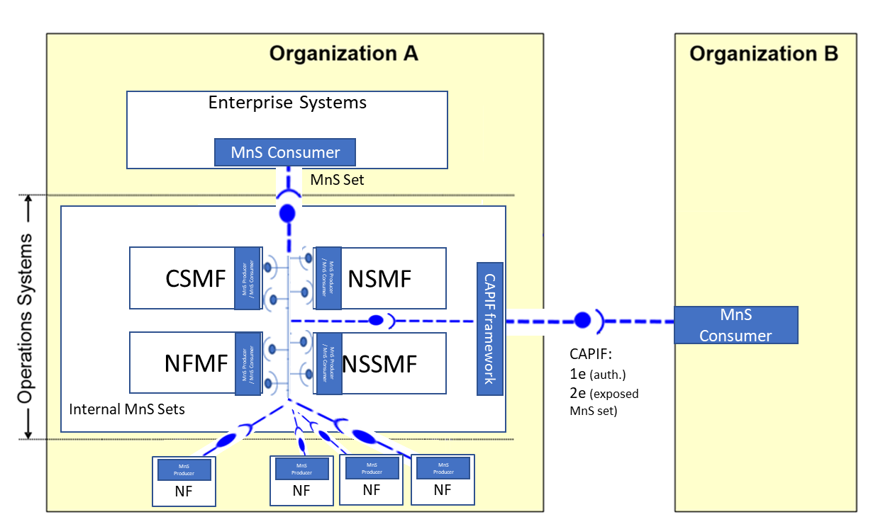

Figure 4.12.2-1: Example of using MnS in management reference model

|  |
| --- |
| **Next Change** |

# 5 Conclusion and Recommendation

## 5.12 Issue #12: illustration of using MnS in management reference model in TS 32.101

A MnS is a set of offered capabilities for management and orchestration of network and services, and it may be used to support the interoperability between different entities (e.g. Enterprise Systems, NM, DM, EM etc.) in TS 32.101 [3]. In this case, these entities can either play the role as MnS producers or MnS consumers. Different set of MnS may be used for the interoperability between different entities.   
It is recommended to add the example of using MnS in management reference model in TS 28.533 [x] to clarify the use of Service Based Management Architecture (SBMA) in management reference model.

|  |
| --- |
| **End of change** |