3GPP TSG-SA5 Meeting #148e S5-233461
Electronic meeting, Online, 17 -25 April 2023

Source: Huawei, Ericsson

Title: Add overview for management sets supported by CRUD operations in SBMA (WOP#5)

Document for: Approval
Agenda Item: 6.8.1.5

1 Decision/action requested
The group is asked to discuss and approval.

2 References
[1] 3GPP TR 28.925: "Study on enhancement of service based management architecture v0.10.0".

3 Rationale
TS 28.533 described that a MnS is composed by a MnS component type A and
- a MnS component type B, or
- a MnS component type B and a MnS component type C.
TS 28.532 described CRUD operations are the MnS component type A and in combination with a NRM (MnS component type B) constitute a MnS.
In SBMA, CRUD operations with different NRM fragments can be used to represent management services to support different management sets. However, in current specifications, there is no overview for management sets supported by CRUD operations in SBMA. It is proposed to add the overview for management sets supported by CRUD operations in SBMA.
Clarification on that if CRUD operations are supported, it is not needed to support the equivilent non-CRUD operations.
4 Detailed proposal
1st Change

4.9 Issue #9: Improvement on the management function description

4.9.1 Description
The following information is documented in TS 32.101 [3] to describe the TMN architecture aspects and the management functions.

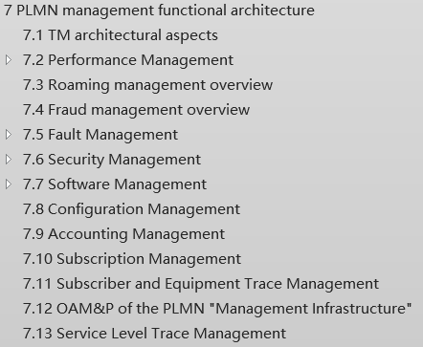
Analysis:
- TS 32.101 [3] defines the management principles and high-level requirements for the management of PLMNs. Some descriptions in corresponding area in clause 7 of TS 32.101 [3] can be improved and used for SBMA.
2. The following management specifications are captured in annex of TS 28.533 [2], as follows.
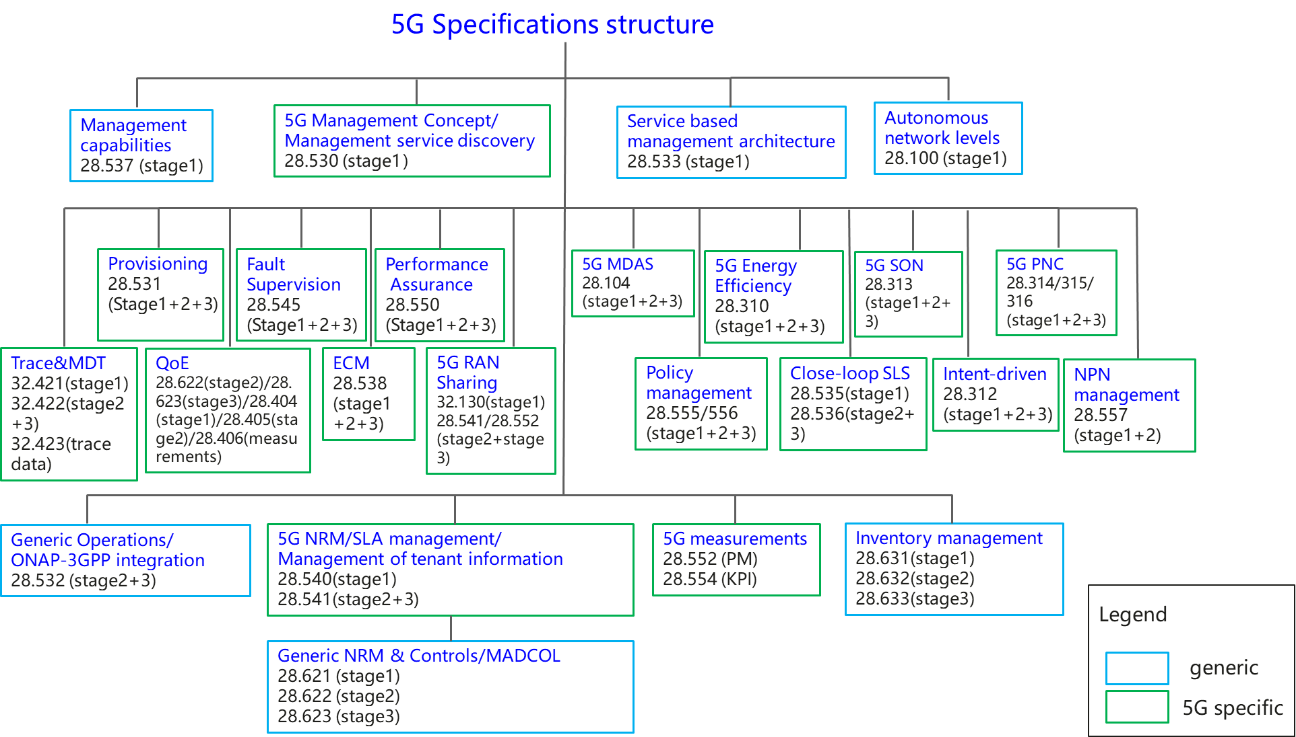
Figure 4.9.1-1: Overview of 5G management specifications
The related management descriptions in TS 28.533 [2] are limited compared with the management functions description in TS 32.101 [3].

4.9.2 Potential solutions

4.9.2.1 Management function description
Elaborate the management functional overviews in TS 28.533 [2] with taking into account of the management function description information in TS 32.101 [3] clause 7.

4.9.2.2 Management set supported by CRUD operations in SBMA
The Management sets (listed below in Table 4.9.2-1) are supported as CRUD operations in SBMA by the Generic Provisioning Management Service, defined in 3GPP 28.532 section 11.1.0.
Following is the overview for management sets supported by CRUD operations in SBMA.
Note: The management sets supported by non-CRUD operations are not listed in the following table (e.g. Streaming management operations, defined in 28.532 section 11.5.1, by Streaming Data Reporting MnS are not-CRUD operations).
Table 4.9.2-1 Overview for management sets supported by CRUD operations in SBMA
Management set | Supported MnS Components
Management set | MnS Component type A | MnS Component type B
Common Management | CRUD operations | Generic NRM (TS 28.622) (e.g. SubNetwork, ManagedElement IOC)
NR Provisioning (LCM+CM) | CRUD operations | NRM fragment for NR  (TS 28.541)
5GC Provisioning  (LCM+CM) | CRUD operations | NRM fragment for NRM 5GC (TS 28.541)
Network Slice Provisioning  (LCM+CM) | CRUD operations | NRM fragment for Network Slice (TS 28.541)
Performance | CRUD operations | PM control NRM fragment (TS 28.622)
Performance Threshold Monitoring | CRUD operations | Threshold monitoring control NRM fragment (TS 28.622)
Trace | CRUD operations | Trace control NRM fragment (TS 28.622)
QoE | CRUD operations | QoE Measurement Collection control NRM fragment (TS 28.622)
Fault Supervision | CRUD operations | FM control NRM fragment (TS 28.622)
File Retrieval | CRUD operations | File retrieval NRM fragment (TS 28.622)
File Download | CRUD operations | File download NRM fragment (TS 28.622)
Subscription | CRUD operations | Notification subscription control NRM fragment (TS 28.622)
Heartbeat | CRUD operations | Heartbeat notification control NRM fragment (TS 28.622)
AI/ML training | CRUD operations | NRM fragment for ML training (TS 28.105)
MDA | CRUD operations | NRM fragment for MDA request and MDA report (TS 28.104)
SON Policy | CRUD operations | NRM fragment for DANR Management (TS 28.541)  NRM fragment for DES Management (TS28.541)  NRM fragment for DRACH Management (TS28.541)  NRM fragment for DMRO Management (TS28.541)  NRM fragment for DPCI Management (TS 28.541)  NRM fragment for CES Management (TS 28.541)  NRM fragment for CPCI Management (TS 28.541)  NRM fragment for DLBO Management (TS 28.541)  NRM fragment for CCO Management (TS 28.541)
Intent driven management | CRUD operations | NRM fragment for intent (TS 28.312)
Edge Computing | CRUD operations | Edge NRM Fragment (TS 28.538)
ManagementDataCollection | CRUD operations | ManagementDataCollection control NRM fragment (TS 28.622)
MnS Registry and Discovery | CRUD operations | MnS Registry NRM fragment (TS 28.622)
Communication service assurance | CRUD operations | Assurance management NRM fragment (TS28.536)

One 5G related management features in Annex E TS 28.533 [2] can be supported by one or multiple above management set(s). For example, the management sets of Provisioning, Performance, Fault Supervision, MDA, SON Policy and Intent driven management can be used to support Energy efficiency management .

4.9.2.2 Notifications supported by management sets in SBMA

TBD

End of changes

