3GPP TSG-SA5 Meeting #148e S5-233461
Electronic meeting, Online, 17 -25 April 2023

Source: Huawei

Title: Add overview for management service features supported by CRUD operations in SBMA (WOP#5)

Document for: Approval
Agenda Item: 6.8.1.5

1 Decision/action requested
The group is asked to discuss and approval.

2 References
[1] 3GPP TR 28.925: "Study on enhancement of service based management architecture v0.10.0".

3 Rationale
TS 28.533 described that a MnS is composed by a MnS component type A and
- a MnS component type B, or
- a MnS component type B and a MnS component type C.
TS 28.532 described CRUD operations are the MnS component type A and in combination with a NRM (MnS component type B) constitute a MnS.
In SBMA, CRUD operations with different NRM fragments can be used to represent management services to support different management features. However, in current specifications, there is no overview for management features supported by CRUD operations in SBMA. It is proposed to add the overview for management features supported by CRUD operations in SBMA.

4 Detailed proposal
1st Change

4.9 Issue #9: Improvement on the management function description

4.9.1 Description
The following information is documented in TS 32.101 [3] to describe the TMN architecture aspects and the management functions.

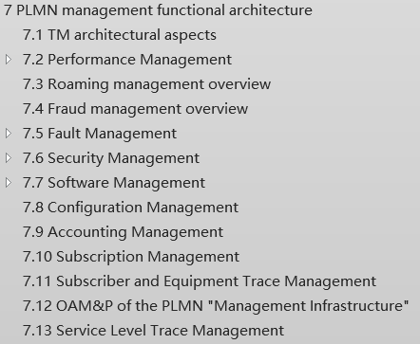
Analysis:
- TS 32.101 [3] defines the management principles and high-level requirements for the management of PLMNs. Some descriptions in corresponding area in clause 7 of TS 32.101 [3] can be improved and used for SBMA.
2. The following management features are captured in annex of TS 28.533 [2], as follows.
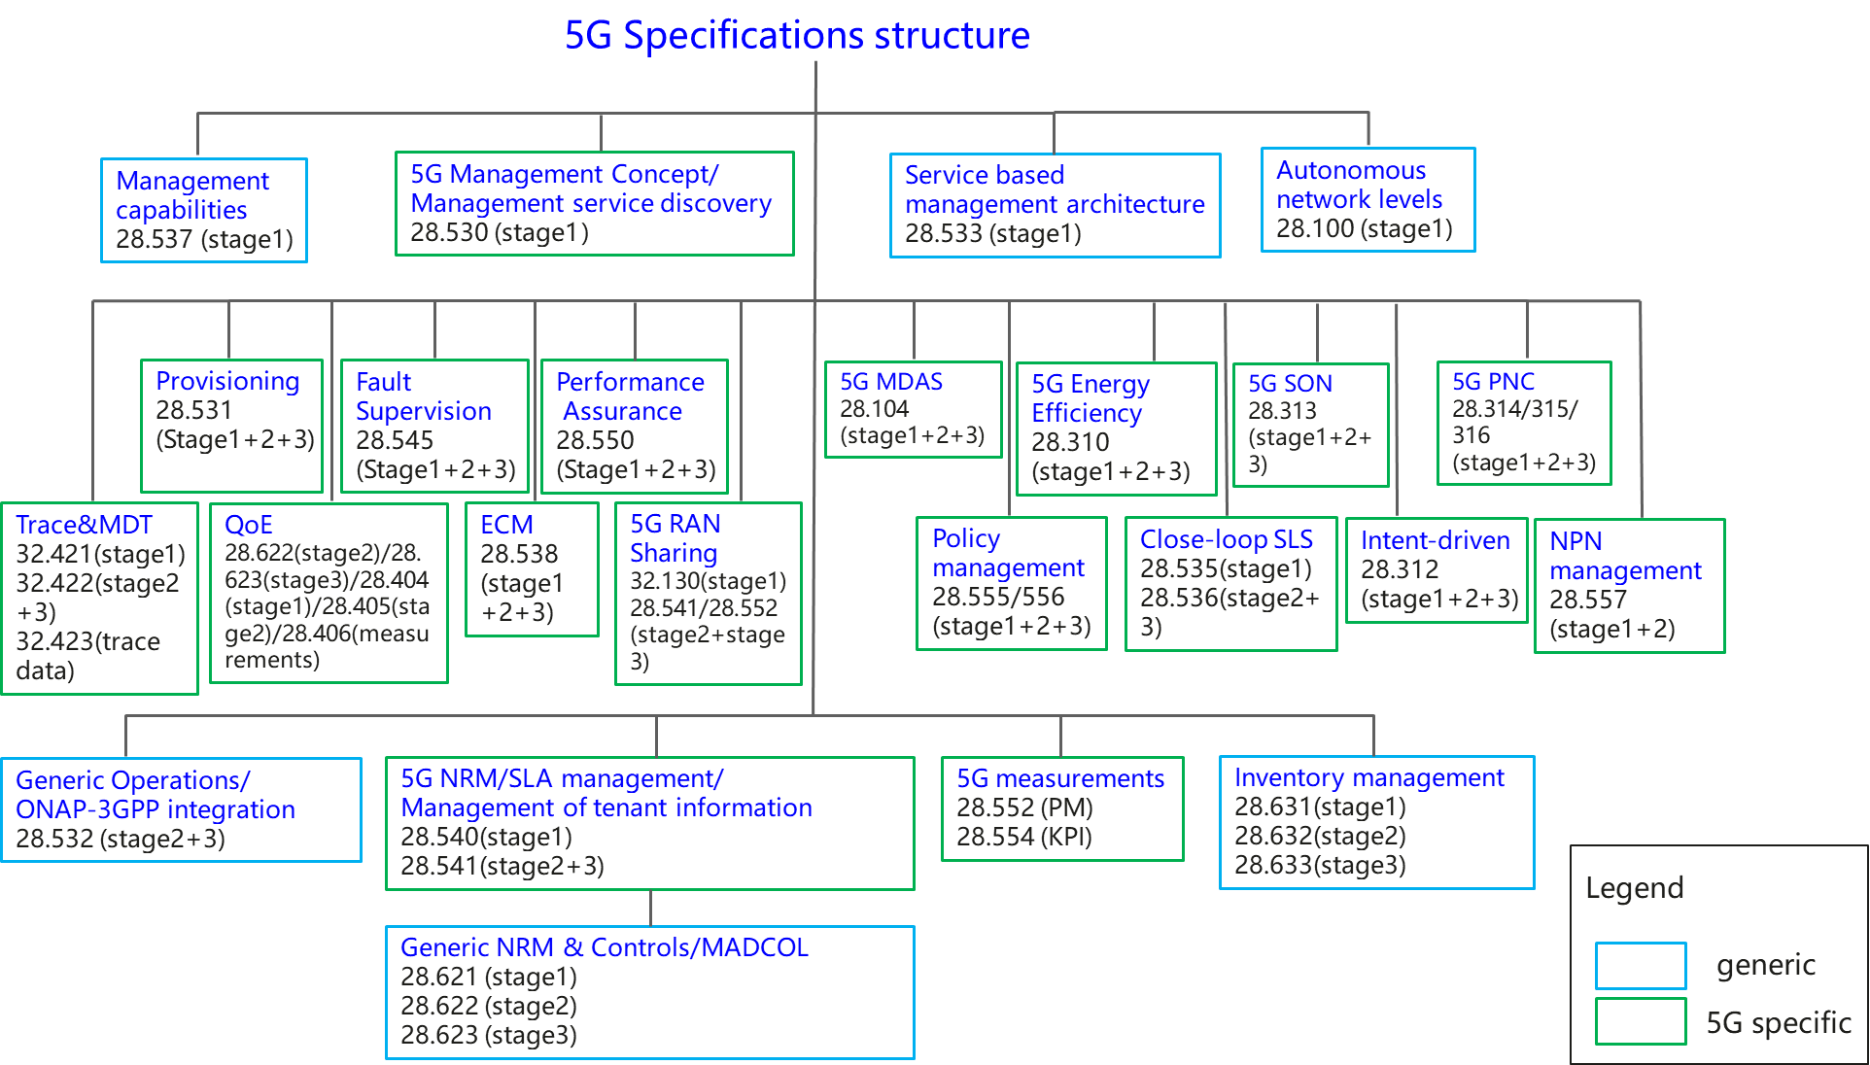
Figure 4.9.1-1: Overview of 5G management specifications
The related management features description in TS 28.533 [2] are limited compared with the management functions description in TS 32.101 [3].

4.9.2 Potential solutions

4.9.2.1 Management function description
Elaborate the management functional overviews in TS 28.533 [2] with taking into account of the management function description information in TS 32.101 [3] clause 7.

4.9.2.2 Management service feature description for the MnS supported by CRUD operations in SBMA
In SBMA, CRUD operations with different NRM fragments can be used to represent management services to support different management service features in different management functional areas. Following are the overview for management service features supported by CRUD operations in SBMA.
Note: The management service features supported by non-CRUD operations are not listed in the following table.
Table 4.9.2-1 Overview for management service features supported by CRUD operations in SBMA
Management Functional area | Management Service Feature | Supported MnS Components
Management Functional area | Management Service Feature | MnS Component type A | MnS Component type B
Architecture and Mechansim | Provisioning (LCM+CM) | CRUD operations and notifications | NRM fragment for NR  NRM fragment for NRM 5GC  NRM fragment for Network Slicing
Architecture and Mechansim | Performance Control | CRUD operations and notifications | PM control NRM fragment (TS 28.622)
Architecture and Mechansim | Performance Threshold Monitoring | CRUD operations and notifications | Threshold monitoring control NRM fragment (TS 28.622)
Architecture and Mechansim | Trace Control | CRUD operations and notifications | Trace control NRM fragment (TS 28.622)
Architecture and Mechansim | QoE Control | CRUD operations and notifications | QoE Measurement Collection control NRM fragment (TS 28.622)
Architecture and Mechansim | FM Control | CRUD operations and notifications | FM control NRM fragment (TS 28.622)
Architecture and Mechansim | File Retrieval | CRUD operations and notifications | File retrieval NRM fragment (TS 28.622)
Architecture and Mechansim | File Download | CRUD operations and notifications | File download NRM fragment (TS 28.622)
Architecture and Mechansim | Subscription Control | CRUD operations and notifications | Notification subscription control NRM fragment (TS 28.622)
Architecture and Mechansim | Heartbeat control | CRUD operations and notifications | Heartbeat notification control NRM fragment (TS 28.622)
Intelligence and Automation | AI/ML training control | CRUD operations and notifications | NRM fragment for ML training (TS 28.105)
Intelligence and Automation | MDA Control | CRUD operations and notifications | NRM fragment for MDA request and MDA report (TS 28.104)
Intelligence and Automation | SON Policy Control | CRUD operations and notifications | NRM fragment for DANR Management (TS 28.541)  NRM fragment for DES Management (TS28.541)  NRM fragment for DRACH Management (TS28.541)  NRM fragment for DMRO Management (TS28.541)  NRM fragment for DPCI Management (TS 28.541)  NRM fragment for CES Management (TS 28.541)  NRM fragment for CPCI Management (TS 28.541)  NRM fragment for DLBO Management (TS 28.541)  NRM fragment for CCO Management (TS 28.541)
Intelligence and Automation | Intent driven management | CRUD operations and notifications | NRM fragment for intent (TS 28.312)
Support of New Service | Edge Computing | CRUD operations and notifications | Edge NRM Fragment (TS 28.538)
Support of New Service | ManagementDataCollection control | CRUD operations and notifications | ManagementDataCollection control NRM fragment (TS 28.622)
Support of New Service | MnS Registry and Discovery | CRUD operations and notifications | MnS Registry NRM fragment (TS 28.622)
Support of New Service | Communication service assurance | CRUD operations and notifications | Assurance management NRM fragment (TS28.536)

One 5G related management features in Annex E TS 28.533 [2] can be supported by one or multiple above Management service feature(s). For example, the management service features of Provisioning (LCM+CM), Performance Control, FM Control, MDA Control, SON Policy Control and Intent driven management can be used to support Energy efficiency management feature.

End of changes

