3GPP TSG-SA5 Meeting #148e S5-233281
Electronic meeting, Online, 17 -25 April 2023

Source: Huawei, Deutsche Telekom

Title: add issue and potential solutions for external data management

Document for: Approval
Agenda Item: 6.8.8.4

1 Decision/action requested
The group is asked to discuss and approval.

2 References
[1] 3GPP TR 28.842: "Study on data management phase 2 v1.2.0".

3 Rationale
This contribution proposes to add new key issue for Managing external management data based on corresponding description in clause 6.4 in TS 28.537 to address the following WOP:
FS_MADCOL_ph2_WoP#4: study methods to manage external management data

4 Detailed proposal

1st Change

4.X Key issue #X: Managing external management data

4.X.1 Description
Clause 6.4.1 of TS 28.537 [2] contains description and the requirements for managing external management data (which is the additional data not specified by 3GPP and used to enrich the management data specified by 3GPP). This functionality provides the capability to enable data consumer to discover and request the external management data to be produced and reported. For example, RAN domain management system (as data consumer) may request cross domain management system (as data provider) to provide some external management data (e.g. electronic map information) for radio network coverage optimization. This functionality is supported based on assumption that the set-up of connection of external data sources (e.g. Sensors) and 3GPP management system to allow the 3GPP management system to obtain and store the external management data. The mechanism for 3GPP management system sets up the connection with 3GPP external entities and collects the external management data is out of scope of this specification. This functionality focuses on the external management data discovery, request and deliver between MnS producer and MnS consumer.
Clause 6.4.2 of [2] is used to describe the use case for managing external management data, which is empty.
Clause 6.4.3 of [2] contains a list of requirements for managing external management data, the solutions for following requirements which need to define MnS capability to support are missing.
REQ-MDMED-CON-2: The 3GPP management system shall enable an authorized data consumer to request external management data to be reported to the requesting or another authorized data consumer.
REQ-MDMED-CON-4: The 3GPP management system shall enable an authorized data consumer to discover stored external management data.
REQ-MDMED-CON-5: The 3GPP management system shall enable an authorized data consumer to retrieve stored external management data.

4.X.2 Problem Statement
Problem#1: For the description for managing data in clause 6.4.1 in TS 28.537 [2], need more description and example to elaborate how the managing external management data functionality can be used.
Problem#2: The solutions for external management data discovery, request and delivery between MnS producer and MnS consumer are missing.

4.X.3 Potential solution
Solution for Problem#1: Improve the description in clause 6.4.1 in TS 28.537 [2], the content in clause 6.4.1 in TS 28.537 [2] can be replaced by following content (the red text is the new proposed content).
Management data which is specified by 3GPP (clause 6.1.1) can be enriched by additional data not specified by 3GPP. This so-called external management data can be produced by data sources of different nature (e.g. sensors) with different formats.
External management data can be used for example as additional input for network optimization and prediction.
The management system should be able to manage this kind of data. That means data consumers should be able to request external management data to be produced and reported. The management system should provide support for storing it. Before data consumer request the external management data, it needs to discover which type of external management data can be produced and reported by management system.
The definition of external data sources and the data formats they use is out of scope of this specification.
This functionality is supported based on assumption that the set-up of connection of 3GPP external entities and 3GPP management system to allow the 3GPP management system to obtain and store the external management data. The mechanism for 3GPP management system sets up the connection with external data sources and collects the external management data is out of scope of this specification. This functionality mainly focuses on the external management data discovery, request and deliver between MnS producer and MnS consumer. Following is an example to illustrate the framework for managing external management data.

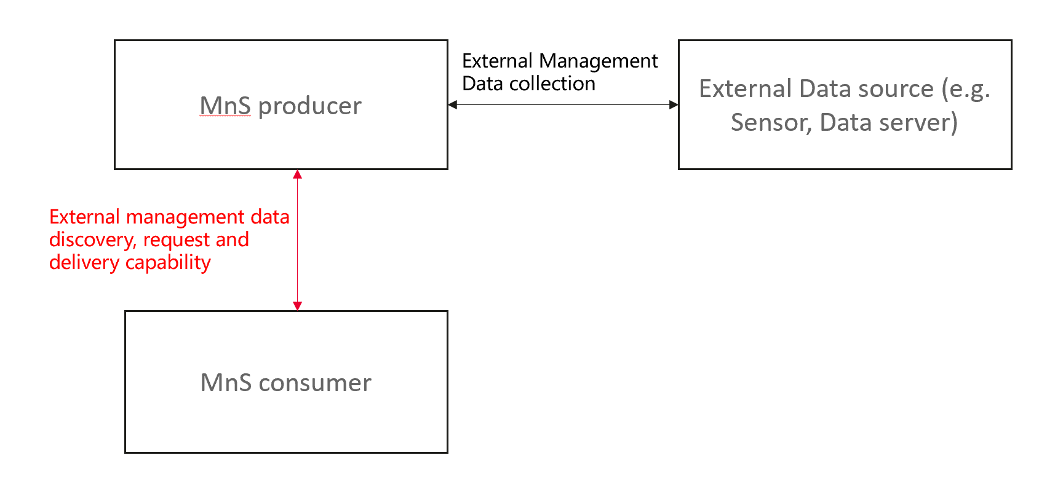
Figure Example to illustrate the framework for managing external management data.
The target is to define generic management mechanisms for external management data discovery, request and deliver, which can scope with any kind of external data sources and data formats.
Solution for Problem#2:
TBD
End of changes

