3GPP TSG-SA5 Meeting #148e S5-233278
Electronic meeting, Online, 17 -25 April 2023

Source: Huawei, Deutsche Telekom,China Mobile

Title: Add procedures for network slice (subnet) delivering and assurance

Document for: Approval
Agenda Item: 6.7.4.3

1 Decision/action requested
The group is asked to discuss and approval.

2 References
[1] 3GPP TR 28.836: "3GPP TR 28.836 Study on intent-driven management for network slicing".

3 Rationale
This contribution proposes to add:
- Procedures for Intent driven approach for network slice service delivering and assurance to support following two use cases in TR 28.836.
- Use case of Intent driven management to deliver a network slice instance
- Use case of Intent driven management to express expectation of network slice service assurance
- Procedures for Intent driven approach for network slice subnet service delivering and assurance to support following two use cases in TR 28.836.
- Use case of Intent driven management to deliver a network slice subnet instance
- Use case of Intent driven management to express expectation of network slice subnet service assurance

4 Detailed proposal

1st Change

6.X Procedures for intent driven approach for network slice (subnet) service delivering and assurance

6.X.1 Introduction
This clause describes the procedures for intent driven approach for network slice (subnet) service delivering and assurance based on generic intent creation procedure defined in clause 6.3.2 in TS 28.312 [5].

6.X.2 Procedure for intent driven approach for network slice service delivering and assurance
Figure 6.X.2-1 illustrates the procedure for intent driven approach for network slice service delivering and assurance, which allows MnS_Consumer_for_Slice (as the role of CSP) to express network slice related requirements as intent expectation to MnS_Producer_for_Slice (as the role of NOP) to deliver and assure a network slice service.

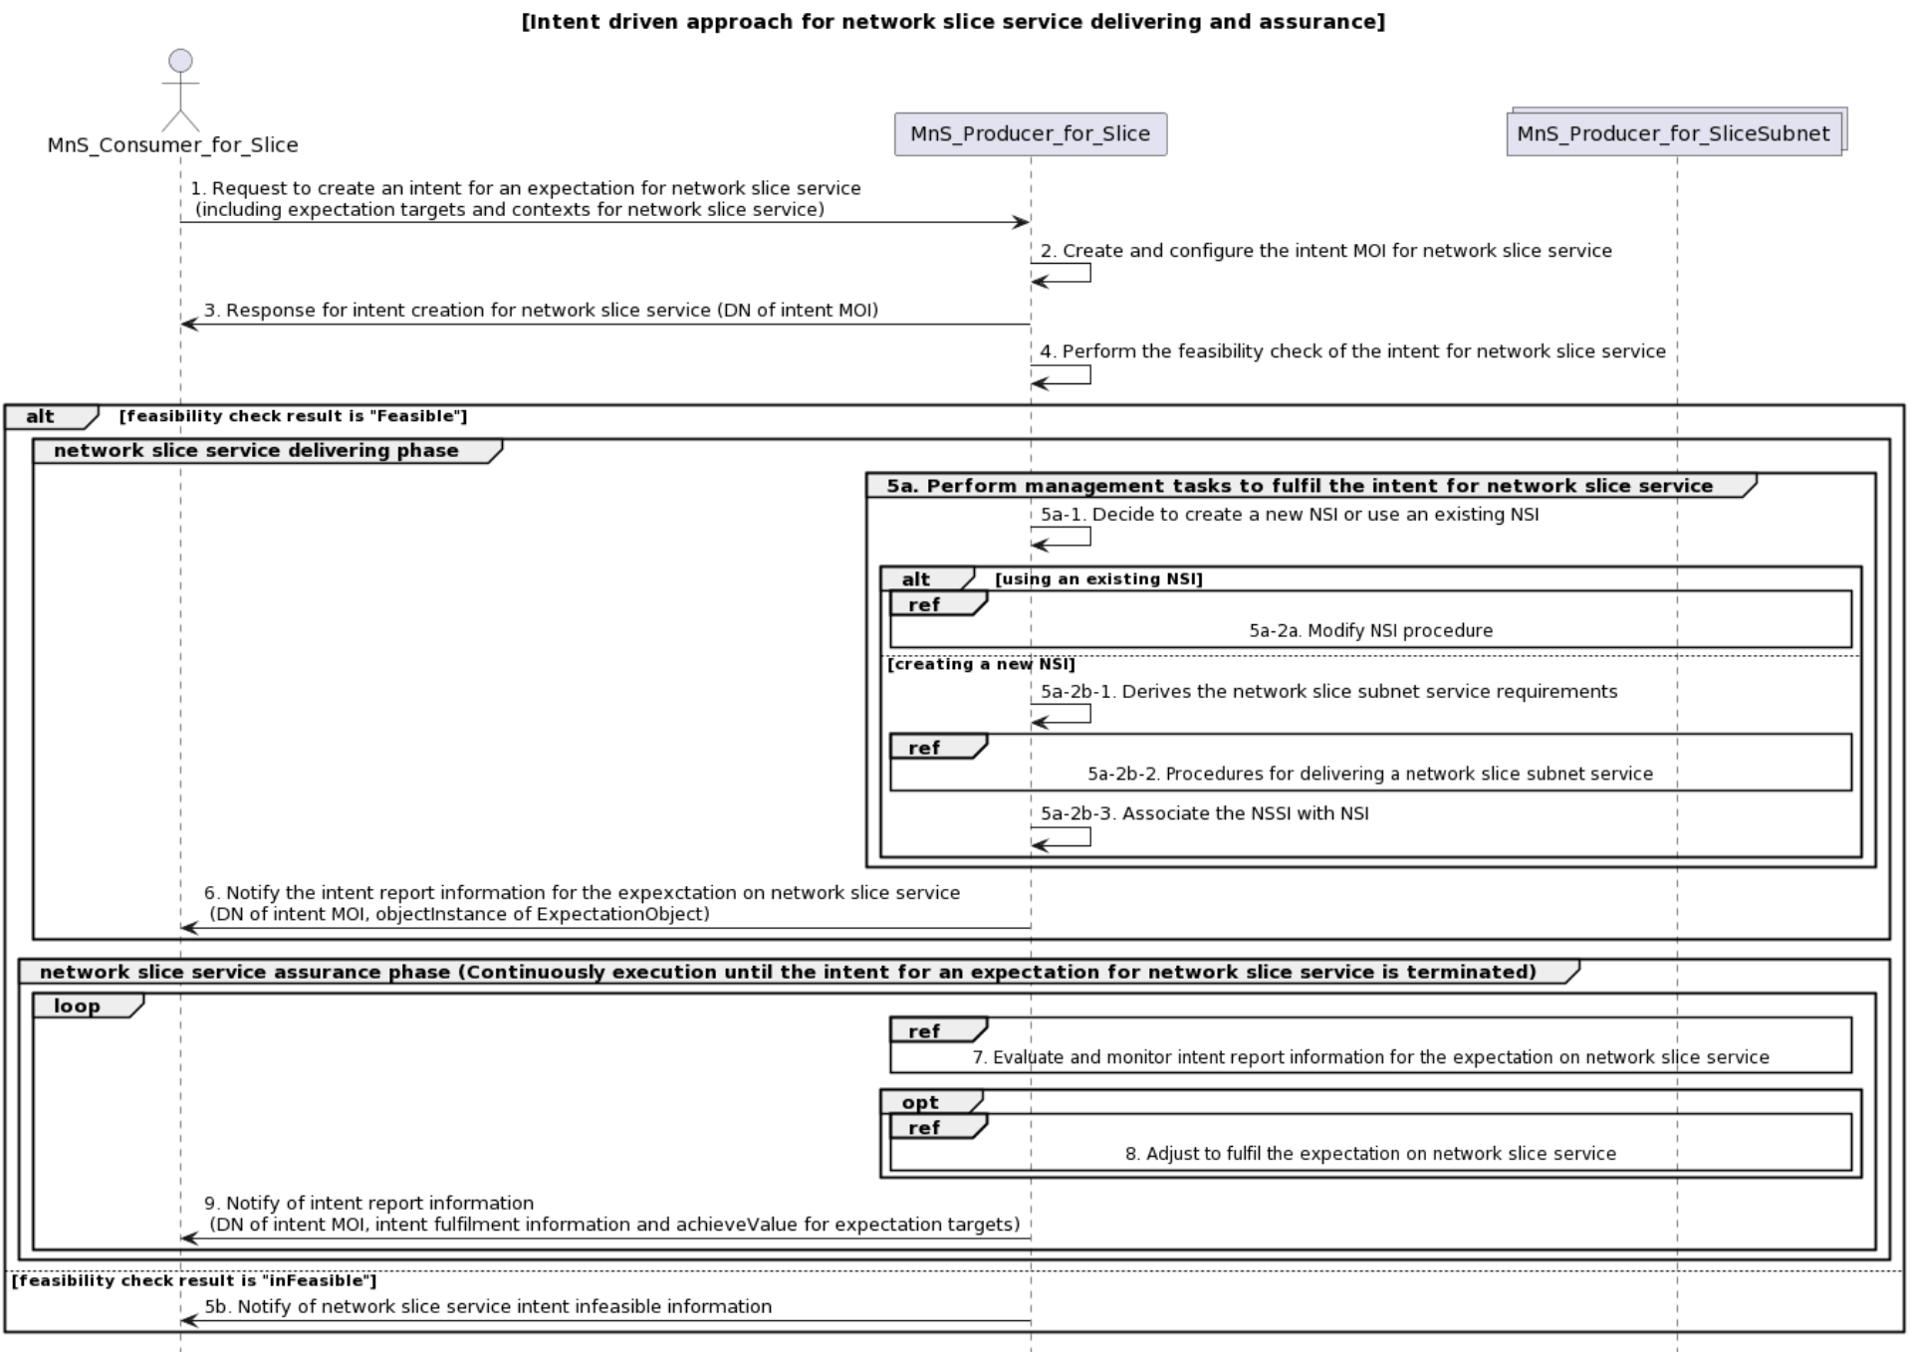

Figure 6.X.2-1 Intent driven approach for network slice service delivering and assurance
- MnS_Consumer_for_Slice sends a request to create an intent for the expectation on network slice service to MnS_Producer_for_Slice with intent information specified (including expectation targets (e.g., latency and throughput) and contexts (e.g., coverageArea) for network slice service delivering and assurance.
- Based on the received request, the MnS_Producer_for_Slice creates the concrete intent MOI for network slice service and configures the new created intent MOI with the received intent information (including expectation targets and contexts for network slice service delivering and assurance).
- MnS_Producer_for_Slice sends a response to the MnS_Consumer_for_Slice with DN of the created intent MOI.
- Based on the created intent MOI for the expectation on network slice service, MnS_Producer_for_Slice performs the feasibility check of the expectation targets and contexts for network slice service delivering and assurance.
In case the feasibility check result is 'feasible', following step 5a-step9 are executed:
For the network slice service delivering phase:
5a. MnS_Producer_for_Slice performs management tasks to deliver a network slice service to fulfil the expectation targets and contexts for network slice service, which may include:
5a-1. MnS_Producer_for_Slice decides to create a new NSI or using an existing NSI.
5a-2a. If using an existing NSI and the existing NSI needs to be modified to satisfy the expectation targets and contexts for network slice service, the MnS_Producer_for_Slice invokes the procedure to modify the existing NSI to support the required network slice service.
5a-2b-1. If creating a new NSI, the MnS_Producer_for_Slice derives the network slice subnet service requirements (the network slice subnet service requirements also can be formulated as intent targets and contexts) from the received expectation targets and contexts for network slice service.
5a-2b-2. The MnS_Producer_for_Slice invokes the procedures for delivering corresponding network slice subnet(s). The procedure for delivering network slice subnet service can use intent driven approach or non-intent driven approach.
5a-2b-3 The MnS_Producer_for_Slice creates the MOI for NetworkSlice and configures the MOI with the DN of MOI for the NetworkSliceSubnet.
6. MnS_Producer_for_Slice should notify SliceIntent_ Consumer the result (DN of intent instance, objectInstance of ExpectationObject) of the delivered network slice service.

For the network slice service assurance phase (step6-step8 are executed continuously until the intent for expectation on network slice service is terminated). Slice Intent_Producer may use one or multiple closed control loop(s) for network slice service assurance.
7. MnS_Producer_for_Slice evaluate and monitors intent report information (including intent fulfilment information and achieveValue for expectation target) for the intent on network slice service.
8. MnS_Producer_for_Slice analyses and adjusts management tasks to ensure the intent on network slice service is continuously satisfied.
9. MnS_Producer_for_Slice should notify SliceIntent_ Consumer the intent report information (DN of intent instance, intent fulfilment information and achieveValue for expectation targets) for the intent on network slice service.
In case the feasibility check result is 'infeasible', following step 5b is executed.
5b. MnS_Producer_for_Slice notifies the MnS_Consumer_for_Slice about the result of feasibility check is ‘infeasible’ and the network slice service cannot be delivered. The notification includes the reasons why the feasibility check result is infeasible (e.g. invalid intent expression, the intent conflict) and corresponding recommendations can also be included in the notification.
In addition, after step3, the MnS_Consumer_for_Slice may check the status and completion of the network slice service instance delivering and assurance procedure by monitoring the values of Intent instance attributes by querying the values or by subscribing to notifications.

6.X.3 Procedure for intent driven approach for network slice subnet service delivering and assurance
Figure 6.X.3-1 illustrates the procedure for intent driven approach for network slice subnet service delivering and assurance, which allows MnS_Consumer_for_SliceSubnet (as the role of NOP) to express network slice subnet service delivering and assurance requirements as intent expectation to MnS_Producer_for_SliceSubnet(as the role of NEP) to assure the service quality of the network slice subnet.

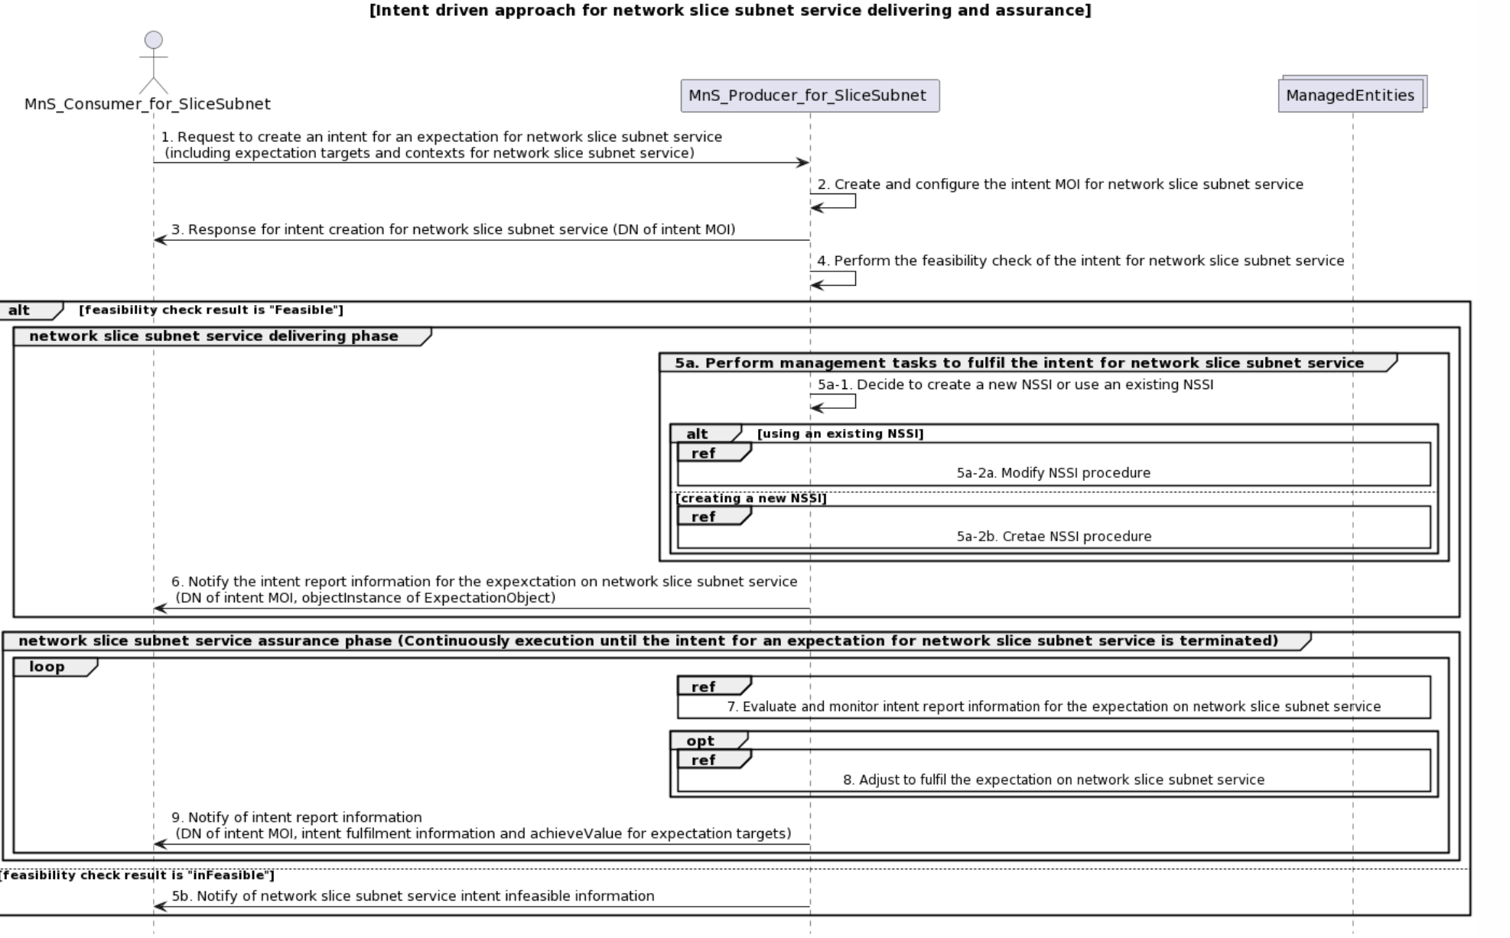
Figure 6.X.3-1 Procedure for intent driven approach for network slice subnet service delivering assurance.
- MnS_Consumer_for_SliceSubnet sends a request to create an intent for the expectation on network slice subnet service to MnS_Producer_for_SliceSubnet with intent information specified (including expectation targets and contexts for network slice subnet service delivering and assurance.
- Based on the received request, the MnS_Producer_for_SliceSubnet creates the concrete intent MOI for network slice subnet service and configures the new created intent MOI with the received intent information (including expectation targets and contexts for network slice subnet service delivering and assurance).
- MnS_Producer_for_SliceSubnet sends a response to the MnS_Consumer_for_SliceSubnetwith DN of the created intent MOI.
- Based on the created intent MOI for the expectation on network slice subnet service, MnS_Producer_for_SliceSubnet performs the feasibility check of the expectation targets and contexts for network slice subnet service delivering and assurance.
In case the feasibility check result is 'feasible', following step 5a-step9 are executed:
For the network slice subnet service delivering phase:
5a. MnS_Producer_for_SliceSubnet performs management tasks to deliver a network slice subnet service to fulfil the expectation targets and contexts for network slice subnet service, which may include:
5a-1. MnS_Producer_for_SliceSubnet decides to create a new NSSI or using an existing NSSI.
5a-2a. If using an existing NSSI and the existing NSSI needs to be modified to satisfy the expectation targets and contexts for network slice subnet service, the MnS_Producer_for_SliceSubnet invokes the procedure to modify the existing NSSI to support the required network slice subnet service.
5a-2b. If creating a new NSSI, the MnS_Producer_for_SliceSubnet invokes the procedures for create the NSSI to support the required network slice subnet service.
6. MnS_Producer_for_SliceSubnet should notify the SubnetIntent_ Consumer about the result (DN of intent instance, objectInstance of ExpectationObject) of the delivered network slice subnet service.

For the network slice subnet service assurance phase (step6-step8 are executed continuously until the intent for expectation on network slice subnet service is terminated). Subnet Intent_Producer may use one or multiple closed control loop(s) for network slice subnet service assurance.
7. MnS_Producer_for_SliceSubnet evaluate and monitors intent report information (including intent fulfilment information and achieveValue for expectation target) for the intent on network slice subnet service.
8. MnS_Producer_for_SliceSubnet analyses and adjusts management tasks to ensure the intent on network slice subnet service is continuously satisfied.
9. MnS_Producer_for_SliceSubnet should notify the SubnetIntent_ Consumer about the intent report information (DN of intent instance, intent fulfilment information and achieveValue for expectation targets) for the intent on network slice subnet service.
In case the feasibility check result is 'infeasible', following step 5b is executed.
5b. MnS_Producer_for_SliceSubnet notifies MnS_Consumer_for_SliceSubnet about the result of feasibility check is ‘infeasible’ and the network slice subnet service cannot be delivered. The notification includes the reasons why the feasibility check result is infeasible (e.g. invalid intent expression, the intent conflict) and corresponding recommendations also can be included in the notification.
In addition, after step3, the MnS_Consumer_for_SliceSubnet may check the status and completion of the network slice subnet service instance delivering and assurance procedure by monitoring the values of Intent instance attributes by querying the values or by subscribing to notifications.

2nd Change

Annex A (informative):
PlantUML source code

A.1 Procedures for slice intent management

A.1.1 Procedure for intent driven approach for network slice service delivering
@startuml
title "[Intent driven approach for network slice service delivering and assurance]"
actor "MnS_Consumer_for_Slice " as MnS_Consumer
participant " MnS_Producer_for_Slice " as MnS_Producer
Collections "MnS_Producer_for_SliceSubnet" as SubnetIntent_Producer
MnS_Consumer -> MnS_Producer: 1. Request to create an intent for an expectation for network slice service \n (including expectation targets and contexts for network slice service)
MnS_Producer -> MnS_Producer: 2. Create and configure the intent MOI for network slice service
MnS_Producer -> MnS_Consumer: 3. Response for intent creation for network slice service (DN of intent MOI)
MnS_Producer -> MnS_Producer: 4. Perform the feasibility check of the intent for network slice service

alt feasibility check result is "Feasible"
group network slice service delivering phase
group 5a. Perform management tasks to fulfil the intent for network slice service
MnS_Producer -> MnS_Producer: 5a-1. Decide to create a new NSI or use an existing NSI
alt using an existing NSI
ref over MnS_Producer,SubnetIntent_Producer: 5a-2a. Modify NSI procedure
else creating a new NSI
MnS_Producer -> MnS_Producer: 5a-2b-1. Derives the network slice subnet service requirements
Ref over MnS_Producer, SubnetIntent_Producer: 5a-2b-2. Procedures for delivering a network slice subnet service
MnS_Producer -> MnS_Producer: 5a-2b-3. Associate the NSSI with NSI
end
end
MnS_Producer -> MnS_Consumer:6. Notify the intent report information for the expexctation on network slice service \n (DN of intent MOI, objectInstance of ExpectationObject)
end

group network slice service assurance phase (Continuously execution until the intent for an expectation for network slice service is terminated)
loop
Ref over MnS_Producer,SubnetIntent_Producer: 7. Evaluate and monitor intent report information for the expectation on network slice service
opt
Ref over MnS_Producer,SubnetIntent_Producer: 8. Adjust to fulfil the expectation on network slice service
end
MnS_Producer -> MnS_Consumer:9. Notify of intent report information \n (DN of intent MOI, intent fulfilment information and achieveValue for expectation targets)
end
end
else feasibility check result is "inFeasible"
MnS_Producer -> MnS_Consumer: 5b. Notify of network slice service intent infeasible information
end

hide footbox
@enduml

A.1.2 Procedure for intent driven approach for network slice subnet service delivering assurance
@startuml
title "[Intent driven approach for network slice subnet service delivering and assurance]"
actor "MnS_Consumer_for_SliceSubnet " as MnS_Consumer
participant "MnS_Producer_for_SliceSubnet " as MnS_Producer
Collections "ManagedEntities" as ManagedEntity
MnS_Consumer -> MnS_Producer: 1. Request to create an intent for an expectation for network slice subnet service \n (including expectation targets and contexts for network slice subnet service)
MnS_Producer -> MnS_Producer: 2. Create and configure the intent MOI for network slice subnet service
MnS_Producer -> MnS_Consumer: 3. Response for intent creation for network slice subnet service (DN of intent MOI)
MnS_Producer -> MnS_Producer: 4. Perform the feasibility check of the intent for network slice subnet service

alt feasibility check result is "Feasible"
group network slice subnet service delivering phase
group 5a. Perform management tasks to fulfil the intent for network slice subnet service
MnS_Producer -> MnS_Producer: 5a-1. Decide to create a new NSSI or use an existing NSSI
alt using an existing NSSI
ref over MnS_Producer,ManagedEntity: 5a-2a. Modify NSSI procedure
else creating a new NSSI
Ref over MnS_Producer, ManagedEntity: 5a-2b. Cretae NSSI procedure
end
end
MnS_Producer -> MnS_Consumer:6. Notify the intent report information for the expexctation on network slice subnet service \n (DN of intent MOI, objectInstance of ExpectationObject)
end

group network slice subnet service assurance phase (Continuously execution until the intent for an expectation for network slice subnet service is terminated)
loop
Ref over MnS_Producer,ManagedEntity: 7. Evaluate and monitor intent report information for the expectation on network slice subnet service
opt
Ref over MnS_Producer,ManagedEntity: 8. Adjust to fulfil the expectation on network slice subnet service
end
MnS_Producer -> MnS_Consumer:9. Notify of intent report information \n (DN of intent MOI, intent fulfilment information and achieveValue for expectation targets)
end
end
else feasibility check result is "inFeasible"
MnS_Producer -> MnS_Consumer: 5b. Notify of network slice subnet service intent infeasible information
end

hide footbox
@enduml

End of changes

