3GPP TSG-SA5 Meeting #148e S5-233274
Electronic meeting, Online, 17 -25 April 2023

Source: Huawei, Deutsche Telekom

Title: Update the Issue#4.6 Intent-driven closed loop control

Document for: Approval
Agenda Item: 6.7.3.2

1 Decision/action requested
The group is asked to discuss and approval.

2 References
[1] 3GPP TR 28.912: "Management and orchestration; Study on enhanced intent driven management services for mobile networks v1.2.0".

3 Rationale
This contribution proposes following updates for the description for Issue#4.6: Intent-driven Closed Loop control
- Update the description and Figure 4.6.1-1 in first paragraph to align with the closed loop description in TS 28.535.
- Update the Figure 4.6.1-2 and corresponding description in second paragraph to reflect the scenario of using Intents towards Closed-Loop Control to automate closed loops management and control.

4 Detailed proposal

1st Change

2 References
The following documents contain provisions which, through reference in this text, constitute provisions of the present document.
- References are either specific (identified by date of publication, edition number, version number, etc.) or non-specific.
- For a specific reference, subsequent revisions do not apply.
- For a non-specific reference, the latest version applies. In the case of a reference to a 3GPP document (including a GSM document), a non-specific reference implicitly refers to the latest version of that document in the same Release as the present document.
[1] 3GPP TR 21.905: "Vocabulary for 3GPP Specifications".
[2] 3GPP TS 28.312: "Management and orchestration; Intent driven management services for mobile networks"
[3] 3GPP TS 28.541: "Management and orchestration; 5G Network Resource Model (NRM); Stage 2 and stage 3".
[4] 3GPP TS 28.554: "Management and orchestration; 5G end to end Key Performance Indicators (KPI)".
[5] TM Forum TMF921A: "TMF921A _Intent_Management_API_Profile_v1.1.0".
[6] 3GPP TR 28.908: "Study on Artificial Intelligence/Machine Learning (AI/ ML) management".
[7] 3GPP TS 28.104: "Management and orchestration; Management Data Analytics (MDA)".
[X] 3GPP TS 28.535: "Management and orchestration; Management services for communication service assurance; Requirements"

2nd Change

4.6 Issue#4.6: Intent-driven Closed Loop control

4.6.1 Description
A Closed Loop (CL) is an entity that implements the capabilities to get data, analyse it, generate decision and execute those decision on the network in general. It is implemented in four stages (i.e. monitor, analyse, decide and execute) and one or multiple stages may be implemented by a specific component (i.e. MnF). The detailed definition and concept for closed loop see TS 28.535[X]. MnS producer of CL management services may implement a Closed-loop Control (CC) to support control capabilities for managing or controlling the closed loop .
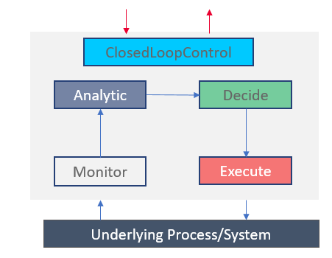
Figure 4.6.1-1: Example relations among closed loop components
Given a set of deployed network functions and/or management functions, the Closed-Loop Control may configure different network and management functions to achieve the desired closed loop goals based on intents with the input “context” (e.g. capabilities, control or use case) provided by the operator, as illustrated by Figure 4.6.1-2. Within the intent driven system, the MnS producer for intent driven MnS may play the role of closed loop control to implement the intent driven closed loop or interact with closed loop control to control the closed loop.

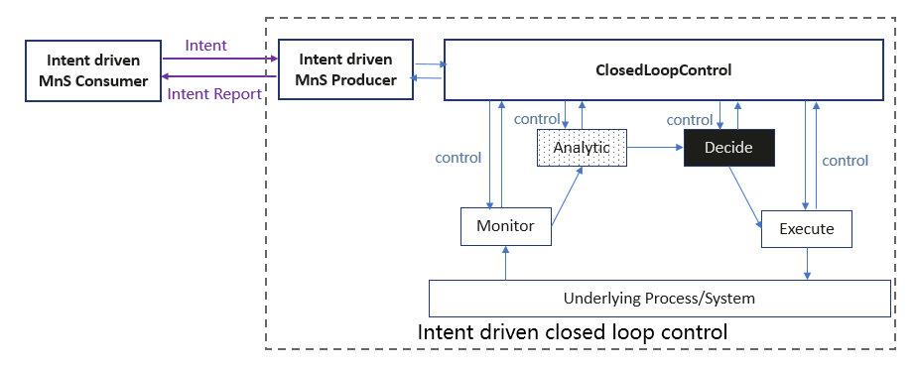
Figure 4.6.1-2: Using Intents towards Closed-Loop Control to automate closed loops management and control
REQ-Intent_GEN_CON_01: The 3GPP management systems shall support a capability to allow a consumer (e.g. an operator) to express an intent to enable the provider of CL management to configure a CL based on an intent that expresses the intent expectations as closed loop goals, KPI, SLS, SLA targets, input-output pairs or capabilities
REQ-Intent_GEN_CON_02: The 3GPP management systems shall support a capability to allow a consumer (e.g. an operator) to express an intent to enable the provider of CL management to configure its constituent management functions and goals to achieve the expectations of the intent.
REQ-Intent_GEN_CON_03: The 3GPP management systems shall support a capability to inform an authorized consumer (e.g. an operator) about closed loops and management functions serving the intent.
End of changes

