3GPP TSG-SA5 Meeting #148e S5-233273
Electronic meeting, Online, 17 -25 April 2023

Source: Huawei

Title: Rapporteur clean up on clause 6

Document for: Approval
Agenda Item: 6.7.3.5

1 Decision/action requested
The group is asked to discuss and approval.

2 References
[1] 3GPP TR 28.912: "Management and orchestration; Study on enhanced intent driven management services for mobile networks v1.2.0".

3 Rationale
This contribution proposes the clean up on clause 6.

4 Detailed proposal
It is proposed to update the following chapter in TR 28.912 [1].

1st Change

2 References
The following documents contain provisions which, through reference in this text, constitute provisions of the present document.
- References are either specific (identified by date of publication, edition number, version number, etc.) or non-specific.
- For a specific reference, subsequent revisions do not apply.
- For a non-specific reference, the latest version applies. In the case of a reference to a 3GPP document (including a GSM document), a non-specific reference implicitly refers to the latest version of that document in the same Release as the present document.
[1] 3GPP TR 21.905: "Vocabulary for 3GPP Specifications".
[2] 3GPP TS 28.312: "Management and orchestration; Intent driven management services for mobile networks"
[3] 3GPP TS 28.541: "Management and orchestration; 5G Network Resource Model (NRM); Stage 2 and stage 3".
[4] 3GPP TS 28.554: "Management and orchestration; 5G end to end Key Performance Indicators (KPI)".

[6] 3GPP TR 28.908: "Study on Artificial Intelligence/Machine Learning (AI/ ML) management".
[7] 3GPP TS 28.104: "Management and orchestration; Management Data Analytics (MDA)".

1st Change

6 Issue investigations and potential solutions for collaboration with other SDOs

6.1 Issue#6.1: Comparison of 3GPP intent management operations and TM Forum intent management operations

6.1.1 Description
TM Form defines the Intent Management operations, which includes intent management operations between Intent Owner and Intent Handler for TM Forum intent. TS 28.312 [2] clause 6.1 also defines the Management operations for Intent, which includes the intent management operations between MnS consumer and MnS producer for 3GPP intent. However, the comparison of 3GPP intent management operations and TM Forum intent management operations is missing, which can provide the guidelines for transform functionality between TM Forum intent management operations and 3GPP intent management operations for the potential intent interface deployment scenario#2 in clause 6.3.2.2.

6.1.2 Potential solutions
The following table illustrates the comparison between 3GPP intent management operations (defined in TS 28.312[2]) and TM Forum intent management operations.
Table6.1.2-1 the comparison between 3GPP Intent Management operations and TM Forum intent management operations
3GPP Intent management operations | TM Forum Intent management operations
createMOI operation, the MOI is instance of intent IOC | Set Intent
modifyMOIAttributes operation, the MOI is instance of intent IOC | Set Intent
getMOIAttributes operation, the MOI is instance of intent IOC | Retrieve Intent
deleteMOI operation, the MOI is instance of intent IOC | Remove Intent
notifyMOIAttributeValueChanges Notification for the attribute "intentFulfillmentInfo" in the instance of intent IOC | Intent Report Event

2nd of changes

6.2.2 Potential solutions
The following table illustrates the comparison between TM Forum intent management functionality and the 3GPP intent management procedures defined in TS 28.312 [1].
Those which are not currently comparable are excluded.
Table6.2.2-1 Comparison of 3GPP Intent Management procedures and TM Forum Intent management functions
3GPP Intent management procedure | TM Forum Intent management functionality
Create an Intent | Create a new Intent
Query an Intent | Retrieve intent
Modify an Intent | Modify existing intent
Delete an Intent | Remove intent

Note: There is additional functionality defined in TMF which is not included above, i.e. Judge/Preference, Probe, and Best/Propose interactions.

3rd of changes

6.3.1 Description
TS 28.312 [2] described different kinds of intents which can be applicable for different kinds of standardized reference interfaces based on roles related to 5G networks and network slicing management. See below:
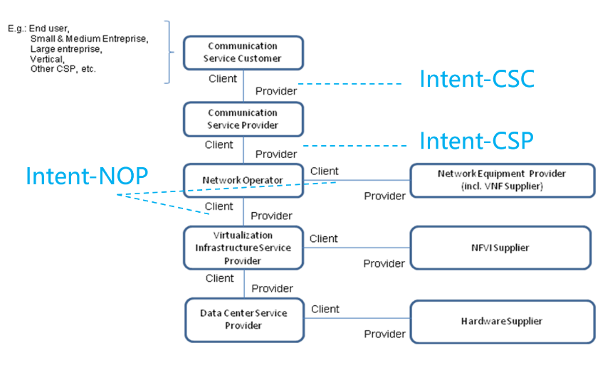
Figure 6.3.1-1 Roles related to 5G networks and network slicing management
3GPP specifies the intent driven MnS (including management operations and intent model) to manage 3GPP network and services, and provides interoperability capability between MnS consumer and MnS producer, TM Forum defines the intent management API (including management operations and intent model) between intent owner and intent handler.
For the management of 3GPP network and services, currently there is no description for the deployment scenarios for intent interface.

6.3.2 Potential deployment scenarios

6.3.2.1 Potential deployment scenario#1
In this deployment scenario, 3GPP intent driven MnS (defined in TS 28.312[2]) can be applicable for following kinds of standardized reference interfaces for the management of 3GPP network and services:
- Management interactions for Intent-NOP between NOP and NEP;
- Management interactions for Intent-CSP between CSP and NOP;
- Management interactions for Intent-CSC between CSC and CSP;
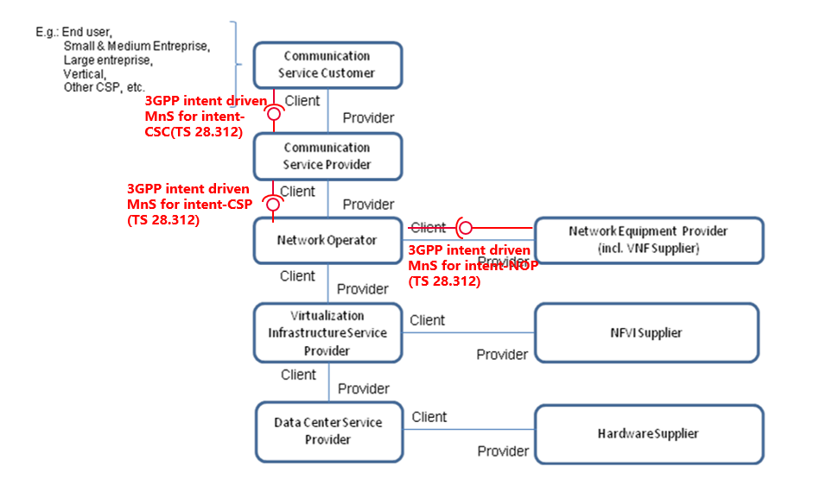
Figure 6.3.2.1-1 Potential intent interface deployment scenario#1

6.3.2.2 Potential deployment scenario#2
In this deployment scenario, 3GPP intent driven MnS can be applicable for following kinds of standardized reference interfaces for the management of 3GPP network and services:
- Management interactions for Intent-NOP between NOP and NEP;
- Management interactions for Intent-CSP between CSP and NOP;
TM Form intent management API can be applicable for following kinds of standardized reference interfaces for the management of 3GPP network and services:
- Management interactions for Intent-CSC between CSC and CSP;
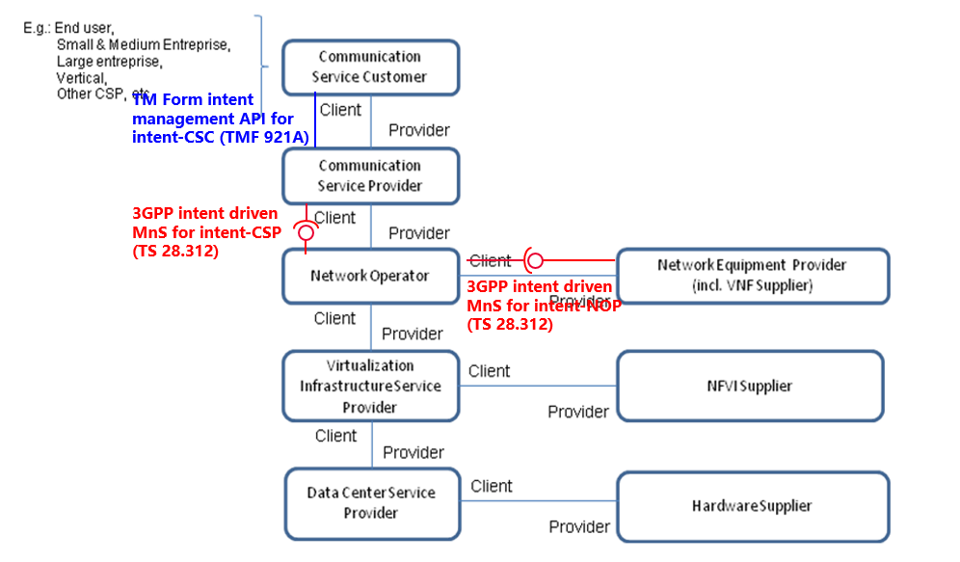
Figure 6.3.2.2-1 Potential intent interface deployment scenario#2
In this intent interface deployment scenario, following contents can be used as guidelines for transformation functionality between TM Forum intent management API for intent-CSC and 3GPP intent driven MnS for intent-CSP.
- Mapping the 3GPP and the TM Forum intentExpectation Models described in Annex C in TS 28.312 [2].
- Comparison of 3GPP intent management operations and TM Forum intent management operations described in clause 6.1.2.
- Comparison of 3GPP Intent procedures and TM Forum Intent management functionality described in clause 6.2.2.
End Change

