3GPP TSG-SA5 Meeting #148e S5-233272
Electronic meeting, Online, 17 -25 April 2023

Source: Huawei

Title: Rapporteur on clause 4

Document for: Approval
Agenda Item: 6.7.3.5

1 Decision/action requested
The group is asked to discuss and approval.

2 References
[1] 3GPP TR 28.912: "Management and orchestration; Study on enhanced intent driven management services for mobile networks v1.2.0".

3 Rationale
This contribution proposes the clean up on clause 4.

4 Detailed proposal
It is proposed to update the following chapter in TR 28.912 [1].
1st Change

4.1 Issue#4.1: intent driven approach for RAN energy saving

4.1.1 Description
Operators are aiming at decreasing power consumption in 5G networks to lower their operational expense with energy saving management solutions. Energy saving is achieved by executing the energy saving actions with suitable parameter configurations, e.g. energy saving state switch, start time and end time, the energy saving thresholds. However, the various combinations of energy saving actions can lead to conflicts. For example, different energy saving actions may be contradictory, or the energy saving actions may conflict with other activities (e.g. network optimization actions). Moreover, it is not straightforward to evaluate the influence on service experience (e.g. UL/DL RAN UE throughput, latency) of energy saving actions beforehand, which makes it difficult to balance the energy saving effect and service experience, for example the energy saving actions may deteriorate the service experience. To avoid affecting the service experience, MnS consumer may express energy saving target with the maximum value of RAN energy consumption in intent expectation, and MnS producer is able to choose an optimal value of RAN energy consumption to save energy as much as possible in the context to satisfy the service experience.
As TS 28.312 [2] described, an intent focuses more on describing the "What" needs to be achieved but less on "How" that outcomes should be achieved, which not only relieves the burden of the consumer knowing implementation details but also leaves room to allow the producer to explore alternative options and find optimal solutions. So, introducing the intent approach for energy saving, which can enable the 3GPP management system to analyse and select the optimal balance between the energy saving effect and service experience by utilizing some intelligence mechanisms. In intent driven approach, a MnS consumer expresses intent expectation for RAN energy saving in the specified area to a MnS producer, which may include the RAN energy saving target (e.g. the maximum value of target RAN energy consumption) and service experience (e.g. RAN UE throughput, latency), as well as the frequencies and RATs to be considered for energy saving. MnS producer analyses and determines the optimal RAN energy saving solution (a set of energy saving actions) to satisfy MnS consumer's intent expectation for RAN energy saving.
It is important to investigate the model for intent expectation for RAN energy saving based on the generic intent model and radio network expectation defined in TS 28.312[2].

4.1.a Potential requirements
REQ-Intent_RAN_EnergySaving: The intent driven MnS shall have capability enabling MnS consumer to express intent containing an expectation on RAN energy saving for the specified area to MnS producer.

4.1.2 Potential solutions
The RadioNetworkExpectation can be reused for expectation on RAN energy saving with some extension.
- Following attributes defined in RadioNetworkExpectation in TS 28.312 [2] can be reused.
- The attribute "coverageAreaPolygonContext", "coverageTACContext" and "pLMNContext" can be used by MnS consumer to specify the area that the intent expectation for RAN energy saving applied.
- The attribute "nRFqBandContext" and "rATContext" can be used by MnS consumer to specify the frequencies and RATs to be considered for energy saving.
- The attribute "aveULRANUEThptTarget", "aveDLRANUEthptTarget", "lowULRANUEThptRatioTarget" and "lowDLRANUEThptRatioTarget" can be used by MnS consumer to specify the service experience to be assured when achieving the energy saving target.
- Following attributes need to be defined in RadioNetworkExpectation for the expectation on radio network energy saving.
- Attribute "RanEnergyConsumptionTarget" describes the energy consumption that the intent expectation is applied, which including attributes: targetName, targetCondition and targetValueRange. The concrete targetValueRange see corresponding KPI "EC_{NG-RAN}" definition in clause 6.7.3.4.1 in TS 28.554 [4].
- Attribute "RanEnergyEfficiencyTarget" describes the energy efficiency that the intent expectation is applied, which including attributes: targetName, targetCondition and targetValueRange. The concrete targetValueRange see corresponding KPI "EE_{MN,DV}" definition in clause 6.7.1.1 in TS 28.554 [4].
2nd Change

4.2 Issue#4.2: Intent conflicts

4.2.1 Description
The MnS consumer may create an intent containing two or more intent expectations, and each intent expectation may contain multiple expectation targets. For example, a Radio Network related intent may express an intent with targets on radio network parameters (like, downlink transmit power, remote electrical tilt) or on KPIs (like, DL UE throughput target, average RSRP target, coverage area). On receiving and after analysing the intent, the MnS producer may realize that the intent expectations or expectation targets in one intent are contradicted, i.e. the MnS producer may detect conflicts in the intent. Also, an intent is considered to have conflict with other intents if the requirements (includes intent expectation and corresponding expectation targets) stated in one intent is conflicted with the requirements (includes intent expectation and corresponding expectation targets) stated in another intent. Following are the intent related conflict scenarios:
- Target conflict, which represents the conflict between two or more expectation targets within the same intent expectation.
- Expectation conflict, which represents the conflict between two or more intent expectations with the same intent
- Intent conflict, which represents the conflict between two or more different intents.
For example, consider two targets target_1=: throughput > threshold_1 and target_2=: interference < threshold_2, and while trying to achieve target_1, target_2 gets degraded, so the producer will see that the targets are conflicting. There is intent conflict between them if they are in different intents, but there is expectation conflict or target conflict between them if they are in the same intent.
Conflicts related to the above intents can also be classified according to the following principles. Subsequently, different solutions can be customized based on different classifications of conflicts to solve the same kind of intent related conflicts.
- Explicit conflict, which represents the conflict between two intents can be identified by the intent model information. For example, for target_3 and target_4, they have different requirements for latency indicators. By analyzing the intent model description information, we can identify that these two targets have target conflicts.
- Implicit conflict, which represents the conflict between two intents cannot be identified by the intent model information. Conflicts will appear only in the process of intent operation. For example, one intent is to increase throughput, and the other intent is to reduce the resource consumption of virtual machines. From the perspective of intent model, the conflict between the two intents cannot be identified by definition. But in the process of intent operation, increasing throughput may increase the utilization of virtual machine resources. At this time, it will conflict with the intent to reduce virtual machine resources.
For the intent conflict, the two or more intents may be proposed by the same MnS consumer, or may be proposed by different MnS consumers. An example of the latter is that the MnS producer cannot satisfy the intents of two MnS consumers simultaneously. From the perspective of intent creation time, conflicting intentions may be proposed at different time, so a newer intent may be in conflict with an intent that is being executed but has not yet been fulfilled. The MnS producer may terminate the intent execution task.
When such conflicts are detected, the MnS producer needs to notify the MnS consumer about the conflict, indicating the intent, intent expectations or expectation targets which give rise to the conflict. Additionally, the MnS producer may also notify the MnS consumer about the additional information (e.g. the impact for other expectation targets when fulfil the specified expectation targets in the same or different intent) for the conflict. The MnS producer can also provide solutions regarding intent conflicts, such as termination of the whole intent, recommended intent (recommended expectations or targets, or termination of part of intent), or updating the execution time of the intent.
Thereby, the MnS consumer may task actions (e.g. modify and delete the intent or intent expectation or expectation targets,) to address such intent conflict or MnS consumer may give some intent conflict handling guidelines (e.g. assign priority for such intent or intent expectation or expectation targets) to MnS producer to solve such intent conflict or eliminate the terminated state which is caused by the reason of conflict detected.

4.2.a Potential requirements
REQ-Intent_conflict-CON-1: The intent driven MnS should have the capability to inform the authorized MnS consumer about intent related conflicts (both explicit and implicit conflicts) as soon as they are identified (either during creation or operation), including intent conflict, expectation conflict and target conflict.
REQ-Intent_conflict-CON-2: The intent driven MnS should have the capability to allow the authorized MnS consumer to give intent conflict handling guidelines to MnS producer to solve such intent conflict and potentially affect the terminated state which is caused by the reason of conflict detected.
REQ-Intent_conflict-CON-3: The intent driven MnS should have the capability to inform the authorized MnS consumer about possible solutions related conflicts, including suggesting to terminate intent instances, recommended intent instances, or recommended execution time of the intent instances.

4.2.2 Potential Solution
When the MnS producer detects a conflict on an intent, an intent expectation or an expectation target, following activities will be taken by MnS producer:
- The MnS producer should notify the MnS consumer whenever such a conflict is detected with intent, intent expectations or expectation targets specified which give rise to the conflict.
- The MnS producer may execute one of the following options to handle the conflict based on the intent conflict handling guidelines configured by MnS consumer:
  - The MnS producer rejects the intent and sends the notification of the rejection message to MnS consumer providing the cause for rejection as the conflict. Additionally, the intent progress status should be marked as terminated with the reason as conflict detected.
  - The MnS producer continues to execute the intent and selects the best alternative targets that can be satisfied.
  - The MnS producer provides to the MnS consumer an indication of the best alternative targets can be satisfied and asks the MnS consumer to either approve or reject the alternative targets.
  - The MnS producer provides to the MnS consumer a recommended context (e.g. execution time as context) of the intent instance and asks the MnS consumer to either accept or reject the alternative context information.
  - The MnS producer determines the intent to terminate or suspend based on priority attribute and preemption attribute such as intent preemption capability and intent preemption protect. And then, the MnS producer asks the MnS consumer to approve the determination of the MnS producer.
Multiple methods may be available on how to derive best alternative targets can be satisfied. As an example, each Intent, intent expectation or expectation target may be characterized by a priority and the guideline from the MnS consumer may be to apply the highest priority intent, intent expectation or expectation target. The MnS producer can preliminarily obtain an overall optimal solution then applies this guideline to accept one of the Intent, intent expectation or expectation targets. The others are rejected providing a notification with the reason as conflict and potentially affect terminated state which is caused by the reason of conflict detected. Another example is such best alternative targets can be derived based on compromise derived from information given by the MnS consumers whose Intents, intent expectations or expectation targets are conflicting. Example information to derive such a compromise may be the relative priorities of the intent, intent expectations and expectation targets or their relative utilities.
Note that the computation: of the compromised value may depend and vary based on the specified target(s). For example, consider the two intents: (i) intent 1 {target: TTT = t₁} and (ii) intent 2 {target: TTT = t₂}. In this case, the compromised value of TTT can be calculated as (t₁ + t₂)/2.
however, if we consider the contradiction example in Expectation conflict of 4.2.1 (target_1=: throughput > threshold_1 and target_2=: interference < threshold_2), in this case MnS producer has to determine the common factor(s) such as the specific network parameters because of which these two targets cannot be satisfied simultaneously. After that, MnS producer may average the values of the common factor(s) which are needed to satisfy target_1 and target_2.
The proposed solution options are feasible for all the possible intent related conflicts. The options are not mutually exclusive but can be combined by the MnS consumer as needed.
For example, given 4 intent instances resulting in conflicts, the MnS producer may select that: the expectation of intent instance 1 can be modified to expectation 1; expectation 2, and the targets of intent instance 2 can be modified to target1, target2, and intent instance 3 is recommended to be cancelled, while intent instance 4 is recommended to be executed at some other time. Then the notified MnS consumer can update or cancel its intent instance according to the solution information provided by the MnS producer.
The proposed solution options have the potential to reject one of the intents that caused the intent conflicts. The rejected intent should not be reexecuted until the ongoing intent is completed because the same intent conflict may occur if the intent is reexecuted until the ongoing intent is not completed.
Intent priority level and preemption: If executed intent and new intent are in conflict and terminating executed intent will solve, MnS producer may use priority level, preemption capability and preemption protect. MnS producer may terminate executed intent if same priority level intent conflicts, executed intent preemption capability is preemptable and new intent preemption capability is preemption.
Extend the Intent <<IOC>> with the following attribute:
- The attribute “intent priority level" can be used by MnS consumer to specify the priority of the intent.
The following two attributes are used for intent management, how to model is FFS.
- The attribute "intent preemption capability" can be used by MnS consumer to specify the preemption capability, whether it shall be triggered, or shall be not triggered,
- The attribute "intent preemption protection" can be used by MnS consumer to specify the preemption protection, whether it is not preemptable, or preemptable.
When new intent is created, MnS producer detects new intent and existing intent are in conflict. MnS producer can handle as follows,
Step1 check intent priority level of intents which are in conflict.
Step2
- In case intent priority level are different, MnS producer prioritize higher priority level intent, if the new intent is prioritized, go to step 4
- In case intent priority level are same, MnS producer check the intent preemption capability of new intent and intent preemption protection of existing one, and handle as Step3.
Step3
- If intent preemption protection of existing intent is not preemptable, MnS producer prioritize existing intent (can’t proceed new intent)
- If intent preemption protection of existing intent is preemptable and intent preemption capability of new intent shall trigger, MnS producer prioritizes the new intent over the existing intent. (go to step 4)
- If intent preemption protect of existing intent is preemptable and intent preemption capability of new intent shall not trigger, MnS producer prioritizes the existing intent (can’t proceed new intent)
Step 4
- When the new intent is prioritized over the existing intent which has conflict with the new intent, the MnS producer can take the following actions (Either A or B)
    - Terminate or suspend the existing intent and send notification to the MnS consumer (for example, in the case of emergency etc.)
    - Notify the conflict and ask for approval of termination or suspension.
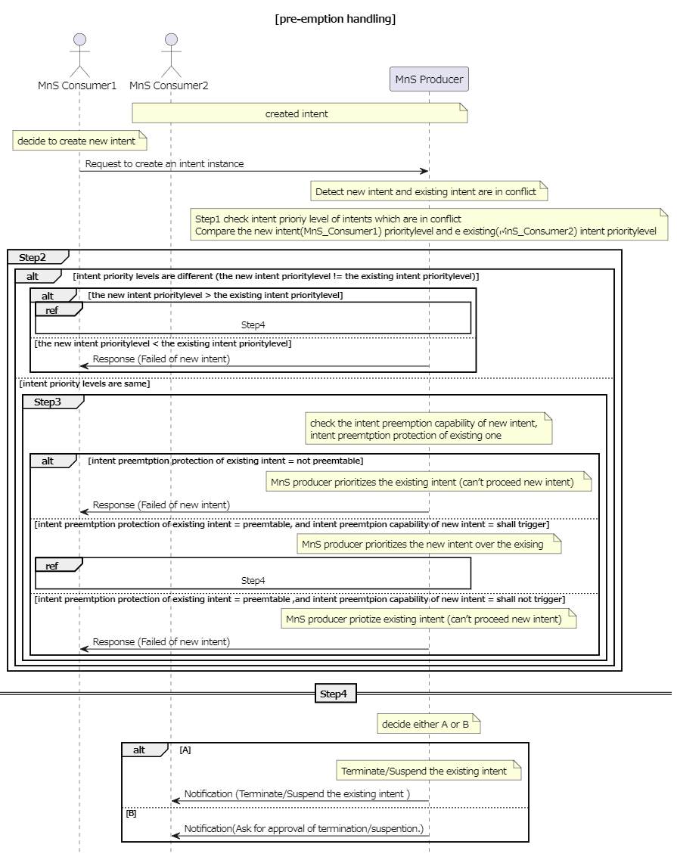
Figure 4.2.2-1
The solutions are feasible and should be expanded in the normative phase.
3rd of changes

4.3 Issue#4.3: Enhancement of radio network intent expectation

4.3.1 Description
In TS 28.312 [2], the radio network expectation is defined in clause 6.2.2.1.1, which is used to support the use case and requirements for clause 5.1.1 Intent containing an expectation for delivering radio network, clause 5.1.4 Intent containing an expectation on coverage performance to be assured and clause 5.1.5 Intent containing an expectation on RAN UE throughput performance to be assured. Following aspects for radio network expectation need to be enhanced:
- Enhancement Aspect1: In existing radio network expectation, only Polygon Area and TAC are specified to represent the coverage area. However, in some scenarios, the MnS consumer may express the radio network expectation targets for the coverage area which is represented by a list of Cell (e.g. CGI).
- Enhancement Aspect2: In clause 5.1.5 Intent containing an expectation on RAN UE throughput performance to be assured, the sentence "optional performance scope (e.g. specific service type, specific UE groups)" is described, which means MnS consumer may express the radio network expectation targets for the specific service type or UE groups instead of the whole radio network.
- Enhancement Aspect3: In existing radio network expectation, only coverage and RAN UE throughput related expectation targets are defined to support coverage performance and RAN UE throughput performance assurance use case. The capacity performance is important for radio network delivering and assurance, so the corresponding radio network capacity performance requirements need to be defined in Radio network expectation.
- Enhancement Aspect4: In clause 5.1.1 Intent containing an expectation for delivering radio network use case, transport setting parameters (including OM transport information and NG transport information) are described in the MnS consumer's expectation for delivering a radio network. It means when the MnS consumer expresses its intent expectation to the MnS producer for delivering a radio network, MnS consumer needs to specify the expected transport information for the radio network to be delivered to support the connection with other network parts (including 5GC network node, transport network node and management system).
- Enhancement Aspect5: Radio network may have different distributions of users in different time periods, and these differences have certain periodic characteristics in time and space. For example, in the university area, users are mainly in teaching buildings during the day, and users are mainly in dormitory buildings at night. In this case, during the day, teaching buildings are busy while at night, they are idle.. Therefore, in view of the difference in the distribution of users in different time periods in same area, it is necessary to defined different time periods as contexts.

4.3.2 Potential solutions
Regarding the Enhancement Aspect 1, it proposes to add attribute "cellContext" in ObjectContext for RadioNetworkExpectation in Clause 6.2.2.1.1.2 to represent the coverage area.
Regarding the Enhancement Aspect 2, it proposes to add attribute "targetedScopeContext" in ObjectContext for RadioNetworkExpectation in Clause 6.2.2.1.1.2. The contextValueRange of "targetedScopeContext" is dataType modelled as tuple [SNSSAI, 5QI]. If MnS consumer only expresses the expectation targets for specific SNSSAI, then the 5QI of the tuple should be absent. If MnS consumer only expresses targets for specific 5QI, then the SNSSAI of the tuple should be absent. If MnS consumer expresses the expectation targets for specific combination of SNSSAI and 5QI, both SNSSAI and 5QI needs to be present.
Regarding the Enhancement Aspect 3, it proposes to add radio network capacity related expectation targets in ExpectationTargets for RadioNetworkExpectation, the radio network capacity related expectation targets can be highUlPrbLoadRatioTarget, highDlPrbLoadRatioTarget, maxNumberofUETarget (specifies the maximum number of UEs may access the network) and activityFactorTarget (specifies the percentage value of the amount of simultaneous active UEs to the total number of UEs). In case of radio network delivering scenario, the radio network capacity related expectation targets can be maxNumberofUETarget and activityFactorTarget. In case of radio network assurance, the radio network capacity related expectation targets are highUlPrbLoadRatioTarget and highDlPrbLoadRatioTarget.
Regarding the Enhancement Aspect 4, it proposes to add transport related contexts (including NgInterfaceContext, OMInterfaceContext and NextHopContext) in ObjectContexts for RadioNetworkExpectation in Clause 6.2.2.1.1.2. NgInterfaceContext represents the context of transport connection to 5GC, which includes a list NGlocalIPaddress and NGremoteIPaddress. OMInterfaceContext represents the context of transport connection to the management system, which includes a list of OMlocalIPaddress and OMremoteIPaddress. The NextHopContext provides information to identify ingress node (s) which are part of a transport network and the attachment circuit between the radio network and the transport network, which includes a list of nextHopInfo defined in TS 28.541[3].
Regarding the Enhancement Aspect 5, it proposes to add attribute "timeContext" in ObjectContext for RadioNetworkExpectation in TS 28.312[2] Clause 6.2.2.1.1.2 to represent the expectation is expressed for specific time periods.
4th of changes

4.4 Issue#4.4: 5GC related intent expectation

4.4.1 Description
TS28.312 [2] describes the generic requirements of intent-driven MnS in clause 5.2. The generic information model definition and scenario specific IntentExpectation definition are given in clause 6.2 in TS 28.312 [2].
Intent driven management may affect management scenarios of 5G Core network which include 5G Core NF provisioning, 5G Core network performance management, 5G Core network fault management and 5G Core network optimization. In this key issue, this study should investigate the potential solution(s) of intent expression of 5G Core network intent expectation.
The 5GC intent expectation may include the specific Expectation Targets related to 5GC subnetwork management and Expectation Targets of 5GC NF management. Intent driven management may affect various management scenarios of 5G Core network. This study is to investigate potential solution(s) for intent expression, including defining expectations for a specific set of these scenarios.
The 5GC intent expectation should investigate the potential solution(s) to extend the generic information model of intent IOC to support 5GC specific intent expectation.

4.4.a Potential requirements

REQ-Intent_GEN_CON_01: The Intent driven MnS shall have the capability to allow MnS producer provide the results of the intent fulfilment to MnS Consumers.
REQ-Intent_Deploy_NF_CON_01: The intent driven MnS for 5GC shall have capability to allow MnS consumer to express Intent expectation for deployment of 5GC NFs or subnetwork.
REQ-Intent_Opt_5GC_CON_01: The intent driven MnS for 5GC shall have capability to allow MnS consumer to express Intent expectation for 5GC performance assurance.

4.4.2 Potential solutions

4.4.2.1 Potential 5GC specific IntentExpectation
The generic information model for intent should be used to provide specific IntentExpectation related to 5GC management.
The IntentExpectation for core network is used to represent MnS consumer’s expectation for 5GC subnetwork or 5GC NF. The ExpectationObject should indicate the 5GC subnetwork or 5GC NF.
- In case of the intent expectation is not for a specific instance or MnS consumer has no knowledge of the DN of the instance, the attribute of objectType need to be specified as 5GC subnetwork or the type of 5GC NF.
- In case of intent expectation is for a specific instance and MnS consumer has the knowledge of the DN of the instance, the attribute of objectInstance needs to be specified.
When IntentExpectation represents an Intent to deliver 5GC subnetwork, 5GC related ObjectContext should be provided to describe the information of 5GC subnetwork, such as network scale, network coverage etc.
When IntentExpectation represents an Intent to deliver 5GC NF, 5GC related ObjectContext should be provided, such as supported features of 5GC NF, related end point interfaces information and 5GC NF software artifact.
When IntentExpectation represents an Intent for 5GC performance assurance, the performance KPIs for 5GC subnetwork or NF are considered as network characteristics, so the performance assurance KPI name and value can be included as values of ExpectationTargets for IntentExpectation. The IntentExpectations in service assurance are diverse and depend on management scenarios. The examples of the performance KPIs related to 5GC which can be used as ExpectationTargets are established PDU session number, maximum registered subscribers and the inter-AMF handover number for 5GC subnetwork.

4.4.2.2 Potential solution for 5GC fault management
The IntentExpectation for core network is used to represent MnS consumer’s expectation for 5GC.
The intent driven management for 5GC fault management can use intent expectation to express the intent of the fault detection and recovery intent for 5GC. When IntentExpectation represents an Intent for 5GC fault management, 5GC related ObjectContext should be provided, such as the information of 5GC NF.
The name and value of ExpectationTargets can be used to provide particular inputs of fault detection and recovery. The alarm notification of particular events and fault types are set to be reported. The expectation target for input requirements of fault detection related to 5GC can be set to support the alarm notification by particular periodic time.
NOTE: The intent expectation can be enhanced to support the fault recovery expectations. One example is that the intent of fault recovery expectation can be expressed to move the traffic to new 5GC NFs which are collocated.
The intent expectation may contain the information related to the 5GC NF or 5GC subnetwork, so the scope the intent expectation applied are provided in intentExpectation field and fulfilment report.
As an example, in case that the intent driven MnS consumer is to express the intent expectation for 5GC fault management, the following attributes to intent driven management of 5GC fault management:
- The new expectationTargets for 5GC fault management could be added in intentExpectation.
- Attribute "recoveryResponseTimeTarget" represents MnS consumer's requirements for reducing recovery response time to a certain value, which is a Integer value.
- Attribute "failureTimeTarget" represents MnS consumer's requirements for reducing network and service failure time to a certain value within a period time.
- The intent expectation may contain the information related to the 5GC NF or 5GC subnetwork , so the scope the intent expectation applied are provided in intentExpectation field and fulfilment report. The objectContexts can be enhanced to contain those information related to the 5GC NFs and 5GC subnetwork.
- Atrribute"plMNInfoContext"describes the PLMN(s) supported by the 5GC NF or 5GC subnetwork that the intent expectation is applied, the ObjectContext include attributes: contextAttribute, contextCondition and contextValueRange. The targetValueRange see corresponding attribute “plMNInfoList” in TS 28.541[3].

4.4.2.3 Potential solution for 5GC optimization
The IntentExpectation for core network is used to represent MnS consumer’s expectation for 5GC.
The 5GC optimization is a fundamental solution that can support to optimize and keep particular one or more than one 5GC performance KPI(s) of 5GC, so some scenarios of 5GC optimization can be also used to support 5GC service assurance. For example, the core network may be set to increase energy efficiency of 5GC during period of time. Another example is that increasing a particular usage ratio of virtual resource consumption is set to core network according to the service request during a period of time, so this optimization intent expectation can be addressed by invoking provisioning MnS to update the 5GC NFs.
When IntentExpectation represents an Intent for 5GC optimization, 5GC related ObjectContext should be provided.
The particular name and value of performance KPI related to 5GC can be set as value of ExpectationTargets for IntentExpectation. Optionally, the value of TargetContexts can be included to show the information of network context of this ExpectationTarget when necessary.
As an example, in case that the intent driven MnS consumer is to express the intent expectation for 5GC energy saving optimization, the following enhancements to intent driven management of 5GC optimization can be added:
- The new expectationTargets for 5GC energy efficiency could be added in intentExpectation. The example of 5GC energy efficiency could be set to reduce the energy consumption by N percentage (e.g., 5%). The period of time should be added as an input in expectationContexts field in intentExpectation when applicable.
- The intent expectation may contain the information related to the 5GC NF or 5GC subnetwork, so the scope the intent expectation applied are provided in intentExpectation field and fulfilment report. The objectContexts can be enhanced to contain those information related to the 5GC NFs and 5GC subnetwork.

5th of changes

4.5 Issue#4.5: Intent Report

4.5.1 Description
In TS 28.312 [2], the Fulfilment information (including the intentFulfilmentInfo, expectationFulfilmentInfo and targetFulfilmentInfo) are defined for the MnS consumer to monitor the intent fulfilment information. The intent report also can contain the current and optional predicted value for performance indicated by corresponding expectation targets (e.g. WeakRSRPRatio for the weakRSRPRatioTarget, Average UL RAN UE Throughput for aveULRANUEThptTarget), which can be used by MnS consumer to validate whether the intent is really fulfilled and to evaluate whether the intent (especially for expectation targets) needs to be updated if needed (improve the target value when corresponding target is fulfilled or reduce the target value when corresponding target is not fulfilled or not fulfilled with the reason of target confliction). Besides, intent conflict information which send by MnS producer to MnS consumer is another type of intent report information. So, following are the three types of information needs to be monitored by MnS consumer:
- Intent Fulfilment information, which represents the properties of a specific fulfilment information for an aspect of the intent (i.e. either an expectation, a target or the whole intent). The detailed information see clause 6.2.1.3.5 in TS 28.312 [2].
- Achieved values for targets, which represent current performance values for corresponding expectation targets.
- Intent conflict information, which represents conflict type (i.e., intent conflict, expectation conflict and target conflict) and possible solution recommendation to address the conflicts.
Different MnS consumer may have different requirements for intent report (e.g. Some MnS consumer may want to have corresponding performance value information while others don't want. Different MnS consumer may want to calculate or monitor the performance value in different period).
While the report (with the current performance values for corresponding expectation targets) is provided at the end of each observation period, the consumer may also wish to know whether the fulfilment info was consistent for the entire observation period. For example, the intent expectation may be reported FULFILLED at the end of observation period. However, it may be possible that within observation period the intent expectation was NOTFULFILLED. The consumer may wish to know this information. This information can be important for the MnS consumer to understand whether the observation period they specified need an update (e.g shortened) or not. Moreover, it helps the MnS consumer to understand whether their expectation is fulfilled during the entire observation period which also gives transparency to the MnS consumer to update their observation period and/or expectations targets specified in the intent.

4.5.a Potential requirements

REQ-Intent_Driven_MnS_Report-1: The intent driven MnS should have the capability to enable the MnS consumer to request intent report information.
REQ-Intent_Driven_MnS_Report-2: The intent driven MnS should have the capability to enable the MnS consumer to obtain intent report information with current performance value for corresponding expectation targets.
REQ-Intent_Driven_MnS_Report-3: The intent driven MnS should have the capability to enable the MnS consumer to obtain intent report information with intent fulfilment information.
REQ-Intent_Driven_MnS_Report-4: The intent driven MnS should have the capability to enable the MnS consumer to obtain intent report information with intent conflict information.
REQ-Intent_Driven_MnS_Report-5: The intent driven MnS should have capability enabling MnS consumer to specify the content of the report.
REQ-Intent_Driven_MnS_Report-6: The intent driven MnS should have capability enabling MnS consumer to configure the frequency of the intent reporting.
REQ-Intent_Driven_MnS_Report-7: The intent driven MnS should allow MnS consumers to receive reports, with different content and intervals.
REQ-Intent_Driven_MnS_Report-8: The intent driven MnS should allow MnS consumer to obtain reports with current values for specified expectation targets.
REQ-Intent_Driven_MnS_Report-9: The intent driven MnS should have capability enabling MnS consumer to obtain intent report information with current context information for corresponding expectation targets.
REQ-Intent_Driven_MnS_Report-10: The intent driven MnS should allow reports to contain information on whether the fulfilment info was consistent throughout the observation period.

4.5.2 Potential solutions

4.5.2.1 Potential solution#1
This solution extends the existing model in TS 28.312 [2] by adding new attributes to the Intent IOC to indicate what is to be observed, and a new IntentReport IOC to enable the MnS consumer to obtain the intent report information.
The following specific changes would be made:
- Extend the Intent <<IOC>> with the following attributes:
- "reportingPeriod", represents MnS consumer's requirements for the reporting period. The performance value for corresponding Expectation Targets will be reported at the end of each period.
- Introduce the IntentReport <<IOC>> to represent the intent fulfilment information, intent conflict information and current performance values for the Expectation Targets in the associated Intent. The MnS consumer can use the "getMOIAttributeValue" operation to query the IntentReport <<IOC>> to obtain the intent report information and/or subscribe the "notifyMOIAttributeValueChanges" notification to obtain the intent report information The IntentReport <<IOC>> includes the following attributes:
- "intentReference", to reference (DN) the associated Intent instance.
- “reportIndicator”, to enable/disable (Boolean) reporting for associated Intent instance.
- "intentFulfimentInfo", to represent the fulfilment information for intent, intent expectation and expectation targets. For detailed information see clause 6.2.1.3.5 in TS 28.312[2].
- "intentConflictInfo", to represent the intent conflict information that should be informed to the MnS consumer. For detailed intent conflict information see clause 4.2.2.
- "TargetAchieveValues", to represent the current performance value for the ExpectationTargets.
- “lastUpdated”, timestamp (DateTime) of latest update.
This could result in NRM for Intent Reporting as follows:

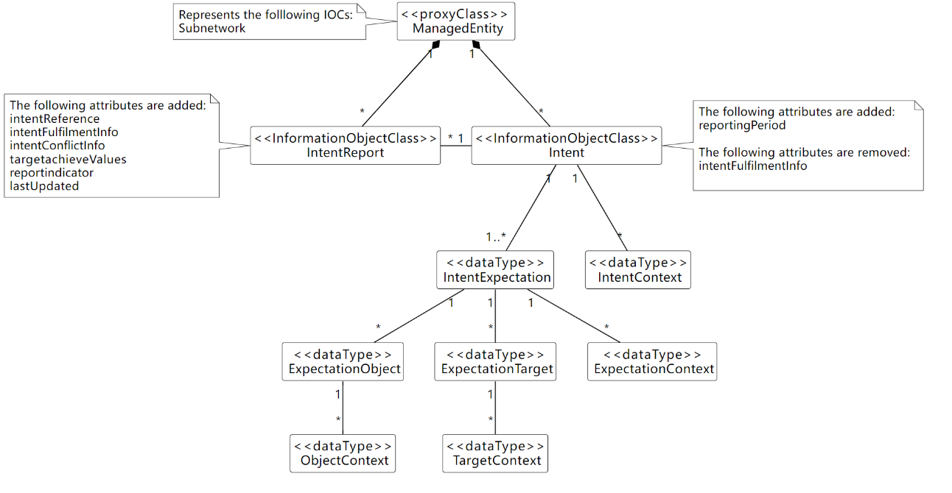
Figure 4.5.2.1-1
Observations on this approach
- Different MnS consumers can query different attributes of IntentReport to obtain corresponding Intent instance report information.
- Different MnS consumers can subscribe to attribute value change notifications for IntentReport <<IOC>> to obtain the notification for different intent report information.
Several benefits are listed below for the solution:
- Separates the intent expectation information (generated by MnS consumer) and intent monitor information (generated by MnS producer).
- MnS consumer can manage Intent instance and IntentReport instances separately.
- Intent <<IOC>> is aligned with intent definition (expectations including requirements, goals and constraints given to a 3GPP system).

4.5.2.2 Potential solution #2
This solution extends the existing model in TS 28.312 [2] by adding new attributes to the Intent IOC to indicate what is to be observed, and a new IntentReport IOC to report the achieved values.
The following specific changes could be made:
- Extend the IntentExpectation <<dataType>> with the following attribute:
- "observationTime", represents MnS consumer's requirements for the observation period of performance value for corresponding Expectation Targets. The performance value for corresponding Expectation Targets will be observed from the start of each observation period, then at the end of each observation period, the value will be derived and configured.
- Introduce the "achieveValue" attribute in the ExpectationTarget to represent the performance value for the ExpectationTarget. Then the MnS consumer can use the "getMOIAttributeValue" operation to query the Intent <<IOC>> to obtain the achieveValue for a given ExpectationTarget.
This could result in NRM for Intent Reporting as follows:

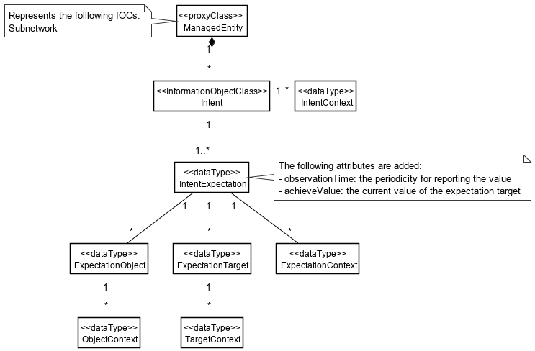
Figure 4.5.2.2-1

The above solution would require, per Intent, that:
  - MnS Consumer configures each IntentExpectation to be reported with ‘observationTime=N’.
  - For each period N, MnS Producer reports the achieved value*.
  - For every period N, MnS Producer updates the achieveValue of each expectation target.
  - MnS Consumer queries achieveValue of interested targets.
Note: would ‘achieveValue’ be current value (per Solution #1, as available in NRM at time of reporting), or some other computed value for the interval is not addressed in the present document. If computed, the definition and format could vary based on which attribute(s) are included.
Observations on this approach:
  - Should avoid mix-and-match of observability.
    - For attributes defined in NRM, existing subscription mechanism can be used to monitor updates. E.g. ‘achieveValue’ proposed in this solution.
    - For content not defined in NRM, new notifications would need to be defined for the intent content to be reported. E.g. associated PM/KPI.
  - The configuration of the report output is contained in the Intent itself.
  - MnS Consumer would need to query (i.e. polling). Notifications would be preferred.
  - Since the observationTime of each IntentExpectation is configured separately, MnS Consumer would need to be aware of how relatively up-to-date each value is.
  - Should use of the term “report” which can be misleading, as there is no ‘report’ object (e.g. NRM, file, stream). This solution is completely notification based.

4.5.2.3 Potential solution #3
This solution would not modify the existing model in TS 28.312 [2]. A separate IntentReportCtrl IOC is proposed. The IntentReport IOC is used to contain the output of the expectation targets, as well as other status information currently contained in Intent. The latter would be removed to further separate the configuration of the Intent, from the monitoring/reporting of it throughout its lifecycle.

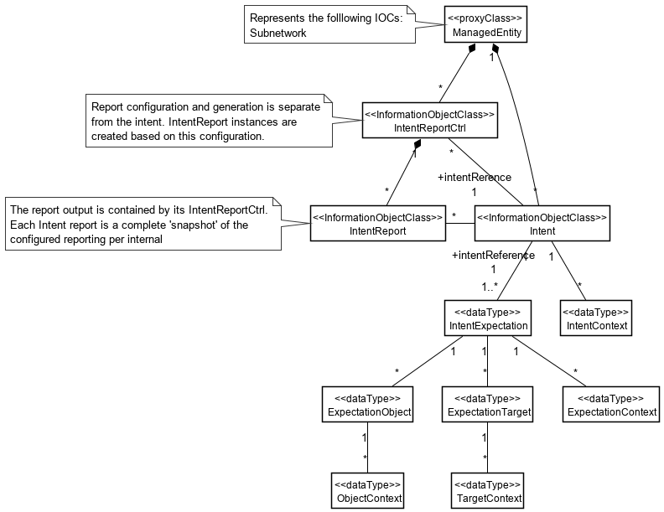
Figure 4.5.2.3-1
The above solution would require, per Intent, that:
  - MnS Consumer configures each IntentReportCtrl with ‘reportingPeriod=N’, and reference ‘intentReference’ to the Intent instance for which the report is to be produced.
  - For each period N, MnS Producer generates an IntentReport instance.
  - For every period N, MnS Producer ‘snapshots’ the Intent values.
  - MnS Consumer receives notification of the new IntentReport instance.
Observations on this approach:
  - The configuration of the report output is external to the Intent itself, and supports ability to configure different reports per Intent. The content (i.e. attributes) and reporting intervals can different for each report generated.
  - Each report is a complete ‘snapshot’ of the Intent at time of generation, available in NRM.
  - MnS Consumer does not need to handle different ‘observationIntervals’ per attribute within same Intent.

4.5.2.4 Potential solution #4
This solution does not modify the existing model in TS 28.312 [2]. A separate IntentReportJob IOC is proposed, along with a file/stream based Intent report similar to other performance reporting.

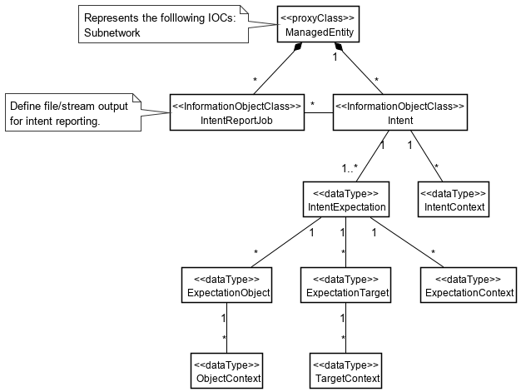
Figure 4.5.2.4-1

The above solution would require, per Intent, that:
  - MnS Consumer configures each IntentReportJob control for file or streaming output, and a reference ‘intentReference’ to the Intent instance for which the report is to be produced.
  - For every period N, MnS Producer outputs the report content as configured in the job.
    - for file based, MnS Consumer receives notification of the new Intent report file.
    - for stream, MnS Consumer receives streaming content.
Observations on this approach:
  - This approach is consistent with other performance related reporting.
  - Each report should be complete and self-describing, and suitable for offline processing and/or archival.
  - A schema will need to be agreed, perhaps based on the existing PM/KPI formats.

4.5.2.5 Potential solution #5
This solution would modify the existing model in TS 28.312 [2] to add configuration of notifications of achieved values. The values to be notified are defined directly in the Intent.

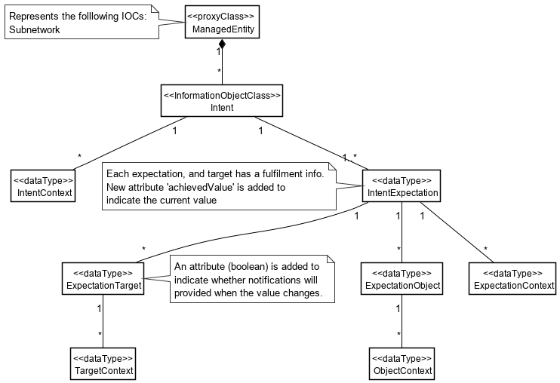
Figure 4.5.2.5-1

  - MnS Consumer configures each Intent with ‘reportIndicator=True’ for values to be monitored.
  - MnS Consumer subscribes to the ‘achievedValues’ in IntentExpection.
  - MnS Consumer receives notifications each time a new value is available.
Observations on this approach:
  - The configuration of the report output is contained in the Intent itself, and is a Boolean. This effectively limits the content of the report to a single report per Intent.
  - This approach is different than subscribing to attribute notifications.
  - The notifications required, and how they represent values in NRM and/or derived values not in the NRM, needs to be defined.
  - There would be no “report’ objects with this approach.
6th of changes

4.6 Issue#4.6: Intent-driven Closed Loop control

4.6.1 Description
A Closed Loop (CL) is an entity that implements the capabilities to get data, analyse it, generate decision and execute those decision on the network. It may be implemented in one or more stages (in Figure 1 as 4 or 3 stages) and each may be implemented by a specific component (i.e. MnF). Each CL may implement a Closed-loop Control (CC) as the producer of CL management services that support control capabilities used to manage or control the closed loop and to support interaction with the external world.
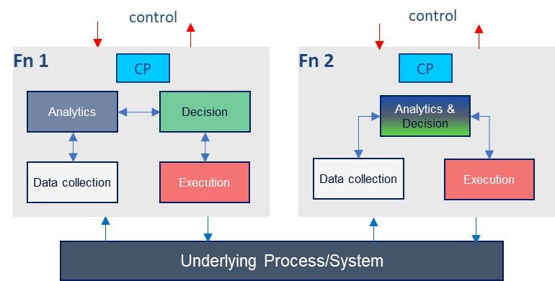
Figure 4.6.1-1: Example relations among closed loop components
Given a set of deployed network functions and/or management functions, the Closed-Loop Control may configure different network and management functions to achieve the desired closed loop goals based on intents with the input “context” (e.g. capabilities, control or use case) provided by the operator, as illustrated by Figure 4.N.1-3. Within the intent driven system, the MnS producer for intent driven MnS may play the role of closed loop control to implement the intent driven closed loop or interact with closed loop control to control the closed loop.
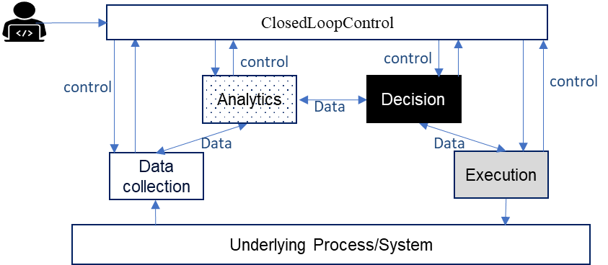
Figure 4.6.1-2: Using Intents towards Closed-Loop Control to automate closed loops management and control

4.6.a Potential requirements
REQ-Intent_GEN_CON_01: The 3GPP management systems shall support a capability to allow a consumer (e.g. an operator) to express an intent to enable the provider of CL management to configure a CL based on an intent that expresses the intent expectations as closed loop goals, KPI, SLS, SLA targets, input-output pairs or capabilities
REQ-Intent_GEN_CON_02: The 3GPP management systems shall support a capability to allow a consumer (e.g. an operator) to express an intent to enable the provider of CL management to configure its constituent management functions and goals to achieve the expectations of the intent.
REQ-Intent_GEN_CON_03: The 3GPP management systems shall support a capability to inform an authorized consumer (e.g. an operator) about closed loops and management functions serving the intent.

7th of changes

4.7 Issue#4.7: Monitoring intent fulfilment information

4.7.1 Description
In TS 28.312 [2], MnS Producer can deploy or configure corresponding managed entities to satisfy the intent. During the execution of intention, MnS Producer continuously monitors intent fulfilment information. One scenario is that an intent may take a long period of policies execution to be satisfied. During the execution of the intent, something may happen, such as a new intent coming, a change in the execution environment. The MnS producer needs to monitor the intent fulfilment information so that policies can be adjusted in time. Another scenario is that the intent contains temporal information, such as how long the consumer could wait before the intent is initially satisfied, which refers to maximum duration. For example, MnS consumer can express the expectation that the coverage targets for certain radio network needs to be ensured in one hour, which means MnS producer have one hour to take/adjust actions to ensure the expected coverage targets for radio network. When the maximum unfulfilled duration is specified, the MnS producer may optimize its intent fulfilment plan, e.g., to decide different actions to be applied on the managed entities or to use different managed services, so that the intent can be fulfilled within the duration.The MnS producer needs to response the intent fulfilment information to the MnS consumer at the beginning and during the execution of the intent.
REQ-Intent_execution_monitoring-CON-1: The intent driven MnS Producer should have the capability to allow the authorized MnS consumer to request intent fulfilment information periodically or event-triggered.
REQ-Intent_execution_monitoring-CON-2: The intent driven MnS Producer should have the capability to inform the authorized MnS consumer about intent fulfilment information periodically or event-triggered.
REQ-Intent_execution_monitoring-CON-3: The intent driven MnS Producer should have the capability to allow the authorized MnS Consumer to provide the deadline expressing the maximum duration before the intent is initially satisfied or the latest time point by which the intent should be satisfied.

4.7.a Potential requirements

4.7.2 Potential solutions
See clause 4.5.2, intent fulfilment information is one kind of intent report information.
To support REQ-Intent_execution_monitoring-CON-3, an attribute “fulfillmentDeadline” needs to be introduced in Intent IOC to represent MnS’s requirements for the maximum unfulfilled duration before the intent is initially satisfied.
The fulfillmentDeadline may be an attribute of the whole intent or one of the expectations of the intent.
8th of changes

4.8.4.2 Mapping of Intents to AI/ML Entities capabilities
The intent driven MnS Producer may rely on available AI/ML capabilities to accomplish the desired intent. Such available AI/ML capabilities may need to be discovered by the consumers as a first step before consumer can request for those AI/ML capabilities to be applied for the intent. Furthermore, the mapping of the discovered AI/ML capabilities to intents needs to be performed. Finally, the according configuration and instructions for execution based on the available AI/ML capabilities is needed in order to achieve desired outcome. For example, in the case of intent fulfilment system leveraging on AI/ML capabilities, the discovered available AI/ML capabilities may be to the extent possible, mapped to incoming user or operators’ intents.
The solution requires to
- Introduce the AIML_capability_mapping_report <<datatype>>, which is generated by intent driven MnS producer
- When an intent driven MnS Producer receives the desired intent management requirements from intent driven MnS Consumer e.g., network operator with a request for a mapping to available AI/ML Entities and their capabilities, the intent driven MnS Producer provides such a mapping of the MLEntities and capabilities e.g. as an AIML_capability_mapping_report to the intent driven MnS consumer to satisfy the received request. The AIML_capability_mapping_report <<datatype>> include the AI/ML capabilities information defined in TR 28.908 [6].
- Support intent creation with specific AI/ML Entities to be used or excluded to fulfil the intent as context information.
When subsequently, the MnS Producer receives the desired intent targets with the context for the specific AI/ML Entities to be used or excluded, the MnS Producer derives the configuration or execution instructions for the selected AI/ML Entities according to the received intent targets and the context for the specific AI/ML Entities, and provides such configuration or execution instructions to AI/ML Entities
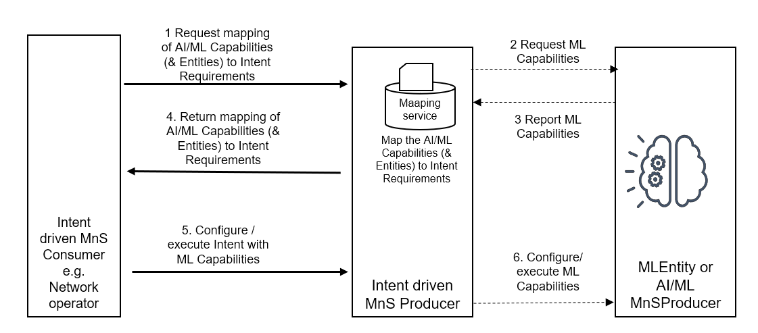
Figure 4.8.4.2-1: Discovery and use of ML capabilities for Intent fulfillment
The solution described in clause 4.8.4 adopts the NRM-based approach, which reuses the existing provisioning MnS operations and notifications. Introducing the AIML_capability_mapping_report <<datatype>> the intent driven MnS Producer can inform its potential intent driven MnS consumers about the AI/ML capabilities it relies on to accomplish intent fulfilment. The intent driven MnS consumers can then request for specific capabilities to be applied for their intents. Therefore, the solution described in clause 4.8.4.1 is a feasible solution.

4.8.4.3 Intent-driven SON orchestration
For an intent to be fulfilled via SON orchestration, the intent needs to relate to network control parameter or to network KPIs. Relatedly, the intent driven SON orchestrator needs to characterize the received into one of three categories represented by table 4.8.4.3-1
Table 4.8.4.3-1
Type | Description | Example intents
Type 1 | Fulfils one of:  - Intent parameters defined on network control parameters, and no context defined  - Intent context defined on network control parameters, and no parameters defined  - Both Intent context and intent parameters defined on network control parameters | - Increase cell X TXP  - Make cell X TXP remain constant  - Make cell X TXP constant and change RET by 3 degrees
Type 2 | Fulfils one of:  - Intent parameters defined on KPI, and no context defined  - Intent context defined on KPI, and no parameter defined  - Both Intent context and intent parameters defined on KPI | - Reduce cell X interference  - Avoid increase in cell X interference  - Increase cell X throughput without changing interference
Type 3 | Fulfils one of:  - Intent parameters defined on network control parameters while Intent context defined on KPI,  - Intent parameters defined on KPI while Intent context defined on network control parameters | - Make cell X TXP constant and reduce interference  - Change cell X TXP to 45 dBm without changing interference

Accordingly, given this evaluation within the MnS producer, if the intent does not relate to any of the three categories above, the Intent-driven SON orchestration should inform the intent consumer that the intent can not be executed via SON orchestration. For this, an attribute may be added in the fulfilmentInfo or intent report for the failure or success of SON orchestration for intent fulfilment. Similarly, an attribute may be added in the FulfilmentInfo <<datatype>> or intent report for indicating when the intent is not in the scope of SON orchestration.
Moreover, when executing via SON, the Intent-driven SON orchestration may observe contradictions in the intent - i.e., cases where targets on different expectation are in conflict. The Intent-driven SON orchestration should inform the intent MnS consumer of such contradictions which occur in the SON orchestration but not necessarily in the intent. For this, an attribute may be added in the FulfilmentInfo <<datatype>> or intent report for a contradiction detected in the SON orchestration.
The related sequence of actions is highlighted by the figure.
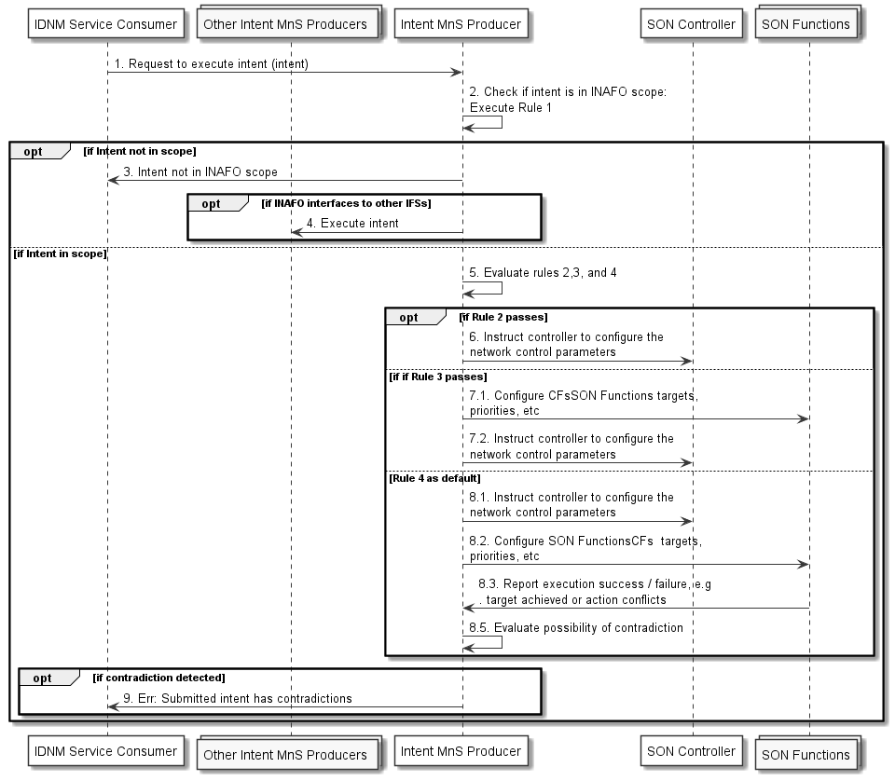
Figure 4.8.4.3-1: Intent-driven SON orchestration
9th of changes

4.9 Issue#4.9: Intent fulfilment feasibility check

4.9.1 Description
The option for MnS producer automatically feasibility check when receive the intent creation and modification request from MnS consumer is described in TS 28.312 [2]. However, the intent fulfilment feasibility check capability which can be used by MnS consumer to request intent-driven MnS producer to check the feasibility for intent fulfilment before intent creation is missing. This functionality can be used to assist MnS consumer to generate the suitable intent information.
When intent-driven MnS producer receiving the request, the intent fulfilment feasibility check may be performed to determine which intents are feasible, including check the satisfaction of intent fulfilment and potential conflicts between one or more intents.
When the intent fulfilment feasibility check is accomplished, MnS producer needs to notify the MnS consumer about the result of feasibility check, indicates that the intent is feasible or infeasible. In addition, the MnS producer may also notify the MnS consumer about the reason why the intent is infeasible (e.g. the intent conflict, the satisfaction of intent fulfilment lowering than threshold).

4.9.a Potential requirements

REQ-Intent_Driven_MnS: The intent-driven MnS producer shall have capability enabling MnS consumer to request to check the feasibility for intent fulfilment.
REQ-Intent_Driven_MnS: The intent-driven MnS producer shall have capability to inform the authorized MnS consumer about the result of intent fulfilment feasibility check, including feasible and infeasible.
REQ-Intent_Driven_MnS: The intent-driven MnS producer shall have capability to inform the authorized MnS consumer about the infeasible reason if intent fulfilment feasibility check result is infeasible.

4.9.2 Potential solutions
The MnS producer may inform the intent fulfilment feasibility check result and the infeasible reason to MnS consumer when the intent fulfilment feasibility check is finished. Following activities will be taken by MnS consumer:
- If the intent fulfilment feasibility check result indicated as feasible, MnS consumer sends a request to create an intent instance to MnS producer (as described in TS 28.312[2] Clause 6.3.2) .
- In case the intent fulfilement feasibility check result is infeasible, MnS consumer may update the intent information based on infeasible reason and may trigger the intent fulfilment feasibility check again.

End Change

