**3GPP TSG-SA5 Meeting #148e *S5-233249rev1***

e-meeting, 17 – 25 April 2023

**Source: Huawei, Deutsche Telekom**

**Title: Conclusion for KI#9 RAN energy saving when using backup batteries**

**Document for: Approval**

**Agenda Item: 6.9.1.2**

# 1 Decision/action requested

**Include the proposed text in TR 28.913**

# 2 References

[1] 3GPP TR 28.913: "Study on new aspects of EE for 5G networks phase 2"

# 3 Rationale

This pCR proposes to introduce a conclusion to Key Issue #9 into TR 28.913 [1].

# 4 Detailed proposal

|  |
| --- |
| **First change** |

# 2 References

The following documents contain provisions which, through reference in this text, constitute provisions of the present document.

- References are either specific (identified by date of publication, edition number, version number, etc.) or non‑specific.

- For a specific reference, subsequent revisions do not apply.

- For a non-specific reference, the latest version applies. In the case of a reference to a 3GPP document (including a GSM document), a non-specific reference implicitly refers to the latest version of that document *in the same Release as the present document*.

[1] 3GPP TR 21.905: "Vocabulary for 3GPP Specifications".

[2] 3GPP TS 28.554: " Management and orchestration; 5G end to end Key Performance Indicators (KPI)".

[3] ETSI GS NFV-IFA 027 V4.2.2 (2021-07): "Network Functions Virtualisation (NFV) Release 4; Management and Orchestration; Performance Measurements Specification".

[4] ETSI ES 202 336-12 V1.2.1 (2019-02): "Environmental Engineering (EE); Monitoring and control interface for infrastructure equipment (power, cooling and building environment systems used in telecommunication networks); Part 12: ICT equipment power, energy and environmental parameters monitoring information model".

[5] ETSI GS NFV-EVE 004 V1.1.1 (2016-03): "Network Functions Virtualisation (NFV); Virtualisation Technologies; Report on the application of Different Virtualisation Technologies in the NFV Framework".

[6] ETSI GR NFV-IFA 029 V3.3.1 (2019-11): "Network Functions Virtualisation (NFV) Release 3; Architecture; Report on the Enhancements of the NFV architecture towards "Cloud-native" and "PaaS"".

[7] 3GPP TS 38.300: "NR; NR and NG-RAN Overall Description; Stage 2".

[8] 3GPP TS 38.401: "NG-RAN; Architecture description".

[9] The Greenhouse Gas Protocol - <https://ghgprotocol.org/sites/default/files/standards/ghg-protocol-revised.pdf>

[10] 3GPP TS 28.530: "Management and orchestration; Concepts, use cases and requirements".

[11] 3GPP TS 28.552: " Management and orchestration; 5G performance measurements".

[12] ETSI GS NFV-IFA 008 V4.3.1 (2022-05): "Management and Orchestration; Ve-Vnfm reference point - Interface and Information Model Specification".

[13] 3GPP TS 28.310: "Management and orchestration; Energy efficiency of 5G".

[14] 3GPP TS 32.551: "Energy Saving Management (ESM); Concepts and requirements".

[15] 3GPP TS 22.261: "Service requirements for the 5G system".

[16] 3GPP TS 22.289: "Mobile Communication System for Railways".

[17] 3GPP TS 22.186: "Enhancement of 3GPP support for V2X scenarios; Stage 1".

[X] ETSI ES 202 336-11: "Environmental Engineering (EE); Monitoring and control interface for infrastructure equipment (Power, Cooling and environment systems used in telecommunication networks); Part 11: Battery system with integrated control and monitoring information model".

|  |
| --- |
| **Next change** |

## 4.9 Key Issue #9: RAN energy saving when using backup batteries

### 4.9.1 Description

#### 4.9.1.1 Introduction

When RAN faces main power failure, it is supported by backup batteries to prolong the service. However, due to cost and deployment space considerations, batteries may have insufficient lifespan. As a result, the period of service time supported by backup batteries may not meet demand, but may be extended by RAN energy saving actions.

RAN energy saving achieved by executing energy saving actions is especially crucial when using backup batteries, and satisfy the following requirements:

# energy saving requirement: the period of time batteries can provide service needs to be maximized, which needs the help of RAN energy saving;

# QoS requirement: the influence on QoS should also be considered when taking energy saving actions.

Hence, when using backup batteries, it is much important to manage energy saving actions to balance the energy saving requirement and the QoS requirement. For example, 3GPP Management System could manage the energy saving actions sent to gNB according to the backup batteries situation and the QoS requirement.

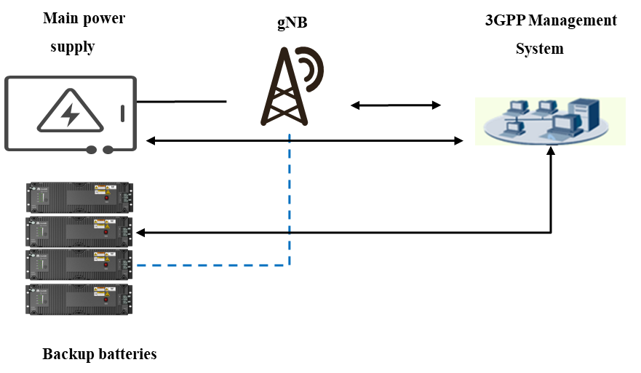

Figure 4.9.1-1: gNB and backup batteries.

#### 4.9.1.2 Potential requirements

REQ-ES_BB-1: The 3GPP management system should be able to monitor the state of charge and discharge of backup batteries of gNBs, i.e. it should be able to know the UPS battery capacity at any time.

REQ-ES_BB-2: The 3GPP management system should be able to monitor the state of the main power supply of gNBs.

### 4.9.2 Potential solutions

#### 4.9.2.1 Potential solution #1: based on information of backup batteries as per ETSI ES 202 336-11 [X]

##### 4.9.2.1.1 Introduction

This potential solution relies partly on ETSI ES 202 336-11 [X] which defines:

# monitored and controlled battery system architectures,

# the information exchanged between a battery system (in a telecom site) and a remote management application.

##### 4.9.2.1.2 Description

Clause 4 of ETSI ES 202 336-11 [X] lists the information that can be monitored and controlled via the interface between the battery system and the remote management application:

- State of Charge (SoC) for each Integrated Battery System (IBS – see definition in ETSI ES 202 336-11 [X] clause 3.1).

Annex A (respectively annex B) of ETSI ES 202 336-11 [X] provides the list of mandatory (resp. non-mandatory) monitoring / supervision information, amongst which the following two attributes can be extracted:

- Operating mode: it represents the working status of backup batteries. The enumeration value of operating mode could be charge, discharge, float charge, sleep, and safe. The change of operating mode is a monitored event and can be sent out from the on-site battery system to a remote management application.

- Estimated remaining battery autonomy (time): it is an information which may be consulted from a remote management application to know the remaining battery autonomy time.

Annex C.1 of ETSI ES 202 336-11 [X] provides the structure of an XML document which can be used to control and monitor battery systems from a remote management application.

Where (i.e. in which SDO) and when the aforementioned information and data models are specified is FFS.

### 4.9.2 Conclusion

an information model (Stage 2) specifying the backup battery information (based on ETSI ES 202 336-11 [X]) that can be monitored for the NG-RAN in the 3GPP management system

4.9.3 Recommendation

It is proposed to continue this work in the context of the normative phase.

|  |
| --- |
| **End of changes** |