3GPP TSG-SA5 Meeting #146Bis-e S5-231044
Electronic meeting, 16 - 19 January 2023

Source: Huawei

Title: Discussion paper on interoperability support using SBMA

Document for: Approval
Agenda Item: 6.1.1

1 Decision/action requested
The group is asked to discuss and approve this tdoc.

2 References
[1] TS 28.925
[2] S5-226509 Add issue on interoperability support using SBMA

3 Rationale
This is cross WI/SI topic as it’s about using of MnS.
3GPP SA5 adopted SBMA from Rel-15. The concept of MnS producer and consumer are developed in standard. So far SA5 provided management services (MnS) in specifications to support interoperability without mentioning who is the consumer and who is the producer. There are pros and cons for this approach. The benefit is the implementor has flexibility to select the features which could fit their requirements, the drawback is the specifications are lack of clear guidance on the collaboration interface between multiple players.
There are following roles specified in TS 28.530 which may need interoperability support from standard:
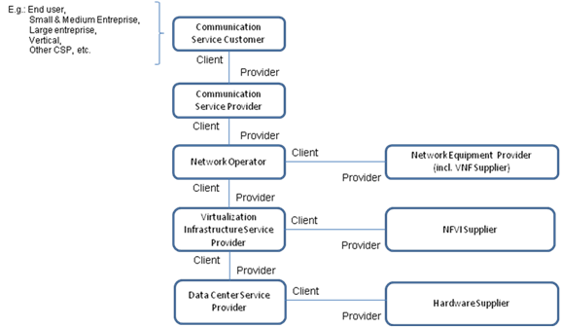

There are following information need to be considered when the interoperability standardization of MnS are discussed:
(1) information exchanged through MnS may be different according to different deployment scenarios. For example, in the following diagram, the MnS-x may provide different information from MnS-z as the management scope of MnF-2(managing multiple network functions) is bigger than MnF-4(managing of one network function).
(2) information exchanged through MnS may be different according to different function realization of “MnS consumer” and “MnS producer”. For example, to fulfil the similar capability with joint efforts from multiple MnFs, the information exchanged through MnS could be different depends on where the MnF is located.
(3) information exchanged through same MnS may also be different according to the use of the MnS between different players
Using fault correlation as example,
(1) MnF-2 could carry the fault correlation management across multiple network functions and provide more management capability through MnS-x compared with MnF-z.
(2) When the fault correlation function is fulfilled by MnF-2 resides in MnS producer, this MnF-2 is a typical example of MnF to be management which should be managed through MnS-x. If the fault correlation function is fulfilled by MnF-1 resides in MnS consumer, the information carried in MnS-x will be different.
(3) The management capability exposure of the MnF-1 carried in MnS-y could be managed in the same way as management capability exposure of MnF-2 carried in MnS-x, but the management content of MnS may be different according to different management needs from different consumers.
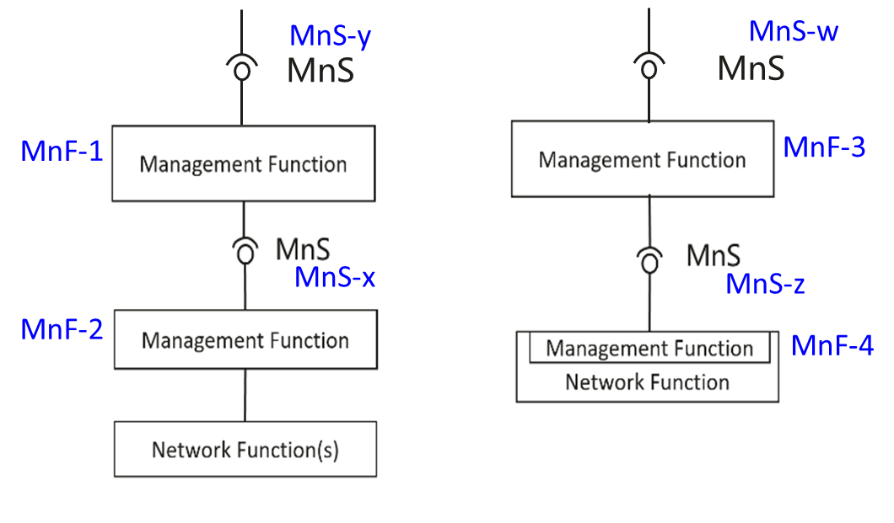

The group is asked to discuss:
- Currently SA5 specifications only provide list of MnS, there is no description regarding in what deployment scenarios to use such MnS.
Option1: SA5 specifications are to further provide description about how to use MnS (e.g. use of MnS according to different MnF location).
Option2: SA5 specifications only provide list of MnS, how to use such MnS are left to implementation.
- The group also needs to discuss the meaning of applicable interoperability between multiple roles specified in SA5.
Option1: SA5 specifications are to further describe how to use MnS according to the information exchange between multiple roles (e.g. CSC, CSP, NOP, NEP).
Option2: The indication of how consumer and producer could be realized in deployment scenarios, the use of MnS are left for implementation.

4 Detailed proposal

We propose SA5 specifications are to describe the usage of MnS from the following aspects:
(1) Description on how to use the MnS for interoperability in different deployment scenarios (e.g. use of MnS according to different MnF location).
(2) Description on how to use the MnS for interoperability between multiple roles (e.g. CSC, CSP, NOP, NEP).

