**3GPP TSG SA5 Meeting #146-bis-e *S5-231043***

e-meeting, 16-19 January 2023

**Source: Nokia**

**Title: Discussion paper on KQI, QoE**

**Document for: Agreement**

**Agenda Item: 6.1.1**

# 1 Decision/action requested

***The group is asked to agree the detailed agreements in section 4.***

# References

1. SP-211433: New Study on Key Quality Indicators (KQIs) for 5G service experience
2. S5-226886: 32.863 v0.4.0 Study on Key Quality Indicators (KQIs) for 5G service experience (Release 18)
3. SP-150676: Updated WID Study KQI for Service Experience
4. ETSI GS F5G 005: "F5G High-Quality Service Experience Factors Release #1"
5. S5-226024 Reply LS to Study on KQIs for 5G service experience
6. 3GPP TR 32.862: Study on Key Quality Indicators (KQIs) for service experience (Release 14)
7. RP-193256: Study on NR QoE management and optimizations for diverse services
8. RP-211406: New WID on NR QoE management and optimizations for diverse services
9. RP-221803: WID update for Enhancement on NR QoE
10. SP-181069: Revised WID on Management of QoE measurement collection
11. 3GPP TS 26.247: “Transparent end-to-end Packet-switched Streaming Service (PSS); Progressive Download and Dynamic Adaptive Streaming over HTTP (3GP-DASH)”.
12. 3GPP TS 26.114: “IP Multimedia Subsystem (IMS); Multimedia Telephony; Media handling and interaction”.
13. 3GPP TS 26.118: “Virtual Reality (VR) profiles for streaming applications”.
14. 3GPP TS 26.346: “Multimedia Broadcast/Multicast Service (MBMS); Protocols and codecs”.
15. SP-200193: New WID on Enhancement of QoE Measurement Collection
16. 3GPP TR 38.890: Study on NR QoE (Quality of Experience) management and optimizations for diverse services

# 3 Discussion

The concept of KQI is very similar to the concept of QoE, as is already in use across 3GPP.

## 3.1 FS_KQI_5G (940032)

The Study on Key Quality Indicators (KQIs) for 5G service experience was approved at SP-94e in December 2021, in SP-211443 [1] and targeted for Rel-18. The latest draft of the output Techincal Report 32.863 v0.4.0 is available in S5‑226886 [2].

A short summary of the current draft:

Issue #1 in the draft TR, §4.1, is the definition of KQI. While there are references to multiple ITU-T documents which offer opportunity for further research, there are two points of note:

* 3GPP TR.32.863 [2] gives a description of KQI:

*The introduction of Key Quality Indicators (KQIs), which reflect the end-to-end service performance and quality, could be used to better represent real customer experience. NGMN NGCOR has defined principles for KQIs which could be used to evaluate the customer experience for fixed and mobile networks. It is proposed that SA5 takes the responsibility to study how to standardize the related service KQIs providing a standardised common base for end-to-end measurements and to fulfil the NGCOR requirements. KQIs have also been defined by ETSI (TS 102.250), 3GPP SA4 (TR 26.944), NGMN (P-SERQU) and QuEST Forum should also be considered.*

*[Note: QuEST Forum has merged with TIA, Telecommunications Industry Association]*

*The intention of KQI for the service experience is to try to reflect the customer experience with indicators reflecting them for example how many stalls occur while watching a movie, time delay before seeing the first screen of a movie. With this information, KQI could closely reflect the customer experience. The KPIs defined in the current specifications, e.g. 3GPP TS 32.450, are not differentiated by services, they only measure the bearer.*

**Observation #1:** KQIs reflect the end-to-end service performance and quality as perceived by the customer’s experience.

* ETSI GS GSG 005 [4] gives a description of KQI:

*The Key Quality Indicators (KQI) are composed by the QoS metrics, which have the largest impact on QoE, namely*

*user centric and service specific quality patterns that directly influence the user perception for each service category. QoS is a measure of the performance of networked services at the network or application level. QoS also refers to a setof techniques that enable the network administrator to manage the network performance differentiating between different users. QoS metrics may include network layer measurements such as packet loss, delay or jitter or application level measurements such as video frame loss, frame freezing, image distortion.*

**Observation #2**: KQIs are composed by QoS metrics which have the largest impact on QoE, namely user centric and service specific quality patterns that directly influence the user’s perception for each service.

The sections of the draft TR for Definition of KQI, Potential solutions and for Conclusion – Impact on normative work are incomplete, these do not contain any agreed text.

Issue #2 in the draft TR, §4.1, is Scenarios for 5G KQI. The list of use case scenarios is Video uploading, Remote controlling, Cloud VR. While the terms Video uploading and Cloud Virtual Reality are clear, Remote controlling on its own is ambiguous and inconclusive.

**Observation #3:** A clear definition is needed for Remote controlling.

Issue #3 in the draft TR, §4.3, is KQIs for Video Uploading. This section has no agreed text. In LS S5-226024 [5] SA4 comments “There is an ongoing work item in Rel-18, 5GMS_Ph2, which aims to complete the missing features and functionalities for uplink streaming.”

**Observation #4**: The SA4 work item 5GMS_Ph2 is relevant to the video uploading use case scenario and should be considered.

Issue #4 in the draft TR, §4.4, is KQIs for Remote Controlling. This section has no agreed text.

Issue #5 in the draft TR, §4.4, is KQIs for Cloud VR. This section contains background information from ITU SG9 and SG12. In LS S5-226024 [5] SA4 comments “The QoE metrics for VR streaming services have been specified in TS 26.118. SA5 may study the KQIs from the network management perspective based on the QoE metrics in TS 26.118.”

**Observation #5:** 3GPP SA4 solutions for VR streaming are relevant and should be included in the TR.

Issue #6 in the draft TR, §4.4, is Relation of KQI with the SLS requirements. The definition and source of the SLS requirements is not specified nor obvious. It should be clarified that these are withint of SA5 scope and not based on business agreements.

**Observation #6**: A clear definition is needed for SLS requirements.

From SA5#142 up through and including SA5#146, nine (9) pCRs have been approved from thirty-seven (37) submitted tdocs, or ~76% of the pCRs have not been able to reach agreement. This is not a typical nor sustainable success rate for SA5. It is useful to consider the reason(s) for this atypical progress. One possibility is that the group is not making progress because there is not agreement on the definition of KQI; another possibility is some members believe some aspects of the work are outside of SA5’s scope of responsibility and expertise. There may be other reasons as well.

In 3GPP Release 13 under WID FS_KQI_5G SA5 conducted a Study on Key Quality Indicators (KQIs) for service experience, which produced TR 32.862 [6]. The TR relies upon external groups to define end user experience. Clause 6 describes how QuEST Forum, ETSI and NGMN view Quality of Experience and customer satisfaction:

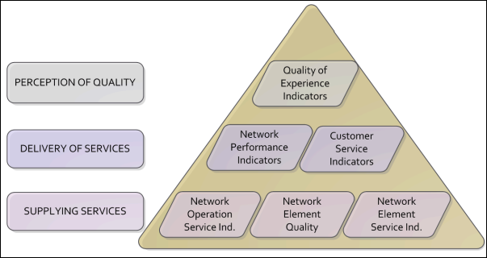  
Figure 1: Pyramid scheme of indicator categories (QuEST Forum)

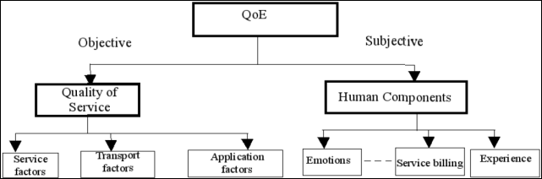  
**Figure 2: QoE Dimensions (ETSI)**

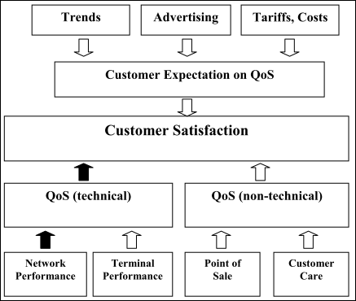  
**Figure 3: Relationship among User satisfaction, QoS and Network performane (ETSI)**

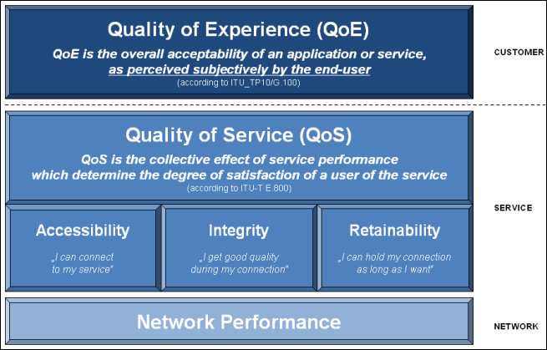  
**Figure 4: NP, QoS, QoE model and terminology (NGMN)**

From these figures it is clear that the three (3) different groups have similar yet not identical view of how to describe the quality perceived by the end user. But all three (3) choose Quality of Experience as perceived by the end user. All include a subjective human or customer service component as well as a objective QoS component ultimately based on network performance.

**Observation #7:** QuEST Forum, ETSI and NGMN have used QoE based on objective QoS plus subjective human/customer service information to describe the end user’s perceived customer experience and satisfaction.

In all cases there is an translation between the observable data, both objective and subjective indicators, and QoE. For many reasons, including different services/applications, different end user preference, vendor choice, vendor differentiation, that these translations must be left to implementation and are not suitable for standardization.

**Observation #8**: Translation from input data “indicators” -both objective and subjective- to QoE are out of scope, not suitable, for standardization and therefore out of scope for SA5.

## 3.2 QoE

QoE measurement collection was defined for UMTS and LTE

In Release 16, SA5 approved a work item WID on Management of QoE measurement collection [10], QOED (760058). This work item enabled QoE measurement collection (QMC) for Dynamic Adaptive Streaming over HTTP (DASH) and Multimedia Telephony Service for IMS (MTSI) client applications on a UE. It must be noted that the parameters to be measured were identified by SA4, responsibple TWG for 3GPP DASH and MTSI CODEC & service, in 26.247 Annex L (normative) [11] for DASH and in 26.114 Annex I (informative) [12] for MTSI.

**Observation #9**: QMC for DASH and MTSI are complete. Both the service definition and the selection of the appropriate performance indicators have been completed by the subject matter experts in SA4.

In Release 17, a Study on NR QoE management and optimizations for diverse services was initiated by RAN3 and RAN2 in RP-193256 [7], FS_NR_QoE (860061). As QMC was already defined for UMTS and LTE, the FS_NR_QoE studied the potential RAN side solution for supporting a generic framework for triggering, configuring, collection and reporting of NR QoE measurement for various 5G use cases. SA4 was identified as responsible for the CODEC aspects and SA5 was also identified as responsible for the QoE measurement configuration and reporting aspects. Study results are available in 38.890 [16].

The Release 17 Study was followed by Work Item NR QoE management and optimizations for diverse services, lead by RAN3 and RAN2 in RP-211406 [8], NR_QoE (911008). Specific 5G services identified in the WID are streaming, MTSI, MBMS, VR and XR. NR SA mode is targeted for support, along with specific radio conditions: RAN overload, measurement in RRC_INACTIVE state and transition to RRC_CONNECTED state, RAN visible QoE parameters, support per slice, alignment with MDT; SA5 is identified to provide support for mobility support of management based QoE measurements.

SA5 New WID on Enhancement of QoE Measurement Collection, SP-200193 [15] eQoE (870027) was approved to build on the work of QOED in Release 16. The objective includes signalling based activation for QMC in UMTS and LTE, VR QMC and specify QMC for NR.

Now in Release 18 the work is continued by Work Item WID update for Enhancement on NR QoE, lead by RAN3 and RAN2 in RP-221803 [9] NR_QoE_enh-Core (941108). The enhancements include cloud gaming services, RRC_CONNECTED, RRC_INACTIVE and RRC_IDLE states for MBS, and support for QoE measurement collection in NR-DC mode. SA4 is identified to provide support for services in their scope; SA5 identifed to provide support as needed.

**Observation #10**: QMC is well recognized across 3GPP as functional solution to collect measurement data that can be used to ensure the user enjoys an acceptable service experience. For UMTS, LTE, NR; streaming, voice, MBMS, VR, XR and cloud gaming; including the consideration of radio conditions: RAN overload, measurement collection in various RRC states, RAN visible QoE parameters, support for slicing, NR-DC; alignment with MDT and TRACE.

# 4 Detailed proposal

The Observations are repeated here for convenience.

**Observation #1:** KQIs reflect the end-to-end service performance and quality as perceived by the customer’s experience.

**Observation #2**: KQIs are composed by QoS metrics which have the largest impact on QoE, namely user centric and service specific quality patterns that directly influence the user’s perception for each service.

**Observation #3:** A clear definition is needed for Remote controlling.

**Observation #4**: The SA4 work item 5GMS_Ph2 is relevant to video uploading use case scenario and should be considered.

**Observation #5:** 3GPP SA4 solutions for VR streaming are relevant and should be included in the TR.

**Observation #6**: A clear definition is needed for SLS requirements.

**Observation #7:** QuEST Forum, ETSI and NGMN have used QoE based on objective QoS plus subjective human/customer service information to describe the end user’s perceived customer experience and satisfaction.

**Observation #8**: Translation from input data “indicators” -both objective and subjective- to QoE are out of scope, not suitable, for standardization and therefore out of scope for SA5.

**Observation #9**: QMC for DASH and MTSI are complete. Both the service definition and the selection of the appropriate performance indicators have been completed by the subject matter experts in SA4.

**Observation #10**: QMC is well recognized across 3GPP as functional solution to collect measurement data that can be used to ensure the user enjoys an acceptable service experience. For UMTS, LTE, NR; streaming, voice, MBMS, VR, XR and cloud gaming; including the consideration of radio conditions: RAN overload, measurement collection in various RRC states, RAN visible QoE parameters, support for slicing, NR-DC; alignment with MDT and TRACE.

Based on the above observations it is recommended to agree the following:

Based on Observations #1, 2 & 7  
**Agreement #1**: For purposes of FS_KQI_5G study item, the term KQI is defined to be (Key Quality Indicator) a measure of the experience perceived by the user, having both qualitative and quantitative components.

Based on Observation #3  
**Agreement #2:** A definition of “Remote controlling” shall be agreed by SA5 before considering any input contributions on §4.4 or §4.6.

Based on Observations #4 & 5  
**Agreement #3**: The Video uploading use case shall be aligned with relevant SA4 solutions including work item 5GMS_Ph2.

Based on Observation #6  
**Agreement #4:** A definition of SLS shall be agreed by SA5 before considering any input contributions on §4.6.

Based on Observation #1, 7, 8 & 9:  
**Agreement #5**: Defining service quality, quality of experience, or how a user perceives a service includes a subjective component in addition to objective indicators. SA5 does not have the expertise nor scope to define subjective experiences of a user and shall consider such definition as out of SA5 scope, leaving the definition of any KQI value to other groups with the necessary expertise.